A true Relation of D^{r}. Dee his Actions with spirits, &c. 73
MENSIS MYSTICUS SAOBATICUS,
Pars prima ejusdem.

fter our divers prayers and contestation of our humility, obedience, and credit in these Actions : and being come now to Cracovia, the place sanctified, whereunto we were willed to make hast, etc. At lenth appeared Nalvage.
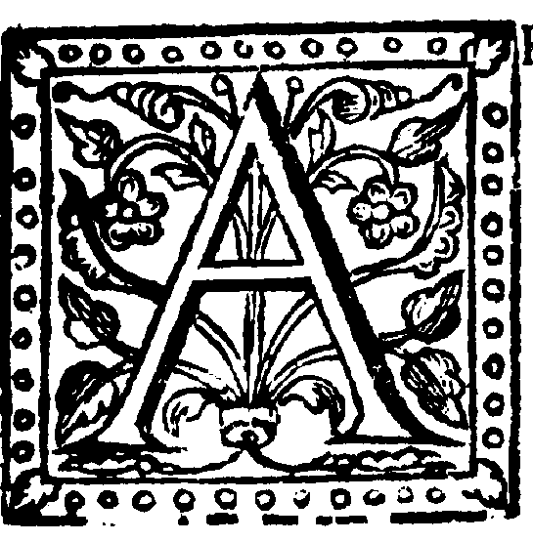
E K. He hath a Gown of white Silk, with a Cape with three pendants with tassels on the ends of them all green: it is fur, white and seemeth to shine, with a wavering glittering. On his head is nothing, he hath

no berd- His physiognomy is like the picture of King Edward the sixth ; his hair hangeth down a quarter of the length of the Cap, somewhat curling, yellow. He hath a rod or wand in his hand, almost as big as my little finger : it is of Gold, and divided into three equal parts, with a brighter Gold than the rest. He standeth upon his round table of Chris-tal, or rather Mother of Pearl: There appear an infinite number of letters on the same, as thick as one can stand by another. the table is somewhat inclined on one side : he standeth in the very middle ; his garment cover-eth his feet: his breast seemeth smooth as the down remaining of a Swan, when all the feathers be off, so is his neck, etc. He is lean and long-visaged.
Δ. The infinite mercies of God be on us : and the light of his countenance shine on us ; and his favourable countenance be on us.
Nal. ...... Amen, unto him that is, and was, and liveth for ever.
E. K. He looketh earnestly on his table, and turneth him to view it.
Nal. ...... All things are in order. Thus saith the Messenger of him which is the God of Wis-dom. Is your worthinesse such, as you can merit so great mercy ? or are your vessels cleansed, and made apt to receive and hold the sweet liquor , pure understanding itself ?
Hath the Sun entred into your bowels, or have you tasted of the night-dew ? Where are your wedding Garments ; or after what sort do you provide for your marriage ? Unseasoned you are and withered flesh, partakers of those things which make you holy : through which partaking and the secret providence of him that is the Highest, you became dignified to the end, and are sufficiently washed for the time of entrance. 0 stiff-necked people you deserve nothing, and yet you have the hire of such as labour. But, what, can corruption be partaker of those things that are incorrup-tible ? or man, which savoureth in himself, can you savour also of the Almighty.
O you weaklings, 0 you of no faith, 0 you Cankers of the earth ; Where is the shame you have ; Where are the tears you let fall ; Where is the humility you are taught to ? Nay you are such as say in your hearts; if the Spring be fair, the Harvest is like to be good: If these thing come to passe, it is the finger of the Lord. But such is your imperfection, sucb are the fruits of the flesh, and the vanity of mortality.
Notwithstanding, consider that you are servants : Do therefore the will of your Master. You are become free : Be faithful and thankful to him that is the giver of liberty : Nay you are be-come children : partakers of the counsel of him that sitteth and seeth, and saith I am. Therefore be sober, faithful, and waver not, for the inheritance of your Father is great : your freedom is without recompense, and your Master the King of Justice.
L Where

