Anne Rice 1941-
http://en.wikipedia.org/wiki/Anne_Rice
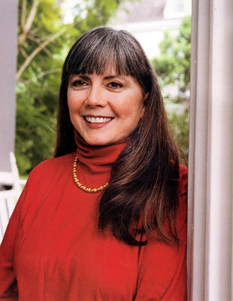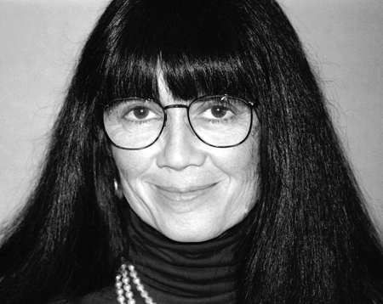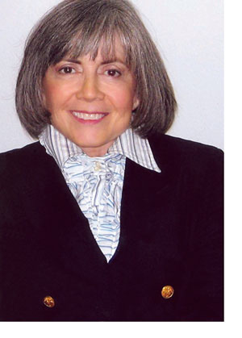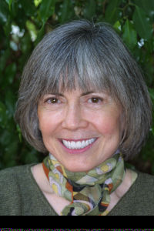

Anne Rice (born October 4, 1941) is a best-selling American author of gothic and later religious themed books. She was born Howard Allen O'Brien. Best known for her Vampire Chronicles, her prevailing thematical focus is on love, death, immortality, existentialism, and the human condition. She was married to poet Stan Rice for 41 years until his death in 2002. Her books have sold nearly 100 million copies, making her one of the most widely read authors in modern history.

Contents
- 1 Biography
  - 1.1 Early years
  - 1.2 Writing career
  - 1.3 Return to Catholicism
  - 1.4 Leaving New Orleans
  - 1.5 Amazon.com incident
- 2 Adaptations
  - 2.1 Film
  - 2.2 Theatre
  - 2.3 Fan fiction
  - 2.4 Music appearances
- 3 Bibliography
- 4 See also
- 5 References
- 6 External links

Biography

Early years
Rice was born and spent most of her early life in New Orleans, Louisiana, which forms the background against which most of her stories take place. She was the second daughter in a Catholic Irish-American family; Rice's sister, Alice Borchardt, also became a noted genre author.
About her unusual given name, Rice said: "My birth name is Howard Allen because apparently my mother thought it was a good idea to name me Howard. My father's name was Howard, she wanted to name me after Howard, and she thought it was a very interesting thing to do. She was a bit of a Bohemian, a bit of mad woman, a bit of a genius, and a great deal of a great teacher. And she had the idea that naming a woman Howard was going to give that woman an unusual advantage in the world."
Rice became "Anne" on her first day of school, when a nun asked her what her name was. She blurted out "Anne" immediately, and her mother, who was with her, let it go without correcting her, knowing how self-conscious her daughter was of her real name.

Writing career
Her father moved the family to north Texas, taking up residence in Richardson, in 1958, when Rice was 16, and she met Stan Rice, whom she would later marry, at Richardson High School. She began college at Texas Woman's University in Denton, but relocated with Stan to California, where the couple put down roots in San Francisco. "I'm a totally conservative person", she later told the New York Times (November 7, 1988). "In the middle of Haight-Ashbury in the 1960s, I was typing away while everybody was dropping acid and smoking grass. I was known as my own square." She would not return to New Orleans until 1989.[1]
Rice and her husband had a daughter Michele, who was born on September 21, 1966 and died of leukemia on August 5, 1972. Their son Christopher Rice, now a novelist, was born March 11, 1978.
She completed her first book, Interview with the Vampire, in 1973 and published it in 1976. This book would be the first in Rice's popular Vampire Chronicles series, which includes 1985's The Vampire Lestat and 1988's The Queen of the Damned. Rice has also published adult-oriented fiction under the pen name Anne Rampling, and has written explicit sado-masochistic erotica as A.N. Roquelaure.
Her fiction is often described as lush and descriptive, and her characters' sexuality is fluid, often displaying homoerotic feelings towards each other. Rice said that the bisexuality was what she was looking for in her characters; a love beyond gender. She also weaves philosophical and historic themes into the dense pattern of her books. To her admirers, Rice's books are among the best in modern popular fiction, possessing those elements that create a lasting presence in the literary canon. To her critics, her novels are baroque, "low-brow pulp" and redundant. A critical analysis of Rice's work can be found in S. T. Joshi's book The Modern Weird Tale (2001).

Return to Catholicism
In 1998, after spending most of her adult life as a self-described atheist, Rice returned to her Roman Catholic faith, which she had not practiced since she was 18. In October 2005, as she reaffirmed her Catholic faith, Rice announced in a Newsweek article that she would "write only for the Lord." She called Christ the Lord: Out of Egypt, her first novel in this genre, the beginning of a trilogy that will chronicle the life of Jesus.
In an interview with Christianity Today, headlined "Interview with a Penitent", Rice declared that she will never again write another vampire novel, saying; "I would never go back, not even if they say, 'You will be financially ruined; you've got to write another vampire book.' I would say no. I have no choice. I would be a fool for all eternity to turn my back on God like that." Some of her fans reacted with shock to the news of her religious and literary conversion, admonishing her in magazine articles, internet weblogs and reader reviews found on the web. Rice responded in a post on Amazon.com (see below) that stated: "And yes, the Chronicles are no more! Thank God!"
Whether Rice would continue to be a supporter of causes like gay rights (her son Christopher is openly gay) was much debated; she has said that Christianity's stance on homosexuality was something she wrestled with as she considered converting. She remains a passionate supporter of the rights of homosexuals and their right to participate in religious worship. Her pattern of political contributions since 1998 suggests that she continues to identify with the Democratic Party [2].

Leaving New Orleans
Rice discovered she had Type 1 diabetes when she went into a diabetic coma in December 1998. She is an advocate for people to get tested for diabetes.
In 2002, Stan Rice died after a long illness. In her subsequent depression, Rice's weight rose to 254 pounds (115 kg). In response to sleep apnea and other weight-related problems, Rice had gastric bypass surgery in 2003.
On January 30, 2004, having already put the largest of her three homes up for sale, Rice announced her plans to leave New Orleans. She cited living alone since the death of her husband and her son's moving out of state as the reasons. "Simplifying my life, not owning so much, that's the chief goal", said Rice. "I'll no longer be a citizen of New Orleans in the true sense." Her decision saved her and her property from the wrath of Hurricane Katrina which ravaged New Orleans in August 2005, though none of her former New Orleans properties took on water.
Rice may also have wished for more privacy from the constant attentions of her fans, who were known to camp out in front of her house; up to 200 or more would gather to see her leave for church on Sundays.
In spring 2005 Rice moved to La Jolla, California, to be nearer her son, Christopher. She moved less than a year later to Rancho Mirage for a warmer climate and a "simpler life."

Amazon.com incident
On September 6, 2004, Rice posted a reply to a number of negative reviews that had appeared on Amazon.com regarding Blood Canticle. She titled her reply, "From the Author to the Some of the Negative Voices Here." This post generated a great deal of publicity online - partly because authors rarely post or respond to reviews on Amazon, and partly because of the tone and nature of her text. Many previous reviews had criticized the quality of writing in Blood Canticle as lazy or shoddy; so when Rice replied by writing an article (of 1,200 words) wherein she proudly dismisses the utility of editors, the incident became fodder for weblogs and Internet sites.

Adaptations

Film
In 1994, Neil Jordan directed a relatively faithful motion picture adaptation of Interview with the Vampire, from Rice's own screenplay. The movie starred Tom Cruise as Lestat, Brad Pitt as the morbid Louis and was a breakout role for young Kirsten Dunst as the deceitful little Claudia.
A second film adaptation of the Vampire Chronicles came out in 2002. Starring Stuart Townsend as the infamous Lestat, the movie combined incidents from the second and third books in the series but released under the title of the third book, The Queen of the Damned. The plot was substantially altered from that of the book, and the film was poorly received by fans and critics alike.
A 1994 film titled Exit to Eden, based loosely on the book Rice published as Anne Rampling, starred Rosie O'Donnell and Dan Aykroyd. The work transformed from a love story into a police comedy, possibly due to the explicit S&M themes of the book.
The Feast of All Saints was made into a miniseries in 2001 by director Peter Medak and renamed Feast of All Saints.
Plans to adapt Rice's "Lives of the Mayfair Witches" trilogy into a twelve hour miniseries to be aired on NBC were dropped after a change of studio head and subsequent loss of interest in the project.

Theatre
On April 25, 2006, the musical Lestat, based on Rice's Vampire Chronicles books, opened at the Palace Theatre on Broadway after having its world premiere in San Francisco, California in December 2005. With music by Elton John and lyrics by Bernie Taupin, it was the inaugural production of the newly established Warner Brothers Theatre Ventures.
Despite Rice's own overwhelming approval and praise, the show received mostly poor reviews by critics and disappointing attendance. Lestat closed a month later on May 28, 2006, after just 33 previews and 39 regular performances.

Fan fiction
Rice has an adamant stance against fan fiction based on her work, releasing a statement on April 7, 2000 that prohibited all such efforts. This caused the removal of thousands of fanfics from the popular FanFiction.Net website.

Music appearances
Cradle of Filth briefly includes Lestat in the song "Libertina Grimm" as "Count Lestats".
Sting got the inspiration for his song "Moon over Bourbon Street" from Interview with the Vampire.
Alternative rock band Concrete Blonde's song "Bloodletting (the Vampire Song)", the title track from the Bloodletting CD, is based on Rice's The Vampire Lestat.
The Australian pop band Savage Garden found their name in The Vampire Lestat, in which Lestat describes the world as "the savage garden".
The Metalcore band Atreyu declares in the song "The Crimson", "I'm an Anne Rice novel come to life."
Legendary punk/goth band The Damned recorded a song called "The Dog" about the child vampire Claudia from Interview with the Vampire on their 1982 album Strawberries.
The Italian band Theatres des Vampires is named after a location featured in several books of The Vampire Chronicles. Their 1999 album is called The Vampire Chronicles.

Bibliography
The Vampire Chronicles:
- Interview with the Vampire (1976)
- The Vampire Lestat (1985)
- The Queen of the Damned (1988)
- The Tale of the Body Thief (1992)
- Memnoch the Devil (1995)
- The Vampire Armand (1998)
- Merrick (2000)
- Blood and Gold (2001)
- Blackwood Farm (2002)
- Blood Canticle (2003)
New Tales of the Vampires: (Other vampire tales that are not within the main sequence, but in the same fictional world)
- Pandora (1998)
- Vittorio the Vampire (1999)
Lives of The Mayfair Witches:
- The Witching Hour (1990)
- Lasher (1993)
- Taltos (1994)
Single novels:
- The Feast of All Saints (1979)
- Cry to Heaven (1982)
- The Mummy, or Ramses the Damned (1989)
- Servant of the Bones (1996)
- Violin (1997)
The Christ Series:
- Christ the Lord: Out of Egypt (2005) - Rice has said that she plans two or three sequels to this work
Short fiction:
- October 4th, 1948
- Nicholas and Jean
- The Master of Rampling Gate (Vampire Novel)
Work written under the pseudonym Anne Rampling:
- Exit to Eden (1985)
- Belinda (1986)
Erotica written under the pseudonym A. N. Roquelaure:
- The Claiming of Sleeping Beauty (1983)
- Beauty's Punishment (1984)
- Beauty's Release (1985)?

See also
- List of bestselling novels in the United States

References
- Rice, Anne (2005), "Author's Note" in Christ the Lord: Out of Egypt, Alfred A. Knopf, New York. ISBN 0-375-41201-8

External links
- Anne Rice's official website
- Reviews written by Anne Rice on amazon.com
- InnerVIEWS with Ernie Manouse: Anne Rice (TV Interview)
- Two audio interviews (1985 and 1988) of Anne Rice by Don Swaim of CBS Radio - RealAudio
- Anne Rice: Do You Know What It Means to Lose New Orleans? (regarding Hurricane Katrina)
- BBC News: "Disappointing start for Elton musical"
- Anne Rice at the Internet Speculative Fiction Database
========================================================================================================================
END

