Israel Regardie (Francis Israel Regudy)1907-1985
http://en.wikipedia.org/wiki/Israel_Regardie
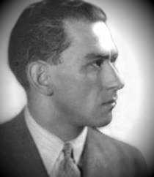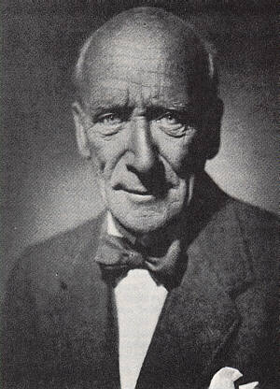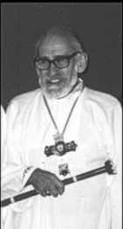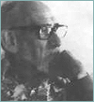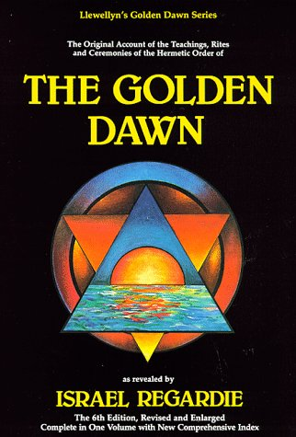
---------------------------------------------------------------------------------------------------------------------------------------------------------------------------------------------------------------------------------------
Israel Regardie (Francis Israel Regudy) (born on November 17, 1907 in London, England, died March 10, 1985 in Sedona, Arizona) was one of the 20th century's most significant occultists and a renewer of occult literature.
(born on November 17, 1907 in London, England, died March 10, 1985 in Sedona, Arizona)

Contents
- 1 Biography
- 2 Legacy
- 3 Published works
- 4 Notes
- 5 References
- 6 External links

Biography
Israel Regardie was born in London to poor Jewish immigrant parents. His family chose the surname 'Regardie' after his brother due to a mixup was enrolled in the British Army under this surname. Regardie emigrated to the United States at the age of 14, and studied art in Washington, DC and Philadelphia, PA. With a Hebrew tutor he gained a linguistic knowledge which would prove invaluable in his later studies of the Qabalah. With easy access to the Library of Congress, he read widely and became interested in theosophy, Hindu philosophy and yoga; he also joined the Rosicrucians at around this time. After reading Part One of Book Four by the occultist Aleister Crowley, he initiated a correspondence which led to his return at 21 to the UK at Crowley's invitation to become the latter's secretary in 1928. The two men parted company four years later in 1932.
Two years later in 1934, he joined the Hermetic Order of the Golden Dawn. When the group disbanded, Regardie acquired the bulk of the Order's documents and compiled the book, The Golden Dawn, which earned him the enmity of the other former members and the reputation of being an oath-breaker because of the information it revealed. However, the book transformed the work of the Order into an entire new branch of the Western Occult Tradition. As Regardie observed in his A Garden of Pomegranates, "...it is essential that the whole system should be publicly exhibited so that it may not be lost to mankind. For it is the heritage of every man and woman--their spiritual birthright." The various occult organizations claiming descent from the original Golden Dawn and the systems of magic practiced by them owe their continuing existence and popularity to Regardie's work.
In 1937, at the age of 30, Regardie returned to the U.S., entering Chiropractic College in New York. In addition, he studied psychoanalysis with Dr. E. Clegg and Dr. J. L. Bendit, and psychotherapy with Dr. Nandor Fodor. He opened a chiropractic office and taught psychiatry -- Freudian, Reichian and Jungian -- retiring in 1981 at the age of 74, when he moved to Sedona, AZ.
He died from a heart attack in the presence of close friends during a dinner at a restaurant in Sedona, Arizona on March 10, 1985 at the age of 78.

Legacy
Regardie is the principal reliable source for much of what is known about the Hermetic Order of the Golden Dawn. His writings and the students he has taught or influenced provide much of the foundation for modern Western occultism. In addition to preserving the knowledge, Regardie also preserved a valid branch of the initiatory lineage of the Golden Dawn in America:
The second significant task carried out by Regardie was, as an Adept, to bring a valid branch of the initiatory lineage of the Golden Dawn to America the alchemical melting pot where the New Age was incubating. Such tasks are not always easy. A. M. A. G. waited here four decades until the threads of the pattern came together. Then, in one of those graceful synchronicities which often play midwife to significant magical events, a couple in Georgia were inspired—at that time scarcely aware of what they were undertaking—to build a Rosicrucian Vault, the powerful ritual chamber required to pass on the Adept Initiation, at precisely the time when two magicians (one on the east coast of the United States and one on the west coast), unknown to each other or to the Georgia couple, came to be ready to receive that Initiation. And A. M. A. G., with the right to confer the Initiation in such a Vault, was the connecting link among them. And so, in one remarkable weekend, Regardie presided over two Initiations into the Inner Order, the first and the last which he ever performed; and the Lamp of the Keryx was passed into American hands.^{[1]}

Published works
- A Garden of Pomegranates
- The Tree of Life
- My Rosicrucian Adventure
- The Art of True Healing
- The Middle Pillar
- The Philosopher's Stone
- The Romance of Metaphysics
- The Art and Meaning of Magic
- Be Yourself, the Art of Relaxation
- New Wings for Daedalus
- Twelve Steps to Spiritual Enlightenment
- The Eye in the Triangle
- Roll Away the Stone
- The Legend of Aleister Crowley (with P.R. Stephenson)

Notes
- ^ Forrest, Adam P. in Cicero (1995), p. 541

References
- Cicero, Chic and Sandra Tabatha (1995). Secrets of a Golden Dawn Temple. Llewellyn Publications. ISBN 0-87542-150-4

External links
- An extended biography
- Page on Regardie by a successor organization to the original Golden Dawn
======================================================================================================================

