The Sixth Book of Moses

by Johann Scheibel [1736-1809]

published in Stuttgart, Germany [1849]

Sixth Book of Moses
Seventh Book of Moses
These two grimoires (originating from the same book) are often cited as being used by Vodun/Obeah practitioners. Although they claim to be Kabbalistic in nature, there is very little if any actual Kabbalah to be found in them. Rather this appears to be a traditional ritual magick system with incantations to summon and dismiss spirits to achieve worldly ends. Published in 1849, and translated into English in 1880, the 6th and 7th Books of Moses claim to include material from 1338, 1383 and 1501, including portions reputedly translated from the "Cuthan-Samaritan" language, which has been extinct since the 12th Century A.D., and about which very little is known. The most interesting aspects of this book are the unique illustrations of magickal seals, with letters in Hebrew and an unknown script; and the lists of names of demonic entities. Note: the images in this grimoire were originally printed in the 19th Century using very primitive printing technology. To prepare them for publication on the Internet, they were scanned from the best source available and then image-processed to bring out details. Unfortunately some of these plates have illegible portions. Note: the first five books of Moses are the traditionally the first five books of the Bible.

THE Sixth Book of Moses.
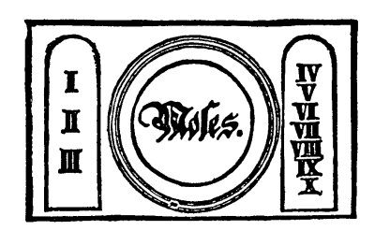

MOSES' MAGICAL SPIRIT-ART.

Translated from the Ancient Hebrew

The Seven Seals of the Spirits
MAGIA ALBA ET NIGRA UNIVERSALIS SEU NECROMANTIA
That is, that which embraces the whole of the White and Black Art, (Black Magic,) or the Necromancy of all Ministering Angels and Spirits; how to cite and desire the nine Choruses of the good angels and spirits, Saturn, Jupiter, Mars, Sun, Venus, Mercury, and Moon.
The most serviceable angels are SALATHEEL, MICHAEL, RAPHAEL, URIEL, together with the Necromancy of the black magic of the best Ministering Spirits in the Chymia et Alchymia of Moses and Aaron.
That which was hidden from David, the father of Solomon, by the High Priest SADOCK, as the highest mystery, but which was finally found in the year 330 A.D., among others, by the first Christian Emperor Constantine the Great, and sent to Pope Sylvester at Rome, after its translation under Julius II, Pontifice Maximus. Typis Manabilis sub poena excommunicationis de numquam public imprimendis sent to the Emperor Charles V., and highly recommended in the year 1520 A.D., approved by Julii II, duos libros quos Mosis condidit arter artistis summus sedalitate SADOCK. Libri hi colorum sacra sunt vota sequenter spiritus omnipotens qui uigil illa facit at est sumis pia necessaria. Fides.
Instruction.
These two Books were revealed by God, the Almighty, to his faithful servant Moses, on Mount Sinai, intervale lucis, and in this manner they also came into the hands of Aaron, Caleb, Joshua, and finally to David and his son Solomon and their high priest Sadock. Therefore, they are Biblis arcanum arcanorum, which means, Mystery of all Mysteries.
The Conversation of God.
Adonai, Sother, Emanuel, Ehic, Tetragramaton, Ayscher, Jehova, Zeboath, the Lord of Hosts, of Heaven and Earth; that which appertains to the Sixth and Seventh Books of Moses, as follows:
Adonai, E El, Zeboath, Jebaouha, Jehovah, E El, Chad, Tetragramaton Chaddai, Channaniah, al Elyon, Chaye, Ayscher, Adoyah Zawah, Tetragramaton, Awiel, Adoyah, Chay, Yechal, Kanus, Emmet. Thus spake the Lord of Hosts to me Moses.
Eheye, Ayscher, Jehel, Yazliah, Ellion. Sum qui sum ab aeterno in aeternum, thou my servant Moses, open thou thine ears, hear the voice of thy God. Through me Jehovah, Aglai, the God of heven and earth, thy race shall be multiplied and shall shine as the stars of heaven. In addition to this I will also give thee might, power and wisdom, to rule over the spirits of heaven and hell.
Over the ministering angels and spirits of the fourth element as well as of the seven planets. Hear also the voice of thy God wherewith I give thee the seven seals and twelve tables. Schem, Schel, Hamforach, that the angels and spirits may always yield obedient service to thee, when thou callest upon them and citest them by these seven seals and twelve tables of my omnioptence; and hereunto thou shalt also have herewith a knowledge of the highest mysteries.
Therefore, thou, my faithful friend, dear Moses, take thou the power and high might of thy God.
Aclon, Ysheye, Channanyah, Yeschayah, E El, Elijon, Rachmiel, Ariel, Eheye, Ayscher, Eheye, Elyon. Through my Seals and Tables.

THE MYSTERY OF THE FIRST SEAL
Seal of the Choir of the Ministering Archangels
CONJURATION
I, N.N., a servant of God, desire, call upon the OCH, and conjure thee through water, fire, air, and earth, and everything that lives and moves therein, and by the most holy names of God, Agios, Tehirios, Perailtus, Alpha et Omega, Beginning and End, God and Man-Sabaoth, Adanai, Agla, Tetragramaton, Emanuel, Abua, Ceus, Elioa, Torna, Deus Salvator, Aramma, Messias, Clerob, Michael, Abreil, Achleof, Gachenas et Peraim, Eei Patris et Peraim Eei filii, et Peraim Dei spiritus Teti, and the words by which Solomon and Manasses, Cripinus and Agrippa conjured the spirits, and by whatever else thou mayest be conquered, that you will yield obedience to me, N.N. the same as Isaac did to Abraham, and appear before me, N.N. this instant, in the beautiful, mild, human form of a youth, and bring what I desire. (This the conjuror must name).
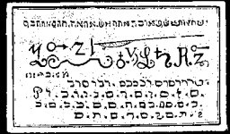
The most useful ministering arch angels of this seal are the following with their Hebrew verbis revelatis Citatiori divinitus coactivis: Uriel, Arael, Zacharael, Gabriel, Raphael, Theoska, Zywolech, Hemohon, Yhael, Tuwahel, Donahan, Sywaro, Samohayl, Zowanus, Ruweno Ymoeloh, Hahowel, Tywael. The particularly great secret and special use of this seal is that if this seal is buried in the earth, where treasures exist, they will come to the surface of themselves, without any presence during a full moon.

THE MYSTERY OF THE SECOND SEAL
The Name is True Seal of the Choir of Hosts or Dominations of the Ministering Angels.
CONJURATION
I, N.N., a servant of God, desire, call upon and conjure thee, Spirit Phuel, by the Holy Messengers and all the Disciples of the Lord, by the four Holy Evangelists and the three Holy Men of God and by the most terrible and most holy words Abriel, Fibriel, Zada, Zaday, Zarabo, Laragola, Lavaterium, Laroyol, Zay, Zagin, Labir, Lya, Adeo, Deus, Alon, Abay, Alos, Pieus, Ehos, Mihi, Uini, Mora, Zorad, and by those holy words, that thou come and appear before me, N.N., in a beautiful human form, and bring me what I desire. (This the conjuror must name.)
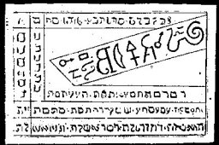
This Seal from the Choir of the Dominationen, or Hosts, the following are the most useful: Aha, Rosh, Habu, Aromicha, Lemar, Patteny, Hamya, Azoth, Hayozer, Karohel, Wezynna, Patecha, Tehom. The special secret of this seal is that if a man carries this Seal with him, it will bring him great fortune and blessing; it is therefore called the truest and highest Seal of Fortune.

THE MYSTERY OF THE THIRD SEAL.
Seal of the Ministering Throne Angels.
CONJURATION
I, N.N., a servant of God, desire, call upon thee, and conjure thee Tehor, by all the Holy Angels and Arch Angels, by the holy Michael, the holy Gabriel, Raphael, Uriel, Thronus, Dominationes principalis, virtutes, Cherubim et Seraphim, and with unceasing voice I cry, Holy, Holy, Holy, is the Lord God of Sabaoth, and by the most terrible words: Soah, Sother, Emmanuel, Hdon, Amathon, Mathay, Adonai, Eei, Eli, Eloy, Zoag, Dios, Anath, Tafa, Uabo, Tetragramaton, Aglay, Josua, Jonas, Caplie, Caphas. Appear before me, N.N., in a mild and human form, and do what I desire. (This the conjuror must name.)
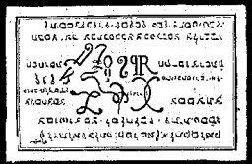
The ministering Throne Angels of this Seal are the following: Theom, Haseha, Amarzyom, Schawayt, Chuscha, Zawar, Yahel. La hehor, Adoyahel, Schimuel Achusaton, Schaddyl, Chamyl, Parymel, Chayo. The special secret of this Throne is that by carrying this Seal with you will cause you to be very agreeable and much beloved, and will also defeat all your enemies.

THE MYSTERY OF THE FOURTH SEAL
Seal of the Ministering Cherubim and Seraphim with their Characteristics
CONJURATION.
I, N.N., a servant of God, call upon thee, desire and conjure thee, O Spirit Anoch, by the wisdom of Solomon, by the obedience of Isaac, by the blessing of Abraham, by the piety of Jacob and Noe, who did not sin before God, by the serpents of Moses, and by the twelve tribes, and by the most terrible words: Dallia, Dollia, Dollion, Corfuselas, Jazy, Agzy, Ahub, Tilli, Stago, Adoth, Suna, Eoluth, Alos, Jaoth, Dilu, and by all the words through which thou canst be compelled to appear before me in a beautiful, human form, and give what I desire. (This the conjuror must name.)
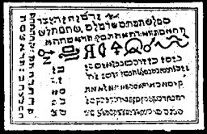
The most obliging ministering Cherubim and Seraphim of this Seal, are the following with their Hebrew calling: Anoch, Sewachar, Chaylon, Esor, Yaron, Oseny, Yagelor, Ehym, Maakyel, Echad, Yalyon, Yagar, Ragat, Ymmat, Chabalym, Schadym.
The special secret of this Seal is that to carry this Seal upon the body will save a person from all misery, and give the greatest fortune and long life.

THE MYSTERY OF THE FIFTH SEAL
Seal of the Angels of Power
CONJURATION
I, N.N., a servant of God, call upon thee, desire and conjure thee, Spirit Scheol, through the most holy appearance in the flesh of Jesus Christ, by his most holy birth and circumcision, by his sweating of blood in the Garden, by the lashes he bore, by his bitter sufferings and death, by his Resurrection, Ascension and the sending of the Holy Spirit as a comforter, and by the most dreadful words: Dai, Deorum, Ellas, genio Sophiel, Zophiel, Canoei, Elmiach, Richol, Hoamiach, Jerazol, Vohal, Daniel, Hasios, Tomaisch, Sannul, Damamlach, Sanul, Damabiath, and by those words through which thou canst be conquered, that thou appear before me in a beautiful, human form, and fulfil what I desire. (This must be named by the conjuror.)
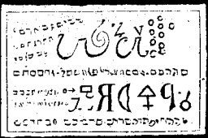
The most serviceable Angels of Power are the following: Schoel, Hael, Sephiroth, Thamy, Schamayl, Yeehah, Holyl, Yomelo, Hadlam, Mazbaz, Elohaym.
The special secret of this Seal is that if this Seal be laid upon the sick in full, true faith, it will restore him, if he has not lived the full number of his days. Therefore, it is called the Seal of Power.

THE MYSTERY OF THE SIXTH SEAL.
The Seal of the Power Angels are Potestatum over the Angels and Spirits of all the Elements.
CONJURATION.
I, N.N., a servant of God, desire, call upon and conjure thee, Spirit Alymon, by the most dreadful words, Sather, Ehomo, Geno, Poro, Jehovah, Elohim, Volnah, Denach, Alonlam, Ophiel, Zophiel, Sophiel, Habriel, Eloha, Alesimus, Dileth, Melohim, and by all the holiest words through which thou canst be conquered, that thou appear before me in a mild, beautiful human form, and fulfil what I command thee, so surely as God will come to judge the living and the dead. Fiat, Fiat, Fiat.
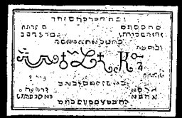
The most obedient Angels of Power, seu Potestates, are the following four elements: Schunmyel, Alymon, Mupiel, Symnay, Semanglaf, Taftyah, Melech, Seolam, Waed, Sezah, Safyn, Kyptip, Taftyarohel, Aeburatiel, Anyam, Bymnam. This is the mystery or Seal of the Might-Angels. The peculiar Arcanum of this Seal of the Mighty is that if a man wears this seal in bed, he will learn what he desires to know through dreams and visions.

THE MYSTERY OF THE SEVENTH SEAL.
Seal of the Angels of the Seven Planets and Spirits.
CONJURATION.
I, N.N., a servant of God, call upon, desire, and conjure thee, Ahael, Banech, by the most holy words Agios, (Tetr.,) Eschiros, Adonai, Alpha et Omega, Raphael, Michael, Uriel, Schmaradiel, Zaday, and by all the known names of Almighty God, by whatever thou, Ahael, canst be compelled, that thou appear before me, in a human form, and fulfil what I desire. Fiat, Fiat, Fiat. (This must be named by the conjuror.)
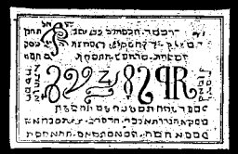
The most obedient Angels and Spirits of this Seal of the Seven Planets are the following: Ahaeb, Baneh, Yeschnath, Hoschiah, Betodah, Leykof, Yamdus, Zerenar, Sahon. This Seal, when laid upon the treasure earth, or when placed within the works of a mine, will reveal all the precious contents of the mine.

END

