The Black Raven

Doctor Johannes Faust's Miracle and Magic Book

or

The Black Raven

or also called

The Threfold Coercion of Hell

Translated into English Language by

Karl Hans Welz
http://www.magitech.com/faust/introfst.html

Dr. Johannes Faust's miracle and wonder book or The Black Raven or also called The Threefold Coercion of Hell Translated into English by Karl Hans Welz

Copyright 1990 by Karl Hans Welz
This book may not be reproduced in whole or in part, by mimeograph or any
other means, without prior permission in writing from the author.
Published 1993 by the Knights of Runes P.O. Box 2070, Decatur, GA 30031
Caput Primum
Caput Secundum
Caput Tertium
Caput Quartum
Caput Quintum
Dr. Faust's Last Testament

Foreword
The book of Doctor Johannes Faust is one of the best known grimoires in the German realm. German magicians usually referred to it as "Doctor Faust's Coercion of Hell." They ascribe its origin to the Jesuits, perhaps a result of the style of the book.

Beginning magicians used this grimoire in the main for its talismans. For the person who knows how to read between the lines, this grimoire offers a lot more. It opens up the access to magical powers of an enormous potential, especially when the student has also access to the Faustian Tarot. This deck of cards is not a tarot deck in the strictest sense, but rather a representation of the energies that slumber deep within ourselves, ready to serve the person who has the courage to awaken them.
I admonish the reader to read between the lines and thus gain access to the magical powers that are inherent in this fascinating book of German sorcery.

I have written a commentary to the Coercion of Hell. In this commentary, I give you some insights in the times of the writing of this book. This brief analysis will explain why the original author had to write the grimoire in this form. In addition, I am giving you some hints of how to read between the lines so you can draw the maximum benefit from this fascinating work of German sorcery.

introductio
This is Doctor Johannes Faustis Miracul Art and Magic Book, or The Black Raven, or also named The Threefold Coercion of Hell. With this book I, Dr. Johannes Faust, have coerced all the spirits so that they had to bring to me whatever I desired: be it go ld, silver, treasures large and small, also the spring-root, and whatever else is available on Earth. All that did I get with this book. I was also capable to dispel the spirits after they had done what I asked them for.

A Warning!

Never read me aloud without a circle
Otherwise I am of great danger to you!
The spirit whom you cannot make to obey
Will attach himself to your skin.
You cannot dispel him
And he works on you very hard
So that he can connect with you totally.
Therefore set up my circle first
And prepare everything very well.
Do not forget the exact sigils of the spirit
Before you begin with the works.
Be sure that you have the symbol
Of the spirit whom you desire most.
If you summon with power
You will achieve big results
This is the way for you
To coerce the spirits
As I have done it myself.
They have to bring you Everything that you demand.

I, Doctor Johann Faust, am skilled in the Free Arts. From an early age on, I have read many books. During my studies, I ran across a book that contained many of these things concerning the summoning of spirits. At first I had my doubts, but I liked the idea of testing the practices that I have read of in the book, for I enjoyed the thought of the results that such practices would bring.

However, as soon as I began to practice, things happened exactly as the book has told: a very powerful spirit (ASTAROTH) stood in front of me. He demanded now from me to tell him why I had called him. Hurriedly I decided that he should be serviceable a nd helpful to me in many situations and desires that I had. As a condition, the spirit demanded that I had to make a treaty with him at first. In the beginning I had little inclination to do so. However, I had only a weak circle since my original thoug ht was to only try things out a bit. For this reason I was in no position to resist and I had to follow that which the spirit asked from me. Soon we had drawn up an agreement that said that the spirit had to serve me for a set time and amount of years.

After this had happened, this spirit introduced Mochiel to me to him he commanded that he should serve me. I asked him (Mochiel) how fast he was, and he answered that he was as fast as the wind. My reply was that he will not serve me and that he should go back to the place where he had come from. Soon after that, Aniguel came. He replied to my question that he was as fast as a bird in the air. "You are still too slow, go away!" I answered. Immediately after this the third spirit stood in front of me. His name was Aziel. I asked him how fast h e was. He answered that he was as fast as human thought. "Good for you," I replied, "I want to have you!" With these words, I accepted him. This spirit has served me a long time as has been written about extensively.

caput primum
With this I want to instruct you how you should act and force the spirits with strongest power so that they have to appear and come in front of your circle and give you everything that you want from them. At the beginning they refuse. You should keep su mmoning them. In most cases do they come when you call them for the third time.

If a spirit now appears and he does so as you requested, i.e., in a beautiful human shape, then it is best to ask him two or three questions so that you will not annoy him. If however the spirit does not come in human appearance, then you should torture him and you should not receive him.

The practitioner and his helpers should have received the absolution before the summoning and they should also have received the Holy Communion. In addition, they should be very skilled in prayer, otherwise the spirits will not obey them. Your faith in the success of the operation needs to be as strong as if it (the success of your summoning) had already happened.
In addition to this, you should consider diligently the day and hour such as Monday at 8 and at 3, Tuesday at 9, at 6, and at 12 midnight. Always work on these two days, when the Moon is full, then the spirits will have to bring everything that you deman d and want. You should do the summoning at a secret place. This ensures that you, the operator, will not be blocked or prevented in your work.

You need to make the circle and everything else with care. You need also to follow all instructions so that you will not make any mistakes. You should also have the pure truth of how you should behave and you should give to the poor and to your sufferin g neighbors.

Keep all that which you have read in this book a secret and do not give it for free to anybody, otherwise you will not be happy. The fees that you receive from what you are doing you should pass on to others and you should help the poor and the persons w ho are suffering and the humble ones out of their difficulties. If you refuse to do so, you will have no luck nor a good star. Let this be a constant warning to you, because never again will you receive those sciences of this world.

Use everything correctly and in secret. Use it the right way, and reveal it to nobody who is not worthy, otherwise your neck shall be broken, and if you tell it to a man of glory and you do not give the money that you received for it to a suffering and p oor man, keep this a secret. Be careful not to make any agreement with the spirits so that you will not suffer and experience that which is going to happen to me.

General Citation of All Spirits
Osola mica rama lamani
Volase cala maja mira salame
Viemisa molasola Rama Afasala
Mirahel Zorabeli Assaja

caput secundum
This chapter describes the making of the circulum.
First: You should trace the circulum with a sword that has nobody yet hurt. On one side of the sword, you should inscribe the following characters.

On the other side, you inscribe these characters below.
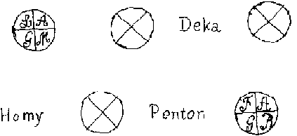

Second: You should trace the circle while you say the following words:
O Le Ja meni sete Mirari jael
la mese mihi Jasala Ale Jona
Masa criel Finamiel-Siona
O la sariel Assa Salimeni Arael
fasa, maja, Paja, Lalemisa Jerobeliel
Majasa faliel mica sariel olomisa
lale masa Hajariel

After you have done this, you make three crosses and you pray three Lord's prayers in the kneeling position.
Third: When you summon, you must put in front of you in the circle the following symbols that you should have traced in red color.
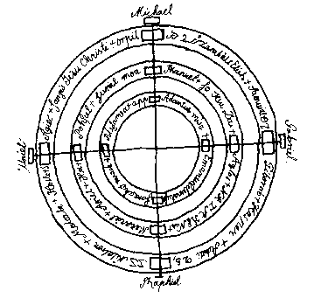

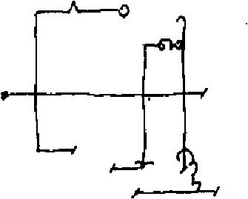
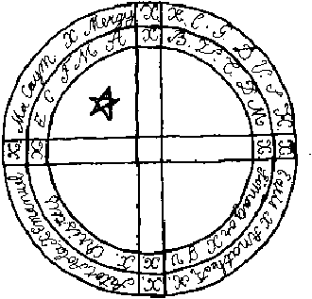
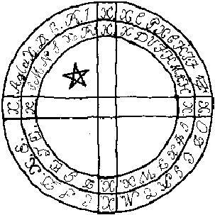

caput tertium
This chapter has to do with the seven Grand Dukes Whenever you intend to summon spirits, you need to put the seal of the spirit whom you want to call three steps in front of the circle so that you can show your intention. The following is the Seal of Aziel, who is the first of the grand dukes:
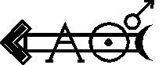

(Sun) They call me Aziel, and I am a ruler over all hidden treasures of the Earth. I have power to open all treasures and I give them to the persons to whom I like to give them. I also try shrewdly to cheat in whichever way I can. My planet is the Sun, and my paladin Carmielis is my servant. I am appearing in the shape of a bull, but I can also assume any other form. You ought to give me rulership over everything because I have many legions of spirits serving me. I am a Grand Duke. You need to coer ce all my subordinates with force, which is the same way you have to coerce me, because I am a Grand Duke on Earth who has many things under his command. Therefore you need to summon me the right way, otherwise I will not appear before you. You should e ngrave my other character (= sigil) in gold. I will only tell you this other seal if you ask me to do so. I am as fast as human thought.

ARIEL'S SEAL
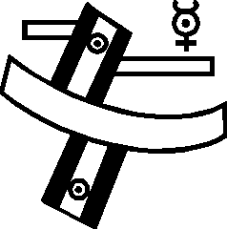

My name is Ariel, and I appear in the shape of a dog. I command everything above and below the Earth. Many legions are under my command, and I am a fast spirit: as fast as a roe deer. Some people will benefit from me. Others I will hurt. I will always be acting in the manner in which you will have summoned me. I am an obstinate spirit who will not follow the call of any person. Therefore you have summon me with power before I will appear. Many millions of spirits are under my command, and I am a ruler over the treasures of all gods. I am as fast as the wind.

MARBUEL'S SEAL
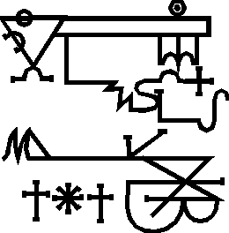
I am the spirit who is ready to serve. I appear in the shape of a ten year old boy. It is useful to summon me at any time, and I am as fast as an arrow.

MEPHISTOPHILIS'S SEAL
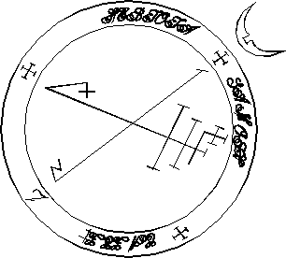

I am the grand master of many arts and of luck in general. You can learn things in an instant. You need to summon me four times. I have quite a selection of spirits under my command who are serving me. Whenever I command them to serve they do so fast.

BARBUEL'S SEAL
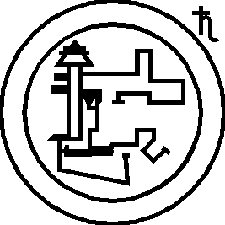

I am a water Lord over the seas and over all waters. I rule over everything that lives in water. I am fast and I may give everything provided that you summon me right. Then I shall appear and I may also please you.

AZIABEL'S SEAL
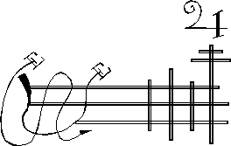

I am a great spirit who appears as a little child. I serve anybody provided that he or she summons me right. I am ruler over the affairs of law. Many spirits have to obey me. I also like to please everybody, and I can make honor, riches, status, and a lot of luck.

ANIFEL'S SEAL


I, Faust, asked once my Grand Duke Aziel how I could tie and coerce humans. He replied to me that he could mot tell me that, so I told him to write it down for me rather than to tell me in words. "Oh!" Said the spirit, "my Faust, I truly should not have made an agreement with you, my Faust! However, I am going to write it down right here so that you will know the answer: My Faust!
1. F. this is my coercion, when I have to say Jesus Christ is in 2.3.
V. the flesh comes
4. with the omnipotence
of god, this is not to discover
5.
and when I should keep my promise to
someone, then he needs to have me swear by
the cross,
6. until I will give my sign
This is the sign as it stands here.
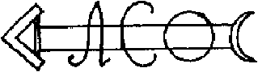

imperium magnum
infernalis

The Infernal Empire is as follows:
1. LUCIFER, the emperor
2. BELIAL, Viceroy
3. SATAN, Governor
4. BEELZEBUB, Governor
5. ASTAROTH, Governor
6. PLUTO, Governor

The following are the seven Grand Dukes of the Infernal Empire:
1. AZIEL
2. MEPHISTOPHILIS
3. MARBUEL
4. ARIEL
5. ANIGUEL
6. ANISEL
7. BARFAEL (Barbuel)

These are the Grand Ministers and secret Infernal Counsels
1. ABBADON
2. CHAMUS
3. MILEA
4. LAPASIS
5. MERAPIS

These are the Spiritus Familiares of the Infernal Empire
1. CHINICHAM
2. PIMPAM
3. MASA
4. LISSA
5. DROMDROM
6. LOMHA
7. PALASA
8. NAUFA
9. LIMA
10. PORA
11. SAYA
12. WUNSOLAY

caput quartum

This chapter contains the summoning and conjurations of the spirits.
Summoning of AZIEL
I, (say your name here), command thee, spirit (here you have to say the name of the spirit), that thou appearst instantly by the power of the word ADBDA and also by the power of the angel AMASALE, and by the power of the star GADALA which rises in the last degree of Capricorn, which I (your name) set up as a symbol of this. I call thee, spirit (name of the spirit) by Durashain, Maim, Lulim + (make a cross whenever the symbol + appears in the text) Menim + Senim + Zaim + Sulim +. I conjure thee spirit (na me of spirit) by Hipim + Repim + Sepim + Gulum + Locsant + Dropep + Schamot +. I (your name), I (your name), I (your name) command, command, command, thee spirit (spirit name) by the power of the heavenly lord + who created heaven and earth and all which is on it, who commands the four winds, who rules over all beings, and whom everything which is alive and created has to obey, that thou, spirit (name of spirit) doest everything for me which I command thee to do, by the power of the following words Alaja + Rasamule + Moliel + Zynagamim + lo + affrisi + Misaniel +, that thou bringst me everything, that thou, spirit (name of spirit) do so now, in speed, your symbol with you in front of my circle. I (your name) call thee by the power of the four winds , by the power of the air, and by all beings created, that thou appearst before my circle right now and that thou doest that without trying to instill fear, in visible shape. I (your name) conjure thee by everything that is alive that thou comest, comest , comest, by the strength of all strengths, which had you overpowered and who commands everything. I conjure thee, air, that thou doest not keep the (name of spirit) from me, but that thou sendest him very soon. Oh la Valasaja + Salajami + Masei +, but that he gives me speech and answer in English language. Amen.

General Summoning of the Spirit

AZIEL
Calemi + Cadem + O spirit (name of spirit) Poramase la hemise + Coelum + et Firmamentum + Casami + Misarajaet + Xamara + Sadalachamim + Dusama + Popiniet + Lemisisaraet + Amen
If he does not come, speak this three times.

Particular Summon of the Grand Duke

ARIEL
I, (your name) summon thee, spirit (name) + come, come, very speedily +. Firmament, earth, air, and everything, that you will not hold back the spirit I command this to you by the great words and names Dala + Makasaim + Rusaloja + Munot + Phalaniet + I coerce you spirit (name) by the strongest coercion Roma + Sa + Ra + Familia + Rominase + come, come, come, immediately, come, come, come, Anasai + fa + fali + monitase + fata + Amen

Main Conjuration of the Grand Duke

ARIEL
Vota + misa + Lasafe + ma + Homina + Sara + Pada + Chagiel + Matachia + Mecha + Enazarael + O hevilame Ga + Hiebani + that thou sendest him before my circle, or else thine punishment shall be seven times as much on thee spirit (name of spirit) in hell, I Roma + sa + fu + Amiel + mien + suisa + Amen

Particular Summon of the Grand Duke

MARBUEL
I (your name) conjure thee Grand Duke (name) by the great ruler in the heaven and on earth, in the water and in the air, in the fire, on earth, in the hell, outside the hell, and by the word which there was at the beginning of the world, who has overwhelm ed you, Great Duke (name) during his victorious descent to hell, and who has stepped on you with his feet. I (your name) conjure thee Grand Duke (name) by all the leaves and grass and by everything that is called world, that you open for me all foundatio ns of the earth and that you bring it in the name and power of the one who has no end + all stones, spirits, and earth spirits, and bring them in front of my circle, and that you immediately do so as I command you according to my will, by + Amala Saim + f ara + lamim + Saumi + ma + Amen. Come, come, come.

General Summon of the Grand Duke

MARBUEL
Ma + Schaffot + Etanahoim + Masalami + Fasta + Apiramus + Misa + ETANOGANASA + Padaschia + I, (your name) call thee (spirit name) by Masa + Hipa + Sapa + Rama + Laja + Meffi + Amen

Main Summon of all spirits when they make noise
O Ma + Raieschia + Nisanatos + Mopsi + Laminasi + Coporasch + Monasha + Alolia + Mygyssa + Pompana + Nosis + Firmamenta + Samasa + Jameschia + Fonascha + Molami + Amen
Poraschalia +++ Minischa +++ Semisa +++
Speak this three times

Conjuration if the spirit refuses to transform himself
Mosa + O Naschi + Gajala + Pressi + Fafa + Hisca + Allismicos + Felschima + Potmas + Saal + Amesda + Proceses + Terra + Festus + Spica + Munisa + Soila + Desca + Elesiamini + Amen +++ Qui venit in nomine Domini O Kyrios + O Kyrie Eleison + Amen +++
Speak this three times

The greeting to all spirits
Palifasta + Firmis + Demecha + Haim +

caput quintum

This chapter has to do with the binding, loosing, flogging, and dismissing of the spirits. The following is for binding, when the spirit does not want to stay. Speak it three times.
Deus + Pata + binde + Jesus + Behalte + Deus + Spiritum + binde + durch + Kraft + Christi + Knuepfe + schliesse + the spirit (spirit name) Amen +++

Threefold loosening when the spirit refuses to answer
O Sa miha + Aseffonila + Ja + La + Mifflahi + Mehahinesi + Milonahireil

Flogging, to be spoken three times
When the spirit does not want to obey hit into the air with the switch, and hit also the spirit's seal. The switches that you use for the flogging of the spirits should be of the wood of juniper. Cut them on a Thursday in the new of the Moon early in th e morning before sunrise in the hours of Mars and Venus. Cut the following words into the switches: "The seed of the woman should stomp the head of the serpent" Defi + Ministrahel + Jasa + Mifana + Hisanam

Conjuration to the flogging
Prescio + Mipot + Domisiac + Tufi + Maha + Huschia + Laemelisete + Hedera + Cade + Veleadis + Locisomnibus + Amesiamin + ARIROSH + Laedemische + Jehonale + Hisipo + Amen +++ Podarasche + Podarasche

Dismissal of all spirits
O spirit (name of spirit) + Portam Benedictam + Sic tecum quasia horas siece mila + Amen

When the spirit does not want to leave, then speak:
Benedictus + est qui omnia regnat + per omnia secula seculorum + in nomine domini +++ Amen +++
You can also summon the Grand Dukes and all other spirits with the citatio that you find in my last will.

Fumigation to summon an evil spirit
Take garlic, sulfur, pitch, Christ herb, Burzel herb (?), put this on coal, and when the smoke rises be careful that the spirit does not press you, and speak the following words: O Lama + Basulai + Monai + Mempis + Lorrate + Pacem +

Doctor Johannes Faust's Noble Secrets

These are Doctor Johannes Faust's noble secrets and sigils that serve to protect every operator and practitioner of the FREE ARTS against the spirits, and which may also be carried with oneself for other purposes for which they are useful. This everyone should keep well and with respect. You should keep such secrets well hidden so that you will not suffer great damage, bad luck, or death. This keep well in mind.
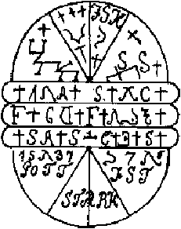

Make this seal on a Sunday morning before Sunrise in the hour of Mars. You have to engrave it in gold. If you carry it on you, it protects you against all spirits so that they cannot hurt you. It also protects you against all your enemies when the seal is in a pouch of red velvet and when you carry it on the right side of the clothing.
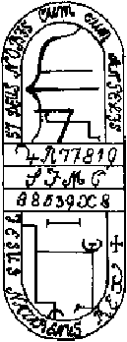

You need to make this symbol on a Friday in the hour of Venus and you have to wear it in front of your chest. When you have dealings with the spirits, then you are secure and free from all danger. You have to draw the symbol on Virgin parchment with the blood of a bat.
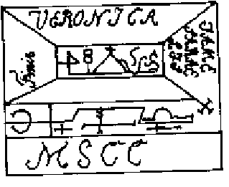

Make this seal on a Monday during the hour of Jupiter. It will free you from all evil spirits.
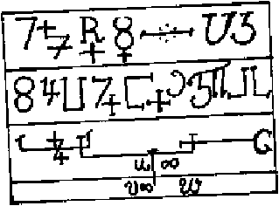

Make this seal in the Night of St. John (June 21st -- the translator) at midnight and on gold. If you bury this seal at a place where spirits are dwelling, they will leave rapidly and they will leave behind all their treasures.<BR
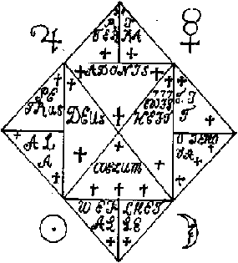

This is a seal with which you can bind and coerce all infernal spirits when you show it to them during citations.
When you engrave this seal on silver and put it on a treasure, it will cause the treasure to rise and the treasure will be yours for certain and all spirits will leave the treasure. This is the most powerful seal that you will ever find.
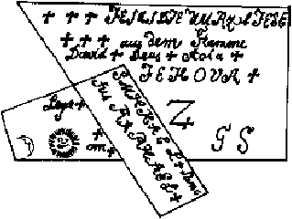
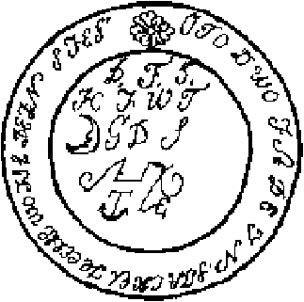
This seal helps your emotions and also your body. If you carry it on you, nobody can harm your body. You will also win in everything that you begin. Everyone will be afraid of you. Engrave the seal in gold in the hour of the Sun on Sunday before Sunri se. With this seal, you can also make yourself invisible when you put it onto yourself in the hour of the Sun.
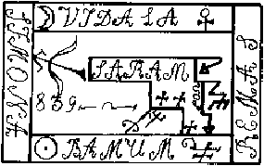

This seal is of use in all operations and it should never be left out, because it is the operator's defense and wall.
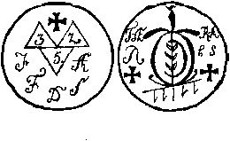

This serves against all spirits and evil beings. When you put it on a place they have to leave it. Engrave it on lead in the hour of Jupiter.
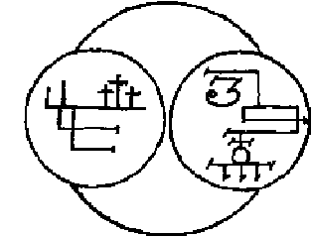

Make this seal in the hour of Mars and Venus on iron and copper, put it for nine days on a place where a treasure is buried, and all spirits will leave this place and you will find the metal covered with blood.
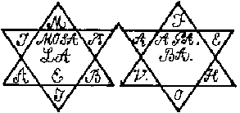
With these seals you can perform miracles. You are secure from all your enemies and nobody can harm you in any way. Fire and water are afraid of you and evil spirits have to leave. It is a powerful remedy against all diseases and you need no medicine. Nobody will deny you any request. Whatever you begin will come to a good outcome. All people have to love you and to fear you. You are fortunate in dealings with the clergy and in court. This is the most powerful seal that you possibly could find. Y ou should engrave this seal on gold in the hour of the Sun.
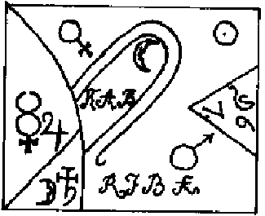

This seal is to be engraved on an alloy that is composed of all seven metals. If you put it on a treasure that has been transformed, this seal will bring the treasure back into its true shape. You should make this seal in the hour of Mercury on a Wednesday.
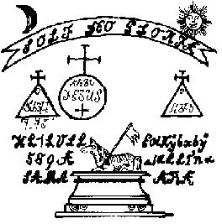

I have bought these last four seals in Holland for the enormous price of 8000 Ducats. I found these seals to be good for any situation. They helped me especially in the digging of treasures. I have been able to do with them anything that I wanted.
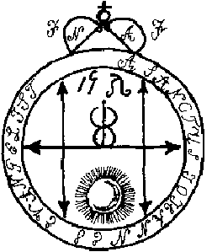
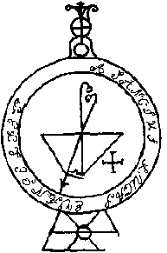
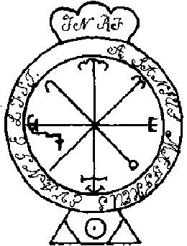

Doctor Faust's
Last Testament
You can achieve spectacular results of your work with grimoires, sigils, magick, etc.,
with a generator of life force (orgone generator, Welz Chi Generator)
Click Here for more details

The following describes the most powerful main summoning and conjuration. With it you can bind all spirits, you can torture them, and you can make them to bring to you everything that you demand of them.

When it happened that my time and hour were soon to come, I decided to leave my testament to every operator, so that he would be able to coerce all spirits under his will and to bind them as well. I have done so with the coercions that follow in this book.

caput primum...
. . . has to do with my agreement. 1. Should you, Lucifer, bring me two tons of gold.
2. Should this gold
be valid everywhere, and all those to whom I give it should benefit from it. 3. Should this gold not be counterfeit nor should it be of material that may be rejected, nor should it disappear or turn into coal or into similar such things, but it should be of such metal which has been used by human beings and which is valid in all places and in all countries.
4. Should all treasures be open to me and it should never be necessary that I have to dig them up with my own hands, but you should bring them to where I want to have them without any effort from my part.
5. Should you hurt me neither on body nor on limbs. You should not attack my health. I should keep body and health in good health without any weakness until I will have finished my set time of life.
6. Should you not only carry me from one place to another with the speed of human thought, no matter how far the places are apart, but you should also give me knowledge of every local language so that I can speak it easily. After I have had my fun at such a place, you should me bring back to my previous place. You should do all this without any harm to me.
7. Should you provide me with a ring which I can use to be invisible and invincible whenever I put it onto my finger.
8. Should you teach me how to prepare the universal medicine, as well as you should show me and tell me the correct use of it, the powers, and the weights and potencies that I have to use when I give it to any person.
9. Should you promise and affirm to me that you will follow all the above points without fail. Should you, however, fail or delay in this, then you should have no peace from this book at any day, and you should not be left in peace any more and in all e ternity.
caput secundum..
. . . has to do with the setting up of the circle
This main circle is much needed for all citations. With it, you are capable to bind the whole infernal army and to coerce and overpower it as well. This is so because this circle is so powerful that no spirit is capable to withstand it no matter how str ong the spirit may be. The other three circles have already been described in previous chapters. On the place where you intend to erect the circle, you need to trace it with a sword with which no hunman being has been hurt. In the hour of Saturn, you t race a cross through it. Then you make the circle with a narrow piece of paper that you lay around the circle. After you have made the circle in such a way, you go into it walking backwards, and you stand on the star. Be sure to make everything in the right size so that you do not miss. Remember well that you need to speak loudly and clearly when you do the summoning.

caput tertium
Before you summon, it is good to read the gospel of St. John that begins with the words "In the beginning was the word . . ." and you read it up to the words ". . . full of grace and truth." Then you go on to the works. Be sure that you have the prescri bed pentacles #20 and #21 with you as well as the four last ones (from the last chapter of the previous book). If you summon a treasure you need to have written in front of your cap the letters: I.N.R.I.
Here is the circle.
This Hazel Serpent is very useful in many of the free arts. You may find it beneath the filbert nut bush. When you find it, do not touch it with your hands. As you see the snake, take a stick of hazel wood and hit it. This is the way to kill the snake . Carry the head and skin with you. This way you will be safe from all enemies and you will always be victorious. You will also receive favors from persons in high positions.

Doctor Johann Faustis
Coat Ride
At first, lay a large red coat on the ground. In the middle of it you trace the following seal.
In the hand you hold the seal as shown below.
Then go onto the coat, walking backwards. You need to be sure to stand in the middle of the symbol, and do not step your feet outside this symbol, otherwise the trip will not be a happy one. When you are standing firmly, you begin with the summoning bel ow and you tell where you want to ride. If you want to leave a room, be sure that the windows are open. If they are not, the spirit will not get out and pass through the walls. The consequence may be great disaster! Be sure that you hold the seal alwa ys tightly in your hand.

citatio
I call thee, spirit Aziel memomui and go with me to (name of the place), I am going to do with you what I want to have. Say this summon three times. After this, the coat will lift off, with you on it, and it will go where you asked it to go.

General Coercion of All Spirits
+ + +
Romubabal + Sualabob + Schobal + Samitasa + Mabul + Absumaba + Bethael + Culiel + Daniel + Faniel + Gabriel + Humigiel + Israel + Kafariel + Musiala + Musia + Sinaelienae linerasiel farami. I coerce you by the power of the mighty one who is everything in everything, I bind you with the power of the majesty of all majesties, with whom Hiob, Salomo, has forced the spirits into water, I bind and coerce also with the power of the depth of wisdom of all wisdoms, that you fulfill my will right now without resi stance. Anami + Misalemi + + +</STRONG

I conjure thee spirit (name of spirit) by the creator of the heaven and earth and the judge of the living and the dead, that thou, spirit (spirit name) appears to me hurriedly and that thou fulfillest what I want. Therefore I coerce thee and bind thee sp irit (name of spirit) the strong lion from the tribe of Juda who destroys hell and who has taken the power and strength from the devils. I (your name) conjure thee spirit (spirit name) with the words of power Musim, Oseth, Sobsles, Saclagis, Aybulle, come, come, come, that from this hour on thou bringst me that treasure of 1000 ducats, money of valid denomination and which does not change, the way I like to have it. This I command thee spirit (name of spirit) by all the words of power in totality Ebelias, Lauthor, Iditasita, Hechiomelle, Alpha et Omega. + + +
This I command thee spirit again by the words of power: Jesus Christus has become flesh, with this I coerce you and bind you spirit (name of spirit) and I conjure you with the Lucifer and Beelzebub and all the leaders of the infernal army, and with whate ver names you all might have. + + +
I, (your name) coerce thee spirit (name of spirit) and I conjure all you devils with the whole of the infernal army, in hell, on earth, in the airs, in the waters, in the ravines, beneath the heaven, in the fire, wherever you may be in all places on the e arth, and none is exempt, that you command immediately the spirit (name of spirit) that he comes and beings me several thousand ducats and as much as I demand and that he brings this immediately, or else fire should fall on all of you, pain, pain, pain, s hall lie on you until you send this spirit (name of spirit) to me so that he fulfills my demands. + + +
The great infernal empire, as many millions of spirits as it has, I conjure you by the blood that has been shed for the human race and with which we are redeemed, and I conjure all the way into the farthest darkness, I will continue to do so until you ful fill my will exactly and immediately now. O Lamisamaia, Herimicala, Masamimema, limarascha, Jupirachiel, Minefira, Hopi Alali Maialiel misa + fige + Riga.

caput quartum
After this the spirit will appear. Then speak to the spirit: + + + As thou havest appeared in a friendly manner after my summoning and as thou havest come without delay, so I tell thee spirit (name of spirit) thanks and praise for such faithful and willing service.

Dismissal
Now go on in peace. Go wherefrom you have come. Do so without any rumbling or noise, without hurting the circle and without hurting anybody. Go on in peace from this place, enjoy your right to freedom from now on. Go in peace by the power of Jesus Chr ist who alone gets praise and honor forever in all eternity, Amen.

Now bless your circle again and thank God. Do not misuse that which you have achieved.
My and our circle, we will open it again in the name of God so that no evil spirit could hurt us. This shall be so in the name of God.
You make this seal above on a Good Friday in the hour of Midnight on lead and copper. If you put it on a treasure, then the treasure gives itself so that you can get it. I have used this in Cologne with a large treasure, and I have done many other thing s with it.
This (seal on previous page) is the pillar that terrifies all spirits. O mementum Hyschakos, Schehalamis, Gabrieles, audi Michaelis, Hyschacos Colimny Kyrie Ochea Janvemi, Malamim Oparasat, Nemnomy, Omniny, Messaca, Aschariel, Mipasata, Owa, Tajiair, Kai , iam.

As Christ has descended to hell, holy words of opening, and no spirit could answer him to this.
With these words you can coerce the spirits, you can bind them and bring them to obedience.

END

