The Equinox 1909 through 1913

Aleister Crowley

http://en.wikipedia.org/wiki/The_Equinox

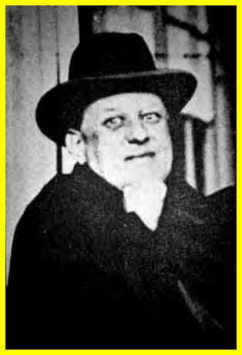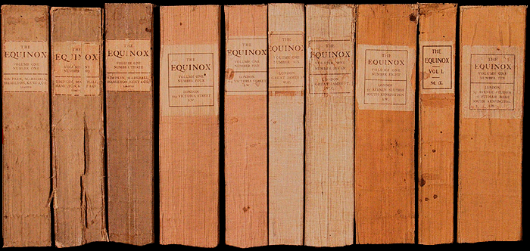

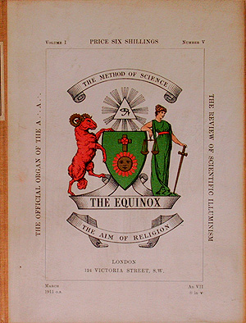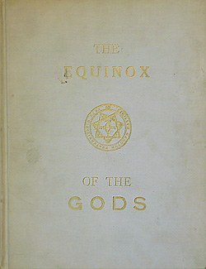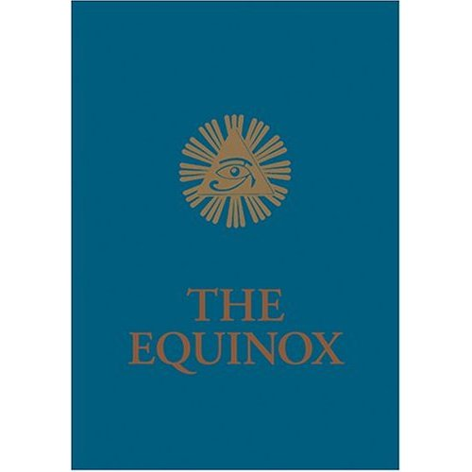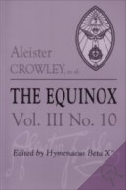

The Equinox (subtitle: "The Review of Scientific Illuminism") is a series of publications in book form that serves as the official organ of the A.'.A.'., the mystical order of Aleister Crowley (although material is often of import to its sister organization, Ordo Templi Orientis). Begun in 1909, it remains one of the definitive works on occultism and magick, while several issues also contain poetry, fiction, plays, artwork, and biographies. The last issue was published in 1998, although two new editions are currently being prepared for publication.

Contents
- 1 Publication History
- 2 Contents of The Equinox
  - 2.1 Volume I
    - 2.1.1 Number 1
    - 2.1.2 Number 2
    - 2.1.3 Number 3
    - 2.1.4 Number 4
    - 2.1.5 Number 5
    - 2.1.6 Number 6
    - 2.1.7 Number 7
    - 2.1.8 Number 8
    - 2.1.9 Number 9
    - 2.1.10 Number 10
  - 2.2 Volume II
  - 2.3 Volume III
    - 2.3.1 Number 1, also called the Blue Equinox
    - 2.3.2 Numbers 2-10
  - 2.4 Volume IV
    - 2.4.1 Number 1, Commentaries on the Holy Books and Other Papers
    - 2.4.2 Number 2, The Vision and the Voice : With Commentary and Other Papers
- 3 Motta Equinox
- 4 See also
- 5 References
- 6 External links

Publication History
The Equinox appeared semianually from the years 1909 through 1913. Volume II was never published, and vol. III:1 was the last in the regular serialized publications. After that, editions of the Equinox were published irregularly by various organizations and are best known for their book title. All issues after III:5 were edited and released after Crowley's death in 1947.
- Vol. I, #1: Spring 1909. Simpkin, Marshall, Hamilton, Kent & Co., Ltd.
- Vol. I, #2: Fall 1909. Simpkin, Marshall, Hamilton, Kent & Co., Ltd.
- Vol. I, #3: Spring 1910. Privately published, London.
- Vol. I, #4: Fall 1910. Privately published, London.
- Vol. I, #5: Spring 1911. Privately published, London.
- Vol. I, #6: Fall 1911. Wieland & Co.
- Vol. I, #7: Spring 1912. Wieland & Co.
- Vol. I, #8: Fall 1912. Wieland & Co.
- Vol. I, #9: Spring 1913. Wieland & Co.
- Vol. I, #10: Fall 1913. Wieland & Co.
- Vol. II: not issued
- Vol. III, #1: Spring 1919. Universal Publishing Co, Detroit MI
- Vol. III, #2: Jesus, Liber 888, and Other Papers—not issued
- Vol. III, #3: The Equinox of the Gods. 1936. London, O.T.O.
- Vol. III, #4: Eight Lectures on Yoga. 1939. London, O.T.O.
- Vol. III, #5: The Book of Thoth. 1944. London, O.T.O.
- Vol. III, #6: Liber Aleph. 1961. Thelema Publishing Co.
- Vol. III, #7: Shih Yi. 1971. Thelema Publishing Co.
- Vol. III, #8: The Tao Teh King. 1975. Weiser.
- Vol. III, #9: The Holy Books of Thelema. 1983. Weiser.
- Vol. III, #10: 1986. Weiser.
- Vol. IV, #1: Commentaries on the Holy Books and Other Papers. 1996. Weiser.
- Vol. IV, #2: The Vision and the Voice with Commentary and Other Papers. 1998. Weiser.

Contents of The Equinox

Volume I

Number 1
- Editorial
- An Account of A.'. A.'.
- Liber Librae [The Book of the Balance]
- Liber Exercitiorum
- The Wizard Way. By Aleister Crowley
- The Magic Glasses. By Frank Harris
- The Chymical Jousting of Brother Perardua
- The Lonely Bride. By Victor B. Neuburg
- At the Fork of the Roads
- The Magician
- The Soldier and the Hunchback: ! And ? By Aleister Crowley
- The Hermit
- The Temple of Solomon the King (Book I)
- The Herb Dangerous (Part I) : A Pharmaceutical Study. By E. Whineray, M.P.S.
- Endpages
- Special Supplement: John St. John: the Record of the Magical Retirement of G. H. by Frater O.'. M.'.

Number 2
- Frontpages
- Editorial
- Liber O [vel Manus et Sagittae sub Figura VI]
- The Herb Dangerous (Part II) : The Psychology of Hashish. By Oliver Haddo
- Reviews
- The Garden of Janus. By Aleister Crowley
- The Dream Circean. By Marital Nay
- The Lost Shepherd. By Victor B. Neuburg
- A Handbook of Geomancy
- The Organ in King's Chapel, Cambridge, By G. H. S. Pinsent
- A Note on Genesis
- The Five Adorations. By Dost Achiha Khan
- Illusion D'amoureux. By Francis Bendick
- The Opium-Smoker
- Postcards to Probationers. By Aleister Crowley
- The Wild Ass. By Alys Cusack
- The Sphinx at Gizeh. By Lord Dunsany
- The Priestess of Panormita. By Elaine Carr
- The Temple of Solomon the King (Book II)
- Amongst the Mermaids. By Norman Roe
- Ave Adonai. By Aleister Crowley
- The Man-Cover. By George Raffalovich
- Stewed Prunes and Prism: The Tennyson Centenary. By A. Quiller, Jr.
- Stop Press Reviews

Number 3
- Frontpages
- Editorial
- Liber XIII [vel Graduum Montis Abiegni: A Syllabus of the Steps Upon the Path]
- AHA! By Aleister Crowley
- The Herb Dangerous (Part III) : The Poem of Hashish. By Charles Baudelaire (Translated By Aleister Crowley)
- An Origin. By Victor B. Neuburg
- The Soul-Hunter
- Madeleine. By Arthur F. Grimble
- The Temple of Solomon the King (Book II "Continued")
- The Coming of Apollo. By Victor B. Neuburg
- The Brighton Mystery. By George Raffalovich
- Reviews
- The Shadowy Dill-Waters. By A. Quiller, Jr.
- Stop Press Reviews and Endpages
- Special Supplement: Liber DCCCCLXIII. the Treasure-House of Images

Number 4
- Frontpages
- Editorial
- Liber III [vel Jugorum]
- Liber A [vel Armorum sub Figura CCCCXII]
- I.NST N.ATTURAE R.EGINA I.SIS. By Omnia Vincam
- Reviews
- My Lady of the Breeches. By George Raffalovich
- Reviews
- At Bordj-An-Nus. By Hilda Norfolk
- ΑΙΝΟΖΙΔΟΖ. By Aleister Crowley
- The Temple of Solomon the King. IV
- Pan to Artemis. By Aleister Crowley
- The Interpreter. By Perdurabo
- The Daughter of the Horseleech. By Ethel Ramsay
- The Dreamer
- Mr. Todd. A Morality. By the Author of "Rosa Mundi"
- The Gnome. By Victor B. Neuburg
- Review
- The Herb Dangerous. Part IV: the Hasheesh Eater
- The Agnostic
- The Mantra-Yogi
- The Buddhist
- The Violinist. By Francis Bendick
- EHE! By George Raffalovich
- Half-Hours with Famous Mahatmas. No. I. By Sam Hardy
- The Thief-Taker. By Aleister Crowley
- Review
- The Eyes of St. Ljubov. By J. F. C. Fuller And George Raffalovich
- Midsummer Eve. By Ethel Archer
- The Poetical Memory
- Adela
- The Three Worms. By Edward Storer
- The Felon Flower. By Ethel Archer
- The Big Stick
- Glaziers' Houses
- In the Temple. By Victor B. Neuburg
- Endpages
- Special Supplement: the High History of Sir Palamedes the Saracen Knight and of his Following the Questing Beast

Number 5
- Frontpages
- Editorial
- Liber HHH [sub figura CCCXLI]
- The Blind Prophet. By Aleister Crowley
- The Training of the Mind. By Ananda Metteya
- The Sabbath. By Ethel Ramsay
- The Temple of Solomon the King
- A Nocturne. By Victor B. Neuburg
- The Vixen. By Francis Bendick
- The Pilgrim. By Aleister Crowley
- My Crapulous Contemporaries, No. IV.—Wisdom While You Waite. By Aleister Crowley
- X-Rays on Ex-Probationers. By Perdurabo
- The Vampire. By Ethel Archer
- The Big Stick
- Correspondence
- Stop Press Reviews
- Special Suplement: Liber CCCCXVIII (XXX Aerum) [vel Saecvli sub figura CCCCXVIII, Being of the Angels of the 30 Aethyrs, the Vision and the Voice]

Number 6
- Frontpages
- Editorial
- Liber X [Liber Porta Lucis]
- Liber XVI [Liber Turris vel Domus Dei]
- Liber XC [Liber Tzaddi vel Hamus Hermeticus]
- Liber CLVI [Liber Cheth vel Vallum Abiegni]
- Liber CC [Liber Resh vel Helios]
- Liber CCCLXX [Liber A'Ash vel Capricorni Pneumatici]
- Three Poems For Jane Cheron. By Aleister Crowley
- Circe. By Ethel Archer
- The Electric Silence
- Song
- The Scorpion. By Aleister Crowley
- The Earth. By Francis Bendick
- Sleep. By Ethel Archer
- The Ordeal of Ida Pendragon. By Martial Nay
- The Autumn Woods. By Victor Neuburg
- The Dangers of Mysticism
- The Big Stick. By John Yarker, E. Whineray, Aleister Crowley, Etc.
- Endpages
- Special Supplement: The Rites of Eleusis

Number 7
- Frontpages
- Editorial
- Liber I [vel Magi]
- Liber XI [Liber Nu]
- Liber LXIV [Liber Israfel]
- Liber LXVI [Liber Stellae Rubeae]
- Liber CLXXV [Astarte vel Liber Berylli]
- Liber CCVI [Liber Ru vel Spiritus]
- Liber CCXXXI
- Liber CD [Liber Tau vel Kabbalae Trium Literarum]
- Liber CDLXXIV [Liber os Asbysmi vel Daath]
- Liber DLV [Liber Had]
- Liber DCCCXXXI [Liber Tau]
- Liber CMXIII [Liber ThIShARB viae Memoriae]
- Adonis. By Aleister Crowley
- The Ghouls. By Aleister Crowley
- The Four Winds. By Aleister Crowley
- Independence. By Aleister Crowley
- Showstorm. By Aleister Crowley
- A Brief Abstract of the Symbolic Representation of the Universe Derived by Doctor John Dee through the Skrying of Sir Edward Kelly. By Aleister Crowley
- Apollo Bestows the Violin. By Aleister Crowley
- Diana of the Inlet. By Katharine Susannah Prichard
- Silence. By Ethel Archer
- Memory of Love. By Meredith Starr
- Across the Gulf. By Aleister Crowley
- The Temple of Solomon the King ("Continued")
- My Crapulous Contemporaries. No. V., the Bismarck of Battersea. By A. Quiller, Jun. (Aleister Crowley)
- Arthur in the Area Again. By Aleister Crowley
- The Big Stick. Reviews By Aleister Crowley and John Yarker
- A Birthday. By Aleister Crowley

Number 8
- Frontpages
- Editorial
- θέλημα : a Tone-Testament By Leila Waddell
- Three Poems. By Victor B. Neuburg
- The Temple of Solomon the King (continued)
- His Secret Sin
- Long Odds
- Doctor Bob. A Sketch By Mary D'este and Aleister Crowley
- The Woodcutter
- La Foire. By Barbey De Rochechouart
- Professor Zircon
- A Brief Abstract of the Symbolic Representation of the Universe, Derived by Doctor John Dee through the Skrying of Sir Edward Kelly. Part II. The Forty-Eight Calls
- Stepney
- The Tell-Tale Heart. Adapted from the Story of E. A. Poe. By Aleister Crowley
- Sorites
- A Description of the Cards of the Tarot, with their Attributions; Including a Method of Divination by their Use
- On-On-"Poet"
- Elder Eel
- The Spadger
- To Persis
- Waite's Wet or the Backslider's Return
- My Crapulous Contemporaries. No. VI. An Obituary
- The New Evelyn Hope
- Reviews
- Special Supplement: Sepher Sephiroth

Number 9
- Frontpages
- Editorial
- The Temple of Solomon the King ("Continued")
- Lines to a Young Lady Violinist on Her Playing in a Green Dress Designed By the Author
- Energized Enthusiasm
- The "Titanic"
- A Literatooralooral Treasure-Trove
- Threnody
- Dischmatal by Night. By Arthur Grimble
- A Quack Painter
- At Sea
- Cancer?
- Dumb!
- The Vitriol-Thrower
- The Fairy Fiddler. By Ethel Archer
- An Evocation of Bartzabel the Spirit of Mars
- The Testament of Magdalen Blair
- Ercildoune. By Aleister Crowley
- Athanasius Contra Decanum
- My Crapulous Contemporaries. No. VII. A Galahad in Gomorrah
- How I Became a Famous Mountaineer. By Percy W. Newlands, P.R.A.S., P.R.B.S., P.R.C.S., P.R.Y.S., P.R.Z.S., Etc., Etc.
- The Tango: A Sketch. By Mary D'este and Aleister Crowley
- The Big Stick
- Reviews

Number 10
- Frontpages
- Editorial
- Liber L. Vel Legis [The Book of the Law]
- Liber ΒΑΤΡΑΧΟΦΕΝΟΒΟΟΚΟΣΜΟΜΑΧΙΑ Svb Figvra DXXXVI
- A Syllabus of the Οfficial Ιnstructions of A.'. A.'.
- The Ship
- As in a Glass, Darkly. By Arthur Grimble.
- Two Fragments of Ritual
- The Disciples
- The Temple of Solomon the King ("Concluded)"
- Rosa Ignota. By Victor B. Neuburg
- The Game of Crowley
- Boo to Buddha
- Crowley Pool
- Hymn to Satan
- A Ballad of Bedlam. By Ethel Archer.
- Dead Weight
- The Big Stick
- Colophon—To Laylah Eight-And-Twenty
- Index to Volume I
- Endpages
- Special Supplement: The Key of the Mysteries

Volume II
Nos. 1-10 are a Period of Silence—no copies.

Volume III

Number 1, also called the Blue Equinox
Main article: The Blue Equinox
- Hymn to Pan
- Editorial
- Præmonstrance of A.’.A.’.
- Curriculum of A.’.A.’.
- Liber II [The Message of the Master Therion]
- The Tent
- Liber DCCCXXXVII [The Law of Liberty]
- Liber LXI [vel Causae A.'.A.'.]
- A Psalm
- Liber LXV [Liber Cordis Cincti Serpente]
- Liber CL [De Lege Libellum]
- A Psalm
- Liber CLXV [A Master of the Temple]
- Liber CCC [Khabs am Pekht]
- Stepping Out of the Old Aeon into the New
- The Seven Fold Sacrament
- Liber LII [Manifesto of the O.T.O.]
- Liber CI [An Open Letter to Those Who May Wish to Join the Order]
- Liber CLXI [Concerning the Law of Thelema]
- Liber CXCIV [An Intimation with Reference to the Constitution of the Order]
- Liber XV [The Gnostic Mass]
- Nekam Adonai!
- A La Loge
- The Tank
- Special Supplement: Liber LXXI [The Voice of the Silence: The Two Paths, The Seven Portals]

Numbers 2-10
- #2: The Gospel According to St. Bernard Shaw (allegedly, never published)
- #3: The Equinox of the Gods.
- #4: Eight Lectures on Yoga
- #5: The Book of Thoth
- #6: Liber Aleph
- #7: Shih Yi (I Ching)
- #8: Tao Teh Ching
- #9: The Holy Books of Thelema
- #10 The Review of Scientific Illuminism, the official Organ of the O.T.O.

Volume IV

Number 1, Commentaries on the Holy Books and Other Papers
- Occultism
- One Star in Sight
- Liber XXXIII. An Account of A.'.A.'.
- Liber Collegii Sancti sub figura CLXXXV (Being the Tasks of the Grades and Their Oaths)
- Liber Vesta vel פרכת sub figura DCC (Book of the Robes of the Order)
- Four Paintings by J.F.C. Fuller
- Liber VIII (The Ritual Proper for the Invocation of Augoeides)
- Liber LXV with Commentary (Liber Cordis Cincti Serpente)
- Liber LXXI, the Voice of the Silence with Commentary
- Shorter Commentaries to the Holy Books

Number 2, The Vision and the Voice : With Commentary and Other Papers
- Liber CDXVIII. The Vision and the Voice with Commentary
- Liber CCCXXV. The Bartzabel Working
- Liber LX. The Ab-ul-Diz Working
- Liber CDXV. Opus Lutetianum, The Paris Working
- Appendix I: ALgerian Diary, 1909
- Appendix II: Diary Fragment, 1910

Motta Equinox
Published by Marcelos Motta and his organization, Thelema Publishing Co., a series entitled The Equinox, Volume V were released.
- Vol. V, No. 1: The Comentaries to Liber AL vel Legis (1975)
- Vol. V, No. 2: Liber LXV and comments and writings by Marcelos Motta (1979)
- Vol. V, No. 3: The Chinese Texts of Magick and Mysticism (1980)
- Vol. V, No. 4: Sex and Religion (1981)

See also
- Works of Aleister Crowley

References
- Crowley, Aleister (1998), written at York Beach, ME, The Vision & the Voice, Samuel Weiser, <http://www.hermetic.com/crowley/l418/418.html>
- Free Encyclopedia of Thelema (2005). The Equinox. Retrieved March 24, 2005.
  - Crowley, Aleister. The Equinox. Weiser Books. ISBN 1-57863-351-6

External links
- The Equinox online.
=============================================================================================================

