Edward Alexander Crowley 1875-1947
http://en.wikipedia.org/wiki/Aleister_Crowley
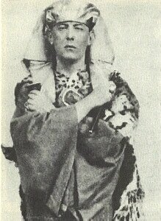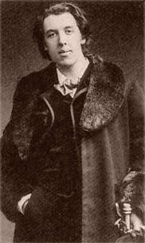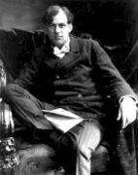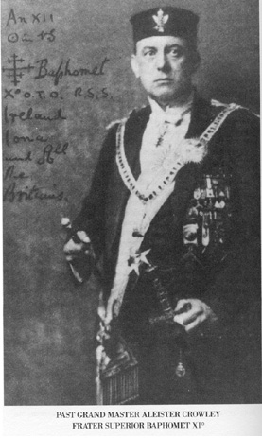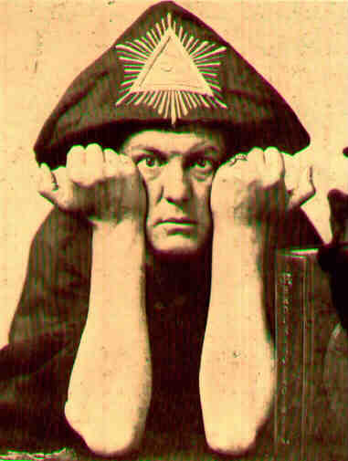

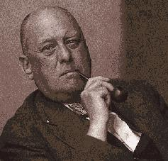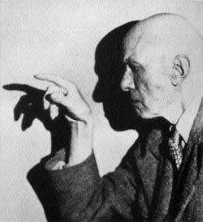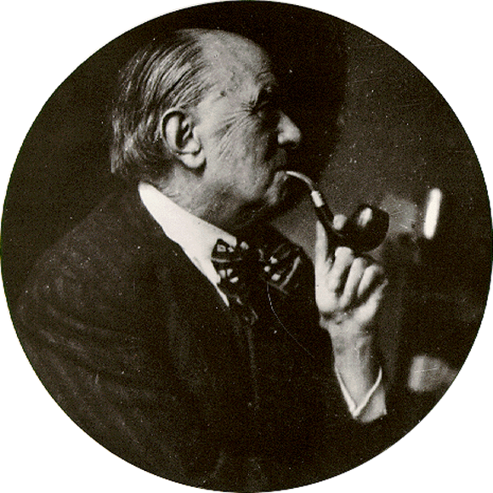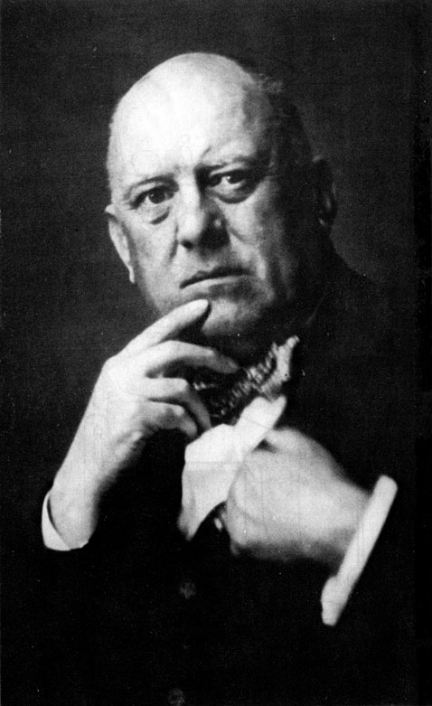
Born 12 October 1875
Royal Leamington Spa, Warwickshire, England Died 1 December 1947
Hastings, England
--------------------------------------------------------------------------------------------------------------------------------------------------------------------------------------------------
Edward Alexander Crowley, (12 October 1875 – 1 December 1947; the surname is pronounced /'krəʊ.li/ i.e. with the first syllable sounding like the bird) was an English occultist, prolific writer, mystic, hedonist, aficionado of chess and mountain climbing, and sexual revolutionary.^{[1]}
Crowley himself claimed to be a Freemason, but the legitimacy of his claims have been disputed.^{[2]}
Other interests and accomplishments were wide-ranging—he was a chess master, mountain climber, poet, painter, astrologer, drug experimenter, and social critic. He is perhaps best known today for his occult writings, especially The Book of the Law, the central sacred text of Thelema. Crowley was also an influential member in several occult organizations, including the Golden Dawn, the A∴A∴ (Argenteum Astrum), and Ordo Templi Orientis (O.T.O.).^{[3]}
Crowley gained much notoriety during his lifetime, and was famously dubbed "The Wickedest Man In the World."^{[4]}

Contents
- 1 Early years
  - 1.1 Bisexuality
- 2 The Golden Dawn
- 3 1904 and after
- 4 Argenteum Astrum and Ordo Templi Orientis
- 5 The Abbey of Thelema
- 6 After the Abbey
  - 6.1 Death
- 7 Thelema
- 8 Chess
- 9 Mountaineering
- 10 Science, magick, and sexuality
- 11 Ouija board
- 12 Writings
- 13 Controversy
  - 13.1 Drugs
  - 13.2 Racism
  - 13.3 Sexism
- 14 Crowley in popular culture
- 15 Quotes
- 16 See also
- 17 Notes
- 18 References
- 19 External links

Early years

Aleister Crowley’s rendition of the Unicursal Hexagram designed by the Hermetic Order of the Golden Dawn
Edward Alexander Crowley was born at 36 Clarendon Square in Royal Leamington Spa, Warwickshire, England, between 11:00pm and midnight on 12 October 1875.^{[5]}
His father, Edward Crowley, once maintained a lucrative family brewery business and was retired when Aleister Crowley was born. His mother, Emily Bertha Bishop, drew roots from a Devon and Somerset family^{[citation needed]}. Both of his parents were Darbyites, members of the most extreme wing of the Protestant sect known as the Exclusive Brethren.^{[6]}
He grew up in a staunch Plymouth Brethren household. His father, after retiring from his daily duties as a brewer, took up the practice of preaching at a fanatical pace. Daily Bible studies and private tutoring were mainstays in "Alick's" childhood; however, after his father's death, his mother's efforts at indoctrinating her son in the Christian faith only served to provoke his skepticism. As a child, his constant rebellious behaviour displeased his devout mother to such an extent she would chastise him by calling him "The Beast" (from the Book of Revelation), an epithet that Crowley would later happily adopt for himself. He objected to the labelling of what he saw as life's most worthwhile and enjoyable activities as "sinful"^{[citation needed]}.
In 1895, he went to Trinity College, Cambridge after schooling at the public school Malvern College and originally had the intention of reading Moral Sciences (philosophy, psychology, and economics), but with approval from his personal tutor, he switched to English literature, which was not then a part of the curriculum offered.^{[7]} His three years at Cambridge were happy ones, due in part to coming into the considerable fortune left by his father.
In December of 1896, following an event that he describes in veiled terms, Crowley decided to pursue a path in occultism and mysticism. By the next year, he began reading books by alchemists and mystics, and books on magic.^{[5]} Biographer Sutin describes the pivotal New Year's event as a homo-erotic experience (Crowley's first) that brought him what he considered "an encounter with an immanent deity".^{[8]} During the year of 1897, Aleister further came to see worldly pursuits as useless. The section on chess describes one experience that helped him reach this conclusion. A few months later, in October, a brief illness triggered considerations of mortality and "the futility of all human endeavor", or at least of the diplomatic career that Crowley had previously considered.^{[9]}
A year later, he published his first book of poetry (Aceldama), and left Cambridge, only to meet Julian L. Baker (Frater D. A.) who introduced him to Samuel Liddell MacGregor Mathers and the Golden Dawn.^{[5]}

Bisexuality
Throughout the period of 1895, he maintained a vigorous sex life, which was largely conducted with prostitutes and girls he picked up at local pubs and cigar shops, but eventually extended into homosexual activities in which he played the passive role.^{[10]} Regarding homosexuality, Crowley most definitely practiced sexual magick rituals with both men and women, but some claim that all of his romantic relationships were with females.^{[11]} They claim that the power of these rituals lay in their 'tabooness', and that Crowley expressed personal distaste for 'recreational' homosexuality. But biographer Sutin recounts Crowley's relationship^{[12]} with, and lasting feelings^{[13]} for, Herbert Charles Pollitt, whom he met while at Cambridge in 1897. Pollitt did not share his partner's mystical leanings, and Crowley had this to say about ending their relationship:
I told him frankly that I had given my life to religion and that he did not fit into the scheme. I see now how imbecile I was, how hideously wrong and weak it is to reject any part of one's personality.^{[14]}
He would have made any public expressions of "distaste" at a time when British law officially forbade homosexuality. The arrest, conviction and imprisonment of Oscar Wilde took place in Crowley's first year at Cambridge. In the autobiographical preface to Crowley's drama The World's Tragedy, he included a section on "Sodomy" where he openly admitted his bisexuality and praised sex between men. However, someone removed these two pages from all copies of the book except those Crowley gave to close friends.^{[15]}
Later, in a January 1929 letter, he writes
There have been about four men in my life that I could say I have loved...Call me a bugger if you like, but I don't feel the same way about women. One can always replace a woman in a few days.^{[16]}
While that claim about women conflicts with other statements and actions of Crowley's,^{[17]} it accurately describes his relationships with Pollitt and various uneducated women during his college years.^{[18]}

The Golden Dawn
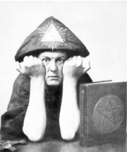
Crowley, in magical garb, displaying the "horns of Pan"
Main article: Hermetic Order of the Golden Dawn
Involved as a young adult in the Hermetic Order of the Golden Dawn, he first studied mysticism with and made enemies of William Butler Yeats and Arthur Edward Waite. Like many in occult circles of the time, Crowley voiced the view that Waite was a pretentious boor through searing critiques of Waite's writings and editorials of other authors' writings.
His friend and former Golden Dawn associate, Allan Bennett, introduced him to the ideas of Buddhism, while Samuel Liddell MacGregor Mathers, acting leader of the Golden Dawn organization, acted as his early mentor in western magick but would later become his enemy. Several decades after Crowley's participation in the Golden Dawn, Mathers claimed copyright protection over a particular ritual and sued Crowley for infringement after Crowley's public display of the ritual. While the public trial continued, both Mathers and Crowley claimed to call forth armies of demons and angels to fight on behalf of their summoner. Both also developed and carried complex Seal of Solomon amulets and talismans.
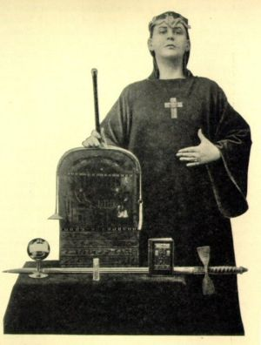
Aleister Crowley in Magickal garb
In a book of fiction, entitled Moonchild, Crowley later portrayed Mathers as the primary villain, including him as a character named SRMD, using the abbreviation of Mathers' magical name. Arthur Edward Waite also appeared in Moonchild as a villain named Arthwaite, while Bennett appeared in Moonchild as the main character's wise mentor, Simon Iff.
While he did not officially break with Mathers until 1904, Crowley lost faith in this teacher's abilities soon after the 1900 schism in the Golden Dawn (if not before).^{[19]} Later that year, Crowley travelled to Mexico and continued his magical studies in isolation. Crowley's writings suggest that he discovered the word Abrahadabra during this time.
In October of 1901, after practicing Raja Yoga for some time, he said he had reached a state he called dhyana — one of many states of unification in thoughts that are described in Magick (Liber ABA) (See Crowley on egolessness).^{[20]} 1902 saw him writing the essay Berashith (the first word of Genesis), in which he gave meditation (or restraint of the mind to a single object) as the means of attaining his goal. The essay describes ceremonial magick as a means of training the will, and of constantly directing ones thoughts to a given object through ritual. In his 1903 essay, Science and Matter, Crowley urged an empirical approach to Buddhist teachings.

1904 and after
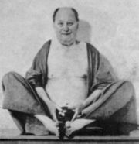
Crowley posing as the Bodhisvattva Hotei
He said that a mystical experience in 1904, while on vacation in Cairo, Egypt, led to his founding of the religious philosophy known as Thelema. Aleister's wife Rose started to behave in an odd way, and this led him to think that some entity had made contact with her. At her instructions, he performed an invocation of the Egyptian god Horus on March 20 with (he wrote) "great success". According to Crowley, the god told him that a new magical Aeon had begun, and that Crowley would serve as its prophet. Rose continued to give information, telling Crowley in detailed terms to await a further revelation. On 8 April and for the following two days at exactly noon he heard a voice, dictating the words of the text, Liber AL vel Legis, or The Book of the Law, which Crowley wrote down. The voice claimed to be that of Aiwass (or Aiwaz) "the minister of Hoor-paar-kraat," or Horus, the god of force and fire, child of Isis and Osiris and self-appointed conquering lord of the New Aeon, announced through his chosen scribe "the prince-priest the Beast." (For citations, see main article The Book of the Law.)
Portions of the book are in numerical cipher, which Crowley claimed the inability to decode (Setian Michael Aquino later claimed to be able to decode them). Thelemic dogma (to the extent that Thelema has dogma) explains this by pointing to a warning within the Book of the Law — the speaker supposedly warned that the scribe, Ankh-af-na-khonsu (Aleister Crowley), was never to attempt to decode the ciphers, for to do so would end only in folly. The later-written The Law is For All sees Crowley warning everyone not to discuss the writing amongst fellow critics, for fear that a dogmatic position would arise. While he declared a "new Equinox of the Gods" in early 1904, supposedly passing on the revelation of March 20 to the occult community, it took years for Crowley to fully accept the writing of the Book of the Law and follow its doctrine.^{[21]} Only after countless attempts to test its writings did he come to embrace them as the official doctrine of the New Aeon of Horus. The remainder of his professional and personal careers were spent expanding the new frontiers of scientific illuminism.
Rose and Aleister had a daughter, whom Crowley named Nuit Ma Ahathoor Hecate Sappho Jezebel Lilith Crowley, in July of 1904. This child died in 1906, during the two and a half months when Crowley had left her with Rose (after a family trip through China). They had another daughter, Lola Zaza, in the summer of that year, and Crowley devised a special ritual of thanksgiving for her birth.^{[22]}
He performed a thanksgiving ritual before his first claimed success in what he called the "Abramelin operation," on October 9, 1906.^{[23]} This was his implementation of a magical work described in The Book of the Sacred Magic of Abramelin the Mage. The events of that year gave the Abramelin book a central role in Crowley's system. He described the primary goal of the "Great Work" using a term from this book: "the Knowledge and Conversation of the Holy Guardian Angel." An essay in the first number of The Equinox^{[24]} gives several reasons for this choice of names:
- Because Abramelin's system is so simple and effective.
- Because since all theories of the universe are absurd it is better to talk in the language of one which is patently absurd, so as to mortify the metaphysical man.
- Because a child can understand it.
Crowley was notorious in his lifetime — a frequent target of attacks in the tabloid press, which labelled him "The Wickedest Man in the World" to his evident amusement. At one point, he was expelled from Italy after having established a sort of commune, the organization of which was based on his personal philosophies, the Abbey of Thelema, at Cefalù, Sicily.

[edit] Argenteum Astrum and Ordo Templi Orientis
Main articles: Argenteum Astrum and Ordo Templi Orientis
In 1907, Crowley's interest took off once again, with two important events. The first was the creation of the Silver Star (A∴A∴), and the second was the composition of the Holy books of Thelema.^{[25]}
According to Crowley, in 1912, Theodor Reuss had called on him to address accusations of publishing O.T.O. secrets, which Crowley dismissed, for having never attained the grade in which these secrets were given (9th degree). Reuss opened up the Book of Lies and showed Crowley the passage. This sparked a long conversation which led to the opening of the British section of O.T.O. called Mysteria Mystica Maxima.^{[26]}

[edit] The Abbey of Thelema
Main article: Abbey of Thelema
Crowley, along with Leah Hirsig, founded the Abbey of Thelema in Cefalù, Sicily in 1920.^{[27]} The name was borrowed from Rabelais's satire Gargantua,^{[28]} where the "Abbey of Theleme" is described as a sort of anti-monastery where the lives of the inhabitants were "spent not in laws, statutes, or rules, but according to their own free will and pleasure."^{[29]} This idealistic utopia was to be the model of Crowley's commune, while also being a type of magical school, giving it the designation "Collegium ad Spiritum Sanctum", The College of the Holy Spirit. The general programme was in line with the A∴A∴ course of training, and included daily adorations to the sun, a study of Crowley's writings, regular yogic and ritual practices (which were to be recorded), as well as general domestic labor. The object, naturally, was for students to devote themselves to the Great Work of discovering and manifesting their True Wills.

[edit] After the Abbey
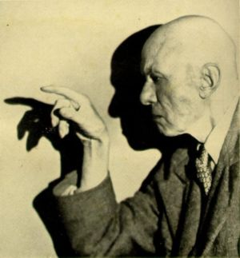
Aleister Crowley, the infamous picture
In 1934, Crowley was declared bankrupt after losing a court case in which he sued the artist Nina Hamnett for calling him a black magician in her 1932 book, Laughing Torso. In addressing the jury, Mr Justice Swift said:
"I have been over forty years engaged in the administration of the law in one capacity or another. I thought that I knew of every conceivable form of wickedness. I thought that everything which was vicious and bad had been produced at one time or another before me. I have learnt in this case that we can always learn something more if we live long enough. I have never heard such dreadful, horrible, blasphemous and abominable stuff as that which has been produced by the man (Crowley) who describes himself to you as the greatest living poet."
During World War II, Ian Fleming and others proposed a disinformation plot in which Crowley would have helped an MI5 agent supply Nazi official Rudolph Hess with faked horoscopes. They could then pass along false information about an alleged pro-German circle in Britain. The government abandoned this plan when Hess flew to Scotland and suffered capture. Fleming then suggested using Crowley as an interrogator to determine the influence of astrology on other Nazi leaders, but his superiors rejected this plan. At some point, Fleming also suggested that Britain could use Enochian as a code in order to plant evidence.^{[30]}

[edit] Death
Aleister Crowley died of a respiratory infection in a Hastings boarding house on December 1, 1947, at the age of 72. According to some accounts, he died on December 5, 1947. He was penniless and addicted to heroin, which had been prescribed for his asthma and bronchitis, many years prior.
Biographer Lawrence Sutin passes on various stories about Crowley's death and last words. Frieda Harris supposedly reported him saying, "I am perplexed," though she did not see him at the very end. According to John Symonds, a Mr Rowe witnessed Crowley's death along with a nurse, and reported his last words as, "Sometimes I hate myself." Biographer Gerald Suster accepted the version of events he received from a "Mr W.H." in which Crowley dies pacing in his living-room. Supposedly Mr W.H. heard a crash while polishing furniture on the floor below, and entered Crowley's rooms to find him dead on the floor. Patricia "Deirdre" MacAlpine, the mother of Crowley's son, Ataturk, denied all this and reports a sudden gust of wind and peal of thunder at the (otherwise quiet) moment of his death. According to MacAlpine, Crowley remained bedridden for the last few days of his life, but was in light spirits and conversational. Readings at the cremation service in nearby Brighton included one of his own works, Hymn to Pan, and newspapers referred to the service as a black mass. Brighton council subsequently resolved to take all necessary steps to prevent such an incident occurring again.^{[31]}

[edit] Thelema
Thelema
WikiProject Thelema
Category:Thelema
Core topics
The Book of the Law
Aleister Crowley
True Will · 93
Magick
Mysticism
Thelemic mysticism
The Great Work
Holy Guardian Angel
The Gnostic Mass
Thelemic texts
Works of Crowley
The Holy Books
Thelemite texts
Organizations
A∴A∴ · OTO · EGC
Deities
Nuit · Hadit
Horus · Ma'at
Babalon · Chaos
Baphomet · Choronzon
Ankh-f-n-khonsu
Aiwass
Other topics
Stele of Revealing
Abrahadabra
Unicursal Hexagram
Oil of Abramelin

This box: view • talk • edit
Main articles: Thelema and Thelemic mysticism
The religious or mystical system which Crowley founded, into which most of his writings fall, he named Thelema. Thelema combines a radical form of philosophical libertarianism with a mystical initiatory system derived in part from the Golden Dawn.
Chief among the precepts of Thelema is the sovereignty of the individual will: "Do what thou wilt shall be the whole of the Law." Crowley's idea of will, however, is not simply the individuals desires or wishes, but also incorporates a sense of the person's destiny or greater purpose: what he termed "True Will."
The second precept of Thelema is "Love is the law, love under will" — and Crowley's meaning of "Love" is as complex as that of "Will". It is frequently sexual: Crowley's system, like elements of the Golden Dawn before him, sees the dichotomy and tension between the male and female as fundamental to existence, and sexual "magick" and metaphor form a significant part of Thelemic ritual. However, Love is also discussed as the Union of Opposites, which Crowley thought was the key to enlightenment.

[edit] Chess
Crowley maintained that he learned chess from books by the age of six, and first competed on the Eastbourne College chess team (where he was taking classes in 1892). He says that he showed immediate competence, beating the handicapped local champion and later editing a chess column for the local newspaper, the Eastbourne Gazette,^{[32]} through which he criticised the Eastbourne team.
He later joined the university chess club at Cambridge, where, he says, he beat the president in his freshman year and practised two hours a day towards becoming a champion — "My one serious worldly ambition had been to become the champion of the world at chess".^{[33]} His writings make it clear that he and his supporters thought he would achieve this goal:
I had snatched a game from Blackburne in simultaneous play some years before. I was being beaten in the Sicilian defence. The only chance was the sacrifice of a rook. I remember the grand old master coming round to my board and cocking his alcoholized eye cunningly at me. 'Hullo,' said he. 'Morphy come to town again!' I am not coxcomb enough to think that he could not have won the game, even after my brilliancy. I believe that his colossal generosity let me win to encourage a promising youngster.
I had frequently beaten Bird at Simpson's and when I got to Cambridge I made a savagely intense study of the game. In my second year I was president of the university and had beaten such first-rate amateurs as Gunston and Cole. Outside the master class, Atkins was my only acknowledged superior. I made mincemeat of the man who was champion of Scotland a few years later, even after I had given up the game. I spent over two hours a day in study and more than that in practice. I was assured on all hands that another year would see me a master myself.^{[34]}
However, he explained that he gave up his chess aspirations in 1897 at the age of 22, when attending a chess conference in Berlin:
But I had hardly entered the room where the masters were playing when I was seized with what may justly be described as a mystical experience. I seemed to be looking on at the tournament from outside myself. I saw the masters — one, shabby, snuffy and blear-eyed; another, in badly fitting would-be respectable shoddy; a third, a mere parody of humanity, and so on for the rest. These were the people to whose ranks I was seeking admission. "There, but for the grace of God, goes Aleister Crowley," I exclaimed to myself with disgust, and there and then I registered a vow never to play another serious game of chess. I perceived with preternatural lucidity that I had not alighted on this planet with the object of playing chess.^{[35]}

[edit] Mountaineering
Crowley was obsessed with mountain climbing. He taught himself by 'scrambling' up Cumberland fells and Beachy Head, after which, he started spending every holiday by switching between the Alps and Bernese Oberland.^{[36]}
In March of 1902, Oscar Eckenstein and Crowley undertook the first attempt to scale Chogo Ri (known in the west as K2), located in Pakistan, and Eckenstein had set out to teach Crowley about the techniques of climbing.^{[36]} The Eckenstein-Crowley Expedition consisted of Eckenstein, Crowley, Guy Knowles, H. Pfannl, V. Wesseley, and Dr Jules Jacot-Guillarmod. They ascended June 8, and after eight days, weather conditions were taking their toll. Two months in, they found themselves back down on the plain, which made this Crowley's first recorded defeat.^{[37]}
In May 1905, he was approached by Dr Jules Jacot-Guillarmod (1868 - 1925) to accompany him on the first expedition to Kangchenjunga in Nepal, the third largest mountain in the world. Guillarmod was left to organize the personnel while Crowley left to get things ready in Darjeeling. On July 31 Guillarmod joined Crowley in Darjeeling, bringing with him two countrymen, Charles-Adolphe Reymond and Alexis Pache. Meanwhile, Crowley had recruited a local man, Alcesti C. Rigo de Righi, to act as Transport Manager. The team left Darjeeling on August 8, 1905, and used the Singalila Ridge approach to Kangchenjunga. At Chabanjong they ran into the rear of the 135 coolies who had been sent ahead on July 24 and July 25, who were carrying food rations for the team. The trek was led by Aleister Crowley, but four members of that party were killed in an avalanche. Some claims say they reached around 21,300 feet before turning back^{[citation needed]}, however Crowley's autobiography claims they reached about 25,000 feet.
Crowley was sometimes famously scathing about other climbers, in particular Glynne Jones, whom he considered a risk-taking self-publicist, and his 'two photographers' (George and Ashley Abraham).

[edit] Science, magick, and sexuality
Crowley claimed to use a scientific method to study what people at the time called spiritual experiences, making "The Method of Science, the Aim of Religion" the catchphrase of his magazine The Equinox. By this he meant that mystical experiences should not be taken at face value, but critiqued and experimented with in order to arrive at their underlying religious or neurological meaning.
In this connection there was also the point that I was anxious to prove that spiritual progress did not depend on religious or moral codes, but was like any other science. Magick would yield its secrets to the infidel and the libertine, just as one does not have to be a churchwarden in order to discover a new kind of orchid. There are, of course, certain virtues necessary to the Magician; but they are of the same order as those which make a successful chemist.^{[38]}
Crowley's magical and initiatory system has amongst its innermost reaches a set of teachings on sex magick. He frequently expressed views about sex that were radical for his time, and published numerous poems and tracts combining pagan religious themes with sexual imagery both heterosexual and homosexual, as well as pederastic. One of his most notorious poetry collections, entitled White Stains (1898), was published in Amsterdam in 1898 and dealt specifically with sexually explicit subject matter. However, most of the hundred copies printed for the initial release were later seized and destroyed by British customs. [4]
Sex magick is the use of the sex act—or the energies, passions or arousal states it evokes—as a point upon which to focus the will or magical desire for effects in the non-sexual world. In this, Crowley was inspired by Paschal Beverly Randolph, an American Abolitionist, Spiritualist medium, and author of the mid-19th century, who wrote (in Eulis!, 1874) of using the "nuptive moment" (orgasm) as the time to make a "prayer" for events to occur.
Crowley often introduced new terminology for spiritual and magical practices and theory. For example, he termed theurgy "high magick" and thaumaturgy "low magick". In The Book of the Law and The Vision and the Voice, the old Jewish magical formula Abracadabra was changed to Abrahadabra, which he called the new formula of the Aeon. He also famously spelled magic in the archaic manner, as magick, to differentiate "the true science of the Magi from all its counterfeits."^{[39]}
He urged his students to learn to control their own mental and behavioral habits, to the point of switching political views and personalities at will. For control of speech (symbolized as the unicorn): he recommended to choose a commonly-used word, letter, or pronouns and adjectives of the first person, and instructed them to cut themselves with a blade to serve as warning or reminder. Later the student could move on to the "Horse" of action and the "Ox" of thought.^{[40]} (These symbols derive from the cabala of Crowley's book 777.) Robert Anton Wilson records a similar course of self-experimentation, but says he used a less drastic form of what Skinner later (writing after Crowley) called "negative reinforcement"[...]I bit my thumb, hard, at each slip.^{[41]}

[edit] Ouija board
Little is published regarding Crowley's advocacy of the Ouija Board. Yet, he had great admiration for the use of one and the Ouija board played a significant role in his magical workings. ^{[42]} ^{[43]}
Jane Wolfe, who lived with Crowley at his infamous Abbey of Cefalu, also used the Ouija board. She credits some of her greatest spiritual communications to use of this implement. Crowley also discussed the Ouija board with another of his students, and the most ardent of them, Frater Achad (Charles Stansfeld Jones): it is frequently mentioned in their unpublished letters.
Throughout 1917 Achad experimented with the board as a means of summoning Angels, as opposed to Elementals. In one letter Crowley told Jones: "Your Ouija board experiment is rather fun. You see how very satisfactory it is, but I believe things improve greatly with practice. I think you should keep to one angel, and make the magical preparations more elaborate."
Over the years, both became so fascinated by the board that they discussed marketing their own design. Their discourse culminated in a letter, dated February 21, 1919, in which Crowley tells Jones, "Re: Ouija Board. I offer you the basis of ten percent of my net profit. You are, if you accept this, responsible for the legal protection of the ideas, and the marketing of the copyright designs. I trust that this may be satisfactory to you. I hope to let you have the material in the course of a week." In March, Crowley wrote to Achard to inform him, "I'll think up another name for Ouija." But their business venture never came to fruition and Crowley's new design, along with his name for the board, has not survived.
Charles Stansfeld Jones wrote a book called 'Crystal Vision through Crystal Gazing, in which he notes that in relationship to skrying (also spelled scrying) "the case of the Ouija Board applies equally to the Crystal."
Crowley has stated, of the Ouija Board, that, "Their is, however, a good way of using this instrument to get what you want, and that is to perform the whole operation in a consecrated circle, so that undesirable aliens cannot interfere with it. You should then employ the proper magical invocation in order to get into your circle just the one spirit you want. It is comparatively easy to do this. A few simple instructions are all that is necessary, and I shall be pleased to give these, free of charge, to any one who cares to apply." ^{[44]}

[edit] Writings
Main article: Works of Aleister Crowley
Crowley was a highly prolific writer, not only on the topic of Thelema and magick, but on philosophy, politics, and culture. He was also a published poet and playwright and left behind a countless number of personal letters and daily journal entries. He self-published many of his books, expending the majority of his inheritance to disseminate his views.
Within the subject of occultism Crowley wrote widely, penning commentaries on magick, the Tarot, Yoga, the Kabbalah, astrology, and numerous other subjects. He also wrote a Thelemic interpolation of the Tao Te Ching, based on earlier English translations since he knew little or no Chinese. Like the Golden Dawn mystics before him, Crowley evidently sought to comprehend the entire human religious and mystical experience in a single philosophy.
Some of his most influential books include:
- The Book of the Law
- Magick (Book 4)
- The Book of Lies
- The Vision and the Voice
- 777 and other Qabalistic writings
- The Confessions of Aleister Crowley
- Magick Without Tears
- Little Essays Toward Truth
- The Goetia: The Lesser Key of Solomon the King
He also edited and produced a series of publications in book form called The Equinox (subtitled "The Review of Scientific Illuminism"), which served as the voice of his magical order, the A∴A∴. Although the entire set is influential and remains one of the definitive works on occultism, some of the more notable issues include:
- III:1 "The Blue Equinox" (largely regarding the structure of OTO)
- III:3, The Equinox of the Gods (covering the events leading up to the writing of Liber Legis)
- III:4, Eight Lectures on Yoga
- III:5, The Book of Thoth (a full treatise on his Thoth Tarot)
- III:6, Liber Aleph (An extended and elaborate commentary on Liber Legis in the form of short letters)
- III:9, The Holy Books of Thelema (the "received" works of Crowley)
Crowley also wrote fiction and plays, most of which have not received significant notice outside of occult circles. Some of his fictional/theatrical works include:
- Diary of a Drug Fiend
- Moonchild
- The Rites of Eleusis
- The Ship
- The Testament of Magdalen Blair
Crowley also had a peculiar sense of humour, which he often utilized as a teaching instrument. He wrote a polemic arguing against George Bernard Shaw's interpretation of the Gospels in his preface to Androcles and the Lion, which was edited by Francis King and published as Crowley on Christ. In his Magick, Book 4 he includes a chapter purporting to illuminate the Qabalistic significance of Mother Goose nursery rhymes. In re Humpty Dumpty, for instance, he recommends the occult authority "Ludovicus Carolus" -- better known as Lewis Carroll. In a footnote to the chapter he admits that he had invented the alleged meanings, to show that one can find occult "Truth" in everything. His "8 Lectures On Yoga" are written under the name Guru Sri Pramahansa Shivaji (which translates into something along the lines of "Great Exalted Guru of Shiva") and are divided into "Yoga for Yahoos" and "Yoga for Yellowbellies". In The Book of Lies, the title to chapter 69 is given as "The Way to Succeed - and the Way to Suck Eggs!" a pun, as the chapter concerns the 69 sex position as a mystical act.
Crowley was also a published, if minor, poet. He wrote the 1929 Hymn to Pan [5], perhaps his most widely read and anthologized poem. Three pieces by Crowley, "The Quest [6]", "The Neophyte [7]", and "The Rose and the Cross [8]", appear in the 1917 collection The Oxford Book of English Mystical Verse. Crowley's unusual sense of humour is on display in White Stains [9], an 1898 collection of pornographic verse pretended to be "the literary remains of George Archibald Bishop, a neuropath of the Second Empire;" the volume is prefaced with a notice that says that " The Editor hopes that Mental Pathologists, for whose eyes alone this treatise is destined, will spare no precaution to prevent it falling into other hands."
Some of his published poetry includes:
- Clouds Without Water. (1974).
- White Stains. (1973).
- The Star and the Garter. (1974).
- Snowdrops From a Curate’s Garden. (1986).
- Golden Twigs. (1988).
- The Scented Garden of Abdullah the Satirist of Shiraz. (1991).
- The Winged Beetle. (1992).
The Greek scholar Dionysios Psilopoulos has written on Crowley as a poet (Ph.D., Edinburgh).

[edit] Controversy

[edit] Drugs
Crowley was a habitual drug user and also maintained a meticulous record of his drug-induced experiences with laudanum, opium, cocaine, hashish, alcohol, ether, and heroin.^{[45]} Allan Bennett, Crowley's mentor, was said to have "instructed Crowley in the magical use of drugs."^{[46]} While in Paris during the 1920s, Crowley also experimented with psychedelic substances, specifically Anhalonium Lewinii, an obsolete scientific name for the mescaline-bearing cactus peyote.^{[47]} In October of 1930, Crowley dined with Aldous Huxley in Berlin, and to this day rumours persist that he introduced Huxley to peyote on that occasion.^{[48]}
Crowley first developed a drug addiction after a London doctor prescribed heroin for his asthma and bronchitis.^{[49]} His life as an addict influenced his 1922 novel, Diary of a Drug Fiend, but the fiction presented a hopeful outcome of rehabilitation and recovery by means of Magickal techniques and the exercise of True Will. At the time of his death he was addicted to heroin, his narcotic of choice.^{[50]}

[edit] Racism
Biographer Lawrence Sutin stated that "blatant bigotry is a persistent minor element in Crowley's writings."^{[51]} The book's introduction calls Crowley "a spoiled scion of a wealthy Victorian family who embodied many of the worst John Bull racial and social prejudices of his upper-class contemporaries,"^{[52]} Sutin also writes, "Crowley embodied the contradiction that writhed within many Western intellectuals of the time: deeply held racist viewpoints courtesy of their culture, coupled with a fascination with people of color."^{[53]}
Crowley defended the use of violence against the Chinese, specifically the lower classes.^{[54]} He applied the term "nigger" to Italians (in Diary of a Drug Fiend Book I, Chapter 9) and Indians,^{[55]} and called the Indian Theosophist, Jiddu Krishnamurti, "negroid."
Crowley, according to his biographer, Lawrence Sutin, used racial epithets to bully his Jewish homosexual lover Victor Neuburg: "Crowley leveled numerous brutal verbal attacks on Neuburg's family and Jewish ancestry...".^{[56]}
Crowley's published expressions of anti-Semitism were disturbing enough to later editors of his works that one of them, Israel Regardie, attempted to suppress them. In 777 and Other Qabalistic Writings of Aleister Crowley (Samuel Weiser, 1975), Regardie, a Jew, explained his complete excision of Crowley's anti-Semitic commentary on the Kabbalah in the 6th unnumbered page of his editorial introduction:
"I am ... omitting Crowley's Preface to the book. It is a nasty, malicious piece of writing, and does not do justice to the system with which he is dealing."^{[57]}
What Regardie had removed was Crowley's "Preface to Sepher Sephiroth", originally published in Equinox 1:8. Written in 1911,^{[58]} at the same time that Menahem Mendel Beilis was accused of ritual cannibalism in Kiev, Russia, it contained a clear statement of Crowley's belief in the blood libel against the Jews^{[59]}:
"Human sacrifices are today still practised by the Jews of Eastern Europe, as is set forth at length by the late Sir Richard Burton in the MS. which the wealthy Jews of England have compassed heaven and earth to suppress,^{[60]} and evidenced by the ever-recurring Pogroms against which so senseless an outcry is made by those who live among those degenerate Jews who are at least not cannibals."^{[61]}
After defending the then-current anti-Semitic pogroms in Kishinev Russia, on the grounds that the deaths of thousands of Jews was a rational response to what he saw as the danger of Jewish ritual cannibalism, Crowley rhetorically asked how a system of value such as Qabala could come from "an entirely barbarous race, devoid of any spiritual pursuit."^{[62]}
Crowley repeated his claim that Jews in Eastern Europe practice ritual child-murder in at least one later work as well, namely the section on mysticism in Book Four or Magick.
Crowley studied and promoted the mystical and magical teachings of some of the same ethnic groups he attacked, in particular Indian yoga, Jewish Kabbalah and goetia, and the Chinese I Ching. Also, in Confessions Chapter 86[10], as well as a private diary which Lawrence Sutin quotes in Do What Thou Wilt chapter 7, Crowley recorded a memory of a "past life" as the Chinese Taoist writer Ko Hsuan. In another remembered life, Crowley said, he took part in a "Council of Masters" that included many from Asia. He has this to say about the virtues of "Eurasians" and then Jews:
I do not believe that their universally admitted baseness is due to a mixture of blood or the presumable peculiarity of their parents; but that they are forced into vileness by the attitude of both their white and coloured neighbours. A similar case is presented by the Jew, who really does only too often possess the bad qualities for which he is disliked; but they are not proper to his race. No people can show finer specimens of humanity. The Hebrew poets and prophets are sublime. The Jewish soldier is courageous, the Jewish rich man generous. The race possesses imagination, romance, loyalty, probity and humanity in an exceptional degree.
But the Jew has been persecuted so relentlessly that his survival has depended on the development of his worst qualities; avarice, servility, falseness, cunning and the rest. Even the highest-class Eurasians such as Ananda Koomaraswamy suffer acutely from the shame of being considered outcast. The irrationality and injustice of their neighbours heightens the feeling and it breeds the very abominations which the snobbish inhumanity of their fellow-men expects of them.

[edit] Sexism
Biographer Lawrence Sutin stated that Crowley "largely accepted the notion, implicitly embodied in Victorian sexology, of women as secondary social beings in terms of intellect and sensibility."^{[63]} Occult scholar Tim Maroney compares him to other figures and movements of the time and suggests that some others might have shown more respect for women.^{[64]}
Crowley stated that women, except "a few rare individuals," care most about having children and will conspire against their husbands if they lack children to whom to devote themselves.^{[65]} In Confessions, Crowley says he learned this from his first marriage.^{[66]} He claimed that their intentions were to force a man to abandon his life's work for their interests. He only found women "tolerable", he wrote, when they served the role of solely helping a man in his life's work. However, he said that they were incapable of actually understanding the work. He also claimed that women did not have individuality and were solely guided by their habits or impulses.^{[67]}
Nevertheless, when he sought what he called the supreme magical-mystical attainment, Crowley asked Leah Hirsig to direct his ordeals, marking the first time since the schism in the Golden Dawn that another person verifiably took charge of his initiation.^{[68]}

[edit] Crowley in popular culture
Main article: Aleister Crowley in popular culture
Crowley has been mentioned in many popular culture mediums, including popular music, books, film, and television. He also appears in the D. Gray Man manga as an active character.

[edit] Quotes
- "Do what thou wilt shall be the whole of the law." - Liber Al Vel Legis
- "Paganism is wholesome because it faces the facts of life." - The Confessions of Aleister Crowley, ch. 8
- "Indubitably, Magick is one of the subtlest and most difficult of the sciences and arts. There is more opportunity for errors of comprehension, judgement and practice than in any other branch of physics." - The Confessions of Aleister Crowley, ch. 20
- "To read a newspaper is to refrain from reading something worth while. The first discipline of education must therefore be to refuse resolutely to feed the mind with canned chatter." - The Confessions of Aleister Crowley, ch. 23
- "The joy of life consists in the exercise of one's energies, continual growth, constant change, the enjoyment of every new experience. To stop means simply to die. The eternal mistake of mankind is to set up an attainable ideal." - The Confessions of Aleister Crowley, ch. 65
- "Roughly speaking, any man with energy and enthusiasm ought to be able to bring at least a dozen others round to his opinion in the course of a year no matter how absurd that opinion might be. We see every day in politics, in business, in social life, large masses of people brought to embrace the most revolutionary ideas, sometimes within a few days. It is all a question of getting hold of them in the right way and working on their weak points." - The Confessions of Aleister Crowley, ch. 56
- "Modern morality and manners suppress all natural instincts, keep people ignorant of the facts of nature and make them fighting drunk on bogey tales." - The Confessions of Aleister Crowley, ch. 57
- "Falsehood is invariably the child of fear in one form or another." - The Confessions of Aleister Crowley, ch. 49
- "Intolerance is evidence of impotence." - The Confessions of Aleister Crowley, ch. 69
- "Ordinary morality is only for ordinary people." - The Confessions of Aleister Crowley, ch. 22
- "I was not content to believe in a personal devil and serve him, in the ordinary sense of the word. I wanted to get hold of him personally and become his chief of staff." - The Confessions of Aleister Crowley, ch. 5
- "To me a book is a message from the gods to mankind; or, if not, should never be published at all.... A message from the gods should be delivered at once. It is damnably blasphemous to talk about the autumn season and so on. How dare the author or publisher demand a price for doing his duty, the highest and most honourable to which a man can be called?" - The Confessions of Aleister Crowley, ch. 68
- "The ordinary man looking at a mountain is like an illiterate person confronted with a Greek manuscript." - The Confessions of Aleister Crowley, ch. 10
- "Love is the Law, Love Under Will." - The Book Of The Law

[edit] See also
- List of Thelemites
- List of Occultists
- Hermetic Order of the Golden Dawn
- Thelemapedia

[edit] Notes
- ^ Sutin, L. (2000). Do What Thou Wilt.
- ^ E.g. Starr M P 2004, "Aleister Crowley: freemason!", Grand Lodge of British Columbia and Yukon, http://freemasonry.bcy.ca/aqc/crowley.html , BC
- ^ Crowley, Aleister. Confessions.
- ^ [Bottomley, Horatio]. "The Wickedest Man In The World", John Bull, 1923-03-24. Retrieved on 2006-05-28.
- ^ ª ^{b} ^{c} The Magical Diaries of Aleister Crowley (Tunisia 1923) : Edited by Stephen Skinner; page 10
- ^ King, Magical World, page 5
- ^ Booth, Martin [2000] (2001). “A Trinity Man”, A Magickal Life (paperback), London: Coronet, 49. ISBN 0-340-71806-4.
- ^ Sutin, p. 38
- ^ Sutin, pp. 37-39
- ^ Magical World of AC, Francis King, page 5
- ^ For example, the FAQ at http://altreligion.about.com/library/faqs/bl_crowleyfaq.htm
- ^ Sutin, p. 47, 159, 245
- ^ Sutin, p. 41-47
- ^ Confessions, quoted by Sutin p. 47
- ^ Sutin, p. 183. See also p. 391 for a later homosexual fantasy.
- ^ letter to Montgomery Evans, January 17, 1929, O.T.O. archives, quoted Sutin p. 334
- ^ See for example Sutin p. 316, 319 on his relationship with Leah Hirsig.
- ^ Sutin, p. 43
- ^ Sutin, pp. 80, 90-91
- ^ Sutin, pp. 85, 94
- ^ Sutin, pp. 195-196
- ^ Sutin, pp. 142-143, 171-173
- ^ Sutin, pp. 173-174
- ^ The Temple of Solomon the King, pub. The Equinox, Vol. I No. 1 (1909) retrieved June 15, 2006 from http://www.the-equinox.org/vol1/no1/eqi01014.html
- ^ Magical World, F.King, page 41
- ^ King, Magical World, pages 80-81
- ^ Sutin, Do What Thou Wilt, p.279
- ^ Nature of the Beast by Colin Wilson; page 73
- ^ Rabelais, F. Gargantua and Pantagruel Ch. 1.
- ^ Sutin, p. 388-389
- ^ Sutin, pp. 417-419
- ^ Lawrence Sutin. Do What Thou Wilt: A Life of Aleister Crowley. ISBN 0-312-25243-9. p. 33
- ^ (Confessions, p. 140)
- ^ (Confessions, p. 140).
- ^ (Confessions, p. 140).
- ^ ª ^{b} Nature of the Beast, by Colin Wilson, page 41
- ^ Wilson, pages 60-61
- ^ Confessions Ch. 64 para. 5
- ^ (Crowley, Magick, Book 4, p.47)
- ^ Liber III vel Jugorum
- ^ Cosmic Trigger: The Final Secret of the Illuminati, p. 62
- ^ Cornelious, J. Edward Aleister Crowley and the Ouija Board. 2005 ISBN 1-932595-10-4
- ^ Mini site for Cornelious, J. Edward’s book, Aleister Crowley and the Ouija Board, http://feralhouse.com/press/mini_sites/ouija/
- ^ Cornelious, J. Edward Aleister Crowley and the Ouija Board. 2005 ISBN 1-932595-10-4
- ^ ["The Confessions of Aleister Crowley: An Autohagiography" by Aleister Crowley (Arkana, 1989); "Do What Thou Wilt: A Life of Aleister Crowley" by Lawrence Sutin. (St. Martin's Press, 2000); "The Magical Diaries of Aleister Crowley" edited by Stephen Skinner (Weiser, 2003)]
- ^ Owen, Alex (2004-04-14). “Aleister Crowley in the Desert”, The Place of Enchantment: British Occultism and the Culture of the Modern, Hardcover, U. Chicago Press, 192. ISBN 0-226-64201-1. Retrieved on 2006-05-28.
- ^ Confessions, pp. 386 & 768.
- ^ Cornelius, 2001.
- ^ "Do What Thou Wilt: A Life of Aleister Crowley" by Lawrence Sutin. (St. Martin's Press, 2000) ch. 7, p. 277
- ^ ["Do What Thou Wilt: A Life of Aleister Crowley" by Lawrence Sutin. (St. Martin's Press, 2000)] p. 416
- ^ Sutin, Lawrence. Do What Thou Wilt", p. 223-224
- ^ Sutin, Lawrence. Do What Thou Wilt", p. 2.
- ^ Ibid., ch. 10, p. 366
- ^ (Crowley Confessions pp. 471-4) "One cannot fraternize with the Chinese of the lower classes; one must treat them with the utmost contempt and callousness."
- ^ (Crowley Confessions pp. 473)
- ^ (Sutin, Lawrence. "Do What Thou Wilt", p. . 197)
- ^ 777 and Other Qabalistic Writings of Aleister Crowley edited by Israel Regardie, (Samuel Weiser, 1975), 6th unnumbered page of the editorial introduction)
- ^ 777 and Other Qabalistic Writings of Aleister Crowley edited by Israel Regardie, (Samuel Weiser, 1975)
- ^ Equinox 1:8
- ^ (Equinox 1:8 -- The MS Crowley referred to in this passage was "Human Sacrifice among the Sephardine or Eastern Jews" by Sir Richard Francis Burton; it was thought so inflammatory and damaging to the author's reputation that it was never published, and in her will Burton's widow Isabel asked for it to be destroyed to protect her husband's name. [1] and [2])
- ^ Equinox 1:8
- ^ Equinox 1:8
- ^ Sutin, ch. 1, p. 28
- ^ Facts and Phallacies by Tim Maroney (1998) (Originally published in The Scarlet Letter, Volume V, Number 2). Retrieved from [3], June 8, 2006
- ^ (Crowley Magick Without Tears p. 254); Aleister Crowley. Magick Without Tears. ISBN 0-941404-17-X.
- ^ (Crowley Confessions p.415); Aleister Crowley. The Confessions of Aleister Crowley: An Autohagiography. ISBN 0-14-019189-5. Gender Bias: "There is yet a further point. My marriage taught me many lessons, and this not the least: when women are not devoted to children --- a few rare individuals are capable of other interests --- they take a morbid pleasure in conspiring against a husband, especially if he be a father. They take advantage of his preoccupation with his work in the world to conceive and execute every kind of criminally cunning abomination. The belief in witchcraft was not all superstition; its psychological roots were sound. Women who are thwarted in their natural instincts turn inevitably to all kinds of malignant mischief, from slander to domestic destruction." -- Chapter 50
- ^ (Crowley Confessions pp. 96-7)
- ^ (Sutin Do What Thou Wilt pp. 282-290)

[edit] References
- Bull, John. "The Wickedest Man in the World". Sunday Express, 24 Mar. 1923. Unverified that this is the article: [11] Verification that the Sunday Express did make article: [12]
- Carroll, Robert Todd (2004). "Aleister Crowley (1875-1947)". The Skeptic's Dictionary. Retrieved 30 December 2004.
- Edward J. Cornelious (2001). The Friends & Acquaintances of Aleister Crowley in Red Flame: A Thelemic Research Journal no. 3.
- J. Edward Cornelious (2005). Aleister Crowley and the Ouija Board
- Crowley, Aleister(1990) "The Tao Teh King, Liber CLVII: THE EQUINOX Vol. III. No. VIII. ASCII VERSION". Retrieved 30 December 2004.
- Free Encyclopedia of Thelema (2005). The Equinox. Retrieved 24 March 2005.
- Kaczynski, Richard (2002). Perdurabo: The Life of Aleister Crowley. New Falcon Publications. ISBN 1561841706
- Lawrence Sutin (2000). Do What Thou Wilt: A Life of Aleister Crowley . ISBN 0-312-28897-2
- Robert Anton Wilson (1977). Cosmic Trigger: The Final Secret of the Illuminati. Pocket Books, New York.
- Roger Hutchinson (1999). Aleister Crowley: The Beast Demystified. Mainstream Publishing, New York. ISBN 1840182296
- Kenneth Grant (1991). Remembering Aleister Crowley
- Martin Booth (2000). A Magick Life: The Life of Aleister Crowley. Coronet Books, London. ISBN 0340718064
- Colin Wilson (1993). Aleister Crowley: The Nature of the Beast. Harpercollins, New York. ISBN 0850305411

[edit] External links
Wikiquote has a collection of quotations related to:
Aleister Crowley
Wikisource has original works written by or about:
Aleister Crowley

- LAShTAL.COM: Home of The Aleister Crowley Society
- Works by Aleister Crowley at Project Gutenberg
- The Naples Arrangement, Crowley's Qabalah
- The most complete resource for books of Crowley in PDF format
- Crowley Controversy FAQ
- Aleister Crowley: A Legacy of Racism and Nationalism
- Aleister Crowley on Thelemapedia
- Aleister Crowley - The Rotten Library
- Aleister Crowley and the Green Goddess
- Entry for Aleister Crowley at the GLBTQ encyclopedia

================================================================================================================================
END

