Zohar, Splendor, radiance
http://en.wikipedia.org/wiki/Zohar
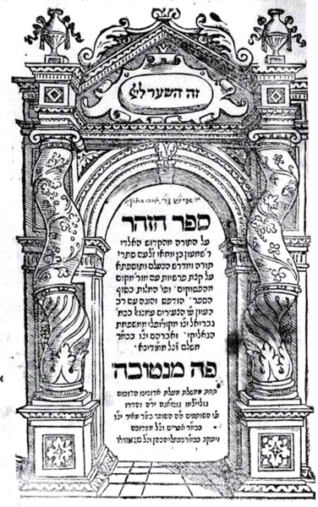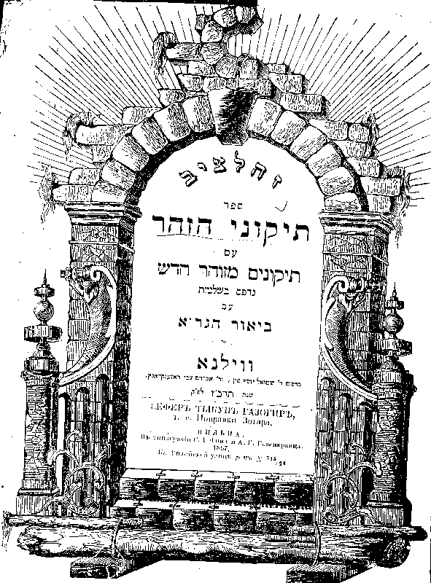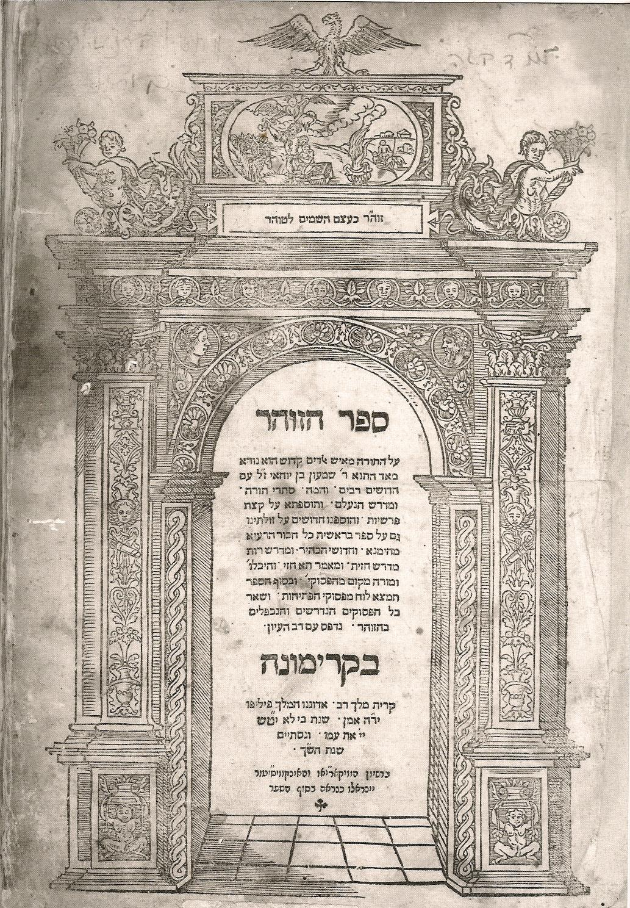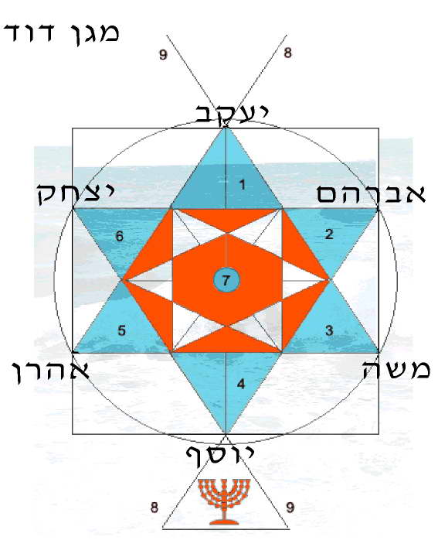
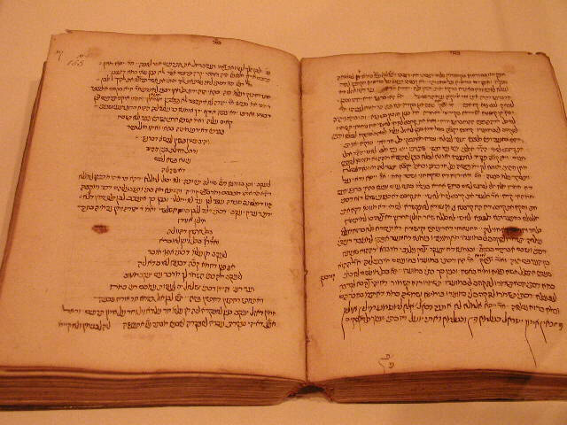
---------------------------------------------------------------------------------------------------------------------------------------------------------------------------------------------------------
The Zohar (Hebrew זהר "Splendor, radiance") is widely considered the most important work of Kabbalah, Jewish mysticism. It is a mystical commentary on the Torah (the five books of Moses), written in medieval Aramaic and medieval Hebrew. It contains a mystical discussion of the nature of God, the origin and structure of the universe, the nature of souls, sin, redemption, good and evil, and related topics.
The Zohar is not one book, but a group of books. These books include scriptural interpretations as well as material on theosophic theology, mythical cosmogony, mystical psychology, and what some would call anthropology.

Contents
- 1 Origin
  - 1.1 Acceptance of authenticity
  - 1.2 Rejection of authenticity
- 2 Mysticism
- 3 Pardes and Biblical exegesis
- 4 Effects on Judaism
- 5 Influence on Christian mysticism
- 6 Appendices and additions
- 7 See also
- 8 References

Origin
According to the 20th century religious historian, Gershom Scholem, most of the Zohar was written in an exalted, eccentric style of Aramaic, a language that was spoken in Israel during the Roman Period in the first centuries of the Common Era. The Zohar first appeared in Spain in the 13th century, and was published by a Jewish writer named Moses de Leon. Scholem, based on accounts from De Leon's contemporaries, and on evidence within the Zohar (Spanish idioms and syntax, for example), concluded De Leon is the actual author. De Leon himself ascribed this work to a rabbi of the second century, Simeon bar Yohai. Jewish legend holds that during a time of Roman persecution, Rabbi Simeon hid in a cave for 13 years, studying the Torah with his son, Elazar [1]. During this time he is said to have been inspired by God to write the Zohar.
The suspicion that the Zohar was found by one person, Moses de Leon, and that it refers to historical events of the post-Talmudical period, caused the authenticity of the work to be questioned from the outset. A story tells that after the death of Moses de Leon, a rich man of Avila named Joseph offered Moses' widow (who had been left without any means of supporting herself) a large sum of money for the original from which her husband had made the copy. She confessed that her husband himself was the author of the work. She had asked him several times, she said, why he had chosen to cr his own teachings to another, and he had always answered that doctrines put into the mouth of the miracle-working Simeon bar Yohai would be a rich source of profit. The story indicates that shortly after its appearance the work was believed by some to have been written by Moses de Leon.

[] Acceptance of authenticity
Over time, the general view in the Jewish community came to be one of acceptance of Moses de Leon's claims; the Zohar was held to be an authentic book of mysticism passed down from the second century, though certain small groups (Baladi Yemenite, Andalusian [Western Sefardic] and some Italian communities) never accepted it as authentic.
The Zohar spread among the Jews with remarkable swiftness. Scarcely fifty years had passed since its appearance in Spain before it was quoted by many Kabbalists, including the Italian mystical writer Menahem Recanati. Its authority was so well established in Spain in the 15th century that Joseph ibn Shem-Tov drew from it arguments in his attacks against Maimonides.
Even representatives of non-mysticism oriented Judaism began to regard it as a sacred book and to invoke its authority in the decision of some ritual questions. They were attracted by its glorification of man, its doctrine of immortality, and its ethical principles, which are more in keeping with the spirit of Talmudic Judaism than are those taught by the philosophers. While Maimonides and his followers regarded man as a fragment of the universe whose immortality is dependent upon the degree of development of his active intellect, the Zohar declared him to be the lord of the Creation, whose immortality is solely dependent upon his morality. According to the Zohar, the moral perfection of man influences the ideal world of the Sefirot; for although the Sefirot expect everything from the Ein Sof (Heb. אין סוף, infinity), the Ein Sof itself is dependent upon man: he alone can bring about the divine effusion. The dew that vivifies the universe flows from the just. By the practice of virtue and by moral perfection, man may increase the outpouring of heavenly grace. Even physical life is subservient to virtue. This, says the Zohar, is indicated in the words "for the Lord God had not caused it to rain" (Gen. 2:5), which means that there had not yet been beneficent action in heaven, because man had not yet been created to pray for it.
The Zohar was quoted by Todros Abulafia, by Menahem Recanati, and even by Isaac of Acco, in whose name the story of the confession of Moses de Leon's widow is related. Isaac evidently ignored the woman's alleged confession in favor of the testimony of Joseph ben Todros and of Jacob, a pupil of Moses de Leon, both of whom assured him on oath that the work was not written by Moses. The only objection worthy of consideration by the believers in the authenticity of the Zohar was the lack of references to the work in Jewish literature; and to this they answered that Simeon ben Yohai did not commit his teachings to writing, but transmitted them orally to his disciples, who in turn confided them to their disciples, and these to their successors, until finally the doctrines were embodied in the Zohar. As to the references in the book to historical events of the post-Talmudic period, it was not deemed surprising that Simeon ben Yohai should have foretold future happenings.

[] Rejection of authenticity
The first attack upon the accepted authorship of the Zohar was made by Elijah Delmedigo. Without expressing any opinion as to the real author of the work, he endeavored to show, in his Bechinat ha-Dat that it could not be attributed to Simeon bar Yohai. The objections were that:
- If the Zohar was the work of Simeon bar Yohai, it would have been mentioned by the Talmud, as has been the case with other works of the Talmudic period;
- The Zohar contains names of rabbis who lived at a later period than that of Simeon;
- Were Simeon ben Yohai the father of the Kabbalah, knowing by divine revelation the hidden meaning of the precepts, his decisions on Jewish law would have been adopted by the Talmud; but this has not been done;
- Were the Kabbalah a revealed doctrine, there would have been no divergence of opinion among the Kabbalists concerning the mystic interpretation of the precepts (Bechinat ha-Dat ed. Vienna, 1833, p. 43).
These arguments and others of the same kind were used by Leon of Modena in his Ari Nohem. A work devoted to the criticism of the Zohar was written, Miṭpaḥat Sefarim, by Jacob Emden, who, waging war against the remaining adherents of the Sabbatai Zevi movement, endeavored to show that the book on which Zevi based his doctrines was a forgery. Emden demonstrates that the Zohar misquotes passages of Scripture; misunderstands the Talmud; contains some ritual observances which were ordained by later rabbinical authorities; mentions the crusades against the Muslims (who did not exist in the second century); uses the expression esnoga, which is a Portuguese corruption of "synagogue,"; and gives a mystical explanation of the Hebrew vowel-points, which were not introduced until long after the Talmudic period.
In the mid-20th century, the Jewish historian Gershom Scholem contended that de Leon himself was the most likely author of the Zohar. Among other things, Scholem noticed the Zohar's frequent errors in Aramaic grammar, its suspicious traces of Spanish words and sentence patterns, and its lack of knowledge of the land of Israel. This finding is still disputed by many within Orthodox Judaism, although not because of any scholarly proofs, but rather because of tradition.
There is, however, a small group among the Orthodox who refuse to accept the Zohar, known as Dor Daim (דרדעים). They are mainly from the Jewish community in Yemen, and claim that the Zohar cannot be true because its ideas clash with the ideas of the Rambam (Maimonides), the great medieval rabbi and rationalist.
Yeshayahu Leibowitz, noted professor of philosophy at the Hebrew University of Jerusalem, claimed that "It is clear that the Zohar was written by de Leon as it is clear that Theodore Herzl wrote Medinat HaYehudim ("A State for the Jews")."
Other Jewish scholars have also suggested the possibility that the Zohar was written by a group of people, including de Leon. This theory generally presents de Leon as having been the leader of a mystical school, whose collective effort resulted in the Zohar.
Another theory as to the authorship of the Zohar is that it was transmitted like the Talmud before it was transcribed: as an oral tradition reapplied to changing conditions and eventually recorded. This view simultaneously believes that the Zohar was not written by Simeon bar Yohai, but was a holy work because it consisted of his principles.
Even if de Leon wrote the text, the entire contents of the book may not be fraudulent. Parts of it may be based on older works, and it was a common practice to ascribe the authorship of a document to an ancient rabbi in order to give the document more weight. It is possible that Moses de Leon considered himself inspired to write this text.
Another tradition holds that Rabbi Shimon wrote that the concealment of the Zohar would last for exactly 1200 years from the time of destruction of the Holy Temple in Jerusalem. The Temple of Jerusalem was destroyed in 70 CE and before revealing the Zohar in 1270, Moses De Leon uncovered the manuscripts in a cave in Israel.

[] Mysticism
Woe unto the man, says Simeon ben Yohai, who asserts that this Torah intends to relate only commonplace things and secular narratives; for if this were so, then in the present times likewise a Torah might be written with more attractive narratives. In truth, however, the matter is thus: The upper world and the lower are established upon one and the same principle; in the lower world is Israel, in the upper world are the angels. When the angels wish to descend to the lower world, they have to don earthly garments. If this be true of the angels, how much more so of the Torah, for whose sake, indeed, the world and the angels were alike created and exist. The world could simply not have endured to look upon it. Now the narratives of the Torah are its garments. He who thinks that these garments are the Torah itself deserves to perish and have no share in the world to come. Woe unto the fools who look no further when they see an elegant robe! More valuable than the garment is the body which carries it, and more valuable even than that is the soul which animates the body. Fools see only the garment of the Torah, the more intelligent see the body, the wise see the soul, its proper being; and in the Messianic time the 'upper soul' of the Torah will stand revealed. —Zohar

Woe unto the man, says Simeon ben Yohai, who asserts that this Torah intends to relate only commonplace things and secular narratives; for if this were so, then in the present times likewise a Torah might be written with more attractive narratives. In truth, however, the matter is thus: The upper world and the lower are established upon one and the same principle; in the lower world is Israel, in the upper world are the angels. When the angels wish to descend to the lower world, they have to don earthly garments. If this be true of the angels, how much more so of the Torah, for whose sake, indeed, the world and the angels were alike created and exist. The world could simply not have endured to look upon it. Now the narratives of the Torah are its garments. He who thinks that these garments are the Torah itself deserves to perish and have no share in the world to come. Woe unto the fools who look no further when they see an elegant robe! More valuable than the garment is the body which carries it, and more valuable even than that is the soul which animates the body. Fools see only the garment of the Torah, the more intelligent see the body, the wise see the soul, its proper being; and in the Messianic time the 'upper soul' of the Torah will stand revealed.

Once, says R. Simeon ben Yohai, I was plunged in a contemplative ecstasy, and I beheld a sublime ray of a brilliant light which illumined 325 circles, and amid which something dark was bathing. Then the dark point, becoming bright, began to float toward the deep and sublime sea, where all the splendors were gathering. I then asked the meaning of this vision, and I was answered that it represented the forgiveness of sins. —Zohar

Effects on Judaism
On the one hand, the Zohar was lauded by many rabbis because it opposed religious formalism, stimulated one's imagination and emotions, and for many people helped reinvigorate the experience of prayer. In many places prayer had become a mere external religious exercise, while prayer was supposed to be a means of transcending earthly affairs and placing oneself in union with God.
On the other hand, the Zohar was censured by many rabbis because it propagated many superstitious beliefs, and produced a host of mystical dreamers, whose overexcited imaginations peopled the world with spirits, demons, and all kinds of good and bad influences. Many classical rabbis, especially Maimonides, viewed all such beliefs as a violation of Judaic principles of faith.
Its mystic mode of explaining some commandments was applied by its commentators to all religious observances, and produced a strong tendency to substitute mystic Judaism in the place of traditional rabbinic Judaism. For example, Shabbat, the Jewish Sabbath, began to be looked upon as the embodiment of God in temporal life, and every ceremony performed on that day was considered to have an influence upon the superior world.
Elements of the Zohar crept into the liturgy of the 16th and 17th centuries, and the religious poets not only used the allegorism and symbolism of the Zohar in their compositions, but even adopted its style, e.g. the use of erotic terminology to illustrate the relations between man and God. Thus, in the language of some Jewish poets, the beloved one's curls indicate the mysteries of the Deity; sensuous pleasures, and especially intoxication, typify the highest degree of divine love as ecstatic contemplation; while the wine-room represents merely the state through which the human qualities merge or are exalted into those of God.
Originally, many held that only Jewish men who were at least 40 years old could study Kabbalah, and by extension read the Zohar, because they were believed to be too powerful for those less emotionally mature and experienced.

[] Influence on Christian mysticism
The enthusiasm felt for the Zohar was shared by many Christian scholars, such as Giovanni Pico della Mirandola, Johann Reuchlin, Aegidius of Viterbo, etc., all of whom believed that the book contained proofs of the truth of Christianity. They were led to this belief by the analogies existing between some of the teachings of the Zohar and certain Christian dogmas, such as the fall and redemption of man, and the dogma of the Trinity, which seems to be expressed in the Zohar in the following terms: "The Ancient of Days has three heads. He reveals himself in three archetypes, all three forming but one. He is thus symbolized by the number Three. They are revealed in one another. [These are:] first, secret, hidden 'Wisdom'; above that the Holy Ancient One; and above Him the Unknowable One. None knows what He contains; He is above all conception. He is therefore called for man 'Non-Existing' [Ayin]" (Zohar, iii. 288b).
This and other similar doctrines found in the Zohar are now known to be much older than Christianity; but the Christian scholars who were led by the similarity of these teachings to certain Christian dogmas deemed it their duty to propagate the Zohar. Shortly after the publication of the work (Mantua and Cremona, 1558) Joseph de Voisin translated extracts from it which deal with the soul. He was followed by many others.
The disastrous effects of the Sabbatai Zevi messianic movement on the Jewish community dampened the enthusiasm that had been felt for the book in the Jewish community. However, the Zohar is still held in great reverence by many Orthodox Jews, especially the Hasidim (Hasidic Jews).

[] Appendices and additions
The Zohar is not considered complete without the addition of certain appendixes, which are often attributed either to the same author, or to some of his immediate disciples. These supplementary portions are almost always printed as part of the text with separate titles, or in separate columns. They are as follows:
- Sifra di-Tsni`uta, consisting of five chapters, in which are chiefly discussed the questions involved in the Creation, such as the transition from the infinite to the finite, that from absolute unity to multifariousness, that from pure intelligence to matter, etc;
- Idra Rabbah, in which the teachings of the preceding portion are enlarged upon and developed; and Idra Zuta, giving a résumé of the two preceding sections.
To the larger appendixes are added the following fragments:
- Raza de Razin, ("Secret of Secrets") dealing with the connection of the soul with the body;
- Sefer Hekalot, describing the seven heavenly halls, paradise, and hell;
- Raya Mehemna, giving a conversation between Moses, the prophet Elijah, and Simeon ben Yohai on the allegorical import of the Mosaic commandments and prohibitions, as well as of the rabbinical injunctions.
- Sitre Torah, on various topics;
- Midrash ha-Ne'elam, explaining passages of Scripture mystically by way of hints and gematria (mystical numerology);
- Saba, containing a conversation between the prophet Elijah and Simeon ben Yohai about the doctrine of metempsychosis;
- Yanuḳa, on the importance of washing the hands before meals and on similar subjects, written in the name of a child of Hamnuna Saba, whence the title Yanuḳa ("child");
- Tosefta and Matnitin, in which are sketched the doctrines of the Sefirot, the emanation of the primordial light, etc.

[] See also
- Kabbalah
- Mysticism
- Sefer Yetzirah
- Bahir
- Baqashot

[] References
- Resources > Medieval Jewish History > Jewish Mysticism The Jewish History Resource Center, Project of the Dinur Center for Research in Jewish History, The Hebrew University of Jerusalem
- Full text with parallel translation, from the Kabbalah Center
- Rabbi Yehudah Ashlag's Sulam on The Zohar
- Reconstructed Aramaic source text used in the first three volumes of Daniel Matt's translation (PDF format)
- A translation/interpretation of the Zohar's opening teaching
- Kabbalah and Jewish Mysticism A Talmudist perspective of Kabbalah
- Who Should Learn the Hidden Torah? A portion of Maimonides [Rambam]'s instruction on who should be taught the deeper aspects of Torah, and how - taken from his book Moreh haNevukhim / Guide for the Perplexed.
- Zohar en Espanol
======================================================================================================================================
END

