**The Hidden History of the Incredibly Evil Khazarian Mafia**

<https://www.veteranstodayarchives.com/2015/03/08/the-hidden-history-of-the-incredibly-evil-khazarian-mafia/4/>

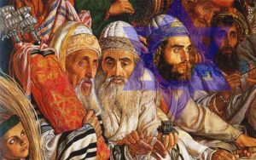

**The Rothschild KM planted has 25 nukes in major American cities and other major cities in Europe in order to blackmail the associated government. This is referred to as their Samson Option, and was first discovered and disclosed by Seymour Hersh:**

The Rothschild KM also gained some S-19 and S-20 Warheads from a corrupt Member of Congress assigned the task to buy up Ukrainian Mirvs on behalf of the USG in order to decommission them. Instead, he sold them to the Israelis and split the money with other key Congressmen involved.

This is high treason and a capital offense punishable by execution. Right after their attack on America, the Rothschild KM told the US Administration that they would detonate city-buster sized nukes in some American cities, including DC, if the Administration refused to allow Israel to create their own large police state occupation force inside America, based on the consolidation of all American Law Enforcement and alphabets under one central Israeli control.

This new Israeli occupation force called Homeland Security (DHS) was initially run by dual citizens and perverts. Former DHS Director Janet Napolitano is being sued for sexual harassment of men working at DHS whom she ordered to move their offices into the men’s lavatory.

Dual Citizen traitor Michael Chertoff, (a name translated from Russian as “son of the devil”), was the criminal mastermind that set up DHS, along with former head of the East German Stasi, Marcus Wolfe, who was hired as a special consultant and died mysteriously as soon as his mission was completed.

The Rothschild KM never thought they would get exposed for their nuclear attack on America on 9-11-11, but they made one of the biggest tactical mistakes in history and overplayed their hand from excess hubris, based on too much easy success due to their extreme money power in the past.

**Soon mainstream America will know that Bibi Netanyahu and his Likudist Party deployed the attack on America on 9-11-01 on behalf of the Rothschild KM:**

They thought that they had complete control over the CMMM and could prevent any of the secret IAEA and Sandia Labs investigation from ever being released to the American public.

They made a serious tactical error because now [the truth about their role in the 9-11-01 attack on America is being published on the worldwide Internet](https://www.veteranstoday.com/2015/01/12/mapping-911-fort-lee/), the world’s new Gutenberg Press. What the Rothschild KM did not understand was the power of the Internet and how truth-nuggets published and broadcast on it resonate with the people of the world and spread like wildfire, at the speed of light. Truth is being diffused to the masses everywhere.

This incredible tactical error by the KM is so great that it will actually doom them to the complete exposure and eventual complete destruction they deserve. Bibi Netanyahu’s order to proceed and deliver the nuclear attack on America on 9-11-01 will go down in history as one of the KM’s biggest mistakes, and the one that will be blamed for their exposure and destruction by the world that is now ganging up against them.

The Russians have now leaked the IAEA and Sandia Labs and Able Danger files given to them by Edward Snowden. Soon all of these files will be provided to all Americans and the world via the Internet, and this cannot be stopped.

A number of Russians in the High Military Command in Russia, and in the highest positions of leadership in the Russian government realize that it was the same Organized Crime Cabal that organized the Khazarians into Bolsheviks to mass-murder 100 million innocent Russians — and these men want payback.

That is why they are making sure that the Rothschild banksters will be put out of business, which will decapitate the Khazarian Mafia from its endless, elastic counterfeit money supply. This is why the BRICS Development Bank was created — to replace the US Petro Dollar as the world’s reserve currency, but this one, unlike the US Petro Dollar is backed by gold, silver and real commodities, with NO counterfeiting allowed.

The CMMM is failing, and most Americans no longer believe any of their prime-time national stories, especially the under-thirty crowd, who cherry pick facts from the Internet and construct their own beliefs.

So many Internet users now reject the CMMM that the truth about the Israelis attacking America on 9-11-01 is becoming easier each day to believe. Soon all of mainstream America will know that Bibi Netanyahu and his Mossad and dual citizens did the 9-11-01 attack on America.

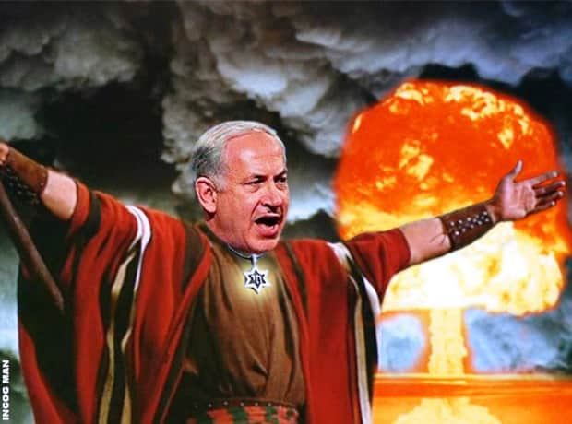

**The American Military High Command knows that Bibi Netanyahu ordered his Mossad and stateside Dual Citizens to attack America using nukes on 9-11-01 on behalf of the Rothschild Khazarian Mafia (KM):**

Various deep cover covert operations are now being deployed globally to expose and decapitate the Rothschild KM from their endless, elastic money supply.

Their days of anti-human power are now limited. The secret, incredibly well-trained US team called the “Nuclear Snake-Eaters” is now hard at work searching all incoming Israeli diplomatic pouches and shipments; driving by and flying over synagogues and Israeli embassies and Mossad safe-houses with high tech gamma-ray and helium-3 neutron detectors; and using ultra-high-tech custom-tuned and -focused satellites to search for any stored nuclear pits, as well as working hard to recover all stolen nuclear pits by the Israelis anywhere in the world outside of Israel.

This super-elite team was alerted by Michael Shrimpton’s phone call to MI-6 notifying them that an Israeli “City Buster” was planted near the Olympic stadium. This call wrongly has landed him in jail. The City Buster was recovered by the “Nuclear Snake-eaters”, who entered England and recovered and disarmed a large city buster. Sadly MI-6 wanted this nuke detonated in order to gain more power for the Khazarian Mafia in England — their home base inside the City of London Financial District — since it has been losing power fast.

A secret name for these KM Chieftains which run much of the world out of the City of London is Gog and Magog, despite what so many historians believe is the secret name of Russia which it is not. It is the secret name of the top KM, and apparently represents where they originally came from.

The secret team of super-elite “Nuclear Snake-eaters” is ready to be deployed to Israel anytime, should the nation collapse after most European corporations divest from Israel, and the US cuts off all aid, in order to comply with American law. It is illegal to give aid to a nation that has nukes, and which has not signed the Nuclear Non-proliferation Agreement. Israel has nukes detectable from satellite-based Helium-3 sensors and has never admitted it, nor has it signed the Nuclear Non-proliferation Agreement. We must all demand that our Congress and Administration obey the law and immediately cut off all aid monetary and military aid to Israel, and arrest all Israeli espionage front directors of AIPAC, JINSA, the Defense Policy Board, the “Joint” in NYC, and the ADL, etc.

It is unknown but suspected that a significant number of these stolen nukes have been already recovered. It has been reported by insiders that a very solemn message was communicated to Bibi Netanyahu and his Likudists, as well as all top members of Israeli espionage fronts in America, like AIPAC, JINSA, the Defense Policy Board, the ADL and the like.

What was this serious warning? If insider reports are accurate, these folks were told that if there is one more Israeli based false-flag attack, those who ordered it or were involved will be hunted down under American National Security and eliminated, and the Israeli defense structures associated with such will be turned to dust.

**The rest of Rothschild KM history will likely be determined by YOU:**

The future of the Rothschild KM will likely be determined by Veterans Today readers and We The People who learn the secret, forbidden history of the Khazarian Mafia that was excised from the history books and libraries by the KM to protect their evil history that no one would accept if it was known.

So share this story with your family, friends, and associates and take it viral. Be clear about this — unless the KM is able to operate in abject secrecy, it will be attacked from all sides and destroyed forever. So take away their secrecy by exposing their hidden history for all Americans to know and understand.

That is why they have worked so hard to buy up and control the CMMM and public mass education including colleges and universities, to make sure the people of the world would never find out about their secret evil, which is so inhuman, so homicidal that the whole world would gang up on them and attack them from all sides at every level they exist at.

The big question remains: Was the true cause of leaders of the Khazarian Mafia’s incredible evil and savagery toward the human race a byproduct or nature or nurture? Some believe that this gross parasitism and inclination to mass-murder, engage in pedophilia and child bloodletting and child sacrifice is due to a toxic culture, best described as malignant Tribalism, characterized by a paranoid group racial superiority delusion. Others think the leaders of the KM are the bloodline of Cain, that is, “children of Cain”, that are the Devil’s own and have absolutely no soul or human conscience, but are pure predators like a wild beast — while at the same time being [incredibly two-faced](https://www.veteranstoday.com/2014/11/22/evil-with-a-nice-face-the-janus-principal/), that is able to put on [a good con and a nice face](https://www.veteranstoday.com/2015/02/27/evil-with-a-nice-face-part-ii/) on the outside. Perhaps it could be both factors. In any case, it is time to expose this evil, the greatest evil the world has ever experienced. It is time for the world to work together to eradicate this problem now and forever, by whatever means necessary.

***Mike Harris*** is the Financial Editor of Veterans Today, a radio host, a former GOP Finance Chairman, Gubernatorial Candidate for Arizona, and a Senior Vice President of Adamus Defense Group, Switzerland. Mike is an expert in full-contact mixed martial arts. His long term expertise in such has gained him a lot of respect and the nickname “Iron Mike”. Mike was a part of the Veterans Today group that attended the [*Damascus Conference to Combat Terrorism*](http://www.veteranstoday.com/2014/12/13/historic-speech-in-damascus-sends-shockwaves-around-the-world/) and Religious Extremism. Mike gave about twenty-five televised interviews that were broadcast to millions of viewers in Syria, Iraq, Lebanon, and Iran. In these interviews, Mike emphasized and supported the historical declaration by Keynote Speaker, Veterans Today Senior Editor, and Chairman Gordon Duff that the real problem behind World Terrorism is a large Organized Crime Syndicate.

For those who have time and interest on the Head of the Khazarian Mafia (KM) Snake.