Arthur Koestler 1905-1983
http://en.wikipedia.org/wiki/Arthur_Koestler
----------------------------------------------------------------------------------------------------------------------------------------------------------------------------------------------------------------------------------------
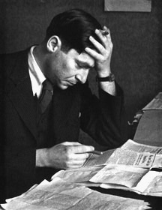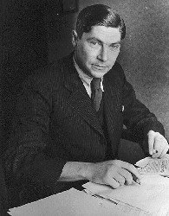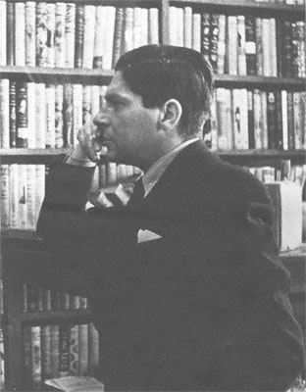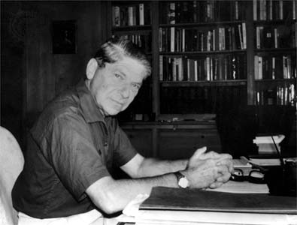
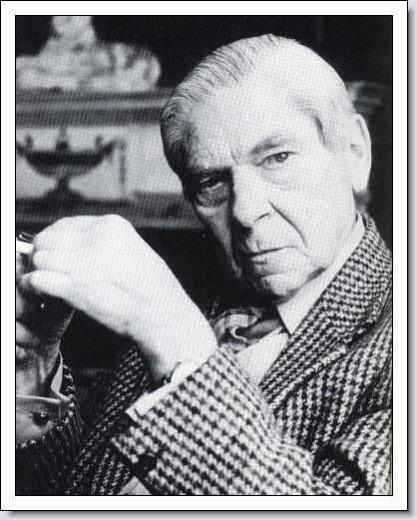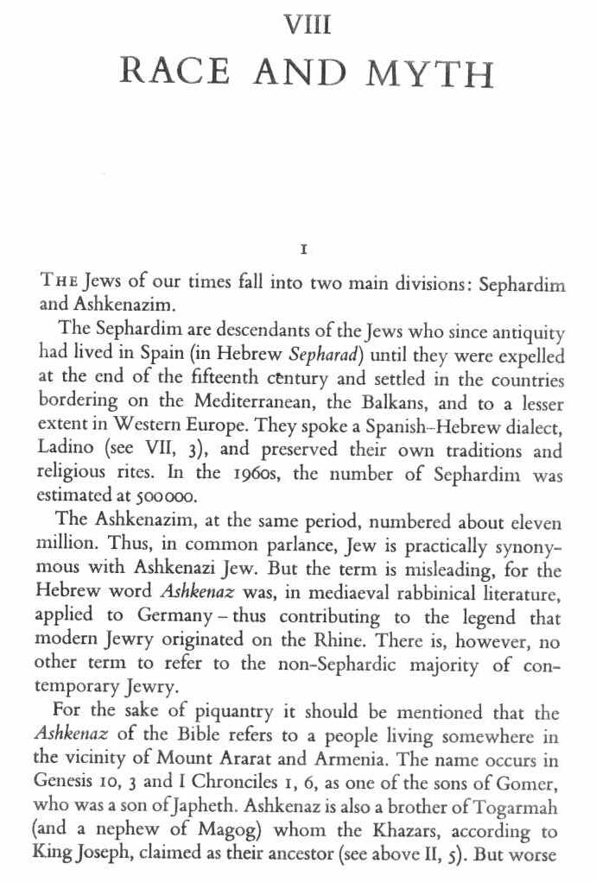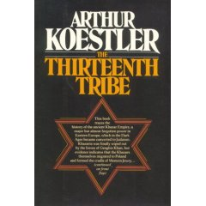
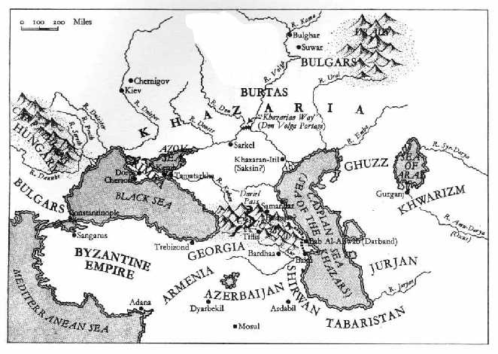
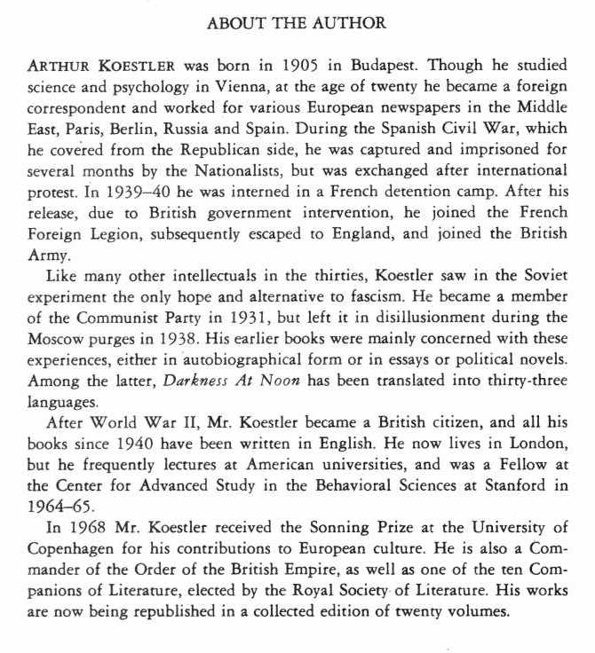
http://www.christusrex.org/www2/koestler/k256.jpg
------------------------------------------------------------------------------------------------------------------------------------------------------------------------------------------------------------------------------------------------
Arthur Koestler (September 5, 1905, Budapest – March 3, 1983, London) was a Hungarian polymath who became a naturalized British subject. He wrote journalism, novels, social philosophy, and books on scientific subjects. He was a communist during much of the 1930s, but later became an outspoken anti-communist. He remained politically active until the 1950s. He wrote several popular books, including Arrow in the Blue (the first volume of his autobiography), The Yogi and the Commissar (a collection of essays, many dealing with Communism), The Sleepwalkers (A History of Man's Changing Vision of the Universe), The Act of Creation, and The Thirteenth Tribe (a new theory on the origins of Eastern European Jews). Koestler's most famous work, the novel Darkness at Noon about the Soviet 1930s purges, ranks with George Orwell's Nineteen Eighty-Four as a fictional treatment of Stalinism. He also wrote Encyclopædia Britannica articles.

Contents
[hide]
- 1 Life
  - 1.1 Speaking out against Nazi atrocities during World War II
  - 1.2 Multilingualism
  - 1.3 Women
- 2 Mixed legacy
  - 2.1 Politics
  - 2.2 Journalism
  - 2.3 Paranormal and scientific Interests
  - 2.4 Judaism
  - 2.5 Hallucinogens
- 3 Cultural influence
- 4 Bibliography
  - 4.1 Autobiography
  - 4.2 Biographies
  - 4.3 Books by Koestler (excluding autobiography)
  - 4.4 Writings as a contributor
- 5 Notes
- 6 External links

[] Life
He was born Kösztler Artúr (Hungarian names have the surname first) in Budapest, Austria-Hungary, to a German-speaking Hungarian family of Ashkenazi Jewish descent. His father, Henrik, was a prosperous start-up industrialist and inventor. His great business success was a "health" soap, which substituted conventional soaps based on animal fats (scarce during the WWI). Henrik's mineral soaps were thought to have health qualities thanks to their weak radioactivity, which in those times was considered curative. When Artur was 14, his family moved to Vienna.
Koestler studied science and psychology at the University of Vienna, where he became President of a Zionist student fraternity. A month before he was due to finish his studies, he burnt his matriculation book and did not take his final examinations but made "aliyah" to Israel (then a British Mandate). From 1926 to 1929 he lived in the British Mandate of Palestine, firstly in a kibbutz in the Jezreel Valley ("Heftzibah"), and later in Tel Aviv and Jerusalem, where he almost starved. He left Palestine for Paris as a correspondent to the Ullstein group of German newspapers. A year later he became science or for Ullstein based in Berlin; a highlight of that post was membership in a 1931 zeppelin expion to the North Pole.
He joined the Communist Party of Germany in 1931, but left it after the Stalinist show-trials of 1938. During this period he traveled extensively in the Soviet Union and climbed Mount Ararat in Turkey. In Turkmenistan, he met the Black American writer Langston Hughes.
In his memoir The Invisible Writing, Koestler recalls that during the summer of 1935 he "wrote about half of a satirical novel called The Good Soldier Schweik Goes to War Again..... It had been commissioned by Willy Münzenberg [the Comintern's chief propagandist in the West] ... but was vetoed by the Party on the grounds of the book's 'pacifist errors' ..." (p. 283).
Soon after the outbreak of World War II, the French authorities detained him for several months in a camp for resident aliens at Le Vernet, in the foothills of the Pyrenees mountains. Upon his release, he joined the French Foreign Legion. He eventually escaped to England via Morocco and Portugal. In England, he served in the British Army as a member of the British Pioneer Corps, 1941-42, then worked for the BBC. He became a British subject in 1945, and returned to France after the war, where he rubbed shoulders with the set gravitating around Jean-Paul Sartre and Simone de Beauvoir (one of the characters in de Beauvoir's novel The Mandarins is believed to be based on Koestler).
Koestler returned to London and spent the rest of his life writing and lecturing. In June 1950, Koestler attended and delivered the keynote address at a conference of anti-Communist intellectuals in Berlin that led to the founding of the Congress for Cultural Freedom. He was made a Commander in the Order of the British Empire in the 1970s.
In 1983, suffering from Parkinson's disease and leukemia, Koestler committed joint suicide with his third wife Cynthia by taking an overdose of drugs. He had long been an advocate of voluntary euthanasia, and in 1981 had become vice-president of EXIT (now the United Kingdom's Voluntary Euthanasia Society). His will endowed the chair of parapsychology at the University of Edinburgh in Scotland.

[] Speaking out against Nazi atrocities during World War II
During the Second World War, Koestler continually spoke out against the atrocities of the Nazi regime in Germany — his Central European Jewish family background made him particularly involved in a way that many British and United States politicians were not. He had also witnessed personally, the growth of extremist tendencies in the region.
Koestler and a minority of writers and public figures believed that if they sufficiently described the horrors being committed in Europe in news media and public meetings, it would spur the West to action. Despite their efforts, these protests often fell on deaf ears. Capturing their frustration, Koestler described these people as the "screamers". In 1944, he wrote:
We, the screamers, have been at it now for about ten years. We started on the night when the epileptic van der Lubbe set fire to the German Parliament; we said that if you don't quench those flames at once, they will spread all over the world; you thought we were maniacs. At present we have the mania of trying to tell you about the killing-by hot steam, mass-electrocution, and live burial-of the total Jewish population of Europe. So far three million have died. It is the greatest mass killing in recorded history; and it goes on daily, hourly, as regularly as the ticking of your watch. I have photographs before me on the desk while I am writing this, and that accounts for my emotion and bitterness.^{[1]}
Despite these frustrations, Koestler and the "screamers" continued their campaign until the late stages of the war.

[] Multilingualism
In addition to his mother tongue German, and the Hungarian of his homeland, Koestler became fluent in English, and French, and knew some Hebrew and Russian. His biographer David Cesarani claims there is some evidence that Koestler may have picked up some Yiddish from his grandfather. Koestler's multilingualism was principally due to his having resided, worked, or studied in Hungary, Austria, Germany, Palestine (pre-1948 Israel), the Soviet Union, the United Kingdom, and France, all by 40 years of age.
Though he wrote the bulk of his later work in English, Koestler wrote his best-known novels in three different languages: The Gladiators in Hungarian, Darkness at Noon in German (although the original is now lost), and Arrival and Departure in English. His journalism was written in German, Hebrew, French and English, and he even produced the first Hebrew language crossword puzzles and wrote the sketches for the first Hebrew cabaret ("HaMatateh").

[] Women
Koestler was married to Dorothy Asher (1935-50), Mamaine Paget (1950-52), and Cynthia Jefferies (1965-83). He also had a very short fling with the French writer Simone de Beauvoir. Cesarani claimed that Koestler beat and raped several women, including film director Jill Craigie. The resulting protests led to the removal of a bust of Koestler from public display at the University of Edinburgh.
Questions have also been raised by his suicide pact with his last spouse. Although he was terminally ill at the time, she was apparently healthy, leading some to claim he persuaded her to take her own life.

[] Mixed legacy
Just as Darkness at Noon was selling well during the Cold War of the 1940s and '50s, Koestler announced his retirement from politics. Much of what he wrote thereafter revealed a multidisciplinary thinker whose work anticipated a number of trends by many years. He was among the first to experiment with LSD (in a laboratory). He also wrote about Japanese and Indian mysticism in The Lotus and the Robot (1960).
This originality resulted in an uneven set of ideas and conclusions. Topics covererd by his works include creativity (Insight and Outlook, Act of Creation) and the history of science (The Sleepwalkers). Some of his other pursuits, such as his interest in the paranormal, his support for euthanasia, his theory of the origin of Ashkenazi Jews like himself, and his disagreement with Darwinism, are more controversial.

[] Politics
Koestler was involved in a number of political causes during his life, from Zionism and communism to anti-communism, voluntary euthanasia, and campaigns against capital punishment, particularly hanging. He was also an early advocate of nuclear disarmament.

[] Journalism
Until the bestseller status of Darkness at Noon made him financially comfortable, Koestler often earned his living as a journalist and foreign correspondent, trading on his ability to write quickly in several languages, and to acquire with felicity a working knowledge of a new language. He wrote for a variety of newspapers, including Vossische Zeitung (science or) and B.Z. am Mittag (foreign or) in the 1920s. In the early 1930s, he worked for the Ullstein publishing group in Berlin and did freelance writing for the French press.
While covering the Spanish Civil War, in 1937, he was captured and held for several months by the Falangists in Málaga, until the British Foreign Office negotiated his release. His Spanish Testament records these experiences, which he soon transformed into his classic prison novel Darkness at Noon. After his release from Spanish detention, Koestler worked for the News Chronicle, then ed Die Zukunft with Willi Münzenberg, an anti-Nazi, anti-Stalinist German language paper based in Paris, founded in 1938. During and after World War II, he wrote for a number of English and American papers, including The Sunday Telegraph, on various subjects.

[] Paranormal and scientific Interests
During the last 30 years of his life, Koestler wrote extensively on science and scientific practice. The post-modernist scepticism colouring much of this writing tended to alienate most of the scientific community. A case in point is his 1971 book The Case of the Midwife Toad about the biologist Paul Kammerer, who claimed to find experimental support for Lamarckian inheritance.
Koestler's trilogy culminating with The Ghost in the Machine and later Janus - a summing up bridges concepts of reductionism and holism with his systemic theory of Open Hierarchical Systems. Holons in a Holarchy have the dual tendency of integration and development and out of balance they tend to a pathology. He included his concept of Bisociation that became a profound basis for other's work on creativity and James Papez/Paul McLean's Schizophysiology to explain the often irrational behaviour of humans as part of Open Hierarchical Systems.
Mysticism and a fascination with the paranormal imbued much of his later work, and greatly influenced his personal life. For some years following his death a Koestler Society in London promoted investigation of these and related subjects. He left a substantial part of his estate to establish the Koestler Parapsychology Unit at the University of Edinburgh dedicated to the study of paranormal phenomena. His The Roots of Coincidence makes an overview of the scientific research around telepathy and psychokinesis and compares it with the advances in quantum physics at that time. It mentions yet another line of unconventional research by Paul Kammerer, the theory of coincidence or synchronicity. He also presents critically the related writings of Carl Jung. More controversial were Koestler's studies of levitation and telepathy.

[] Judaism
Although a lifelong atheist, Koestler's ancestry was Jewish. His biographer David Cesarani claimed that Koestler deliberately disowned his Jewish ancestry.
When Koestler resided in Palestine during the 1920s, he lived on a kibbutz. This experience provided background for his novel Thieves in the Night.
He supported the statehood of Israel, but remarked that the Balfour Declaration of 1917 amounted to "one nation solemnly promising to a second nation the country of a third."^{[citation needed]} He believed that Israel would never be destroyed short of a second Shoah.^{[citation needed]} However, he opposed a diaspora Jewish culture: In an interview published in the London Jewish Chronicle around the time of Israel's founding, Koestler maintained that all Jews should either migrate to Israel or else assimilate completely into their local cultures.^{[citation needed]} As for Jewish culture in Israel, Koestler proposed that Israel drop the Hebrew alphabet for the Roman.^{[citation needed]}
Koestler's book The Thirteenth Tribe advanced the controversial thesis that Ashkenazi Jews are not descended from the Israelites of antiquity, but from the Khazars, a Turkic people in the Caucasus who converted to Judaism in the 8th century and were later forced to move westwards into current Russia, Ukraine and Poland. Koestler stated that part of his intent in writing The Thirteenth Tribe was to defuse anti-Semitism by undermining the identification of European Jews with Biblical Jews, with the hope of rendering anti-Semitic epithets such as "Christ killer" inapplicable. Ironically, Koestler's thesis that Ashkenazi Jews are not Semitic has become an important claim of many anti-Semitic groups.
Some Palestinians have eagerly seized upon this thesis, believing that to identify most Jews as non-Semites seriously undermines their historical claim to the land of Israel. The main thesis of The Thirteenth Tribe has since been tentatively disproven by genetic testing. A 2000 study of haplotypes by Hammer et al found that the Y chromosome of most Ashkenazi and Sephardic Jews was of Middle Eastern origin, containing mutations that are also common among Palestinians and other Middle Eastern peoples, but uncommon in the general European population. This suggested that the male ancestors of the Ashkenazi Jews could be traced primarily to the Middle East.^{[2]} A 2006 study by Behar et al, based on haplotype analysis of mitochondrial DNA (mtDNA), suggested that about 40% of the current Ashkenazi population is descended matrilineally from just four women. These four "founder lineages" were "likely from a Hebrew/Levantine mtDNA pool" originating in the Near East in the first and second centuries CE.^{[3]}

[] Hallucinogens
In November, 1960, Koestler participated in Timothy Leary's early experiments with psilocybin at Harvard. According to fellow participant Charles Olson, Koestler was distressed by the effects of the drug and isolated himself in an unfurnished bedroom in the Cambridge house Leary used for his project.^{[citation needed]} Koestler again experimented with psilocybin at the University of Michigan at Ann Arbor, comparing this trip to Walt Disney's Fantasia.
In Return Trip to Nirvana, published in the Sunday Telegraph in 1967,^{[citation needed]} Koestler wrote about the drug culture and his own experiences with hallucinogens. The article also challenged the defence of drugs in Aldous Huxley's The Doors of Perception:
I profoundly admire Aldous Huxley, both for his philosophy and uncompromising sincerity. But I disagree with his advocacy of "the chemical opening of doors into the Other World", and with his belief that drugs can procure "what Catholic theologians call a gratuitous grace". Chemically induced hallucinations, delusions and raptures may be frightening or wonderfully gratifying; in either case they are in the nature of confidence tricks played on one's own nervous system.

[] Cultural influence
In his younger days, the singer Sting was an avid reader of Koestler^{[citation needed]}. His band of the time, The Police, were to name one of their albums Ghost in the Machine after one of Koestler's books. Their album Synchronicity was also inspired by Koestler's The Roots of Coincidence, which discusses Carl Jung's theory of the same name. Koestler knew little about the burgeoning New Wave music scene, and is alleged to have said^{[citation needed]}:
Look at this. Did you ever see a magazine called the New Musical Express? It turns out there is a pop group called The Police—I don't know why they are called that, presumably to distinguish them from the punks—and they've made an album of my essay The Ghost in the Machine. I didn't know anything about it until my clipping agency sent me a review of the record.
The cyberpunk manga and anime series Ghost in the Shell was also inspired by Koestler's The Ghost in the Machine.
Inspector Finch can also be seen reading a copy of The Roots of Coincidence in the graphic novel, V for Vendetta. Koestler is referenced several times in the work.
In the 2002 film Red Dragon, The Act of Creation is one of the books seized from Hannibal Lecter's cell.

[] Bibliography
A comprehensive introduction to Koestler's writing and thought is this 1980 anthology of passages from many of his books, described as "A selection from 50 years of his writings, chosen and with new commentary by the author":
- 1980. Bricks to Babel. Random House, ISBN 0-394-51897-7

[] Autobiography
- 1952. Arrow In The Blue: The First Volume Of An Autobiography, 1905-31, 2005 reprint, ISBN 0-09-949067-6
- 1954. The Invisible Writing: The Second Volume Of An Autobiography, 1932-40, 1984 reprint, ISBN 0-8128-6218-X
- 1937. Spanish Testament.
- 1941. Scum of the Earth.
- 1984. Stranger on the Square.
The books The Lotus and the Robot, The God that Failed, and Von Weissen Nächten und Roten Tagen, as well as his numerous essays, all contain autobiographical information.

[] Biographies
- Atkins, J., 1956. Arthur Koestler.
- Buckard, Christian G., 2004. Arthur Koestler: Ein extremes Leben 1905-1983. ISBN 3-406-52177-0.
- David Cesarani, 1998. Arthur Koestler: The Homeless Mind. ISBN 0-684-86720-6.
- Hamilton, Iain, 1982. Koestler: A Biography. ISBN 0-02-547660-2.
- Koestler, Mamaine, 1985. Living with Koestler. ISBN 0-297-78531-1 or ISBN 0-312-49029-1.
- Levene, M., 1984. Arthur Koestler. ISBN 0-8044-6412-X.
- Mikes, George, 1983. Arthur Koestler: The Story of a Friendship. ISBN 0-233-97612-4.
- Pearson, S. A., 1978. Arthur Koestler. ISBN 0-8057-6699-5.
Langston Hughes's autobiography also documents their meeting in Turkestan during the Soviet era.

[] Books by Koestler (excluding autobiography)
- 1933. Von Weissen Nächten und Roten Tagen. Very difficult to find.
- 1935. The Good Soldier Schweik Goes to War Again.... Unfinished and unpublished.
- 1937. L'Espagne ensanglantée.
- 1939. The Gladiators, 1967 reprint, ISBN 0-02-565320-2. A novel on the revolt of Spartacus.
- 1940. Darkness at Noon, ISBN 0-09-942491-6
- 1942. Dialogue with Death. Abridgement of Spanish Testament.
- 1943. Arrival and Departure, novel. 1990 reprint, ISBN 0-14-018119-9
- 1945. The Yogi and the Commissar and other essays.
- 1945. Twilight Bar. Drama.
- 1946. Thieves in the Night (novel).
- 1949. The Challenge of our Time.
- 1949. Promise and Fulfilment: Palestine 1917-1949.
- 1949. Insight and Outlook.
- 1951. The Age of Longing.
- 1955. The Trail of the Dinosaur and other essays.
- 1956. Reflections on Hanging.
- 1959. The Sleepwalkers: A History of Man's Changing Vision of the Universe. ISBN 0-14-019246-8
- 1960. The Watershed: A Biography of Johannes Kepler. (excerpted from The Sleepwalkers.) ISBN 0-385-09576-7
- 1960. Lotus and the Robot, ISBN 0-09-059891-1. Koestler's journey to India and Japan, and his assessment of East and West.
- 1961. Control of the Mind.
- 1961. Hanged by the Neck. Reuses some material from Reflections on Hanging.
- 1963. Suicide of a Nation.
- 1964. The Act of Creation.
- 1967. The Ghost in the Machine. Penguin reprint 1990: ISBN 0-14-019192-5.
- 1968. Drinkers of Infinity: Essays 1955-1967.
- 1970. The Age of Longing, ISBN 0-09-104520-7.
- 1971. The Case of the Midwife Toad, ISBN 0-394-71823-2. An account of Paul Kammerer's research on Lamarckian evolution and what he called "serial coincidences".
- 1972. The Roots of Coincidence, ISBN 0-394-71934-4. Sequel to The Case of the Midwife Toad.
- 1972. The Call Girls: A Tragicomedy with a Prologue and Epilogue (novel).
- 1973. The Lion and the Ostrich.
- 1974. The Heel of Achilles: Essays 1968-1973, ISBN 0-394-49596-9.
- 1976. The Thirteenth Tribe: The Khazar Empire and Its Heritage, ISBN 0-394-40284-7.
- 1976. Astride the Two Cultures: Arthur Koestler at 70, ISBN 0-394-40063-1.
- 1977. Twentieth Century Views: A Collection of Critical Essays, ISBN 0-13-049213-2.
- 1978. Janus: A Summing Up, ISBN 0-394-50052-0. Sequel to The Ghost in the Machine
- 1981. Kaleidoscope. Essays from Drinkers of Infinity and The Heel of Achilles, plus later pieces and stories.

[] Writings as a contributor
- Encyclopaedia of Sexual Knowledge (1935)
- Foreign Correspondent (1939),
- The Practice of Sex (1940)
- The God That Failed (1950) (collection of testimonies by ex-Communists)
- Attila, the Poet (1954) (Encounter ; ; 1954.2 (5)). On loan at the UCL library of the School of Slavonic & Eastern European Studies.
- UCL library online
- Beyond Reductionism: The Alpbach Symposium. New Perspectives in the Life Sciences (co-or with J.R. Smythies, 1969), ISBN 0-8070-1535-0
- The Challenge of Chance: A Mass Experiment in Telepathy and Its Unexpected Outcome (1973)
- The Concept of Creativity in Science and Art (1976)
- Life After Death, (co-or, 1976)
- Humour and Wit. I: Encyclopædia Britannica. 15th ed. vol. 9.(1983)
- *humour - Encyclopædia Britannica(by Arthur Koestler)

[] Notes
- ^ "On Disbelieving Atrocities", New York Times Magazine, January 1944 and reprinted in The Yogi and the Commissar, Macmillan (1945), pp. 88-92.
- ^ Hammer, M. F., A. J. Redd, E. T. Wood, M. R. Bonner, H. Jarjanazi, T. Karafet, S. Santachiara-Benerecetti, A. Oppenheim, M. A. Jobling, T. Jenkins, H. Ostrer, and B. Bonné-Tamir (May 9 2000). "Jewish and Middle Eastern non-Jewish populations share a common pool of Y-chromosome biallelic haplotypes". Proceedings of the National Academy of Sciences.
- ^ Behar, Doron M., Ene Metspalu, Toomas Kivisild, Alessandro Achilli, Yarin Hadid, Shay Tzur, Luisa Pereira, Antonio Amorim, Lluı's Quintana-Murci, Kari Majamaa, Corinna Herrnstadt, Neil Howell, Oleg Balanovsky, Ildus Kutuev, Andrey Pshenichnov, David Gurwitz, Batsheva Bonne-Tamir, Antonio Torroni, Richard Villems, and Karl Skorecki (March 2006). "The Matrilineal Ancestry of Ashkenazi Jewry: Portrait of a Recent Founder Event". The American Journal of Human Genetics 78 (3): 487-97. PMID 16404693.

[] External links
- Koestler Parapsychology Unit - Koestler and his third spouse left a large sum of money for research into parapsychology: this funded, amongst other things, the Koestler Parapsychology Unit at Edinburgh University
- Hungarian site on Koestler
- Arthur Koestler Project
- Koestler's Legacy - Fortean Times article on the centenary of Koestler's birth
- Online biography
- - General Properties of Koestler's Open hierarchical Systems
=================================================================================================================================

http://en.wikipedia.org/wiki/The_Thirteenth_Tribe

The Thirteenth Tribe (1976) is a book by Arthur Koestler.
It advances the controversial thesis that North/East European, or Ashkenazi Jews, are not descended from the Israelites of antiquity, but from a group of Khazars, a people in the Caucasus who converted to Judaism in the 8th century and were later forced to move westwards into current Russia, Hungary, Ukraine and Poland. Koestler stated that part of his intent in writing the book was to defuse anti-Semitism by undermining the identification of European Jews with the Jews of the Bible, rendering anti-Semitic epithets such as "Christ killer" inapplicable. Arthur Koestler himself was a Hungarian Ashkenazi Jew by ancestry, and so took a special interest in the subject.
Contrary to Koestler's intentions, his thesis that Ashkenazi Jews are not Semitic (or only minimally so) has become an important claim of many anti-Semitic groups. Palestinian advocates have eagerly adopted this idea, since they believe identifying most Jews as non-Semites would seriously undermine Jewish historical claims to the land of Israel.

Genetic evidence
The main thesis of The Thirteenth Tribe has been tentatively disproven by genetic testing; a 2000 study of haplotypes by Hammer et al found that the Y chromosome of most Ashkenazi and Sephardic Jews was of Middle Eastern origin, containing mutations that are also common among Palestinians and other Middle Eastern peoples, but uncommon in the general European population. This study suggested that the male ancestors of the Ashkenazi Jews could be traced primarily to the Middle East.^{[1]}
A 2006 study by Behar et al, based on haplotype analysis of mitochondrial DNA (mtDNA), suggested that about 40% of the current Ashkenazi population is descended matrilineally from just four women. These four "founder lineages" were "likely from a Hebrew/Levantine mtDNA pool" originating in the Near East in the first and second centuries CE.^{[2]}

Notes
- ^ Hammer, M. F., A. J. Redd, E. T. Wood, M. R. Bonner, H. Jarjanazi, T. Karafet, S. Santachiara-Benerecetti, A. Oppenheim, M. A. Jobling, T. Jenkins, H. Ostrer, and B. Bonné-Tamir (May 9 2000). "Jewish and Middle Eastern non-Jewish populations share a common pool of Y-chromosome biallelic haplotypes". Proceedings of the National Academy of Sciences.
- ^ Behar, Doron M., Ene Metspalu, Toomas Kivisild, Alessandro Achilli, Yarin Hadid, Shay Tzur, Luisa Pereira, Antonio Amorim, Lluı´s Quintana-Murci, Kari Majamaa, Corinna Herrnstadt, Neil Howell, Oleg Balanovsky, Ildus Kutuev, Andrey Pshenichnov, David Gurwitz, Batsheva Bonne-Tamir, Antonio Torroni, Richard Villems, and Karl Skorecki (March 2006). "The Matrilineal Ancestry of Ashkenazi Jewry: Portrait of a Recent Founder Event". The American Journal of Human Genetics 78 (3): 487-97. PMID 16404693
====================================================================================================================================
END

