Talmud
http://en.wikipedia.org/wiki/Talmud
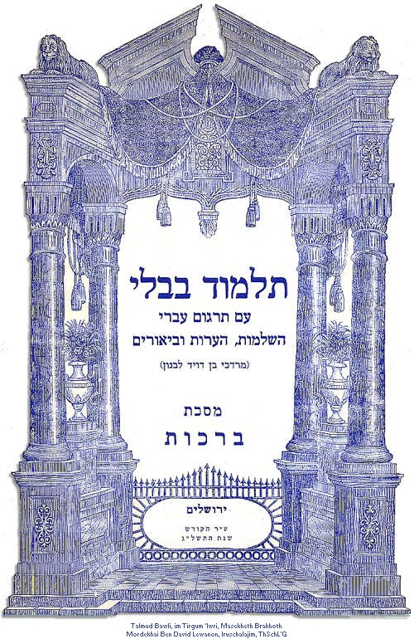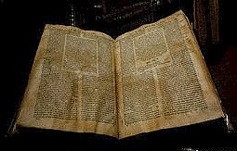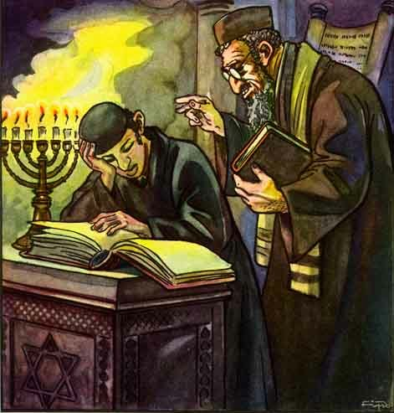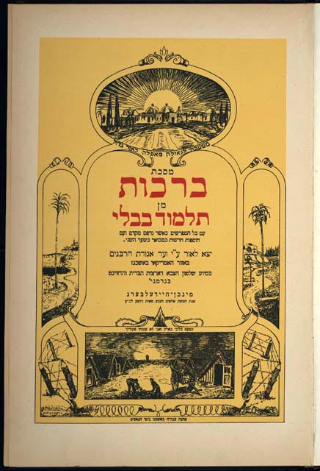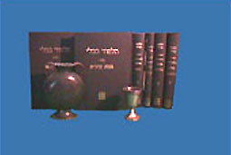
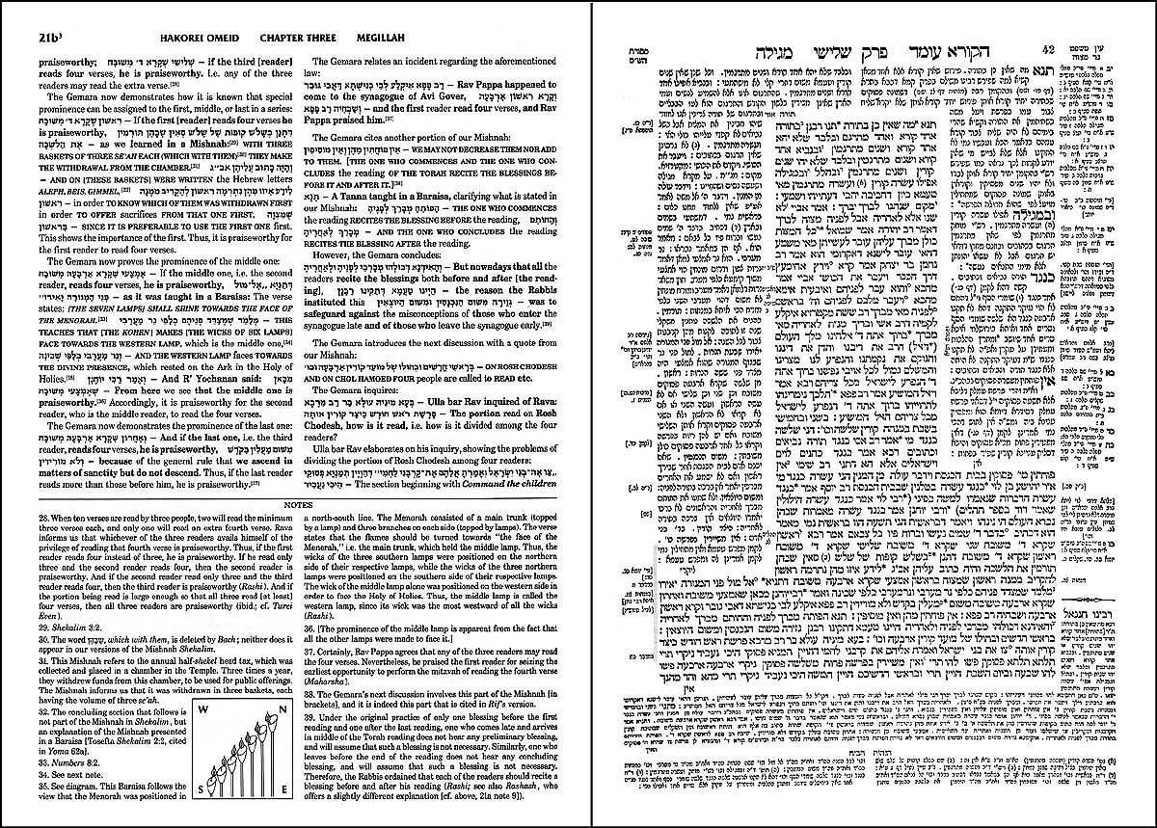
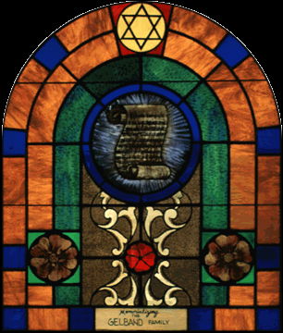
--------------------------------------------------------------------------------------------------------------------------------------------------------------------------------------------------------
The Talmud (Hebrew: תלמוד) is a record of rabbinic discussions pertaining to Jewish law, ethics, customs and history. The Talmud has two components: the Mishnah, which is the first written compendium of Judaism's Oral Law; and the Gemara, a discussion of the Mishnah and related Tannaitic writings that often ventures onto other subjects and expounds broadly on the Tanakh. The terms Talmud and Gemara are often used interchangeably. The Gemara is the basis for all codes of rabbinic law and is much quoted in other rabbinic literature. The whole Talmud is traditionally also referred to as Shas (a Hebrew abbreviation of shishah sedarim, the "six orders" of the Mishnah).

Contents
- 1 Origins of the Talmud
- 2 Mishnah
  - 2.1 Structure and content
- 3 Beraita
- 4 Gemara
  - 4.1 Methodology
  - 4.2 Halakha and Aggadah
- 5 Talmud
  - 5.1 Talmud Yerushalmi (Jerusalem Talmud)
  - 5.2 Talmud Bavli (Babylonian Talmud)
  - 5.3 Comparison of style and subject matter
- 6 Printing of the Talmud
- 7 Talmud commentary and study
  - 7.1 The Gaonim
  - 7.2 Halachic and Aggadic extractions
  - 7.3 Understanding the Talmud
  - 7.4 Pilpul
  - 7.5 Brisker method
- 8 Critical method
  - 8.1 Talmud scholarship today
- 9 Role of the Talmud in Judaism
  - 9.1 Sadducees
  - 9.2 Karaism
  - 9.3 Reform Judaism
  - 9.4 The Talmud in modern-day Judaism
- 10 External attacks on the Talmud
  - 10.1 Charges of racism
- 11 The Daf Yomi ("Daily Page")
- 12 Translations
  - 12.1 Translations of Talmud Bavli
  - 12.2 Translations of Talmud Yerushalmi
- 13 See also
- 14 References
  - 14.1 General
  - 14.2 Notes
- 15 On Mishnah and Talmud
  - 15.1 Historical study
- 16 External links
  - 16.1 General
  - 16.2 Full text resources
  - 16.3 Talmudic layout
  - 16.4 Pertaining to the "Daf Yomi" program
  - 16.5 Refutation of anti-Semitic allegations concerning the Talmud
  - 16.6 Audio

Origins of the Talmud

Mishnah
The Mishnah (משנה) is a compilation of legal opinions and debates. The name means “redaction,” from the verb shanah שנה, to repeat or review. This name may hint at the original oral memorization method of studying rabbinic discourse.
Statements in the Mishnah are typically terse, recording brief opinions of the rabbis debating a subject; or recording only an unattributed ruling, apparently representing a consensus view. The rabbis of the Mishnah are known as Tannaim (sing. Tanna תנא).
Since it sequences its laws by subject matter instead of by biblical context, the Mishna discusses individual subjects more thoroughly than the Midrash, and it includes a much broader selection of halakhic subjects than the Midrash. The Mishna's topical organization thus became the framework of the Talmud as a whole.

Structure and content
The Mishna consists of six orders (sedarim, singular seder סדר). Each of the six orders contains between 7 and 12 tractates, called masechtot (singular masechet מסכת; lit. "web"). Each masechet is divided into chapters (peraqim) composed of smaller units called mishnayot (singular mishnah). Not every tractate in the Mishnah has a corresponding Gemara. Also, the order of the tractates in the Talmud differs in some cases from that in the Mishnah; see the discussion on each Seder.
- First Order: Zeraim ("Seeds"). 11 tractates. It deals with prayer and blessings, tithes, and agricultural laws.
- Second Order: Moed ("Festival Days"). 12 tractates. This pertains to the laws of the Sabbath and the Festivals.
- Third Order: Nashim ("Women"). 7 tractates. Concerns marriage and divorce, some forms of oaths and the laws of the nazirite.
- Fourth Order: Nezikin ("Damages"). 10 tractates. Deals with civil and criminal law, the functioning of the courts and oaths.
- Fifth Order: Kodashim ("Holy things"). 11 tractates. This involves sacrificial rites, the Temple, and the dietary laws.
- Sixth Order: Tohorot ("Purity"). 12 tractates. This pertains to the laws of ritual purity.

Beraita
In addition to the Mishnah, other tannaitic works were recorded at about the same time or shortly thereafter. The Gemara frequently refers to these tannaitic statements in order to compare them to those contained in the Mishna and to support or refute the propositions of Amoraim. All such non-Mishnaic tannaitic sources are termed beraitot (lit. outside material, "Works external to the Mishna"; sing. beraita ברייתא).
Beraita includes the Tosefta, a tannaitic compendium of halakha parallel to the Mishna; and the Halakhic Midrash, specifically Mekhilta, Sifra and Sifre.

[] Gemara
See Gemara for further discussion.
In the three centuries following the redaction of the Mishna, rabbis throughout Palestine and Babylonia analyzed, debated and discussed that work. These discussions form the Gemara (גמרא). The Gemara mainly focuses on elucidating and elaborating the opinions of the Tannaim. The rabbis of the Gemara are known as Amoraim (sing. Amora אמורא). Gemara means “completion,” from gamar גמר : Hebrew to complete; Aramaic to study.

[] Methodology
Much of the Gemara consists of legal analysis. The starting point for the analysis is usually a legal statement found in a Mishna. The statement is then analyzed and compared with other statements in a dialectical exchange between two (frequently anonymous and sometimes metaphorical) disputants, termed the makshan (questioner) and tartzan (answerer).
These exchanges form the "building-blocks" of the gemara; the name for a passage of gemara is a sugya (סוגיא; plural sugyot). A sugya will typically comprise a detailed proof-based elaboration of a mishnaic statement.
In a given sugya, scriptural, Tannaitic and Amoraic statements are brought to support the various opinions. In so doing, the gemara will bring semantic disagreements between Tannaim and Amoraim (often ascribing a view to an earlier authority as to how he may have answered a question), and compare the Mishnaic views with passages from the beraita. Rarely are debates formally closed; in many instances, the final word determines the practical law, although there are many exceptions to this principle. See Gemara for further discussion.

[] Halakha and Aggadah
The Talmud contains a vast amount of material and touches on a great many subjects. Traditionally talmudic statements can be classified into two broad categories, Halakhic and Agaddic statements. Halakhic statements are those which directly relate to questions of Jewish law and practice (Halakha). Aggadic statements are those which are not legally related, but rather are exegetical, homiletical, ethical or historical in nature. See Aggada for further discussion.

[] Talmud
The process of "Gemara" proceeded in the two major centres of Jewish Scholarship, Israel and Babylon. Correspondingly, two bodies of analysis developed, and two works of Talmud were created. The older compilation is called the Palestinian Talmud or the Talmud Yerushalmi. It was compliled sometime during the fourth century in Palestine. The Babylonian Talmud was compiled about the year 500 C.E., although it continued to be ed later. The word "Talmud", when used without qualification, usually refers to the Babylonian Talmud.

[] Talmud Yerushalmi (Jerusalem Talmud)
Main article: Jerusalem Talmud
The Gemara here is a synopsis of almost 200 years of analysis of the Mishna in the Academies in Israel (mainly Tiberias and Caesaria.) Due to the location of the Academies, the agricultural laws of the Land of Israel are discussed in great detail. Traditionally, it was redacted in the year 350 C.E. by Rav Muna and Rav Yossi in Israel. It is referred to traditionally as the Talmud Yerushalmi (The Jerusalem Talmud) however, the name is a misnomer, as it was not written in Jerusalem. As such it is also known more accurately as the The Talmud of the land of Israel.
It is written in both Hebrew and a western Aramaic dialect that differs from its Babylonian counterpart.

[] Talmud Bavli (Babylonian Talmud)
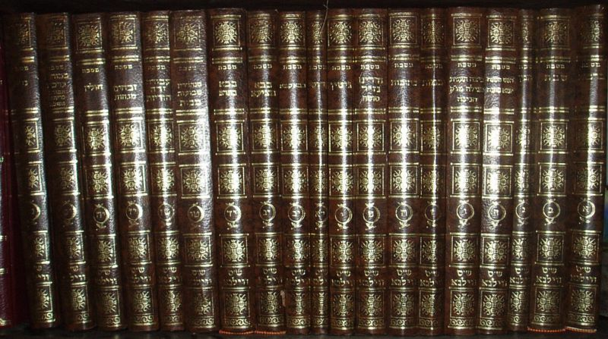
A full copy of the Babylonian Talmud.

Talmud Bavli (the "Babylonian Talmud") comprises the Mishnah and the Babylonian Gemara. This Gemara is a synopsis of more than 300 years of analysis of the Mishna in the Babylonian Academies. Tradition ascribes the initial ing of the Babylonian Talmud to two Babylonian sages, Rav Ashi and Ravina.
The question as to when the Gemara was finally put into its present form is not settled among modern scholars. Some of the text did not reach its final form until around 700. Traditionally, the rabbis who ed the talmud after the end of the Amoraic period are called the Saboraim or Rabanan Saborai. Modern scholars, also use the term Stammaim (Heb. = closed, vague or an unattributed source) for the authors of unattributed statements in the Gemara. (See eras within Jewish law.)

[] Comparison of style and subject matter
There are significant differences between the two Talmud compilations. The language of the Jerusalem Talmud is a western Aramaic dialect which differs from that of the Babylonian. The Talmud Yerushalmi is often fragmentary and difficult to read, even for experienced Talmudists. The redaction of the Talmud Bavli, on the other hand, is more careful and precise.
In the Bavli, however, gemara exists only for 37 out of the 63 tractates of the Mishna: most laws from the Orders Zeraim (agricultural laws limited to the land of Israel) and Toharot (ritual purity laws related to the Temple and sacrificial system) had little practical relevance in Babylonia and were therefore not included. The Yerushalmi, though, covers a number of these tractates.
The influence of the Babylonian Talmud has been far greater than that of the Yerushalmi. In the main, this is because the influence and prestige of the Jewish community of Israel steadily declined in contrast with the Babylonian community in the years after the redaction of the Talmud and continuing until the Gaonic era. Furthermore, the ing of the Babylonian talmud was superior to that of the Palestinian version, making it more accessible and readily usable.

[] Printing of the Talmud
The first complete ion of the Babylonian Talmud was printed in Italy by Daniel Bomberg during the 16th century. In addition to the Mishna and Gemara, Bomberg's ion contained the commentaries of Rashi and Tosafot. Almost all printings since Bomberg have followed the same pagination. In 1835, a new ion of the Talmud was printed by the Menachem Romm of Vilna. Known as the Vilna Shas, this ion (and later ones printed by his widow and sons) have become an unofficial standard for Talmud ions.
A page number in the Talmud refers to a double-sided page, known as a daf; each daf has two amudim labelled א and ב, sides A and B. The referencing by daf is relatively recent and dates from the early Talmud printings of the 17th century. Earlier rabbinic literature generally only refers to the tractate or chapters within a tractate. Nowadays, reference is made in format [Tractate daf a/b] (e.g. Berachot 23b). In the Vilna ion of the Talmud there are 5,894 folio pages.

[] Talmud commentary and study
From the time of its completion, the Talmud became integral to Jewish scholarship. This section outlines some of the major areas of Talmudic study.

[] The Gaonim
The earliest talmud commentaries were written by the Gaonim (approximately 800-1000, C.E.) in Babylon. Although some direct commentaries on particular treatises are extant, our main knowledge of Gaonic era talmud scholarship comes from statements embedded in Geonic responsa which shed light on talmudic passages. After the death of Hai Gaon, however, the center of Talmud scholarship shifts to Europe and North Africa.

[] Halachic and Aggadic extractions
One area of talmudic scholarship developed out of the need to ascertain the Halacha. Early commentators such as Rabbi Isaac Alfasi (North Africa, 1013-1103) attempted to extract and determine the binding legal opinions from the vast corpus of the talmud. Alfasi's work was highly influential and later served as a basis for the creation of halachic codes. Another influential medieval Halakhic commentary was that of Rabbi Asher b. Jehiel (d. 1327).
A fifteenth century Spanish Rabbi, Jacob ibn Habib (d. 1516), composed the En Yaaqob. En Yaaqob (or Ein Yaaqov) extracts nearly all the aggadic material from the talmud. It was intended to familiarize the public with the ethical parts of the Talmud and to dispute many of the accusations surrounding the contents of the Talmud.

[] Understanding the Talmud
The talmud is often cryptic and difficult to understand. Its language contains many Greek and Persian words which over time became obscure. A major area of Talmudic scholarship developed in order to explain these passages and words. Some early commentators such as Rabbenu Gershom of Mainz (10th c.) and Rabbenu Hannanel (early 11th c.) produced running commentaries to various tractates. These commentaries could be read with the text of the Talmud and would help explain the meaning of the text. Using a different style, Rabbi Nathan b. Jechiel created a lexicon called the Arukh in the 11th century in order to translate difficult words.
By far the most well known commentary on the Babylonian Talmud is that of Rashi (Rabbi Solomon ben Isaac, 1040-1105). The commentary is comprehensive, covering almost the entire Talmud. Written as a running commentary, it provides a full explanation of the words, and explains the logical structure of each Talmudic passage. It is considered indispensable to students of the Talmud.
Medieval Ashkenazic Jewry produced another major commentary known as Tosafot ("additions" or "supplements"). The tosafot are collected commentaries by various medieval Ashkenazic Rabbis on the Talmud. One of the main goals of the Tosafot is to explain and interpret contradictory statements in the talmud. Unlike Rashi, the Tosafot is not a running commentary, but rather comments on selected matters. Often the explanations of Tosafot differ from those of Rashi.
Over time, many other commentaries have been produced. Some of the more widely known are those of "Maharshal" (Solomon Luria), "Maharam" (Meir Lublin) and "Maharsha" (Samuel Edels)

[] Pilpul
During the 15th and 16th centuries a new intensive form of casuistic talmud study arose. Complicated logical methods were used to explain minor points of contradiction within the talmud. The term Pilpul, which means pepper in hebrew, and which was applied to this type of study, hearkens back to the talmudic era and refers to the intellectual sharpness of this type of study.
Pilpul study posited that the Talmud should contain no redudancy or contradiction whatsoever. New categories and distinctions (Hillukim) were created in order to resolve Talmudic contradictions by logical argument. This new pilpulistic style was first recorded by Isaac Canpanton (d. Spain, 1463) in his Darkhei haTalmud.
Pilpul study reached its height in the 16th and 17th centuries when expertise in pilpulistic analyis was considered an art form and became a goal in and of itself within the yeshiva world. The popular new method of talmud study was not without critcs, already in the 15th century, the ethical tract Orhot Zaddikim criticizes pilpul and its emphasis on intellectual acuity. Many 16th and 17th century rabbis also were critics of Pilpul, Among them may be noted Judah Loew b. Bezalel (the Maharal), Isaiah Horowitz, and Jair Hayyim Bacharach. Eventually, by the 18th century, pilpul study waned, and other styles of learning such as that of the school of Elijah b. Solomon, the Vilna Gaon, became popular.^{[1]}

[] Brisker method
In the late nineteenth century another trend in Talmud study arose. Rabbi Hayyim Soloveitchik (1853-1918) of Brisk (Brest-Litovsk) developed and refined this style of study. Brisker method involves the analysis of rabbinic arguments within the talmud or among the rishonim and explaining the differing opinions by placing them within a categorical structure. The brisker method is highly analytical and is often criticized as being a modern day version of Pilpul. Nevertheless, the influence of the Brisker method is great. Most modern day Yeshivot study the Talmud using the Brisker method in some form. And it is through this method that Maimonides' Mishne Torah was transformed from being solely a halachic work to one of talmudic interpretation as well.

[] Critical method
The Text of the Talmud has been subject to critical scrutiny throughout its history. As Yonah Fraenkel shows in his book Darko Shel Rashi be-Ferusho la-Talmud ha-Bavli, one of Rashi's major accomplishments was textual emendation. Rabbenu Tam, Rashi's grandson and one of the central figures in the Tosafist academies, polemicizes against textual emendation in his less studied work Sefer ha-Yashar. However, the Tosafists, too, emended the Talmudic text (See e.g. Baba Kamma 83b s.v. af haka'ah ha'amurah or Gittin 32a s.v. mevutelet) as did many other medieval commentators (see e.g. R. Shlomo ben Adrat, Hidushei ha-Rashb"a al ha-Sha"s to Baba Kamma 83b, or Rabbenu Nissim's commentary to Alfasi on Gittin 32a).
Leaders of the Reform movement, such as Abraham Geiger and Samuel Holdheim, subjected the Talmud to severe scrutiny as part of an effort to break with traditional rabbinic Judaism. In reaction, Orthodox leaders such as Moses Sofer became exquisitely sensitive to any change and would reject any critical analysis of Talmud. Talmud study was thus caught in the debate between the Reformers and Orthodoxy.
Somewhere in between these two diametrically opposed views arose a new school, which developed the Historical-Critical method of Talmud study. Scholars and rabbis of this outlook believed that Jewish Law was the product of a long development and that tampering with this process should be avoided. On the other hand, they believed that traditional Jewish sources, such as the Talmud, should be subject to academic inquiry and critical analysis. Exponents of this view were Zecharias Frankel, Leopold Zunz and Solomon Judah Leib Rappaport.
Because the modern method of historical study had its origins in the era of religious reform, the method was immediately controversial within the Orthodox world. Still, many of the nineteenth century's strongest critics of Reform, including strictly orthodox Rabbis, utilized this new scientific method. Notable among them were Nachman Krochmal, Zvi Hirsch Chajes, and Meir Lebush Malbim. Other Orthodox Rabbis, such as Samson Raphael Hirsch, rejected critical study of the Talmud.

[] Talmud scholarship today
Some trends within contemporary talmud scholarship are listed below.
- Orthodox Judaism maintains that the oral law was revealed together with the written law. As such, most of Orthodox Judaism has resisted any effort to apply the historical method to the Talmud. It also resists imputing motives to the authors of the Talmud.
- Some scholars hold that there has been extensive orial reshaping of the stories and statements within the Talmud. Lacking outside confirming texts, they hold that we cannot confirm the origin or date of most statements and laws, and that we can say little for certain about their authorship. In this view, the questions above are impossible to answer. See, for example, the works of Louis Jacobs and Shaye J.D. Cohen.
- Some scholars hold that the Talmud has been extensively shaped by later orial redaction, but that it contains sources which we can identify and describe with some level of reliability. In this view, sources can be identified by tracing the history and analyzing the geographical regions of origin. See, for example, the works of Lee I. Levine and David C. Kraemer.
- Some scholars hold that many or most the statements and events described in the Talmud usually occurred more or less as described, and that they can be used as serious sources of historical study. In this view, historians do their best to tease out later orial additions (itself a very difficult task) and skeptically view accounts of miracles, leaving behind a reliable historical text. See, for example, the works of Saul Lieberman, David Weiss Halivni, and Avraham Goldberg.

[] Role of the Talmud in Judaism
The Talmud is the written record of an oral tradition. It became the basis for many rabbinic legal codes and customs. Not all Jews, in the past and present, have accepted the Talmud as having religious authority. This section briefly outlines such movements.

[] Sadducees
The Sadducees were a Jewish sect which flourished during the second temple period. One of their main arguments with the Pharisees (later known as Rabbinic Judaism) was their rejection of an Oral Law.

[] Karaism
Another movement which rejected the oral law was Karaism. It arose within two centuries of the completion of the Talmud. Karaism developed as a reaction against the Talmudic Judaism of Babylonia. The central concept of Karaism is the rejection of the Oral Law, as embodied in the Talmud, in favor of a strict adherence to the Written Law only. This opposes the fundamental Rabbinic concept that the Oral Law was given to Moses on Mount Sinai together with the Written Law. Karaism has virtually disappeared, declining from a high of nearly 10% of the Jewish population to a current estimated .002%.

[] Reform Judaism
With the rise of Reform Judaism during the nineteenth century the authority of the Talmud was again questioned. The talmud was seen (together with the written law as well) as being a product of late antiquity and of having relevance merely as a historical document.

[] The Talmud in modern-day Judaism
See also How Halakha is viewed today; The Halakhic process.
Orthodox Judaism continues to stress the importance of Talmud study and it is a central component of Yeshiva curriculum. The regular study of Talmud among laymen has been popularized by the Daf Yomi a daily course of talmud study initiated by Rabbi Meir Shapiro in 1923. Traditional Rabbinic education continues to lay heavy emphasis on the knowledge of Talmud. This is so even though Halakha is generally studied from the medieval codes and not directly from the Talmud. See also: Orthodox beliefs about Jewish law and tradition.
Conservative Judaism similarly emphasises the study of Talmud within its religious and rabbinic education. Generally, however, the Talmud is studied as a historical source-text for Halakha. The Conservative approach to legal decision-making emphasizes placing classic texts and prior decisions in historical and cultural context, and examining the historical development of halakha. This approach has resulted in greater practical flexibility than that of the Orthodox. See also: The Conservative Jewish view of the Halakha.
Reform Judaism does not emphasize the study of Talmud to the same degree in their Hebrew schools, but they do teach it in their rabbinical seminaries; the world view of liberal Judaism rejects the idea of binding Jewish law, and uses the Talmud as a source of inspiration and moral instruction. See also: The Reform Jewish view of the Halakha and view of the Talmud.

[] External attacks on the Talmud
The history of the Talmud reflects in part the history of Judaism persisting in a world of hostility and persecution. Almost at the very time that the Babylonian savoraim put the finishing touches to the redaction of the Talmud, the emperor Justinian issued his edict against the abolition of the Greek translation of the Bible in the service of the Synagogue. This edict, dictated by Christian zeal and anti-Jewish feeling, was the prelude to attacks on the Talmud, conceived in the same spirit, and beginning in the thirteenth century in France, where Talmudic study was then flourishing.
The charge against the Talmud brought by the convert Nicholas Donin led to the first public disputation between Jews and Christians and to the first burning of copies of the work (Paris, Place de Grève,1244). The Talmud was likewise the subject of a disputation at Barcelona in 1263 between Nahmanides (Rabbi Moses ben Nahman) and Pablo Christiani. This same Pablo Christiani made an attack on the Talmud which resulted in a papal bull against it and in the first censorship, which was undertaken at Barcelona by a commission of Dominicans, who ordered the cancellation of passages reprehensible from a Christian perspective (1264).
At the disputation of Tortosa in 1413, Geronimo de Santa Fé brought forward a number of accusations, including the fateful assertion that the condemnations of pagans and apostates found in the Talmud referred in reality to Christians. Two years later, Pope Martin V, who had convened this disputation, issued a bull (which was destined, however, to remain inoperative) forbidding the Jews to read the Talmud, and ordering the destruction of all copies of it. Far more important were the charges made in the early part of the sixteenth century by the convert Johannes Pfefferkorn, the agent of the Dominicans. The result of these accusations was a struggle in which the emperor and the pope acted as judges, the advocate of the Jews being Johann Reuchlin, who was opposed by the obscurantists and the humanists; and this controversy, which was carried on for the most part by means of pamphlets, became the precursor of the Reformation^{[citation needed]}.
An unexpected result of this affair was the complete printed ion of the Babylonian Talmud issued in 1520 by Daniel Bomberg at Venice, under the protection of a papal privilege. Three years later, in 1523, Bomberg published the first ion of the Palestinian Talmud. After thirty years the Vatican, which had first permitted the Talmud to appear in print, undertook a campaign of destruction against it. On New-Year's Day (September 9, 1553) the copies of the Talmud which had been confiscated in compliance with a decree of the Inquisition were burned at Rome; and similar burnings took place in other Italian cities, as at Cremona in 1559. The Censorship of the Talmud and other Hebrew works was introduced by a papal bull issued in 1554; five years later the Talmud was included in the first Index Expurgatorius; and Pope Pius IV commanded, in 1565, that the Talmud be deprived of its very name.
The first ion of the expurgated Talmud, on which most subsequent ions were based, appeared at Basel (1578-1581) with the omission of the entire treatise of 'Abodah Zarah and of passages considered inimical to Christianity, together with modifications of certain phrases. A fresh attack on the Talmud was decreed by Pope Gregory XIII (1575-85), and in 1593 Clement VIII renewed the old interdiction against reading or owning it. The increasing study of the Talmud in Poland led to the issue of a complete ion (Kraków, 1602-5), with a restoration of the original text; an ion containing, so far as known, only two treatises had previously been published at Lublin (1559-76). In 1707 some copies of the Talmud were confiscated in the province of Brandenburg, but were restored to their owners by command of Frederick, the first king of Prussia. The last attack on the Talmud took place in Poland in 1757, when Bishop Dembowski, at the instigation of the Frankists, convened a public disputation at Kamenetz-Podolsk, and ordered all copies of the work found in his bishopric to be confiscated and burned by the hangman.
The external history of the Talmud includes also the literary attacks made upon it by Christian theologians after the Reformation, since these onslaughts on Judaism were directed primarily against that work, even though it was made a subject of study by the Christian theologians of the seventeenth and eighteenth centuries. In 1830, during a debate in the French Chamber of Peers regarding state recognition of the Jewish faith, Admiral Verhuell declared himself unable to forgive the Jews whom he had met during his travels throughout the world either for their refusal to recognize Jesus as the Messiah or for their possession of the Talmud. In the same year the Abbé Chiarini published at Paris a voluminous work entitled "Théorie du Judaïsme," in which he announced a translation of the Talmud, advocating for the first time a version which should make the work generally accessible, and thus serve for attacks on Judaism. In a like spirit modern anti-Semitic agitators have urged that a translation be made; and this demand has even been brought before legislative bodies, as in Vienna. The Talmud and the "Talmud Jew" thus became objects of anti-Semitic attacks, although, on the other hand, they were defended by many Christian students of the Talmud.
Despite the numerous mentions of Edom which may refer to Christendom, the Talmud makes little mention of Jesus directly or the early Christians. There are a number of quotes about individuals named Yeshu that once existed in ions of the Talmud; these quotes were long ago removed from the main text due to accusations that they referred to Jesus, and are no longer used in Talmud study. However, these removed quotes were preserved through rare printings of lists of errata, known as Hashmatot Hashass ("Omissions of the Talmud"). Some modern ions of the Talmud contain some or all of this material, either at the back of the book, in the margin, or in alternate print. These passages do not necessarily refer to a single individual and many of the stories are far removed from anything written in the New Testament. Many scholars are convinced that these people cannot be identified as the Christian Jesus.

[] Charges of racism
Some groups and individuals consider that passages in the Talmud show that Judaism is inherently racist. Critics of these charges argue that the passages in question do not indicate inherent racism on the part of the Talmud (and Judaism), but rather mistranslation, falsification, and selective choice of quotes out of context, on the part of those making the charges. The Anti-Defamation League's report on this topic states:
By selectively citing various passages from the Talmud and Midrash, polemicists have sought to demonstrate that Judaism espouses hatred for non-Jews (and specifically for Christians), and promotes obscenity, sexual perversion, and other immoral behavior. To make these passages serve their purposes, these polemicists frequently mistranslate them or cite them out of context (wholesale fabrication of passages is not unknown)...
In distorting the normative meanings of rabbinic texts, anti-Talmud writers frequently remove passages from their textual and historical contexts. Even when they present their citations accurately, they judge the passages based on contemporary moral standards, ignoring the fact that the majority of these passages were composed close to two thousand years ago by people living in cultures radically different from our own. They are thus able to ignore Judaism's long history of social progress and paint it instead as a primitive and parochial religion.
Those who attack the Talmud frequently cite ancient rabbinic sources without noting subsequent developments in Jewish thought, and without making a good-faith effort to consult with contemporary Jewish authorities who can explain the role of these sources in normative Jewish thought and practice.
Rabbi Gil Student, a prolific author on the internet, refutes anti-Talmud accusations and writes:
Anti-Talmud accusations have a long history dating back to the 13th century when the associates of the Inquisition attempted to defame Jews and their religion [see Yitzchak Baer, A History of Jews in Christian Spain, vol. I pp. 150-185]. The early material compiled by hateful preachers like Raymond Martini and Nicholas Donin remain the basis of all subsequent accusations against the Talmud. Some are true, most are false and based on quotations taken out of context, and some are total fabrications [see Baer, ch. 4 f. 54, 82 that it has been proven that Raymond Martini forged quotations]. On the Internet today we can find many of these old accusations being rehashed...

[] The Daf Yomi ("Daily Page")
Thousands of Jews worldwide participate in Daf Yomi - literally the daily page (of Talmud) - as part of a monumental program. Daf Yomi was initiated by Rabbi Meir Shapiro in 1923 at the First World Congress of Agudath Israel in Vienna. With 2711 folios in the Talmud, one cycle takes about 7.5 years. Daf Yomi started its 12th cycle of study on March 2, 2005.

[] Translations

[] Translations of Talmud Bavli
There are four contemporary translations of the Talmud into English:
- The Schottenstein ion of the Talmud, Mesorah Publications. In this translation, each English page faces the Aramaic/Hebrew page. The English pages are elucidated and heavily annotated; each Aramaic/Hebrew page of Talmud typically requires three English pages of translation. See also: Mesorah Talmud site.
- The Soncino Hebrew-English Talmud Isidore Epstein, Soncino Press. In this translation, each English page faces the Aramaic/Hebrew page. Notes on each page provide additional background material. See also: Soncino Talmud site.
- The Talmud of Babylonia. An American Translation, Jacob Neusner, Tzvee Zahavy, others. Atlanta: 1984-1995: Scholars Press for Brown Judaic Studies. Complete.
- The Talmud: The Steinsaltz ion Adin Steinsaltz, Random House (incomplete). This work is in fact a translation of Rabbi Steinsaltz' Hebrew language translation of and commentary on the entire Talmud. See also: Steinsaltz Talmud site.

[] Translations of Talmud Yerushalmi
Talmud of the Land of Israel: A Preliminary Translation and Explanation Jacob Neusner, Tzvee Zahavy, others. University of Chicago Press. This translation uses a form-analytical presentation which makes the logical units of discourse easier to identify and follow.
This work has received many positive reviews. However, some consider Neusner's translation methodology idiosyncratic. One volume was negatively reviewed by Saul Lieberman of the Jewish Theological Seminary.
Schottenstein ion of the Yerushalmi Talmud Mesorah/Artscroll. This translation is the counterpart to Mesorah/Artscroll's Schottenstein ion of the Talmud (i.e. Babylonian Talmud). Mesorah/Artscroll's website for the Schottenstein ion of the Yerushalmi Talmud

[] See also
- Jerusalem Talmud
- Mishnah
- Minor Tractates
- Tosefta
- Beraita
- Gemara
- Ein Yaakov
- Rabbinic literature
- The Kallah Month
- Yeshiva

[] References

[] General
- Maimonides Introduction to the Mishneh Torah (English translation)
- Maimonides Introduction to the Commentary on the Mishnah (Hebrew Fulltext), transl. Zvi Lampel (Judaica Press, 1998). ISBN 1-880582-28-7
- Adin Steinsaltz The Talmud: A Reference Guide (Random House, 1996). ISBN 0-679-77367-3
- Adin Steinsaltz The Essential Talmud (Basic Books, 1984). ISBN 0-465-02063-1; see also here
- Zvi Hirsch Chajes "Mevo Hatalmud", transl. Jacob Shachter: The Students' Guide Through The Talmud (Yashar Books, 2005). ISBN 1-933143-05-3
- Shmuel Hanaggid Introduction to the Talmud, in Aryeh Carmell Aiding Talmud Study (Philipp Feldheim, 1986). ISBN 0-87306-428-3
- Nathan T. Lopes Cardozo The Infinite Chain : Torah, Masorah, and Man (Philipp Feldheim, 1989). ISBN 0-944070-15-9
- D. Landesman A Practical Guide to Torah Learning (Jason Aronson, 1995). ISBN 1-56821-320-4
- Aaron Parry The Complete Idiot's Guide to The Talmud (Alpha Books, 2004). ISBN 1-59257-202-2
- R. Travers Herford Christianity in Talmud and Midrash (Ktav Pub Inc, 1975). ISBN 0-87068-483-3

[] Notes
- ^ On Pilpul, seePilpul, Mordechai Breuer, Encylopedia Judaica and H.H. Ben Sasson, A History of the Jewish People, p. 627, 717.

[] On Mishnah and Talmud
- Y. N. Epstein, Mevo-ot le-Sifrut haTalmudim
- Hanoch Albeck, Mavo la-talmudim
- Louis Jacobs, "How Much of the Babylonian Talmud is Pseudepigraphic?" Journal of Jewish Studies 28, No. 1 (1977), pp. 46-59
- Saul Lieberman Hellenism in Jewish Palestine (New York: Jewish Theological Seminary, 1950)
- Jacob Neusner Sources and Traditions: Types of Compositions in the Talmud of Babylonia (Atlanta: Scholars Press, 1992).
- David Weiss Halivni Mekorot u-Mesorot: Eruvin-Pesahim (Jerusalem: Jewish Theological Seminary, 1982)
- Yaakov Elman, "Order, Sequence, and Selection: The Mishnah’s Anthological Choices,” in David Stern, ed. The Anthology in Jewish Literature (Oxford: Oxford University Press, 2004) 53-80

[] Historical study
- Shalom Carmy (Ed.) Modern Scholarship in the Study of Torah: Contributions and Limitations Jason Aronson, Inc.
- Richard Kalmin Sages, Stories, Authors and ors in Rabbinic Babylonia Brown Judaic Studies
- David C. Kraemer, On the Reliability of Attributions in the Babylonian Talmud, Hebrew Union College Annual 60 (1989), pp. 175-90
- Lee Levine, Ma'amad ha-Hakhamim be-Erez Yisrael (Jerusalem: Yad Yizhak Ben-Zvi, 1985), (=The Rabbinic Class of Roman Palestine in Late Antiquity)
- Saul Lieberman Hellenism in Jewish Palestine (New York: Jewish Theological Seminary, 1950)
- John W McGinley " 'The Written' as the Vocation of Conceiving Jewishly". ISBN 0-595-40488-X
- David Bigman, Finding A Home for Critical Talmud Study,

[] External links

General
- Talmud, jewishencyclopedia.com
- Talmud Commentaries, jewishencyclopedia.com
- Jewish History: Talmud, aish.com
- Talmud/Mishna/Gemara, jewishvirtuallibrary.org
- Jewish Law Research Guide, University of Miami Law Library
- A survey of rabbinic literature, Ohr Somayach

[] Full text resources
- Mishna
- Tosefta
- Talmud Yerushalmi
- Talmud Bavli
- Rodkinson English translation (1903, parts only).
- Images of each page of the Babylonian Talmud.

[] Talmudic layout
- "A Page from the Babylonian Talmud" image map from Prof. Eliezer Segal
- Talmud and its Shape: colour coded daf, upenn.edu
- A page of Talmud from the World Union of Jewish Students (WUJS)
- A Tour of the English-language Steinsaltz ion of the Talmud page
- point by point summary and discussion by daf

[] Pertaining to the "Daf Yomi" program
- Sephardic Rabbi Eli Mansour's Daily Gemara Page - Daf Yomi
- A general resource for Daf Yomi
- Calendar for this Daf Yomi cycle
- Mishnah corresponding to the daily Daf
- Daf-A-Week: A project to study a daf per week
- Rabbi Adin Steinsaltz's Daily Insights on Daf Yomi

[] Refutation of anti-Semitic allegations concerning the Talmud
- The Talmud in Anti-Semitic Polemics, Anti-Defamation League.
- The Real Truth about the Talmud
- Talmud Exposed
- Mishpocha
- Falsifiers of the Talmud

[] Audio
- Shiurim on the Talmud, mp3shiur.com
==============================================================================================================================
END

