
Kabbalah in the Bibliotheca Philosophica Hermetica - Hebrew Kabbalah - printed works
http://www.xs4all.nl/~bph/kabbalah_bks.html

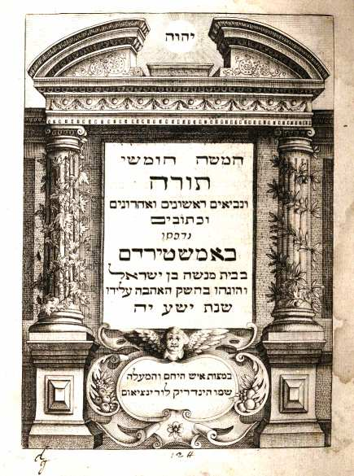 | Biblia Hebraica ... Ex accuratissima recensione doctissimi ac celeberrimi Hebræi Menasseh ben Israel. Amsterdam, Hendrick Laurensz, 1635  The ‘most learned and renowned Hebrew’, R. Menasseh ben Israel, provided this edition of the five Mosaic books, the sine qua non for (the works of) the Kabbalists.

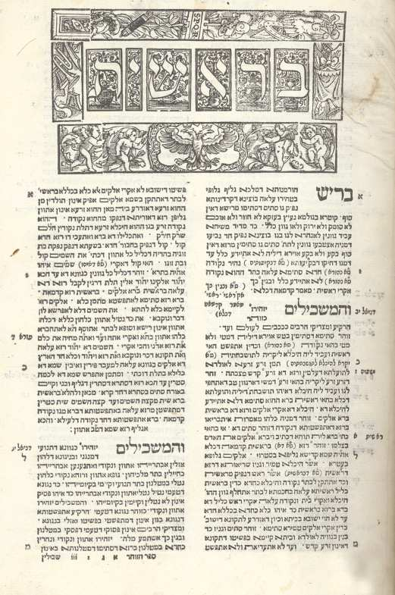 | Sefer ha-Zohar. [Eds. I. Gabriel and A. ben Meshullam]. Cremona, Vicenzo Conti, 1559–60  Second edition (editio princeps Mantua 1558) of this pseudepigraphical seminal work of the Spanish Kabbalah, centred around the second–century R. Simeon bar Jochai but produced by the Castilian kabbalist R. Moses de Leon (1240–1305) and his circle. It was already commented on within a decade of its first circulation and has remained the standard kabbalistic text. According to the colophon, the imprimatur was already given in 1558, the year of the first edition of the Zohar.  Some early marginal annotations in Hebrew and various ownership marks (one dated 1696) on the colophon page.

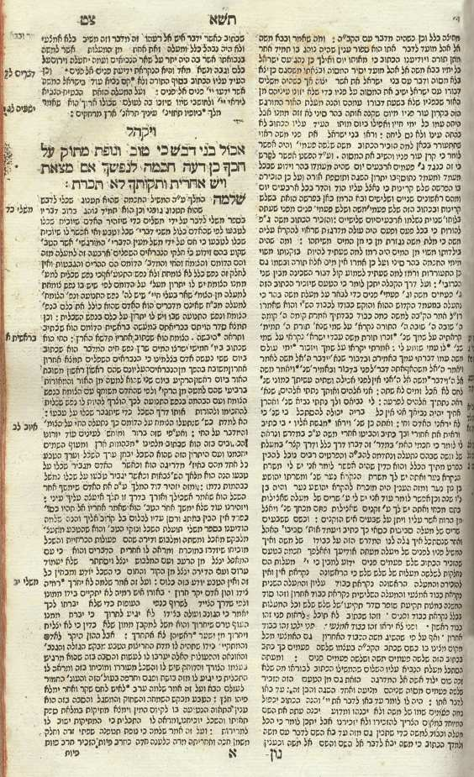 | Bachya ben Hlava ben Asher. Rabenu Bechaye al ha-Torah. Korzec, Abraham ben Isaac and Elijah ben Jacob Segal, 1799  A Kabbalistic commentary on the Torah by the 13th–century ‘divine kabbalist’ Bachya ben Asher of Saragossa, begun in 1291, and probably with knowledge of the Zohar, which was then being circulated. First printed in Venice in 1492, Bachya’s clarity of style made this commentary very popular and it went through many editions. Although Bachya generally did not name his kabbalistic sources explicitly, he demonstrably often consulted the works of his contemporary Gikatilla.

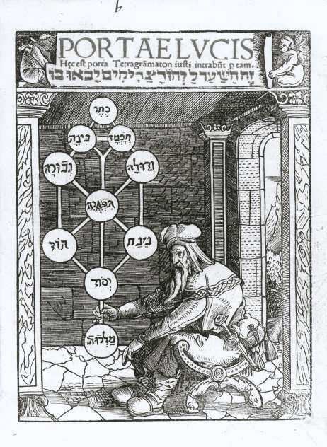 | Joseph ben Abraham Gikatilla. Portae lucis. Augsburg, Johann Miller, 1516  Latin translation of Gikatilla’s Sha’arei Orah by the Jewish convert Paulus Ricius.  Gikatilla (1248–c. 1325), a friend of Moses de Leon, the author of the Zohar, was initially influenced by the ecstatic Kabbalah of Abraham Abulafia, but later turned his attention to the theosophical Kabbalah as contained in the Zohar. Sha’arei Orah, written around 1290, is an important summary of the symbolism of the Sefirot and one of the major works of Spanish Kabbalah. The image of the Sefirot on the title-page is the earliest known representation in print.

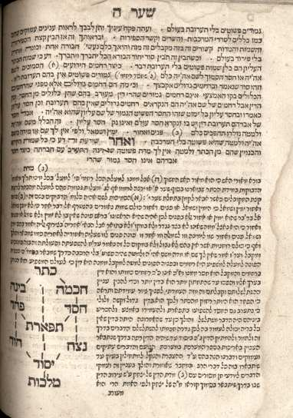 | Joseph ben Abraham Gikatilla – Matthatias ben Solomon Delacrut. [Commentary on] Sha’arei Orah. Offenbach, s.n., 1715  R. Delacrut’s commentary is printed in Rashi to distinguish it from Gikatilla’s work. First published posthumously in Cracow in 1600 by Delacrut’s son Joseph, this early 18th–century edition claims that until the addition of Delacrut’s commentary, Gikatilla’s Gates of Light, like a ‘hidden revelation’, could not be understood. The usefulness of Delacrut’s commentary, it is stated, is obvious for anyone who has eyes to see.

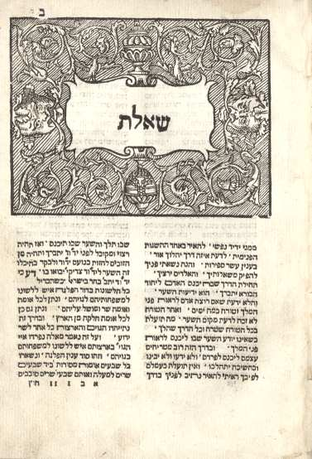 | Joseph ben Abraham Gikatilla. Sha’are Zedek. Riva di Trento, Jacob Macaria, 1561  One of Gikatilla’s disquisitions on the ten Sefirot under the title The Gates of Justice. Gikatilla was the first to equate the Ein Sof with the first Sefirah, keter.  The book was printed by the physician Jacob Macaria, who in 1558 established a renowned Hebrew press in Riva di Trento.  Some early manuscript notes in Hebrew on the (cropped) title-page.

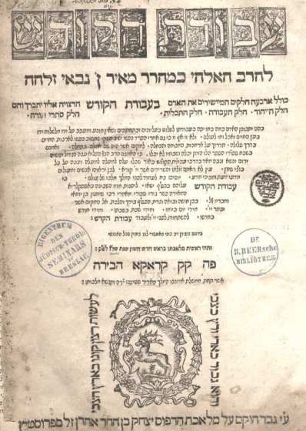 | Meir ben Ezekiel ben Gabbai. Avodat ha-Kodesh. Cracow, Isaac ben Aaron Prostitz, 1576–77  R. Meir ben Gabbai (1480–after 1540), a Kabbalist of the generation of the Spanish exiles, wrote the most comprehensive and organized summary of the Kabbalah prior to the Safed period. The book consists of four parts: 1. on the unity of God; 2. on the worship of God; 3. on the purpose of man’s existence; 4. an explanation of the esoteric parts of the Torah.  The first Hebrew press in Cracow was established in 1534; Isaac ben Aaron Prostitz attained great success with his press, which he set up in Cracow in 1569.  Contemporary binding (blind-tooled), early ownership marks and library stamps of the Jüdisch-Theologisches Seminar Breslau and the Dr. B. Beer’sche Bibliothek on the title-page.</

Guillaume Postel, Abrahami patriarchae liber Jezirah. Paris, for Guillaume Postel, 1552
The Hebraist Guillaume Postel (1510–1581) had already supplied a Latin version of the Sefer Yetzirah with his own mystical comments ten years before the first Hebrew edition of 1562. This was not the only Hebrew work Postel translated: the printer Daniel Bomberg who in 1520 had published the Babylonian Talmud, dedicated to Pope Leo X, supplied Postel with copies of the Sefer ha-Bahir and the Zohar. Most of the translations made by Postel remained in manuscript.
Provenance: ex libris of G.J. Arvanitidi.
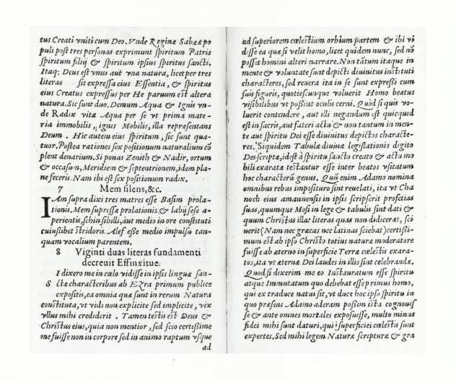

Sefer Yetzirah. Mantua, Yakob ha-Kohen de Gazuolo, 1562
The earliest extant Hebrew text of systematic, speculative thought on cosmology and cosmogony (composed 3rd–6th c. CE) was first printed in the West in 1562. But the Sefer Yetzirah was already known to the Christian Kabbalists Pico and Reuchlin in a translation (1480) of R. Isaac. There are two versions of the Sefer Yetzirah; even the longest one not exceeding 1,600 words. God created the world by means of 32 secret paths of wisdom, made up of the ten Sefirot and the 22 elemental letters of the Hebrew alphabet. The concept of the Sefirot made its first appearance in this work.
Early ownership marks in Hebrew on the final page; some marginal annotations in Hebrew.
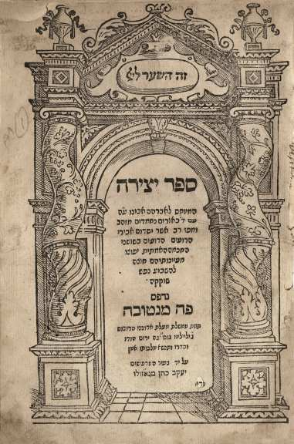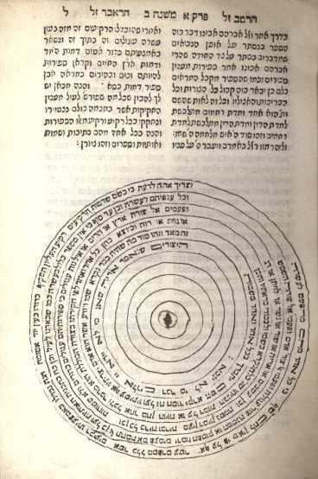

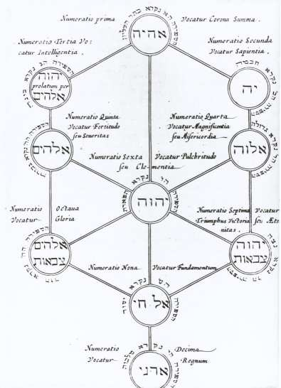 | Johannes Stephanus Rittangelius. [Sefer Yetzirah] Id est Liber Jezirah qui Abrahamo patriarchae adscribitur. Amsterdam, Jodocus and Johannes Janssonius, 1642  Latin translation of Sefer Yetzirah by J.S. Rittangelius, Professor of Hebrew in Koningsberg. It formed the basis for Campegius Vitringa’s Sacrarum observationum liber primus (1683), with which this book is bound in the BPH copy; Vitringa’s work also supplied an exposition of the ‘Sefiroth Cabbalisticae’.  Through contemplation of the mysteries of the Hebrew letters and the Sefirot, Abraham attained a revelation of God, which is why the book was attributed to him.  From the library of Walter Pagel.

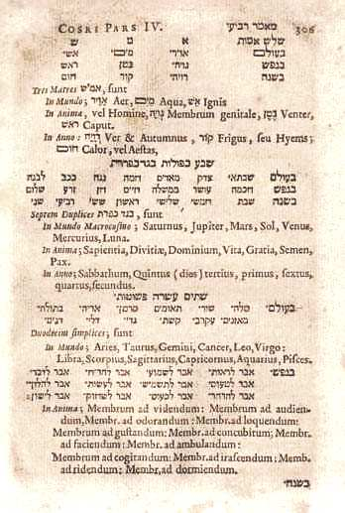 | Yehudah ha-Levi. [Kuzari] Liber Cosri. Basel, Georg Decker, 1660  Translated into Latin by the Hebraist Johannes Buxtorf (II), with the Hebrew text adjacent, this famous defence of Judaism in the form of a dialogue between a pagan prince and a Jewish sage contains a section on the Sefer Yetzirah (part IV, 25), which begins with ‘Judaeus’ remarking on the Sefer Yetzirah that it is ‘profundus, & longam requirit explicationem [it is profound, and requires thorough explanation].  Editor Buxtorf felt called upon, incidentally, to warn the reader about the dangers of the Kabbalah in a note to ha-Levi’s exposition of the Sefer Yetzirah: ‘Cabalistica enim doctrina abyssus est imperscrutabilis, labyrinthus inextricabilis, nec introitum ostendens nec exitum: fructus ejus nullus’ (p. 318)—the doctrine of the Kabbalah is an unfathomable abyss, a dark labyrinth, without entrance or exit: it is a doctrine entirely unprofitable. The interested reader is referred to Rittangelius’ edition of Sefer Yetzirah, which had appeared 18 years earlier.

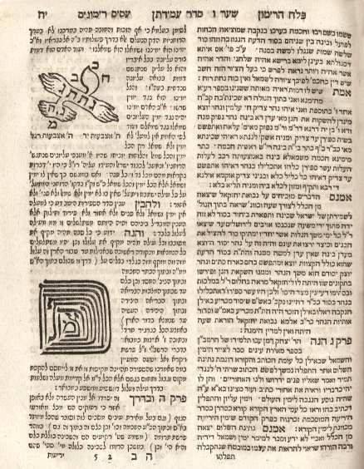 | Mordecai ben Jacob of Prague. Pa’amon ve’Rimmon [and] Sefer Pelach ha-Rimmon. Amsterdam, s.n., 1708  ‘The Book of the Bell and the Pomegranate’ contains according to the title-page a useful kabbalistic summary to learn to understand the creation and the divine.  It also offers a commentary on the Asis Rimmonim of a follower of Moses Cordovero, Samuel Gallico, who provided this summary of Cordovero’s Pardes Rimmonim.  Contemporary gold-tooled binding.

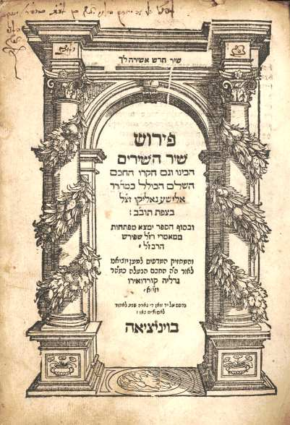 | Elisha ben Gabriel Gallico. Perush Shir ha-Shirim. Venice, Giovanni di Gara, 1587  A commentary on the Song of Songs, by the Talmudic scholar and Kabbalist Elisha Gallico, a pupil of the Safedian mystic Joseph Caro. It was prepared and researched, according to the title-page, in Safed, the famous Kabbalistic centre in the sixteenth century, home of Moses Cordovero and Isaac Luria. The mystical school of Safed was the first to interpret the Song of Songs as a dialogue between God and the soul.  Provenance: library stamp of the University of Haifa, 1950s; some early ownership marks on the title-page.

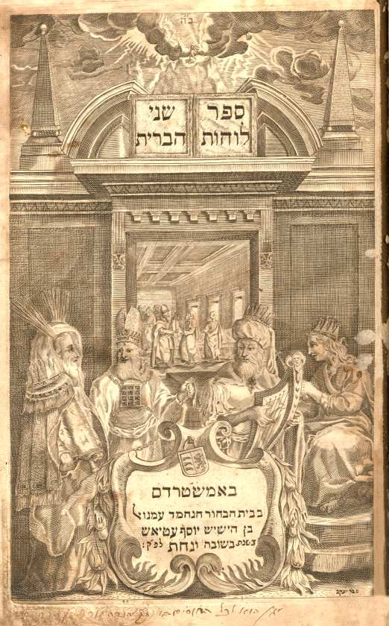 | Isaiah ben Abraham Halevi Horowitz. Shenei luchot ha-Berit. Amsterdam, Immanuel Athias, 1698 [and] Shabbetai Sheftel Horowitz. Vavei ha’ Ammudim. Amsterdam, Immanuel Athias, 1698  Isaiah Horowitz (1565?–1630) moved to Eretz Israel in 1621, where he was greatly influenced by the works of the Safedian mystics Luria, Cordovero and Caro. He combined halakah, homiletic and Kabbalah for the purpose of offering directions towards leading an ethical life. Especially Shenei luchot ha-Berit is characteristic for the way the Kabbalah pervaded every aspect of life. Horowitz’s son Sheftel edited the work and provided an introduction to it.  Contemporary gold-tooled binding with a supralibros connecting it to a Moshe bar Haron Halevi; underneath the name a hand pouring a jug. Early ownership marks in Hebrew on the fly-leaf facing the title-page and on the fly-leaf facing the colophon of Sheftel’s work.

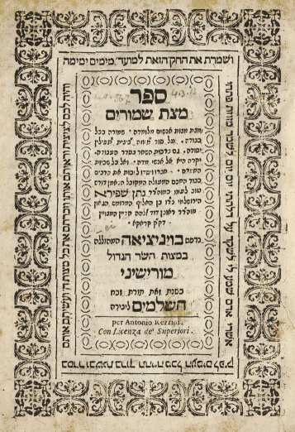 | Nathan ben Reuben David Spiro. Sefer Mazzat Shimmurim. Venice, [Venturin ben David for] Antonio Rezzini, 1660  Spiro was one of the Kabbalists in Jerusalem who in the first half of the seventeenth century produced editions and redactions of Lurianic teachings. Spiro also produced works of his own, which were printed in Italy, where he spent some of his later years. Mazzat Shimmurim contains instructions for the use of mezuzot, tefilin etc. and discusses the meaning and the use of the blessings, all ‘according to the Kabbalah’, as is stated in the sub-title.

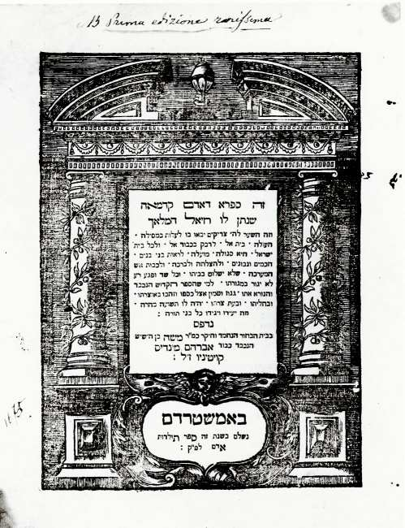 | Sefer Raziel ha-Malach. Amsterdam, Mozes ben Abraham Mendes Coutinho, 1701  The book of the first man, Adam Kadmon, given to him by the angel Raziel. Sefer Raziel is a collection of mystical, cosmological and magical Hebrew works, compiled not much earlier than the 17th century. This edition was prepared by R. Isaac ben Abraham of Neustadt from a manuscript in his possession: in the preface Isaac expresses the belief that the presence of the book would protect the owner’s house from fire.  At the end of the book various magical precepts and sigils.  The BPH owns two copies of this edition.

Menasseh ben Israel. De Creatione Problemata XXX. Amsterdam, Menasseh ben Israel, 1635
Menasseh’s press was the first Hebrew press to have been set up in Amsterdam, in 1626. Problema XV discusses the pre-existence of the souls; Menasseh adduces on p. 67 evidence from the Midrash ha-Ne’elam, the earliest part of the Zohar. Although Menasseh also freely quoted from pagan and Christian sources on the subject, he believed that the idea of pre-existence was essentially of Hebrew origin.
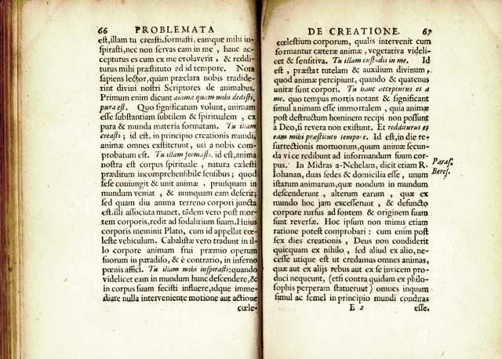

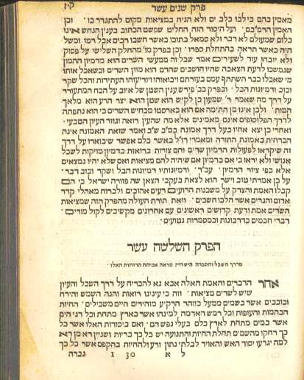 | Menasseh ben Israel. Sefer nishmat hayim. Amsterdam, Samuel ben Israel Soeiro, 1651  Menasseh claimed that on the issue of the pre-existence of the soul, the kabbalists ‘were followed by Pythagoras, Hermes Trismegistus, Plato [...] and others who had thirstily drunk from their words [i.e. of the Jews]’.  Early ownership notes in Hebrew on one of the endpapers.

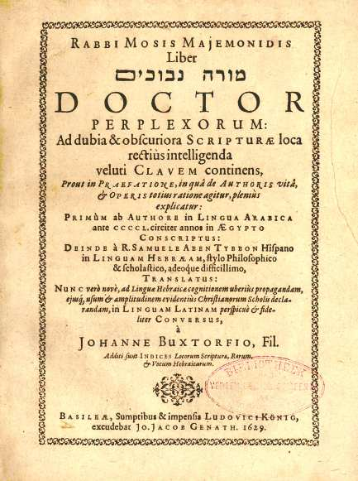 | Moses ben Maimon, Liber doctor perplexorum. Basel, Ludwig Koenig, 1629  ‘Bien étonnés de se trouver ensemble’: Maimonides, the ‘Prince of Jewish rationalist philosophers’, was occasionally claimed by Kabbalists to be one of their own. Chaim Wirszubski detected Maimonides’ transformation into a Kabbalist nowhere more effectively than in the translation of Hayye ha-Nefesh, Abulafia’s mystical commentary on the Guide of the Perplexed by Flavius Mithridates, one of Pico della Mirandola’s Hebrew tutors.  This translation by Johannes Buxtorf (II) follows the Hebrew translation made from the Arabic of Maimonides by Samuel ben Thybbon.
END

