
Kabbalah in the Bibliotheca Philosophica Hermetica Christian Kabbalah - printed works

http://www.xs4all.nl/~bph/kabbalah_christian_bks.html

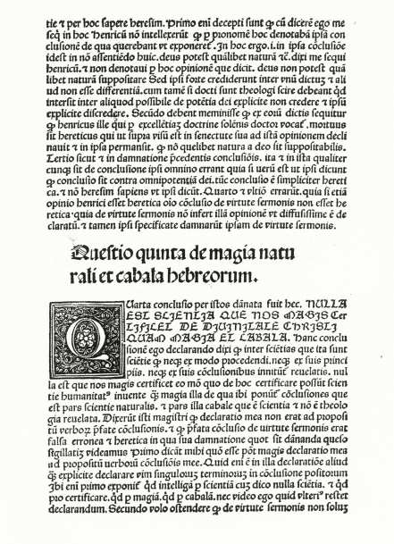 | Giovanni Pico della Mirandola, Opera. Bologna, Benedictus Hectoris, 1496 [and] Apologia conclusionum suorum. [Naples, Francesco del Tuppo, 1487]  Pico (1463–1494) was the first humanist to present the Kabbalah to his Christian contemporaries – the very word was until then unknown. That Pico was the first to have introduced the Kabbalah into Christian culture, is explicitly mentioned in the first book of Reuchlin’s De arte cabalistica:</  In our days the Latins, under the guidance of Count Pico della Mirandola, before whom the word was unknown in Latin, call them Cabbalists or Cabbalici. Then Marrano asks: ‘Do you know, most learned Simon, that man who was the first to make known to the Latins the word Cabbala?’ Simon responds: ‘Yes, I knew him, as I believe, when a few years ago he lived exiled amongst the French and the Savoyards. He was expelled from his country and forced to flee because of the odious persecution inflicted on him by those, who were envious of his excellent philosophical studies and his noble mind’.  Pico studied Hebrew under Elie del Medigo and Flavius Mithridates. He wrote DCCCC Conclusiones (1486) which were subsequently suppressed by the Pope because of their controversial nature. Pico wrote two series of Conclusiones cabalisticae: the first, ‘secundum secretam doctrinam sapientum Hebraeorum Cabalistarum quorum memoria sit semper in bonum’ (according to the secret teachings of the wise Hebrew Kabbalists, blessed be their memory) and a second ‘secundum opinionem propriam ex ipsis Hebraeorum sapientum fundamentis Christianam religionem maxime confirmantes’ (according to his own opinion from the basic principles of the Hebrew sages themselves, which best confirm the Christian religion). Pico claimed that magic and Kabbalah were the two instruments best fitted to prove the divinity of Christ: ‘Nulla est scientia, quae nos magis certificet de divinitate Christi, quam magia et cabala’. Pico also used or mentioned Kabbalistic doctrines in other of his works, notably the Oratione de Dignitate Hominis and the Heptaplus (his exposition of the first lines of Genesis).

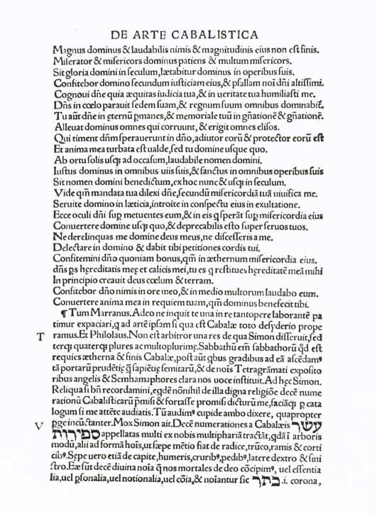 | Johannes Reuchlin, De verbo mirifico. [Basel], Johann Amerbach, [1494] [and] De arte cabalistica. Hagenau, Thomas Anshelm, 1517  First editions of De verbo mirifico and De arte cabalistica. When Gershom Scholem accepted the Reuchlin prize in 1969, he said that were he to believe in gilgul or metempsychosis, he might imagine himself to be a reincarnation of Johannes Reuchlin (1455–1522), the first non-Jew thoroughly to have studied the world and the language of Judaism and to have introduced the scholarly study of Judaism in Europe.  Reuchlin, who was born in Pforzheim, Germany, had become acquainted with Pico during his second Italian stay of 1490–1493 and had caught the latter’s enthusiasm for the Hebrew Kabbalah to the extent that he started to learn Hebrew in Rome and collect kabbalistic and magical Hebrew books. De verbo mirifico was the first book in Latin devoted to the Kabbalah and also contained a defence of Pico’s Conclusiones; at the time (1494) Reuchlin still possessed only a rudimentary knowledge of the subject; De arte cabalistica (1517), a ‘classic’ of the Christian Kabbalah, is much more objective and sympathethic towards its subject.

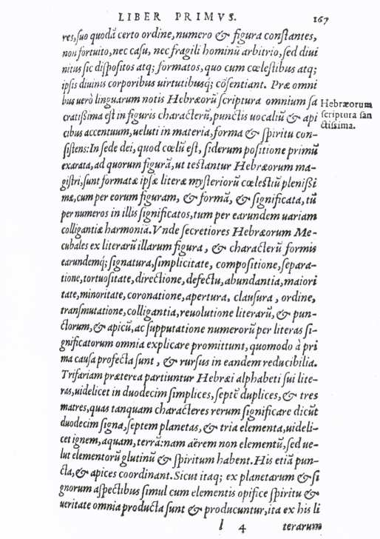 | Henricus Cornelius Agrippa, De occulta philosophia. Lyon, Godefroy and Marcellin Beringen, 1550  Unlike Pico and Reuchlin, Henricus Cornelius Agrippa’s knowledge of the Kabbalah was derivative, but his De occulta philosophia, a compendium of all the occult sciences of his day, first printed in 1533 and often reprinted, became one of the most important sources for the Kabbalah in the Christian world; his emphasis on ‘practical’ Kabbalah or magic later causing a mistaken association of Kabbalah with numerology and even with witchcraft. Agrippa equated Kabbalah largely with magic; a result of Pico’s Christian interpretation of Kabbalah and magic.

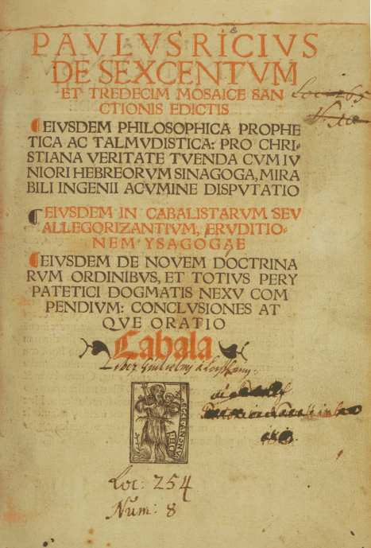 | Paulus Ricius, Talmudica novissime in latinum versa periocunda commentariola [and other works]. Augsburg, Sigmund Grimm, 1519 [and] De sexcentum et tredecim mosaice sanctionis edictis [and other works]. Augsburg, Johann Miller, 1515  Paulus Israelita, baptized Paulus Ricius (d. 1541) may be considered one of the architects of the Christian Kabbalah. After his conversion to the Christian religion, he attempted to refute Jewish arguments against his newly-acquired faith by means of the Kabbalah: thinking for instance that he had discovered proof for the Trinity and other Christian doctrines in Jewish mystical works.  He also adduced passages from the Talmud and the Kabbalah in defence of the Christian religion.

Jehuda Abravanel (called Leone Ebreo), Dialoghi d’amore. Venice, Aldus Manutius, 1541
First printed in 1535 but already completed in 1505, Abravanel’s Dialoghi d’amore was one of the works to contribute most to the dissemination of the Kabbalah, outside the more specialized studies of for instance Pico and Reuchlin. In Pistorius’ compendium De arte cabalisticae, for instance, the Dialoghi occupy an important place. In this metaphysical work on love, Abravanel (c.1460–after 1523) fused original interpretations of biblical and rabbinic traditions as well as of Greek myths.
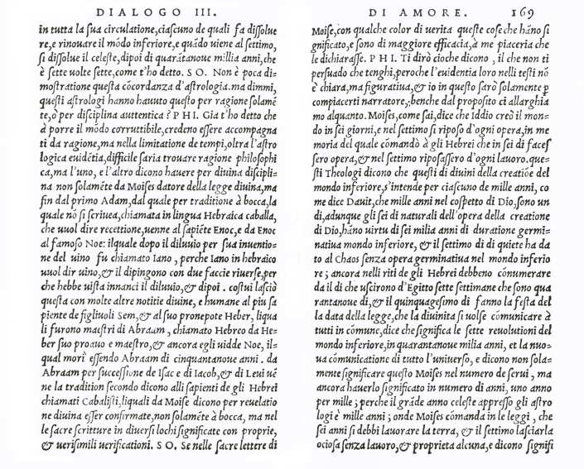

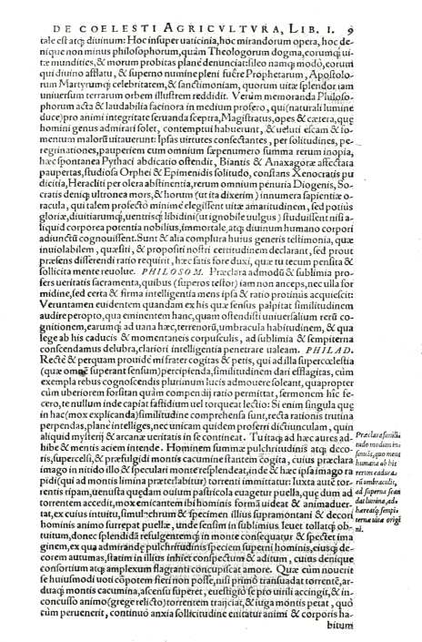 | Johannes Pistorius, Artis cabalisticae, Basel, Sebastian Henricpetri, (1587)  Pistorius (1546–1608) offered the world a compendium containing some of the most important (Christian) kabbalistic works, amongst which Ricius’ De coelesti agricultura; Gikatilla’s Portae lucis; Leone Ebreo’s Dialoghi d’amore; Reuchlin’s De arte cabalistica and De verbo mirifico; furthermore a Latin translation of Sefer Yetzirah, and a commentary, by the Franciscan Archangelo de Burgonovo, on a number of Pico’s Conclusiones cabalisticae.

Jacob Böhme. Theosophia revelata. s.l., s.n., 1730
When F.C. Oetinger, a follower of Jacob Böhme, asked the Frankfurt Kabbalist Koppel Hecht (d. 1729) how he might best gain an understanding of the Kabbalah, Hecht referred him to Jacob Böhme (1575–1624), a Christian author whose metaphors, Hecht told him, nevertheless bore close resemblance to those of the Kabbalah. Böhme’s doctrine of the origins of evil, for instance, whereby he defined evil as a dark and negative principle of the wrath of God, bears all the characteristics of Kabbalistic thought. The affinity between his ideas and those of the theosophical Kabbalah were evident to all of Böhme’s followers, from Abraham von Franckenberg (d. 1652) to Franz von Baader (d. 1841).
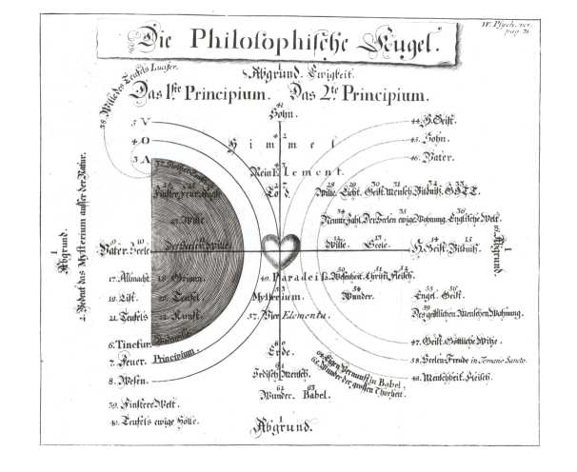

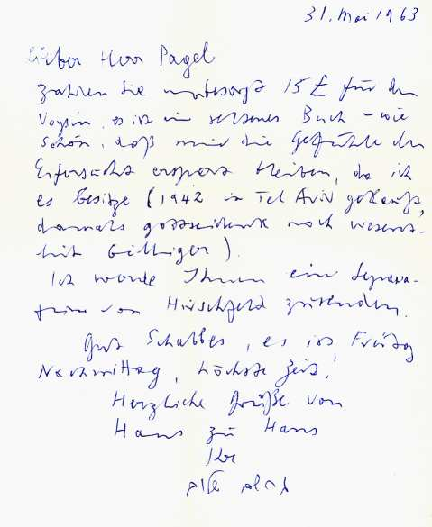 | Joseph de Voysin. Disputatio Cabalistica. Paris, Tussanus Du Bray, 1635  A book with an interesting provenance: the binding bears a supra libros of the great James Ussher, Archbishop of Armagh (1581–1656), and the copy also contains a letter from Gershom Scholem (31 May 1963) to a later owner, Walter Pagel, advising him to pay the £15 the book cost at the time: it is a rare book, Scholem assures him, noting at the same time that as a collector he is happy to be spared the feeling of envy since he already acquired a copy of the book in Tel Aviv in 1942.

Christian Knorr von Rosenroth, Kabbala denudata seu doctrina Hebraeorum transcendentalis et metaphysica. Sulzbach, Abraham Lichtenthaler, 1677 [and] Kabbalae denudatae tomus secundus. Id est Liber Sohar restitutus, Frankfurt, Johann David Zunner, 1684
Influential compendium of kabbalistic texts in two parts, the first part of which contains the following texts:
1. A key to the Kabbalah, i.e. the explanation and division of all names and divine homonyms according to the sefirotic degrees, derived from Moses Cordovero’s Pardes Rimmonim.
2. Joseph Gikatilla’s Sha’arei Orah.
3. Lurianic Kabbalah translated into Latin after a manuscript.
4. Index of the greater part of Kabbalistic subjects of the Zohar.
5. A summary of Aesch Mezareph (The Fire of the Goldmakers).
The second part, or Liber Sohar restitutus, which was printed in Sulzbach in 1684, contains amongst other works the Latin translation of Hayyim Vital’s Sefer ha-Gilgulim as De revolutionibus animarum, and also announced the Adumbratio Kabbalae Christianae [...] ad conversionem Judaeorum: Christian Kabbalah once again put in the service of the conversion of the Jews. The Adumbratio appeared separately in 1684 and is set in a dialogue between a ‘Kabbalista’ and a ‘Philosophus Christianus’. The outcome is a foregone conclusion, as the Kabbalist opens the discussion with the words: ‘Nôsti, amice, nihil urgeri acrius, quam conversionem nostram?’—Don’t you know, my friend, that there is nothing more urgent than our conversion!
