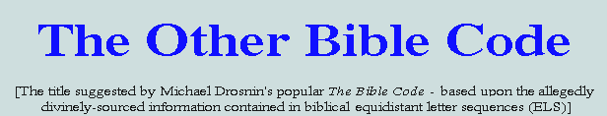
It is a logical consequence of Darwinian thinking that man is not alone in the universe; that other civilizations exist and flourish out there; that among these must be some superior to our own, able and willing to instruct us in the elusive art of peaceful coexistence. With the opening of the new millenium we therefore find many eyes turned heavenwards in anticipation of some non-random signal emanating from the depths of space that would confirm the existence of such beings. Assuming the fulfilment of these expectations, it is highly likely that regular communication would follow and, in due course, direct contact.
In the initial stages of this scenario mathematical absolutes - particularly those associated with number and form - are expected to assume fundamental roles. For example, the repeated transmission of a sequence comprising the first thousand or so cubic numbers is highly likely to capture the interest and attention of any intelligent receptor - thereby achieving the immediate purpose of announcing its author's galactic presence.
However, in their eagerness to pursue extraterrestial liaisons and find salvation among the stars the world's scientific and intellectual elite appear to have overlooked a similar message closer to home - one expressed in equally persuasive terms. In the following pages it is proposed to identify and correct this oversight by drawing attention to some real and remarkable phenomena and their far-reaching implications. These are associated, in particular, with the Bible's opening Hebrew words, the Greek form of the name Jesus Christ (understood by Christians to be The Creator), and the riddle of Revelation 13:18.
For a concise overview of the findings to date it is recommended that The Beginning of Wonders be read first - followed by the remaining pages, in the order given.
Vernon Jenkins MSc
Please note: restructured website building in progress here
New pages added 2007-03-04:
1) The Bible - a self-authenticating text: www.whatabeginning.com/ObDec.htm
2) Two tessellations of Genesis 1:1: www.whatabeginning.com/Misc/Tess1/P.htm www.whatabeginning.com/Misc/Tess2/P.htm
3) An important matter arising from the first of these: www.whatabeginning.com/Misc/Tess1A/P.htm
4) Themes from Creation's Blueprint - Part 4: www.whatabeginning.com/Themes/Part4/P.htm
5) Creation Geometries - Part 3: www.whatabeginning.com/CGeoms/Part3/P.htm
And,
added 2007-04-02:
6) Revelations of a Biological Abacus: www.whatabeginning.com/Misc/Genetics/Genetics_VS.htm
added 2007-05-26:
7) The Unique Utterance: www.whatabeginning.com/Misc/Pyrotechnics/Pyrotechnics.htm
8) Paper-folding for Beginners: www.whatabeginning.com/A4/Origami/P.htm
added 2007-06-04
9) A Substantial Difference: www.whatabeginning.com/Misc/Order/P.htm
added 2007-07-10
10) The Music Lesson: www.whatabeginning.com/Music/M_Lesson.htm

DECLARATION: This site is dedicated to the service of our Creator, Sustainer and Saviour - The Lord Jesus Christ. Its principal aim is to uphold the supreme Authority of the Judaeo-Christian Scriptures as the one unique body of revealed truth (graciously provided for our eternal well-being) by presenting hard evidence of a self-authenticating principle, closely integrated with the original Hebrew and Greek texts. Such findings defy all naturalistic explanation; accordingly, they represent a challenge to those unbelievers who assume reason to be life's only dependable and sufficient guide.
"The secret things belong unto the LORD our God: but those things which are revealed belong unto us and to our children forever, that we may do all the words of this law." (Deuteronomy 29:29)

Main Index
- The Ultimate Assertion
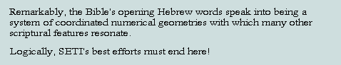
- The Arbiters of Truth
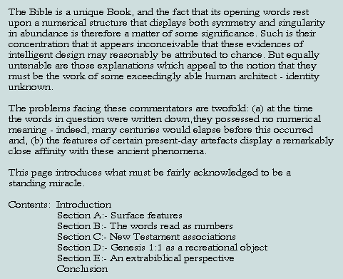
- The Lamp
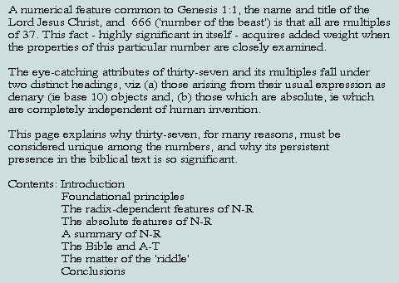
- 666 - and All That!
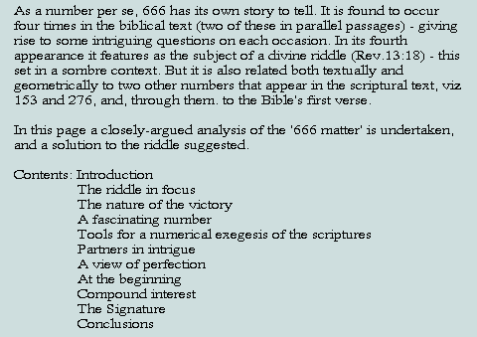
- Exceptional Measures
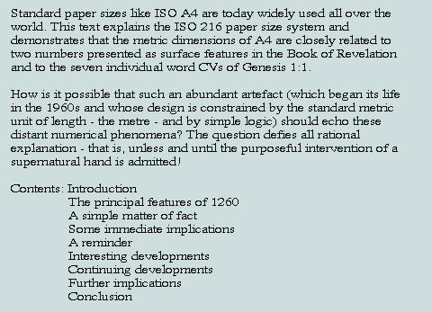
- What's in a Name?
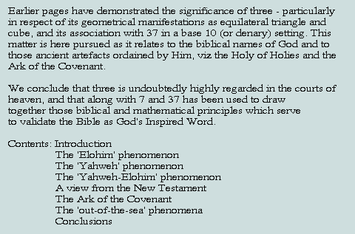
- An Oracle Restored
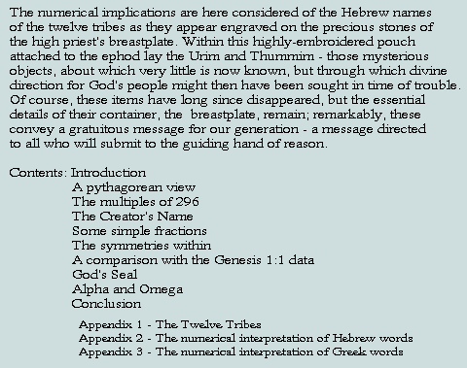
- From First Principles
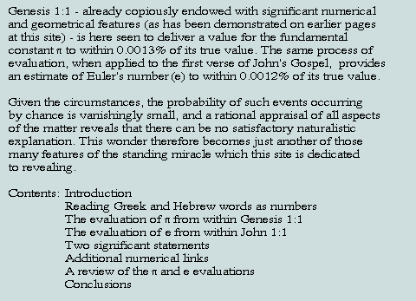
- A Numerical View of Beginnings
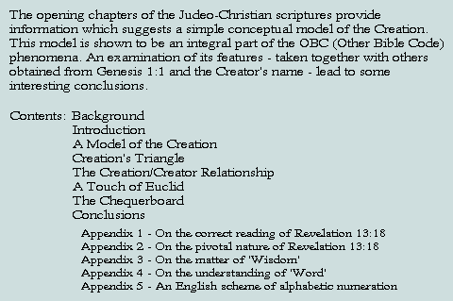
- In Order to Impress
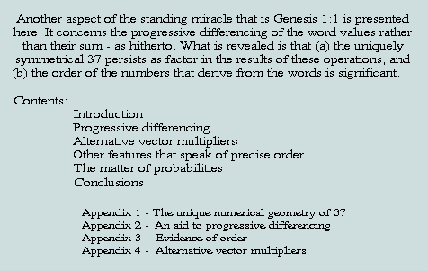
- The Postscript (a reworking of Exceptional Measures)
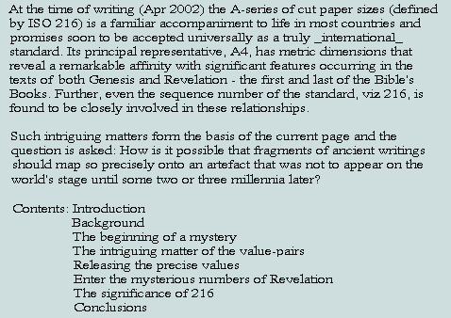
- Israel: Person, Nation and Land
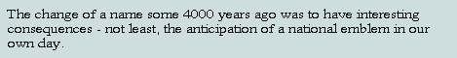
- Squaring the Cubes
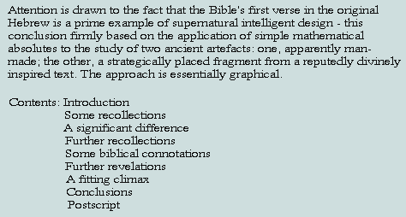
- Figuring Facts
- Judging by Appearances
- Inner Conviction
- New for Old

The Ultimate Assertion:
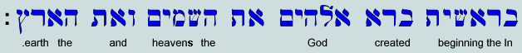
EVIDENCE OF SUPERNATURAL DESIGN IN THE DIVINE PROLOGUE
The opening verse of the Judaeo-Christian scriptures must be regarded as the most remarkable combination of words ever written - and for reasons that include the following:
1) The Hebrew words (reading right to left) may be alternatively, and fairly, read as a set of 7 natural numbers, thus:
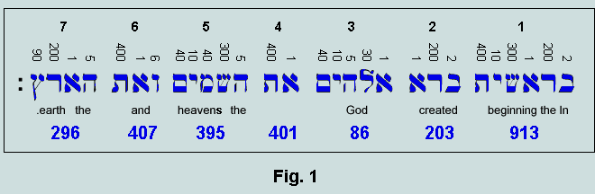
Above the text we have the values assigned to the letters - following the historically attested scheme of alphabetic numeration. Recorded below are the totals which represent the values of the words (now interpreted as strings of numerals). Observe that the 4th (and central) word is not translated as it indicates here that the following noun is the definite and direct object of the transitive verb.
The verse total (ie the sum of the 7 word values) is 2701, or 37 x 73 (an interesting case of digit symmetry). It is worth observing that the number of letters in this first verse is 28 (2nd perfect number) - the first word having 6 (1st perfect number). All known perfect numbers are even and triangular; 6 (= 1+2+3) is the 3rd triangular, and 28 (=1+2+3+4+5+6+7) is the 7th.
2) There are a number of geometries associated with 2701 - the numerical expression of Genesis 1:1 - thus:
- Most obviously, the 37 x 73 rectangle:
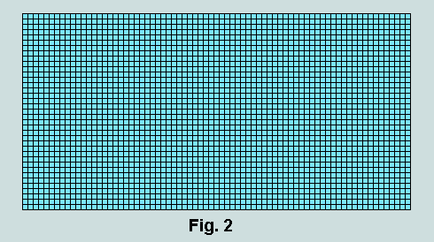
- The 37 x (55 + 91)/2 trapezium:
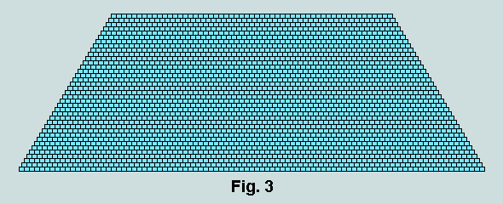
- The 73rd triangle:
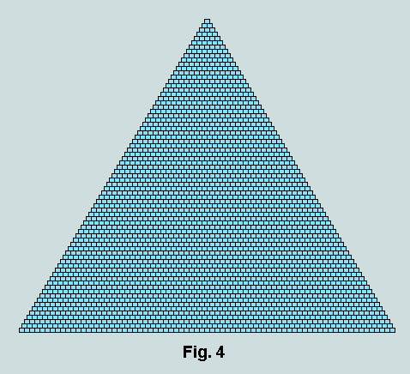
3) Observe that the outline of each of the foregoing figures comprises 216, or 6 x 6 x 6 counters; assuming these to be unit cubes (as implied in Fig. 2), they may be stacked to create the unique cube depicted below:
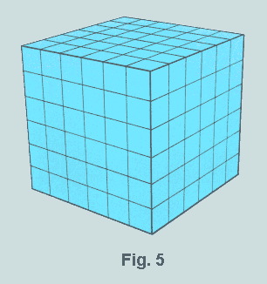
This is the only cube whose superficial area is numerically equal its volume.
4) At this point in the proceedings something more needs to be said about the prime numbers, 37 and 73 - factors of Genesis 1:1. As it turns out, they are related geometrically in two distinct ways. The facts are presented in Fig. 6.
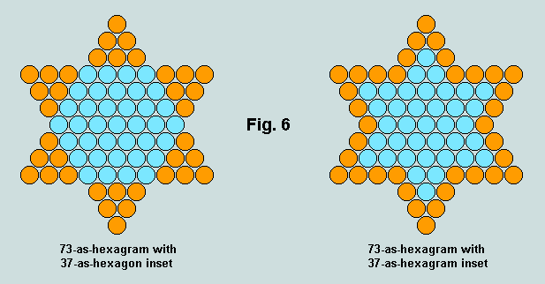
It follows, therefore, that there are yet further ways of representing this verse pictorially. Of particular interest is the 'star of stars', ie 73-as-hexagram formed from units of the related 37-as-hexagram, thus:
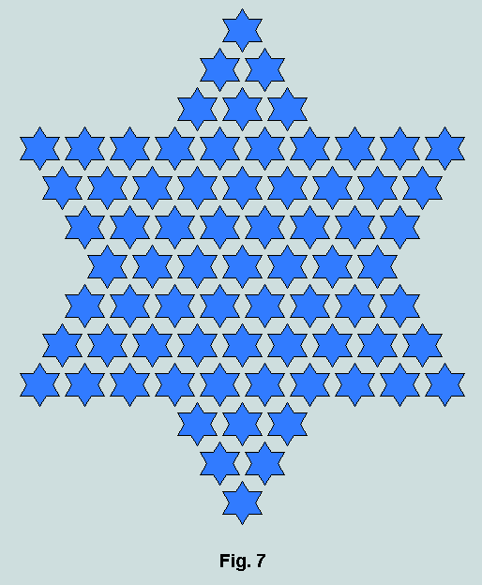
5) The matters presented above may be conveniently referred to as the macro features of the numerics of Genesis 1:1. A consideration of interactions occurring within the verse leads to the portrayal of a number of its many arresting micro features. Consider, for example, the following:
- Words 6 and 7 (each a multiple of 37) total 703, or 19 x 37, and we find a geometrical relationship between these factors of a kind similar to that shared by 37 and 73, thus:
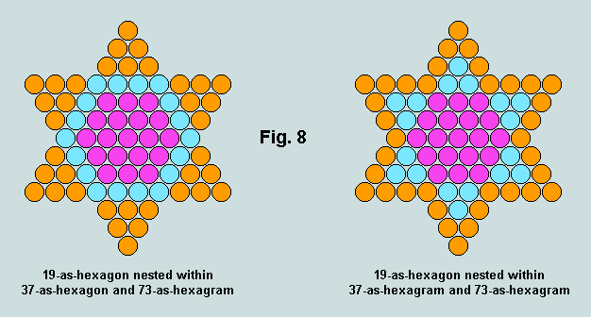
- 703 itself may assume different geometrical forms - all compatible with those representing the complete verse, thus:
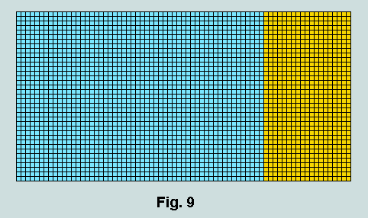
This diagram reveals a natural division within the verse - the blue rectangle of 1998 units representing the sum of words 1 - 5, and the orange rectangle the sum of words 6 and 7.
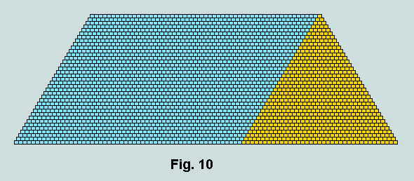
Here, it is revealed that 703 is 37th triangular number (coloured orange) - the blue parallelogram representing the sum of the first 5 words.
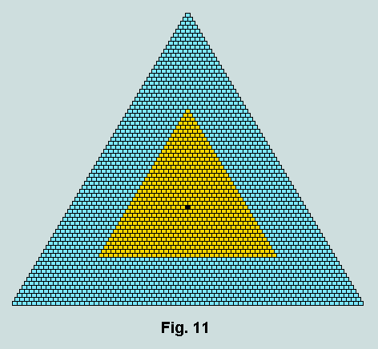
The 37th triangle (value, 703) is here shown centred within the triangle representing the complete verse, viz 2701. Rotating the inner triangle through 180 degrees about the common centre (rendered black), we make a significant discovery:
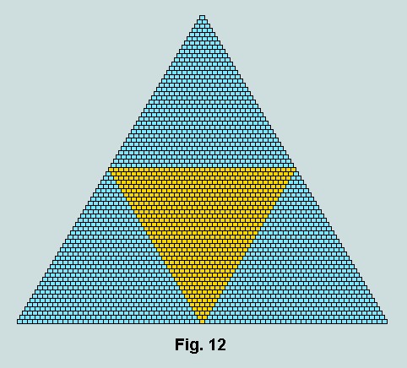
Observe the geometrical compatibility here; also the fact that each of the 3 blue triangles has the value 666 - a number that Christians meet with elsewhere.
Finally under this heading, here is how 703 appears as a symmetrical hexagon within the 'star of stars' expression of Genesis 1:1:
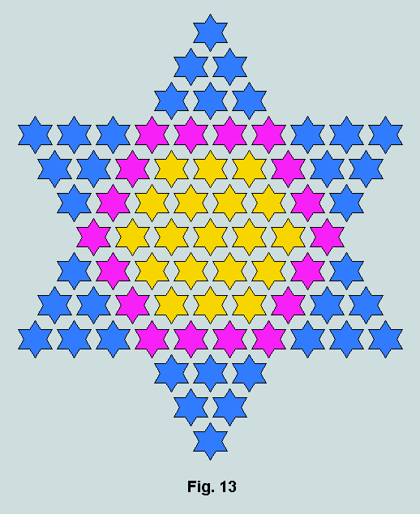
It will be remembered that the 73 'star' units in this figure each represent 37-as-hexagram. The inner hexagon of 19 thus represent 703 (ie the sum of words 6 and 7), and the hexagonal ring of 18 (coloured purple), 666.
- But further insights arise. For example, the sum of words 1 and 3 (ie 913 and 86) = 999 - as does the sum of words 2, 4 and 5 (ie 203, 401 and 395). These facts can now be incorporated into the Figs. 9 and 10 with telling effect, thus:
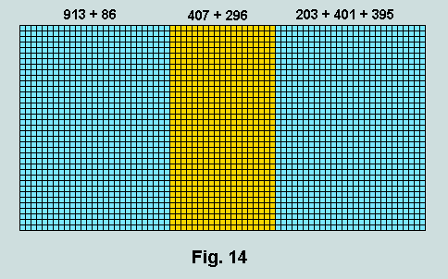
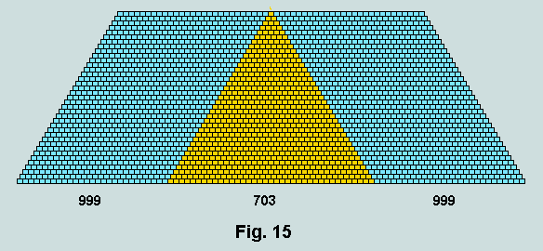
- Again, it may be observed that when the first word, 913, is temporarily removed from the scene the remainder divide evenly as follows: 203 + 395 + 296 (representing words 2, 5 and 7) = 86 + 401 + 407 (representing words 3, 4 and 6) = 894. This result is best depicted within the foregoing trapezium - the difference (999 - 894) being 105 - another triangular number (the 14th). Here, then, is the revised version of Fig.15:
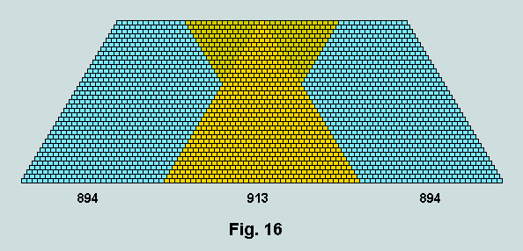
The involvement of the 14th triangle (105) has the added significance that its double, 210, is also triangular (the 20th). This is a rare phenomenon in the infinite series of triangles.
- A further interesting observation concerns the respective totals of the odd and even words. Thus, 913 + 86 + 395 + 296 = 1690 = 10 x 169 = 10 x 8th hexagon; and 203 + 401 + 407 = 1011 = 3 x 8th hexagram. Clearly, these figures tessellate; one significant arrangement takes the form of the trefoil depicted below.
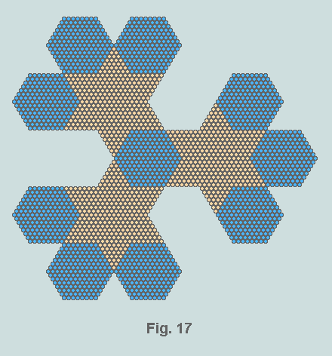
The total number of counters involved here is obviously 2701. So the list of symmetrical representations of the Bible's first verse is further, and remarkably, extended.
6) Because the triangular form of Genesis 1:1 has a centroid counter (a feature shared by only 1 in 3 triangular numbers) it is capable of uniting with an inverted copy of itself to yield a hexagon (by intersection) and a hexagram (by union). The following diagram illustrates the principle as it is applied to Fig.12 above:
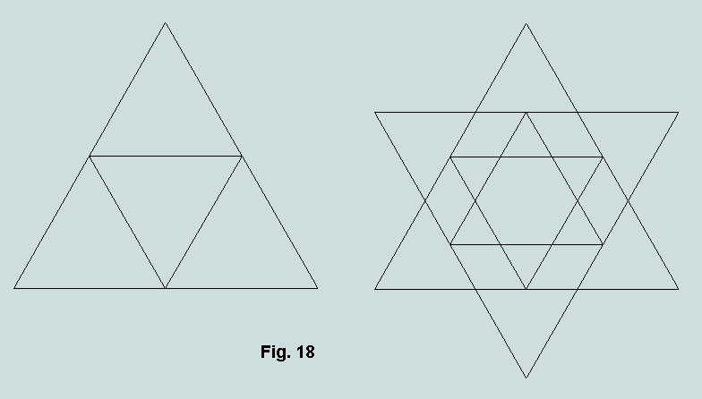
It may be observed that the inner triangle (representing the sum of the two final words of the verse) is also a 'generator' triangle in this sense. A particularly significant outcome of this operation concerns the hexagon so generated with triangle inset. To clarify the discussion, these features are made the focus of attention in the following diagram.
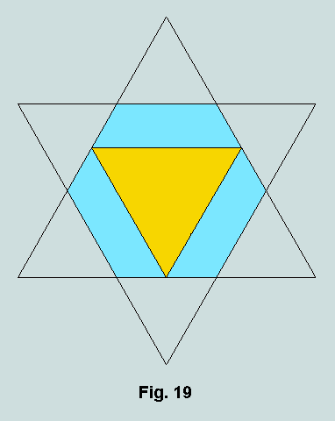
The value of the triangle is of course known to be 703 (ie 407 + 296). That of the hexagon is 1801 - a direct consequence of the generating triangle being 2701.
At this point, let us look again at the Bible's opening Hebrew words - but now including the first of the second verse:
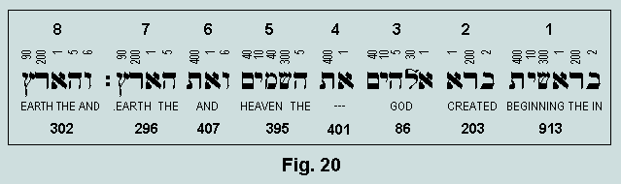
Clearly, read as a number this 8th word of Scripture is 302. Observe now the sequence of words 4 - 8 (within which the triangle 703 resides as words 6 + 7); they total 1801, ie the value of the hexagon derived from the self-intersection of 2701-as-triangle. This sequence of words confirms, therefore, what we actually see in the geometry. Again, it should not pass unnoticed that the sum of words 4 and 8 is also 703, and that the total for the now augmented first verse is 3003 - the 77th triangular number. It follows from this last observation that the 8th word functions as a perfect numerical 'plinth' for Genesis 1:1.
7) Further concerning 1801 - the hexagon inscribing 2701-as-triangle - observe that it is also generated within Genesis 1:1 as the sum of words 1, 3, 5 and 6 (ie 913 + 86 + 395 + 407), and has an outline of 144, or 12^2. As demonstrated in Figure 16, 913 (the Bible's first word) may be regarded as the sum of 2 or 3 triangles, thus: 913 = 703 + 210, or 703 + 105 + 105. The following diagram reiterates the basis of a significant development based on these facts:
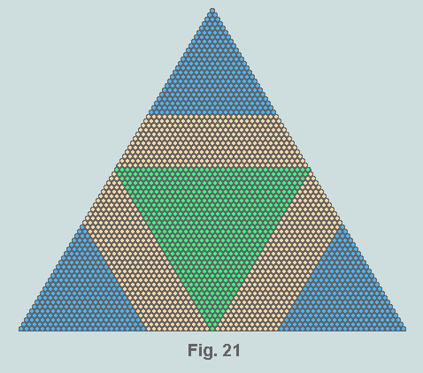
The trapezia rendered orange each comprise 366 counters, ie (1801 - 703)/3. Observe that 703-as-triangle may be converted into 913 - and without loss of symmetry - by attaching 6 equal trapezia, each of value 35, in the manner shown below:
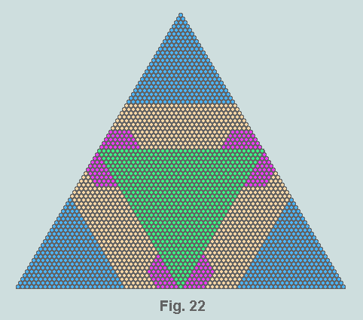
Clearly, the centre of the figure (representing the Bible's first verse) is dominated by a symmetrical representation of 913 (the Bible's first word), thus:
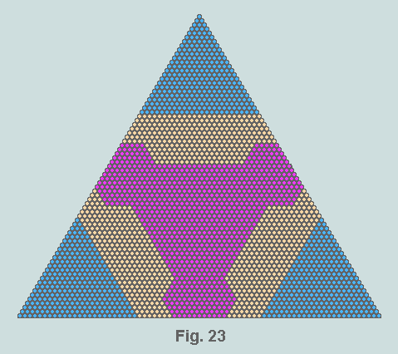
Significantly, each of the areas rendered orange comprises 296 counters - 296 being the last of the 7 words of Genesis 1:1. In total, therefore, they represent 888 counters. This happens to be the numerical reading of the name 'Jesus' from the Greek, nominative case ('Christ' being 1480, or 5 x 296). How appropriate then that He who is said to have created all things (eg John 1:3) is here seen to be associated with 'the earth' and to share a central position with the Bible's first word within the Bible's first verse!
8) Finally, let us take a look at the geometries of the individual words. As the following diagram reveals, these display the features of a set of jigsaw pieces when confined within the limits of the rectangular form of Genesis 1:1 (Fig.2), thus:
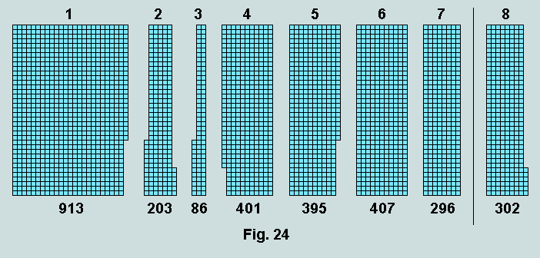
The height of each of these figures is 37 units. Observe that each of the short projecting spurs on words 1 - 5, together with their respective recesses, are multiples of 6 (words 6 and 7 are, of course, multiples of 37 - hence, spurless). Note also that word 8 follows the same pattern. Clearly, many multiples of 37 may be created by combining two or more interlocking pieces. In fact, in respect of Genesis 1:1, 23 of the possible 127 unique combinations are multiples of 37, whereas the expectation for a random set is only 3 or so.
9) So the big questions are, "Who is responsible for encapsulating so much mathematical detail into the 7 Hebrew words of this powerful and fundamental assertion? And why?" It should be clearly understood by those attempting to formulate rational answers to these questions that the testimony of the coordinated numerical geometries, briefly explored here, is considerably enhanced by the many other numerical wonders detailed at the website referenced below; further, that these features were 'set in stone' millennia before the invention of the Hebrew alphabetic numbering scheme!

Vernon Jenkins MSc
Created: 2003-01-25
Modified: 2003-02-10
http://www.otherbiblecode.com
email: vernon.jenkins@virgin.net
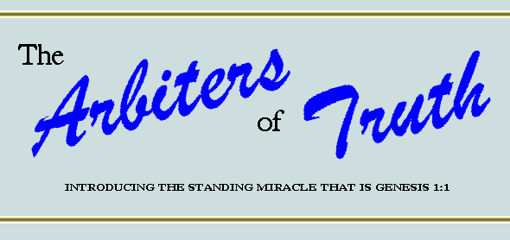
Index:
- Introduction
- Section A - Surface features
- Section B - The words read as numbers
- Section C - New Testament associations
- Section D - Genesis 1:1 as a recreational object
- Section E - An extrabiblical perspective
- Conclusion
Return to Homepage

Introduction
Viewed purely as a literary composition, the Bible is without parallel
- in its continuity - written over a 1600-year span by more than 40 authors drawn from every walk of life
- in its translation and circulation - published in more languages and read by more people than any other book
- in its survival - through persecution and criticism
- in its teachings, its frank portrayal of man, and its prophecies - many of which have already been accurately fulfilled
- in its influence on human behaviour, on reform, and on literature, art and music
But the uniqueness of the Bible goes far beyond these considerations; it claims for itself the added distinction of being divinely-inspired, for we read "All Scripture is given by inspiration of God, and is profitable for doctrine, for reproof, for correction, for instruction in righteousness: That the man of God may be perfect, thoroughly furnished unto all good works." (2Tm.3:16,17). These words clearly imply that this Book has been specifically provided for our benefit - to impart reliable information that addresses the deepest issues of life: in particular, the character of our Creator, the origin and purpose of life, the true nature of man, and what it is that follows this earthly existence.
The truth of divine inspiration has been remarkably confirmed in recent years by the discovery that the opening verse of the Bible - obviously numbered among the most widely read of all time - is copiously watermarked with structures that spring from the heart of mathematics. Indeed, as expressed in the original Hebrew, Genesis 1:1 may be fairly claimed to be the most remarkable combination of words ever written, and the evidence presented here, though by no means exhaustive, is sufficient to explain why. Supplemented by the other pages provided on this site, here is proof that the many and varied numerical features associated with these strategically placed words are clearly present by design - but, at the same time, defying all natural explanation!
The object of our study takes the form of a powerful and fundamental assertion: "In the beginning God created the heavens and the earth." - this information conveyed in a sequence of seven Hebrew words comprising a total of 28 letters, thus:
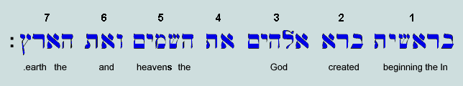
There are two things to note here: (a) in accordance with standard practice, the words are written and read from right to left, and (b) the central word (necessary to sustain the grammar) is untranslatable.
Return to Index
Section A:- Surface Features
Let us immediately observe that the number of Hebrew letters in Genesis 1:1 is four times the number of words.
#1: No. of letters = 28; No. of words = 7; letters = 4 x words.
Separating the letters and arranging them in rows - one in the first, two in the second, three in the third, and so on - a simple geometrical relationship between letters and words is revealed, thus:
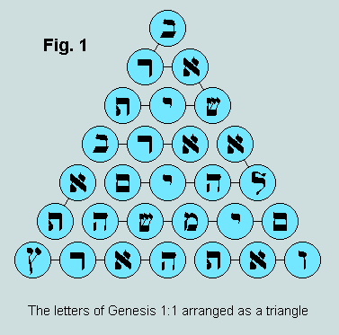
#2: The 28 letters of the verse form a numerical triangle of side 7 units.
However, as the following figures reveal, two further triangles are found to occur on word boundaries:
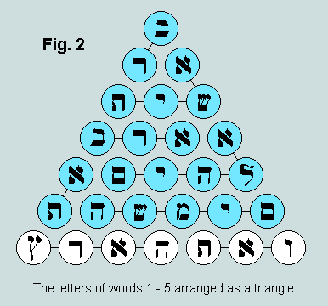
#3: The 21 letters of words 1 to 5 form a numerical triangle of side 6 units - 6 itself being a numerical triangle.
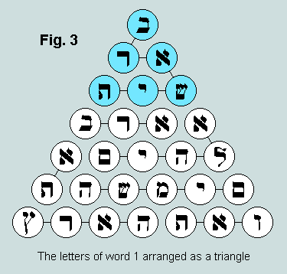
#4: The 6 letters of word 1 form a numerical triangle of side 3 units - 3 itself being a numerical triangle.
These elements of numerical geometry are examples of what may conveniently be referred to as figurate numbers.
#5: A figurate number - as here understood - is one which, when represented as a set of uniform circular or spherical counters, completely fills a symmetrical polygonal or polyhedral frame.
In the examples given, the relevant frame has the form of an equilateral triangle - which, for the Christian, clearly has trinitarian implications.
The triangles of letters representing first word and first verse, viz 6 and 28, are further related in being first and second perfect numbers. To qualify for the title perfect a number is required to equal the sum of those smaller numbers (including 1) which divide it exactly. Thus, 6 is perfect because 1+2+3 = 6; and 28 is perfect because 1+2+4+7+14 = 28. Such objects are exceedingly rare - there being only 5 instances in the first 8 billion natural numbers; all known examples are even and triangular; they have interested the world's foremost mathematicians from the earliest times.
#6: The numbers of letters forming the Bible's first word and first verse are 6 and 28, respectively; these are first and second perfect numbers, and third and seventh triangular numbers
The number of words in this first verse may be identified with another symmetrical figure (one involving sixness rather than threeness), viz a numerical hexagon, thus:
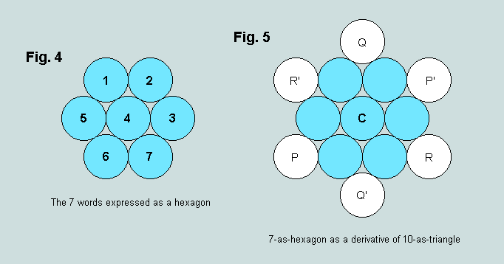
#7: The 7 words of Genesis 1:1 form a numerical hexagon and thereby reveal a hidden relationship with both 6 and 10.
As can be seen, figures of this kind derive directly from a pair of identical triangles that possess a central counter - the so-called centroid- or generator- triangles. One in every three terms of the infinite triangle series possesses this feature. In Fig.5 above the numerical triangle PQR - value 10 - is first copied in situ as P'Q'R' and this then rotated by 180 degrees about the centroid counter C to generate, in combination with PQR, two symmetrical figures: a hexagon of 7 (by overlap - or intersection), and a 6-pointed star, or hexagram, of 13 (by addition - or union).
#8: In any given sequence of numerical triangles, 1 in 3 will be built around a central counter, and thus will be capable of generating a related hexagon/hexagram pair by self intersection/union.
An examination of Fig.1 reveals that 28 is also a generator triangle; this - combined in like manner with a rotated copy of itself - gives rise to the hexagon/hexagram pair, 19/37, thus:
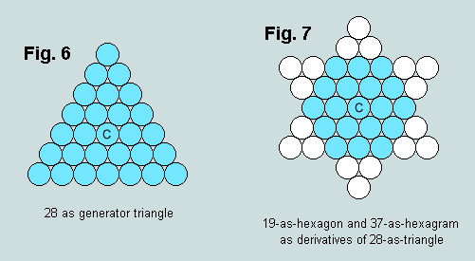
Ten, of course, is closely associated with the naming and writing of numbers, and features also as collective unit in metrication and decimalisation. Interestingly (since all numbers presented here are expressed as denary - or base 10 - objects), the sum of each pair of digits representing the figurate numbers involved in Fig.7 is ten! Furthermore, as Fig.9 reveals, ten has an absolute presence which is completely independent of all other considerations - a quality which it transfers to Genesis 1:1 by association.
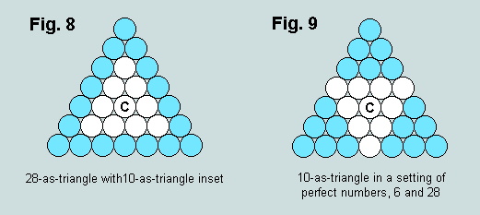
In Fig.8, we have 10-as-triangle centred within 28-as-triangle - the outline of the latter being revealed as 18.
#9: The outline of the triangle of Genesis 1:1 letters is 18 - or 6+6+6.
When the inner triangle is rotated by 180 degrees about its central counter (c) a trio of 6-as-triangle is generated. The resulting symmetry reveals the close connection between this important number, ten, and the two first perfect numbers.
#10: Ten-as-triangle (also known to the Pythagoreans as tetraktys) has a close affinity with the two first perfect numbers - hence with the lexical structure of Genesis 1:1.
A comparison of Figs.1 and 6 reveals that the letter occupying the triangle centroid is (yod) - appropriately, the 10th of the Hebrew alphabet; similarly, Figs.4 and 5 identify the central word - the untranslatable (aleph, tau) comprising the first and last letters of the same alphabet.
#11: Occupying the centroid position in the triangle of Genesis 1:1 letters, we find ; similarly, at the centre of the hexagon of words, we find - untranslatable, and represented by the first and last letters of the Hebrew alphabet.
To summarise: the key themes revealed in this examination of the lexical features of Genesis 1:1 are the manifestations of numerical geometry, viz generator triangle, hexagon/hexagram pair, and 10-as-tetraktys in a setting of perfect numbers.
Return to Index
Section B:- The words read as numbers
All Hebrew words and word sequences have a cryptic numerical presence arising from the ancient practice (from c200 BC) of using the complete set of 22 alphabetic characters as numerals [details of this scheme are provided here]. Numbers are formed by assembling a string of letters whose sum represents the required value. We shall find it convenient to use the term characteristic value (hereafter "CV") for a Hebrew word or phrase interpreted in this manner. On this basis, Genesis 1:1 may be fairly read as a sequence of seven numbers, thus:
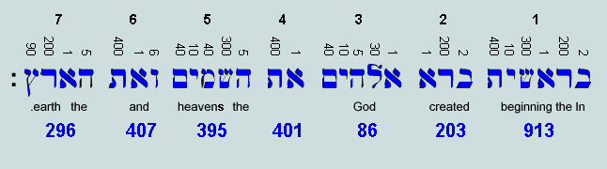
In this presentation, letter CVs are shown above, and word CVs (sums of the corresponding letter CVs), below. Viewed naturalistically, the latter can have no information content: they appear to be merely fortuitous appendages of passing interest. However, as we have seen, the Bible is no ordinary book. It claims that our Creator is its Author. If this indeed be the case then it would surely be unwise to dismiss the possibility that these numbers - indelibly associated as they are with its opening words - represent an additional and valid tool of biblical exegesis. Let us therefore consider what these numbers might have to tell us.
- Factors of the word CVs
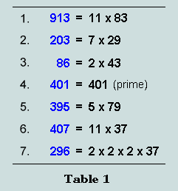
Observe that the first word is by far the largest numerically, and that Elohim (translated 'God') is the smallest. Note too that 37 is a factor of words 6 and 7 ( 'and the earth').
- Sums of the word CVs
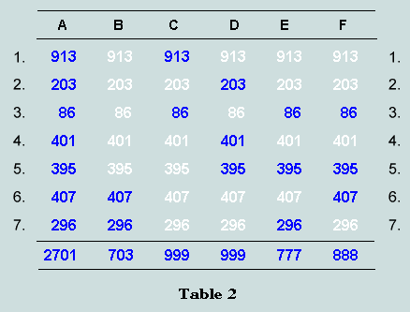
The CV of the complete verse (ie the sum of the 7 word CVs) is 2701 (column A). This factorises in an interesting way, viz 2701 = 37 x 73. Remarkably, these factors are symmetrically revealed when the number is added to that formed by reversing its digits, ie 2701 + 1072 = 3773.
#12: Expressed as base 10 numbers, the prime factors of the verse CV, 37 and 73, involve the digits 3 and 7, and are reflective. They are also related absolutely in being 4th hexagon/hexagram pair - the generator triangle involved being the 10th, ie 55.
But 2701 (representing Genesis 1:1) has further significant attributes. For example, like 28 it has a geometrical presence as a triangular number - one standing on a base of 73 and having an outline of 216, or 6x6x6 (it may be remembered that the outline of 28-as-triangle was 18, or 6+6+6 - see #9).
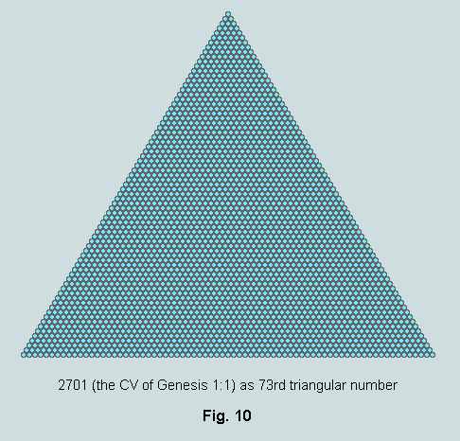
Again, its digits combine in various ways to produce further instances of numerical geometry, thus: 2+7+0+1 = 10 (4th triangle); 2+701 = 703 (37th triangle); 27+01 = 28 (7th triangle); and 270+1 = 271 (10th hexagon). Further, 2701 is a generator triangle (ie it is centred - the centroid counter occupying the 25th position in the 49th row) and gives rise to the 25th hexagon/hexagram pair 1801/3601 by self intersection/union.
#13: The verse CV, 2701, turns out to be a remarkable number possessing a significant presence when viewed as denary object or as geometrical absolute.
To continue our examination of the foregoing table: the sum of the two multiples of 37, words 6 and 7 (column B), is 703 - 37th triangular number - its factors being 19 and 37.
#14: The combined CV of words 6 and 7 is 703 - the prime factors of this number, 19/37, being the hexagon/hexagram pair generated by 28-as-triangle (see Fig.7).
Further, we find that this triangle fits precisely within 2701 - the verse triangle. It thus mirrors the structure of Fig.9 and, in the process, generates a triple of 666-as-triangle (anticipated by the triple of 6-as-triangle in the earlier figure!). As is demonstrated elsewhere, 666 is uniquely triangular.
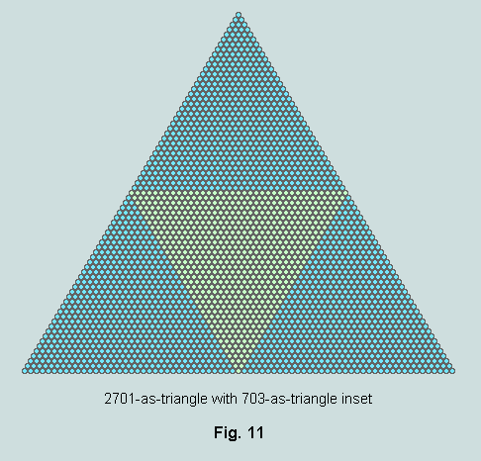
#15: 2701 (verse total) and 703 (sum of words 6 and 7) are coordinated geometrically and closely associated with the unique triangular number, 666.
Referring to the remaining columns of Table 2, note the manner in which the CVs generate 3-digit sums that are each a multiple of 111, or 3x37. Clearly, their complements are multiples of 37 also.
#16: Genesis 1:1 is saturated with the factor 37 which include a number of its eye-catching repeated-digit multiples.
The next table reveals the fact that the residual CVs are precisely bisected, (a) when the first word, and (b) the final two words, are omitted from the proceedings. In the first case, the sum involved is 894; in the second, 999.
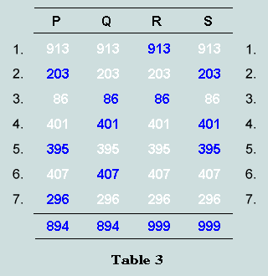
#17: When the first word, or words 6 and 7, are withdrawn, the residue in each case divides equally on word boundaries.
These particular verse divisions also have geometrical implications. Thus, as Fig.12 reveals, Genesis 1:1 may be represented as a trapezium in which 703-as-triangle again occupies centre stage, now flanked by two numerical parallelograms of 999 (ie 27x37) counters apiece. The combination has 37 rows - the first of 55 counters and the 37th of 91; its outline is again 216, or 6x6x6.

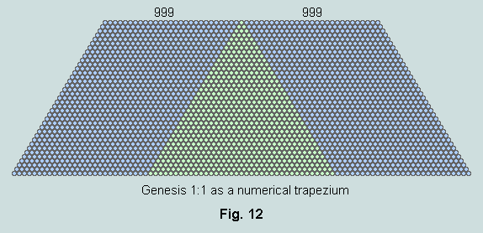
The difference between 999 and 894 is 105 - 14th triangular number. As the following figures reveal, 913 (the CV of the first word of Genesis 1:1) may be viewed as the sum of the three triangular numbers 105, 703 and 105.
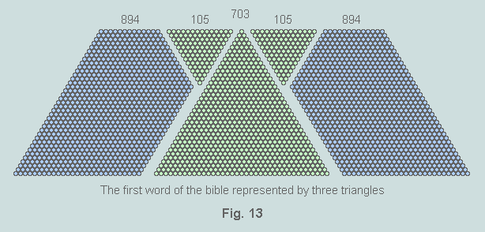
Bringing these five components together, we now have yet another symmetrical view of the Bible's first verse - one in which the first word appears as central element. Keep in mind that each figure in the following composite represents the sum of word CVs - as defined in Table 3.
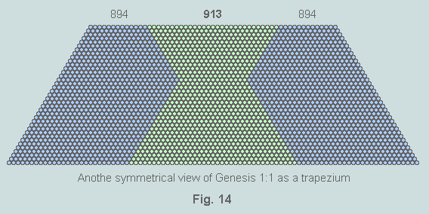
The entry of 894 into the proceedings focusses attention on the smaller, extrabiblical, set of four 3-digit numbers which satisfy the requirement that each is the sum of the cubes of its digits. I refer to {153, 370, 371, 407}. The sum of the first three of these is 894; the 4th is the 6th of Genesis 1:1; and the sum of the four is 1301 (compare with 2701) - this appearing in column P of Table 3 above. Moreover, two members of this set are multiples of 37, viz 370 and 407, whose sum is 777 (and thus equal to the sum of the nouns God, heaven and earth that occur in Genesis 1:1).

#18: There is a close affinity between Genesis 1:1 and the secular set {153, 370, 371, 407}. In addition, the first, 153, appears as a New Testament 'surface feature' in John 21:11
- Genesis 1:1 as a tessellated trefoil
Another division of the 7 CVs into the sums of 'odds' and 'evens' leads to yet more symmetrical representations of the verse. The details may be found here.
- Sums of the digits of the word CVs
A further feature of interest concerns the digit sums of these 7 word CVs. These are presented in Table 4. Here the primary digit sums occupy column K. Apart from that derived from word 3, we see that all are prime numbers - but that the sum of the two digits of this is also prime. Column L summarises the situation up to this point - every entry now a prime number. Finally, the secondary sums are recorded in column M. Observe that the column totals are 82 (digit reverse of 28 - the letter count of Genesis 1:1), 73 and 37 (the factors of Genesis 1:1) - 37 being the numerical hexagram representing the self-union of 28-as-triangle (see Fig.7).
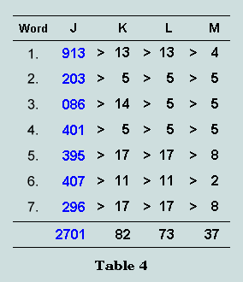
- Products of the letter and word CVs
A very large whole number is generated when the letter CVs are multiplied together. Thus, proceeding word by word, we have:
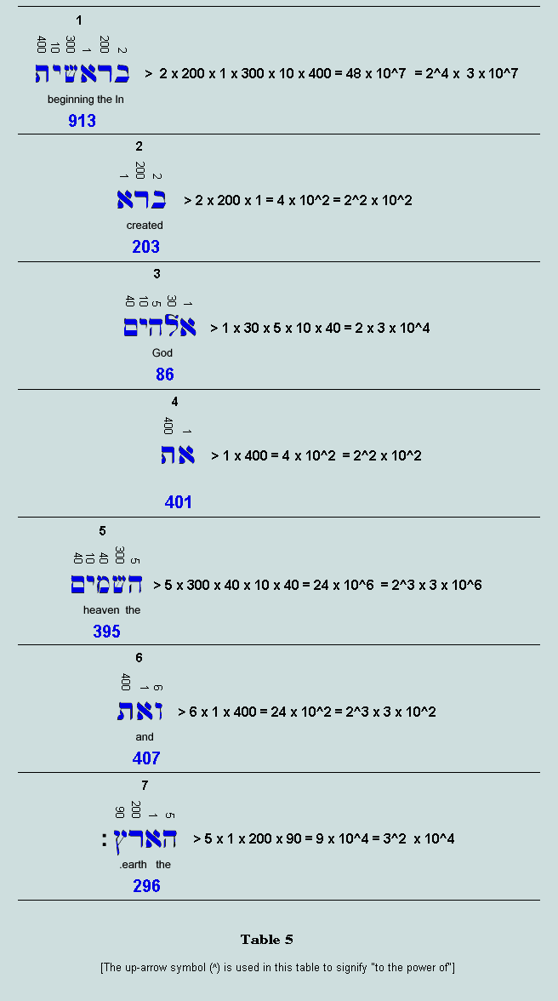
Clearly, if these seven products are multiplied together we obtain the desired result, viz 2^15 x 3^6 x 10^27, or - since each of the exponents is a multiple of 3 - (2^5 x 3^2 x 10^9)^3.
#19: The product of the letter values is a perfect cube.
This number may be alternatively expressed as 2.3887872 x 10^34
Another large number is obtained by multiplying together the word CVs, thus:
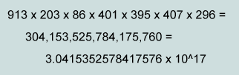
Observe, in the second line, that if the six groups of three digits are added together, we obtain 2701 - the CV of the verse! Also that the sums of their digits (following the procedure of Table 4) are 73 and 37, respectively, ie the factors of 2701.
The ratio of these products is 3.04153... / 2.38878... x 10^(-17), or 1.273255... x 10^(-17). This figure - multiplied by 10^17 - is within 0.0013% of the ratio of the perimeter of a square to the circumference of its inscribed circle (or, alternatively, the ratio of their areas). In other words, the significant 5-digit string "12732" is common to both.
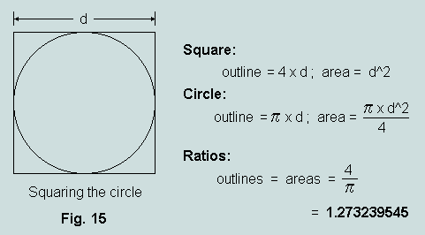
#20: The ratio of the word and letter products of Genesis 1:1 is related to the matter of squaring the circle.
The inversion of this ratio leads to a value for the universal constant "pi" in a very interesting and remarkable manner, thus:
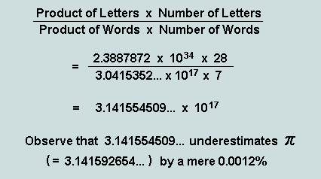
#21: The clear evidence that the Bible's first verse contains, within itself, all that is necessary to determine a value for 'pi ' correct to 0.001% - and in such a straightforward manner - suggests overwhelmingly that its Author, at the instant of its composition, was already fully aware of its later numerical implications; indeed, had designed it with these (and the other matters) in mind.

- Concatenations of word CVs
Observe that in base 10 representation all Genesis 1:1 word CVs have three digits (which involves writing the 3rd as '086' rather than '86'). The 21-digit number formed by concatenation these 7 values factorises thus:
913203086401395407296 = 2^6 x 7 x 37 x 131 x 1291 x 4159 x 7879 x 9941
This result is particularly interesting for two reasons: (a) 2368 (ie 64 x 37) is a factor - this being the CV of the Greek form of the name "Jesus Christ", nominative case - and since the claim is made (eg Jn.1:1-3, 10) that he is our Creator (ie the 'God' of Genesis 1:1), the matter is potentially significant; and (b) the fact that it has 13 prime factors - the largest having only 4 digits - is indicative of low probability and hence of design.
Only 120 of the 5040 concatenated arrangements are exactly divisible by 2368 - all of which are required to end with words 6 and 7 in situ. One final observation concerns the concatenation of these, viz 407296, which factorises thus: 2 x 86 x 2368. Since the related words are translated "and the earth", and 86 happens to be the CV of word 3 ('God'), the association of these numbers strongly suggests that Jesus Christ is, indeed, God Incarnate!
#22: The CVs of Jesus (888) and of Christ (1480) each have 37 and 296 (ie 8 x 37, and 7th word of Genesis 1:1) as factors. Since this opening verse is saturated with multiples of 37 - an object uniquely interesting per se - this particular number effectively binds together these several textually-related components.
- The cubic connection
Observe that 37 (along with all numerical hexagons) is the difference of two consecutive cubes, thus: 37 = 64 - 27 = 4^3 - 3^3; and that 73 (its digit reversal and other factor of 2701) is the difference between hypercube and cube, thus: 73 = 81 - 8 = 3^4 - 2^3. But there are other associations of interest; for example:
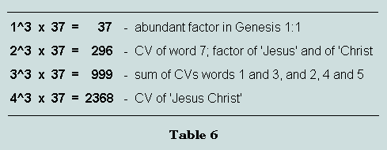
#23: These multiples of 37 (defined by the cubes of the rows of the tetraktys) strengthen the association of Jesus Christ with Genesis 1:1 and also uphold the Bible's claim to his being Creator. In this connection it is also worth noting the comments of #11, viz that the central letter of Fig.1 is 'yod', ie the first of 'Yeshua' (Hebrew form of 'Jesus'), and the central (untranslatable) word of Fig.4 is formed from the first and last letters of the Hebrew alphabet - clearly, equivalent to Alpha and Omega - the First and the Last (see Revelation 1:8, 21:6 and 22:13).
- A coordinated set
The CVs of Genesis 1:1 are not independent. Each can be shown to be a function of the parameters 37 (unique number) and 6 (first perfect number), thus:
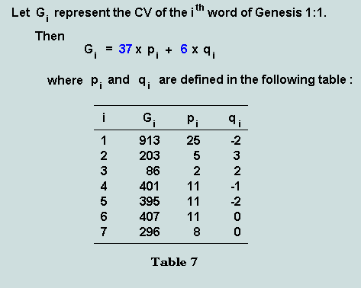
#24: The 7 word CVs of Genesis 1:1 are functions of the parameters 37 and 6, and are therefore related.
To summarise: many of the features found in this set of numbers are developments of those hinted at in the lexical structure - in particular, the structures of numerical geometry (specifically, triangle, hexagon and hexagram), and the important roles played by 37 (derivative of 28 - second perfect number) and 6 (first perfect number); other significant associations involve the Creator's name, the cubes and the problem of squaring the circle.
Return to Index
Section C: - New Testament Associations
Attention has already been drawn to the close numerical affinity that exists between the Lord's name, 'Jesus Christ', and Genesis 1:1 - the common factor 37 being the principal numerical binding agent. However, there is another matter that warrants attention. It concerns the riddle of Revelation 13:18 in which the uniquely triangular number 666 is associated with a promise of wisdom to those who, with understanding, read words as numbers. A detailed consideration of the issues is provided in the accompanying page 666 - and All That! - where two more triangular numbers, 153 (John 21:11) and 276 (Acts 27:37), are shown to be closely involved with 666 in directing attention to the Bible's first verse. Here is the nub of the matter expressed diagrammatically:
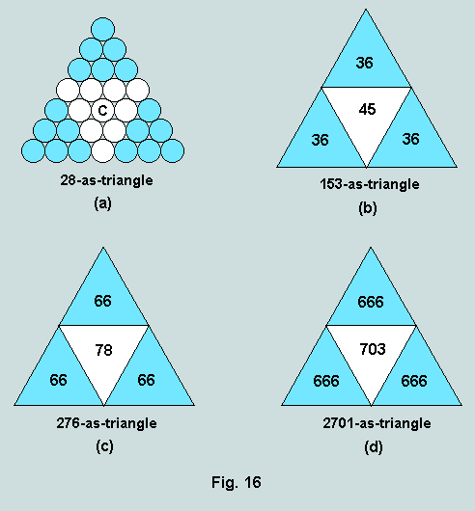
At (a), we have a repeat of Fig.9 where 10 - radix or base of our number system - is shown as tetraktys (ie its triangular form) in a setting of perfect numbers 6 (number of letters in the first word of the Bible) and 28 (number of letters in the first verse). Clearly, this is a highly significant structure per se - and one that is completely independent of radix. It is also a matter of some significance that, as denary objects, 6, 36 (or 6x6), 66 and 666 are all triangular. Observe now that if structure (a) is taken as a template, and satellites of 36, 66 and 666 be substituted around the triangular core (which, must become a triangle of order one more than these), then the respective outcomes are as shown at (b), (c) and (d).
At (d), of course, we have the triangular form of Genesis 1:1 with the 37th triangle representing the sum of words 6 and 7 inset.
#25: The riddle of Revelation 13:18 specifies the numerical features of Genesis 1:1.
To summarise: it may be argued that Revelation 13:18 - taken together with John 21:11 and Acts 27:37 - effectively specifies the numerical structure of Genesis 1:1. This strongly suggest that both have emanated from the same mind.
Return to Index
Section D: - Genesis 1:1 as a recreational object
It comes as something of a surprise to find that the word CVs display features that appear designed to catch the eye of those interested in recreational mathematics. Two examples will suffice.
- The resilience of word CVs 1 to 5
These words form what might be termed the 'supernatural component' of the statement. Their sum is 1998 which divides 999/999 on word boundaries (see Table 3). When written in reverse, the sum of these 5 numbers is still 1998 - as it is when the same cyclic permutation is applied to the digits of the individual values (rows 2 and 3), or to the block of five (rows 4 and 5), thus:
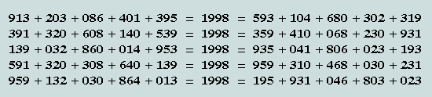
- The deletion of zeros phenomena
Here again is the numeric reading of Genesis 1:1:
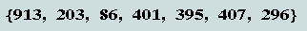
Observe that the 2nd, 4th and 6th word CVs have no 'tens' digit. Clearly, the central zeros are essential to maintain the integrity of these numbers, but as the foregoing analysis has demonstrated, this set of 7 is full of surprises. Accordingly, we are interested to know what would be the effect of omitting these zeros.
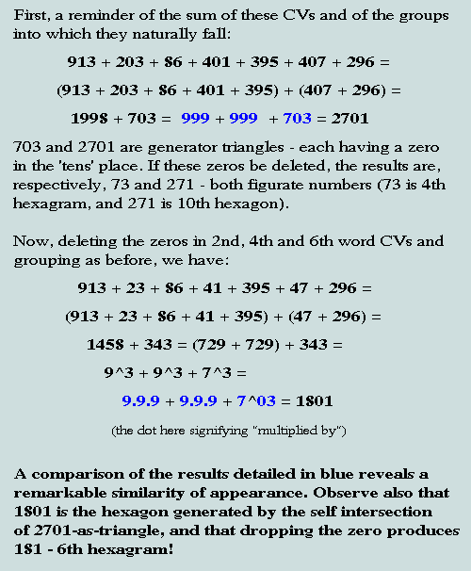
#26: Clearly, to plan such wonders must require foreknowledge of the system of numeration we enjoy today!
To summarise: these phenomena suggest that the Lord is prepared to use the lowliest of means to reach the heart of the unbeliever!
Return to Index
Section E: - An extrabiblical perspective
There are secular voices which reveal numerical links with Genesis 1:1. These provide hard evidence of supernatural intelligent design and purpose. Two examples follow.
- The abundant artefact
Earlier, in Section B, it was revealed that each of the word CVs of Genesis 1:1 could be expressed concisely in terms of the two parameters 37 and 6 - Table 7 defining the required coefficients. In an alternative schema, the final six may be similarly defined, now using the triangular number 105 with 99 - difference between 105 and the first perfect number, 6. Here is a picture of the background geometry:
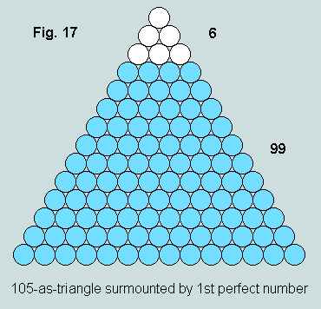
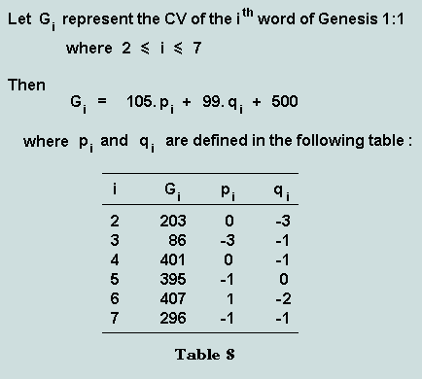
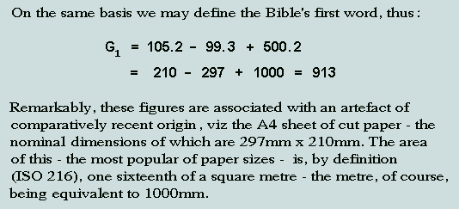
Observe also that if the triangle of Hebrew letters (Fig.1) be superimposed on the triangle in which 10 appears in the context of perfect numbers 6 and 28 (Fig.9) then the sums of the letter CVs within the four segments are as shown below:
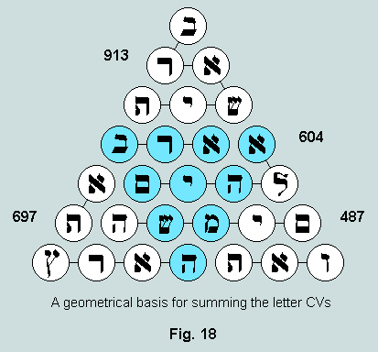
Let us now observe that these companions of 913 (CV of the Bible's first word) may all be simply expressed in terms of the same parameters, viz 105, 99 and 500, thus: 697 = 2.500 - 2.99 - 105; 604 = 2.500 - 4.99; and 487 = 2.500 - 2.99 - 3.105.
#27: The word CVs of Genesis 1:1 are echoed in the metric dimensions of an artefact that came into being in the 1960's. Adding to the mystery is the fact that the standard governing this matter is designated ISO 216 - 216 (or 6x6x6) being the outline of both Genesis 1:1 triangle (Fig.11) and trapezium (Fig.13).
The page Exceptional Measures describes these matters in greater detail.
- A square of distinction
The sequence of natural numbers 1 - 36 can be represented as a square 6x6 matrix, thus:
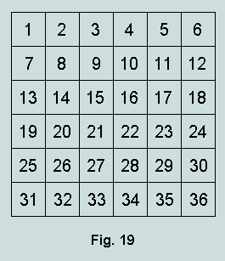
The sequence total is 666 (or 6 x 111) - the unique 36th triangular number. Summing the triangles and the squares indexed by these numbers (ie 1+3+6+...+630+666 and 1+4+9...+1225+1296) we obtain 8436 and 16206, respectively, ie 12 x 703 and 6 x 2701. Observe that 666, 703 and 2701 are the first three triangular multiples of 37 that define the geometry of Genesis 1:1 (see Fig.11 and Fig.16d). The grid of Fig.19 has 6 rows and 6 columns. Since the three sums referred to have 6 as factor, we inquire whether it be possible - by rearranging the numbers within the matrix - to generate for each row the totals 111, 2x703 and 2701 (for the numbers, and for the triangles and the squares they index, respectively). This is indeed possible. Here is a solution:
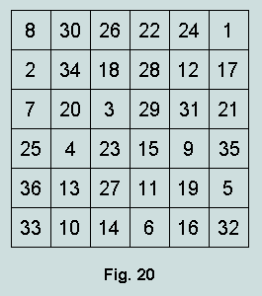
However, in addition to meeting these requirements, we now find, (a) the sum in each column and long diagonal is also 111 (or 3x37), (b) the four corner elements total 74 (or 2x37), (c) the peripheral elements total 370 (or 10x37), and (d) the central 16 total 296 (or 8x37).
#28: The 6x6 square demonstrates that there exists an absolute and extrabiblical relationship between the numbers 666, 703, 2701 and 296 - all multiples of 37 - and Genesis 1:1; in addition, 111 figures in the verse as factor of 777, 888 and 999; again, a number of these relationships carry geometrical overtones. Also, it should not go unnoticed that 370 links the square with the smaller set {153, 370, 371, 407} - already shown to be linked to be closely linked to the verse (see #19).
To summarise: here is further evidence of the miraculous; how does it come about that A4 - carefully specified by man as the most reasonable paper size for general use in a metric environment - embodies close links with the word CVs of Genesis 1:1? Clearly, nothing was further from the minds of those who drafted ISO 216; and neither, presumably, was the reference number of the document representing the outcome of their deliberations - 216, or 6x6x6, being the outline of 2701-as-triangle!! And as for the square array, the suggestion must be that its features played a significant part in the divine planning of Genesis 1:1!
Return to Index
Conclusion
The vexed question of origins is clearly subsidiary to the two more fundamental questions: Is there a God? and, if so, Is He the Sovereign God of the Judeo-Christian Scriptures? It is surely unreasonable to suppose that the defence of God's Being and Sovereignty should depend entirely upon the ingenuity and zeal of well-meaning supporters, and it should come as no surprise, therefore, to find that the Bible has within itself the means of delivering a crushing response to all who would challenge its veracity. Accordingly, we find integrated with the opening Hebrew words a remarkable confluence of numerical symmetry with features of considerable rarity or uniqueness. Such attributes invite a consideration of following train of logic:
- the opening words of Holy Scripture must, logically,be ascribed to the only eye-witness, viz God the Creator
- circa 200 BC, each of these words - in common with all written Hebrew words - acquired an additional meaning as a number
- on close examination, these numbers are found to be associated with a rich and meaningful structure which encompasses other portions of the biblical text as well as certain extrabiblical matters; this suggests, overwhelmingly, that they are not random accretions to the text - as might be supposed - but rather are features of design
- patently, such phenomena do not evolve
- they came into human view many centuries after these words were first recorded
- we can only conclude that these arbiters of truth are of supernatural origin and, because they elevate the significance of these controversial words, engender a high view of God, and are consistent with the remainder of Scripture, they must be regarded as purposeful additions - planned and implemented by the Creator Himself!
- these conclusions - backed up as they are by self-evident truths - pose formidable problems for all unbelievers, encourage believers, and remove all obstacles to a literal understanding of the Scriptures - the Creation narrative, in particular!
Vernon Jenkins MSc
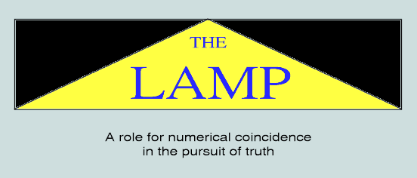
Index:
- Introduction
- Foundational principles
- The radix-dependent features of N-R
- The absolute features of N-R
- A summary of N-R
- The Bible and A-T
- The matter of the 'riddle'
- Conclusions
Return to Homepage
1 - Introduction
A well-defined structure (hereafter, N-R) is found to exist in the world of number per se - its roots extending into the arbitrary system, based upon ten, that man has devised to facilitate the writing and naming of numbers. There is the suggestion here that although essentially based upon his counting by fingers and thumbs, for other reasons, ten appears to be the natural choice of system radix! But there are other far-reaching implications: it transpires that the Judeo-Christian Scriptures are undergirded by a similar structure (hereafter A-T) which closely maps onto N-R!
Return to Index
2 - Foundational principles
Of all natural or 'counting' numbers, thirty-seven (usually written '37', or three tens plus seven) deserves special mention. As a denary object it is observed to involve the digits 3 and 7 - each of considerable biblical significance, whose sum is ten - radix or collective unit of the denary system of numeration. However, it is particularly in combination with three and its multiples that the attention-attracting features of thirty-seven are fully revealed. Some of the more striking of these are documented below; many are radix-dependent while others are absolute - ie independent of place, of time, and of man's hand! As the account unfolds, a second number, ninety-one, will be seen to emerge as a natural companion of thirty-seven.
Return to Index
3 - The radix-dependent features of N-R
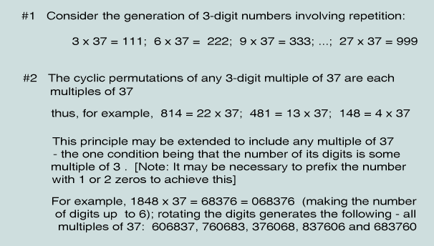
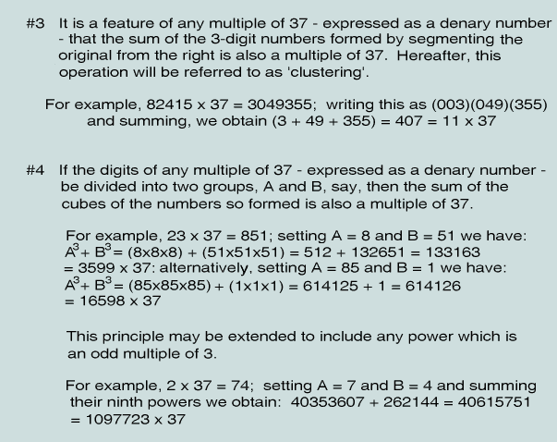
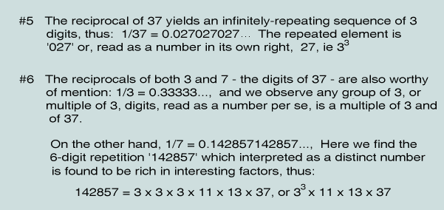
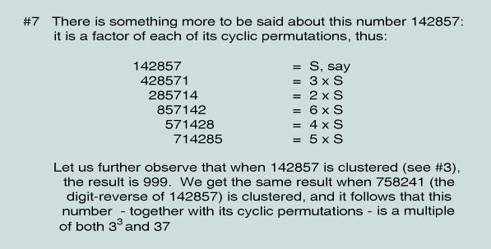
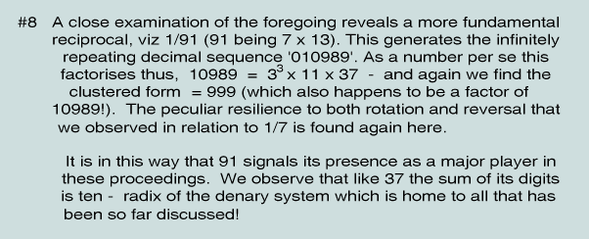
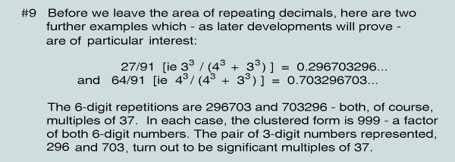
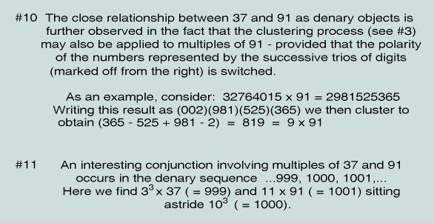
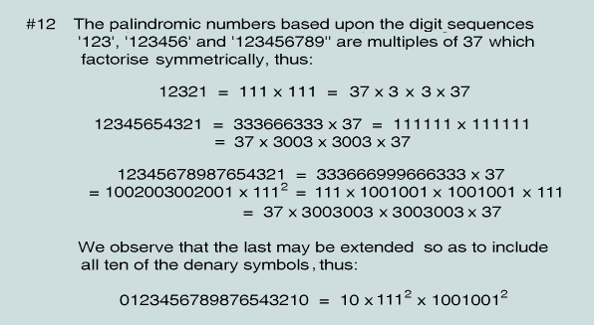
This list could be extended, but from what has already been catalogued it is clear that from the point of view of radix-dependency, the symbiotic combination {10, 37, 3} - now augmented by 91 - has been established as an essential and prominent feature of N-R
Return to Index
4 - The absolute features of N-R
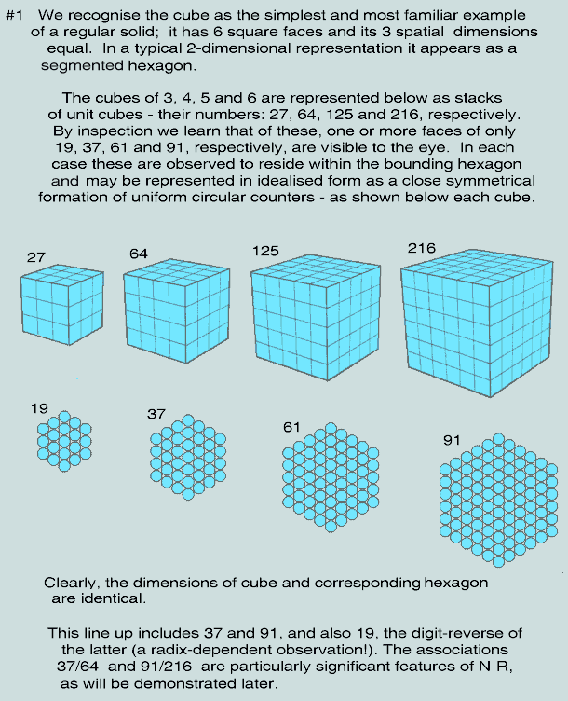
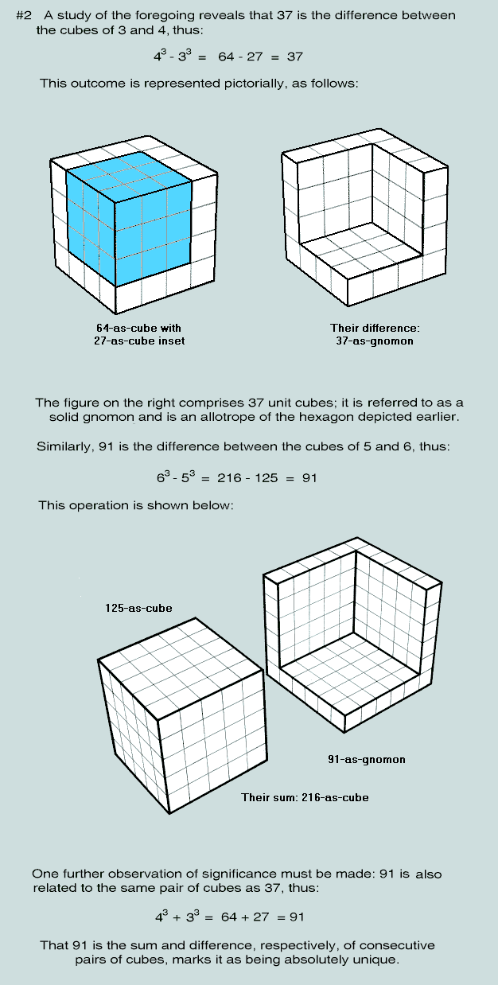
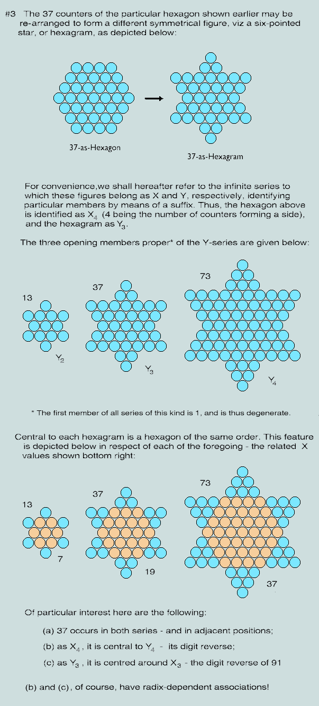
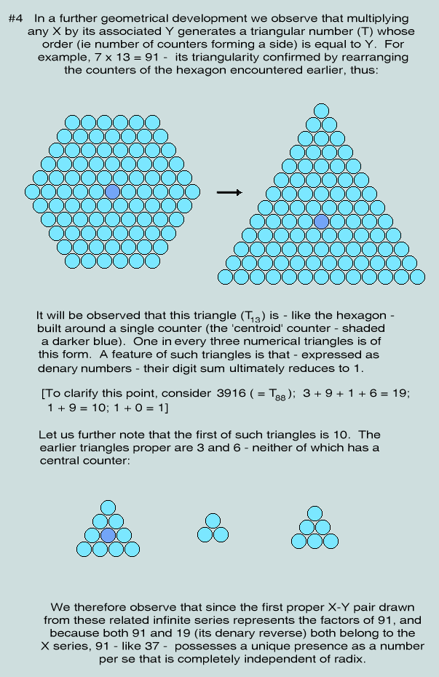
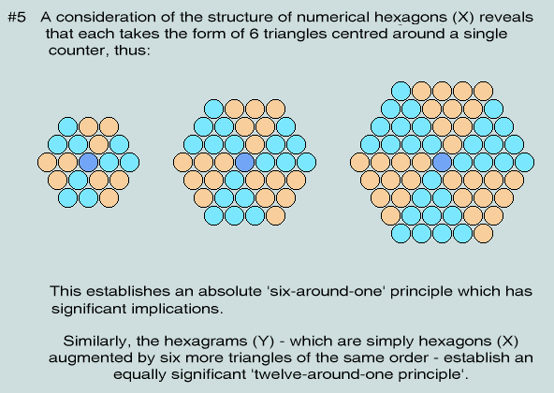
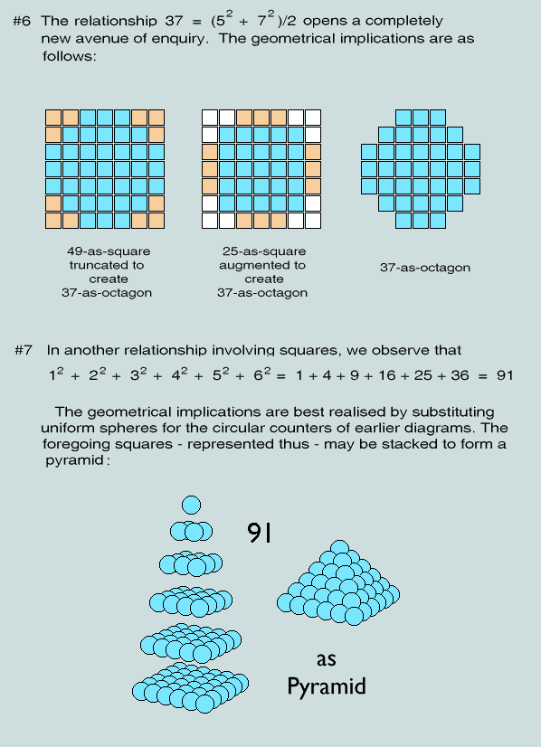
Return to Index
5 - A summary of N-R
The foregoing account identifies 37 and 91 as trifigurate numbers. In other words, each may be represented as a symmetrical arrangement of uniform counters in three distinct ways: 37, as hexagon, hexagram and octagon; 91, as triangle, hexagon and pyramid. This shared attribute of trifiguracy is neither bettered nor matched by any other natural number! Furthermore, 37 and 91 are related as difference and sum, respectively, of the cubes of 3 and 4.
In a denary context (familiar to all!) - and particularly in association with 3 and its multiples - this relationship is extended, and gives rise to many eye-catching curiosities that are particularly appealing to those seeking recreation through numbers. No other number, in this context, offers anything approaching the same degree of interest!
These observations are augmented by information from another quarter: Mr. J. Iuliano has drawn this author's attention to the following:
- the number 37 is rooted in the double periodic modular forms of Fermat's Last Theorem;
- an expression of the fine structure constant - ie the amplitude of an electron to emit or absorb a photon - involves 37, thus:
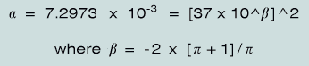
[Note: the up-arrow (^) is used here to represent 'to the power of ']
Clearly then, N-R - the structure that is defined by these parameters - is both real and unique, and it therefore follows that any artefact that is based upon the same parameters must command the widespread attention and respect of all who claim to follow truth - no matter where it leads!
Return to Index
6 - The Bible and A-T
The original Hebrew, Aramaic and Greek documents which form the basis of all Bible translations are also sets of numbers. [This matter is explained and elaborated here and here.] Attention focuses particularly on
- the opening Hebrew words of the first book - Genesis, and
- the Creator's name, 'Jesus Christ' (see Jn. 1 : 3, 10) as rendered in NT Greek,
for it is there that we meet the highest concentrations of the A-T phenomena.
Here are their salient features:
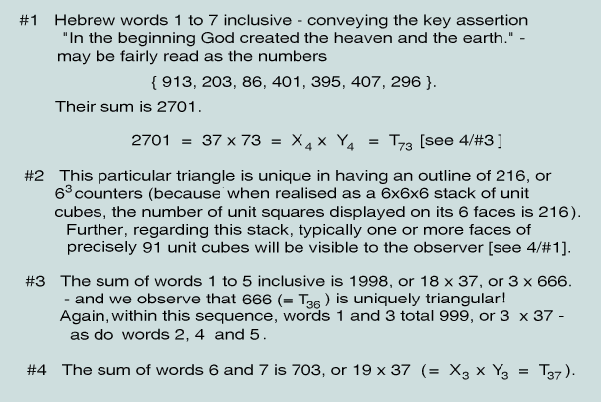
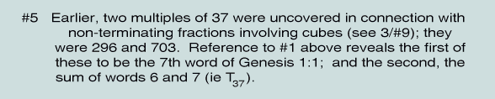
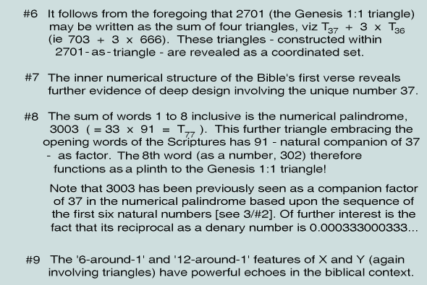
Clearly, 37 and its companion 91 - both remarkable as numbers per se, as we have seen - feature strongly in the first eight words of the Scriptures! However, the account is not complete for we have yet to consider the numerical implications of the Creator's name as it is rendered in the Greek, nominative case, of both Septuagint and New Testament:
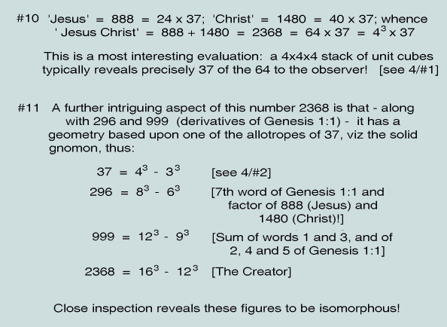
In other words, the 'Elohim' of Genesis 1:1 - a context dominated by 37, as we have seen - is also a multiple of 37 - and a unique one at that!!
Details relating to the foregoing statements may be found here, here and here.
Return to Index
7 - The matter of the 'riddle'
There is an explicit reference to 666 in Revelation 13:18. This multiple of 37 and unique triangular number is found in the context of an invitation to read Hebrew and Greek words as numbers - with the promise of wisdom to those who do! Intriguingly, the number is of the same form as 888 - 'Jesus'!
Later, in the same Book, the Christian is warned of the dire consequences of '...taking away from the words of the book of this prophecy...' - in particular, ignoring or trivialising the riddle and its clear implications (Rev.22:19).
There can be little doubt that A-T - the biblical number structure whose salient features have been briefly described above - is specified by the riddle of Rev.13:18.
Return to Index
8 - Conclusions
A careful assessment of the circumstances attending the writing of the documents which were to form part of the Bible reveals, (a) that the words of Genesis 1 predated by many centuries the use of Hebrew letters as numerals and, (b) that the Greek forms of 'Jesus' and 'Christ' were already in being some centuries before the Incarnation. Thus, unless we invoke some remarkable and extensive miracle of chance, the conclusion that must be drawn is that a supernatural hand has purposefully engineered these wonders!
Though other facets of the phenomena are to be found elsewhere in the Scriptures (these including powerfully-symbolic imagery), it is in the first eight strategically-placed Hebrew words (augmented by the New Testament evidence re the Creator's name), that they achieve their maximum impact. There they are seen to function as a seal that (a) confirms God's being and sovereignty, (b) speaks of his abiding interest in us, and (c) establishes the self-authenticating credentials of his word to man.
Vernon Jenkins MSc
666 - and All That!
"Here is wisdom. Let him that hath understanding count the number of the beast: for it is the number of a man; and his number is Six hundred threescore and six." (The Revelation of Jesus Christ, 1:1, 13:18)

Index:
- Introduction
- The riddle in focus
- The nature of the victory
- A fascinating number
- Tools for a numerical exegesis of the scriptures
- Partners in intrigue
- A view of perfection
- At the beginning
- Compound interest
- The Signature
- Conclusions
Return to Homepage
1 - Introduction
The number 666 has long been respected as an object of dark mystery. This stems largely from the specific reference in the Bible's last book where it is presented as the key to an intriguing riddle - one set in the broader context of a time of extreme apostasy and world domination by the beast. Less well-known are its three other scriptural appearances - two occurring in parallel passages; significantly, these raise further questions about this number. Thus, in 1Kings 10:14 and 2Chronicles 9:13 we read of the annual tribute of gold received by King Solomon; the specific figure, 666 talents, is quoted - yet we are also given to understand that this was just part of the total amount. Why this sum should be singled out for special mention is not made clear. However, it is undoubtedly interesting that Solomon - the personification of wordly wisdom and expert at solving riddles - should be so linked with Revelation 13:18. Again, in Ezra 2:13 we learn that following the Babylonian exile 666 males of the sub-clan of Adonikam returned safely to Israel. But in a parallel passage (Nehemiah 7:18) the figure is given as 667! The discrepancy in book-keeping - though slight - seems designed to further engage our attention. And strangest of all, what are we to make of the oblique reference to 666 in Revelation 15:2 where we read of those whose ultimate victory over the beast includes victory over his number?!
Return to Index
2 - The riddle in focus
There can be little doubt, (a) that it is God who has chosen the number 666 as a tag for the beast, (b) that it is He (God) who poses the question, and (c) that its solution is intended to further some serious purpose (the words of Revelation 22:19 and the imperative of the riddle itself making this abundantly clear). At first sight the problem appears to consist in the equating of a man's name with the number 666; however, if this really is the nub of the matter, why is it that we then encounter insuperable problems? For example, such a procedure would require that there be in place a widely acceptable system of alphabetic numeration. While this would have been true when the words of Revelation were first written (the widespread use of Greek and Hebrew letters as numerals providing a natural basis for such a conversion), it is no longer so - unless, of course, we are intended to confine our attention to Greek and Hebrew names only. But, even then, it is hard to see a definitive solution emerging, and we are left with the question that should, perhaps, have been asked at the outset: What serious purpose is likely to be served, anyway, in identifying an individual whose name bears this number? It is hardly likely that it would offer us some input into a rewriting of the prophecy of Revelation 13!
A strictly literalistic approach to the riddle seemingly destined to fail, therefore - this suggested by the investigator's need for understanding (AV), or insight (NIV) - we seek some further guidance. Because the Greek language has no indefinite article, the word may be equally translated, "of a man" or "of man". Hence we find "...number of a man." (AV) rendered, "...man's number" (NIV), and "...number of humanity" (NLB - footnote) - which, though disposing of some of the problems noted above, offer little more in the way of positive assistance. However, the alert reader will be already aware of one clue as to what the riddle's solution might involve, viz the use of gematria - ie the reading of the original Greek and Hebrew words and/or word sequences of the scriptures as numbers! But before setting off along this track there is the intriguing matter of Revelation 15:2 to be addressed: What are we to understand by "victory... over"... 666?
Return to Index
3 - The nature of the victory
What does it take to overcome a number - this number, in particular? We observe that to achieve success in any area of endeavour - be it military conflict or other - it is necessary that you first know your enemy. A reasonable strategy, therefore, appears to be as follows:
- determine the features of 666 as a number per se
- if it is found to possess textual links with other numbers, examine their features also
- consider the scriptural contexts in which each of the instances of 666 are found
Implementing these principles alone may not be sufficient to reveal the whole truth - but they must, surely, bring it closer!
Return to Index
4 - A fascinating number
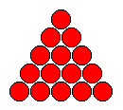
Mathematics is universally respected as a primary source of objective truth. In essence it is concerned with number and form - concepts that are found uniquely combined in a particular class of objects: the figurate numbers. The simplest of these arises directly from the operation of counting by reciting the sequence of natural numbers thus: "One, one plus two, one plus two plus three,...", so generating the triangular numbers, 1, 3, 6, and so on, without limit. A typical example is seen in the game of snooker where, at the beginning of each frame, the fifteen 'reds' are arranged in the fashion of an equilateral triangle. Clearly, the symmetry of form observed is a fundamental property of fifteen; it is completely independent of any symbolism invented to represent it, and is universal and immutable.
It transpires that 666 is a triangular number. Because it stands on a base of 36 it is designated the 36th in the series. But 36 is also triangular (the 8th) - as is every other numerical attribute of 666! This remarkable fact - demonstrated below - is crowned by the realisation that the sum of these triangular attributes is 216, or 6.6.6 - ie a cube of side 6! This cube is itself unique in that the number of squares that are visible on its six faces is equal to the number of unit cubes from which it is constructed.

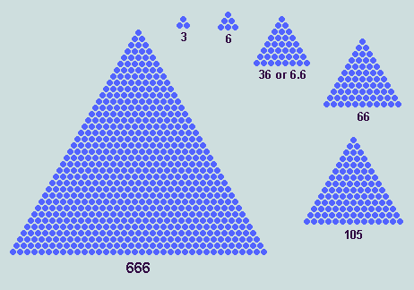
[It should not escape our attention that the riddle speaks of counting the number of the Beast. This is made literally possible in the foregoing figure!]
Numerical attribute of 666 | Value | Order of Triangle
No of sides and angles | 3 | 2
Visible feature of 666 | 6 | 3
No of counters forming a side | 36, or 6.6 | 8
Visible feature of 666 | 66 | 11
No of counters forming outline | 105 | 14
The fertile role played by the digit '6' in this scenario is striking: 6, 6.6 (six times six), 66, and 666 are all triangular! This remarkable sequence (which does not extend beyond this point) is, of course, radix-dependent. In other words, were these numbers to be expressed in any system other than denary the visual binding would disappear.
The entry of these rare examples of plane and solid numerical geometry into these proceedings is highly significant for they represent another important clue in our quest. Attention has already been drawn to the simple but remarkable truth that the scriptures, as originally written, may be fairly read as sets of numbers! Of course, it would be natural to suppose that such numbers were mere 'accidents of circumstance' - and hence, utterly devoid of meaning. But what if it could be shown that they possess substantial links with the elements of numerical geometry depicted above?!
Factorising 666, we obtain
- 666 = 6. 111 = 6. (3. 37)
- 666 = 18. 37 = (6+6+6). 37
The pleasing form of 111 (ie 100+10+1) and its multiples also depends on the background presence of ten - this feature disappearing if we write the number in binary (1101111), in octal (157), in hexadecimal (6F), or indeed, in any other system of numeration. We have already noted that 3 - here represented as the number of digits, as the sum of the digits, and as a factor - is triangular.
Concerning 37 and 6, we have the interesting equality 37 = 666/(6+6+6); but, more generally, we remain firmly in the realm of numerical geometry where we find further examples of their close relationship, thus:
- Thirty-seven uniform counters may be arranged on a flat surface to form any one of three symmetrical figures, octagon, hexagon, and hexagram:

It is one of just two trifigurate numbers (the other being 91), but superior in possessing a total of 16 axes of symmetry. To make matters even more interesting,
- 73 (its denary reflection) is a unifigurate with hexagram symmetry:

- This hexagram is found to be geometrically coordinated with the hexagon and hexagram forms of 37
- In analogous relationships, 37 and 19 are also seen to be coordinated
- The octagonal form of 37 participates in similar relationships with the squares, 49 and 25
- 37-as-hexagon is a typical view of 64-as-cube and, being itself the difference of consecutive cubes, it has a 3-D presence as a solid gnomon:
And, regarding the factor 6 per se: in addition to being third triangular number (as we have already seen), it is also first perfect number and a feature of the hexagon, hexagram and cubic geometries listed above.
Return to Index
5 - Tools for a numerical exegesis of the scriptures
If the numbers represented by the words and verses of the scriptures do represent a second channel of communication (instituted by their author, for reasons of his own) - as hinted at by the riddle - then it would be reasonable to infer that the solution we seek consists of a set of mathematical keys that, (a) would confirm the fact of an encryption and (b) enable us to deduce matters of significance concerning the scriptures and their author. Let us, therefore, summarise the keys that arise directly from our examination of 666:
- the symmetrical structures of numerical geometry - notably the triangle, hexagon, hexagram, square and cube; independent of radix, time and place, these absolutes of regular form speak to all generations and conditions of men
- in particular, we observe the elevated status of 37; its geometrical coordination with 73, with 19, with 25 and 49, and with 64 (its implied 3D projection);
- and again, the visually arresting series of triangular numbers, 6, 36 (6.6), 66, and 666
- numbers of the form 'ddd' (1<=d<=9), ie simple multiples of 111
- 10 - the 'collective unit', or radix, in our denary system of numeration and measurement - an unseen but vital component of all the radix-dependent phenomena listed here
In due course we shall examine a number of prominent biblical features for the presence of one or more of these keys. However, before we do that, it is appropriate that we make one final observation regarding 666.
Return to Index
6 - Partners in intrigue
Our attention is drawn to two further numbers that - like 666 - lie 'on the surface' of the biblical text, viz 153 and 276. These are explicitly and precisely given as the number of fishes caught in a net (John 21:11), and the number of souls saved from a shipwreck (Acts 27:37), respectively. Readers of the New Testament may readily confirm that its allusion to large numbers - exceeding 100, say - are comparatively rare, and that the bulk of those that do occur are either 'round' - ie end with one or more zeros, like 144,000 (Revelation 14:3) - and/or are approximate - eg 'about 5,000' (Matthew 14:21) - and/or are expressions of a measurement of some kind - eg '200 cubits' (John 21:8) - and therefore depend on time and place. Indeed, the only exceptions are 153, 276, and 666! This trio is further distinguished by the common theme 'out of the sea'; further, the fact that 'none were lost' links the first with the second; and 'onlooker standing on the seashore' links first with third. Again, all three numbers are triangular! But matters do not end there, for we find that these triangles are related in a subtle way - the explanation launching us immediately into a test of our hypothesis.
Return to Index
7 - A view of perfection
In a simple but remarkable instance of numerical geometry we find 10-as-triangle (known to the Pythagoreans as tetraktys) occupying a central position in a triangular setting of the perfect numbers, 6 and 28 (3rd and 7th triangular numbers, respectively). The picture is powerfully symbolic: the trio of satellite 6's spell out the number '666', and the outline of the composite 28-as-triangle is 18, or (6+6+6)!

Taking this structure as a template - and observing that the order of the core triangle is one more than that of its satellites - we proceed to make each remaining member of the unique triangular series, 6, 6.6, 66, and 666, satellite, in turn. The results are given in the following table.
Satellite | Core | Composite
6 | 10 | 28
6.6 (36) | 45 | 153
66 | 78 | 276
666 | 703 | 2701
We observe 153 and 276 - the biblical companions of 666 - appearing in the 'composite' column. But it is to the bottom row of figures, 666, 703, and 2701, that our attention is principally directed. These are the first three triangular multiples of the unique trifigurate, 37. Thus: 666 = 18.37, 703 = 19.37, and 2701 = 37.73. The pairs of prime factors involved in the last two will be recognised as the geometrically-compatible figures depicted earlier. And, one additional coincidence, the outline of 2701-as-triangle comprises 216 counters, or 6.6.6 - sum of the attributes of 666, as observed earlier!
Here is a geometrical representation of these figures:
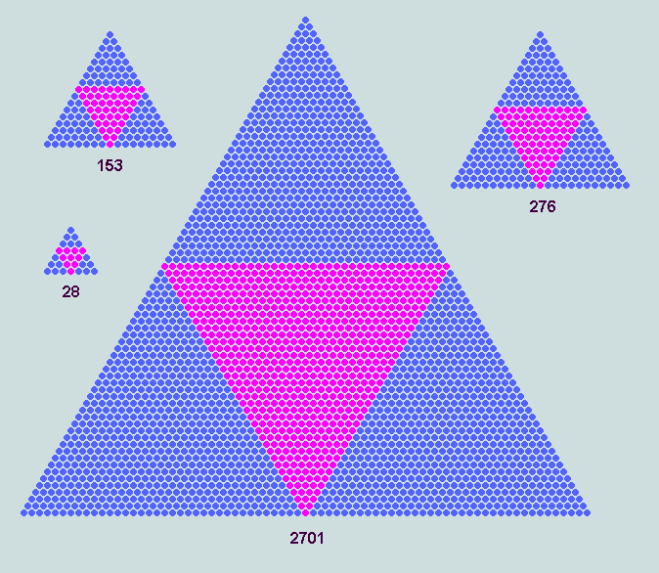
The final picture takes us back to the beginning of the Bible's first book - Genesis - where we find in the opening verse of seven Hebrew words the informative message, "In the beginning God created the heavens and the earth."
8 - At the beginning
Return to Index
Here, in the original (reading from right to left), are the seven words of the Bible's first verse (Genesis 1:1) with AV English and numeric translations:
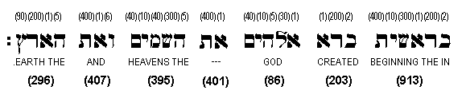
Along the top are the values of the letters, read as numerals according to the alphabetic scheme introduced into Israel c 200 BC; the numbers below represent the word values - these derived (following historical practice) by summing the corresponding letter values. The central word is untranslatable - but necessary to sustain the grammar of the verse.
Let us immediately observe the following:
- there are 28 letters in these 7 words (ie the value and order of the 'template' triangle depicted above!)
- the verse value (ie the sum of the seven word values) is 2701 (=37.73) - the 3rd triangular multiple of 37 (depicted above!)
- words 6 and 7 (translated, 'and the earth') - each a multiple of 37 - total 703 (=19.37) - the 2nd triangular multiple of 37 (the inscribed triangle depicted above!)
- words 1 to 5 (i.e. the first five of the Bible) total 1998, or 3.666 - ie three times the 1st triangular multiple of 37!
- closer scrutiny reveals that the whole set of seven is even more deeply committed to the unique number, 37, as the following transformation, modulo 37, reveals:
{913,203,86,401,395,407,296} => {-12,18,12,-6,-12,0,0}
This implies that of the 127 possible combinations of these seven values, 23 will be found to be multiples of 37 - ie nearly 7 times the number expected in a truly random set! In this process, we find that each of the seven values is involved precisely 12 times. We further observe that the ubiquitous 6 is a factor of each element of the transformed set.
Several of these multiples of 37 - expressed in denary notation in the usual way - are, like 666, of the form 'ddd', thus:
913+86 = 203+401+395 = 999; 86+395+296 = 777; 86+395+407 = 888
Particularly interesting is the fact that words 1 to 5 divide evenly, and that the sum of the last two (ie 703) is 296 (the last) short of the same total, 999!
Return to Index
9 - Compound interest
Because the factors of 2701 (=37.73) have prominent and related geometries of their own, further symmetrical representations of Genesis 1:1 are made possible. The following figure is constructed of 73 elements - each a symmetrical arrangement of 37 counters (in this case, solid gnomons - but octagon, hexagon, and hexagram forms are possible alternatives).
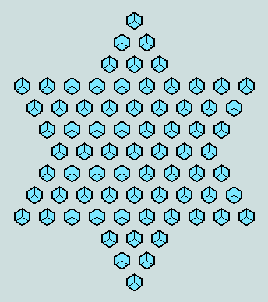
[Of course, such compound geometries can be inverted - thus, 73-as-hexagram could appear as an element in any of the four possible arrangements of 37.]
Similarly, 703 (=19.37) - representing "...and the earth." - can be expressed as a compound hexagon and integrated with the foregoing figure to obtain:
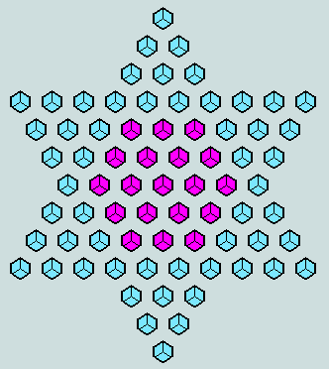
One further step is possible in this graphical expression of Genesis 1:1. Around the central hexagon we observe a hexagonal ring of 18 elements representing 18.37, or 666. This feature is displayed below, and with it we are reminded of the subject matter of Revelation 13 - "...and the earth." (mankind included) - in the tight embrace of the beast!
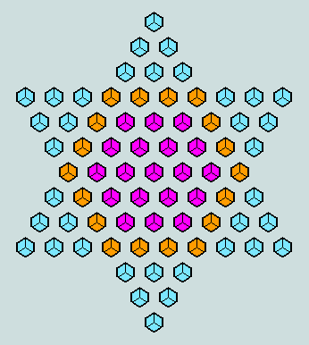
At this point, we have to ask whether it is reasonable to believe that such a rich confluence of coordinated numerical geometries and possibilities of expression - as here demonstrated - are likely to arise by chance in the first seven words of a large book for which the claims, God-breathed ...useful for teaching, rebuking, correcting, and training in righteousness, are made (2Timothy 3:16, NIV)?
Clearly, such miracles are not commonplace! However, they continue...
Return to Index
10 - The Signature
It is the Christian's understanding that the God who introduces himself in the Bible's first verse is none other than Jesus Christ (see John 1:1-3, 10; Colossians 1:16: Hebrews 1:10). The New Testament authors wrote in Greek using words which may also be fairly read as numbers, as we have seen. It follows that the name Jesus and the title Christ each possess an uncontrived numerical dimension. Skeptics will no doubt contest this, arguing that these writers would have been aware of the numerical implications of what they wrote and - assuming they would also have known of the Genesis 1:1 phenomena - must have engineered name and title accordingly. This suggestion overlooks the fact that identical forms of both name and title are to be found in the Septuagint (a Greek translation of the Old Testament dating from c.300 BC). This important matter is addressed elsewhere - but here are some of the more obvious details:
Jesus - is the Greek form of the Hebrew name Joshua, ie Jehovah is salvation; it had been assigned to the babe in the manger by divine decree in the words of the angel, "… and thou shalt call his name Jesus: for he shall save his people from their sins." (Matthew 1:21).
Christ is the Greek form of the Hebrew title mashiach - ie Anointed One or Messiah - the promised saviour who would, one day, come to redeem mankind from its sins; His tacit acceptance of the title follows Peter's utterance, "Thou art the Christ, the Son of the living God." (Matthew 16:16).
It must be significant that Holy Scripture identifies the Christ explicitly by name, but the Antichrist by the number of his name - 666! Significant, too, that God has chosen this unique numerical object to mark the Antichrist and to associate it with the promise of wisdom. As explained earlier, the Greek form of the Lord's name and title may also be fairly read as a pair of numbers, or characteristic values; thus, in the nominative case, Jesus = 888 - the inevitable outcome of the divine edict of Mt.1:21 - and the title, Christ = 1480. Some of the implications of these evaluations are now considered:
- 888 is of the same visually-arresting form as 666; like 777 and 999 (features of Genesis1:1) both are multiples of 111, or 3x37
- 888 (= 24.37) and 1480 (= 40.37) are multiples of 37 and of 296 (= 8.37) - the latter being the characteristic value of the 7th Hebrew word of Genesis1:1, meaning the earth; clearly, it has an obvious and direct association with Jesus, the One having a unique earthly mission, viz the redemption of mankind!
- the ratio of these numbers is 3:5 - precisely that of the sides of the mercy seat or propitiatory (Exodus 25:17); it may be noted that Paul uses this term to describe the role of Jesus as High Priest (Romans 3:25), and the matter is mentioned again in Heb.9
- the sum of these numbers is 2368 (= 64.37), or 43.(43-33) - significant because the cube is a biblical symbol of holiness (eg 1Kings 6:20, Revelation 21:16), and because a typical 2-D view of 64-as-cube is 37-as-hexagon!
Already we observe several of the numerical keys derived from the preceding examination of 666, and our attention is drawn to the dominant role played by 37. Its significance in Genesis 1:1 (representing the creation) has already been demonstrated; here it is again - now associated with the Creator! It seems evident that this unique number is being used to establish a powerful numerical linkage between subjects that are already related textually! However, to continue with our analysis:
- As we have already seen, the third numerical hexagram has 37 elements - 24 of these forming its outline. These features lead to elegant expressions of The Name. The compound symmetries depicted in the following diagrams involve 64-as-cube (the purple elements), 37-as-solid gnomon (shaded blue), and 27-as-cube (smaller elements, also shaded blue).
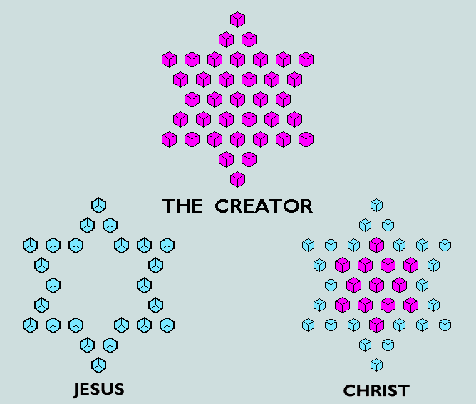

The topmost figure represents 2368 as a hexagram of 37 cubes, each of value 64; at lower left we have an outline hexagram of 24 elements, each of value 37 - total, 888; on its right we have an inner hexagram of 13 elements, each of value 64, and an outline hexagram of 24 cubes, each of value 27 - total, 1480.
These structures may be symmetrically superimposed upon that derived earlier for Genesis1:1 with powerful symbolic effect!
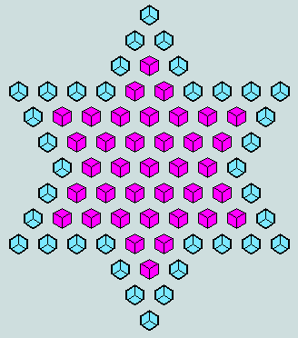
Of course, the inner hexagram representing The Creator, Jesus Christ, may be exchanged for a hexagon of 37 cubic elements; in this form, it covers, precisely, the earth in the grip of the beast!
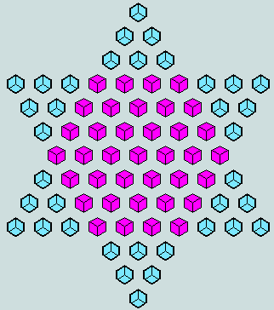
The total represented by each of these figures is 3700 - the sum of the names of the twelve Hebrew tribes engraved on the jewels of the high priest's breastplate of judgment (Exodus 28:15-30). A close examination of this matrix reveals the unique trifigurate, 37, in yet another significant role!
- The characteristic value of the 7th and last word of Genesis 1:1 - translated the earth - is 296, or 8. 37. In addition, it has been shown to be a factor of both components of The Name. Significantly, therefore, the 4th solid gnomon may be combined with a further seven to form a hollow cube of 296 units. This construction is depicted in the following diagrams - those on the left illustrating the early stages of this process.
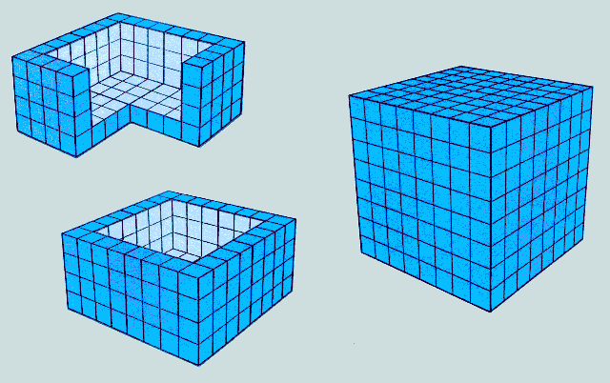
The cube which fits perfectly inside this structure is, of course, 6.6.6, or 216 - the triangular outline of Genesis 1:1! There is the strong suggestion of profound symbolism here, for from within this first verse comes that which ultimately embraces it! And we are led to understand how special man is in the eyes of his Creator. Again, the symbolism built into the numbers themselves should not be overlooked: 8.8.8 (the cube of 8) suggesting 888 ('Jesus' - the Christ); 6.6.6 suggesting 666 (the Beast, or Antichrist); and their difference, 296 ('the earth' - centre of the battle that rages for the souls of men!). A further matter of interest concerns the outer- and inner- dimensions of these cubes: written side by side to form a denary object, these numbers spell '86' - the characteristic value of God as we find it in the Bible's third word!
- Finally, it should be noted that three of the hollow cubes described above (representing 'Jesus') may be combined with a further five (representing 'Christ') to form a larger cube (representing The Name).
Return to Index
^{11 - Conclusions}
Whilst it is perhaps premature to claim that the riddle has been completely solved, the course followed in the preceding pages has yielded significant fruit. We are already a lot wiser - as Revelation 13:18 promised we would be! Significantly, there exists no loophole for the proponent of naturalism, for backing the empirical data are certain historical facts that cannot be lightly dismissed, viz
- the Hebrew scheme of alphabetic numeration post-dated Genesis 1:1 by many centuries;
- the Lord's name and title appeared in Septuagint Greek some 300 years before his birth.
What we have been considering, therefore, is watertight evidence of supernatural design! And it all makes sense, for it is not unreasonable to believe that the Creator would want to underwrite the truth of a statement that He foresaw would, one day, be flatly denied, or watered-down, by the majority of the world's intellectuals; moreover, that He would also want them to know the true identity of its Author!
Of man's many failings, the greatest is to believe that God is either dead, or else is One whose thoughts and actions are limited by what he (man) considers possible or appropriate. If the foregoing analysis has taught us anything, it is that He is neither of these, but rather an Almighty and Boundless Being who is in control, has ever been in control, and will ever remain in control, of all things!
He has already provided us with an intelligible message (the biblical text); now He has made it possible for all who will to witness a standing miracle formed in the numbers that adhere to the opening words of His message. Clearly, its purpose is to win the heart of the unbeliever, and strengthen the faith of all who already believe.
Incidentally, the meaning of the Hebrew name Adonikam (introduced in section 1) is My Lord has arisen!
^{Vernon Jenkins MSc}
Formerly Senior Lecturer, Dept. Mathematics and Computer Science, The Polytechnic of Wales (now the University of Glamorgan).
Author of The Ultimate Assertion: Evidence of Supernatural Design in the Divine Prologue, CEN Tech.J., vol.7(2), 1993,pp.184-196
Exceptional Measures
The specification of a latter-day artefact (and more) foretold

Index:
- Introduction
- The principal features of 1260
- A simple matter of fact
- Some immediate implications
- A reminder
- Interesting developments
- Continuing developments
- Further implications
- Conclusion
Return to Homepage
1 - Introduction
The remarkable features of 666 as a number per se have already been demonstrated in the earlier paper, "666 - and All That!", and the riddle in which it features (Rv.13:18) shown to be the key to a fuller understanding of other passages of Scripture - Genesis 1:1 in particular. But another large number appears in close proximity to 666 and it is appropriate that we now give it some attention. It refers to a harrowing period of time - intriguingly presented first as 1260 days (Rv.12:6), then as "a time, times, and half a time" (Rv.12:14; also Dn.12:7!), ie one plus two plus a half years, and again as 42 months (Rv.13:5) - the two latter clearly relating to a 360-day year and 30-day month.
What lies behind this interesting variety of expression? Is it possible that the reader's attention is being purposely drawn to some significant matter concerning 1260? Such questions can only be answered by first studying the features of 1260 as a number per se - thereafter, allowing it to lead us where it will.
Return to Index
2 - The principal features of 1260
Like 666, its close scriptural companion, 1260 displays imposing geometries based upon the equilateral triangle:
(1) Though not itself triangular, it is the LCM (lowest common multiple) of 12 triangular numbers (the first 9 and 3 more)! In other words, 1260 is the smallest number into which 1, 3, 6, 10, 15, 21, 28, 36, 45, 105, 210, and 630, exactly divide.
(2) It is seen to be 12 x 105 - 105 being the perimeter of 666-as-triangle and 14th triangular number - a fact that establishes a firm geometrical link between 1260 and its biblical neighbour, 666.
(3) To add to the uniqueness of the occasion, we observe that of the 1413 triangular numbers in the first million natural numbers, only 4 have the property displayed here by 105, viz that its double, 210, is also triangular!
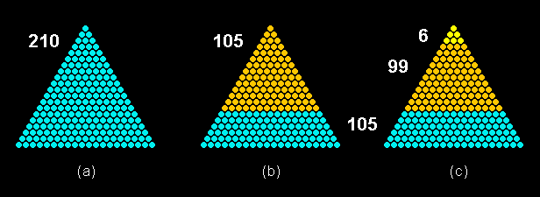
Figure 1: Important subdivisions of 210-as-triangle.
[Note: the significance of (c) will be made clear as we proceed]
Because of this rare phenomenon, the 21st numerical hexagon comprising 6 x 210-as-triangle symmetrically arranged around a single counter is equal to the 15th numerical hexagram comprising 12 x 105-as-triangle, similarly arranged.
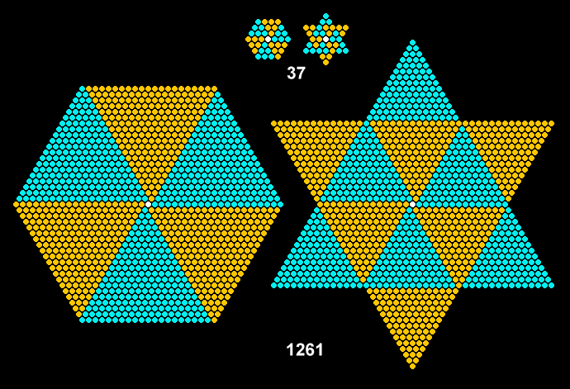
Figure 2: The geometrical forms of 1261 mirror those of 37.
Without the central counters, these figures represent 36 (the dimension of 666-as-triangle) and 1260, respectively. What is portrayed here is an exceedingly rare phenomenon - there being only 3 examples in the first million natural numbers! It will be noted that the first example is 37 - highest prime factor of 666 and abundant factor of Genesis 1:1.
(4) Clearly, the day following this 1260-day period of tribulation will be the 1261st - represented here by the completed hexagon or hexagram!
(5) Symbolically, the six-around-one principle of the hexagon speaks of the creation week; the twelve-around-one of the hexagram, of the Lord and the twelve tribes, or of the Lord and his disciples!
(6) Significantly, the same symmetries are to be found in what abounds in nature, viz the snow crystal!
Clearly, these attributes of 1260 are completely in accord with earlier observations - and they lead us into new pastures of discovery!
Return to Index
3 - A simple matter of fact
Recommended as an international standard by ISO in 1961, the A-series of cut paper sizes is now well-established in many countries. It is based upon a rectangle (A0) having an area of one square metre and sides in the ratio 'square-root of two to one'. These proportions are automatically conferred upon its progeny - A1, A2, A3, and so on - by the simple process of halving. All dimensions are expressed to the nearest whole number of millimetres.
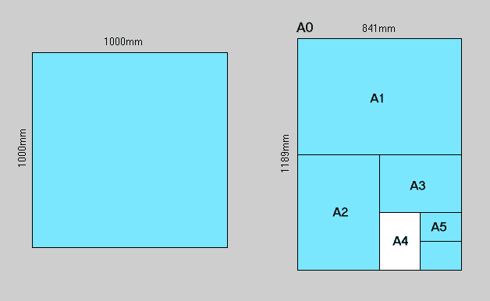
Figure 3: The basis and derivation of the A-series of cut paper sizes.
Its best-known representative is A4 - currently the most popular medium for recording and communicating the written word. This is nominally 297mm x 210mm and represents an area of one sixteenth of a square metre.
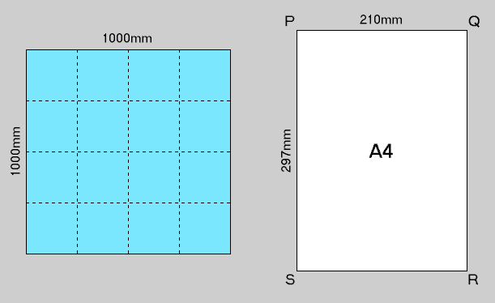
Figure 4: A dimensioned A4 sheet
Return to Index
4 - Some immediate implications
As the following diagram reveals, six A4 sheets laid side-by-side have a combined width of 6 x 210, or 1260 millimetres. Two more sheets, aligned and set lengthwise below these - one at each end - are seen to be separated by a gap of 666 millimetres!
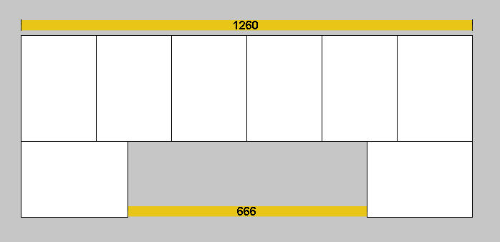
Figure 5: 666/1260 revealed in a symmetrical arrangement of A4 sheets.
Return to Index
5 - A reminder
Earlier pages have drawn attention to the following set of eight numbers that represent a fair alternative reading of the Hebrew of the Bible's opening verse (of 7 words) and next following word:
G = { 913, 203, 86, 401, 395, 407, 296, 302 }
That these are found to be simple derivatives of A4 (its design based upon the metre, its standard subdivision - the millimetre, and the square-root of 2 - or vice-versa!) - is clearly a matter of some consequence!
Return to Index
6 - Interesting developments
Let us note right away that the 7th of these numbers is one less than 297 (length of an A4 sheet in millimetres), and that the 3rd is one less than 87 - the difference (in millimetres) between it sides. [This matter is pursued in the third of the appendices referred to in section 8.] However, our immediate observations will involve the use of a pair of intersecting rulers, graduated in millimetres: the horizontal ruler having the ability to move up or down only, and the vertical ruler, right or left only.
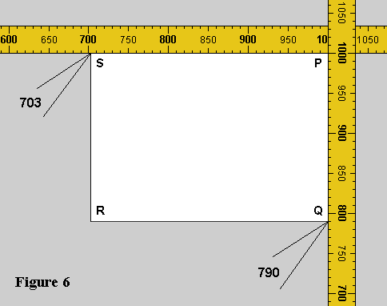
Here, with the point P set at 1000 on each scale, we observe, (a) that S falls on 703 (ie 1000 - 297); 703 = 401 + 302 (ie 4th + 8th) = 407 + 296 (ie 6th + 7th) = 2nd triangular multiple of 37; and (b) that Q falls on 790 (ie 1000 - 210); 790 = 395 + 395 (ie 2 x 5th).
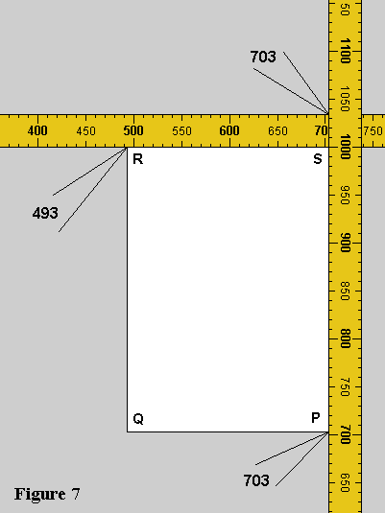
Rotating the sheet 90 degrees clockwise about S, and moving the rulers so as to maintain contact with the sheet edges, we observe that R falls on 493, ie 86 + 407 (ie 3rd + 6th), and P on 703.

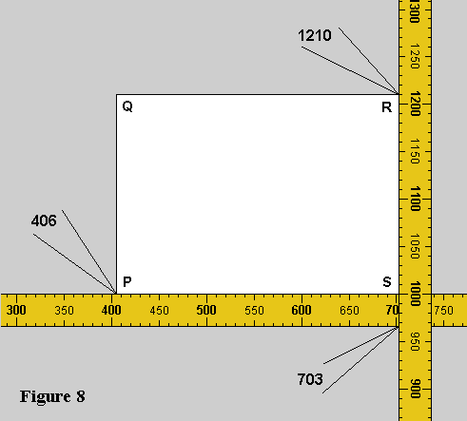

A further clockwise rotation of 90 degrees with ruler adjustment brings P into line with 406, or 203 + 203 (2 x 2nd); R falls on 1210 (one of the 'friendly number' pair, 1184/1210, and rare phenomenon).

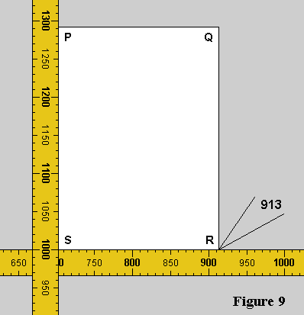

In a final clockwise step about S we observe that R falls on 913 (ie the 1st of the Genesis 1:1 set!
This complete sequence has therefore uncovered all eight G-values - but mainly in combinations of two. However, one further observation concerning A4 combined with a minor adjustment of approach brings more specific results!
Return to Index
7 - Continuing developments
The nominally 297mm x 210mm A4 sheet may be envisaged as comprising six identical panels of exact size 99mm x 105mm. This particular arrangement is anticipated by Figure 1(c) where a segmented 210-as-triangle is shown as the sum of 6, 99 and 105.
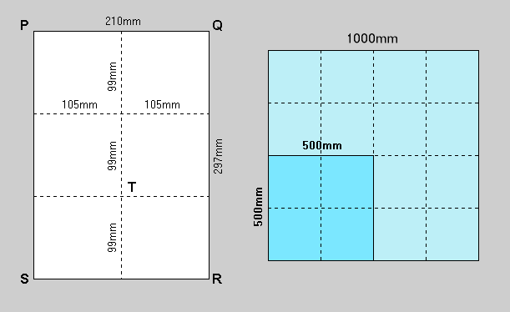
Figure 10: Showing a segmented A4 sheet and new scope of interest.
We begin by placing corner P of the segmented sheet at the 500mm point of intersection of the two rulers:
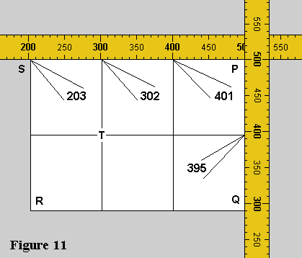
As can be seen, four of the eight G-values are immediately revealed at the points of intersection with the segmented sheet, viz 203(2nd), 302(8th), 401(4th) and 395(5th)!
Rotating the sheet counterclockwise by 90 degrees about T and adjusting the ruler positions, we obtain:
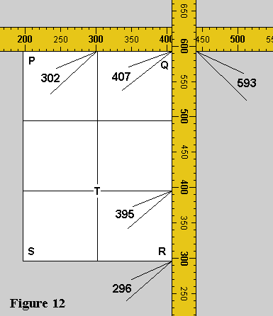
At Q we find 407 (the 6th G-value) represented on the horizontal scale, and 593 (digit-reverse of the 5th G-value) on the vertical scale. Again, at R, we find 296 (the 7th G-value).
In a final operation, the sheet is rotated counterclockwise by 90 degrees about R to obtain:
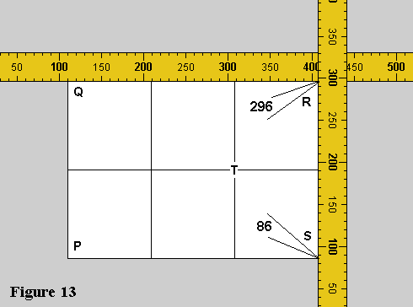
At S we find 86 (the 3rd G-value). Thus all values except the first, 913, have been generated by this current series of maneouvres. However, this number was identified earlier as the only single value arising from manipulations involving the unsegmented sheet. Thus, the whole of the G-set has been derived simply from operations involving nothing more than an A4 sheet and two rulers graduated in millimetres!
Return to Index
8 - Further implications
Matters arising from the foregoing observations are developed in three appendices (which should be read in order), as follows:
Appendix A - A closer examination of the Genesis/A4 enigma.
Appendix B - The parameter coefficients revisited.
Appendix C - An examination of the 'plus one' principle.
Return to Index
9 - Conclusion
In this page we have succeeded in drawing together a number of seemingly independent strands:
- the numbers 1260 and 666 - given explicitly in the Book of Revelation (and, in respect of the first, the Book of Daniel also);
- the fundamental properties of these as numbers per se - particularly their substantial and related geometries;
- man's innate desire and ability to compose, make, and appreciate music
- the metric dimensions of an artefact - only some 40 years old - now commonly used world-wide, viz the A4 sheet;
- the numerical implications of another, much older, artefact - the Book of Genesis (c 1300 BC).
In attempting to explain these matters it is also desirable that we consider the following:
- the principle of alphabetic numeration which underpins the reading of Greek and Hebrew words as numbers dates from c 600 BC and c 200 BC, respectively;
- the Book of Revelation written c 95 AD;
- the gradually emerging scale of 'equal temperament' placed on a solid footing by J.S. Bach's '48 Preludes and Fugues' (Part 1 - 1721; Part 2 - 1744) - leading to the flowering of the western classical music tradition;
- the metre adopted as the standard unit of length in France in 1799 - being defined as one ten-millionth part of the great circle passing through Paris; associated with this, the now familiar series of prefixes was established for the multiples and sub-multiples of 10;
- the introduction of metrication and decimalisation in the UK in the 1970's; this was to include the A-series of trimmed paper sizes.
Under the heading Ignoring God leads to a Downward Spiral, E.H. Peterson paraphrases the Lord's words through Paul thus:
"But God's angry displeasure erupts as acts of human mistrust and wrongdoing and lying accumulate, as people try to put a shroud over truth. But the basic reality of God is plain enough. Open your eyes and there it is! By taking a long and thoughtful look at what God has created, people have always been able to see what their eyes as such can't see: eternal power, for instance, and the mystery of his divine being. So nobody has a good excuse. What happened was this: People knew God perfectly well, but when they didn't treat him like God, refusing to worship him, they trivialized themselves into silliness and confusion so that there was neither sense nor direction left in their lives. They pretended to know it all, but were illiterate regarding life. They traded the glory of God who holds the whole world in his hands for cheap figurines you can buy at any roadside stand." (Romans 1:18-23, 'The Message')
Reader, God will no longer allow anyone of sound mind to place 'a shroud over truth'. The matters we have considered can only be explained by an appeal to the supernatural! They must represent a decisive and merciful act of God. Through them we infer that he is deeply concerned that none should be led astray by their foolish imaginations since he has - here, and elsewhere in 'The Other Bible Code' - provided tangible evidence of his Being and Sovereignty!
Vernon Jenkins MSc
What's in a Name?

Index:
- Introduction
- The 'Elohim' phenomenon
- The 'Yahweh' phenomenon
- The 'Yahweh-Elohim' phenomenon
- A view from the New Testament
- The Ark of the Covenant
- The 'out-of-the-sea' phenomena
- Conclusions
Return to Homepage
1 - Introduction
It has been claimed that three is a numerical symbol for all that is substantial or complete. The argument usually begins with an appeal to classical geometry where a minimum of three straight lines is seen to be required to form a plane figure; and three dimensions of length, breadth and height, are necessary to define a solid - the simplest example being the cube. It is further pointed out that there are three great divisions completing time viz, past, present and future; three persons in grammar express and include all the relationships of mankind; thought, word and deed, complete the sum of human capability; God's prime attributes are three viz, omniscience, omnipresence and omnipotence; and so on.
Again, as readers of the Bible will know, three is frequently found associated with matters of spiritual substance. Consider, for example, the Three Persons of the Trinity to each of whom in turn the Seraphim direct their cry, "Holy, Holy, Holy"; the Lord - represented by the same three persons - appeared to Abraham 'in the plains of Mamre'; and Jesus rose on the third day (having been crucified at the third hour) and it was for three hours (from the 6th to the 9th) that darkness shrouded him; and so on. Clearly, therefore, there exists a convincing catalogue of instances which support the proposition that, in the appropriate context, three represents absolute solidity and perfection.
The purpose of this paper is to bring forward further powerful evidences confirming the significance of three to those dwelling in 'the courts of heaven'. In line with previous submissions, the procedures will focus particularly on the reading of the information provided in the numbers that are a fair alternative reading of Hebrew and Greek words and phrases, and their representation as related symmetrical structures of geometry.
Return to Index
2 - The 'Elohim' phenomenon
The Hebrew word 'Elohim' (pronounced 'Eloheem' and traditionally translated 'God' - though it is actually the plural form of 'Eloah'!) is first encountered as the third word of Genesis 1:1 (reading from right to left in the traditional manner):
Note that 'Elohim' has five letters whose values as numerals ( their 'characteristic values' or CVs) are 1, 30, 5, 10 and 40, respectively.
[Those unfamiliar with the Hebrew scheme of numbering kindly click here]
This name for God occurs 228 times in the Torah (or Pentateuch). The researcher, Ian Mallett, has recently drawn attention to the interesting fact that if its letters are read as three groups of three - that is, 1st/2nd/3rd, 2nd/3rd/4th and 3rd/4th/5th - the corresponding CVs (obtained by summing the constituent numerals) are 36, 45 and 55, ie a rising and consecutive sequence of triangular numbers (the 8th, 9th and 10th). These facts are detailed in the following panel:
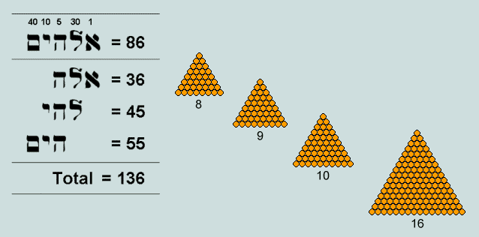
Observe that the sum of these three triangles is 136 - which is also triangular - and the sum of their order numbers, 27 (or 3^3). Note too that when 16 (the order number of 136) is added to the latter sum, the total becomes 43 - largest prime factor of 'Elohim'.
Clearly, three - the first triangular number proper - is a persistent feature of these proceedings, for consider:
- Genesis 1:1 - the Bible's opening verse (in which 'elohim' first appears as third word) - has the form of an equilateral triangle precisely inset with a second equilateral triangle representing the two final words - translated "and the earth."
- The factors of Genesis 1:1 viz, 37 and 73, are revealed as hexagon and hexagram, respectively, when the third of the elohim triangles, 55 (incidentally, symbolizing a pair of human hands!) is symmetrically united with an inverted copy of itself, thus:
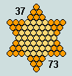
- its plural form lends support to the Christian doctrine of the Trinity
- having 5 letters, there are just three successive groups of three adjacent letters
- each group of 3 yields a triangle
- these triangles are in rising ordered sequence
- the sum of these 3 triangles yields another - 136
- this sum - as a denary (or base 10) number - has three digits which reveal the first three triangular numbers (1, 3 and 6)
- again, the digit sums are interesting: 1+3+6 = 10 (triangular); (3+6)+(4+5)+(5+5) = 28 (triangular); 2+8 = 10, and 1+0 = 1 (first, and degenerate, member of the triangular series)
- other radix-dependent features of interest include: (a) with 'Elohim', the first word of Genesis 1:1 forms 999 and, (b) with the other two nouns 'heaven' and 'earth', it forms 777; these three-digit eye-catchers are multiples of 111, or 3 x 37
- finally, as already noted, three is itself triangular!
Can such a remarkable confluence - involving the name of the Creator himself - be fairly considered fortuitous? Is it not more reasonable rather to regard the phenomenon as a notable example of supernatural design? However, to draw such a conclusion at this juncture would be somewhat premature - there being further evidences to weigh.
Return to Index
3 - The 'Yahweh' phenomenon
The proper name of the God of Israel, the mystical four-letter tetragrammaton - vocalized as YaHWeH or JeHoVaH, and invariably rendered 'The Lord' by the translators of the AV - is first encountered in association with 'Elohim' in Genesis 2:4. Its letters reveal a different pattern of three consecutive triangular numbers, thus:
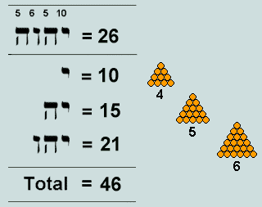
Return to Index
4 - The 'Yahweh Elohim' phenomenon
In combination with 'Elohim' (the pair translated "The Lord God") a further pattern of three ascending triangles is revealed in the sums of the straight groups of three letters, thus:
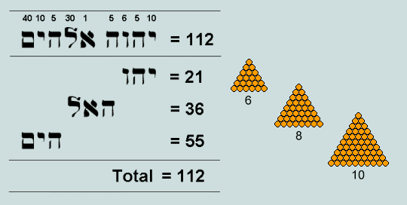
Notice that the order numbers of these triangles form a Pythagorean triple - twice the simplest primitive (3, 4 ,5).
Return to Index
5 - A view from the New Testament
The first chapter of John's Gospel makes it clear that the 'Elohim' of Genesis 1:1 is none other than The Lord Jesus Christ. We are therefore led to expect some evidence of numerical design involving three in respect of this Name. In the original Greek, nominative case, it appears as follows:
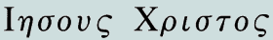
Identical forms of both name and title are to be found in the Septuagint - a Greek translation of the Hebrew Old Testament dating from c300 BC - though not in combination. The numerical implications are as follows:
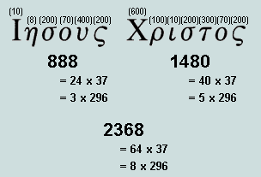
[Those unfamiliar with the Greek scheme of numbering kindly click here]
These remarkable facts invite close examination and comment:
- both components are multiples of 37; they are thus bound numerically to Genesis 1:1 which, in both whole and part, is saturated with this factor
- both components are multiples of 296, or 8 x 37 - 7th word of Genesis 1:1, translated "the earth"; this further link with the Bible's first verse is enhanced by the realization that the subject under discussion is God Incarnate.
- the ratio Jesus : Christ is seen to be 3 : 5, ie precisely that between the sides of the 'mercy seat' or 'propitiatory' (Ex.25:17); remarkably, both Paul and John refer to Jesus as 'a propitiation' (Ro.3:25, 1Jn.2:2).
- the cube has now become a significant feature of the proceedings, thus (a) the repeated eights representing 'Jesus' - 8 being the cube of 2, and (b) sixty-four (the cube of 4) appearing as factor of 'Jesus Christ'; this latter fact is the more remarkable when it is perceived that in a typical view of a cubical stack of 64 unit cubes, one or more faces of precisely 37 (the other factor) are visible.
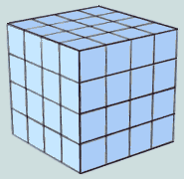
It should not pass unnoticed that the cube represents a biblical symbol of holiness - as evidenced by 1Kings 6:20 and Rev.21:16. This is also implied in Exodus 25 re the 'Holy of Holies' - central feature of Tabernacle worship.
Return to Index
6 - The Ark of the Covenant
This wooden chest with its golden lid - the 'mercy seat' - occupied the inner sanctum of the Tabernacle; it was there that the High Priest met with God annually on the Day of Atonement to plead forgiveness for the sins of the people. The details of its construction were conveyed to Moses by God - these backed up by the solemn words "... look that thou make (it) after the pattern, which was shewed thee in the mount."
The required dimensions of the ark were "two cubits and a half shall be the length thereof, and a cubit and a half the breadth thereof, and a cubit and a half the height thereof." (Ex.25:10). And for the mercy seat: "two cubits and a half shall be the length thereof, and a cubit and a half the breadth thereof." (Ex.25:17); clearly, the perimeter was to be 8 (the cube of 2) cubits
Our concern is with the stated numbers of cubits rather than with precise dimensions. Let us therefore begin by removing the fractions - simply achieved by taking as our new unit of length the 'half cubit'. The ark is then seen to be a cuboid of dimensions 5 x 3 x 3, and the mercy seat, a 5 x 3 rectangle. The following diagram portrays the complete structure:
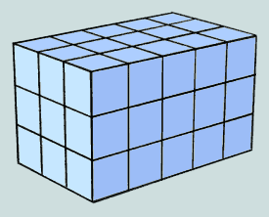
There are a several attributes of interest:
- the mercy seat has an area of 15 units; 15 is 5th triangular number
- the superficial area of the ark is 4 x 15 + 2 x 9, or 78 units; 78 is 12th triangular number; also, 78 = 3 x 26 = 3 x 'Yahweh'
- the volume of the ark is 45 units; 45 is 9th triangular number
- the number of unit cubes involved in the frame of the ark is 4 x 5 + 2 x 4, or 28; 28 is 7th triangular number
Careful study reveals that, in respect of this high concentration of triangularity in its numerical characteristics, this particular cuboid surpasses all two million others when length, width and height are each taken over the range 2 - 127 units.
Return to Index
7 - The 'out-of-the-sea' phenomena
The page 666 - and All That draws particular attention to three dimensionless triangular numbers that occur as 'surface features' of the New Testament; they are 153 (Jn.21:11), 276 (Acts 27:37) and 666 (Rev.13:18) - 17th, 23rd and 36th triangular numbers, respectively. All are observed to have supernatural connections. The last has the form of 888, 777 and 999, and is therefore a multiple of 3 and 37. But, as a triangular number, 666 is unique in that, (a) all its numerical attributes are triangular numbers and, (b) it participates as a triplet in a geometrical rendering of Genesis 1:1.
It is further demonstrated that all three triangles - taken in association with the unique triangular sequence 6, 6x6 and 66 (3rd, 8th and 11th, respectively) - point inevitably, and directly, to the Bible's first verse.
Return to Index
8 - Conclusions
A series of tests involving computer searches and simulations have established the following additional facts:
- The Torah (or Pentateuch) comprises 79,976 Hebrew words (ignoring hyphens). Of these, 15,058 have 5 letters and involve 4109 distinct words. While 9 possess certain of the features listed in Section 2 above, only one has all the observed triangular riches. In this respect, therefore, 'elohim' is unique.
- When the 5,153,632 arrangements of 5 Hebrew letters were generated and examined for the same triangular characteristics, again, only 'Elohim' was equal to the challenge.
- Concerning the sum of a running sequence of 3 triangular numbers being itself triangular: there are just 6 instances of the phenomenon in the first 10 million natural numbers.
The following inferences may be made from a consideration of all these data:
- 3, undoubtedly, is a number that possesses a substantial spiritual dimension
- along with 10 and 37, 3 is revealed to be a key component of the 'validating principle' that our Creator foresaw would be needed in our day to fulfil his promise: "...the wisdom of their wise men shall perish..."(Is.29:1)
- his plan involves numerical geometry - in particular, the triangle and its simple derivatives
- the Hebrew of the OT, and the Greek of the NT are seen to be speaking 'with one voice: Jesus is undoubtedly 'Elohim', Redeemer and Lord.
It is appropriate that we consider one final point of interest re the Bible's opening verse:
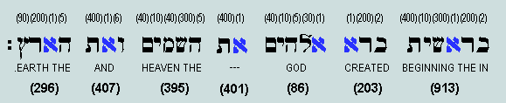
'Aleph' (shown in blue) - the first letter of the Hebrew alphabet, and of 'Elohim' - occurs 6 times, in positions 3, 9, 10, 15, 23 and 26. These figures total 86, or 'Elohim'.
Poetry and parable aside, it was ever intended that we read and understand the Bible literally - notwithstanding the problems raised by unbelieving scientists and intellectuals (whose assumptions, concerning reality are, anyway, always suspect - and rarely declared). It is inevitable that the 'wisdom of the wordly wise' will, one day, be destroyed. May these numerical facts - immune to all manipulation, and now seen to be endorsed by the Lord's signature - bring that day closer.
An Oracle Restored

Some observations on a remarkable discovery

Index:
1. Introduction
2. The contiguous multiples of 37
3. The multiples of 296
4. The Creator's Name
5. A pythagorean view
6. Some simple fractions
7. The symmetries within
8. A comparison with the Genesis 1:1 data
9. God's Seal
10. Alpha and Omega
11. Conclusion
Appendix 1: The Twelve Tribes
Appendix 2: The numerical interpretation of Hebrew words
Appendix 3: The numerical interpretation of Greek words

1. Introduction
One of the principal reasons for the 'Mt.Sinai encounter', recorded in Exodus 25-31, was to instruct Moses as to the precise details of construction of the portable sanctuary that would function as God's dwelling place on earth - the tabernacle - together with its furnishings, and manner of use.
Concerning the high-priestly vestments, we read particularly of the oracle - the Urim and Thummim (Ex.28:30) - provided for the guidance of the people in difficult and uncertain times. Details are lacking of the nature and use of these items⁽¹⁾, but we are informed that they were held in a pouch - called the breastplate (or, in some translations, breastpiece) - attached to the front of the ephod - the outmost garment of the high priest. This breastplate was formed from a single piece of highly-embroidered linen cloth one cubit long and half a cubit wide, folded over in two to form a square, half a cubit by half a cubit (about 9in.x 9in). It was adorned with twelve precious stones on which were engraved the names of the tribes - ie those of the sons and grandsons of Jacob arranged according to their order of birth. These were set out in four rows of three stones each (Ex.28:15-30) [Appendix 1].
[Link to a Web site on the Tabernacle]
In Ian Mallett's paper The Breastplate of Judgment⁽²⁾, attention is drawn to the many interesting features attending the matrix of integers formed from the characteristic values (hereafter "CVs") [Appendix 2] of the breastplate names:
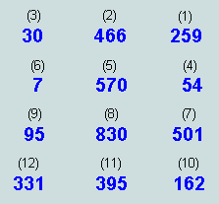
Return to Index
2. The contiguous multiples of 37
The following attributes, predicated upon 37⁽³⁾ and its multiples, may be readily ascertained:
- The value of the matrix (i.e. the sum of its components) is 3700, or 10^2x37⁽⁴⁾
- Of these, the 6 occupying 'odd' positions total 1850, or 50x37, and the 6 occupying 'even' positions, the same
- The first 9 form a square; they total 2812, or 76x37
- The remainder - forming the final row of 3 - total 888, or 24x37
- The first value is 259, or 7x37
- The remaining values in the square may be grouped into 4 connected pairs - each representing a multiple of 37, thus:
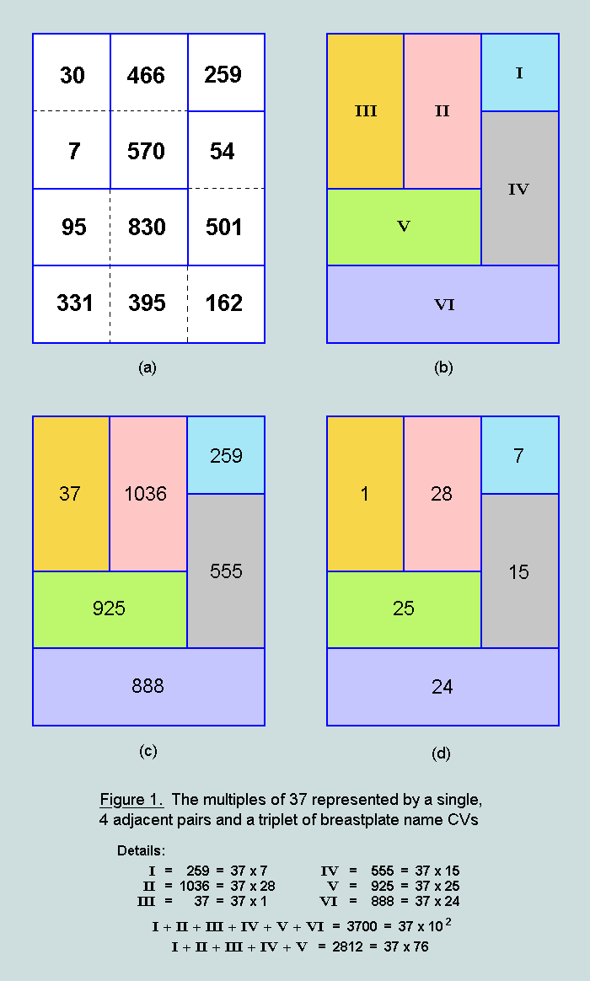
At (a), we have the breastplate matrix and observe that it may be divided into 6 regions, here designated I, II, III, IV, V and VI - as at (b) - such that the sum of the name CVs within each region is a multiple of the uniquely-symmetrical number 37 - as represented at (c) - the corresponding multipliers of 37 being depicted at (d).
Return to Index

3. The multiples of 296
Remarkably, the 6 segments of the breastplate, defined above - each a multiple of 37 - may be combined to generate the first nine multiples of the interesting number 296 (= 8.37). The details are presented in the following set of miniatures:
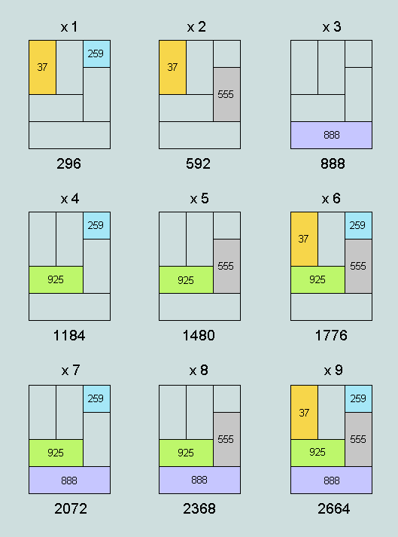
Figure 2. The multiples of 296 as combinations
of these segments
This fact is highly significant because of the associations 296 has with earlier discoveries in the biblical text: it is the characteristic value of the 7th and final Hebrew word of Gen.1:1 (meaning 'the earth'), and is a factor of the Greek form of both 'Jesus' (= 888, or 3.296) and 'Christ' (= 1480, or 5.296). Further, it represents the difference between the cubes of 6 and 8, and is a factor of 1184 - one of a unique pair of 'friendly' numbers.
A computer simulation reveals that only 1% of random sets of 6 multiples of 37, over the same range, will be found to possess this feature.

Return to Index

4. The Creator's name.
We read in John's Gospel, "He was in the world, and the world was made by him, and the world knew him not." (ch.1, v.10). Remarkably, the breastplate is imprinted with our Creator's 'signature' - the bottom row (value 888) conveying the encoded name, 'Jesus', and the connected block above (value 1480), the title, 'Christ', thus:
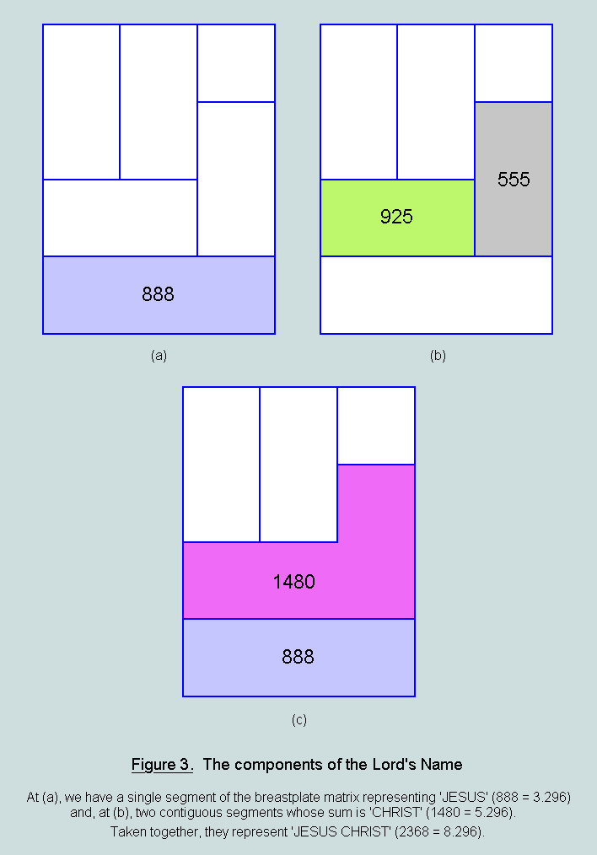
And we further observe powerful symbolism in the fact that the ratio, name:title, represented numerically by 888:1480, or 3:5, is identical with that of the sides of the mercy seat (Ex.25:17-22) - central element in tabernacle worship! [Details concerning the derivation of the characteristic values of the Creator's name and title are given in Appendix 3.]
Return to Index
The foregoing facts lead directly to a pythagorean view of the breastplate - one in which the Lord's Name plays an essential role.

5. A pythagorean view
As we have just seen, the breastplate matrix (value 100x37) may be divided into two blocks, thus:
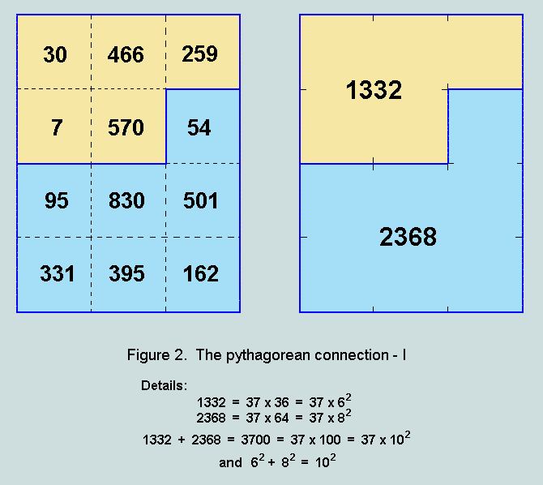
Here, it may be observed that the square roots of the multipliers of 37, {6,8,10} form a pythagorean triple that is a simple multiple of the classic case, {3,4,5}! Four such triangles are generated when a square of side 10 units is rotated by 36.87° (nearly 37°!) within a centred square of side 14 units, thus:
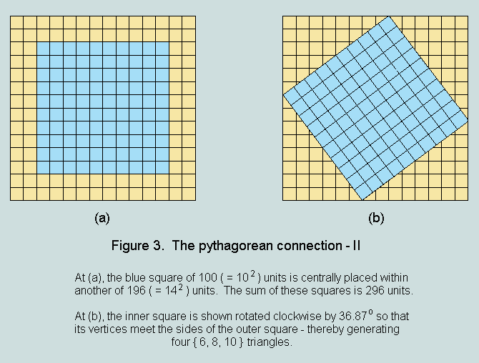
The sum of these squares is 296 - a number that has already been shown to be an essential feature of the breastplate.
Return to Index

6. Some simple fractions.
It has already been observed that the sum of the odd-numbered names is precisely one half of the total, and therefore equal to the sum of the even numbered names. However, as revealed below, there is another arrangement which halves the structure numerically, and two which divide it in the ratio 1/4:3/4, thus:
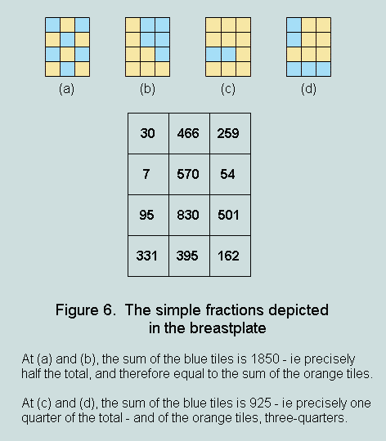
Further, in 925, we have the value of the Creator's name and title, as derived from the English analogue of the Hebrew alphabetic numbering scheme⁽⁵⁾. A computer simulation reveals that about 5% of equivalent random sets exhibit these combined properties.
Return to Index

7. The symmetries within
We observe that 7 of the 12 integers in the array exhibit interesting relationships of the form,
Multiple (M) / Divisor (D) = Quotient (Q)
Thus:
259 (the 1st) / 7 (the 6th) = 37

570 (the 5th) / 30 (the 3rd) = 19

162 (the 10th) / 54 (the 4th) = 3

570 (the 5th) / 95 (the 9th) = 6

The order of appearance of these elements in the matrix is as follows:
259 30 54 570 7 95 162
i.e. M D D M D D M

and we observe symmetry in the types represented, and between types, thus:
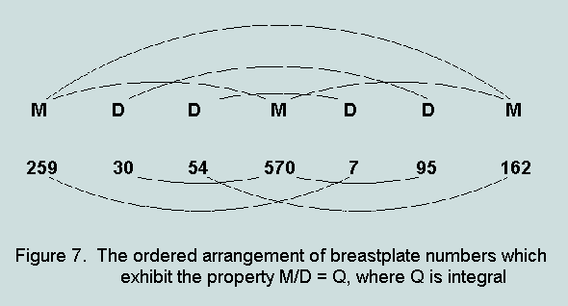
Further, an examination of the four quotients (Q) - 19, 3, 37, and 6 - reveals them to be significant and related figurate ⁽⁶⁾ numbers, thus:
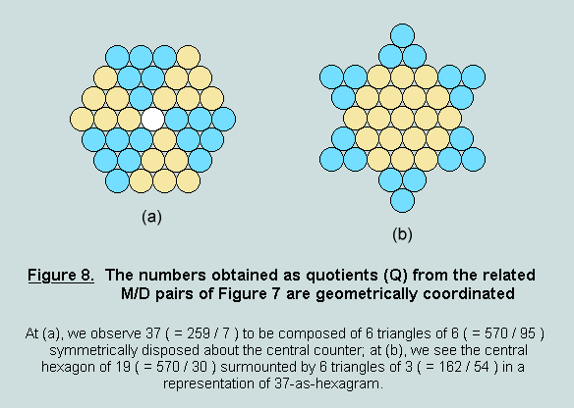

Return to Index

8. A comparison with the Genesis 1:1 data⁽⁷⁾
There are a number of points of contact between the numerical features of the breastplate, as outlined above, and those of the Hebrew Bible's first verse:
- both reveal 37 to be the dominant factor (a feature heralded by their totals: Gen.1:1 = 2701 = 37 x 73; breastplate matrix = 3700 = 37 x 100;
- the total of Gen.1:1 divides thus: 2701 = 999 + 999 + (999 - 296); the breastplate total may be written, 3700 = 999 + 999 + 999 + (999 - 296), or 2701 + 999; indeed, as the following figure reveals, this combination is actually present (as are the many multiples of 296, as we have already seen):
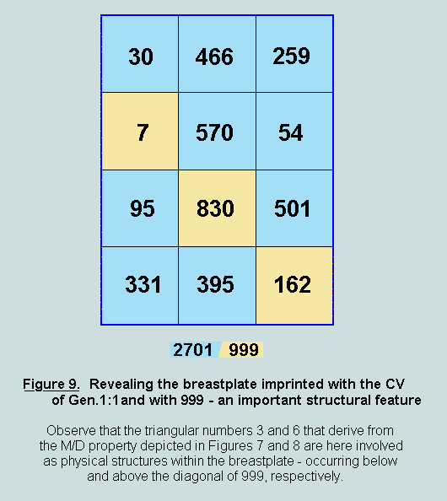
- the factors of 2701, viz 37 and 73, and of 703 (i.e. 999 - 296), viz 19 and 37, are richly figurate; the same structures are implied by the breastplate data as Figure 8 reveals (observe that 6 x 6-as-triangle symmetrically disposed about 37-as-hexagon yields a hexagram of 73);
- the multipliers of 37 in both Gen.1:1 and Creator's name (ie 73 and 64, respectively) are themselves related to 37: 73, by digit reversal, and 64, by the cube suggested by the hexagonal form of 37⁽³⁾.
Clearly, they are the work of one supreme author!
Return to Index

9. God's Seal.
As has been demonstrated in an earlier paper ⁽⁸⁾, 2368 and 2701 - symbols of the Creator and Creation, respectively - are also objects of considerable significance per se in the field of numerical geometry⁽⁹⁾. Both exhibit compound symmetries which take the form of two-dimensional arrangements of uniform three-dimensional elements⁽¹⁰⁾
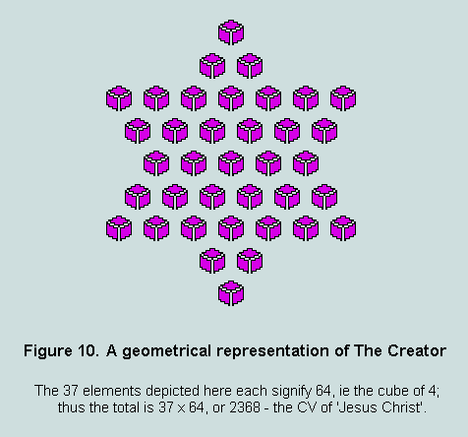.
Here we observe 37 cubes - each of 64 units⁽¹¹⁾ - set out as a regular hexagram. Remarkably, the figure is harmonised by the fact that these cubes are represented in two-dimensions by numerical hexagons - each of 37 units⁽³⁾! The total represented is 37x64, or 2368 - the characteristic value (CV) of the Lord (Appendix 3).
In the next diagram, 2701, or 37x73 - the CV of Gen.1:1 - is depicted as a hexagram of 73 gnomons - each of 37 units⁽³⁾.
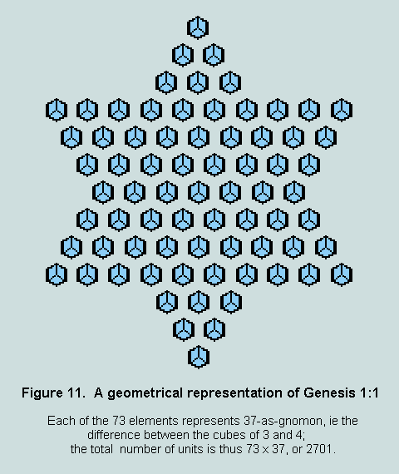
Figure 10 may now be centred and superimposed on Figure 11, thus:
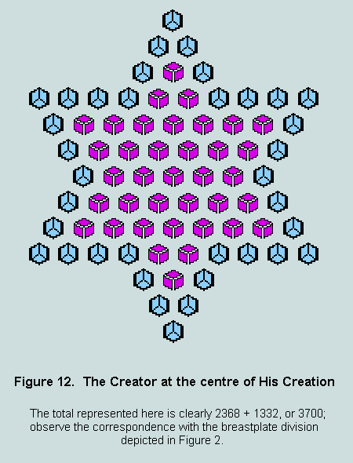
The 'halo' of 36 visible gnomons (blue) embodies 36x37, or 1332 units, and the total represented by the whole is thus 1332+2368, or 3700 units - the sum of the 12 breastplate names! However, it should not go unnoticed that the components of the total are to be found in a principal division of the breastplate matrix [Figure 2], and therefore participate in the pythagorean connection noted in Section 2! Further, the 24 gnomon elements underlying the outline of the central hexagram represent 24x37, or 888 units - the CV of 'Jesus' and bottom row of the matrix!
Alternatively, the last diagram may be perceived as the augmentation of Figure 11 by a hexagram of 37 smaller cubes - each of value 27 (i.e. 3^3). Clearly, the value represented by this hexagram would be 27x37, or 999. We observe that both 999 and 2701 are present in the breastplate - and form a significant division of it [Figure 9].
The fact that these constructions are hybrid - incorporating both two- and three-dimensional elements - is itself symbolic: it mirrors the dual nature of Jesus who was both perfect man and God!
Referring again to Figure 2 we observe that the division of the figure into two groups of 5 and 7 tiles, respectively, establishes further links with the Gen.1:1 phenomena. Thus we find that 37 is the arithmetic mean of 25 (= 5^2) and 49 (= 7^2) and, again, the centroid element⁽¹²⁾ of the 73rd numerical triangle (an alternative representation of Gen.1:1⁽⁸⁾) is found to occupy the 25th position in the 49th row!
Return to Index

10. Alpha and Omega.
The phrase, I am Alpha and Omega..., occurs three times in the text of the Bible's last book (Rev.1:8, 21:6, 22:13) - its final appearance being followed by the words, ...the beginning and the end, the first and the last. It is the Lord Jesus Christ who is making the amazing claim that all things are from him and for him!⁽¹³⁾ In the original Greek this significant phrase is rather peculiarly expressed each time it appears, thus: whereas the first letter of the alphabet, Alpha, is given by name (''), the last, Omega, is given only as a symbol ('')!⁽¹⁴⁾ The matter appears to have been designed to attract the attention of the careful reader. But to what purpose?
Consulting Appendix 3, we observe the following numerical implications of this arrangement:
CV() = 532; CV() = 800; their sum = 1332 = 36 x 37
The more obvious expressions of the phrase would have involved either the names, or the symbols, of both letters, with the following numerical implications:
CV() = 532; CV() = 849; their sum = 1381 = a prime number
CV(A) = 1; CV() = 800; their sum = 801 = 3 x 3 x 89
and the final possibility of symbol followed by name:
CV(A) = 1; CV() = 849; their sum = 850 = 2 x 5 x 5 x 17
Clearly, the only arrangement to yield a multiple of 37 is precisely that found in the text! - and we observe that the particular multiple, 1332 - representing 'Alpha and Omega' - is that which not only accompanies 2368 ('The Lord') in the breastplate matrix [Figure 2] but also functions as the outline hexagram ('the halo') in the representation of 'The Lord of Creation' [Figure 11(c)]!!
Again, in the context of the first verse of the Bible (Gen.1:1) - that 'treasure-trove' of numerical geometry ⁽⁷⁾⁽⁸⁾ - we find a similar association: the central Hebrew word is formed from the first and the last letters of the alphabet; immediately preceding it is 'Elohim', meaning 'God' - the Creator!
It seems abundantly obvious, therefore, that He who created all things and designed the breastplate is also the One who inspired the writing of the Book of Revelation!
Return to Index

11. Conclusion.
Behind the original jewels of the breastplate lay the Urim and Thummim - those mysterious instruments ordained by God for the guidance of his people. They, along with the breastplate and ephod were lost during the Babylonian captivity. However, in essence, they live on in the miracle of the breastplate matrix! Here, indeed, is an oracle for today! Here is tangible and compelling evidence of God's Being and Sovereignty, and a guarantee of biblical truth! Those whose beliefs and actions are guided by reason now have an opportunity to grasp these fundamental realities, recognising that in these days God is drawing our attention to hitherto-unnoticed designs which authenticate scripture beyond reasonable doubt.
To quote the writer of The Breastplate of Judgment: "What mind could conceive such an amazing array of mathematical phenomena save the Creator himself, the Wonderful Numberer, Jesus Christ, who is the Messiah of Israel and the Saviour of the world?"
Vernon Jenkins MSc
2001-04-20
email: vernon.jenkins@virgin.net
Return to Index
Link to Double Indemnity
This page was last modified 2006-03-11.

(1) The Urim and Thummim were clearly more than the equivalent of a pair of dice (as some have contended) for God did not always provide an answer (1Sam.14:36-37, 28:6). The response came either by a voice from heaven or by an impulse upon the mind of the high priest. This oracle was of great use to Israel (e.g. Nu.27:21, 1Sam.23:6-12).

(2) Obtainable from PALMONI RESEARCH, 4 Tynesdale, Whitby, Ellesmere Port, CH65 6RB, U.K.

(3) As an integer, thirty-seven has unique geometrical properties: 37 uniform squares or circles (as appropriate) can be arranged to fill any one of three symmetrical frames - octagon, hexagon, or hexagram; in hexagon form, it represents a typical 2D view of a cube of dimension 4, i.e. a stack of 64 unit cubes; it is also the difference between the cubes of 4 and 3. These features are illustrated in the following diagrams:
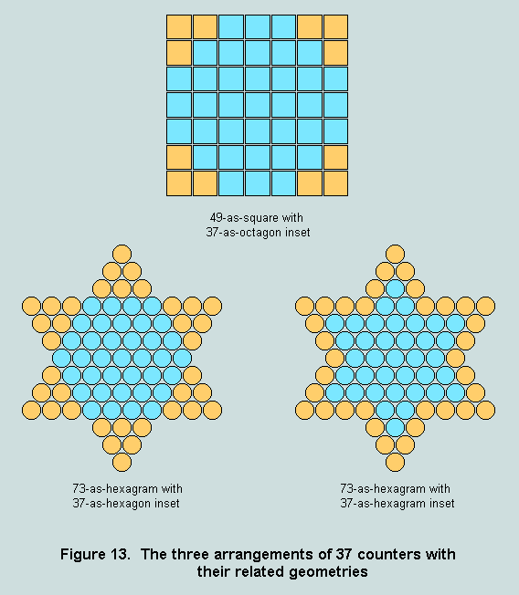

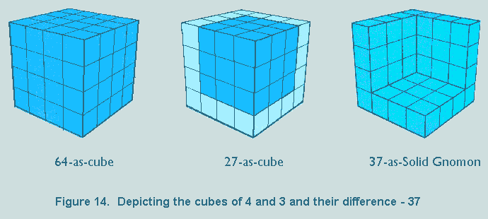
Clearly, 37 is associated with 16 axes of symmetry, and in this sense it is the most symmetrical of all numbers. But, in addition, as a denary object, it provides a basis for many interesting mathematical recreations (see The Ultimate Assertion: Evidence of Supernatural Design in the Divine Prologue, CEN Tech.J., vol.7(2), 1993, Appendix, pp.192-196).

(4) This appears significant since the breastplate was itself a square, and 10 is a highly significant number: a prominent feature of human anatomy, principal radix of man's number systems from the beginning, and collective unit in the now near universal principles of decimalisation and metrication.

(5) In Appendix 2, an outline is provided of the historically-attested Hebrew alphabetic numbering scheme. If the Roman alphabet is superimposed on this, and the values 500, 600, 700, and 800, assigned to the extra four letters W, X, Y, and Z, we then have a modern equivalent of this ancient scheme. Under this regime, the name 'JESUS' would assume the value 515 (i.e. 10+5+100+300+100), and the title 'CHRIST', 410 (i.e. 3+8+90+9+100+200); 'JESUS CHRIST' would therefore become 925, or 5^2x37.

(6) In the context of this page a figurate number is one which, when represented as a set of uniform circular or spherical counters, completely fills a polygonal or polyhedral frame. Examples are illustrated above.

(7) Such data are presented in the The Beginning of Wonders and in a number of printed documents, including The Ultimate Assertion: Evidence of Supernatural Design in the Divine Prologue. Please email the author for details.

(8) See for example The Arbiters of Truth

(9) Numerical geometry describes the study of those two- and three-dimensional structures that involve both number and form, i.e. the figurate numbers. These lie close to the heart of mathematics, and the symmetries represented are absolute in the sense that they are independent of radix, of time, and of place.

(10) Here, the 4th solid gnomon (= 37, difference between the 4th and the 3rd cubes) and the 4th cube (= 64 units) are symbolically represented by


(11) The 'units' referred to in this account are the unit cubes which function as counters in the construction of the diagrams.

(12) One in every three numerical triangles is built around a single counter which then functions as the centroid element - i.e. that which is equidistant from each of the three sides. Such a triangle is the 73rd.

(13) See also Colossians 1:16

(14) The writer is indebted to Captain Richard Prendergast for drawing his attention to this interesting anomaly.

Appendix 1 - The Twelve Tribes
Jacob fathered 12 sons by four women: his wives, Leah and Rachel; and his concubines - maidservants of Leah and Rachel - and surrogate mothers, Zilpah and Bilhah (Gen.29:31-35; 30:1-24; 35:16-18). The following table lists the names of the sons, in order of birth, with their respective mothers.
1. | REUBEN | Leah
2. | SIMEON | Leah
3. | LEVI | Leah
4. | JUDAH | Leah
5. | DAN | Rachel/Bilhah
6. | NAPHTALI | Rachel/Bilhah
7. | GAD | Leah/Zilpah
8. | ASHER | Leah/Zilpah
9. | ISSACHAR | Leah
10. | ZEBULUN | Leah
11. | JOSEPH | Rachel
12. | BENJAMIN | Rachel
Jacob's favorite son, Joseph, sold into slavery through the treachery of his elder brothers, ultimately became Pharaoh's 'right-hand man', married an Egyptian, and fathered two sons, MANASSEH and EPHRAIM (Gen.41:50-52). These two particular grandsons of Jacob were destined to become proxies for their father in the above list. The tribes - now numbering 13, and each identified by the name of its progenitor - remained in Egypt for some 400 years. Following the Exodus, and before entering the 'promised land', a significant event took place: at God's command, the sons of Levi were set apart and dedicated to His service; in due course, they would therefore not feature in the apportionment of the land between the tribes (Deut.10:8-9). Accordingly, we deduce that the name of Levi would not appear on the breastplate, for the high priest who bore it would himself have been of that tribe; again, as we have seen, Joseph would have been represented by his two sons. A reading of Nu.1 confirms these facts.
Many centuries after these events occurred, it became the practice to use Hebrew letters as numerals. All written words and names have since become fairly interpretable as numbers. Details of the Hebrew alphabetic numbering scheme are given in Appendix 2. The names of the tribes of Israel (assuming it is these that were engraved on the jewels of the breastplate), in progenitor birth order, and with their full numerical interpretations, are listed in the table below along with their Strong's reference number bracketed. [Note: to verify these Hebrew spellings you may access www.blueletterbible.org using the relevant reference number.]
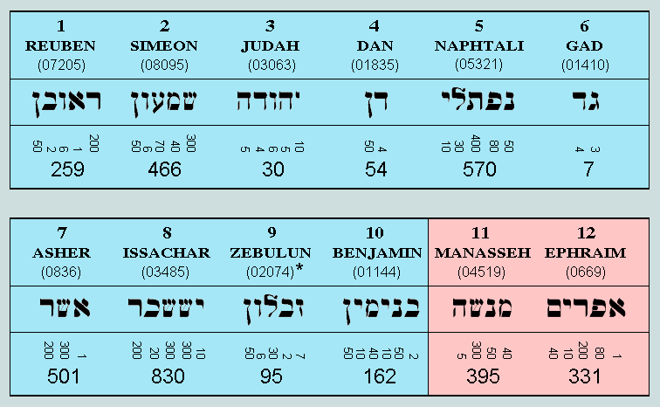
* In contrast to the other 11, the Hebrew rendering of the name Zebulun occurs in different ways - as detailed below:
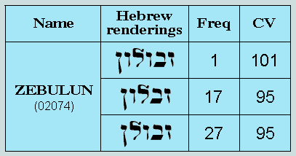
Observe that the column headed 'Freq(uency)' records the number of times each variation occurs in the Old Testament text; and that headed 'CV', the numerical values to be associated with these. For the purposes of the current exercise, it is clear that latter may be read either as 101 or 95. However, the latter is preferred here because, (a) it relates to the most frequent of the variations, (b) it is this value that raises the total of the 'Tribes of Israel' to a significant multiple of 37, and the one which establishes many of the internal breastplate characteristics.
It is worth noting that this layout corresponds with the engravings on the two onyx stones mounted on the shoulderpieces of the ephod (Ex.28:9-12).
The following diagrams present a summary of the matters discussed above.
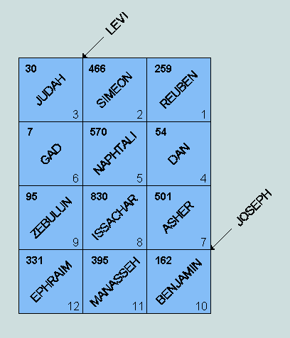
The breastplate is here represented as a tiled rectangle - the tiles being numbered from right to left, in the Hebrew manner - with the omitted names, Levi and Joseph, shown in their proper positions, by order of birth.
Here, finally, is the breastplate prepared for analysis as a 4 x 3 matrix of name CVs:
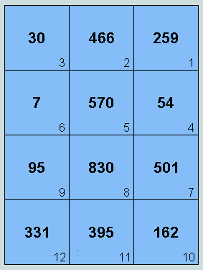

Return to Index

Appendix 2 - The Hebrew Alphabetic Numbering Scheme
The Hebrew alphabet has 22 letters - five with 'end forms', i.e. variants used only when words end with one or other of these letters. From circa 200 BC, as the following table reveals, each letter was made to function as a numeral - thus copying the earlier Greek model (c 600 BC).
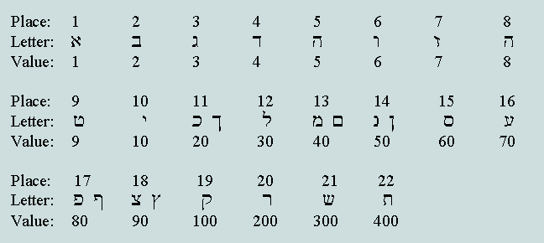
The practice that existed then was to record numbers on an additive basis, i.e. the value represented by a string of letters was simply the sum of the tabular values assigned to each. The characteristic value (CV) of a conventional Hebrew word, name, or phrase, is obtained in this manner. As an illustration of the procedure, the characteristic value of the name SIMEON is derived below. We observe that all Hebrew reading proceeds from right to left. 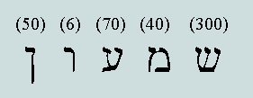
Thus, CV (SIMEON) = 50 + 6 + 70 + 40 + 300 = 466
Return to Index

Appendix 3 - The numerical interpretation of Greek words
The Greek alphabet is an ordered set of 24 upper/lowercase pairs of characters. The position and numerical value of each letter of each of these pairs is detailed below:
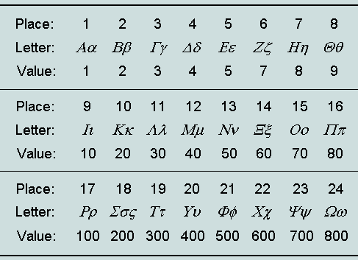
This scheme was introduced circa 600 BC for the purpose of recording numbers on an additive basis, the missing values, 6 and 90, being represented by non-alphabetic symbols. Thus, every string of letters was potentially a number - interpreted by summing the tabular values of the letters.
As a unique example of this procedure, the characteristic values (CVs) of the Lord's Name and Title are evaluated below:
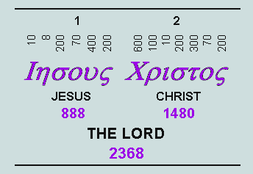
Observe that the letter values appear above and their respective sums below.

Index
- Introduction
- Reading Greek and Hebrew words as numbers
- The evaluation of p from within Genesis 1:1
- The evaluation of e from within John 1:1
- Two significant statements
- Additional numerical links
- A review of the p and e evaluations
- Conclusions

Return to Homepage

1. Introduction
In mathematics, the sciences, and engineering, the two most widely known (and used) dimensionless constants are p (pi) and e. Both are transcendental numbers, ie neither can be defined exactly by the ratio of two integers, nor by any algebraic process.
The first (p) is most famously involved in the mensuration of circle and sphere, and has been known from ancient times. Its value is 3.141592654... - commonly approximated by the simple fraction 22/7, or 3.142857... (error: + 0.04%). Leibniz discovered that it was possible to express this number precisely as an infinite alternating series involving the reciprocals of the odd integers, thus:
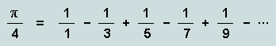
The second (e) is of a more recent vintage (18th century). Known also as 'Euler's number', it occurs naturally in any situation where a quantity increases at a rate proportional to its value, such as a bank account producing interest, or a population increasing as its members reproduce.
Like p, this constant (e) can also be expressed precisely by an infinite series involving integers, thus:
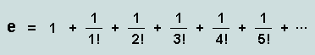
Here, the denominators are the factorial numbers, 1, 1x2, 1x2x3, and so on.
What has come to light just recently is the fact that both these fundamental constants may be derived from the scriptures: p from the Hebrew of Genesis 1:1, and e from the Greek of John 1:1 by the application of a simple procedure - the errors involved being of the order of a mere 0.001%.
Return to Index
2. Reading Greek and Hebrew words as numbers
A significant feature of the Christian scriptures - though hardly ever referred to by theologians - is that all translations rest upon Hebrew, Aramaic and Greek texts whose letters and words may also be fairly read as numbers. Evidences of these yesteryear alphabetic numbering systems confront us still - as, for example, on the dials of many townhall clocks and in the verse and chapter numbering of some of the older books on our shelves.
What distinguishes the Hebrew/Aramaic and Greek systems from the Roman are, (a) all alphabetic characters were requisitioned for use as numerals and, (b) the value represented by a string of letters was simply the sum of its constituent parts. Clearly, words being nothing more than strings of characters conveying ideas, such ideas - when expressed in Hebrew, Aramaic and Greek - are firmly (and unavoidably) anchored to discrete numbers; and though such words may, from time to time, be conveniently "interpreted" so as to mean something different from their literal reading, it is clear that the number upon which each rests is inviolable.
If we believe that the words of the scriptures were authored by God himself, then it is but a short step to believe also that the numbers we now find indelibly linked to these words were contrived by him. It follows that Paul's Spirit-led teaching, "All scripture is given by inspiration of God, and is profitable for doctrine, for reproof, for correction, for instruction in righteousness..." (2Tm.3:16), must encompass these numbers, and any information they may be found to convey.
[Please click for details of the Hebrew/Aramaic and Greek schemes].
In the following sections the term characteristic value (CV) is used to describe the letter- and word- values which derive from the application of these schemes to the original texts of Old and New Testaments.
Return to Index
3. The evaluation of p from within Genesis 1:1
The Bible's first verse comprises 7 Hebrew words formed from a total of 28 letters. Hitherto, attention has focused particularly on the sums of the word CVs in total and in part. Now, however, it is the word and letter products that occupy centre stage. Observe that, although each word CV is the sum of its letter CVs, the product of the latter bears no clear and obvious relationship to the former. Essential features of this analysis involve the two verse ratios
- (product of letter CVs) / (product of word CVs) = R1, say, and
- (number of letters) / (number of words) = R2, say
Writing the product (R1 x R2) in standard mathematical fom, an accurate value for p is revealed.
The details may be found here.
Return to Index
4. The evaluation of e from within John 1:1
The number of words in this verse is 17, comprising a total of 52 letters.
Again, writing the product (R1 x R2) in standard mathematical form, an accurate value for e is revealed.
The details may be found here.
Return to Index
5. Two significant statements
Notwithstanding the great time interval between their respective inceptions, it is clear that there exists a strong textual bonding between Genesis 1:1 and John 1:1. Here are the translations as they are found in the King James Bible:
- "In the beginning God created the heaven and the earth." and
- "In the beginning was the Word, and the Word was with God, and the Word was God."
For the Christian, these writings are highly significant and informative once the identity of "the Word" has been ascertained. The matter is resolved in John 1:14 where we read, "And the Word was made flesh and dwelt among us ...". Undoubtedly, then, Jesus Christ = the Word.
These key texts inform the reader of two significant things (concerning which, there is today much controversy!):
- Jesus Christ is God (an estate he foresook during the period Incarnation - Ascension);
- in addition to being Redeemer and Lord, he is also the Creator.
Return to Index
6. Additional numerical links
It is worth remembering that the numerical interpretations of these verses, ie the respective sums of their letters, are 2701 and 3627; a closer examination of these reveals, (a) that these possess reflective factorisations, thus: 2701 = 37 x 73, and 3627 = 39 x 93, and (b) that they display significant and integrated numerical geometries, thus:
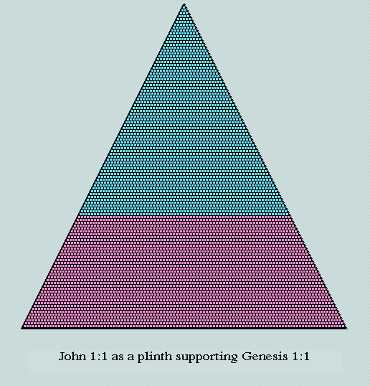
As has been demonstrated in earlier pages, 2701 is 73rd triangular number (represented here in blue). However, the sum of Genesis 1:1 and John 1:1 is also triangular, thus: 2701 + 3627 = 6328 (itself an anagram of 2368 - CV of "Jesus Christ"!) = 112th in the series! It follows that 3627 may be realised as a numerical trapezium - parallel sides, 74 and 112, and height, 39.
The diagram is highly symbolic: the equilateral triangles* suggesting God's triune nature; the plinth, a symbol of Christ in his role as Creator, and as Sustainer of his creation (Col.1:16, 17).
*Clearly, the triangles as rendered here are not equilateral. This is because of the limitations of the medium. Envisaged instead as a packed arrangement of uniform spheres on a flat surface, the truth of this statement is apparent.
It may be remembered that the outline of the Genesis 1:1 (blue) triangle comprises 216, or 6x6x6, counters. That of the 112th (ie the complete triangle above) is also noteworthy; it has 333, or 9 x 37 counters. This happens to be the difference between 2701 and 2368, ie between Creation's prologue (Gen.1:1) and the Creator (Jesus Christ).
Again, because the last two Hebrew words of Gen.1:1 (translated, "... and the earth.") have a combined CV of 703 (37th triangle), the upper triangle of the foregoing diagram may be segmented, thus:
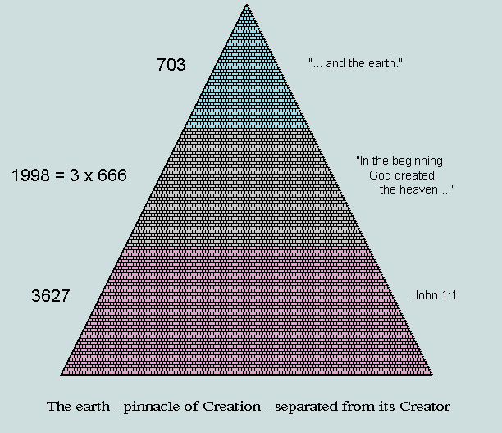
The appearance of a triple of 666 as the 'area of separation' is a notable feature, and undoubtedly associated with deep symbolism.
Finally, observe that CV("Word") = 373 - a neat integration of the Gen.1:1 factors, 37 and 73, and a numerical palindrome.
Return to Index
7. A review of the p and e evaluations
Let us first observe that any estimate of p or e that is obtained as the ratio of two integers must, necessarily, be an approximation. It is therefore interesting, and undoubtedly significant, that the errors involved in the foregoing derivations, viz -0.0012 and +0.0011, respectively, are small, of the same order of magnitude, and of opposite polarity.
It is appropriate that we derive a 'handle' on the kind of odds against this being a chance happening - bearing in mind the fundamental nature and close relationship of the sources involved. Here, again, are the first 10 digits of "estimate: true value" for p and e, respectively, with matching significant digits underlined:
3.141554509 : 3.141592654 and 2.718312812 : 2.718281828
Clearly, if these figures are rounded, both p and e are seen to be correct to 5 significant figures. Based upon a random distribution of the variables (a not unreasonable assumption in the circumstances), a simple estimate of the combined probability of these events may therefore be obtained as follows:
Since the first digit in each case could have been any one of nine in the range 1-9, and each of the remaining matching digits, any one of ten in the range 0-9, each event is associated with a probability of 1/90,000; and because they are independent, the final assessment is of the order of ten billion* to 1 against them occurring fortuitously.
*As used here, the term 'billion' is equivalent to 10^9.
Return to Index
8. Conclusions
Let us briefly recap:
- The Hebrew letters and words of the Old Testament and the Greek letters and words of the New Testament each have an uncontrived numerical dimension (the CV, or "characteristic value") that arises directly from their involvement in the alphabetic numbering systems of these early peoples.
- The application of a simple numerical procedure to the Hebrew letters and words of the Bible's first verse (Gen.1:1) generates an approximation of p, correct to 5 significant figures (error: 0.0012%).
- The application of the identical procedure to the first verse of the Gospel of John (which has much in common with Gen.1:1) generates an approximation of e, also correct to 5 significant figures (error: 0.0011%).
- It would be extremely unreasonable to suppose that these events are fortuitous accidents; rather, highly likely that they are features of purposeful design.
- The circumstantial evidence, viz the textual and geometrical links between these verses, strongly confirms this view.
Clearly, the planning of these wonders must have preceded the writing of Genesis 1:1 (2nd millenium BC), the Hebrew alphabetic system of numeration (c200 BC), and the writing of John 1:1 (c100 AD). Further, the fundamental constant e could not have been known by man before the 18th century AD!
Quite obviously, therefore, what we have described here has to be viewed as a purposeful supernatural act! And because the verses on which the phenomena are centred speak of "Elohim" and "Jesus Christ", it is not hard to deduce the identity of their author.
The standing miracle (for it is nothing less!) informs us as follows:
- The statements of Gen.1:1 and John 1:1 were made by the same author (and scientist); henceforth, their truth cannot be questioned by any of rational mind.
- There are now strong reasons for believing the whole of God's Word - read literally - to be completely trustworthy.
- It is now clear that God has therein provided empirical evidence of his being and sovereignty; in this 'Age of Reason' - (and gross apostasy!) - he is acting decisively so that none should perish through ignorance or foolish presumption.
Return to Index
Return to Homepage
Vernon Jenkins MSc
2001-06-19
email: vernon.jenkins@virgin.net
http://www.otherbiblecode.com

Acknowledgements
The author is grateful to all who have been involved in this project, viz Peter Bluer, Craig Paardekooper, Iain Strachan and Bevan Williams.
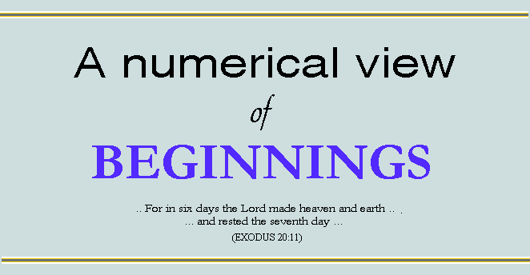
Index
- Background
- Introduction
- A Model of the Creation
- Creation's Triangle
- The Creation/Creator Relationship
- A Touch of Euclid
- The Chequerboard
- Conclusions
- Appendix 1 - On the correct reading of Revelation 13:18
- Appendix 2 - On the pivotal nature of Revelation 13:18
- Appendix 3 - On the matter of 'Wisdom'
- Appendix 4 - On the understanding of 'Word'
- Appendix 5 - An English scheme of alphabetic numeration
Return to Homepage
1. Background
OBC (The Other Bible Code) is a highly integrated structure that exists within God's Word - as mediated by the Hebrew and the Greek systems of alphabetic numeration. Readers are alerted to the presence of this structure by the 'riddle' of Revelation 13:18 (Appendices 1, 2 and 3) which offers wisdom to those who, with understanding, read words as numbers - at the same time indicating which particular numerical features are to be considered significant. Those interested in following truth - no matter where it leads - are thus particularly led to seek multiples of 37 (itself a unique number per se) and instances of numerical geometry (666 being uniquely triangular). These are immediately found in abundance in the Bible's first verse and in both components of the Lord's name.
Return to Index
2. Introduction
There has been - and continues to be - much controversy regarding the manner by which man, and all he observes around him, came into being. The process described in the Bible's opening chapter is either denied outright, or otherwise interpreted so as to harmonise with the widely-held belief in evolution. Few understand the words to convey a literal meaning.
Our interest here concerns the bare essentials of the matter as they are reiterated by the Lord on Mt. Sinai (and quoted above). Clearly,
- the creative act was two-dimensional - its products: heaven and earth - and
- the period that followed was different in kind from that which had gone before.
These components are associated with the numbers 6 and 1, respectively.
It is our purpose to develop from these simple beginnings a conceptual model of the Creation. The relevance of this model will emerge as certain of its features are found to coincide with the principal numerical attributes of Genesis 1:1 (detailed elsewhere at this site). In this confidence, we proceed to examine other features of the model in order to further our understanding of the event and of related scriptural fundamentals.
Return to Index
3. A Model of the Creation
As has been implied above, the Creation may be treated as a three-dimensional event - which suggests that the application of simple principles of coordinate geometry will best lead to a satisfactory conceptual realisation. We proceed accordingly.
Fig.1 depicts a standard left-handed coordinate system in the region of the origin (O). Proceeding from O, the progression of events in time is recorded along each axis: the 6 days of earth's creation along x, and the 6 days of heaven's creation along z. The suggestion is that the square OLMN (shaded blue) lying in the xz-plane is a fair geometrical expression of the week's creative activity.
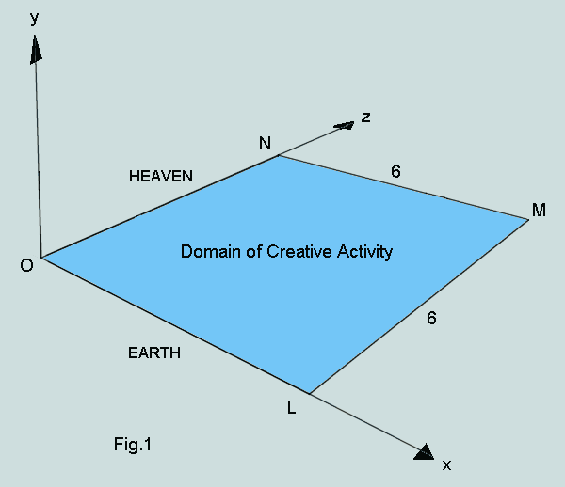
In Fig.2, the 'day of rest' that follows the 6 days of activity is similarly represented by an identical square, O'L'M'N', lying in a plane parallel to the xz-plane and displaced 1 unit in y.
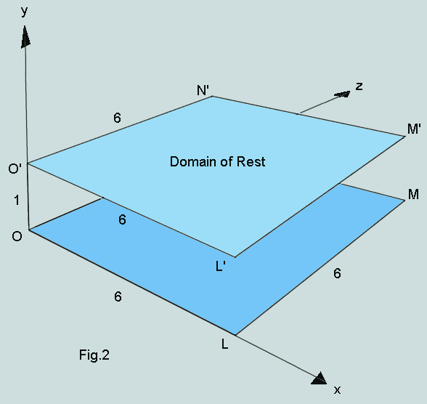
Clearly, these two squares which model the creation week may be regarded as the lower- and upper- faces of a cuboid whose dimensions in x, y and z, respectively, are 6, 1 and 6. This figure is shown below in transparent representation (Fig.3). Interestingly, two of its principal defining characteristics, the diagonals M'O and M'L, are, respectively, the square roots of 73 and 37 - prime factors of the 73rd triangular number, 2701, and of Genesis 1:1! Further, this numerical triangle has an outline of 216, ie the cube, each of whose 6 faces equal the squares OLMN and O'L'M'N'. These facts add credence to the suggested model.
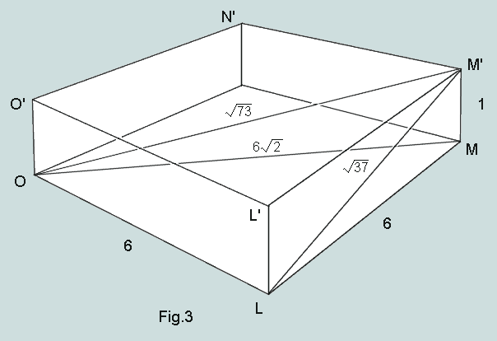
With the side OL, these diagonals form the right-angled triangle OLM' which rests within the cuboid - a summary, so to speak, of the Creation.
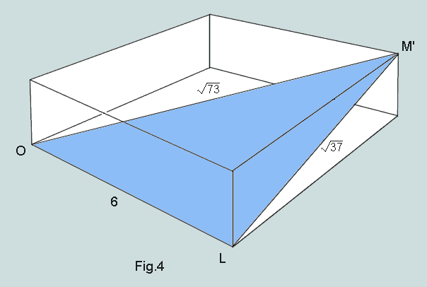
Return to Index
4. Creation's Triangle
Observe that triangle OLM' (Fig.5) - now removed from its context - is the outcome of a logical pictorial representation of the information provided in Genesis 1, 2 (and reiterated in Exodus 20:11).
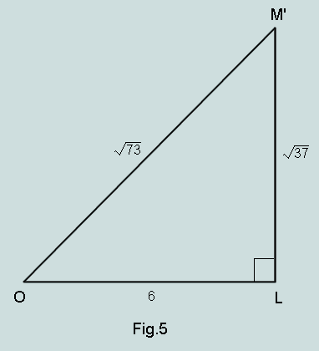
By scaling up this triangle by the factor, square root of 37, we obtain the following figure, PQR, whose sides are seen to be clearly related to scriptural features of interest.
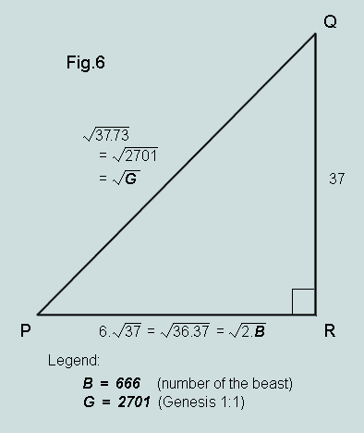
Return to Index
5. The Creation/Creator Relationship
It has been demonstrated on earlier pages that
- the 7 Hebrew words of Genesis 1:1, read as numbers, total 2701, or 37 x 73
- the Greek nominative forms of 'Jesus' and 'Christ', read as numbers, total 2368, or 37 x 64
It follows that the numerical difference between this overview of the Creation and the Creator is 333, or 9 x 37. We thereby learn that 73 is the sum of the two squares, 9 and 64. The following diagram (Fig.7) depicts a significant implication of this fact:
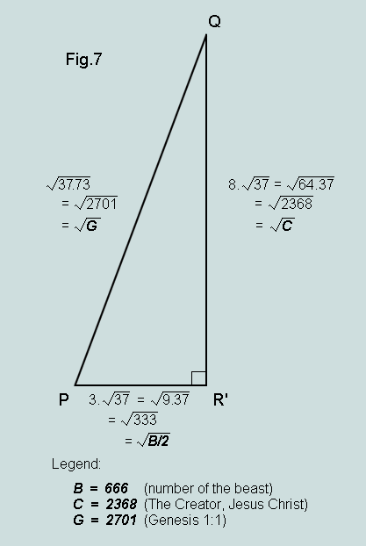
Return to Index
6. A Touch of Euclid
It is an important conclusion of conventional geometry that the angle in a semicircle is a right angle. Since the two triangles of Figs 6 and 7 are right-angled, and have identical hypotenuses, they may be presented together within a circle of diameter root 2701, thus:
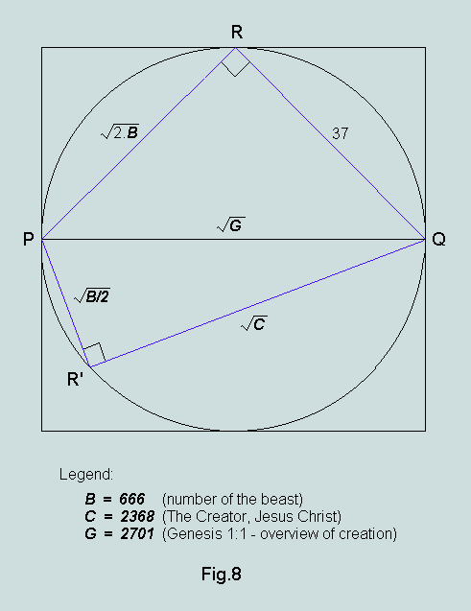
Some interesting conclusions follow:
- the area of the square that escribes this circle is 2701, ie Gen.1:1
- the area of the circle is p/4 x 2701, or 2121.36...; while the result appears to have little significance in this context, it will be remembered that the factor p/4 may be derived (to a high degree of accuracy) from within Gen.1:1 (for details see "The Arbiters of Truth", Section B)
- the product of the chords, PR x PR' = B = 666
- the area of triangle PQR' = 444; since its double, 888, represents 'Jesus', we may show this result as the area of the rectangle PR''QR', thus:
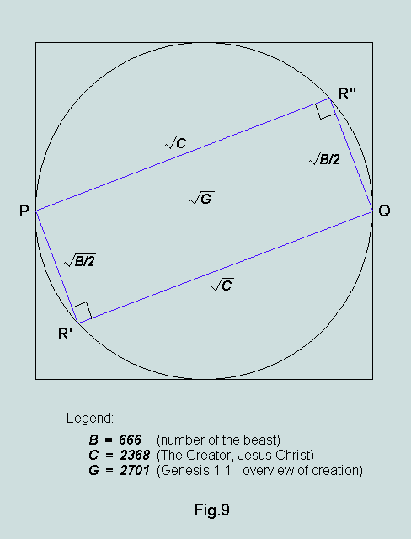
As can be seen, this figure mysteriously accomodates all the principal biblical constituents, B, C and G. There is, undoubtedly, much of a symbolic nature here!
Observe that the ratio of the sides of this rectangle is 8:3 (identical to that of superficial area to volume in the original cuboid); this has implications of further interest.
Return to Index
7. The Chequerboard
The backcloth here takes the form of the familiar square chequerboard of 64 unit squares. We will take each unit square to represent the uniquely symmetrical trifigurate number, 37. On this basis
- the whole board represents 64 x 37, or 2368 - "The Creator"
- areas U + V represent 24 x 37, or 888 ('Jesus'); and areas U + W, 40 x 37, or 1480 ('Christ')
- V (= 9 x 37, or 333) is the difference between Gen.1:1 and Creator
- the ratio of the sides of U is 3:5, ie identical to that of the sides of the mercy seat - a symbol of the Creator
- W represents 25 x 37, or 925; this represents the evaluation of 'Jesus Christ' when the English letters are read as numerals on a pseudo-Hebrew basis (Appendix 5)
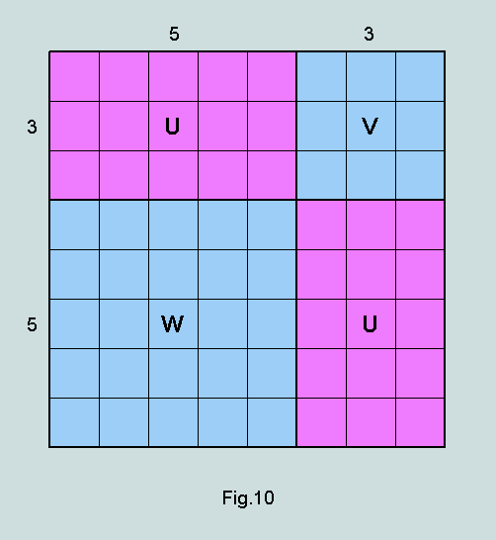
Return to Index
8. Conclusions
The suggested model is convincing in every way and - by some impressive examples of positive feedback - amply justifies its own existence. But, more importantly, it demonstrates the close coordination that exists between key biblical themes, viz the Creation (as represented by the Genesis 1:1 overview and the 6:1 division of the days), the Creator (and his identity), and Christ and Antichrist (the 'beast'). In that it also focuses attention on a secular artefact - the chequerboard (whose relevance to OBC has been voiced in earlier pages) - it leads to a broader understanding of the Creator's modus operandi.
It is difficult to avoid the conclusion that these clear evidences of supernatural agency, drawn mainly from the biblical text, powerfully confirm God's Being and Sovereignty, the Unity and Truth of his Word, and much else! Since the Lord has gone to such lengths to counter man's natural tendency to deny his Person and confute his Word, he must now expect a positive response from those endowed with his likeness.
Vernon Jenkins MSc
2001-07-29
email: vernon.jenkins@virgin.net
http://www.otherbiblecode.com
Return to Index
Return to Homepage

Appendix 1: On the correct reading of Rev.13:18
Doubts continue to be expressed in some quarters concerning our proper understanding of the 'number of the beast'. Is it 666 or 616? Apparently both appear as possible candidates in the early Greek manuscripts. However, I suggest there are a number of good reasons why we should accept 666 as the God-ordained number, viz
(a) generations of scholars involved in the study and translation of the Greek originals have clearly understood the true value to be 666 - otherwise why would this number unfailingly appear in the text proper and 616, if at all, in a footnote?
(b) the evaluation of 'Jesus', the Christ, from the Greek (nominative case) is 888; hence, that of the Antichrist is more likely to be the counterfeit lookalike, 666, than 616;
(c) 666 is the epitome of numerical geometry; as 'triangle of triangles' it features in the geometrical representation of Genesis 1:1; on the other hand, 616 is devoid of any such properties.
(d) 666 as triangle is linked to two other dimensionless NT numbers, 153 and 276 - both of which are also triangular - by the theme "out of the sea'; details are provided on the page "666 - and All That!" at http://www.otherbiblecode.com
Return to Index
Appendix 2 - On the pivotal nature of Revelation 13:18
As investigations have proceeded over the past 20 or so years, it has become increasingly obvious that Revelation 13:18 is a pivotal verse. Here is the statement as we find it expressed in the Authorised Version of the Bible:
"Here is wisdom. Let him that hath understanding count the number of the beast: for it is the number of a man; and his number is Six hundred threescore and six."
These much-neglected words (from the mouth of the Lord) are highly informative - and this quite independently of what appears at first glance to be their prime purpose, viz the identification of a particular individual - for consider:
- he (the Lord) sanctions the reading of alphabetic characters as numbers;
- these numbers are clearly 'counting' numbers, ie positive integers;
- the principle appears in an appropriate context, for both Hebrew and Greek (the languages of the Judeo-Christian Scriptures) used systems of alphabetic numeration;
- the specific number, 666, is given;
- for the investigator, the offer of wisdom is the prize
These strands of information are summarised in the following diagram:
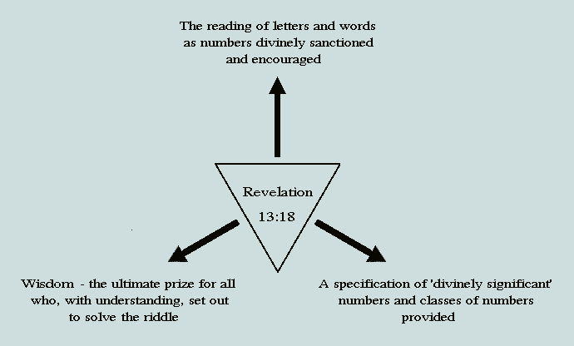
Return to Index
Appendix 3 - On the matter of 'Wisdom'
It will be remembered that 'wisdom' was offered to him who proceeded to put the above principles into practice - the aim, ostensibly it seems, being to identify a person whose name could be fairly read as 666. Interestingly, we find that 'wisdom' in the Hebrew is 'chokmah', thus:
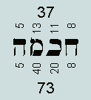
The word (read from right to left) has 4 letters. Above each letter is printed its ordinal position in the Hebrew alphabet; and below, its value as a numeral according to the scheme instituted c200BC. As may be seen, the associated sums are 37 and 73, respectively. The first, of course, is a factor of both 666 and 888; and 73 is its digit reflection. These numbers, of course, are the factors of Genesis 1:1.
[Note: the ordinal values of letters do not normally figure in OBC analysis; however, because of the importance of this word 'wisdom', and because of its unique numerics, this special treatment is, undoubtedly, justified.]
Return to Index
Appendix 4 - On the understanding of 'Word'
The first verse of the Gospel of John, as rendered in the original Greek, reads (left to right) as follows:
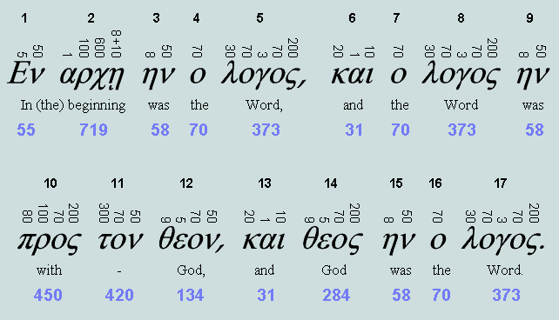
As may be seen, 'Word' (or 'Logos') appears three times. In the Stoic philosophy, this represented the active principle living in and determining the world; in Christian theology it represents the Word of God incarnate, ie Jesus Christ (John 1:10,14).
Read as a number, 'Word' has the value 373 - a telescoping of 37 and 73, factors of Genesis 1:1 and the numbers we have found to be associated with 'Wisdom'.
Return to Index
Appendix 5 - An English scheme of alphabetic numeration
Aa = 1; Bb = 2; Cc = 3; Dd = 4; Ee = 5; Ff = 6; Gg = 7; Hh = 8; Ii = 9; Jj = 10, Kk = 20, Ll = 30; Mm = 40; Nn = 50; Oo = 60; Pp = 70; Qq = 80; Rr = 90; Ss = 100; Tt = 200; Uu = 300; Vv = 400; Ww = 500; Xx = 600; Yy = 700: Zz = 800
As in the Hebrew scheme, the evaluation of names or words is carried out by adding together the numbers represented by the constituent letters.
Example:
- J (=10) + e (=5) + s (=100) + u (= 300) + s (=100) = 515
- C (=3) + h (=8) + r (=90) + i (=9) + s (=100) + t (=200) = 410
- Jesus Christ = 925 = 25 x 37
While this scheme may appear hypothetical to us, there is good reason to believe that it is the recipient of God's approval, for consider:
888 ('Jesus', Greek) = 515 ('Jesus', English) + 373 ('Word' = 'Jesus') !

Another view of the miracle that is Genesis 1:1
1. Introduction
It turns out that the seemingly mundane observation that 37 uniform circular counters resting on a flat surface may be grouped together to form any one of three distinct symmetrical figures (Appendix 1) has far-reaching consequences. Most obviously, because the number is unique in respect of this universal attribute, its presence as factor in each component of the Creator's name (NT Greek), and among the 7 Hebrew words of the Bible's first verse speaks eloquently of intelligent selection, design and purpose. Many evidences to support this conclusion have been offered in earlier pages; these have largely focused on matters arising from sums of the word characteristic values (or CVs, ie the numbers arising from a fair alternative reading of the words) - in particular, the coordinated numerical geometries - and it has been argued that these remarkable features combine to point conclusively to the emergence from the Judeo-Christian Scriptures of what may fairly be described as a standing miracle.
Our purpose here is to extract further attributes of the miracle by examining word CV differences and related matters. These suggest beyond all doubt that the Genesis 1:1 number set is indeed an exceedingly rare and precisely-ordered structure - one that has undoubtedly been so fabricated as to maximise its already closely-knit associations.
2. Progressive differencing
The following diagram depicts a standard differencing operation - a simple procedure familiar to numerical analysts - involving, in this case, the 7 word CVs of the opening verse of the Judeo-Christian Scriptures.
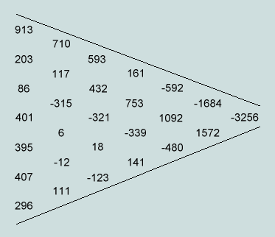
The leftmost column - reading from top to bottom - represents the familiar Genesis 1:1 number set; each figure in the succeeding columns is derived as the arithmetic difference between the upper and lower numbers on its immediate left.
Ignoring the negative sign, the ultimate result of this process is 3256 (= 88 x 37) which happens to be the LCM of the two final values of the set, 407 and 296. This result is certainly very interesting, and on closer inspection is seen to be equivalent to the vector multiplication of this set by the 7th row of a form of Pascal's triangle. This is explained in Appendix 2.
Interestingly, the sum of -3256 and 2701 (the triangular sum of the same 7 values) is -555. Of interest also is the result of successively differencing the first 5 of the 7 (representing the 'supernatural' component of the verse and, geometrically, as their sum, the three satellite triangles, each of 666).
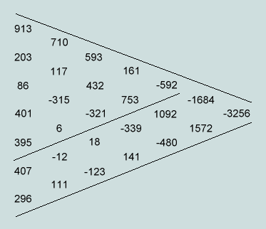
The outcome is shown in context to be -592. Again, ignoring the negative sign, this is seen to be 16 x 37, or 2 x 296 (the 7th term of the Gen.1:1 set). That of its complement (words 6 and 7 - each a multiple of 37) is 111, or 3 x 37.
The following diagram summarises these two latter outcomes in context.
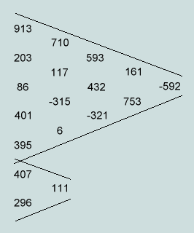
These multiples of 37 - a number already found to be a prominent feature of this verse - suggest that the order of these CVs is also significant. That this is indeed the case is demonstrated in Appendix 3 where, of the 5040 possible permutations of these 7 numbers, the biblical arrangement is 1 of only 4 that display features that are completely consistent with earlier observations.
3. Alternative vector multipliers
The concept of forming the sum of the products of the Genesis 1:1 CVs and the corresponding terms of a symmetrical vector (viz a row of the modified Pascal triangle), suggests there may be other structures to which this verse is equally resilient in respect of generating a multiple of 37 in this manner. Two examples are given.
- The first concerns symmetical vectors of the form {A,B,C,D,C,B,A) in which A,B,C,D are in arithmetic progression (Appendix 4). For example, if we take any number as the first term (A = -7, say), and any number as common difference (B-A = C-B = D-C = 5, say), then the particular vector becomes {-7, -2, 3, 8, 3, -2, -7} and applying this to Genesis 1:1, as described (the embedded dot here signifying 'multiplied by':
(-7.913) + (-2.203) + 3.86 + 8.401 + 3.395 + (-2.407) + (-7.296) = -5032 = -136.37
- The second concerns the asymmetrical vector comprising the first 7 triangular numbers, {1,3,6,10,15,21,28}. Here is the calculation:
1.913 + 3.203 + 6.86 + 10.401 + 15.395 + 21.407 + 28.296 = 28808 = 2^3.13.277 = 8.3601
Observe that 3601 has a direct geometrical connection with 2701 (sum of the Genesis 1:1 CVs); it is the hexagram that is formed in the symmetrical union of 2701-as-triangle with itself.
4. Other features that speak of precise order
- The concatenation of word CVs
If the 7 word CVs of Genesis 1:1 are regarded as single digits in a number system, radix 1000, then the number thus represented is the concatenation of these CVs, and it factorises thus:
913203086401395407296 = 2^6 x 7 x 37 x 131 x 1291 x 4159 x 7879 x 9941
This result is particularly interesting for two reasons: (a) 2368 (ie 64 x 37) is a factor - this being the CV of the Greek form of the name "Jesus Christ", nominative case - and since the claim is made (eg Jn.1:1-3, 10) that he is our Creator (ie the 'God' of Genesis 1:1), the matter is potentially significant; and (b) the fact that it has 13 prime factors - the largest having only 4 digits - is indicative of low probability* and hence of design.
Only 120 of the 5040 concatenated arrangements are exactly divisible by 2368 - all of which are required to end with words 6 and 7 in situ. One final observation concerns the concatenation of these, viz 407296, which factorises thus: 2 x 86 x 2368. Since the related words are translated "and the earth", and 86 happens to be the CV of word 3 ('God'), the association of these numbers strongly suggests that Jesus Christ is, indeed, God Incarnate!
*The probability of the concatenated Genesis 1:1 number factorising to have all factors < 10,000 has been calculated by computer simulation to be of the order of 1 in 35,000.
- Genesis 1:1 as a tessellated trefoil
Dividing the 7 CVs into the sums of 'odds' and 'evens' leads to compelling symmetrical representations of the verse. The details may be found here.
5. The matter of probabilities
The Hebrew words of the Torah (or Pentateuch) number 79,976. In a computer simulation sets of 7 were chosen randomly and tested for the foregoing properties:
- the sum a multiple of 37 (p = 0.027)
- another multiple of 37 by progressive differencing (p = 0.027)
- another multiple of 37 by progressively differencing the first 5 (p = 0.031)
- another multiple of 37 by progressively differencing the last two (p = 0.034)
The observed probabilities are shown bracketed.
On this basis alone the Genesis 1:1 set represents a 1.5 million to 1 longshot. This is lifted beyond 200 million to 1 when the AP multiplication requirement is included.
6. Conclusions
It might well be supposed that a multiple of some number N - representing the sum of 7 individual components - must yield another multiple of N when the same set of 7 is progressively differenced. This assumption is clearly incorrect, and it follows that the persistence of the unique number 37 as factor (a feature that is here closely dependent on the ordering of the words) provides further reasons (if any more were needed!) for believing the opening verse of the Judeo-Christian Scriptures to be far more than a powerful and foundational assertion; in addition, it is undoubtedly a wonderfully designed numerical artefact, solidly linked with the Creator's name!
As we contemplate the many facets of this standing miracle the word that strongly comes to mind is PURPOSE! Why should the Lord, from the beginning, have built these numerical features into His Word? Why have they remained hidden until now? And why are they proving to be so unpopular - particularly among those who, by definition, are lovers of truth? I suspect that such intriguing questions - and more - must soon be answered.
Vernon Jenkins MSc
2001-11-18
The Postscript
Abstract: At the time of writing the A-series of cut paper sizes (defined by ISO 216) is a familiar accompaniment to life in most countries and promises soon to be accepted universally as a truly _international_ standard. Its principal representative, A4, has metric dimensions that reveal a remarkable affinity with significant features occurring in the texts of both Genesis and Revelation - the first and last of the Bible's Books. Further, even the sequence number of the standard, viz 216, is found to be closely involved in these relationships. Such intriguing matters form the basis of the current paper and the question is asked: How is it possible that fragments of ancient writings should map so precisely onto an artefact that was not to appear on the world's stage until some two or three millennia later?
1. Introduction
The present page is essentially an abridged reworking of Exceptional Measures (also to be found on this site). Its aim is to highlight and explain the message that is carried by an artefact familiar to more than 90% of the world's population, viz the A4 sheet of cut paper.
2. Background
- Tradition has it that the first five books of the Judaeo-Christian Scriptures (the Pentateuch or Torah) were penned by Moses during the 13th Century BC. Their Hebrew words are to be found today inscribed in synagogue scrolls and Jewish Bibles. With the introduction of alphabetic numeration into Israel c200 BC, these words acquired an additional numerical presence. Our attention focuses particularly on the first eight of these - ie the seven of Genesis 1:1 and the first of Genesis 1:2. Here are the numbers which represent a fair reading of these words: { 913, 203, 86, 401, 395, 407, 296, 302 }. (Appendix 1)
- Moving on to the 1st Century AD and the writing of the Bible's concluding Book, The Revelation (of Jesus Christ), we find divine sanction for reading Hebrew (and Greek) words as numbers; indeed, Rv.13:18 encourages us to do so! - the number 666 being offered as the key to wisdom. A second number, 1260, is found in unusual circumstances in the close vicinity of 666 (see Rv.12:6,14;13:5). (Appendix 2)
- Today the ISO 216 A-series of cut paper sizes is a familiar accompaniment to life in most countries outside the USA and Canada (Appendix 3). Its principal representative, A4 (depicted below), has an area of 1/16th square metre and a height-to-width ratio of square root of two (1.4142). It is the most convenient (and therefore the most popular) size for recording and communicating the written word. Observe that it is logically based upon the metre - a unit of length derived directly from terrestial measurement (Appendix 4).
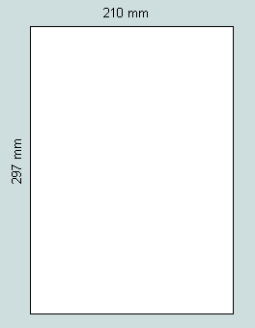
It turns out that those writers, designers, and others responsible for bringing these three artefacts into being were responding to the dictates of a higher authority!
3. The beginning of a mystery
From the previous diagram we observe that the height of A4, viz 297mm, is numerically one more than 296 - the reading of the Bible's 7th word. This, of course, might well be quickly dismissed as happenstance were it not for the fact that the difference, (height - width), is 87mm, ie numerically one more than 86 - the Bible's 3rd word! A complete investigation reveals that the immediate neighbours of all but the first of the 8 values may be simply expressed in terms of the metric dimensions of an A4 sheet. Here are the details:
Let H and W represent the height and width of the sheet in mm; and let P and Q represent H/3 and W/2, respectively. We then have: H = 297, P = 99, W = 210 and Q = 105.
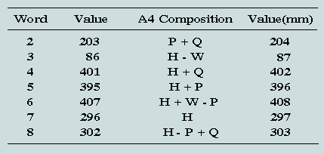
The table lists the values of words 2 to 8, Genesis 1, together with the corresponding A4 components which yield a length in mm one more, in each case.
Clearly, there is a principle at work here which calls for further investigation.
4. The intriguing matter of the value-pairs
Since the A-series is based upon the square metre - and, ultimately, the metre as unit of length - it is but a short step to bring a sheet of A4 into contact with a rule graduated in mm. The following diagram depicts operations in which an edge of the sheet is made to coincide with the ruler's 1000mm mark.
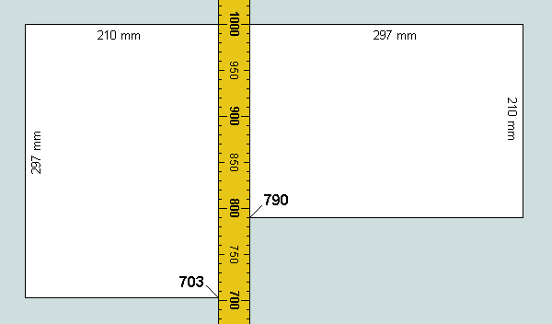
On the left, we find the opposite edge at 703 (ie 1000 - 297), and observe that 703 = 407 + 296 (ie the sum of words 6 and 7, precisely) = 401 + 302 (ie the sum of words 4 and 8, precisely).
On the right, the opposite edge stands at 790 (ie 1000 - 210), and note 790 = 395 + 395 (ie twice word 5, precisely).
This interesting development may be extended by representing an A4 sheet as six equal panels of dimension 99mm x 105mm, thus:
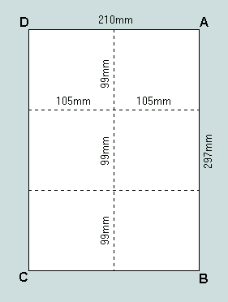
We continue bylabelling the points of intersection, thus:
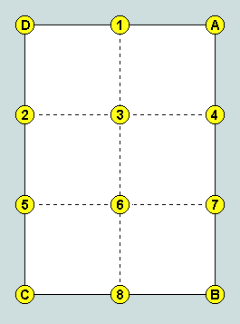
The picture we now have may be regarded as a segment of a field in which a potential (expressed in mm) is associated with each of the marked points - linear distance representing difference in potential (displacements right and up, positive; left and down, negative).
Setting A's potential to 1000 units, we then have, for example, B's potential as 703 (ie 1000 - 297), C's as 493 (ie 703 - 210), D's as 790 (ie 1000 - 210), and so on. The complete picture is summarised in the following table where the potential at each of the marked points is shown to be the sum of two members of a set comprising words 2 - 8 of Genesis 1:1 and the number 500 - asterisks signifying the active components.
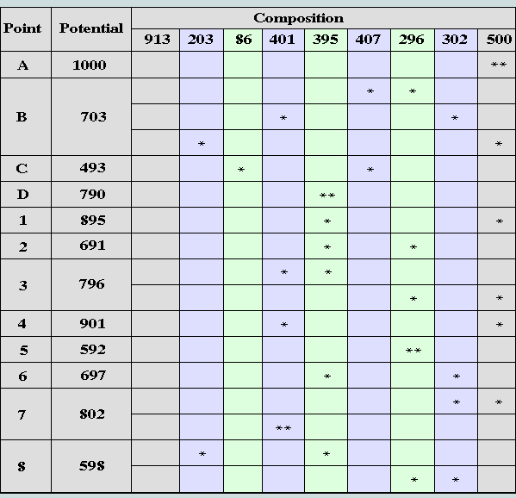
Observe, (a) that the first word does not figure in this particular analysis and, (b) the table reveals alternative realisations for the potential at points B, 3, 7 and 8.
5. Releasing the precise values
If the potential at A is halved (to 500 - the value already seen to be closely involved with words 2 - 8) and the sphere of activity augmented (by the addition of further A4 sheets), then the precise values of words 2 - 8 are revealed as the potentials existing at the several points of intersection, thus:
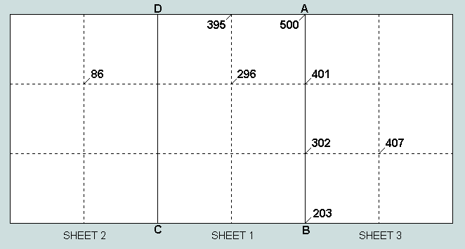
But one is entitled to ask, Where is the elusive first word in all this? The exercise cannot really be considered complete unless it can be demonstrated that A4 is also able to deliver 913 precisely in as simple a manner as it has the following seven.
To accomplish this it is necessary that we step back to the earlier procedure which provided the clue to the pairs phenomena, thus:
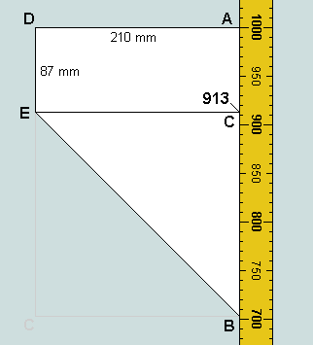
Here we have the A4 sheet folded diagonally such that CB lies on AB, and 913 is revealed at C as (1000 - 297 + 210)!
6. Enter the mysterious numbers of Revelation
Finally, concerning 1260 and 666 - those numbers appearing explicitly in chapters 12 and 13 of the Bible's last Book - a simple diagram reveals their combined connection with A4, thus:
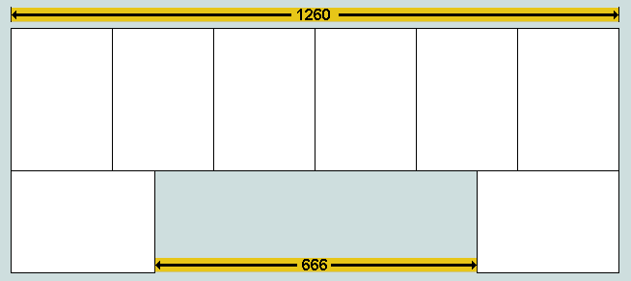

The combined width of six A4 sheets laid side-by-side is clearly 6x210, or 1260mm. Subtracting 2x297, or 594, we obtain 666mm.
7. The significance of 216
Observe that the A-series, and A4 in particular, is defined in the document headed ISO 216. Now 216 is the cube of 6 which, (a) written as 6.6.6, has the same visual impact as 666, and (b) happens to be the outline of the Genesis 1:1 triangle. In the context of our discussion, therefore, this sequence number could not be more appropriate!
8. Conclusions
As generally understood, an artefact is something that is conceived and constructed purely by human agency. However, to explain the relationships presented here the writers of the Biblical passages and those involved in the development of the A-series clearly required something more than mere self-generating ingenuity! An adequate explanation must demand the existence of an omniscient, omnipotent, interested and purposeful Supervisor. Who better to fulfil this role than the God of the Judaeo-Christian Scriptures?
All things considered, therefore, it is hard to avoid the conclusion that the ubiquitous A4 sheet functions as a fitting postscript to the biblical data. However, the fact that it has been considered necessary to provide such proof of biblical integrity in our day should not pass unnoticed. It is deeply thought-provoking and should cause all who love truth to carefully ponder this whole matter!
Vernon Jenkins MSc
email: vernon.jenkins@virgin.net
Return to Homepage
2002-01-24
For further details of the 'A4 phenomena' see the page 'Exceptional Measures' at www.otherbiblecode.com where many other features of the standing miracle are also provided.
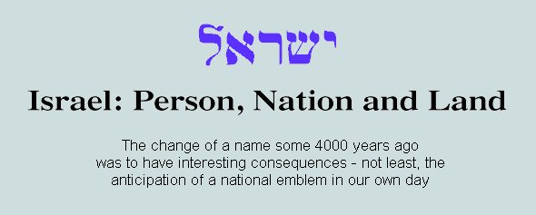
Chosen also by number
It is perhaps not surprising that of all biblical names having earthly connotations ISRAEL is found to occur more frequently than any other - and by a handsome margin. The name - meaning God strives - was divinely bestowed upon Jacob (c1800 BC) following his remarkable struggle with a stranger (Gen.32:24-28), and was later passed on to his descendants and their land.
The value of read as a number (ie its characteristic value) is 541 - one that is an integral part of the scheme of numerical design revealed in Gen.1:1, for consider:
- 541 uniform circular counters may be set out on a flat surface to form a perfect Star of David, or hexagram (Figure 1a), and Israel is thus observed to possess the symmetrical form of its own national emblem - a fact that defies logical explanation - for there exists no evidence to show that this coincidence was intended!
- the outline of this figure comprises 108 counters - identical with the outline of the triangle representing "... and the earth." - the rendering of the two final Hebrew words of the Bible's first verse (Figure 1b)
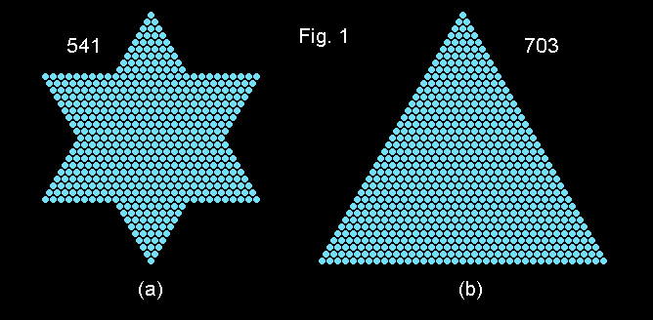

- these figures each have 37 rows of counters - 37 having a particular significance in the numerical structure of Gen.1:1 (see The Arbiters of Truth)
- 541-as-hexagram has 12 sides, each comprising 10 counters; the first clearly relates to the number of the tribes of Israel; the second to an essential anatomical feature of man, and principal collective unit, or radix, of his numbering and measuring systems
- the hexagon having the same number of rows is the 19th (ie each of its 6 sides comprises 19 counters); as can be seen (Figure 2c), it comprises a total of 1027 counters, while that representing the hexagonal core of the hexagram (Figure 2b) is the 10th (Figure 2a) and comprises 271 (or 0271) counters; both these numbers - each clearly compatible with 541 - are digit permutations of 2701 - 73rd triangle and characteristic value of Gen.1:1
- the triangle which generates the hexagram (by self union) is the 28th (Figure 2b); its value is 406 - near neighbour of 407 (characteristic value of the 6th word of Gen.1:1) and precisely twice that of word 2, viz 203
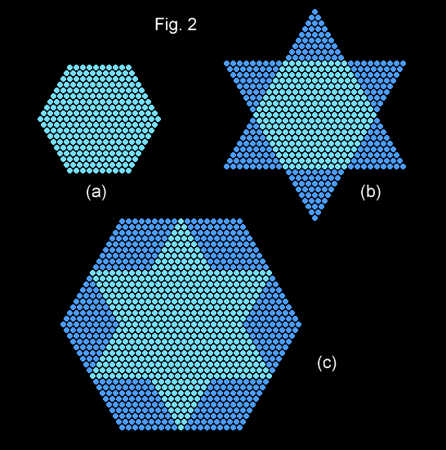

- again, 28 is itself a triangular number (the 7th), 2nd perfect number, and the number of letters of Gen.1:1
Conclusion
Clearly, the Bible's second channel of communication, viz that opened by the reading of its Hebrew and Greek words as numbers (as per the alphabetic numbering schemes used by these ancient peoples), provides precise and visually-compelling information that poses important questions for mankind - questions that will be urgently addressed by all who love Truth.
Vernon Jenkins
2002-07-28
(Transcribed from a document first prepared by the author 1991-01-24)

Appendix - The derivation of the characteristic value of Israel
The term characteristic value (CV) refers to a numerical attribute of every Hebrew or Greek word, or group of words, that has its origin in one or other of the the alphabetic schemes of numeration used by these ancient peoples - introduced c200 and c600 BC, respectively.
The Jewish scheme is set out in the following table where the Hebrew alphabet of 22 letters - 5 of these having end-forms - is presented as a set of numerals:

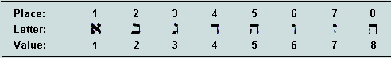
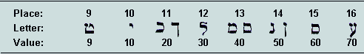
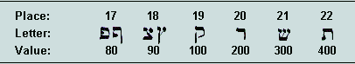

The practice then was to record numbers on an additive basis, ie the value represented by a string of characters was the simple sum of the character values as shown above.
Thus, the evaluation of Israel proceeds as follows:
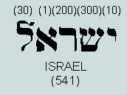
The reading is from right to left with letter values shown above, and their sum below.
A second number may be derived from the same word by summing the ordinal positions of the letters within the alphabet - its so-called place value (PV). Further reference to the table reveals the PV to be (12 + 1 + 20 + 21 + 10), or 64. This is significant in being, (a) bifigurate (it exists both as square of 8, and as cube of 4), (b) as cube of 4 it is typically represented in 2-D by the 4th numerical hexagon, viz 37 (abundant factor of Gen.1:1), and (c) 37x64, or 2368, represents the evaluation of Jesus Christ from the New Testament (and Septuagint!) Greek.
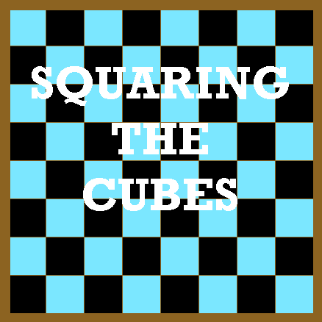

1 - Introduction
As has been demonstrated in earlier pages, 'Aleph-Tau' - the numerical phenomena associated with the opening words of the Hebrew Scriptures and with the Greek form of the Creator's Name - have many interesting ramifications which lend themselves to graphical expression. Here, we consider again their impressive pedigree, and their relationship with a simple artefact, the chequerboard (well-known to those interested in the games of draughts and chess) - a structure consisting of an 8x8 arrangement of 64 unit squares. Of immediate interest is the fact that a 4x4x4 cube may be built from 64 unit cubes. Sixty-four is therefore an example of a 'bifigurate' number; it is the smallest that may exist both as square and as cube.
Attention is drawn to the use of two symbols in the numerical expressions which follow: the period or full stop ('.'), representing 'multiplied by', and the up-arrow ('^'), 'to the power of'.
2 - Some recollections
To fully appreciate subsequent developments the reader is reminded of certain key facts (established in earlier pages), viz
- in a typical view of 64-as-cube one or more faces of just 37 unit cubes are visible:
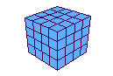
- there are only two numbers that reveal more than two visually symmetrical forms; they are 37 and 91:
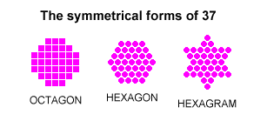
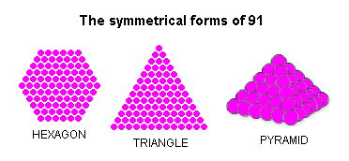
- these - the most geometrically-active of numbers - are, respectively, the difference and the sum of the cubes of 4 and 3, ie 64 and 27, thus:
37 = 64 - 27, and 91 = 64 + 27
- reversing the digits of these numbers (a radix-dependent operation!) we obtain 73 and 19 - each of which has a single symmetrical form, thus:
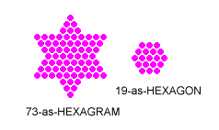
The results serve to emphasise the hidden but essential role played by 10 in certain aspects of these proceedings.
3 - A significant difference
Those having memories of early school algebra will no doubt have noticed something interesting about the cubic connections of 37 and 91, viz the fact that if these geometrically-unique numbers be multiplied together a 'difference of two squares' scenario is uncovered, thus:
37.91 = (64 - 27).(64 + 27) = 64^2 - 27^2 = (4^3)^2 - (3^3)^2 = 3367
In the following diagram, this result is represented by the number of unit squares in the area coloured blue:
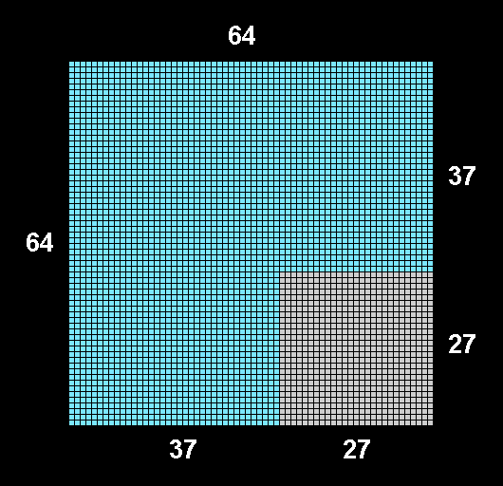

The larger square - comprising 4096 units - may be envisaged as a chequerboard of chequerboards, thus:
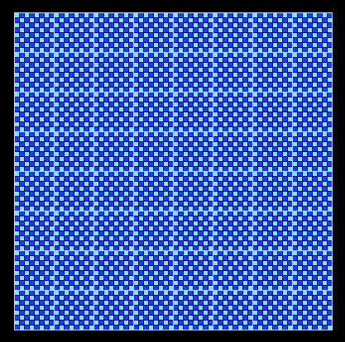

So far, these developments have concerned certain unique properties of number per se, but now the interesting observation that they also relate to something familiar to most people, viz a standard chequerboard.
4 - Further recollections
We proceed by considering other (apparently unrelated) matters which display close affinities with the foregoing structure. They derive from a completely different kind of artefact, viz the original text of Holy Writ. The following facts (established in earlier pages) form an essential backcloth to these further observations:
- the cube per se is a symbol of holiness (1Kings 6:20, Rev.21:16)
- the opening 8 words of the Bible (as rendered in the original Hebrew) may be fairly read as the numbers: 913, 203, 86, 401, 395, 407, 296, and 302; the first 7 - belonging to Genesis 1:1 - total 2701, 73rd triangular number; the 6th and 7th total 703, 37th triangular number; all 8 total 3003, 77th triangular number
- 37 and 73 are factors of 2701; 19 and 37 are factors of 703; 91 is a factor of 3003
- the entire numerical structure of Genesis 1:1 is founded on 37
- from the Greek of both Septuagint and New Testament the letters forming the name 'Jesus' total 888, and those forming the title 'Christ', 1480; 37 is a factor of 888, of 1480, and of their sum, 2368
- 666 is unique as a number per se, and is highly significant as a biblical number; 37 is a factor
5 - Some biblical connotations
Having reminded ourselves of the results of earlier discoveries, we return to the figure generated from purely numerical considerations in Section 3. A simple development involves extending the inner edges of the smaller square so as to divide the 'difference of squares' into three rectangular panels, thus:
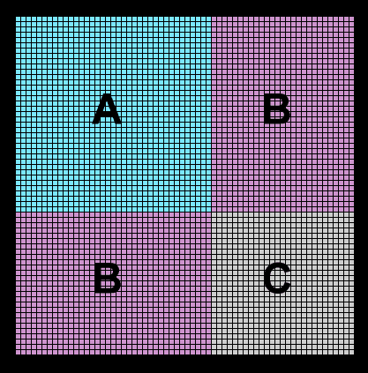

Here, we find the following:
- A = 1369 = 37^2; B = 999; C = 729 = 27^2 = 9^3 = 9.9.9
- (A + 2.B + C) = 4096 = 64^2 = 16^3; (B + C) = 1728 = 12^3
- (A + B) = 2368 = 'Jesus Christ' = Creator's Name
- C (as we have seen) may also be depicted as a cube - with apposite implications
Clearly, the preponderance of cubes, the 999/9.9.9 phenomenon, and the uncontrived presence of 'The Divine Signature', "Jesus Christ", combine to produce a highly-remarkable picture. It is appropriate that we remind ourselves that this has all emanated from our consideration of the product of two unique numbers!
6 - Further revelations
In our next figure, the square area A is depicted as the sum of two triangles, D and E. Here, D = 703, and E = 666 - their sum, 1369, the square of 37.
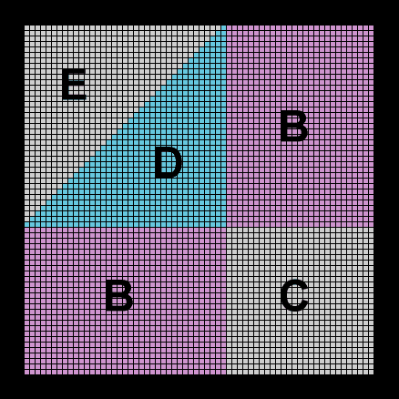

A significant consequence of this operation is:
(B + D + B) = 2701 = Genesis 1:1 (representing The Creation!)
contained by the pair of rectangles, (B + D + E) - each a representation of The Creator!
Further, in this coloured septagon we see groups of values of the 7 words of Genesis 1:1, thus:
- B = 999 = 913 + 86 (words 1 and 3 - "In the beginning...God...")
- D = 703 = 407 + 296 (words 6 and 7 - "...and the earth.")
- B = 999 = 203 + 401 + 395 (words 2, 4 and 5 - "...created...the heaven...")
The outline of this septagon comprises 216 (= 6^3 = 6.6.6) unit squares. So the complete figure contains a second instance of the phenomenon alluded to earlier, viz 666/6.6.6! And this, physically rotated through 180 degrees, yields 9.9.9/999!! Clearly, such coincidences involving the symbols man has chosen to represent numbers - quite independently of current considerations - carry far-reaching implications!
7 - A fitting climax
We have seen that certain sums formed from the Genesis 1:1 number set {913, 203, 86, 401, 395, 407, 296} may be expressed as symmetrical elements of numerical geometry within the confines of a chequerboard of chequerboards. But further developments along these lines are possible arising from the fact that the sum of word-values 2 to 7, viz 1788, divides evenly without infringing word boundaries. Thus, 203(2) + 395(5) + 296(7) = 86(3) + 401(4) + 407(6) = 894.
[Note: the bracketed suffix to each word-value indicates its position within the verse.]
Since, 894 = 999 - 105, and 105 happens to be a triangular number (the 14th), we may represent these new facts by removing a triangular segment from one corner of each of the rectangles marked B in the last diagram. A typical outcome is shown below:
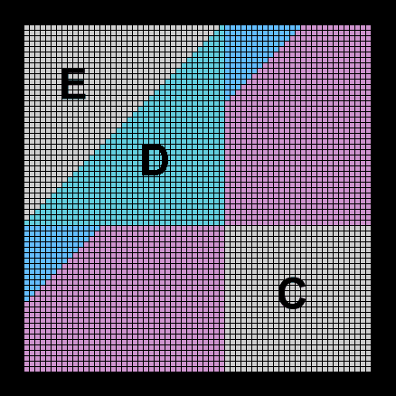
The union of these triangles with D generates a symmetrical representation of 913 - the Bible's first Hebrew word - thus, 105 + 703 + 105 = 913. Calling this F, and each of the 894s, G, we then have a new representation of Genesis 1:1, viz G + F + G:
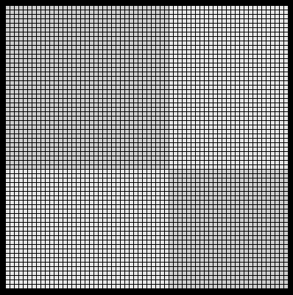
Because two of the word-values are themselves multiples of 37, viz 407(6) and 296(7), further divisions are possible within each area marked G:
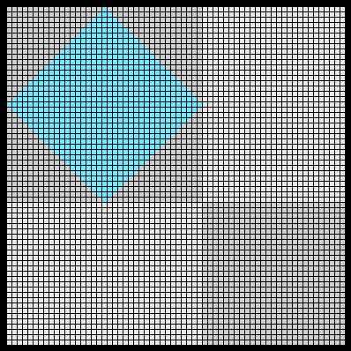
Here, G1 = 296(7) = 8.37; G2 = 203(2) + 395(5); G3 = 86(3) + 401(4); G4 = 407(6) = 11.37.
Finally, because 105 (the 14th triangle) displays the rare phenomenon that its double, 210, is also a triangle (the 20th), an equivalent result may be achieved by removing this segment from one of the areas B, thus:
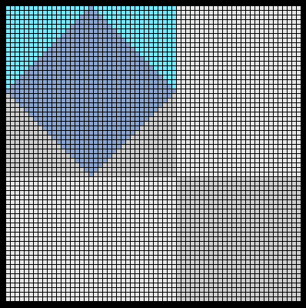
We now have an asymmetrical view of the first word (but still worked out within the original structure). Let us call this area H, and the deficient area, I. Clearly, I = 999 - 210 = 789 which represents the sum 86(3) + 407(6) + 296(7). The area B that remains must then account for 203(2) + 401(4) + 395(5) = 999, as before.


Observe that the Bible's opening word turns out to be the sum of two or three triangles: one arising from the sum of the two closing Hebrew words of the first verse (translated "and the earth") together with one or two involved in the exceedingly rare event, 'triangle(1) = 2.triangle(2)' - there being only 8 instances of the phenomenon in the first million triangular numbers (residing within the first hundred billion natural numbers!). They combine to make this word rather special!! Again, since the first occurrence of the phenomenon occurs early on with 3 (2nd triangle) and 6 (3rd triangle), and explains why 37 has both hexagon and hexagram symmetries (37 = 12.3 + 1 = 6.6 +1), we have an indirect link between it and 37.
Two final points: the area (B + D + E + B) represents the product of the two trifigurate numbers, 37 and 91 - the starting point for these deliberations; the significance of the lurking presence of 666 (area E) should not be overlooked.
8 - Conclusions
Little more remains to be said. Here we have clear and detailed evidence of supernatural intelligent design! As more telling aspects of 'The Miracle' appear, the more untenable become the positions of the atheist, agnostic, and liberal theist. Can there really be any more doubt concerning God's Being and Sovereignty? What more could He do to lead the unbeliever to understand that His Son, Jesus, is both Creator and Lord? and that the Bible - His word to man - is to be believed rather than challenged?!

Vernon Jenkins MSc
First published: 1999-7-25
Augmented: 2002-11-1
Augmented with supplement: 2002-11-5
email: vernon.jenkins@virgin.net
- home page

Postscript
One final thought occurs in respect of an earlier diagram: if we pick out a diagonal of the 64.64 square and, again, that of the 37.37 square, we construct a cross of 100 (= 10^2) units, thus:
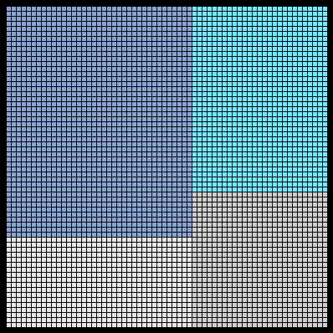
In this process we shall have delineated Genesis 1:1 and 666, and drawn attention to the radix of our number system and principal collective unit in mensuration. Further, the product of the dimensions of the cross is 64.37 (ie 4th cube multiplied by the number of unit cubes typically visible in part), 2368, or The Lord!
VJ
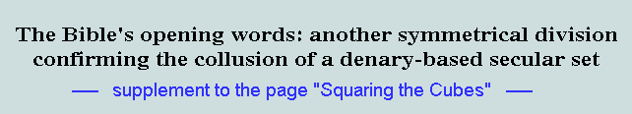
1 - Introduction
We have already seen that a fair alternative reading of the Hebrew text reveals the opening 8 words of Torah to be the numbers {913, 203, 86, 401, 395, 407, 296, 302} - the first 7 representing Genesis 1:1, and the 8th, the first word of the following verse. Just as the sum of the first 7 (ie 2701) is found to be a triangular number (the 73rd) and multiple of 37 (the first of the two trifigurate numbers), so the sum of the first 8 (ie 3003) is also revealed to be triangular (the 77th) and multiple of 91 (the other trifigurate number). Again, the addition of words 6 and 7 (ie 703) generates a third triangular number (the 37th) - the sum of words 1 - 5 (ie 1998), as we have seen, dividing evenly as (913 + 86) = (203 + 401 + 395) = 999. A similar situation arises within words 2 - 7, where we found (203 + 395 + 296) = (86 + 401 + 407) = 894. In these divisions we noted the exclusion of the final pair and the first, respectively, of Genesis 1:1. The purpose of this supplement is to consider a third instance of an even division in these opening words (now, however, augmented to 8) involving the exclusion of 401 - the central, and untranslatable, word of the first verse.
2 - The continuing story
Let us then observe that (913 + 86 + 302) = (203 + 395 + 407 + 296) = 1301 - so that the pattern here takes the form 1301 + 401 + 1301 = 3003. Both 1301 and 401 are prime numbers and, like 2701 (sum of the first 7) are each equivalent to 1 modulo 10^2. Again, each may be expressed as the sum of two squares, thus: 1301 = 625 + 676 (ie 25^2 + 26^2), and 401 = 400 + 1 (ie 20^2 + 1^2). Further, because the first is the sum of adjacent squares, it has a single geometrical presence as the 26th diamond, depicted below:

Again, 1301 - 401 = 900 = 30^2; thus, 401 = 1301 - 30^2 - and a neat pictorial representation appears possible. However, 1301-as-diamond is unable to accomodate so large a square, and the best available geometrical expression of 3003 is the following:
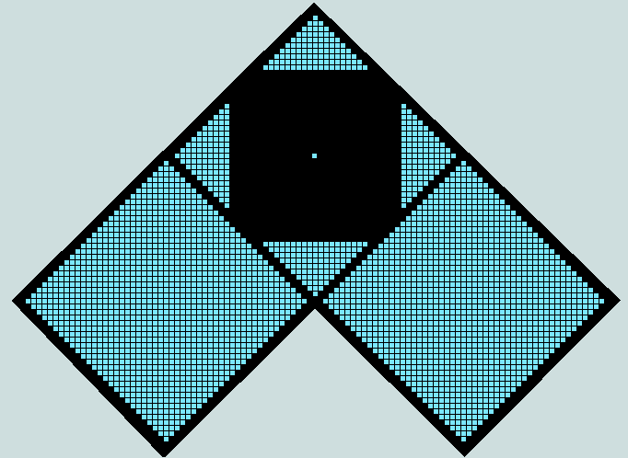
Observe that in the symmetry that accompanies this third division 401 appears (within the confines of 1301-as-diamond) as 4.10^2 + 1. The affinity that clearly exists between these numbers that define the sum of the first 8 words should not be overlooked. Things needn't have happened this way! Even their difference, 900, misses out on being a factor of 2701 (ie Genesis 1:1) by a mere hair's breadth!
3 - The 'Stickler' set
One of the first FORTRAN programming exercises encountered by the writer required the student to determine all 3-digit numbers that were each the sum of the cubes of their individual digits. These were designated "The Sticklers" by the author of the book in which the problem appeared. It turns out that there are just four numbers that meet this specification, viz {153, 370, 371, 407}. The 2nd and 4th are multiples of 37 - their sum, 777; the former is a cyclic permutation of 703 (sum of words 6 and 7 of the Bible's first verse) and of 37, while the latter is the actual value of word 6! But observe also that the 1st and 3rd occur as surface features of the Judaeo-Christian Scriptures: 153 (17th triangular number) - the number of fishes caught in a net (John 21:11), and 371 - the duration of the Flood in days (Genesis 7-8)! But of particular interest in the current context is the fact that the sum of the first three is 894, while all four total 1301! As we have seen, these precise numbers appear in connection with even divisions within the first eight words of the Bible. All things considered, therefore, there clearly exists a surprisingly high degree of integration between what otherwise must be considered to be independent sets.
4 - Conclusion
There can be little doubt that He who first uttered the Bible's opening words was not only aware of the Sticklers, but actually incorporated them into the underlying structure. Who is able to provide a natural explanation of such mysteries? Who has the courage to begin to try?!
Let us finally observe that the Sticklers essentially involve the cubes of the natural numbers as mediated by 10 - radix of our number system.
Vernon Jenkins MSc
2002-11-4

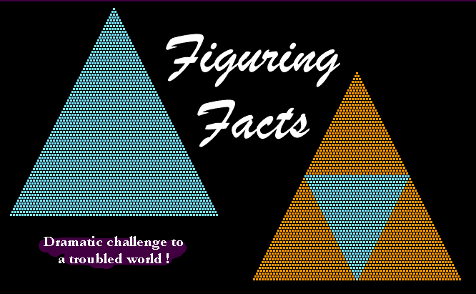
"Come now, and let us reason together, saith the Lord" (Isaiah 1:18)
It is not generally appreciated that the collection of early Hebrew and Greek writings that form the basis of what we now call 'The Bible' is at the same time a set of numbers. This situation arises quite naturally from the fact that during the centuries immediately preceding the birth of Jesus these peoples adopted alphabetic systems of numbering - ie the letters of their alphabets were made to double as numerals. These schemes - together with a hypothetical English version based upon the Hebrew model - are described in the appendix; also provided there are the evaluations of the Hebrew Bible's opening verse (Genesis 1:1) and the Creator's Name, 'Jesus Christ'.
At a more primitive level any whole number may be represented by a group of counters - typically, coins of the same denomination, or sugar cubes. In such cases the counters can sometimes be arranged to form 2-d or 3-d symmetrical structures or, more rarely, two, or even three, distinct structures. Clearly, such combinations of number and form are independent of time and place, and of all the many schemes of symbolism devised by man for recording the 'How many's?' of human experience. They are, therefore, prime and indisputable examples of absolutes in an increasingly relativistic world.
The number thirty-seven is a case in point; it is unique in being associated with three 2-d patterns, possessing between them a total of 16 axes of symmetry: hexagon (diagrams A1 and D1, below), six-pointed star, or hexagram (B1), and octagon (C1). Associated with each of these is a symmetrical 'relative': thus, the hexagon, A1, forms the core of the hexagram, A3; the hexagram, B1, has the hexagon, B3, as its core; the octagon, C1, is built around the square, C3; the hexagon, D1, is a 2-d representation of the cube, D2 - the number of unit cubes from which it is constructed (ie sixty-four) also existing as the square, D3.
Thus, we see 37 linked absolutely with 73 (its digit reverse), 19, 25, and 64, respectively. It is therefore a remarkable fact that if 37 - the most symmetrical of all numbers - be multiplied by each of these derivatives in turn, numbers of direct biblical interest are generated!
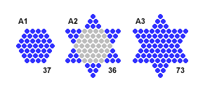
- 37 x 73 = 2701 = "In the beginning God created the heaven and the earth." (Genesis 1:1) = opening verse of the Bible. The triangle (left) above comprises 2701 counters; each of its sides is formed from 73 counters.

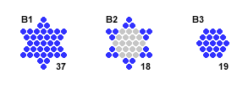
- 37 x 19 = 703 = "...and the earth." (the sum of words 6 and 7 of Genesis 1:1). The inset triangle (right) above comprises 703 counters - each of its sides comprising 37 counters. We observe that it fits precisely within the 2701 triangle, and is hemmed in by a trio of smaller triangles - each of 666 counters.

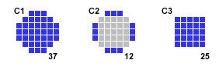
- 37 x 25 = 925 = 'Jesus Christ' (English: pseudo-Hebrew).

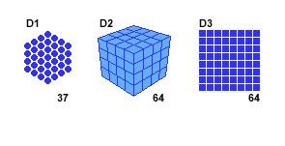
- In a typical view of a stack of 64 small cubes, 37 are partially visible; the remaining 27 are not.
- 37 x 64 = 2368 = 'Jesus Christ' (Greek) - 3 rows of the square, D3, accounting for 'Jesus' (ie 888), and the remaining 5 rows, for 'Christ' (ie 1480)!
- 37 x 27 = 999 = "In the beginning God..." = "...created the heaven..." (Genesis 1:1, words 1 + 3 and 2 + 4 + 5, respectively).

We live in a world in which man's imaginations have led him to conclude that there is no God - or, if there is, that he is too small to be bothered about! Is it any wonder then that Jehovah - the Creator and Sovereign Lord of All - has decided, in our day, to confound His enemies and bolster the faith of those who love Him? The method He has chosen is beautiful in its economy and simplicity. It involves the stripping down of the words of Holy Scripture to their numerical values - thus dispensing with the clouding nuances of language and interpretation - and relating these to the 'visual aids' outlined here. The fact that the central figure in these developments is the trifigurate number 37 must, in itself, confirm the purposeful action of the divine hand.
Reader, what is your response to the news that the biblical text is self-authenticating? Are you prepared to gamble your life that the associated numerical phenomena are 'accidents of chance' or, otherwise, arise from the activities of some worldly conspiracy? Who but a Transcendent and Divine Being could have devised and implemented such a scheme many centuries before the invention of the numerical codes that make it apparent to us?
Vernon Jenkins MSc.
January 8th, 1999
email: vernon.jenkins@virgin.net
See also: http://www.jsampson.co.uk/miracla1.htm
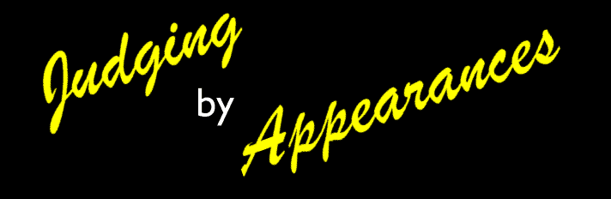
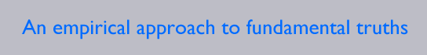
Introduction
In general, whole numbers appear to the eye, (a) as objects or events of interest to be counted, or (b) as strings of symbols to be interpreted. The first concern absolutes and may be idealised with reference to collections of uniform spheres. The second are to do with matters of human expediency; they involve choice of radix, and the creation (or adaptation) of a set of symbols, together with rules for their use. The currently-used method of number writing represents the final stage in a long process of evolutionary development; included in this was a period during which complete alphabets were requisitioned for use as numerals as, for example, among the Greeks (from c.600 BC) and the Jews (from c.200 BC). Because the original documents of the Judaeo-Christian Scriptures were written in Hebrew (Old Testament) and Greek (New Testament) it follows that they may also be fairly read as sets of numbers. (Hebrew and Greek schemes).
Whether arising from (a) or (b), numbers sometimes exhibit interesting patterns. In the case of (a), it may be possible to place the objects to be counted (uniform spheres, as suggested) inside a regular polygonal or polyhedral frame so as to fill it precisely and completely. In such situations the numbers represented are said to be figurate. A typical example is found in the game of snooker - the 15 'reds' being tightly arranged in equilateral triangle fashion prior to the commencement of each frame. With regard to (b), it may be that the repetition of a particular digit catches the eye, or it is seen that a number reads the same backward as forward, or again that a simple digit rotation yields a multiple of the original number.
When many events of these kinds are observed to occur in a small set of numbers, we may feel strongly led to attribute them to intelligent design (ID).
[Please note: following standard mathematical practice, the period (.) will here be used to signify 'multiplied by'.]
An Auspicious Beginning
In his writings, Ivan Panin has drawn attention to the interesting fact that the 7 Hebrew words of the Bible's first verse total 2701, or 37.73 - both factors prime. Here are the details:
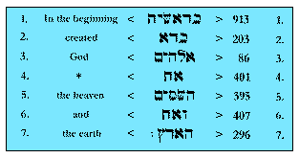

However, more interested in following a trail of 7's, and apparently having little understanding of probability theory, he completely missed a far more significant thread and entered a world of fantasy - nevertheless, unearthing the occasional nugget of gold.
The developments that Panin missed are now considered.
- 2701 is 73rd triangular number; the outline of this triangle is formed of 216, or 6.6.6 counters, thus:
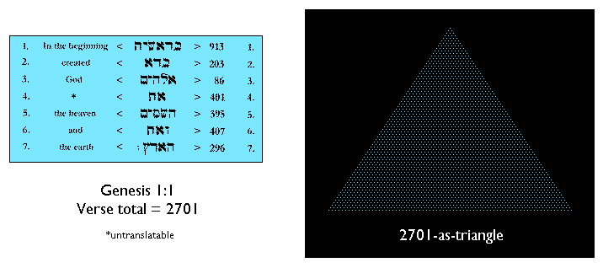
- large multiples of 37 exhibit the interesting property that the sum of the numbers formed by grouping the digits in threes from the right will always be a multiple of 37; in this particular instance, 701 + 002 = 703, or 19.37 - this being the sum of the two final words of this opening verse (each a multiple of 37) , ie 407 + 296 = 703
- 703 is 37th triangular number, thus:
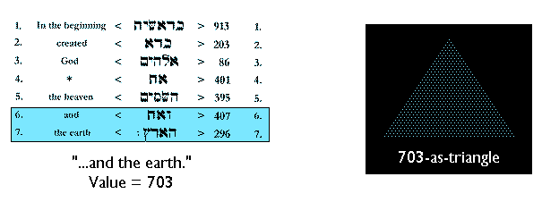
- when inverted, this fits precisely within 2701-as-triangle, dividing the remaining area into a trio of 666-as-triangle, thus:
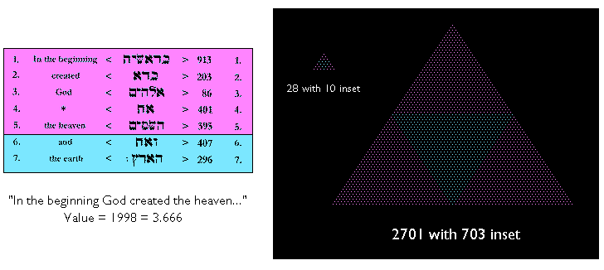
- the picture incorporates the first three triangular multiples of 37 and is highly symbolic: we are reminded of the general context of Revelation 13 and the number of the beast, 666
- a small replica of this structure has been included (top left); it depicts 10 - radix of the denary system and basic collective unit in metrication and decimalisation - in a setting of perfect numbers, viz 6 and 28 - 3rd and 7th triangular numbers, respectively - the latter spelling out the number of Hebrew words and letters of Genesis 1:1; the satellite trio of sixes, and the outline of 28-as-triangle are further suggestive of 666
- because Panin missed these numerical geometries he also failed to observe that the sum of the Bible's first 8 words, 3003, is also triangular (77th in the series); it follows that word 8 - the first of Genesis 1:2 (value 302) - takes the form of a trapezium of 4 rows supporting (and underscoring!) the Genesis 1:1 triangle; here are the details:
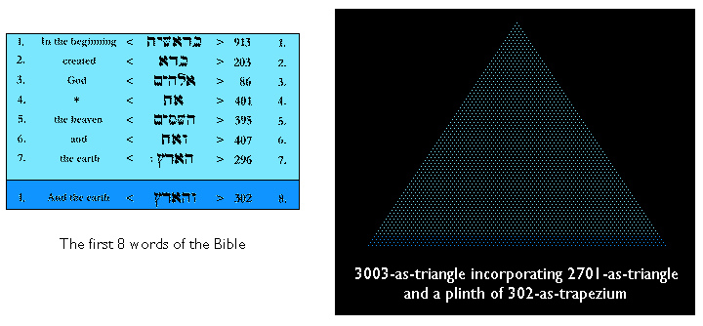
- it is interesting - and possibly significant - that Genesis 1:1 seems to imply the larger triangle, thus: concatenating the factors (and order numbers of the main participants) of 2701 we obtain 3773, and actually see 3003 (its value) embracing 77 (its order number in the triangular series)!
- another feature linking the two is to be found in the word sequence 4 to 8, inclusive; the sum of these 5 numbers is 1801 - ie the numerical hexagon representing the symmetrical self-intersection of the Genesis 1:1 triangle, thus:
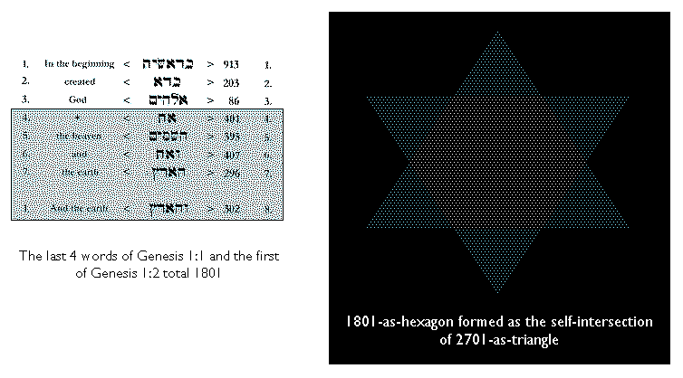
- 3003 may be written, 33.91; in other words, division by 91 simply removes the central zeros of the palindrome
Clearly, there is sufficient material here to attract the attention of all earnest seekers of truth. But the story is only half told, and we continue...
The Plot Thickens
The foregoing analysis has revealed 37 to be a key player in the Genesis 1:1 phenomena. However, the depth of its involvement is greater yet, for consider:
- of the 127 sums formed from combinations of the 7 words of this verse, 23 are found to be multiples of 37, ie nearly 7 times the number expected of a random set!
- included among these are the eye-catching analogues of 666, viz 999 (occurring twice as the sums of words 1 and 3, and of 2, 4 and 5), 777 (sum of the three nouns, 3+5+7), and 888 (3+5+6)
- 37 may be written as the difference of the cubes of 4 and 3, thus: 37 = 64 - 27; on the other hand, 91 (factor of 3003, and digit reverse of 19 - factor of 703) is the sum of the same two cubes, thus: 91 = 64 + 27
- but, even more remarkably, 37 and 91 are unique among the natural numbers in that they may each be realised geometrically in 3 distinct ways, thus:
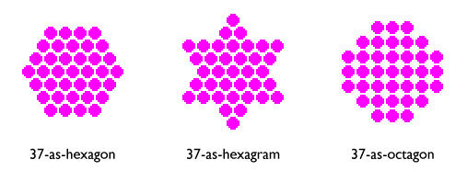
and
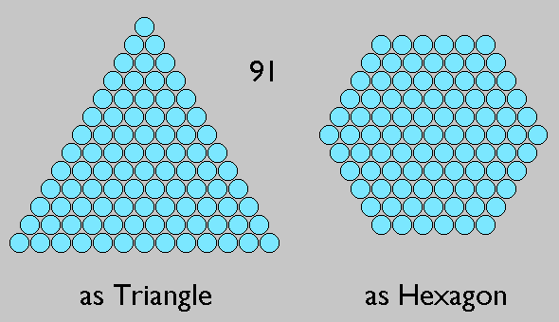

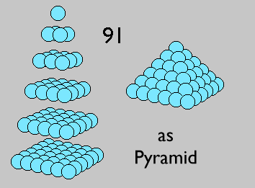

- no instances of higher orders of figuracy (as here defined) are known to exist
- 73 and 19 - the numbers formed by reversing the digits of 37 and 91 - each possess a single geometrical form that is closely coordinated with 37, thus:
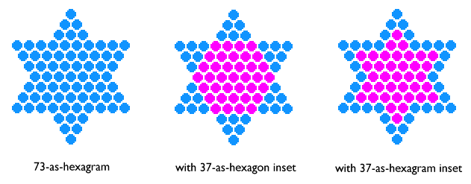
and
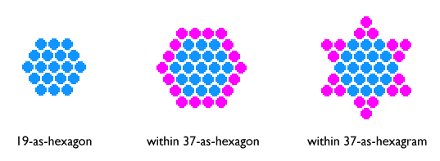

- for figures having the same order, the product hexagon.hexagram = triangle; the instances relevant to this discussion are tabulated below:
Order | Hexagon (X) | Hexagram (Y) | X.Y = Triangle | Comments
2 | 7 | 13 | 91 | Factor of 3003
3 | 19 | 37 | 703 | "...and the earth."
4 | 37 | 73 | 2701 | Genesis 1:1
- these triangles and their factors are therefore implied by the following figures:
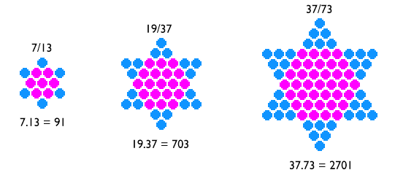
- the 6/1 theme of the creation narrative is clearly seen in these composite figures
In Search of an Author
There can be little doubt that this confluence of coincidences, springing from the heart of mathematics, speaks loudly of intelligent design. Could it be that Panin's basic assumptions have been right all along? - that God, in His infinite wisdom, has by these means provided man with empirical evidence of His Being and Sovereignty? To ascribe the phenomena to chance - bearing in mind the nature of the Book in which they occur, and their strategic position and content - surely demands a leap of faith of mammoth proportions; on the other hand, to believe they are the work of man, one has to hypothesise the existence of some mathematical/literary genius writing many centuries before the introduction of alphabetic numeration into Israel.
That the phenomena are undoubtedly of supernatural origin, and intended to achieve some serious purpose, is made clear by the following extension to the foregoing analysis:
- the Creator's name (Jesus Christ), as we find it in the Greek of both New Testament and Septuagint (c 300 BC), is 2368, or 64.37
- its components are 888 (Jesus), or 24.37, and 1480 (Christ), or 40.37
- as an eye-catching analogue of 666, and a multiple of 37, 888 is clearly linked with the phenomena previously described
- however, there is a further link: the HCF of 888 and 1480 is 296 - the value of the Bible's 7th word, translated 'the earth'; to find it a factor of both components of the name of one who claimed to be God Incarnate cannot be lightly dismissed!
- but for even more convincing evidence, we turn again to numerical geometry: 64 is, of course, the cube of 4; to represent it in on screen we typically draw 37-as-hexagon; this one figure thus implies 2368 (Jesus Christ), the product of 64 and its 2D representation!
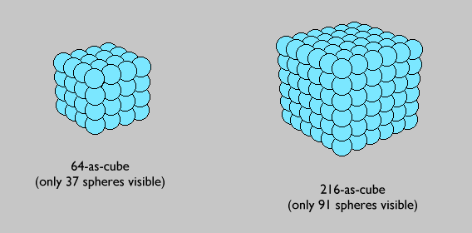

- the second figure depicts the 6th cube, 6.6.6 - outline of the Genesis 1:1 triangle; typically, we see only 91 of its 216 elements

Vernon Jenkins MSc
7th February, 1999
email: vernon.jenkins@virgin.net
See also: http://www.jsampson.co.uk/miracla1.htm for 'Aspects of a Miracle'
INNER CONVICTION
A further look at the miracle of Genesis 1:1
Introduction
The potentially-explosive significance of the Aleph-Tau Phenomena (ie the intricate numerical structures underlying the opening words of the Hebrew Bible) rests upon the clear understanding that these are the work of an exceedingly able and purposeful mind. It is argued elsewhere that they represent a message from The Creator - one that is particularly relevant to this generation. Without doubt, the train of logic that leads inexorably to this conclusion will tempt many to dismiss the features as fortuitous. It is the purpose of this paper, therefore, to counter any such claim by presenting further independent evidence of intricate design. In particular, it reveals that the individual words are related numerically; and that they appear to have been carefully selected so as to maintain the momentum of our interest and wonder - notably, in generating the many multiples of 37 that permeate the opening verse, Genesis 1:1.
2 - Genesis 1:1 as a rectangle
It has been demonstrated in earlier pages that the characteristic value (ie the sum of its 28 letters, read as numerals) of this 7-word verse is the large triangular number, 2701 - product of the mutually-reflective prime pair, 37 and 73. This implies that the verse may also be realised as a 37x73 rectangle, thus:
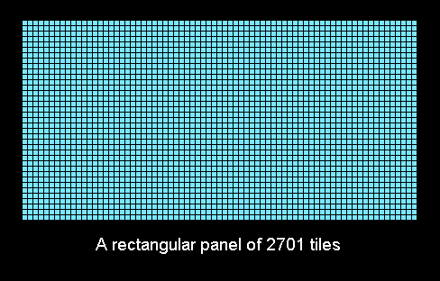
It will be observed that the outline of this figure comprises 216, or 6.6.6 units.
3 - Its components
We further observe that within this structure words 6 and 7 may be represented as rectangles of the same height, for both are multiples of 37: thus, 407 = 11 x 37, and 296 = 8 x 37. Remarkably, the differences between each of the remaining words and nearest multiples of 37 form a coordinated set of multiples of 6, as here revealed:
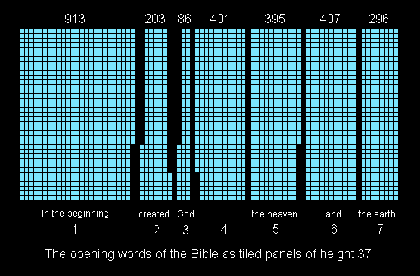
Furthermore, all word-values lie relatively close to a multiple of 100. Both features extend beyond Genesis 1:1 to the next word. This - as has already been demonstrated - functions also as a perfect numerical plinth for a triangular representation of the opening verse.
These features lead to two formal descriptions of Genesis 1:1 and following word.
4 - An interlocking set
The catalogue of elementary rectangular panels contained within Genesis 1:1-as-rectangle is presented below. It reveals that the first five words give rise to two mutually-exclusive pairs of composite units - referred to as (A,B) and (A',B'). The rectangles associated with words 6 and 7 are designated C and D, respectively. Word 8 - first of Genesis 1:2 - is also depicted (in combination with word 4). The resulting rectangle is designated E.
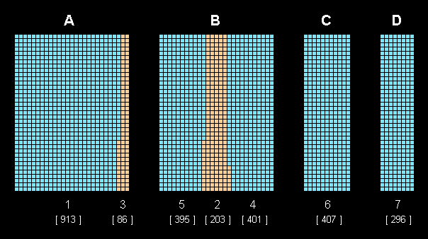
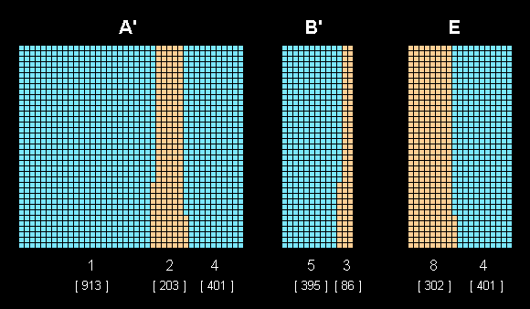
Regarding the first verse, these basic units and their various combinations give rise to a total of 23 rectangles - each representing a multiple of 37. Details of these structures are provided in the following table - their compositions given first in terms of the elementary rectangles - A, B, A', B', C, D - and again, as sums of the word-values.
n | Panel Composition |  |  |  |  |  | Word-Value Composition |  |  |  |  |  |  | 37.m | m
n | A' | A | B | B' | C | D | 913 | 203 | 86 | 401 | 395 | 407 | 296 | 37.m | m
1 | 0 | 0 | 0 | 0 | 0 | 1 | 0 | 0 | 0 | 0 | 0 | 0 | 1 | 296 | 8
2 | 0 | 0 | 0 | 0 | 1 | 0 | 0 | 0 | 0 | 0 | 0 | 1 | 0 | 407 | 11
3 | 0 | 0 | 0 | 0 | 1 | 1 | 0 | 0 | 0 | 0 | 0 | 1 | 1 | 703 | 19
4 | 0 | 0 | 0 | 1 | 0 | 0 | 0 | 0 | 1 | 0 | 1 | 0 | 0 | 481 | 13
5 | 0 | 0 | 0 | 1 | 0 | 1 | 0 | 0 | 1 | 0 | 1 | 0 | 1 | 777 | 21
6 | 0 | 0 | 0 | 1 | 1 | 0 | 0 | 0 | 1 | 0 | 1 | 1 | 0 | 888 | 24
7 | 0 | 0 | 0 | 1 | 1 | 1 | 0 | 0 | 1 | 0 | 1 | 1 | 1 | 1184 | 32
8 | 0 | 0 | 1 | 0 | 0 | 0 | 0 | 1 | 0 | 1 | 1 | 0 | 0 | 999 | 27
9 | 0 | 0 | 1 | 0 | 0 | 1 | 0 | 1 | 0 | 1 | 1 | 0 | 1 | 1295 | 35
10 | 0 | 0 | 1 | 0 | 1 | 0 | 0 | 1 | 0 | 1 | 1 | 1 | 0 | 1406 | 38
11 | 0 | 0 | 1 | 0 | 1 | 1 | 0 | 1 | 0 | 1 | 1 | 1 | 1 | 1702 | 46
12 | 0 | 1 | 0 | 0 | 0 | 0 | 1 | 0 | 1 | 0 | 0 | 0 | 0 | 999 | 27
13 | 0 | 1 | 0 | 0 | 0 | 1 | 1 | 0 | 1 | 0 | 0 | 0 | 1 | 1295 | 35
14 | 0 | 1 | 0 | 0 | 1 | 0 | 1 | 0 | 1 | 0 | 0 | 1 | 0 | 1406 | 38
15 | 0 | 1 | 0 | 0 | 1 | 1 | 1 | 0 | 1 | 0 | 0 | 1 | 1 | 1702 | 46
16 | 1 | 0 | 0 | 0 | 0 | 0 | 1 | 1 | 0 | 1 | 0 | 0 | 0 | 1517 | 41
17 | 1 | 0 | 0 | 0 | 0 | 1 | 1 | 1 | 0 | 1 | 0 | 0 | 1 | 1813 | 49
18 | 1 | 0 | 0 | 0 | 1 | 0 | 1 | 1 | 0 | 1 | 0 | 1 | 0 | 1924 | 52
19 | 1 | 0 | 0 | 0 | 1 | 1 | 1 | 1 | 0 | 1 | 0 | 1 | 1 | 2220 | 60
20 | 1 | 0 | 0 | 1 | 0 | 0 | 1 | 1 | 1 | 1 | 1 | 0 | 0 | 1998 | 54
21 | 1 | 0 | 0 | 1 | 0 | 1 | 1 | 1 | 1 | 1 | 1 | 0 | 1 | 2294 | 62
22 | 1 | 0 | 0 | 1 | 1 | 0 | 1 | 1 | 1 | 1 | 1 | 1 | 0 | 2405 | 65
23 | 1 | 0 | 0 | 1 | 1 | 1 | 1 | 1 | 1 | 1 | 1 | 1 | 1 | 2701 | 73
It will be observed that each word of the verse is involved precisely 12 times in this set of multiples of 37 - implying that they are of equal weight. Note also that here is yet another multiple of 6!
Regarding panel E: this, in combination with A, B', C and D creates an additional crop of multiples of 37 in the augmented verse.
5 - A notable factor
On the average, in any randomly-selected set of integers, 1 in every 37 will be a multiple of 37. Applying this principle to the 127 values represented by the 7 words of Genesis 1:1 and their various combinations, it is to be expected that 3 or 4 will have 37 as a factor. As has been shown here, there are actually 23 - ie over 6 times the expected number! This result becomes a dramatic feature of the accompanying factor profile for the verse where, for each of the values over the range 2 to 50, the frequency of its occurrence as factor in the set of 127 values determines the height of the corresponding column. The ideal profile - delineated by the smaller white squares - provides a backcloth against which the significance of the event may be assessed. In addition, when we consider again the singular attributes of 37 per se, it is indeed difficult to argue that this particular set is random!
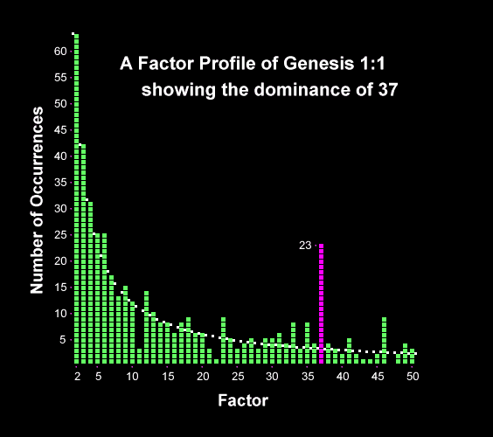

6 - The 3:5 motif
Panels C and D - representing words 6 and 7, and each a multiple of 37 - have an additional significance in the context of the whole verse, for consider:
- 3.C + 5.D = 3.407 + 5.296 = 1221 + 1480 = 2701 = Genesis 1:1
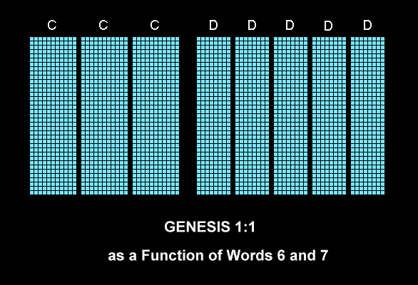

- 3.D + 5.D = 3.296 + 5.296 = 888 + 1480 = "Jesus" + "Christ" = 2368 = "Our Creator and Lord"
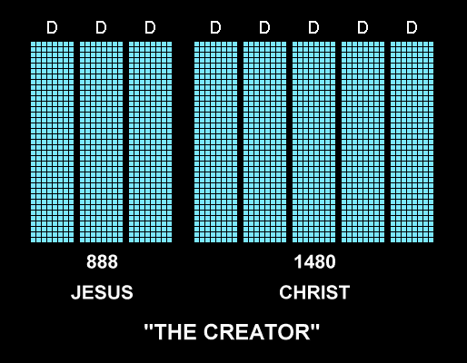

It may be remembered that the MERCY SEAT - golden lid to the Ark of the Covenant - had (by divine decree!) sides in the ratio 3:5 (Ex.25:17). Clearly, the fact that the Apostle Paul uses this term of the Lord (Ro.3:25) lends added significance to the foregoing; also that it is 'from above the mercy seat' that God meets and communes with man (Ex.25:22)!
7 - Conclusions
Attention has here been drawn to some further aspects of the numerical phenomena found associated with the Bible's opening words and Creator's Name, and to the extreme odds against these being attributable to chance. Undoubtedly, in any other field of investigation, such irrefutable evidence would be widely accepted as proof positive that they must be the work of an exceedingly able and purposeful mind. However, in this particular context, judgments are inevitably influenced by cognitive dissonance. An awareness of what amounts to a universal and deep-seated aversion to drawing conclusions of this kind - with their far-reaching implications - is, in itself, further powerful evidence for believing the Aleph-Tau phenomena to be of divine origin.
Vernon Jenkins MSc
10.7.99
email: vernon.jenkins@virgin.net
See also: http://www.jsampson.co.uk/miracla1.htm for 'Aspects of a Miracle'
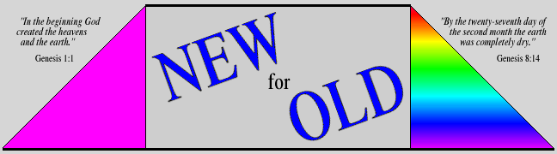
Squaring the Cubes - Part 2
1 - Introduction
The circumstances attending Genesis 8:14 are interesting: because of man's gross wickedness divine judgment has now been exercised; apart from Noah's family and the animals inhabiting the ark all terrestial life has been extinguished by the mabbul (or Flood). We are about to read of a new beginning; the cleansed Earth is to be populated again at God's command: "Then God said to Noah, 'Come out of the ark, you and your wife and your sons and their wives. Bring out every living creature that is with you...so they can multiply on the earth and be fruitful and increase in number upon it'. So Noah came out..." (Genesis 8:15-18). The previous verse therefore stands at a critical point in Earth history: clearly, it is in the nature of an epilogue to the Antediluvian/Diluvian Age - to which Genesis 1:1 is the prologue. But it also functions as a prologue to the Postdiluvian experience - of which we are part!
It is therefore a matter of some significance that the sum of the 8 Hebrew words of Genesis 8:14 is the large triangular number, 2701 - and thus identical to the sum of the 7 of Genesis 1:1 (as demonstrated in earlier pages)! Here are the details:
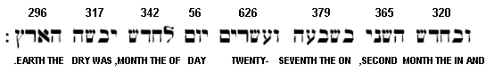
The reading is from right to left with the characteristic value of each word (ie the sum of the numerals represented by its letters) shown above the text.
[It may be noted that though this is the 15th instance of a running sequence of Hebrew words yielding the total, 2701 (Genesis 1:1 included) it is only the 2nd to map onto a complete verse.]
2 - Some advantages of being 2701
For a moment, let us remove this object from its biblical context and consider its principal features as a number per se. They are quite impressive - as the following selection demonstrates:
- its factors, as denary numbers, are the reflective primes 37 and 73 - the first, trifigurate, and most symmetrical of numbers
- these factors are revealed when 2701 is added to its reverse, thus: 2701 + 1072 = 3773 (this holds for no other 4-digit number; it is therefore a unique denary feature)
- as 73rd triangle (ie standing on a base of 73 units) it possesses an outline of 216, or 6.6.6 (see below, left); in the first million natural numbers it is one of only 5 numerical triangles having a cubic outline
- it is, moreover, a 'centroid triangle', ie it is built around a single counter (a feature of one in three numerical triangles); in this case the centroid element occupies the 25th and 49th rows - as counted from side and vertex, respectively (see below, right); 25 and 49 are, of course, the squares of 5 and 7; in the first million natural numbers only 3 are triangular and display square centroid distances
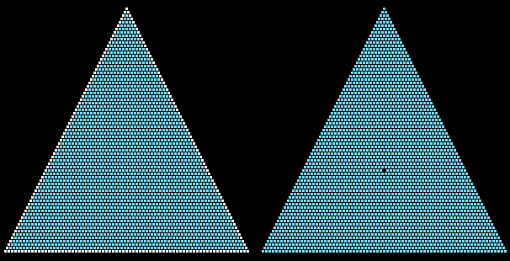

3 - Genesis 8:14 in a chequerboard of chequerboards
In the earlier page ('Squaring the Cubes') it was revealed that the Creator's Name ('Jesus Christ') may be linked with Bible's first verse (Genesis 1:1) by means of a 64x64 square with 27x27 square inset - combinations of the opening 7 words there appearing in rectangular or triangular form. The same procedure may be applied to Genesis 8:14 - with interesting effect.
As before, we begin with the basic structure:
The 64x64 square is shown divided into a 27x27 square (bottom right), a 37x37 square (top left), and two 27x37 rectangles.
[It will be remembered that, in this figure, the characteristic value of the Creator's Name, 64x37, is represented twice!]
Within the larger shaded square we first construct a numerical diamond (comprising a total of 685 unit squares), thus:
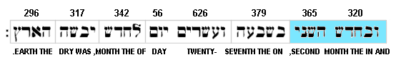
We observe that this corresponds with the sum of words 1 and 2!
Taking two of the four triangles representing the remainder of the 37x37 square (each triangle, 171 units), we find their sum to be 342 - value of word 6, thus:
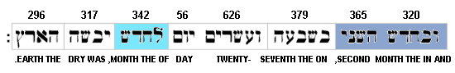
The two remaining triangles together with a complete row of 37 total 379 - value of word 3, thus:
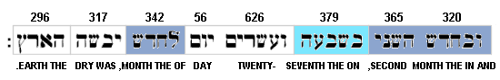
The 8th word, 296, is a simple multiple of 37, and may be represented by an 8x37 rectangle, thus:
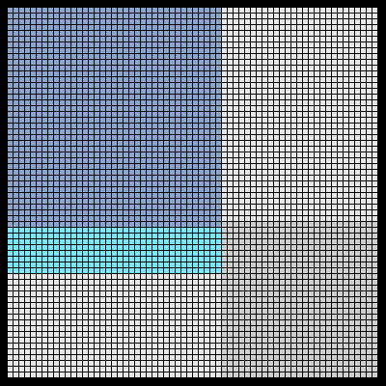
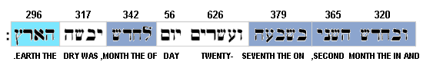
The remaining three words total 999 - value of the rectangle, top right, thus:
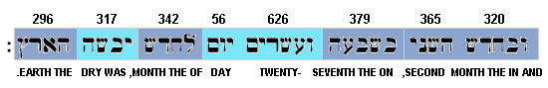
Here, then, is the final outcome of these developments: a six-sided area representing 2701:
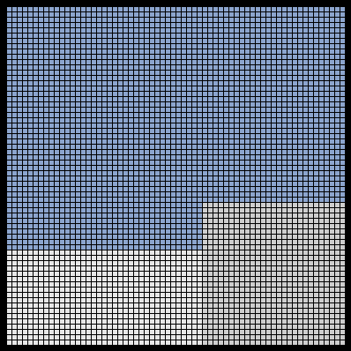

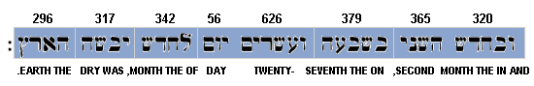
Observe, (a) that it is contained within a 46x64 rectangle, (b) that its outline, as before, is 216, or 6.6.6 - the cube of 6, and (c) that the unshaded 18x37 rectangle (left) consists of 666 unit squares, and the 27x27 square (right), 729, or 9.9.9 - the cube of 9!
Clearly, things didn't have to turn out this way!
4 - Some other numerical links with Genesis 1:1
- the final word in each verse ('earth') has the value 296; this, it will be remembered, is a factor of 'Jesus', of 'Christ', and therefore of the Creator, 'Jesus Christ'
- the interesting numbers 777 and 999 occur as sums in both verses
- the numerical hexagon which fits precisely within 2701-as-triangle is the 25th, and has the value 1801; the sum of the sequence of 5 words comprising the last four of Genesis 1:1 and first of Genesis 1:2 is 1801; the sum of the sequence of six comprising the last of Genesis 8:13 and first five of Genesis 8:14 is also 1801
- 666 - unique triangular number and surface feature of the Bible's last book, Revelation - is a common feature of both verses
5 - Conclusions
It is clear that the verses which function as a pair of 'bookends' to what may be called 'Phase 1' of Earth history are securely bound together numerically! In addition, it has been demonstrated that both are inextricably linked with the Creator's Name. It follows that Genesis 8:14 must be regarded as an integral part of the 'standing miracle' (represented by the Aleph-Tau Phenomena) which previous pages have sought to define.
Despite the clear words of Genesis 6-9, it is widely believed that the mabbul was nothing more than an intense, but essentially local, flood. Without this understanding Darwinians would find it impossible to justify their reading of the history of this planet. But if that were true, why the direct, powerful, and logical language of the biblical narrative? And why its numerical affirmation? Is it any longer reasonable to believe that the event was anything but global?!
Vernon Jenkins MSc
21.8.99
email: vernon.jenkins@virgin.net

