

A Revelation From Christ Within The NIV Bible
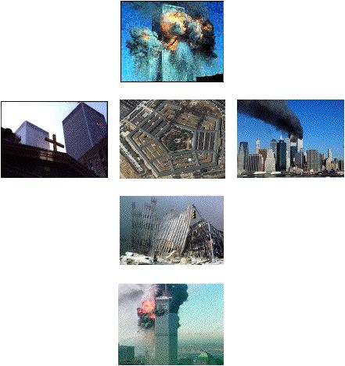

Please note: links are at the end of this page

The New Bible Code Book

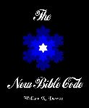
I'm delighted to announce that my book, The New Bible Code, is on sale as of December 2006. The publisher is TGS publishing and the link below will take you to the page on which the book is listed.
The New Bible Code Book
The book is much more than just a summary of this website. I've tried to organise the material so that the reader isn't overwhelmed with too many numbers and illustrations, partly by introducing them in gradual stages, partly by relating the incredible story of how I was prepared to find the code, very little of which appears on this website. For instance, I was given a master key with which to unlock the code, apparently from the Apostle Paul. I relate how the key was given to me, show how it works, and reveal the stunning, apocalyptic message it unlocks.
Introduction
"Newton...regarded the universe as a cryptogram set by the Almighty."
(John Maynard Keynes, writing about Isaac Newton)
Two opposing views of the nature of our universe compete daily for our attention. The first, generally known as materialism, holds that the cosmos and everything it contains is essentially lifeless, mechanistic, dominated by chance, comprehensible in terms of simple causes and without meaning or purpose. It is promoted by some influential figures within the scientific establishment.
However, workers within that same community have long been making observations that cannot be accommodated within the materialistic paradigm, ranging from phenomena such as ‘spooky action at a distance’ (non-locality) displayed by subatomic particles, to the findings of transpersonal psychologists about the nature of the human psyche. This information implies a reality more akin to the pictures painted by the world's great religions: a universe that is the ongoing creation of a purposeful Intelligence. I hope to add weight to the case for such a Creator, by showing you stunning evidence of His active presence in our lives.
In classical antiquity it was common practice to use letters as numerals. The Hebrew, Greek and Latin languages all employed letter numerals and the practice survives to this day in Latin as Roman numerals. Under this type of numeration system some or all letters are assigned numerical values. Any number can then be represented either by a single letter or by strings of letters, the individual values of which are usually summed to obtain a total. Since words are themselves strings of letters, numerical values for any word or phrase can also be calculated. This may seem to be nothing more than a game, but it has long been associated with an esoteric art generally known as gematria: the discernment and study of what appears to be an intelligently-designed numerical substructure within some ancient languages, particularly biblical Hebrew. In particular, words and phrases related by meaning also appear to be related through their numerical value, a phenomenon that has no naturalistic explanation. Modern societies generally use a separate system of numerals to denote quantity and therefore we now have little need to use letters in this way. However, investigators have repeatedly observed that when ancient systems of alphabetic numeration are applied to modern English, an intelligently-designed substructure is again revealed.
The numeration of English words and phrases is the basis for a numerical code I have discovered, encrypted within the text and structure of the New International Version Bible (2001, edition, British text) and within the details of two recent events of worldwide impact. This code, which I call the New Bible Code, is an elegant tapestry of meaning, its weft and weave attesting to the reality of a Divine Artist, the tableaux within depicting recent world-shaking events from a higher perspective.
Why was the NIV chosen as the vehicle for this code? The code’s foundations were laid down within the original scriptures and earlier Bible versions, manifesting as chapter and verse numbers, book ordering and tabulated numbers. However, most of the code is found within the text itself. Only one bible version could have been chosen, because the encoding of numbers within passages of text is critically dependent upon sentence structure. Secondly, the NIV is written in English, which is now the international language of choice. Thirdly, the NIV is the most popular modern English translation of the Bible; this is wholly appropriate for a code whose message is universal.
The New Bible Code contained a built-in timelock. It could not, in any case, have been decoded before the creation of the NIV Bible, which dates from about the 1970s. However, the timelock is very precise. The version ‘given’ to me for decoding is the 2001 edition. Additionally, my unlocking of the code was greatly assisted by a special type of key, but I did not receive the key until November 2001. The code therefore seems to have fully manifested in that year; in fact, its purpose is intimately bound up with the event that shook the world one bright September day...
Acknowledgments
I discovered the New Bible Code whilst on a remarkable journey that eventually led me to the findings of researchers working with the original Hebrew and Greek scriptures, from whom I have learned much. I would like to pay tribute here to the late E. W. Bullinger, for his seminal writings on bible numbers. I am also grateful to Vernon Jenkins for the insights I have gained from his mathematical exegesis of the Hebrew and Greek scriptures. I would like to thank Richard McGough for his excellent database of numerical values of Greek and Hebrew words. Kenneth Libbrecht of Caltech University kindly allowed me to use a few of his stunning snow crystal photographs and an anonymous Christian sent me a fractal snowflake design which is almost identical to the Creation Snowflake. The writings of M. Scott Peck, C. S. Lewis, Robert M. Pirsig and Carl Jung were a constant source of inspiration, as was the music of John Adams and Philip Glass. Finally, I would also like to thank my family for their saintly patience with me as, bible in one hand, calculator in the other, I absorbed myself in this most unusual quest.
In Christ,
Bill Downie
email: william.downie@btopenworld.com
Site Created: 14/5/03
Latest update: 23/10/07
The New Bible Code
The Signature Of Christ Revised
This self-contained article serves as an easy introduction to the New Bible Code. The page also features an equidistant letter sequence (ELS) encoding that supports my gematria-based findings.
About Numbers Revised
This page contains three articles giving a brief overview of the mechanics of the New Bible Code, with introductions to alphabetic numeration, gematria, figurate numbers and fractal snowflakes.
From The Beginning Revised
The NIV Bible's first three verses are the source of many of the New Bible Code's most important numbers.
The Creation Snowflake
Simple illustrations of the six days of Creation in numerical geometry lead us to a sequence of fractal snowflakes that are a living metaphor for Creation and a primary source for the gematria of the Creator.
September the 11th
The New Bible Code indicates that the events of 9/11 have a significance that transcends the merely historical to enter the realms of biblical prophecy. This page contains the central message of the New Bible Code and leads to further pages of supporting evidence.
The Crucifixion of Jesus Christ
9/11 was the first of two defining events that represented the Crucifixion and Resurrection of Our Lord.
The Resurrection of Jesus Christ
The funeral of Pope John Paul II symbolised the Resurrection of Our Lord.
His Love
Encodings within the NIV of the number 13 lead us to the Bible's heart, where another message from our Creator awaits us.
Irrational Encryptions
Encoded within some of the Bible's most famous verses are good approximations of the three most important numbers in mathematics, and a fundamental physical constant.
Immanuel
The name ‘Immanuel’ is taken by Christians to refer to Jesus Christ. A simple numerical analysis of the three verses wherein the name ‘Immanuel’ is found confirm this belief in spectacular fashion.
In His Name
This page contains a geometric analysis of the numerical signature of Jesus Christ, the number encoded within the three Immanuel verses. The analysis leads us back to the Hebrew Bible and to an astounding discovery about its opening verse.
The Gospel Triangles NEW
The opening verses of the four Gospels present a triangular mirror, reflecting both the 3-plus-1 structure of the Gospels and the person about whom they were written.
Genesis Genealogies NEW
The genealogical record from Adam to Joseph contains staggering confirmation of the reality of Christ’s return, along with an insight into its real meaning for us.
The Signature Of Christ
Introduction

If the millions of aficionados of Dan Brown’s The Da Vinci Code, are anything to go by, many people have a sizeable appetite for mystery. Mr. Brown’s best seller is, of course, a work of fiction. Nonetheless, because he suggested that some of its premises may have a historical basis and that the established Church may be suppressing this information, his book and the film made from it have generated feverish interest among sensation seekers in the possibility that Jesus may have had a wife and left a bloodline.
Now, for those whose appetite for suspense is not satisfied by fiction and speculation, I would like to present a very real mystery. What if someone found the signature of Jesus Christ? Moreover, what if this signature had been placed within a modern version of the Bible, evidencing that Jesus had a hand in shaping it and that therefore he is in some way very much alive, just as Christians claim? What if the signature was actually a kind of watermark, the authenticating seal of a staggering message encrypted within the Bible? This is not fiction, nor is it in any way exaggerated. These are the conclusions to which I have come after years of revelation, research and discovery, as I slowly and painstakingly uncovered a genuine code hidden within the New International Version (NIV) Bible (note 1).
Alphabetic Numeration
In fact there are several signatures to show you. Before I can do so, however, I have to teach you the language in which they were written. This is by no means an arduous task; it simply requires me to show you how words can be read as numbers, something you may already be familiar with in the system of Roman numerals, where any number can be represented by a string of letters from the latin alphabet. For example, the number 1160 can be represented in Roman numerials by the letters MCLX, the individual numerical values of each letter being (in this case) summed to give the desired total.
MCLX = 1000 + 100 + 50 + 10 = 1160
Latin is not the only language in which letters can substitute for numbers; in biblical times this was also the case for Hebrew and Greek. The letters of these alphabets were converted into numbers through systems of alphabetic numeration. Hebrew letters doubled as numbers according to a scheme where the first nine letters of this twenty-two-letter alphabet were assigned the values 1 to 9, the next nine letters took the values 10 to 90 and the last four took the values 100 to 400. The Greek system of numeration was similar. In this way, any number could be represented as a string of letters, the number being the sum of the individual letter values.
Now words are also strings of letters, which means that they too can be assigned a numerical value. For instance, the Hebrew word transliterated as ‘Yahweh’, which means ‘the Lord’, has a value of 26, calculated as shown:
The NIV Bible is, of course, written in modern English. However, the Hebrew system of alphabetic numeration can also be applied to English letters. Under this scheme the letters from A to I take the values 1 to 9, J to R take the values 10 to 90 and S to Z take the values 100 to 800. This yields a number called here the standard value of the word or phrase for which it is calculated (note 2). This numeration system is in fact one of two on which the code I have found is based. The other system is even simpler: the place value of each letter of the alphabet becomes its numerical value. So the letters from A to Z take the values 1 to 26. This yields a number I call the ordinal value.
With these two keys I found the signature of Christ.
Here is an example of how English words and phrases are numerated under the ordinal value and standard value systems (identified by their initial letters in parenthesis):
God (o) = 7 + 15 + 4 = 26
God (s) = 7 + 60 + 4 = 71
Each of the signatures are found only after the same decoding procedure is followed. This procedure, which took me over three years to work out, has two steps:
1. A passage of text from the NIV is converted into a number under the ordinal value system.
2. This is the standard value of a name or title for Jesus Christ.
This is what I call a signature of Christ.
The Signatures
An example will make things stunningly clear. Here are the first twelve words of the NIV Bible, numerated under the ordinal value system.
Genesis 1 (words 1 to 12)
In the beginning God created the heavens and the earth. Now the...
Ist 12 words NIV Genesis (o) = 515
Jesus (s) ..................................= 515
This is, in fact, the first signature of Christ. Notice that the signature is found within a block of twelve words. In the Bible the number twelve is associated with God, who led the twelve tribes of Israel, and Jesus himself, with twelve disciples. “One swallow does not a summer make.” said Aristotle. In similar vein, a sceptic could say: “One apparently meaningful connection does not a code make.” So let’s see if the next twelve words are also meaningful.
Genesis 1 (words 13 to 24)
earth was formless and empty, darkness was over the surface of the...
Words 13 to 24 NIV Genesis (o) = 654
Word (s) ......................................= 654
In the prologue of John we are told that “In the beginning was the word...”. John’s ‘word’ is of course a reference to Jesus Christ, who was the Word Incarnate, and this is therefore another signature.
If we bisect each of these twelve-word segments, further signatures are revealed. Here are the first twenty-four words of Genesis, broken into six-word segments, with their ordinal values.

Genesis 1 (words 1 to 6)
In the beginning God created the...
Genesis 1 (words 7 to 12)
heavens and the earth. Now the...
Genesis 1 (words 13 to 18)
earth was formless and empty, darkness...
Genesis 1 (words 19 to 24)
was over the surface of the...
1st 6 words NIV Genesis (o) .......= 252
Words 7 to 12 NIV Genesis (o) ...= 263
Words 13 to 18 NIV Genesis (o) .= 391
Words 19 to 24 NIV Genesis (o) .= 263
Now here is the value under the Hebrew system of numeration of the Hebrew word for Jesus (transliterated as Yehoshua) and the standard value of the English title by which he is also known, ‘Messiah’.
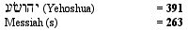
Incredibly, it would appear that three of these shorter segments also contain signatures! Also, if we sum the second and third numbers we again obtain 654, the standard value of ‘word’. Thus there are six numerical signatures, all found within the NIV Bible’s first twenty-four words. Three signatures are associated with blocks of twelve words, the other three with blocks of six words. These are displayed in figure 1.
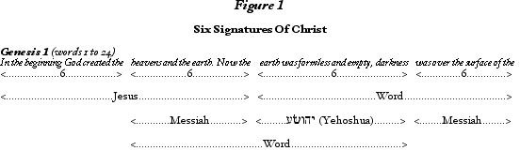
Afterword
Could random forces have produced such a wonder? Proponents of the chance hypothesis are confronted by the following extraordinary and independent facts:
a) The signatures are precisely aligned with a sequence of four blocks of six words.
b) These happen to be the opening twenty-four words of the NIV Bible, not some obscure passage therein.
c) These words begin the biblical description of God’s creation of heaven and earth; the underlying signatures are all of God Incarnate.
In other words the signatures form a distinctive, eye-catching pattern, are found in the most significant location within all of Scripture—where they would be most likely to be discovered—and are meaningfully related to the subject matter of the text, despite the fact that the numeration process obliterates any meaning conveyed by the words. Any one of these phenomena could have occurred naturally, but to attribute all of these phenomena to chance is simply unreasonable, because they form a profoundly-meaningful whole. Therefore I draw the conclusion that these signatures are neither chimeras nor statistical flukes; they are clearly and magnificently the result of intelligent design. Moreover, the Designer has signed His work, so you are left in no doubt as to His identity. All that remains for us to know is why He signed this particular version of His Word, a mystery this website attempts to unravel.
Verification Of the Signature Through An Equidistant Letter Sequence Encoding
The New Bible Code is an example of an alphanumerical code, whereby numbers are encoded and decoded by means of gematria. This is in contrast to the more famous equidistant letter sequence (ELS) codes, supposedly found in the Torah (the Hebrew Bible). In this type of code, words and phrases are encoded within the text by separating their constituent letters from each other, rendering them undetectable to the reader of the text. The message can only be decoded by knowing the number of letters (the ‘skip’) between each encoded letter (the skip is always the same between each letter of an encoded message). The search for ELS codes requires the decoder to render the text as a continuous string of letters, chop it up into equal numbers of letters, then place them below each other in sequence. Any messages encoded at that skip interval will then be clearly visible, running vertically down the text.
The search for ELS codes normally requires a computer programme. However, a simple manual search can also be undertaken, if the skip intervals are small. This is what I have done with the opening few verses of the NIV bible, with the following result, at a skip interval of 29.
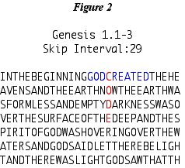
Notice how the word ‘CODE’ intersects the plaintext words ‘GOD CREATED’. The skip interval of 29 is significant, as this is the reduced value of the word ‘Messiah’. In addition, the digits cross add to 11, a number which is supremely important to the New bible Code, through the events of September the 11th. The first letter, ‘C’, is also the eighteenth letter in the NIV Bible, continuing the ‘six’ theme that characterises the encodings at this location within the NIV Bible—see also the Creation Snowflake and From the Beginning.
I discovered this apparent ELS encoding in about 2004 and at first I thought it might be coincidental. However, that was before I discovered the signatures of Christ. On rechecking this phenomenon in April 2007, I noticed something truly astounding: the last letter of the word CODE is also the last letter of the NIV Bible’s first twenty-four words! These are of course the words within which the signatures of Christ are found. In fact one encoded letter is found within each group of six words, as shown below:
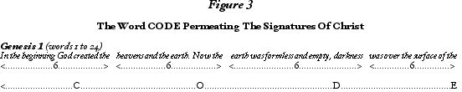
Therefore we have further evidence for the reality of the signatures of Christ and the New Bible Code (note 3), this evidence encoded by an entirely different yet complementary method and further displaying the limitless capabilities of the Encoder Himself.
Bill Downie
20/6/06
Latest revision 6/7/07
Home
Notes:
1. The reader may be wondering why the NIV Bible was chosen as the repository for such a code. A clue as to the motives of whoever was responsible may be in the fact that the NIV is the most popular modern English translation of the Bible. In addition, English is now the international language of choice. This would suggest that the aim was to expose as many people as possible to the encoded information, maximising the chances of discovery. You may also wonder how I came to look for a ‘bible code’ in the first place. The incredible truth is that I was given this task in 2001 as a kind of ‘assignment’, revealed to me through a remarkable series of synchronicities and one apparently genuine miracle. Three of these events, including the miracle, involved the NIV Bible.
2. As far as I am aware, the first person to apply the Hebrew system of numeration to the English language was Vernon Jenkins (The Other Bible Code).
3. This is also supporting evidence for the reality of the Torah codes.

The following three pages give the technical information required for a full understanding of the New bible Code. I recommend you read them in the order given.
Gematria In A Nutshell
This is a short in introduction to the historical practice of alphabetic numeration, the art of gematria that developed alongside it and the use of gematria in the encoding of the NIV Bible by an unknown power.
Figuring Numbers
This article shows how many numbers are associated with series of geometric figures, which can be represented by regular arrays of discrete units. Many such numbers—known as figurate numbers—are part of the New Bible Code.
A Flurry Of Snowflakes
Snow crystals are related a mathematical object known as the Koch snowflake. This article shows how the procedure leading to the Koch snowflake can be approximated to create a class of numerical snowflakes that are a central feature of the New Bible Code.
Bill Downie
21/5/07
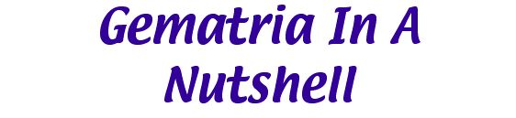
Alphabetic Numeration
To understand the practice of alphabetic numeration we have to travel back to biblical times. The Hebrew Bible was first recorded almost entirely in the Hebrew, the New Testament in Greek. In those days, it was common practice in many languages to use strings of letters to represent numbers. Each letter in the string represented a number, and they were summed to give a total. A vestige of this practice is the system of Roman numerals, where seven letters are assigned numerical values.
M = 1000, D = 500, C = 100, L = 50, X = 10, V = 5, I = 1
So the number 1160 can be represented as MCLX.
MCLX = 1000 + 100 + 50 + 10 = 1160
The ancient Greeks at first used a numeral system similar to the Romans. However, by the 4th Century BC, and possibly much earlier, this had been superceded by a more comprehensive system, known as Ionian numerals. This is a system whereby the twenty-seven numbers 1 to 9, 10 to 90 and 100 to 900 were each represented by a single letter. The numbers 6, 90 and 900 were represented by otherwise unused, archaic letters (note 1). However, only the numerical substitutions involving the twenty-four letters of the Greek alphabet are of interest here. This slightly abridged system of alphabetic numeration is shown below.
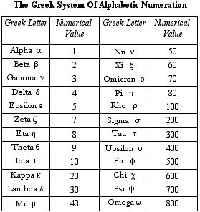
Sometime in the 1st Century BC, the Hebrews adapted the Ionian system of numeration to their own alphabet (note 2). This has only twenty-two characters, so only the numbers 1 to 9, 10 to 90 and 100 to 400 were represented by single Hebrew characters. However, the numbers from 500 to 900 were sometimes represented by the sufit (end) forms of five characters (note 3). As before, only the simpler substitution scheme is of interest. This is shown below.
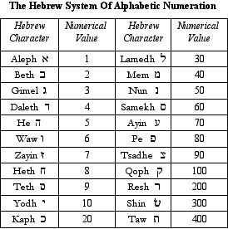
Both the Hebrew and Greek numeration schemes were purely additive. Numbers were represented either by a single letter or, if necessary, by strings of letters, the individual values of which were summed to obtain a total. For instance the number 401 could be represented by placing the letters aleph (= 1) and taw (= 400) together (note 4), giving 401.
These strings of letters had no meaning in themselves: they were used purely for counting. However, words are also strings of letters and therefore can also be assigned numerical values. For instance, the Hebrew word transliterated as ‘Yahweh’, which means ‘the Lord’, has a numerical value of 26, calculated as shown:
The numeration of words is associated with the kabbalistic art known as gematria to the Hebrews and isopsephia to the Greeks, whereby a kind of numerical cyphertext within each language has been discerned and studied. I will concentrate here on Hebrew gematria.
Hebrew Gematria
Hebrew gematria is associated with the Kabbalah, the mystical strain of Judaism. For kabbalists, words of equal or related numerical value are thought to be ‘explanatory of each other’, which is seen as evidence that the Hebrew language is of divine origin. As well as studying the language itself, kabbalists also looked for numerical codes hidden within the Hebrew Bible, which has remained essentially unchanged since at least the 10th Century AD (note 5). The word ‘gematria’ itself comes from a Greek word meaning ‘earth measures’. As hinted at by the word’s derivation, Hebrew gematria also involves the study of geometric figures—so-called ‘sacred geometry’.
As an example of Hebrew gematria, I showed above that the numerical value of the Hebrew word for ‘the Lord’ is 26, which is 13 x 2. The Hebrew words transliterated as ‘ahavah’, which means ‘love’, and ‘echad’, meaning ‘unity’, have numerical values of 13.
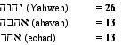
Love and unity are primary attributes of the Lord, and this similarity in meaning between all three Hebrew words is reflected in their numerical values. Another layer of meaning is found when we observe that 13 is a figurate number and can be represented by a hexagram—or Star of David—with 13 regularly-spaced units.
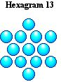
This relationship between numbers and words has no reasonable naturalistic explanation, because words with similar meaning are often spelled very differently and the chances of strings of different letters sharing numerical properties are low. Furthermore, gematria can also be applied to phrases and passages of text. Therefore the lexicon, spelling rules and grammatical structure of at least some languages appear to have evolved not unconsciously, as we might assume, but under intelligent guidance, to create a hidden layer of information beneath the written word.
As gematria developed, other schemes of numeration were investigated and found to be useful. Perhaps the most commonly employed alternative scheme (and the most natural one) is the replacement of a letter by its ordinal (place) value in the alphabet. Another valid system is the reduction of the ordinal value to one digit by cross-addition, as in pythagorean numerology. Both systems are used by kabbalists, in addition to the one outlined above (note 6).
English Gematria
There is no tradition of using the letters of the English language to double as numbers, for which Roman and later Arabic numerials have always been employed. However, as knowledge of alphabetic numeration and gematria spread across Europe, the Greek and Hebrew systems were adapted to other languages, including English. Since then, numerous investigators have asserted that the English language, like its biblical cousins, contains a numerical cyphertext.
Two substitution schemes have emerged as particularly useful in cracking the New Bible Code. One is the English equivalent of the Greek and Hebrew schemes, which I call the standard value system. The other is the substitution of a letter by its ordinal (place) value, which I call the ordinal value system. Both schemes are tabulated below.
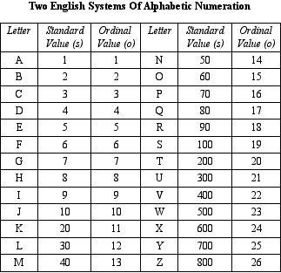
As with the Greek and Hebrew systems, the numerical value of an English word or phrase is calculated by summing the individual letter values under a single scheme. The scheme applied is indicated by its initial letter, shown in parenthesis. For example, here is the gematria of the word ‘Jesus’, calculated under the standard and ordinal value systems.
Jesus (s) = 10 + 5 + 100 + 300 + 100 = 515
Jesus (o) = 10 + 5 + 19 + 21 + 19 .......= 74
Two further numeration systems play a minor role within the new Bible Code. The first is based on the reduction of the ordinal value to one digit by cross-addition, as in pythagorean numerology, all letters taking on the values 1 to 9. I call this the reduced value system, denoted by (r). A fourth scheme is the sum of the standard, ordinal and reduced values, which I call the combined value, denoted by (c). Here are the reduced and combined values of the name ‘Jesus’.
Jesus (r) = 1 + 5 + 1 + 3 + 1 = 11
Jesus (c) = 515 + 74 + 11...= 600
Two final notes:
1. The New Bible Code is actually based on two tiers of encoded numbers. The first tier is gematria itself, the meaningful connections between words and phrases that have been woven into our languages. The second tier is the encoding of numbers into lengthy portions of text, such as sentences and verses, within the NIV Bible. This level is essentially independant of the one below, although it has been created to exploit the connections that are found within the first level.
2. The New Bible Code is based on the English language, but a few Hebrew and Greek words are also included. Therefore, all three languages and all the keys I show above were necessary for breaking the code.
Confluence
Of course, many numbers can be extracted from a string of words by numerating different portions of text. For instance, within a string of ten words, fifty-four shorter strings can be identified, some of which will, by chance, happen to coincide with a significant gematria value. How can we tell the difference between a real encoding and the ‘background noise’ of random numbers? Moreover, words occasionally share numerical values. How do we know what word a number is meant to imply?
This is where the phenomenon of confluence comes to our aid. Encoded numbers are usually found in clusters, often arranged within the text in regular patterns. These are statistically-unlikely and therefore significant phenomena. Furthermore, there is always a meaningful relationship between the words the encoded numbers represent and the passage with which they are associated, or the location in which they are found—another form of confluence.

The Ordinal Value-to-Standard Value Decoding Process
A unique feature of the New Bible Code is the way in which its numbers are meant to be decoded. This process utilises both numeration keys and has two stages:
Stage 1: A number is derived by calculating the ordinal value of a passage of biblical text, or occasionally from other significant sources.
Stage 2: The number derived is the standard value of a word or phrase meaningfully related to the passage itself. The encoded words are normally English, but may occasionally be Greek or Hebrew.
By this means one number serves as the link between two groups of words. Because the same input/output rules are repeatedly found (although there are minor variations on this basic format) this phenomenon is obviously of great significance.
An Example
A dramatic example of an encoded number is given below. This is a good example both of the two-stage encoding process and of the phenomenon of confluence (note 7).
Rev. 13:18
This calls for wisdom. If anyone has insight, let him calculate the number of the beast, for it is man's number. His number is 666.
NIV Rev 13:18 (o) = 1151
Beelzebub (s) ........= 1151
This is evidence for intelligent activity, rather than random action, on two counts. Firstly, it can be seen that the number is encoded within the entire verse, rather than one of the 324 substrings within the verse, which would be much less significant. Secondly, there is a highly meaningful relationship between the subject of Revelation 13:18 and the word “Beelzebub”. There is no known mechanism for a bleed-through of information from the surface text to create such a cyphertext. Any meaning should be lost through the conversion of letters to numbers by one numeration system and back to letters via a different numeration system. Therefore we have startling evidence for the existence of encoded information.
One final point about gematria should be noted here. Except at the extreme upper and lower ends of the scale of numerical values, the proportion of words that share the same numerical value is roughly given by the value itself. So the ordinal value of ‘Jesus’, 74, tells us that about 1 in 70 or 80 words share that value. What this means is that standard values, which are very much higher, are shared by very few words. The standard value of ‘Jesus’, 515, is shared by very few other words, and no other name that I am aware of. Similarly, the standard value of ‘Beelzebub’, 1151, is, in all likelihood, unique to this name; certainly I know of no other name for a spiritual being with this numerical value. Therefore the use of the standard value system to decode numbers (even though they are encoded using the ordinal value system) guarantees very little confusion about which word a number is meant to signify.
Further Sources of Numbers
The very structure of the Bible itself appears to be the result of intelligent design, for the purpose of encoding yet more numbers. In particular, many biblical passages appear to have been strategically placed so as to make use of various textual features:
1. Chapter and verse numbers.
2. The place values of books, chapters and verses.
3. The place values of key words within passages of text.
4. The number of words (and even letters) in clauses, sentences and verses.
5. Numerical tables.
6. Numbers appearing within passages of text.
Biblical Numerics
Certain biblical numbers are wrapped in symbolic meaning, being repeatedly found in association with the same ideas or themes. The study of these relationships is known as biblical numerics and some familiarity with this subject is necessary for a full appreciation of the code, which makes use of traditional biblical numerics. A brief summary of the meanings associated with some common biblical numbers, taken from E. H. Bullinger’s Number In Scripture, is given below.
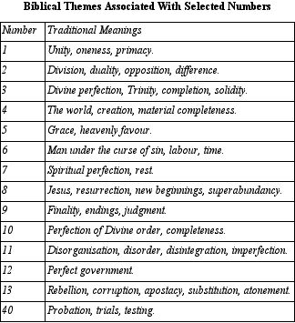
For information on figurate numbers, see Figurate Numbers.
For information on fractal snowflakes, see A Flurry of Snowflakes.
Bill Downie
24/2/05
Last revision:
17/5/07
home
Notes:
1. These were digamma (6), stigma (6), koppa (90) and sampi (900).
2. For the historical background, I am summarising the online paper Numeration Systems, by Gary Hardegree, University of Massachusetts, 2001.
3. The five characters are kaph (500) mem (600), nun (700), pe (700), tsadhe (900).
4. Hebrew words and letter strings are read from right to left.
5. The Masoretic Text.
6. There are still other methods of numeration employed by kabbalists. For instance, each character has its own Hebrew word, which is numerated to give another value for each character. Kabbalists also practice character permutations and study initial characters.
7. the digits of 666 are counted as three sixes, as if they were letters.

Introduction

Gematria is founded upon correlations between the meanings carried by words and their numerical values. The numerical relationship between words may be a simple equality or the sharing of important factors. However, in some cases the link is based upon the numerical properties of geometric figures that can be represented by regular arrays of discrete units (note 1).
Regular arrangements of flat discs on a surface can give rise to representations of plane figures such as the triangle, square, pentagon and hexagon. Similarly, spheres or cubes can be regularly packed to build solid objects such as the cube, tetrahedron and pyramid. By adding more units these figures can be increased in size, stepwise. Each figure is therefore associated with a series of numbers, representing the number of units required to build ever larger versions of a particular shape. All such numbers are described as figurate.
Units can be packed in different formations, each lending itself to the creation of characteristic shapes. We begin with the most natural formation: triangular packing.
Plane Figures - Triangular
Units on a surface can be packed in triangular formation. The first four members of the series of triangular numbers are illustrated below.
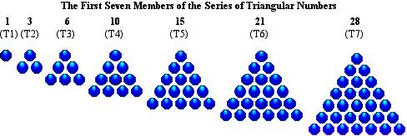
All series of figurate numbers begin with a single unit, the second member of each series always being the first to show its characteristic shape. Each triangle in the series is given a place value, or order. Triangle 10 is the fourth in the series and can alternatively be referred to as T4.
The series of triangular numbers is created by simply adding the natural numbers in order, something that can be intuited by observing that the place value of a triangle is the same as the number of units along its base. The formula for calculating the nth triangular number is as follows T(n) = 1/2n(n + 1).
Three more geometric figures that can be created from triangular packing are the hexagon, hexagram and trapezium.
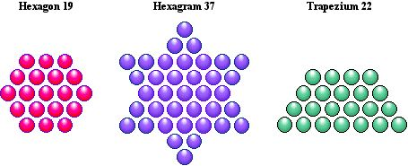
Hexagon 19 and hexagram 37 are closely related to triangle 28, because they are produced by its intersection with an inverted copy of itself. Every third triangle can undergo this process, which can be repeated to create approximations of the Koch snowflake. Trapezium 22 is also obviously related to triangle 28, but less obviously to triangle 66, which can be trisected into three such trapezia (note 2).

Plane Figures - Square
Units can pack in square formation to give more plane figures: principally the square, the diamond and the octagon (note that this is not a regular octagon, which has its own numerical series).
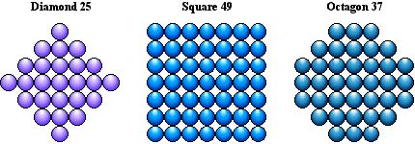
Diamond 25 and octagon 37 can both be derived from square 49. Every odd square will yield a diamond in this way, and every third square will give an octagon.
Plane Figures - Pentagonal, Hexagonal, Etc.
Units can be arranged in pentagonal formation to give the series of pentagons, in hexagonal formation to create hexagons, and so on. Here are pentagon 22 and hexagon 28.
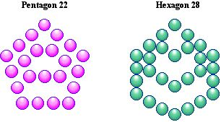
Centred Figures
Note that pentagon 22 and hexagon 28, as they are drawn here, extend downwards from the top. Most of the figures I have shown so far do likewise, extending outwards from an edge. But centred hexagon 19 and diamond 25, shown earlier, grow out from a central unit and are called centred figures. Some more centred figures are shown next.
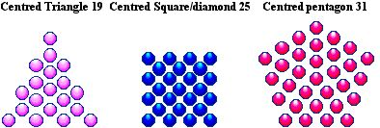
Observe that the centred square is just the diamond rotated through 45 degrees.
Solid Objects
Regular solids, such as the cube, tetrahedron and square pyramid can similarly be represented by tightly packed arrangements of spheres or cubes. As with plane figures, all solids are associated with their own numerical series.
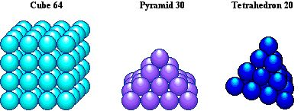
Polyfiguracy
Some numbers can be represented by two or more regular shapes. These are known as polyfigurate numbers. If two shapes can be created, the number is bifigurate. A very few numbers, such as 37 and 91, are trifigurate.
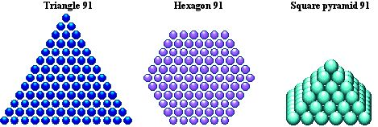
Structural Properties
All plane and solid shapes of any complexity have structural properties. Some basic structural properties of the triangle and the cube are shown here.
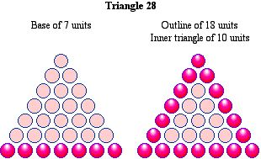

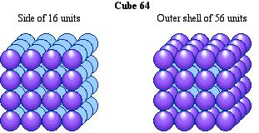
Series of Figurate Numbers
The first 16 terms of some regular plane figures and solids are shown in the table.
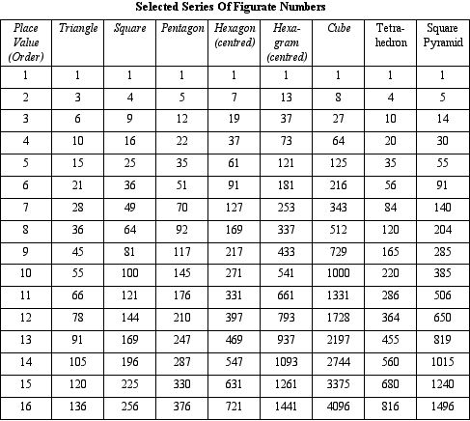
The table below shows the approximate percentage of numbers that are figurate (as defined above) for three ranges. The proportion of figurate numbers decreases as the range increases, so there will be less likelihood of large numbers being figurate, and therefore more significance to the phenomenon.
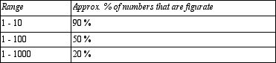
Bill Downie
17/5/04
Last revision
21/5/07
home
Notes
1.By 'geometric figures' I mean regular plane and solid figures (polygons and polyhedrons), including fractal snowflakes and star figures, that can be created by tightly packed arrangements of regular units. I now include figures packed in triangular, square, pentagonal and hexagonal formation and all centred figures, although I have excluded higher dimensional figures. I may include more figures in future pages.
2. Trapezia of different hieghts can be constructed. The one shown has equal numbers of units on the top and side and is numerically equal to the pentagonal numbers.

Introduction
A fresh snowfall is one of nature’s most spectacular miracles, transforming the drabbest landscape, adding excitement to the dullest day and forcing all of us, even those who try to shut nature out of their lives with all the technological blinkers of civilisation, to acknowledge its silent power and timeless beauty. Snowfalls are accumulations of snowflakes, which are themselves aggregates of tiny, six-sided figures known as snow crystals. If you are ever fortunate enough to look at snow crystals under a microscope you will have entered a magical, diamantine world, a universe of pristine beauty and - because no two snow crystals are identical - of infinite variety. Before long, you will also notice that snow crystals show an interesting sixfold symmetry. No matter how dissimilar two crystals might be, they will both depend on the number six for their basic structure:
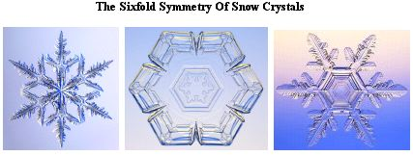
Underlying the natural complexity on display in these photographs is the geometric form of the hexagon—of which the central snow crystal is a near approximation. The hexagonal symmetry of the snowflake is also seen in a purely mathematical object, known as the Koch Snowflake.
The Koch Snowflake
The intricate structure of natural snow crystals is described in mathematical terms by the language of fractal geometry, because snow crystals approximate to a class of geometric figures known as fractals. These objects have mind-blowing properties such as fractional dimension (hence ‘fractal’) and self-similarity (they look the same at different scales). The prototypical fractal snowflake is the Koch snowflake, created by the following iterative process (note 1):
Step 1: Subdivide each side of an equilateral triangle into three equal portions. With each central portion do the following: draw an equilateral triangle which has the central portion as its base, then subtract that base.
Steps 2, 3...: Repeat step 1 with each side of the new figure.
This process is illustrated below, for the first three steps:
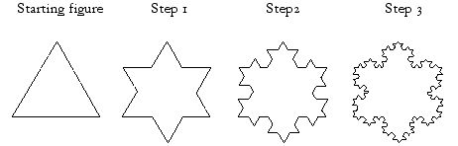
The process can go on for ever, but the figure created from step 3 is practically identical to the true fractal, which can of course never be completed. For the mathematically-inclined reader, the dimension of the outline of the Koch snowflake is log4/log3, or 1.261859... Amazing but true.
Note that the first step creates a hexagram, the outline of the Star of David. This is a clue to a more intuitive way of creating the Koch Snowflake, by merging the triangle, and each triangle thereafter created, with an inverted copy of itself:
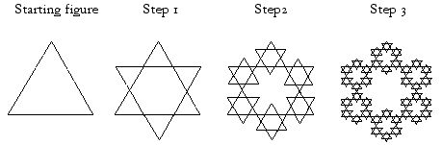
This method also has the advantage of creating internal structure within the fractal. So now after step 1 we see the Star of David proper, with an internal hexagon clearly delineated. Steps 2 and 3 create closer approximations of the Koch snowflake, nested within which are snowflakes of a different design. Standalone versions of these internal snowflakes can be created from a hexagon by a variation of the process leading to the Koch Snowflake, where we draw triangles that points inwards, rather than outwards.
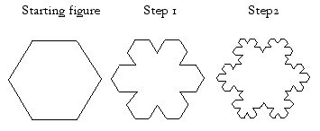
These snowflakes are identical to the internal figures created in the previous sequence.
The Koch Snowflake Emulated
In numerical geometry, the creation of the Koch Snowflake can be emulated for one or more steps to obtain approximations of this figure. Every third triangle in the triangular number series—those with a single unit at their geometric centre—can merge with an inverted copy of themselves in this way. Triangle 28 (T7) has a single unit at its geometric centre, therefore it can give rise to a hexagram/hexagon pair, as shown here.
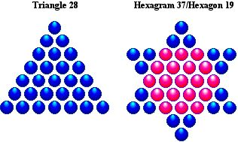
Triangle 28 can only be taken one step towards the Koch snowflake. A good example of a triangle that can be taken two steps towards the Koch Snowflake is triangle 253 (the 22nd in its series). This process is illustrated below:
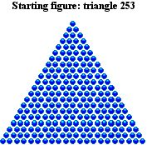

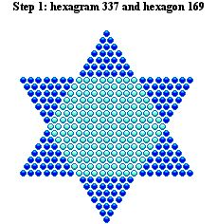

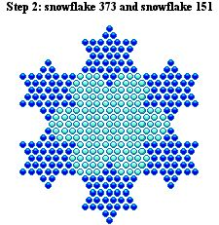
The Inner Snowflake
The internal snowflake of 151 units can also be created ‘standalone’ by the alternative process described earlier, which starts with a hexagon. This is illustrated below.
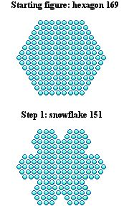
Building The Snowflake From Crystals
Real snowflakes are accretions of smaller crystals. Similarly, snowflake 151 can be built from two simple geometric snow crystals—hexagon 19 and hexagram 37—as illustrated below.
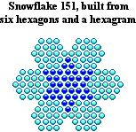
Note that there are six hexagons surrounding a central hexagram. This 6-plus-1 pattern is familiar to us in the Creation story, in which God manifested the heavens and the earth in six days before resting on the seventh day. The series of fractal snowflakes created by this process is a unique and central feature of the New Bible Code.
Bill Downie
17/5/04
Last revision
18/5/07
home
Notes:
1. In mathematics an iterative process is one in which, at each step of the process, the same operation is repeated on the outcome of the previous step.

Introduction
Genesis 1:1 - 3 (NIV)
In the beginning God created the heavens and the earth. Now the earth was formless and empty, darkness was over the surface of the deep, and the Spirit of God was hovering over the waters. And God said, "Let there be light," and there was light.
The prologue of Genesis begins with God’s act of Creation, in three famous verses that foreshadow the modern 'Big Bang' theory of the origin of our universe. Appropriately, these verses are the origin of a dazzling burst of encoded numbers that stream out into the NIV Bible, shining a bright new light on God’s Word and revealing that the true light is indeed our Lord Jesus Christ.
Many of the numbers encoded in the first few verses of Genesis are shown on this page. Others are found in The Signature Of Christ, Irrational Encryptions, His Love and The Creation Snowflake.
God in Genesis 1:1 - 3 (NIV)
Genesis 1:1 - 3 (NIV)
1. In the beginning God created the heavens and the earth. 2. Now the earth was formless and empty, darkness was over the surface of the deep, and the Spirit of God was hovering over the waters. 3. And God said, "Let there be light," and there was light.
The word 'God' is found three times in the first three verses of Genesis. Three is of course the number that best represents God’s triune nature. As befitting the importance of the word we use to name our Creator, it has been positioned to encode further numbers.
1. Position Within Each Verse
The position of the word 'God' within each of the first three verses is as follows. 'God' is word 4 in Gen 1:1, word 20 in Gen 1:2 and word 2 in Gen 1:3.
4 + 20 + 2 .............= 26
God (o) .................= 26
2. Absolute Position
The position of the word 'God' counting from the beginning of the prologue, is as follows. 'God' in Gen 1:1 is word 4 from the beginning. 'God' in Gen 1:2 is word 30 from the beginning. 'God' in Gen 1:3 is word 37 from the beginning.
4 + 30 + 37 ............= 71
God (s) ..................= 71
3. Position of God in Genesis 1:1
The number of letters to ‘God’ in Genesis 1:1, the first time the word is given, is 17.
God (r) ....................= 17
4. Absolute Position of the individual letters.
The positions of the individual letters of the word 'God' from the beginning are given below.
G, o, d in Gen 1:1 are letters 15, 16, and 17
G, o, d in Gen 1:2 are letters 124, 125, 126
G, o, d in Gen 1:3 are letters 154, 155, 156
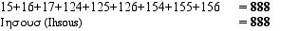
‘Ihsous’ is the Greek rendering of the word ‘Jesus’.
Genesis 1 (NIV) - Three Eighteen-Word Strings
A second Genesis miracle involving the number three is the existence of three eighteen-word strings encoded with the names of the Creator. These begin at Genesis 1:1, 1:2 and 1:3. 18 is 3 x 6, and these encodings also continue the ‘six’ theme which is the hallmark of other encodings at this location—see The Signature Of Christ.
Genesis 1:1 - 4 (NIV)
1. In the beginning God created the heavens and the earth. 2. Now the earth was formless and empty, darkness...
2. Now the earth was formless and empty, darkness was over the surface of the deep, and the Spirit...
3. And God said, "Let there be light," and there was light. 4. God saw that the light was good...
1. Eighteen-word string from Gen 1:1
1. In the beginning God created the heavens and the earth. 2. Now the earth was formless and empty, darkness...
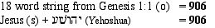
2. Eighteen-word string from Gen 1:2
2. Now the earth was formless and empty, darkness was over the surface of the deep, and the Spirit...
18 word string from Genesis 1:2 (o) ........= 912
The Lord Jesus (s) .................................. = 912
3. Eighteen-word string from Gen 1:3
3. And God said, "Let there be light," and there was light. God saw that the light was good...
18 word string from Genesis 1:3 (o) ......= 699
Lord Jesus (s) .................................... . ..= 699
Jesus Christ in Four Opening Verses
The books of Genesis, Exodus, Leviticus and Numbers form the bulk of the Pentateuch (the five books of Moses) and are the first four books of the Bible itself. In the NIV Bible, the first verse of each of these four books is encoded with numbers that reveal a divine signature. Note that each number is encoded over the first twelve words of each book. In biblical numerics twelve is the number of perfect government, as shown by God leading the twelve tribes of Israel and Jesus choosing twelve disciples.
Genesis 1:1 - 2 (NIV)
1. In the beginning God created the heavens and the earth. 2. Now the earth was formless and empty, darkness was over the surface of the deep, and the Spirit of God was hovering over the waters.
1st 12 words of Genesis (o) ...............= 515
Jesus (s) ........................................... .= 515
Exodus 1:1 (NIV)
1.These are the names of the sons of Israel who went to Egypt with Jacob, each with his family.
1st 12 words of Exodus (o) .................= 515
Jesus (s) ................................. ...........= 515
Leviticus 1:1 (NIV)
1. The Lord called to Moses and spoke to him from the Tent of Meeting. he said
1st 12 words of Leviticus (o) .............= 519
Christ (c) .................................. .........= 519
Numbers 1:1 (NIV)
1. The Lord spoke to Moses in the Tent of Meeting in the Desert of Sinai on the first day of the second month of the second year after the Israelites came out of Egypt. He said
1st 12 words of Numbers (o) .............= 519
Christ (c) ...................................... ....= 519
So we have two encodings of the standard value of ‘Jesus’, followed by two encodings of the combined value of ‘Christ’. The pattern of twelves is further developed within the prologue of Genesis. See The Creation Snowflake.
Jesus Christ in The Bible’s Alpha and Omega Verses
Revelation 1:8 (NIV)
“I am the Alpha and the Omega,” says the Lord God, “who is and who was, and who is to come, the Almighty.”
In conscious reflection of God’s statement in Revelation 1:8, the first and last verses in the NIV Bible are given a divine seal. Notice that, as usual, every number is extracted using the ordinal value system, but takes on meaning under the standard value system.
Genesis 1:1 - 2 (NIV)
1. In the beginning God created the heavens and the earth. 2. Now the earth was formless and empty, darkness was over the surface of the deep, and the Spirit of God was hovering over the waters.
1st 12 words of Genesis (o) ...........= 515
Jesus (s) .............................. ...........= 515
Revelation 22:21 (NIV)
21. The grace of the Lord Jesus be with God’s people. Amen.
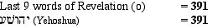
The jewel on the crown of this encoding is found by summing the two verses in which these numbers are found.
Genesis 1:1 (NIV)
In the beginning God created the heavens and the earth.
Revelation 22:21 (NIV)
The grace of the Lord Jesus be with God’s people. Amen.
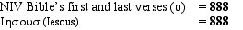
So the NIV Bible’s alpha and omega verses contain the standard values for the name of our saviour in English, Hebrew and Greek. Here we have God’s Word authenticated by the numerical signature of His Son, given in triplicate!
Bill Downie
31/3/05
Revised
28/4/07

A Frozen Miracle

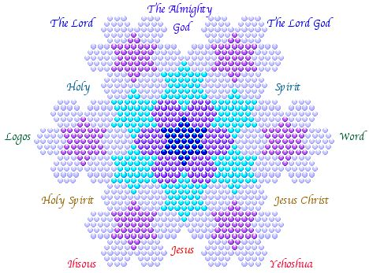
by Bill Downie
william.downie@btopenword.com

Prologue
The figure shown above, which I call the Creation Snowflake, belongs to an infinite series of nested snowflakes that are related to a well-known fractal called the Koch Snowflake. Because the Creation Snowflake is constructed from discrete units, its structural properties can be described by a set of numbers. These turn out to be related through gematria to the names most often used to identify the Christian God. This remarkable fact is underlined by the discovery of a set of numbers that completely define the Creation Snowflake, encoded within the opening two verses of the NIV Bible. These verses describe God’s creation of the universe, which we now know is fractal in nature and for which the Creation Snowflake would therefore be a suitable metaphor. Furthermore, the metaphor extends to the construction of the snowflake itself, which repeats the six-plus-one day pattern of creation described in the opening chapter of Genesis.
The correspondance between the numerico-geometric properties of the Creation Snowflake, the numerical values of the names of the Christian God and the numerical values and subject matter of the NIV Bible’s opening statements (the NIV being the most popular modern English version of the Christian Bible) cannot reasonably be expected to have occurred by chance, therefore this phenomenon would appear to be the result of intelligent design.
For a brief introduction to snowflakes—real, fractal and numerical—please click here.
For a brief introduction to gematria please click here.
The Creation: 1
Exodus. 20:11 (NIV)
For in six days the Lord made the heavens and the earth, the sea, and all that is in them, but he rested on the seventh day. Therefore the Lord blessed the Sabbath day and made it holy.
According to Genesis 1 and the above succinct passage in Exodus, the Lord created the heavens and the earth in six days then rested on the seventh day. This day He blessed, conferring special status on it. Starting from these numbers I will show how a visual metaphor for creation ex-nihilo can be conjured, using a process of seeded growth that produces increasingly accurate approximations of the Koch Snowflake and that imitates the growth of real snowflakes.
The Six Days of Creation
The six days of Creation have been symbolised in the Kabbalah by a hexagonal ring of units (see note 1).
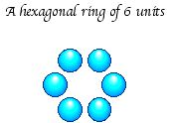
In manifesting 6 units as a ring we create a ‘free’ space within it, an arena for further creation. The ring enclosing a circular space is reminiscent of the kabbalistic explanation of Creation, where the Ein Sof (God beyond God) “withdrew itself into its essence, from itself to itself within itself” (see note 2), to create a spherical primal space, into which it emanated to begin the evolution of the universe we know. This is itself consistent with the modern ‘big bang’ theory of cosmogony.
The Seventh Day
The 'free' space can then be filled or seeded with another unit, to create centred hexagon 7, representing the completed seven-day period.
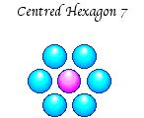
The seventh, ‘free’, unit represents the seventh day, the day of rest. So hexagon 7 serves as a visual metaphor for the first completed week of creation (see note 3). In the Kabbalah, the outer ring of six discs now represents the Ein Sof after it had withdrawn from its own centre, the inner disc symbolising the created universe.
Nature builds larger structures from smaller ones, using atoms to build molecules, which grow into snow crystals, which accumulate into snowflakes. Taking nature’s economy and elegance as our example, we can use the hexagon we created as the ‘day’ unit for a second illustration of the six-day Creation period.
The Creation: II
The Six Days of Creation
Returning to the original ring of six units, if we replace each single unit with hexagon 7 itself, we create a ring of hexagons.
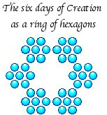
We now witness an interesting phenomenon: the space in the centre takes on a new shape, that of a hexagram.
The Seventh Day
The shape that fills the space in the above ring and completes this version of the first week of Creation is centred hexagram 13, the smallest hexagram that can be created from discrete units and the simplest approximation of the Koch snowflake.
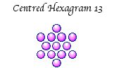
Recall that the seventh day was blessed by God and made holy. This special status is perfectly symbolised by the Star of David—the modern symbol of Judaism and an ancient symbol of Christ. Thirteen, in addition to being a hexagram number and the first approximation of the Koch Snowflake in numerical geometry, is also the gematria of a Hebrew word for love: ahavah.
In His Love, I show how the number 13 is encrypted within the NIV and how this leads us to the Bible's very heart, and a message from our Creator.
Therefore in filling the ring with hexagram 13 we are infusing it with 'love', or if you like, filling it with Spirit (see note 4). The filling of the empty space within our hexagonal ring with hexagram 13 is very symbolic of the act of creation, undoubtedly the supreme act of love.
Filling the 'free space' in the ring with centred hexagram 13 creates an example of a fractal snowflake.
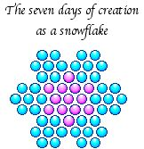
The fractal snowflake is a perfect symbol of growth from a central point or seed and thus represents the initial moments of creation, described in Genesis 1, when God manifested the heavens and the earth. This snowflake, which is built from 55 individual discs, is fundamentally hexagonal in nature. This is easily shown by filling the indentations around its perimeter with discs to create centred hexagon 61.
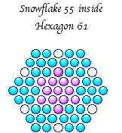
Serendipitously, the number 61 repeats idea of the 6-plus-1 creation period, from which we modelled the inner snowflake (see note 5).
Inspired by the biblical account of creation and the example of nature’s snowflakes—and using the simplest possible materials—we have created the first centred hexagon and centred hexagram numbers and a fractal-like snowflake. In the third and final exercise we will create a slightly larger snowflake. We will then cause it to grow just like a real snowflake by continually repeating the ‘creation function’, on the resulting figure. This iterative process will generate increasingly accurate approximations of the Koch Snowflake and its internal snowflake, a sequence of figures I call the Creation Snowflake. As this magnificent figure crystallises before our eyes I will show how, at each stage, we can derive numbers related to the Trinity, principally through English gematria.
This is where the miracle begins.
The Creation: III
Snowflake Ring 114
For the first two representations of the six days of creation, we used first a single unit then a hexagon with 7 units. These are the first two members of the centred hexagon series. The third member of this series is hexagon 19, with which we now create a third ‘six-day’ ring.
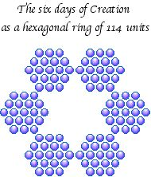
As I said earlier, in the Kabbalah this outer ring symbolises the Ein Sof (God beyond God) after it had withdrawn into itself. The number of units required to create this figure is 114, which, auspiciously, is the combined gematria value of the English word ‘God’ (see note 6).
God (c) .......................= 114
The withdrawal of the Ein Sof from its own centre created an internal space within which the creation of the universe would occur. The number 114 is also related to the idea of origins through gematria.
The source (o) ...........= 114
The beginning (o) ......= 114
The tabernacle (o) .....= 114
In Judaism, the Tabernacle has immense significance. It is a very special ‘tent of meeting’, which Exodus tells us was first constructed according to the Lord’s instructions by the Israelites as they were were encamped at mount Sinai. The significance of the Tabernacle is that it is God’s tent; a vessel for his Spirit, when he comes down to dwell among his people. Exodus 40:34 tells us that on the day the first tabernacle was completed it was filled with “the glory of the Lord”.
Exodus 40:34

“Then the cloud covered the Tent of Meeting, and the glory of the Lord filled the tabernacle.”
Hexagram 37
The figure that fills our tabernacle is hexagram 37.
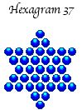
Spirit (r) ..........= 37
The Lord (r) ....= 37
Given that this hexagram represents the Spirit of the Lord filling the tabernacle, it is astounding that 37 is the reduced value for both ‘the Lord’ and ‘Spirit’! How wonderful, too, that the reduced values of these alternative names for God can be organised into the sacred symbol of the star of David!
Snowflake 151
If we now place the inner hexagram within the outer ring of 114 units we obtain a rather beautiful fractal snowflake, fashioned from 151 individual units.
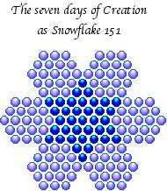

Jesus Christ (o) .................= 151
Holy Spirit (o) ..................= 151
And we have manifested the ordinal values of the second and third Persons of the Trinity! Astoundingly, several well known phrases that are meaningfully related to Jesus Christ have gematria values of 151:
Jesus is Lord (o) ................= 151
The Incarnation (o) ............= 151
Christ the King (o) ............= 151
The sacrificial lamb (o) ......= 151
Snowflake 151 (and indeed the entire Creation Snowflake) is built from two related figures: the hexagon and the hexagram. These words are themselves encoded with the same numerical signature.
Hexagon (o) .......................= 74
Hexagram (o) .....................= 77
Jesus (o) ...........................= 74
Christ (o) ...........................= 77
So Christ’s English name is inscribed on every branch and platelet of the Creation Snowflake!
We could say that hexagram 37 is the seed for the Creation Snowflake, and that snowflake 151 is the first generation figure. Now I am going to grow larger snowflakes by iterations (repetitions) of the process illustrated above, using the completed figure at each stage as the central snowflake for the next iteration. In doing so I will create a sequence of snowflakes that are visual metaphors for God’s ongoing creative activity.
Snowflake Ring 222
As can be intuited from the shape of the outline of snowflake 151, this figure can be surrounded by a ring of hexagrams, identical in size to its central hexagram. The ring, which requires 222 units for its construction, is illustrated below.
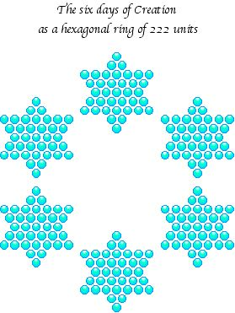
This ring of stars (each hexagram of 37 units representing the words ‘the Lord’ and ‘Spirit’ through gematria) surrounds the snowflake representing Jesus Christ and shines with his Spirit.
The Spirit of Christ (o) = 222
Snowflake 373
Inserting snowflake 151 into this ring of stars to complete the seven days of Creation once more, creates a larger snowflake, having 373 units.
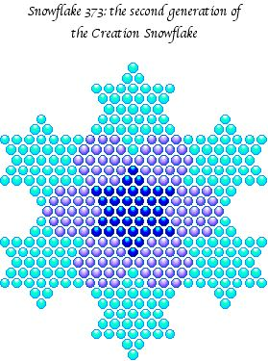
In the Greek system of numeration, 373 is the standard value of ‘Logos’, which means ‘word’:
I think you’ll agree that we now have a figure resembling a real snow crystal, with some of the intricacy of its natural counterpart. The symmetry of these surface features is matched by that of the numbers represented by the outer ring (222), inner snowflake (151) and completed figure (373). These features combine to make snowflake 373 a unique geometric object and an ideal symbol of divine harmony and perfection.
‘Logos’ translates as ‘word’ and the word incarnate is of course Jesus Christ, therefore it can be no coincidence that snowflake 373 contains the inner snowflake that represents his name. Snowflake 151 in turn encompasses hexagram 37, so we have a trio of nested figures that are the seed and the first two generations in the growth of our snowflake. The numbers of units forming each figure are firmly linked through gematria with some of the names most synonymous with God (see note 7).
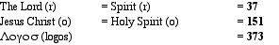
Snowflake Ring 906
Snowflake 373 can now be ringed by six versions of its own internal snowflake to form an elaborate, but still hexagonal, diadem of 906 discs, illustrated below.
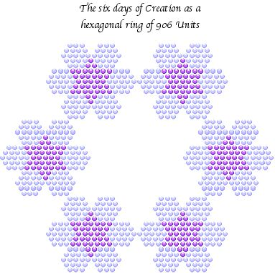
906 is the summed standard values of the word 'Jesus' in English and Hebrew:
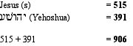
In additon, the ring is made from six snowflakes of 151 units, 151 being the ordinal value of ‘Jesus Christ’ and ‘Holy Spirit’.
Snowflake 1279
As the snowflake accumulates, ever more wonders are revealed. By filling snowflake ring 906 with snowflake 373, a magnificent snowflake, comprising of 1279 units, is created. This is illustrated below.
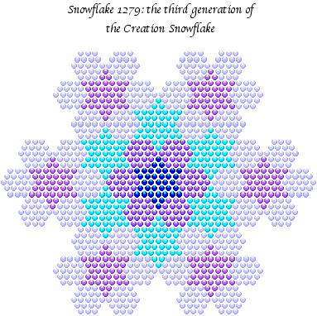
This dazzling fractal is imprinted with the divine watermark of the Creator Himself:
The Almighty God (s) ..................= 1279
I indicated above how snowflake ring 906 is associated with the standard values of the English and Hebrew words for ‘Jesus’. Amazingly, 1279 is the sum of the standard values of the Greek and Hebrew words for Jesus!
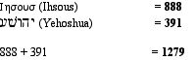
It follows that 1279 is also the sum of names for our Lord in all three languages:
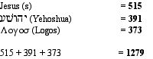
This is the completed Creation Snowflake, every glittering platelet inscribed with the Creator’s signature, every surface feature reflecting the divine harmony within.
An Outline of the Creation Snowflake
For the frosting on the cake we turn now to the outline of the Creation Snowflake and that of each of the figures within it. As the snowflake grows the number of discs around its perimeter grows along with it. These form the outline of each snowflake, defining its characteristic shape and giving rise to a further sequence of numbers. With sublime economy of material, the Miracle Maker has utilised these very numbers to encode further numerical signatures.
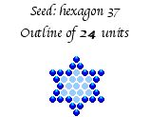
Word (r) ....= 24
Holy (r) .....= 24

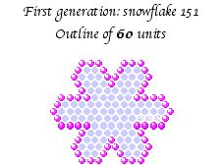

Word (o) ...= 60
Holy (o) ....= 60

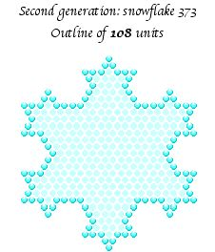

The Lord God (o) = 108

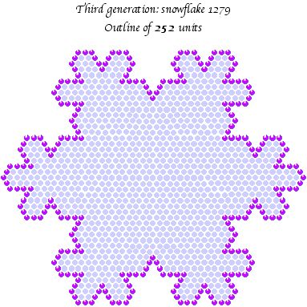
“In the beginning God created the...” = 252
These are the six opening words of the NIV Bible and they are the first of a series of jewels, which have been carefully placed within the NIV Bible’s opening words.
The Creation Snowflake In Genesis
Genesis 1:1-2 (NIV)
1. In the beginning God created the heavens and the earth. 2. Now the earth was formless and empty, darkness was over the surface of the deep and the Spirit of God was hovering over the waters.
These are the first eighteen words of the NIV Bible, trisected into three blocks of six words. The first six words have an ordinal value of 252, which is the number of units forming the outline of the snowflake.
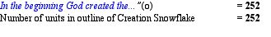
The number six here echoes the six-fold symmetry of the snowflake, suggesting that it may be worth our while numerating the next six words.
The one we call ‘Messiah’ is of course Jesus, whose Hebrew name is encoded within the third group of six words.
Summing, now, the first two groups of six words, we obtain a twelve-word segment which is the sum of 252 and 263.
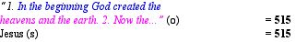
Summing the second and third groups of six words, we obtain the absolute value of ‘word’.
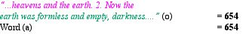
It only remains for us to sum the entire block of eighteen words to complete our analysis. Here we find another number related to the Creation Snowflake.
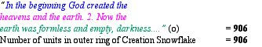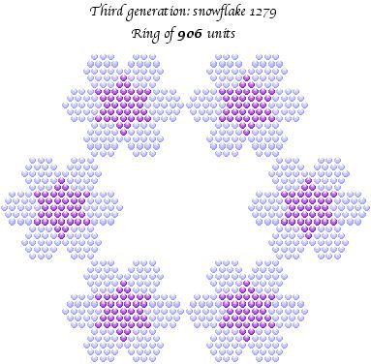
So the NIV Bible’s first eighteen words contain two numbers derived from the Creation Snowflake. What about the completed figure? A partial manifestation will not do; we should rightly expect to witness the entire snowflake. Actually, it is right under our feet, carpeting the second verse of the NIV Bible.
Genesis 1:1-2 (NIV)
1. In the beginning God created the heavens and the earth. 2. Now the earth was formless and empty, darkness was over the surface of the deep and the Spirit of God was hovering over the waters.
Genesis 1:2 (o) ......= 1279
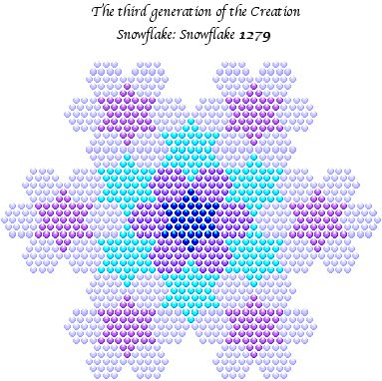
Summary
Snowflake 1279 is encoded within the NIV Bible’s first two verses, through three numbers that completely define it (see note 8):
1. The outline of 252 units is encoded as the ordinal value of the first six words of the NIV Bible.
2. The hexagonal outer ring of 906 units is encoded as the ordinal value of the first eighteen words of the NIV Bible.
3. The total number of units in the snowflake, 1279, is encoded as the ordinal value of Genesis 1:2 in the NIV Bible.
The three encodings are shown here in turquoise, along with the ordinal value of these words.
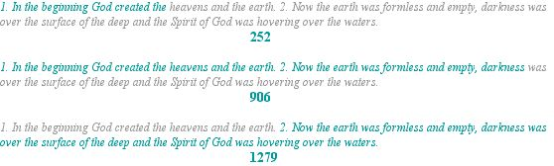
Furthermore the first eighteen words of the NIV Bible can be trisected into three equal portions of six words, that reveal a set of numbers, each of which is the standard value for a name or title for God incarnate:
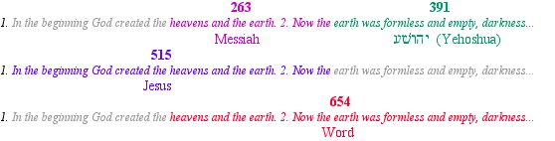
Note that these numbers are all the standard values of the names (including the Hebrew word), but are encoded within each portion of text as ordinal values. This is the signature of the New Bible Code and is further evidence of deliberate activity, rather than chance occurrence.
There is something else to note here: we saw that the first eighteen words can be trisected into three groups of six words and that they are the number of units required to construct the outer ring of the snowflake, which is six-sided, and which represents the six days of Creation. Here we see the number six used as an extra unifying feature, further demonstrating that these numbers did not come together through happenstance.
As if this is not enough to delight and astonish us, Genesis 1:2 also holds an encryption of a fundamental physical constant, known as alpha, the fine structure constant. For further information, see Irrational Encryptions. Further numbers are encoded within the first three verses of the NIV Genesis, strewn in decorative fashion around the three numbers from which the Creation Snowflake can be constructed. For further details, see From The Beginning.
Could so many gematria values related to the Trinity be present within the Creation Snowflake simply by chance? A very conservative estimate of the probability of such an occurrence is 1 in 35000, but the true odds are likely to be very much higher, especially when the chances of the snowflake being encoded within the first two verses of the NIV Bible are factored in. For details please click here.
Epilogue
The Creation Snowflake is a kind of geometric mandala (see note 9), representing Creation itself: our universe of manifest forms. These forms adhere to the laws of fractal geometry, as is seen most delightfully in snow crystals, which display myriad variations on fractals such as the Koch Snowflake, the fractal towards which the Creation Snowflake itself grows. The Creation Snowflake is therefore the perfect illustration of creative activity. Moreover, every branch and platelet of this mandala bears the signature of its Creator, the God of the Judaeo-Christian scriptures, whose formation of the universe is described in the opening words of Genesis. These are the very words within which the snowflake has crystallised, therefore the Creation Snowflake has communicated to us in a unique and memorable way that its Creator is also the Creator of this universe. The location of the snowflake within the NIV Bible, the most popular modern English translation of the Christian scriptures, is a signal of further encodings within the NIV and is an authenticating watermark on the Christian Bible itself.
Could random forces have created such a wonder? If there is a line between coincidence and synchronicity, between chance and purpose, then we crossed it long ago, and have now wandered into an enchanted realm where miracles occur. But unlike weeping statues and ephemeral apparitions, this miracle is frozen in time and can therefore be witnessed by all who care to do so. Words fail me in attempting to fully communicate the magnificence of the Creation Snowflake; I can only turn to the Bible and quote the opening words of Psalm 105—this time from the KJV Bible—which convey the wonder of it far more effectively than I could:
Psalm 105 v.1-2 (KJB)
“O give thanks unto the Lord; call upon his name; make known his deeds among the people.
Sing unto him, sing psalms unto him; talk ye of all his wondrous works.”
Bill Downie
14/3/05
Latest revision
21/4/07
Home

Notes
1. See The Secret Doctrine of the Kabbalah, by Leonora Leet.
2. The Essential Kabbalah, by Daniel C. Matt.
3. Seven is an important number for the authors of the Bible, who considered it to be the most auspicious of numbers, standing for spiritual perfection. Consequently, seven is woven into more biblical passages than any other number.
4. The idea that God’s love permeates the universe has some support in the work of a Japanese researcher known as Masaru Emoto, who has spent many years freezing water then photographing the water crystals as they form. The unique feature of his work is that before he freezes the water he first projects thoughts onto it. What he discovered was that pure, unpolluted water or, alternatively, water onto which loving, peaceful thoughts were projected crystallised into perfect symmetrical forms, identical to snow crystals. Water subjected to angry or hateful thoughts crystallised into irregular forms or not at all. Polluted water also refused to crystalise. However, when a body of polluted water was prayed over, it too formed regular crystals upon freezing.
5. Hexagon 61 can also be created from triangle 91, by self intersection. Interestingly, 61 is the reduced value of ‘Holy Spirit’ and 91 is the ordinal value of 'Spirit'.
6. It should be borne in mind, however, that the combined system is tentative and has no precedent in Hebrew gematria.
7. I thank Richard A. McGough for discovering the link between snowflake 373 and the Greek word ‘logos’. The reduced, ordinal and standard values of the name ‘Jesus Christ’ are 43, 151 and 925. The combined value of 1119 is simply the sum of these three values, of course, and is therefore 373 x 3.
8. The inner snowflake of 373 units may also be encoded here: the first thirty-nine letters of the NIV Bible have a gematria of 373. However, this string of letters ends in the middle of a word; the others are encoded at the word or verse level, which is far less likely to happen by chance and is therefore much more significant.
9. A mandala (from the Sanscrit word for wheel) is a circular space, usually quartered, which is used as an aid to meditation by Buddhist monks. C. G. Jung used mandalas as an aid to psychoanalysis.

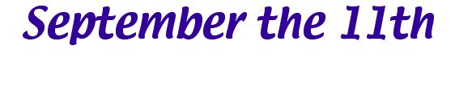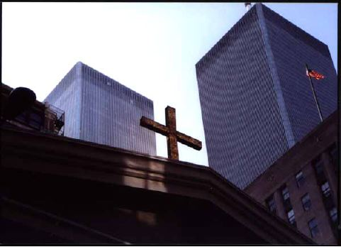

The folly of Interpreters has been to foretell times and things by this Prophecy, as if God designed to make them Prophets. By this rashness they have not only exposed themselves, but brought the Prophecy also into contempt. The design of God was much otherwise. He gave this and the Prophecies of the Old Testament, not to gratify mens curiosities by enabling them to foreknow things, but that after they were fulfilled they might be interpreted by the event, and his own Providence, not the Interpreters, be then manifested thereby to the world.

Isaac Newton: Observations Upon The Apocalypse Of St. John

God comforts the afflicted and afflicts the comfortable.
Christian proverb
Prologue
Two years before the most momentous day in recent history there was a rare total eclipse of the sun, seen over parts of the USA and Europe. In the UK, where I live, the total eclipse corona was first visible in Cornwall on the 11th of August 1999 at 11:11AM BST. In other times solar eclipses were thought to be harbingers of destruction, but nowadays we see no meaning at all in the passing of the moon in front of the sun. Perhaps the ancients were wiser than are we.
The internet is awash with conspiracy theories about the identities and motives of the real perpetrators of 9/11. While I have no doubt that the official story of what happened on that day is possibly far from the truth and that there may well have been a conspiracy of some kind, the identities of the earthly perpetrators are of no consequence. They played their parts in the 9/11 drama, but the director was offstage and well beyond any human manipulation.
I have my own small part to play here, a part which began on that very morning. I woke up to hear an inner voice speak the words “Serpent power”. I had an idea of what they might mean and I knew from recent experience that something important was happening, so I wrote the words down and went off to work. Serpent power is also called Kundalini energy. According to Hindu mythology, Kundalini is the serpent goddess, who is supposed to lie coiled at the base of the spine. This energy gives us strength and creative power. Serpent power is also the power of anger and conflict: men in battle are supposed to be harnessing Kundalini energy. According to practitioners of yoga, under certain conditions this energy can rise up through the ‘chakras’ and give rise to a ‘Kundalini awakening’, a dramatic and potentially dangerous moment of enlightenment.
I left work early in the afternoon and drove home, unaware of the apocalyptic events unfolding across the atlantic ocean. Around 3.00PM my wife telephoned me to say that something extraordinary had happened and that I should put the television on. I immediately did just that. I sat there, hardly moving, for eight hours, watching with horror, fascination and an odd sense of unreality as the serpent struck the USA, causing the deaths of three thousand people, the destruction of the twin symbols of global capitalism and the ‘Kundalini awakening’ of our sleeping world.
As I absorbed all the news reports and interviews, my sense of the unreality of it all was compounded by something else. I couldn’t help noticing a growing string of numerical coincidences involving the number 11. For instance, the date was the 11th, the twin towers resembled the number 11, the first airplane to strike was flight 11 and there were 110 storeys in each building. In the weeks, months and years that followed, I found and was given many more of them. These included facts that seemed to indicate that the site was historically linked with eleven. For instance, Manhattan Island, on which the twin towers stood, was discovered on September the 11th.
Could this string of elevens be accounted for simply by chance? Certainly some of them could. Furthermore, the date of the attack, the target and other elements could have been deliberate decisions on the part of, or opportunities taken by, the perpetrators to assign it a significance. But others, such as historical events relating to the date, were more difficult to explain away. I sensed from the start that a more likely explanation for the unusual frequency with which the number eleven appeared in the facts and figures surrounding 9/11 was a phenomenon first described by the great psychologist Carl Jung: synchronicity, or meaningful coincidence. It shone out like a beacon, signalling for those of us with ‘ears to hear’ that 9/11 had a significance that went far beyond that of other events in history.
For a brief introduction to gematria (necessary for a full appreciation of the following information) please click here.
The 9/11 Targets
From any picture of the Pentagon and the twin towers, it can easily be seen that they visually depict two numbers: 5 and 11.
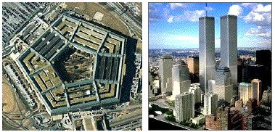
In fact the buildings could be said to be pictograms for these two numbers. This relationship is even more profound than may at first be supposed. These targets were watermarked with the numbers 5 and 11.
The Pentagon and 5
1. The Pentagon building, seen from above, is a perfect pentagon, a regular five-sided figure.
2. As can be seen from the picture, the Pentagon building is made of five concentric pentagons.
3. The Pentagon has five floors.
4. The ordinal value of the words ‘the Pentagon’ is the cube of 5:
The Pentagon (o) = 125 = 5 x 5 x 5
5. The ordinal value of the word ‘Pentagon’ is a pentagonal (five-sided) number:
Pentagon (o) = 92, the 8th pentagonal number.
The Twin Towers and 11
The clustering of elevens around the events of 9/11 is well known. Here are ten of the huge number of 11-related coincidences involving the twin towers and 9/11.
1. The date of the event was the 11th.
2. The twin towers resembled the number 11.
3. The first plane to strike was flight 11.
4. There were 110 storeys in each building.
5. Both buildings collapsed to the 11th storey.
6. The towers burned for 99 days. 99 = 9 x 11.
7. 9 + 1 + 1 = 11.
8. New York was the 11th state to join the federal union.
9. Manhattan Island, on which the twin towers stood, was discovered on September the 11th.
10. The 9/11 Commission hearings closed on 17/6/04, 1010 days after 911.
The number eleven is deeply woven into the gematria surrounding 9/11, suggesting that even the English language has been employed to bring the message of 9/11. Here are some of the connections I found:
Osama bin Laden (o) = 110
Osama bin Muhammad bin Laden (o) = 209 = 11 x 19
New York (o) = 111
Nine one one (o) = 110
Nine hundred and eleven (o) = 198 = 11 x 18
September the eleventh two thousand and one (o) = 440 = 11 x 40
There are many, many more such signs, involving the numbers of passengers on the flights themselves and other peripheral 9/11 events, recorded on several 9/11 websites (for instance, see september11news.com). These show beyond any reasonable doubt that the events of September the 11th, 2001 were the focus for an immense clustering of meaningful numbers. Even more impressive, however, is the voluminous evidence that the synchronicities surrounding 9/11 extend well beyond the confines of the event itself.
Other Contemporary Signs
Several books and films that were released in or around 2001 show signs of having been mysteriously influenced by 9/11, even though they were all created or at least begun, well before that day. Notable in this regard are Oceans Eleven (2001); Harry Potter and the Philosopher’s Stone (2001), in which Harry was taken to Hogwarts on his 11th birthday; The Two Towers (2002), the second in the Lord of The Rings trilogy; The Matrix (1999), in which Neo is first seen opening the door to his appartment, numbered 101. The number 101 may have been a reference to George Orwell’s dystopian novel 1984, in which London is dominated by four monolithic government buildings, the most sinister of which contains the infamous room with that number.
Other well-known and fairly recent films may also contain prophetic information. In Alfred Hitchcock’s masterly film The Birds (1963), the birds begin attacking en masse on the eleventh birthday of Mitch Brenner’s sister. The Exorcist (1973) is set in Washington DC and involved a girl who was eleven years old when the malevolent spirit entered her home (this raises the interesting possibility that 9/11 was a kind of exorcism). 2001: A Space Odyessy (1968) featured a huge, rectangular monolith, discovered on the Moon in 2001. The Omen (1976) is an apocalyptic tale about the rise of the antichrist, whose name is Damien Thorn.
Damien Thorn (o) = 121 = 11 x 11
antichrist (o) ........= 121 = 11 x 11
The uncanny timing of the solar eclipse in 1999, which began in the UK at 11:11AM BST on the 11th of August, seem to forewarn us of 9/11. Another astronomical event that may have constituted a sign is the so-called Harmonic Concordance of 2003, where the planets in our solar system, observed from earth, appeared to form a near perfect hexagon/hexagram in the sky behind the moon. This event peaked on the 9th of November (11/9) of that year (this was also when I produced my first version of this page).
Other events in the recent past may have anticipated 9/11. One such event was the great northeast USA blackout of 1965. This infamous electricity blackout took place on November the 9th of that year in and around New York, of all places. The number of days from that event to 9/11 is 13090 or 11 x 1190. An event that may have had personal significance was a world-famous UFO encounter only two miles from where I live, at Dechmont Law. This traumatic encounter involved a landscape gardener who regularly worked alongside a friend of mine. He was working alone in some local woods one morning when he encountered an unknown and unusually shaped aircraft. Two spheres emerged from the craft, rolled towards him (leaving tracks on the ground) and attached themselves to his trousers, ripping two large holes in them. The ripped trouser legs may have symbolised the future destruction of the twin towers. The date of this encounter, twenty-two years prior to 9/11, was November the 9th, 1979.
Finally, Pope John Paul II, the head of the Roman Catholic church from 1978 until 2005, was the 264th Pope, 264 being 11 x 24. He was also the 110th Pope from Celestine II to "the end of the world", according to the prophesies of St. Malachy. The funeral of Pope John Paul II and its relationship to 9/11 is discussed in The Resurrection Of Jesus Christ.
In biblical numerics the number 11 means subversion and disorder, ideas which resonate with the events of 9/11. The numeral 11 itself, consisting of two separate digits, implies the number 2 in its duality. Therefore it is also an ideogram for the related ideas of division and duality, associated in biblical numerics with the number 2. Visually, the numeral ‘11’ resembles the horns of a beast.
The number 5 is biblically associated with God’s grace, love and heavenly favour. These are not ideas that spring to mind when contemplating the Pentagon, symbol of the USA’s military power. However, in The Crucifixion of Jesus Christ we will see that the Pentagon itself has been employed as a symbol for an idea that does indeed carry these associations.
Why has the number 11 been so assiduously encoded into the 9/11 event and, apparently, into natural phenomena, historical events and western popular culture of the period around 9/11? What is the role of the number 5? Before we can answer these questions we need to take a closer look at 9/11 through the lens of gematria.
As you proceed, you will see that many of the numbers are derived by calculating ordinal values, but eventually take on meaning under the standard value system. This is also true of the most significant encodings I have found within the NIV Bible, suggesting that they emanated from the same source.
The World Trade Centre and The Pentagon
The names the World Trade Centre, the north tower, the south tower and the Pentagon have ordinal values that reflect the internal structure of a series of nested cubes.
Let’s start with the cube of 5, which has 125 units:
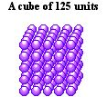
This cube will fit perfectly into a shell of 218 units....
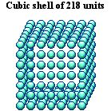
...to create a larger cube, the cube of 7, with 343 units:
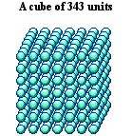
These two numbers are the ordinal values of the 9/11 targets:
The Pentagon (o) .................................................= 125
The World Trade Centre (o) ................................= 218
The World Trade Centre (o) + The Pentagon (o) = 343
Therefore the three buildings involved in the 9/11 tragedy encode cube 343 and two numbers that derive from its internal structure. 343 is the cube of 7, the most sacred number in biblical numerics.
The North Tower and The South Tower
Of the collection of buildings comprising the World Trade Centre, only two were struck. These were the twin towers of the World Trade Centre, individually known as The North Tower and The South Tower. The gematria values of these names encode a number representing another shell that can surround cube 343 to create an even larger cube.
This cube will fit perfectly into a shell of 386 units....
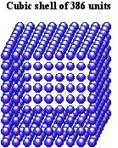
...to create an even larger cube, that of 9, with 729 units:
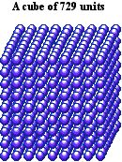
It so happens that 386 is the sum of the individual ordinal values of the names ‘the North Tower’ and ‘the South Tower’.
The North Tower (o) + The South Tower (o) ...........................= 386
Therefore from the ordinal values of the 9/11 targets we can obtain three nested cubes, those of 5, 7 and 9:
The Pentagon (o) .......................................................= 125 = 5 x 5 x 5
The World Trade Centre (o) + 125 ..........................= 343 = 7 x 7 x 7
The North Tower (o) + The South Tower (o) + 343 = 729 = 9 x 9 x 9
Perhaps significantly, the largest cube, encompassing the entire set of numbers, is the cube of 9, the biblical number representing endings, finality and judgment.
A Dimensional Shift

Cube 729: 2D Diagonal Projection
The 2D projection of every cube along one of its internal diagonals is a hexagon. If the 2D diagonal projection of cube 729 is taken we obtain hexagon 217, also the ninth member of its series. This transformation is shown below.
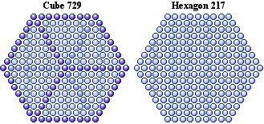
As I showed above, 729 is the sum of the ordinal values of the 9/11 targets. Amazingly, the number 217 is also implied by the 9/11 targets. Although only two towers were actually hit, three towers were totally destroyed on 9/11: WTC 1, WTC 2 (these were the twin towers) and WTC 7.
The chronological order in which the three buildings fell was as follows:
WTC 2 at 10:05AM
WTC 1 at 10:28AM
WTC 7 at 5:20PM
This gives us the sequence 2, 1, 7 which implies the number 217.
217 and 9/11
Cleverly concealed within the bible is startling evidence linking the numbers 217, 729 and 911.
1. The Bible’s 217th verse is, incredibly, Genesis 9:11. This describes the making of a covenant between God and man.
Gen. 9:11 (NIV)
I establish my covenant with you: Never again will all life be cut off by the waters of a flood; never again will there be a flood to destroy the earth.
2. The Bible’s 911th chapter is Haggai 2, which begins as follows:
Hag. 2:1 (NIV)
On the twenty-first day of the seventh month, the word of the Lord came through the prophet Haggai.
The ordinal ‘twenty-first’ followed by ‘seventh’ implies 217.
3. Recalling that 729 is the cube of 9, we note that the Bible’s 729th verse is Genesis 27:1. Again we see the digits 2, 1 and 7 employed.
217 and the Beast
Within the NIV, The number 217 is also associated with another concept, that of the beast of Revelation.
1. The Bible’s 521st verse is Genesis 21:7
The beast (s) = 521
2. Taking the numbers 2, 1, 7 in their natural ascending order, we obtain 127. The Bible’s 127th verse is Genesis 5:21, implying 521 once more.
3. The bible’s 666th verse is Genesis 25:7, which tells us the life span of Abraham.
7. Altogether Abraham lived a hundred and seventy-five years.
Genesis 25:7 (o) = 521
The beast (s) = 521
4. The bible’s 666th chapter is Ecclesiastes 7, entitled ‘Wisdom’. This chapter has 29 verses, and stating chapter and verse gives 7:29, implying the number 729. The first verse of the NIV version of this chapter is shown below:
1. A good name is better than fine perfume, and the day of death better than the day of birth.
Ecclesiastes 7:1 (o) = 729 = 9 x 9 x 9
1st six words Ecclesiastes 7:1 (o) = 216 = 6 x 6 x 6
There is another, more subtle, link between 217 and the beast, or more specifically, the number 666. The numbers 127, 271 and 721 are all numerical anagrams of 217, and, like this number, they are all centred hexagonal numbers. This unique feature of numerical geometry links the digits 2, 1 and 7 in a geometric sense with the number 6.
So here we see numbers associated with the beast found alongside the numbers 217 and 729, the very numbers that were encoded into the fall of the twin towers and the 9/11 event in general. Why would this be the case?

The Mark of The Beast

The number of the beast is, in fact, clearly stamped upon the events of 9/11, marking them for our urgent attention and suggesting they have a significance beyond the merely historical.
The three cities involved in the 9/11 event were, to give them their full names, the City of Boston, the City of New York and the City of Washington DC.
The City of Boston (o) + The City of New York (o) + The City of Washington DC (o) = 666
The last three US presidents are also marked with this number. Note that this only applies to them in their presidential capacity, perhaps because the presidency is the ultimate expression of temporal power.
President George Bush (o) + President Bill Clinton (o) + President George Bush (o) = 666
Another ‘666’ is found in the names of the city on which the 9/11 attacks were focused and on the date itself. Note that, as usual, it is the ordinal values that encode information.
New York (o) + Nine Eleven (o) = 216 = 6 x 6 x 6
The ordinal value of the words ‘nine eleven’, the name by which that apocalyptic day is universally known, is the triangular number 105.
Nine Eleven (o) = 105
The number 666 happens to be a triangular number, every important structural property of which is also triangular. One of these properties is the outline of triangle 666 of the number 666, which has 105 units and is itself the 14th triangular number.
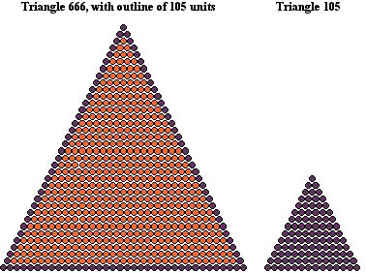

The Watermarked Targets
I am now going to show the first of two geometrically significant dismantlings of cube 729, to obtain two important numbers.
By subtracting the shell of 218 units from cube 729 we obtain the significant number 511 (figure 59).
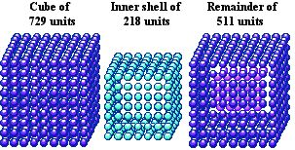
Firstly, 511 is linked to 9, the number of endings, finality and judgment, through number theory in mathematics. 511 is the 9th Mersenne number. These are an important class of numbers, which are calculated by the following formula:
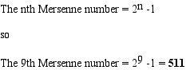
Secondly, 511 is the sum of the ordinal values for the three individual targets on 9/11:
The Pentagon (o) + The North Tower (o) + The South Tower (o) = 511
At the start of this page I showed some of the voluminous evidence that the 9/11 targets were and are associated with the numbers 5 and 11, as well as visually depicting these numbers. Now, incredibly, we see that the ordinal value of the targets themselves is the number 511.
There is a geometric solution to this mystery which adds a new dimension of meaning to the 9/11 tragedy. If this interpretation is correct, and the numerico-geometric connections I summarise in this page are more than simply fabulous coincidence, the events of 9/11 transcend the merely historical to enter the realms of biblical end-time prophecy.
The ‘end times’ is a series of apocalyptic future events predicted in many of the Bible’s prophetic passages, most notably in the books of Daniel and Revelation. These prophecies have been given many interpretations by theologians, from the esoteric to the frankly embarrassing, but are acknowledged by the vast majority of Christians to be a time of great tribulation, at the end of which Christ comes to defeat the powers of darkness and usher in a new era of peace and love. This final event is of course the Second Coming Of Jesus Christ.
Second Coming
If the events of September the 11th, 2001 were in some way connected with the Second Coming we might expect this to be encoded within the principle phrases used to describe the event, such as ‘Second Coming’, ‘The Second Coming’, ‘The Second Coming of Jesus Christ’, etc. Let us begin with ‘Second Coming’, the ordinal value of which is given below:
Second Coming (o) = 121 = 11 x 11
The number 121 has the unique geometric property of forming both a square and a centred hexagram. I showed earlier how the World Trade Centre is symbolised by the number 11 and the Pentagon by the number 5. Astoundingly, these are the place values of the number 121 in the two series of figures to which it belongs!
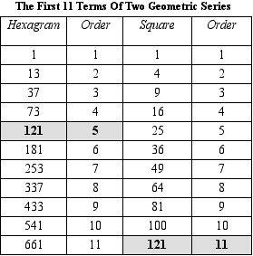
The two figures are illustrated below. The hexagram, shown first, is a perfect archetypal symbol for Christ, who was a Jew from the line of David. Note how both figures have internal properties that perfectly mirror the gematria of the words ‘Second’ and ‘Coming’.
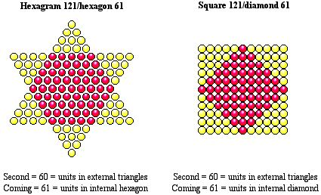
The standard value of the words ‘Second Coming’ is 391 (see note 1), which is the standard value of the Hebrew word for Jesus, transliterated as ‘Yehoshua’.
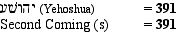
391 is also found in connection with the three destroyed WTC buildings, which were also known as ‘Building One’, ‘Building Two’ and ‘Building Seven’.
Building One (o) = Building Two (o) + Building Seven (o) = 391
Christ’s Second Coming
I showed earlier how cubes 125, 343 and 729 are encoded within the names of the 9/11 targets. The largest of these cubes, 729, has as its 2D diagonal projection hexagon 217. It so happens that hexagram 121 fits precisely into that hexagon. This arrangement is shown in figure 62.
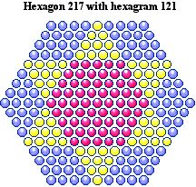

Christ’s Second Coming (o) = 217
This is no fanciful pairing of figure and phrase: if we count the individual units in each of the three coloured zones created by the superimposition of hexagram 121 on hexagon 217, we discover that these three numbers are also the ordinal values of the individual words in the phrase ‘Christ’s Second Coming’.
Christ’s (o) = 96 = units in outer rhombii
Second (o) ..= 60 = units in outer triangles
Coming (o) .= 61 = units in inner hexagon
This degree of coordination between numerical values and geometric properties is stunning evidence of intelligent design, rather than random forces, and is singularly appropriate for the message being conveyed.
The relationship between 121 and 217 is cemented when we transform the above image from 2D to 3D. The 3D figure which projects hexagon 217 with internal hexagram 121 is cube 729, with three slices made along the centre of each of its three planes. This is shown below, with the slices coloured for easy identification.
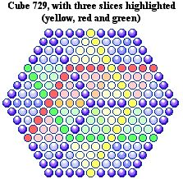
As you can see, hexagram 121 is the 2D projection of the subtracted units. However, when we count these subtracted units we find, to our astonishment, that they total 217! Here the link through gematria between the numbers 121, 217 and 729 is underscored by their profound geometric interconnections (see note 2).
Finally, if we take a 2D projection of the sliced cube, we obtain the figure below.
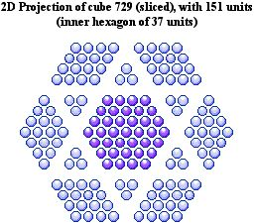
This is remarkably similar to the first generation of the Creation Snowflake, also with 151 units!
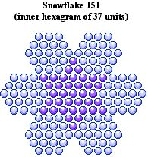
The general form of each figure, an inner figure of 37 units surrounded by a symmetrical arrangement of 114 units, is the same. The same gematria connections also apply.
Jesus Christ (o) = 151
Holy Spirit (o) .= 151
God (c) .............= 114
The Lord (r) .......= 37
Spirit (r) .............= 37
The Second Coming
I constructed cubes 125, 343 and 729 from the gematria of the 9/11 targets. Then, by examining the inner structure of cube 729, I recreated the individual gematria values of the targets and found a significant new number. The individual targets are all either cubes or the difference between two cubes, as shown below:
The Pentagon (o) ......................................................= 125
The World Trade Centre (o) = 343 - 125 ................= 218
The North Tower + The South Tower = 729 - 343 = 386
We have one further subtraction to perform: 729 - 125 = 604. This is illustrated in the next figure, along with the phrase with standard value equal to the number of units remaining.
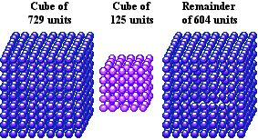

The North Tower (o) + The South Tower (o) + The World Trade Centre (o) = 604
The Second Coming (s) .....................................................................................= 604
The Second Coming Of Jesus the Messiah
The news of the Second Coming was delivered by four airplanes that smashed into three buildings representing the beast of Revelation. This message was also borne in the very flight numbers and departure points of these angels of death.
1. The three airplanes that hit their intended targets on 9/11 are given below:
Flight 11 hit the North Tower.
Flight 175 hit the South Tower.
Flight 77 hit the Pentagon.
11 + 175 + 77 = 263
Messiah (s) ...= 263
2. The fourth hijacked airplane crashed in Pennsylvania. Adding its flight number to the sum we obtain the ordinal value for the following phrase (see note 3).
11 + 175 + 77 + 93 .........................................= 356
The Second Coming of Jesus the Messiah (o) = 356

The Second Coming Of Jesus Christ
The flight numbers of the hijacked airplanes sum to 356, which, as I showed above, is the ordinal value of the phrase “The Second Coming of Jesus the Messiah.” It turns out that the number 356 has the property of effecting an alchemical transformation of other numbers related to 9/11, which I have already derived from the names of the targets. Note that, yet again, the numbers are derived from ordinal values but take on meaning under the standard value system, a ‘signature’ of the New Bible Code.
The World Trade Centre (o) + The Pentagon (o) ...........................= 343
343 + 356 ........................................................................................= 699
Lord Jesus (s) ..................................................................................= 699
The North Tower (o) + The South Tower (o) + The Pentagon (o) = 511
511 + 356 ........................................................................................= 867
The Word (s) ...................................................................................= 867
New York (o) + Washington D.C. (o).............................................= 248
248 + 356 ........................................................................................= 604
The Second Coming (s) ...................................................................= 604
The flights left from three airports, as detailed below:
American Airlines Flight 11 left from Logan International Airport
United Airlines Flight 175 left from Logan International Airport
American Airlines Flight 77 left from Dulles International Airport
United Airlines Flight 93 left from Newark International Airport (see note 4).
Adding the ordinal values of the airports to the numbers of the flights that left from each airport, a procedure identical to adding the number 356 to the sum of the locations only, we obtain the central message of the New Bible Code.
Logan International Airport (o) + 11 ..= 309
Logan International Airport (o) + 175 = 473
Dulles International Airport (o) + 77 ..= 399
Newark International Airport (o)+ 93 = 414
309 + 473 + 399 + 414 ......................= 1595
The Second Coming of Jesus Christ (s) = 1595
I said at the start of this page that the numbers 5 and 11 were encoded into the 9/11 event through the designs, names and histories of the targets and through the details of the event itself. In this final numerical value, these numbers make a final, triumphant appearance.
1595 = 5 x 11 x 29
The number 29 itself is the reduced value of the word ‘Messiah’, whose return was announced through this miracle of numerical synchronicity.
Bill Downie
Last updated
5/5/07

The following pages show the evidence I have gathered from the NIV Bible in support of the hypothesis I outlined in this page: that the events of September the 11th, 2001 announced the Second Coming of Jesus Christ.
Genesis++
Exodus+
Numbers
Deuteronomy++
Judges++
Solomon’s Gold++
Ezra
Psalms
Jeremiah
Daniel
Amos
Matthew
Mark
Luke
John
Acts
Revelation
Feeding the 5000
Home

Notes
1. 391 is 17 x 23. The 17th and 23rd triangular numbers are 153 and 276, which are specifically mentioned in the New Testament: in John 21:11 there is a catch of 153 fish; in Acts 27:37 276 people are saved from a shipwreck. Both stories are metaphors for the idea of salvation.
2. When we subtract 217 from 729 we obtain 512, which is 8 x 8 x 8. 888 is the value of the Greek word for Jesus.
3. Normally the encoded numbers are standard values, this appears to be one of the few occasions when an ordinal value has been encoded.
4. After 9/11, Newark International Airport was renamed Newark Liberty International Airport. I am using the name existent at the time of 9/11.

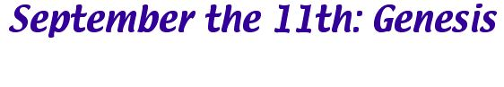
Introduction
This page is the first of several summarising the evidence I have uncovered that 9/11 was prophesised throughout the Bible. Some of the prophecies are recognised as such, but others are what I would term ‘hidden’; that is, they would not normally be considered prophecies as such and supposedly relate historical events, or perhaps recount myths. Nevertheless, these narratives refer to September the 11th by metaphor and allegory, or contain archetypal themes—for instance, the idea of duality, division and destruction—that resonate with the events of 9/11. Moreover, these same passages are usually tagged in some way with the key number 11, or related numbers.
These passages are found in all bibles, of course. However, in the NIV Bible we find that critical verses and passages at these locations are also encoded with significant numbers by means of English gematria. Here we also see the phenomenon of confluences of independantly derived, yet meaningfully related numbers, something which is statistically unlikely, therefore highly significant. The encoded numbers encourage us to read these passages with fresh eyes, revealing that 9/11 was the end point of biblical prophecy.
Genesis 1 (NIV) - 1st 7 words
I begin with a small but perfect encoding, encompassing the NIV Bible’s first seven words, which summarises all that follows. Seven is the number representing spiritual perfection and has been
1. In the beginning God created the heavens and the earth.
1st 7 words Genesis 1 (o) .......................= 326
The Second Coming of Jesus Christ (o) ..= 326
Genesis 1 (NIV) - 1st 18 words
The first 24 words of the NIV Bible are already dealt with in The Signature of Christ, From the Beginning and The Creation Snowflake. However, the first eighteen words contain its essential message.
1. In the beginning God created the heavens and the earth. Now the earth was formless and empty, darkness...
Words 1 to 12 Genesis 1 (o) ..= 515
Jesus (s) .................................= 515
1. In the beginning God created the heavens and the earth. Now the earth was formless and empty, darkness...
Words 13 to 18 Genesis 1 (o) = 391
Second Coming (s) .................= 391
Genesis 1:10 (NIV)
The chapter and verse, read as a number, implies 110, which is 11 x 10. The ordinal value of the verse is also a multiple of 11. This is an example of confluence; in fact Gen 1:10 is the first verse the NIV Bible to encode a multiple of 11. Appropriately, it also encodes the essential message of the New Bible Code.
10. God called the dry ground “land”, and the gathered waters he called “seas”. And God saw that it was good.
Genesis 1:10 (o) = 803 = 11 x 73
Jesus (r) ..............................= 11
Second Coming (r) ..............= 73
Genesis 1:11 (NIV)
This is the Bible’s 11th verse. Once again we observe a correlation between a verse number and its gematria.
11. Then God said, “Let the land produce vegetation: seed-bearing plants and trees on the land that bear fruit with seed in it, according to their various kinds.” And it was so.
Genesis 1:11 (o) = 1507 = 11 x 137
Genesis 3:15 (NIV)
In this dramatic verse God tells the serpent that because he deceived Eve, her offspring and his own would thereafter be enemies. Genesis 3:15 has been identified as the starting point of all biblical prophecy. It might therefore be expected that a verse of this importance would receive the attentions of whoever encoded the NIV - and this is indeed the case.
15. And I will put enmity between you and the woman and between your offspring and hers; he will crush your head and you will strike his heel.
1st clause Genesis 3:15 (o) = 831
The Second Coming (c) ......= 831
Two (c) ..............................= 831
15. And I will put enmity between you and the woman and between your offspring and hers; he will crush your head and you will strike his heel.
2nd clause Gen 3:15 (o) .....= 519
Christ (c) ............................= 519
So the verse that is the beginning of biblical prophecy cleaves naturally into two parts yielding numbers that strongly imply the Second Coming of Christ. The theme of the verse is division and conflict, signified in biblical numerics by the numbers 2 and 11. The number 2 also represents the Second Coming; 11, as these pages show, is one of two numbers that are specifically encoded into 9/11 (the other is 5).
Genesis 5, 9 and 11 (NIV)
In September the 11th, I show how the Pentagon and the Twin Towers represent the numbers 5 and 11. The number 9 itself is paired with 11 in ‘9/11’. Interestingly, these three verses contain the Bible’s first two numerical lists, of the genealogy and lifespans of the patriachs. The list in chapter 5 takes us from Adam to Noah, then tells the story of the flood. Chapter 9 ends with the lifespan of Noah, which completes the list in chapter 5. The list in chapter 11 begins just after the story of the Tower of Babel (see below) and just before the story of Abram, who was instructed by God to leave his people and go to a new land, which he did, with Lot. These stories are all resonant with meaning in the context of the Second Coming, and their chapter placing and conjunction with the lists can be no accident.
The list totals are given below.
Genesis 5
15750 = 5 x 5 x 5 x 126
Genesis 5 + 9
17050 = 11 x 5 x 5 x 62
Genesis 11
3066 = 511 x 6
First of all, the chapter 5 total is a triple multiple of 5. Notice how adding the chapter 9 total to that for chapter 5 now gives a multiple of 11 and a double multiple of 5). The total in Genesis 11 alone is 3066, or 511 x 6. As I show in the 9/11 page, 511 is derived from cube 729 by subtracting the inner shell of 218 units.
Genesis 5:15 (NIV)
This is part of the list of Adam’s genealogical line, given in full later. Verse 15 is shown below. I am summing the individual digits in the numeral ‘65’ here.
15. When Mahalalel had lived 65 years he became the father of Jared.
Genesis 5:15 (o) = 451 = 11 x 41
So the ordinal value of this verse is a multiple of 11. The reason I have highlighted this particular verse is because of its numbering and location:
1. The number implied by the chapter and verse is 515.
Jesus (s) = 515
2. This is the Bible’s 121st verse.
Second Coming (o) = 121 = 11 x 11
Genesis 9:11 (NIV)
In this numerically-significant verse, God tells Noah and his sons that he will establish his covenant with them. Yehoshua HaMashiah is the Hebrew title meaning ‘Jesus Christ’.
11. I establish my covenant with you: Never again will all life be cut off by the waters of a flood; never again will there be a flood to destroy the earth.”
Genesis 9:11 (o) .....................................................................= 1358
Did 9/11 mark a new covenant between God and man?
Genesis 9/11 is the Bible’s 217th verse. As shown in September the 11th, this number and its numerico-geometric properties encode the message of the Second Coming. In particular, we have
Christ’s Second Coming (o) = 217
Genesis 11:1-2 (NIV)
The first 11 chapters of Genesis form a self-contained section, dealing with the early history of the earth. The story of the building of the tower of Babel, a project to which God put a stop to thwart man's ambitions, is told over the first 9 verses of Genesis 11!
Verses 1 and 2, which constitute the first paragraph of this meaningful chapter, are encoded with some astounding numbers.
1. Now the whole world had one language and a common speech.
Genesis 11:1 (o) = 484 = 11 x 11 x 4
Note that there are 11 words in Genesis 11:1. We move on now to Genesis 11:2.

2. As men moved eastward, they found a plain in Shinar and settled there.
Genesis 11:2 (o) = 625 = 5 x 5 x 5 x 5
Finally, summing both verses, we obtain a numerical value for Jesus Christ.
Genesis 11:1-2 (o) ....= 1109
Lord Jesus Christ (s) = 1109
Apparently the tower of Babel did, in fact, exist in what is now Iraq - although, of course, the story also has metaphorical significance. But the NIV account has also been encoded with numbers that would appear to allude to 911. Please also note the placing at chapter 11 of this story of man’s excessive ambition and how God thwarted it.
Genesis 11:9 (NIV)
Gen 11:9 itself, with the same digits as 911, is shown below:
9. That is why it was called Babel - because there the LORD confused the language of the whole world. From there the LORD scattered them over the face of the whole earth.
Genesis 11:9 (o) = 1443 = 111 x 13
New York (o) ........................= 111
Genesis 10 and Genesis 19 (NIV)
It is in Genesis 10 that we first hear mention of the cities of Sodom and Gomorrah, which were destroyed by the Lord because they had given themselves over to evil. The connection between these two cities and 9/11 is established by the biblical locations of the verses in which their story is told.
1. Their first mention is in Genesis 10:19, which uses the same digits as 9/11.
2. This verse is the 254th in Genesis. 9/11 took place on the 254th day of that year and of the new millenium.
Our Lord Jesus Christ (o) = 254
Risen (s) ...........................= 254
3. The destruction of Sodom and Gomorrah is described in chapter 19, the first verse of which is Genesis 19:1. Once again 9/11 is implied.
4. The chapters 10 and 19 again imply 9/11.
So Sodom and Gomorrah are metaphors for the twin towers, or New York and Washington or more generally for the decadence of western civilisation.
Genesis 22 (NIV)
This is the unsettling story of God asking Abraham to sacrifice his only son, Isaac. Abraham is about to obey God, but is then told to substitute a Ram, having satisfied God that he is a faithful servant. However, the underlying gematria gives new meaning to the tale.
Verse 13 describes the substitution of the ram. This could be a metaphor for the later crucifixion of Jesus Christ. However, I believe it also refers to the destruction of the twin towers: all three events have the same meaning.
13. Abraham looked up and there in a thicket he saw a ram caught by its horns. He went over and took the ram and sacrificed it as a burnt offering instead of his son.
Genesis 22:13 (o) .....= 1374
Lord Jesus Christ (c) = 1374
Genesis 22:13 is the Bible’s 561st verse.
561 .........................= 11 x 51
I think the ram has the dual function of representing Jesus Christ and the twin towers, both sacrificed in our stead. This metaphor is also employed in Daniel 8, where the strutting ram has his horns shattered by the flying goat—an extraordinary prophesy of 9/11. For more on the idea of Jesus Christ/the twin towers as ‘burnt offerings’, see September the 11th: Exodus.
Genesis 25:7 (NIV)
Genesis 25:7 is the Bible’s 666th chapter, and tells us the lifespan of Abraham.
7. Altogether Abraham lived a hundred and seventy-five years.
Genesis 25:7 (o) = 521
the beast (s) ......= 521
Genesis 31:45-46 (NIV)
This chapter tells how Laban pursued and caught up with Jacob, who had fled from him on the instruction of God and after a growing dispute between the two men. After airing their differences they agree to make a covenant, symbolised by a pillar and a heap of stones.
The shape of these stones and the idea of a covenant (see ‘Genesis 9/11’ above) suggest 9/11 once more. Note that both the key numbers 11 and 5 are encoded here.
45. So Jacob took a stone and set it up as a pillar.
Genesis 31:45 (o) = 418 = 11 x 38
Genesis 31:45 implies the number 3145, which is a multiple of 5.
46. He said to his relatives, “Gather some stones.” So they took stones and piled them in a heap, and they ate there by the heap.
Genesis 31:45 (o) = 1090 = 5 x 218
The World Trade Centre (o) .= 218
Genesis 31:46 implies the number 3146, which is a double multiple of 11.
Bill Downie
Last updated: 2/5/07

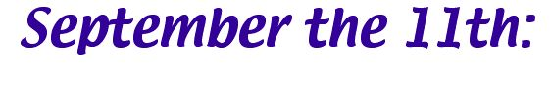

Exodus
Exodus 7:10 (NIV)
In this famous verse, Aaron throws down his staff, which becomes a snake (Note: For a deep insight into this story, I recommend Exegesis On The Rod Of Aaron by Reb Yakov Leib HaKohain).
10. So Moses and Aaron went to Pharaoh and did just as the Lord commanded. Aaron threw his staff down in front of Pharaoh and his officials, and it became a snake.
Exodus 7:10 (o) = 1331 = 11 x 11 x 11
Note that it was Aaron, not Moses, who flung down his staff (which went on to swallow the staffs of the magicians). Why would this be? In Exodus 7:1, The Lord says this to Moses:
1. Then the Lord said to Moses, “See, I have made you like God to Pharaoh, and your brother Aaron will be your prophet”.
This explains why Aaron throws down the staff. He is Moses’ prophet and is throwing down the staff on Moses’ behalf. Seen in this light, the gematria of Moses and Aaron makes perfect sense.
Moses (o) = 71
God (s) = 71
Note that the chapter and verse numbers in Exodus 7:1 and 7:10 imply the number 71.
Aaron here represents Christ. The staff which became a serpent and swallowed the other serpents represented the power that destroyed the World Trade Centre. In Hebrew gematria the words for the Messiah (Ha Mashiah) and the Serpent (Ha Nachesh) have the same numerical value.
Exodus 27 and 38 (NIV)
The book of Exodus has two chapters devoted to a description of the Lord’s instructions for the preparation of, and the actual preparation of, the altar of burnt offering. These are chapters 27 and 38, which are the Bible’s 77th and 88th.
77 = 11 x 7
88 = 11 x 8
That is remarkable enough, but the numbers 77 and 88 are the ordinal values for the sacrificial lamb himself:
Christ (o) = 77
Immanuel (o) = 88
If the twin towers and Pentagon were the ‘sacrificial offering’, then the ‘altar’ was the USA.
The altar of burnt offering (o) = 261
The United States of America (o) = 261
Bill Downie
Last updated: 6/1/07

Deuteronomy
Deuteronomy 20:20 (NIV)
Buried in Deuteronomy 20 is an obscure verse giving instructions for the felling trees - those without fruit can be felled. This verse has clear parallels to Mark 11, where Jesus causes a fig tree to wither, the fig tree being out of season. The connection between these verses, forged through gematria, is that both are allusions to 9/11, the twin towers being the ‘fruitless trees’ that were felled.
20. However, you may cut down trees that you know are not fruit trees and use them to build siege works until the city at war with you falls.
Deuteronomy 20:20 (o) = 1474 = 11 x 134
Deuteronomy 20:20 is the 555th verse in Deuteronomy, thus the number 5 appears to be encoded here too. Recall that the numbers 5 and 11 are symbolised by the Pentagon and the twin towers. The internal gematria of the verse only adds to the evidence. Note that this encoding ends on the word ‘trees’ which I am saying represents the twin towers.
20. However, you may cut down trees that you know are not fruit trees and use them to build siege works until the city at war with you falls.
First six words Deut. 20:20 (o) = 363 = 11 x 11 x 3
Additionally, 363 is the gematria of the Hebrew words for ‘the Messiah’ (Ha Mashiah) and ‘the Serpent’ (Ha Nachesh).
Bill Downie
Last updated: 7/1/07

Judges
The numbers 5 and 11 lie at the heart of the New Bible Code, associated with the Pentagon (5) and the World Trade Centre (11), the attacks upon which marked the Second Coming of Jesus Christ. Here we see how the Bible has been constructed so that these numbers coincide with others, already identified with the Second Coming and the end times. This confluence of numbers stands as mute testament to the brilliance and intricacy of the Bible’s design and to the reality of the code itelf.
Judges 5 (NIV)
1. First of all Judges 5 is the Bible’s 216th chapter.
216 = 6 x 6 x 6
In the New Bible code, the number 5 symbolises the stigmata borne by Christ, also symbolised by the Pentagon.
2. Judges 5:11 is the 125th verse in Judges.
125 = 5 x 5 x 5
The Pentagon (o) = 125
3. Verse 15 has a gematria value that is an interesting multiple of 11.
15. The princes of Issachar were with Deborah; yes, Issachar was with Barak, rushing after him into the valley. In the districts of Reuben there was much searching of heart.
Judges 5:15 (o) = 1551 = 11 x 141

Jesus (s) = 515
Again and again we see Jesus Christ and 11 coinciding. Remember, the reduced value of ‘Jesus’ is 11.
Judges 11 (NIV)
1. Judges 11 is the bible’s 222nd chapter. In the New Bible code, 11 and 222 are key numbers for the Second Coming.
Second Coming (o) = 121 = 11 x 11

The Lord’s Second Coming (o) = 222
Second (s) = 222
The number 222 also has a role to play within the Creation Snowflake.
Judges 11 is the story of Jephthah the Gileadite, who was driven from his half-brothers’ house, because he was the son of another woman, but who was later asked to lead the Gileadites in battle. Despite his earlier rejection he did so, and was successful in battle. Replace Jephthah the Gileadite with Jesus the Messiah and you have the story of his first and second comings.
Judges 20 (NIV)
This chapter contains one of the best suite of encodings I have encountered, which is a miracle of subtlety, repaying careful study. The plaintext story is of battles between the Israelites and the Benjamites after the murder of a Levite’s concubine. This theme of enmity and war has apparently been appropriated to serve as a metaphor for the end times.
1. First of all I would like to look at the positioning of this chapter.
a) Judges 20 is the Bible’s 231st chapter.
231 = 11 x 21
2. Judges 20:10 is the 555th verse in the book.
Let’s listen to what this verse has to say.
10. We’ll take ten men out of every hundred from all the tribes of Israel, and a hundred from a thousand, and a thousand from ten thousand, to get provisions for the army. Then, when the army arrives at Gibeah in Benjamin, it can give them what they deserve for all this vileness done in Israel.”
10 + 100 + 100 + 1000 + 1000 + 10000 = 12210 = 11 x 1110
These numbers are in three pairs, which subtract to give 90, 900 and 9000 and sum to give 110, 1100 and 11000
3. This chapter is strewn with numbers. The numbers given up to verse 10 are shown below.
1. ...came out as one man and assembled before the Lord in Mizpah.
2. ... four hundred thousand soldiers armed with swords.
6. ... and sent one piece to each region of Israel’s inheritance.
8. ... All the people rose as one man, ...
10. We’ll take ten men out of every hundred from all the tribes of Israel, and a hundred from a thousand, and a thousand from ten thousand, to get provisions for the army. Then, when the army arrives at Gibeah in Benjamin, it can give them what they deserve for all this vileness done in Israel.”
Sum of numbers up to verse 10 = 412214 = 11 x 37474
Again we arrive at a multiple of 11.
4. The 48th and final verse in Judges 20 is given below:
48. The men of Israel went back to Benjamin and put all the towns to the sword, including the animals and everything else they found. All the towns they came across they set on fire.
a) First I will take the gematria of the entire verse.
Judges 20:48 (o) = 1683 = 11 x 153
b) Next I will show the individual gematria values of each sentence and clause:
48. The men of Israel went back to Benjamin and put all the towns to the sword, including the animals and everything else they found. All the towns they came across they set on fire.
1st sentence Judges 20:48 (o) = 1210 = 11 x 11 x 10
48. The men of Israel went back to Benjamin and put all the towns to the sword, including the animals and everything else they found. All the towns they came across they set on fire.
1st clause Judges 20:48 (o) = 704 = 11 x 64
48. The men of Israel went back to Benjamin and put all the towns to the sword, including the animals and everything else they found. All the towns they came across they set on fire.
2nd clause Judges 20:48 (o) = 506 = 11 x 46
48. The men of Israel went back to Benjamin and put all the towns to the sword, including the animals and everything else they found. All the towns they came across they set on fire.
2nd sentence Judges 20:48 (o) = 473 = 11 x 43
c) The chapter and verse numbers imply 2048.
2048 = 8 x 8 x 8 x 4
d) Finally, and magnificently, counting from the start of the Bible, there are 7104 verses to Judges 20:48.
7104 = 888 x 8
The Lord’s Second Coming (s) = 888
Bill Downie
Last updated: 7/1/07

Solomon’s Gold
The number 666 is found in four different places in the bible: most famously in Revelation 13, where it is given as the identification mark of the beast. Another location is in Ezra 2, where it is given as the number of the Adonikam returning from Babylon. In the NIV, both locations contain extraordinary encodings of numbers related to 9/11.
This leaves two further quotations of the number, in parallel passages in 1 Kings 10 and 2 Chronicles 9, which boast of the riches of King Solomon. I felt certain that there would be a 9/11-related encoding at these locations, but at first I could find no gold there. Then I noticed that in each chapter the number 666 is preceeded, a few verses beforehand by another number, 120. In fact, 120 and 666 are the first two numbers to appear in these chapters, both being associated with gold. That was when I, too, struck ore.
1 Kings 10:10 and 10:14 (NIV)
10. And she gave the king 120 talents of gold, large quantities of spices, and precious stones. Never again were so many spices brought in as those the queen of Sheba gave to King Solomon.
14. The weight of the gold that Solomon received yearly was 666 talents,
120 + 666 = 786
the devil (c) = 786
The chapter and verse numbers imply 1010 and 1014.
1010 + 1014 = 2024 = 11 x 184
Later, in 2 Chronicles, this story is repeated.
2 Chronicles 9:9 and 9:13 (NIV)
9. Then she gave the king 120 talents of gold, large quantities of spices, and precious stones. There had never been such spices as those the queen of Sheba gave to King Solomon.
13. The weight of the gold that Solomon received yearly was 666 talents,
120 + 666 = 786
the devil (c) = 786
The chapter and verse numbers imply 99 and 913.
99 + 913 = 1012 = 11 x 92
Summing the chapter and verse numbers we of course obtain another multple of 11.
2024 + 1012 = 3036 = 11 x 276
276 is the 23rd triangular number and the number of souls saved during a shipwreck, as told in Acts 27. According to Bullinger it is also the number most associated with satan.
Note that while the quoted numbers sum to give a very significant gematria value, the chapter and verses in which they are found, in each case, yield numbers that sum to give a multiple of 11 (at odds of 121-to-1 against). So we find the number 666, gold (money) and the devil linked in an encoding that also bears the stamp of 9/11, through its numerical emblem, 11.
Bill Downie
Last updated: 7/1/07

Ezra & Nehemiah
The books of Ezra and Nehemiah contain some of the most dazzling encodings I have yet discovered, second only to Genesis in importance. Note that some of these encodings are revealed by comparing listed numbers in Ezra with parallel lists in the book of Nehemiah.
Ezra 2:3-17 (NIV)
In chapter two the returning exiles from Babylon are numbered by tribe. The first group of eighteen names and their tallies are listed below.
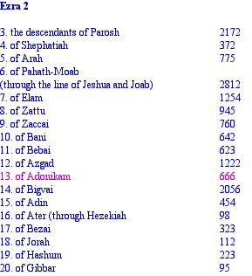
I have highlighted verse 13 in pink because this verse is the centre of an incredible set of encodings.
1. 666 is the 11th number on the list.
2. The sum of the numbers to 666 is 12243
12243 = 11 x 1113
12243 = 7 x 1749
The Holy Spirit (c) = 1749
3. Subtracting the numbers given in a parallel list in Nehemiah from the Ezra tallies shows the 666 ringed by the number 11.
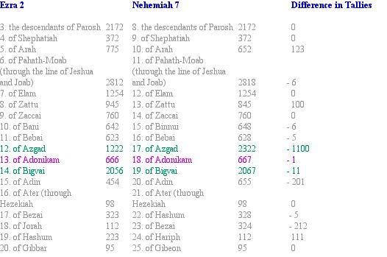
The difference between the combined numbers of Azgad and Bigvai in each book is therefore 1111, or 11 x 101. Even more remarkably, these numbers sum to 7667, or 11 x 697. Here in these Ezra encodings we see 666 firmly linked to the number 11 (see note 1).
4. September the 11th, 2001 is universally known as 9/11. If we now highlight verses 9 and 11 in the Ezra version of the list, we find two numbers which are the standard values of English phrases related to the Second Coming.
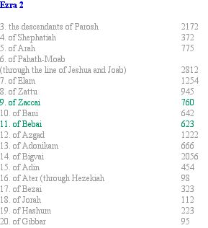

The Lord is Risen (s) = 760
Our Father (s) = 760
Two (s) = 760
The Christ (s) = 623
5. Summing the two numbers given in verses 9 and 11, we obtain a total of 1383
760 + 623 = 1383
The Second Coming of our Messiah (s) = 1383
6. If we continue the pattern by skipping a number, we come to 666.
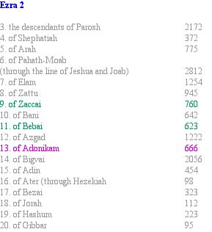

760 + 623 + 666 = 2049
The Second Coming of Jesus Christ (c) = 2049
7. If we continue this pattern for another two numbers, we have a sequence of five numbers, with 666 at the centre. This is shown below.
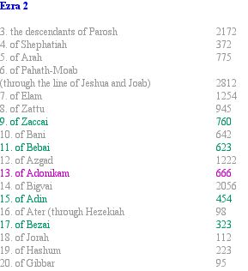

760 + 623 + 666 + 454 + 323 = 2826
The Second Coming of Our Lord Jesus Christ (s) = 2826
8. The meaning these numbers convey is reinforced by the gematria of the words themselves. Note that in the second calculation I am summing the values of the digits in the numbers, as if they were letters, a method I have previously found to be valid.
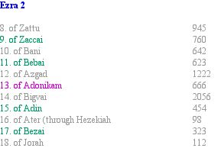
of Zaccai + of Bebai + of Adonikam + of Adin + of Bezai (o) = 306
Second (c) = 306

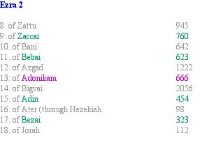
Zaccai + 7 + 6 + Bebai 6 + 2 + 3 + Adonikam 6 + 6 + 6 + Adin 4 + 5 + 4 + Bezai 3 + 2 + 3 (o) = 264
Coming (c) = 264
So these names and their tallies encode the combined values of the words Second and Coming! Note that the last verse is Ezra 2:17 and that I have already shown how the number 217 plays a starring role in the visual metaphor for the Second Coming I constructed from the gematria of the events of 9/11.
9. If we now sum the tallies from both lists, checking the running total at each name for divisibility by 11, we find, to our astonishment, that the only names at which multiples of 11 are found are (with the exception of the central name, Adonikam) the very names highlighted above!
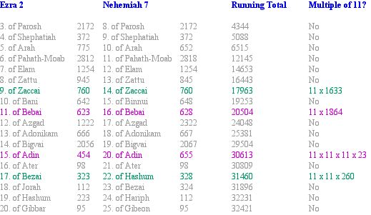
Notice how the same names on the list are again involved! This is something which is fantastically unlikely to have happened by chance and is stunning confirmation of the reality of these encodings. The name ‘Adonikam’ is not associated with a multiple of 11 this time, but its importance is clearly signalled by its central position.
10. There is a list of numbers in chapter 1. By summing these numbers, continuing on to the list in chapter 2, then stopping at 666, we obtain a total that sums up the message of the New Bible Code.
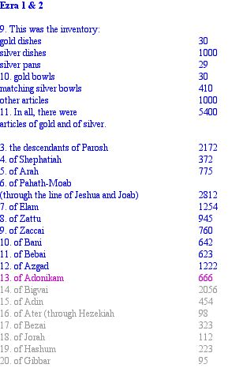
The sum of the numbers to 666 is 20142.
20142 = 1119 x 18
Jesus Christ (c) = 1119
Note that 18 is 6 + 6 + 6 and that the verse numbers in Ezra and Nehemiah where the Adonikam are numbered as 666 and 667 are the chapter and verse numbers in Revelation giving the number 666: 13:18. Chapter numbers were added to the Bible in the 13th century and verse numbers included in the 16th century, millenia after the texts had been written.
Ezra 2:3-17, Nehemiah 7:8-23 (NIV)
The name ‘Bezai’ appears on both lists, in Ezra 2:17, where it is the last verse in the string of five encoded verses I decode above, and Nehemiah 7:23. (see note 2).
17 x 23 = 391

Yehoshua (Jesus - HG) = 391
Second Coming (s) = 391
Bezai = 43
Jesus Christ (r) = 43
The lists to ‘Bezai’ are shown below.
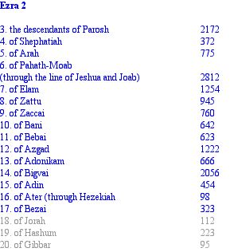

Sum of numbers to ‘Bezai’ = 15174
Jesus Christ = 151
Jesus = 74

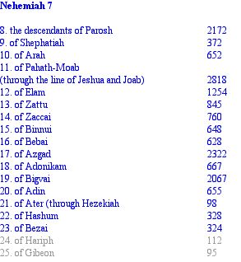

Sum of numbers to ‘Bezai’ = 16610 = 11 x 1510
Jesus Christ = 151
Jesus (r) = 11
Ezra 2:17-20, Nehemiah 7:22-25 (NIV)
A little further down the list there is another discrepancy between Ezra and Nehemiah. The Hashum are listed 17th in Ezra but 15th in Nehemiah. The appropriate section of each list is shown below, along with the difference in the tallies.
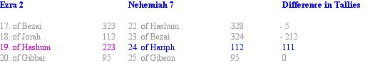
The Nehemiah list can be rearranged to agree with Ezra's ordering, giving the following difference in tallies.
The difference between these two numbers is very significant:
111 - (-105) = 216 = 6 x 6 x 6
216 is the cube of 6 and an alternative way of expressing the same concept as the repeated digits 666. Moreover, the number 105 is the 14th triangular number and it is itself the outline of triangle 666, the 36th triangular number.
Ezra 2:69, Nehemiah 7:70-72 (NIV)
These passages list contributions to the rebuilding of God's house by the heads of families in Jerusalem.
Ezra 2:69
According to their ability they gave to the treasury for this work 61000 drachmas of gold, 5000 minas of silver and 100 priestly garments.
Nehemiah 7:70-72
Some of the heads of families contributed to the work. The governor gave to the treasury 1000 drachmas of gold, 50 bowls and 530 garments for priests. Some of the heads of families gave to the treasury for the work 20000 drachmas of gold and 2200 minas of silver. The total given by the rest of the people was 20000 drachmas of gold, 2000 minas of silver and 67 garments for priests.
Sum contributions listed in Ezra = 66100
Sum contributions listed in Nehemiah = 45847
66100 + 45847 = 111947 = 11 x 10177
Ezra 4:8 - 6:18 (NIV)
This is one of two sections of the Old Testament written in Aramaic (the other is in Daniel). It concerns opposition to the rebuilding of the temple in Jerusalem by Tattenai, the governor of Trans-Euphrates, and Shethar-Bozenai and their associates, who are mentioned four times. After the recovery of a decree by King Darius, authorising the rebuilding, Tattenai and his officials thereafter cooperated. The central figure here is Tattenai, the governor of Trans-Euphrates.
The Aramaic section begins at Ezra 4:8 and ends at Ezra 6:18. Adding the two numbers implied by the first and last verses we obtain:
48 + 618 = 666
Tattenai (s) = 666
Tattenai is mentioned in four verses. 5:3, 5:6, 6:6 and 6:13. Adding the numbers implied by the first and last verses in which Tattenai is given, we obtain:
53 + 613 = 666
These encodied 666s point to an eschatological meaning for the story of Tattenai and, through the 666-centred encodings found in Ezra 2, with 9/11.

Tattenai
This takes us to an important discovery made by Eighth Day Assembly - see links on the homepage. In Strong’s Hebrew Concordance, Tattenai is the last entry, number 8674. The three numbers preceeding this are 8671, 8672 and 8673. The Hebrew words under these entries mean
8671: ninth
8672: nine
8673: ninety
Related to this we have
Tattenai (o) = 90

Tattenai (s) = 666
In biblical numerics nine means finality, completion and judgment. The position of Tattenai at the very end of Strong’s Concordance, and in association with so many nines, can only mean one thing. We have now arrived at the ‘end of time’ (see note 3).
Tattenai’s initial opposition to the rebuilding of the Jerusalem temple, overturned by the recovered decree from King Darius, may have a modern analogy. The twin towers and what they stood for, were a stumbling block to the reinstitution of God’s kingdom on earth. If the twin towers represented Tattenai and his cohorts, their ‘overturning’ may symbolically mean that God’s temple can now be rebuilt.
Nehemiah 4:3
Nehemiah’s version of the story of the opposition to the rebuilding of the temple mentions a fox, in chapter 4, verse 3, in a comment by Tobiah the Ammonite, assistant of Sanballat.
3.Tobiah the Ammonite, who was at his side, said, “What they are building—if even a fox climbed up on it, he would break down their wall of stones.”
This features another hidden 666.
Fox (s) = 666
Moreover, the fox is an old pseudonym for the devil.
This is, in fact, the third biblical mention of a fox, the first two being found in the Book of Judges.
Judges 15:4-5
4. So he went out and caught three hundred foxes and tied them tail-to-tail in pairs. He then fastened a torch to every pair of tails, 5.lit the torches and let the foxes loose in the standing corn of the Philistines. He burned up the shocks and standing corn,. together with the vineyards and olive groves.
If we read the chapter and verse numbers as single numbers—giving 154, 155 and 43—then sum them, we obtain another number related to the devil.
154 + 155 + 43 = 352
satan (s) = 352
Finally, Nehemiah 4 is the Bible’s 417th chapter.
satan (c) = 417
Like Tattenai, Sanballat was opposed to the rebuilding, which was completed in any case. The association of the devil with the opposition to the rebuilding is hugely significant here, for the New Bible Code identifies the World Trade Centre and the Pentagon as manifestations of satan’s power.
Ezra 8:3-14 (NIV)
This is part of a list of the family heads returning from Babylon with Ezra, which begins in verse 2. The numbers of their men begin in the second part of verse 3, and I am counting from here to the end of the list.
3.150 men;
4. 200 men;
5. 300 men;
6. 50 men;
7. 70 men;
8. 80 men;
9. 218 men;
10. 160 men
11. 28 men;
12. 110 men;
13. 60 men;
14. 70 men.
Number of men associated with family heads = 1496 = 11 x 136
Ezra 9:11 (NIV) Ist 18 words
11. you gave through your servants the prophets when you said ‘The land you are entering to possess is a land polluted by the corruption of its peoples. By their detestable practices they have filled it with their impurity from one end to the other.
Gematria of 1st 18 words = 1100
The number 18, being 6 + 6 + 6, is associated with 666 in the New Bible Code. This is especially evident in Revelation 13:18 and in the placing of the Adonikam in Nehemiah. Here we see 11 and 18 encoded together once more.
Nehemiah 9:11 (NIV)
In chapter 9 of Nehemiah, the Israelites are confessing their sins to God and praising Him. Verse 11, numerically identified with 9/11, is given below.
11. You divided the sea before them, so that they passed through it on dry ground, but you hurled their pursuers into the depths, like a stone into mighty waters.
Gematria Nehemiah 9:11 = 1628 = 11 x 148
Notice that the verse speaks of division, one of the attributes of the number 11. The verse has four clauses which are themselves bisected into opposing pairs. The first two clauses speak of God parting the Red Sea for the Israelites.
11. You divided the sea before them, so that they passed through it on dry ground, but you hurled their pursuers into the depths, like a stone into mighty waters.
Gematria clauses 1 and 2, Nehemiah 9:11 = 759 = 11 x 69
The second pair of clauses refer to the destruction of their pursuers.
11. You divided the sea before them, so that they passed through it on dry ground, but you hurled their pursuers into the depths, like a stone into mighty waters.
Gematria clauses 1 and 2, Nehemiah 9:11 = 869 = 11 x 79
Bill Downie
Last updated: 3/3/06
Introduction
Psalms
Home

Notes
1. The sum all the numbers of the men of Israel returning from Babylon, as recorded in both books, is 60907, or 11 x 5537.
2. Note that in John 21:11 and Acts 27:37, the numbers 153 and 276 are given in the context of the catching of fish and the saving of souls from a shipwreck, both metaphors for salvation. These are the 17th and 23rd triangular numbers.
3. Interestingly, the Hebrew word for Tattenai, whose English transliteration is TTNY, has the same initials as Twin Towers, New York.

Psalms
Psalm 119 (NIV)
Psalm 119 is significant for being the Bible's longest chapter, divided into stanzas numbered after each character in the Hebrew alphabet (Hebrew characters double as numbers, the basis of Hebrew gematria). This psalm is two chapters after Psalm 117, the Bible's central and shortest chapter. These extremes of length mark both psalms out for attention.
1. The number 119 is a simple reversal of the digits 911, which suggests a link to 9/11. This is supported by a simple analysis of its structure.
Number of verses in Psalm 119 = 176 = 11 x 16
Number of stanzas in Psalm 119 = 22 = 11 x 2
2. Psalm 119 is the Bible's 597th chapter.
Immanuel (c) = 597
Again a number associated with Jesus Christ is woven into this fabulous tapestry.
Bill Downie
Last updated: 4/3/06

Jeremiah
Jeremiah 9:11 (NIV)
Jeremiah 8 and 9 concern the subject of sin and punishment. In Chapter 9, verse 11 Jeremiah threatens the destruction of Jerusalem and other towns, which could be seen as a prophecy of the real events of 9/11.
11. “I will make Jerusalem a heap of ruins, a haunt of jackals; and I will lay waste the towns of Judah so that no-one can live there.”
Jeremiah 9:11 (o) ...= 1122 = 11 x 102
The internal structure of the verse contains two gematria numbers for Jesus Christ.
11. “I will make Jerusalem a heap of ruins, a haunt of jackals; and I will lay waste the towns of Judah so that no-one can live there.”
1st 12 words Jeremiah 9:11 (o) = 475

Immanuel (s) ............................= 475
The second encoding spans the first 22 (11 x 2) words of the verse.
11. “I will make Jerusalem a heap of ruins, a haunt of jackals; and I will lay waste the towns of Judah so that no-one can live there.”
1st 22 words Jeremiah 9:11 (o) .....= 888

Finally, Jeremiah 9 is the Bible’s 754th chapter and 754 is the gematria of Jesus Christ in Hebrew!
So we have the gematria of names by which we know Jesus Christ encoded three times, along with the two numbers that most symbolise 9/11 - in a short verse that predicts the destruction of Jerusalem. I think that Jerusalem represents New York here, and that this is another prophecy of the Second Coming.
Jeremiah 51:48 (NIV)
In the midst of a message from God about Babylon, delivered through the prophet, we find a confluence of elevens, highlighting a verse prophesising an attack on Babylon from the north.
48. “Then heaven and earth and all that is in them will shout for joy over babylon, for out of the north destroyers will attack her,” declares the Lord.
Jeremiah 51:48 (o)...............= 1386 = 11 x 126
5148.........................= 11 x 468
Bill Downie
Last updated: 23/10/07

Daniel
Daniel 8:1 - 7 (NIV)
This section contains some of the most important encodings in the entire NIV Bible, within a staggeringly accurate prophecy of 911. Recorded here is Daniel's vision of a ram being attacked by a goat. Later on Daniel is told by Gabriel that the vision concerns 'the time of the end'.
3. I looked up and there before me was a ram with two horns, standing beside the canal, and the horns were long. One of the horns was longer than the other but grew up later. 4. I watched the ram as he charged towards the west and the north and the south. he did as he pleased and became great.
5. As I was thinking about this, suddenly a goat with a prominent horn between his eyes came from the west, crossing the whole earth without touching the ground. 6. He came towards the two-horned ram I had seen standing beside the canal and charged at him in great rage. 7. I saw him attack the ram furiously, striking the ram and shattering his two horns. The ram was powerless to stand against him; the goat knocked him to the ground and trampled on him, and none could rescue the ram from his power.
This scene has obvious parallels with 911, and this is powerfully reinforced by some astounding underlying gematria.
1. Verses 3 and 4 introduce the ram, who has two long horns, stands next to a body of water, became great and did as he pleased—characteristics shared by the World Trade Centre.
3. I looked up and there before me was a ram with two horns, standing beside the canal, and the horns were long. One of the horns was longer than the other but grew up later. 4. I watched the ram as he charged towards the west and the north and the south. he did as he pleased and became great.
Gematria verses 3 and 4 = 3102 = 11 x 282
So the verse appears to be watermarked with the key number 11.
2. Verses 5, 6 and 7 are a devastatingly accurate account of the attacks themselves.
5. As I was thinking about this, suddenly a goat with a prominent horn between his eyes came from the west, crossing the whole earth without touching the ground. 6. He came towards the two-horned ram I had seen standing beside the canal and charged at him in great rage. 7. I saw him attack the ram furiously, striking the ram and shattering his two horns. The ram was powerless to stand against him; the goat knocked him to the ground and trampled on him, and none could rescue the ram from his power.
Gematria verses 5, 6 and 7 = 4555 = 911 x 5
And the gematria is equally devastating!
Here we have three verses giving a staggeringly accurate description of the 9/11 attacks—the goat with a single horn, which flies over the whole earth without touching the ground, is a perfect description, in a preindustrial age, of an airplane—and their gematria ‘just happens’ to be a multiple of 911.
3. Finally, Daniel 8 is the Bible’s 858th chapter.
858 = 11 x 78
Therefore the numbers whisper that Daniel's vision was of the attacks of September the 11th, 2001, an event 2500 years after that great prophet's time.
Daniel 9:11 (NIV)
This verse, the numbering of which implies 9-11, is from a prayer by Daniel petitioning God to look with favour upon Israel, even though it had turned its back on Him. Verse 11 is the first to speak of the disaster God has brought upon them.
11. All Israel has transgressed your law and turned away, refusing to obey you. "Therefore the curses and sworn judgements written in the Law of Moses, the servant of God, have been poured out on us, because we have sinned against you."
First 11 words (o) = 666
First 18 (6 + 6 + 6) words (o) = 1100
There is a clear link here between 11 and 666 in a verse that is numerically identical to 9/11. Daniel's words also describe the modern world, which has turned its back on God once more.
Daniel 11:9 (NIV)
This verse, the numbering of which also implies 911, tells of an invasion and retreat by the king of the North against the king of the South, an incident with clear parallels to the events of 911.
9. Then the king of the North will invade the realm of the king of the South, but will retreat to his own country.
Daniel 11:9 (o) = 1100
Daniel 12:1 (NIV)
Daniel 12 is a prophecy of the end times and thus is one of the most carefully studied chapters in the bible. Like much of Daniel, this chapter speaks to us in a in a kind of symbolic language, which conveys its message in colourful but obscure metaphor. However, with the New Bible Code, a clear and unambigiuous interpretation at last becomes possible. Recall that 11 is the key number for the Second Coming.
1. At that time Michael, the great prince who protects your people, will arise. There will be a time of distress such as has not happened from the beginning of nations until then. But at that time your people—everyone whose name is found written in the book—will be delivered.
Daniel 12:1 (o) = 2618 = 11 x 238
First 11 words Daniel 12:1 (o) = 627 = 11 x 57
The chapter and verse numbers imply the number 121.
Second Coming = 121 = 11 x 11
Daniel 12:10 (NIV)
Daniel 12:10 also implies the number 121.
10. Many will be purified, made spotless and refined, but the wicked will continue to be wicked. None of the wicked will understand, but those who are wise will understand.
Daniel 12:10 (o) = 1562 = 11 x 142
Daniel 12:11-12 (NIV), Daniel 8:14 and Revelation 12:11-12
The last three verses of Daniel are perhaps the most mysterious of all, offering us two numbers, 1290 and 1335, with which to determine the number of days between two prophesised end-time events: the abolition of the daily sacrifice and the ‘abomination that causes desolation’. These are suspiciously similar to Revelation’s twice-mentioned 1260 days. We find a further connection when we note that the verses in which Daniel’s numbers are written are the same as the chapter numbers where Revelation’s numbers are given: 11 and 12.
The numbers are tabulated below, along with the chapter and verse numbers in which they are found.
Book | Chapter & Verse | Time Period in days
Daniel | 12:11 | 1290
Daniel | 12:12 | 1335
Revelation | 11:3 | 1260
Revelation | 12:6 | 1260

1. Adding the two numbers in Daniel 12 with both numbers in Revelation, we obtain:
1290 + 1335 + 1260 + 1260 = 5145 = 343 x 15
THIS IS JESUS, THE KING OF THE JEWS (Matt. 27:37) = 343
Relating to 9/11, we have:
The World Trade Centre + The Pentagon = 218 + 125 = 343
Note: there is more to this sum than meets the eye. Imagine constructing a large cube from 343 spheres. The outer surface of this cube will require 218 spheres, which, if stripped away, will leave a smaller cube of 125 spheres.
2. Reading each chapter and verse numbers as a single number then summing them (including the adjusted number in Daniel), we obtain:
1211 + 1212 + 113 + 126 = 2662 = 11 x 11 x 11 x 2
So we have a triple multiple of 11, encoded along with these end-time numbers! This is further evidence that 9/11 really was the event towards which all end-time prophecy was directed.
Bill Downie
16/1/05
Last updated: 14/6/06

Amos
Amos 9 (NIV)
Amos 9 begins with these prophetic words:
1. I saw the Lord standing by the altar, and he said: “Strike the tops of the pillars so that the thresholds shake. Bring them down on the heads of all the people; those who are left I will kill with the sword. Not one will get away, none will escape.”
The prophecy is of the attacks on the twin towers (the pillars, whose tops were struck) on 9/11.
This chapter is marked with a kind of cross, whose beams are the names of Jesus in Greek and Hebrew, and also of the Second Coming in English.
1. The Crossbar.
Amos 9 is the bible’s 888th chapter. The number 888 is the standard value in Greek of the word ‘Jesus’:
The Lord’s Second Coming (s) = 888
2. The Stake.
The book of Amos is just after Joel, with 3 chapters and Obadiah, with 1 chapter. The chapters in these three books, read consecutively, give us the digit sequence 391.
Second Coming (s) = 391
The crossing of the two numbers is illustrated below. Column 2 shows the number of chapters in each book. Column 3 shows the number of chapters counting from the beginning of the Bible to the end of each book, in other words the place value of the final chapters.
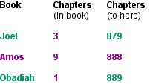
This confluence of important numbers implies the three ideas that perfectly sum up the entire new Bible Code: Jesus, 9/11 and the Second Coming, with the crucifixion subtly implied.
Bill Downie
Last updated: 14/6/06

Matthew
Matthew 5:21 (NIV)
This verse states the admonition against murder. The gematria reflects this theme, as does the chapter and verse numbers, which imply 521. Note that, as with many of the most significant encodings, the numbers are encoded as ordinal values, but take on meaning under the standard value system.
21. “You have heard that it was said to the people long ago, ‘Do not murder, and anyone who murders will be subject to judgment.’
Matthew 5:21 (o) = 1151
Beelzebub (s) = 1151
Beast (s) = 521
Matthew 7:19 (NIV)
Here, Jesus is telling us that trees that do not bear good fruit are cut down. This verse bears the same message as Mark 11:20 and Deuteronomy 20:20.
19. Every tree that does not bear good fruit is cut down and thrown into the fire.
Matthew 7:19 (o) = 779
Appearing of Christ (s) = 779
Matthew 7:19 is the New Testament’s 191st verse. Look at the three numbers here: 719, 779 and 191. Do they not resemble 911? I think that the ‘trees without good fruit’ are the twin towers.
Matthew 24:2 (NIV)
This chapter is the first in the New Testament to concern itself with ‘the end of the age’. In one of the Bible’s clearest references to 911, Jesus tells his disciples that, at this time, the temple will be destroyed.
2. “Do you see all these things?” he asked. “I tell you the truth, not one stone will be left standing on another; every one will be thrown down.”
Matthew 24:2 (o) = 1294
Appearing of Jesus Christ (s) = 1294
2. “Do you see all these things?” he asked. “I tell you the truth, not one stone will be left standing on another; every one will be thrown down.”
1st 11 words Matthew 24:2 (o) = 440 = 11 x 40
September the eleventh, two thousand and one (o) = 440
2. “Do you see all these things?” he asked. “I tell you the truth, not one stone will be left standing on another; every one will be thrown down.”
1st 22 words Matthew 24:2 (o) = 968 = 11 x 11 x 8
The chapter and verse numbers, 24 and 2, taken together read 242.
242 = 11 x 11 x 2
Bill Downie
Last updated: 15/6/06
Mark
Mark 11
In Mark 11 we encounter the strange and unsettling account of Jesus causing a fig tree to wither. This is the same chapter as his triumphal entry into Jerusalem. Why would the son of God do something so impetuous, especially at this time? The episode is especially puzzling when we read that it was not even the season for figs. However, when the story is seen in the light of the New Bible Code, some understanding is gained.
Mark 11:20 (NIV)
This verse recounts how the disciples came upon the withered fig tree.
20. In the morning, as they went along, they saw the fig-tree withered from the roots.
Gematria Mark 11:20 = 803 = 11 x 73
Jesus (r) = 11
The Second Coming (r) = 73
The withered tree is named as a fig, which is the verse’s 11th word.
Fig = 22 = 11 x 2
Mark 11 is the Bible’s 968th verse. This is a double multiple of 11.
968 = 121 x 8
Second Coming = 121 = 11 x 11
The second factor, 8, is the number assigned to Jesus. Finally, the chapter and verse numbers imply 1120, which is an anagram of 121.
So the story of Jesus causing the fig tree to wither is revealed as a prophecy of 9/11.
A blazing light now illuminates this chapter, by which we clearly see that Jesus’ triumphal entry into Jerusalem on a colt and His actions in the Temple—overturning the tables of the moneychangers and the benches of the dove sellers—are all prophecies of 9/11. This, incidentally, was the only time that Jesus used violence during His ministry, another prophecy of the destruction of 9/11.
Bill Downie
Last updated: 21/1/07
Luke
Luke 21:11
In this verse, the 11th in the chapter, Jesus reveals to his disciples some of the signs of ‘the end of the age.’
11. There will be great earthquakes, famines and pestilences in various places, and fearful events and great signs from heaven.
Luke 21:11 (o) = 1111 = 11 x 101
The first 11 words also have an ordinal value that is a multiple of 11.
11. There will be great earthquakes, famines and pestilences in various places, and fearful events and great signs from heaven.
Ist 11 words Luke 21:11 (o) = 693 = 11 x 63
Luke 21:27
In this verse Jesus tells his disciples that he will return in power and glory, a prophecy of the Second Coming. The verse is shot through with the number 11, indicating that this event and 9/11 may be one and the same.
27. At that time they will see the Son of Man coming in a cloud with power and great glory.
Luke 21:27 (o) = 814 = 11 x 74
Jesus (r) = 11
Jesus (o) = 74
The gematria of the first 11 words is also a multiple of 11.
27. At that time they will see the Son of Man coming in a cloud with power and great glory.
1st 11 words Luke 21:27 (o) = 451 = 11 x 41
Luke 23:32
Crucified alongside Jesus were two criminals, one on either side of him. The occurence of the idea of ‘twoness’ anywhere in the Bible immediately leads me to look for an encoding of numbers relating to 9/11. When I analysed Luke’s account this is exactly what I found.
32. Two other men, both criminals, were also led out with him to be executed.
Luke 23:32 (o) = 693 = 11 x 63
Eleven (o) = 63
The chapter and verse numbers, read as a single number, give 2332:
2332 = 11 x 212
What this encoding appears to be suggesting is that the story of the crucifixion of Jesus is a also a kind of prophecy of 9/11, or that 9/11 was a re-enaction of the crucifixion. The two criminals were represented by the twin towers. Jesus, ‘pierced with a spear’, was represented by the Pentagon, also ‘pierced’ on 9/11. See the 9/11 page for further symbolism.
Luke 23:33
The next verse continues the story of the crucifixion.
33. When they came to the place called the Skull, there they crucified him, along with the criminals, one on his right, the other on his left.
Luke 23:33 (o) = 1210 = 11 x 11 x 10

Second Coming (o) = 121
What these verses are again indicating is that the two criminals represent the twin towers.
Bill Downie
Last updated: 15/6/06
John
John 9:11 (NIV)
This chapter tells the story of Jesus healing a blind man by rubbing mud in his eyes, then sending him to the pool of Siloam to wash. In verse 11 (implying 9/11) the man describes to his fellows how he was healed.
11. He replied "The man they call Jesus made some mud and put it on my eyes. He told me to go to Siloam and wash. So I went and washed, and then I could see".
John 9:11 (o) = 1298 = 11 x 118
John 9 is the New Testament's 77th chapter, 77 being 11 x 7 and the ordinal value of 'Christ'.
The rubbing of mud into the man's eyes is a metaphor for the destruction of the twin towers, an event that will open the eyes, not of one man, but of the entire world.
John 13:5 (NIV)
The story told in John 13 has some similarities with that of John 9, only this time Jesus is washing his disciples' feet.
5. After that, he poured water into a basin and began to wash his disciples' feet, drying them with the towel that was wrapped round him.
John 13:5 (o) = 1232 = 11 x 112
Yet again there is independant confirmation that this is a real encoding through the placing of the story.
Finally, John 13 is the bible's 1010th chapter!
John 15:1 (NIV)
In this well-known verse Jesus proclaims that he is the true vine. The numerical features of this verse and its position within the Bible combine to produce a remarkable confluence of numbers.
1. I am the true vine, and my Father is the gardener.
John 15:1 (o) = 418 = 11 x 38
1. The chapter and verse numbers imply 151.
Jesus Christ (o) = 151
2. John is the Bible's 43rd book.
Jesus Christ (r) = 43
3. John 15 is the Bible's 1012th chapter. 1012 is an anagram of 121, the gematria of "Second Coming"
1012 = 11 x 92
Note: There are only two New Testament chapters which, when converted to their Old Testament place value, are a multiple of 11 and when converted to their New Testament place value, have digits which sum to 11 (none are multiples of 11). One is the above chapter, the other is the Bible's 1111th chapter and the New Testament's 182nd chapter, Colossians 4.
Bill Downie
Last updated: 15/6/06
Feeding The Five Thousand
All four gospels contain accounts of one of Jesus’ most spectacular miracles, the feeding of five thousand people with a few loaves and fishes. A second, less well-known fact is that, in two of these gospels - Matthew and Mark - Jesus feeds four thousand people in similar fashion. Why would two very similar accounts appear so closely together in two of the gospels? These stories, whether or not they are based on real events, have more to say to us than the simple recounting of a miracle.
However, the main point of interest for me is that these accounts are peppered with numbers. Moreover, the numbers vary between each account in a manner that suggests they themselves have a deeper message to convey. I struggled with these numbers on and off for two years, trying in vain to extract some esoteric significance. However, I was looking for subtleties that just weren’t there. Moreover, at first I didn’t realise that the events of 9/11 were encoded throughout the Bible. But once I knew what I was looking for, it only took me a few minutes to correctly decode the numbers.
Rather than give each gospel account in full, I simply reproduce the verses that contain numbers. After that I show how these numbers can be very simply combined to create totals with factors that point to the events of 9/11.
Matthew 14 (NIV)
Jesus Feeds the 5000
17. “We have only five loaves of bread and two fish”, they answered.”
19. ...Taking the five loaves and the two fish and looking up to heaven, he gave thanks and broke the loaves....
20. They all ate and were satisfied, and the disciples picked up twelve basketfuls of broken pieces that were left over.
21. The number of those who ate was about five thousand men, besides women and children.
Sum of numbers = 5 + 2 + 5 + 2 + 12 + 5000 = 5026
Matthew 15 (NIV)
Jesus Feeds the 4000
32. “...I have compassion for these people; they have already been with me three days and have nothing to eat....”
34.“How many loaves do you have?” Jesus asked. “Seven”, they replied, and a few small fish”.
36. Then he took the seven loaves and the fish,...
37. They all ate and were satisfied. Afterwards, the disciples picked up seven basketfuls of broken pieces that were left over.
38. The number of those who ate was four thousand, besides women and children.
Sum of numbers = 3 + 7 + 7 + 7 + 4000 = 4024
Mark 6 (NIV)
Jesus Feeds the 5000
37. ...They said to him.“That would take eight months of a man’s wages!”....
38. ...When they found out they said, “Five—and two fish.”
40. So they sat down in groups of hundreds and fifties.
41. Taking the five loaves and the two fish and looking up to heaven, he gave thanks and broke the loaves. Then he gave them to his disciples to set before the people. He also divided the two fish among them all.
43. and the disciples picked up twelve basketfuls of broken pieces of bread and fish.
44. The number of the men who had eaten was five thousand.
Sum of numbers = 8 + 5 + 2 + 100 + 50 + 5 + 2 + 2 + 12 + 5000 = 5186
Mark 8 (NIV)
Jesus Feeds the 4000
2. “I have compassion for these people; they have already been with me three days and have nothing to eat.”
5.“How many loaves do you have?” Jesus asked. “Seven”, they replied.”
6. ...When he had taken the seven loaves ad given thanks, he broke them and gave them to his disciples to set before the people, and they did so.
8. The people ate and were satisfied. Afterwards, the disciples picked up seven basketfuls of broken pieces that were left over.
9. About four thousand men were present...
Sum of numbers = 3 + 7 + 7 + 7 + 4000 = 4024
Later in this chapter there is a discussion between Jesus and his disciples about the two miracles, from which more numbers emerge.
19. “When I broke the five loaves for the five thousand, how many basketfuls of pieces did you pick up?” “Twelve,” they replied.
20. “And when I broke the seven loaves for the four thousand, how many basketfuls of pieces did you pick up?” They answered, “Seven.”
Sum of numbers = 5 + 5000 + 12 + 4000 + 7 = 9031
Luke 9 (NIV)
Jesus Feeds the 5000
12. Late in the afternoon the Twelve came to him and said...
13. ...They answered, “We only have five loaves of bread and the two fish—unless we go and buy food for this crowd.”
14. (About five thousand men were there). But he said to his disciples, “Make them sit down in groups of about fifty each.”
16. Taking the five loaves and the two fish and looking up to heaven, he gave thanks and broke them.
17. They all ate and were satisfied, and the disciples picked up twelve basketfuls of broken pieces that were left over.
Sum of numbers = 12 + 5 + 2 + 5000 + 50 + 5 + 2 + 12 = 5088
John 6 (NIV)
Jesus Feeds the 5000
7. Philip answered him, “Eight months wages would not buy enough bread for each one to have a bite!”
9. “Here is a boy with five small barley loaves and two small fish, but how far will they go among so many?”
10. ...There was plenty of grass in that place and the men sat down, about five thousand of them.
13. So they gathered them and filled twelve baskets with the pieces of the five barley loaves left over by those who had eaten.
Sum of numbers = 8 + 5 + 2 + 5000 + 12 + 5 = 5032
Summing the Totals
A summary of the totals for each book and chapter is given below:
Matthew 14: 5026
Matthew 15: 4024
Mark 6: 5186
Mark 8: 4024 and 9031
Luke 9: 5088
John 6: 5032
Summing these totals in ways suggested by the distribution of the accounts themselves (for instance, there are multiple accounts in Matthew and Mark, as distinct from the single accounts in Luke and John), we obtain numbers encoded for two thousand years yet speaking to us of a modern event. Notice how, time and again, the number 11, the archetypal symbol of 9/11, is a factor of these totals.
1. Grand Total: Matthew + Mark + Luke + John
5026 + 4024 + 5186 + 4024 + 9031 + 5088 + 5032 = 37411 = 11 x 3401
2. Matthew + Mark (first total only)
5026 + 4024 + 5186 + 4024 = 18260 = 11 x 1660
3. Matthew + Mark
5026 + 4024 + 5186 + 4024 + 9031 = 27291 = 11 x 2481
4. Luke + John
5088 + 5032 = 10120 = 11 x 920
5. Matthew + Mark + Luke + John
5026 + 4024 + 5186 + 4024 + 5088 + 5032 = 28380 = 11 x 2580
6. 5000 Only: Matthew + Mark + Luke + John
5026 + 5186 + 5088 + 5032 = 20332 = 391 x 52
Second Coming (s) = 391
7. Mark 8, both totals
4024 + 9031 = 13055 = 373 x 35
Summing the Chapter Numbers
The chapter numbers appear to have been deliberately chosen, because they provide totals that further link the story of the feeding of the multitudes with the Second Coming.
1. Total of Chapter numbers
14 + 15 + 6 + 8 + 9 + 6 = 58
Second Coming (r) = 58
2. Total Ordinal Value of Chapter numbers
Summing the biblical ordinal values of the above chapters we obtain confirmation of the encoding of the number 58.
Matthew 14 is the bible’s 943rd chapter.
Matthew 15 is the bible’s 944th chapter.
Mark 6 is the bible’s 963rd chapter.
Mark 8 is the bible’s 965th chapter.
Luke 9 is the bible’s 982nd chapter.
John 6 is the bible’s 1003rd chapter.
943 + 944 + 963 + 965 + 982 + 1003 = 5800
Second Coming (r) = 58
Summing the Chapter and Verse Numbers
The chapter and verse numbers can also be read as a single number. For instance, Matthew 14:17 can be read as the number 1417 (see note 1). The total sum of the numbers created this way is given below:
Total sum of chapter and verse numbers = 25197 = 227 x 111

September the eleventh (o) = 227
New York (o) = 111
This, along with the encoded elevens and numbers related to Jesus Christ, is supporting evidence for my contention that 9/11 was the signal event for the Second Coming.
Bill Downie
Last updated: 16/5/06
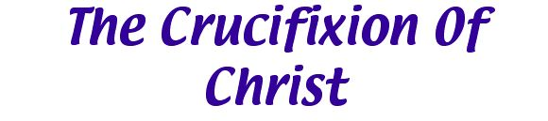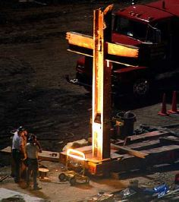

Introduction
In the previous web page, 9/11, I showed evidence I had gathered from the cluster of synchronicities surrounding the terrorist attacks on September the 11th, 2001 and from gematria, that this apocalyptic event announced the Second Coming of Jesus Christ. Here I show that 9/11 was the first act in a two-part drama, with an eschatologically-meaningful interlude of three-and-a-half years. These events, taken together, symbolise the Crucifixion and Resurrection of Jesus Christ. 9/11 represented the Crucifixion of Christ; the page following this one deals with the Resurrection of Christ.
The Crucifixion
Two days after 9/11, firemen dicovered a cross in the ruins of the north tower, the remains of two intersecting beams. The cross came to symbolise the grief of many people at that time and is now on display in New York as a memorial to those who perished in the towers. But could that cross have a larger and more universal meaning than the deaths of 3000 people?
A clue to this larger meaning lies in the longitudes of New York and Washington DC. The locations of these cities show a precise correlation with the longitudinal ordinates 74 and 77 degrees west.
The longitude of New York is 74 degrees, 0 minutes and 0 seconds west
The longitude of Washington D.C. is 77 degrees, 0 minutes and 1 second west
The numbers 74 and 77 are the ordinal values of the words ‘Jesus’ and ‘Christ’.
Jesus (o) = 74
Christ (o) = 77
The Cross
In the previous web page I showed that the names the World Trade Centre and the Pentagon have ordinal values that reflect the internal structure of cube 343.
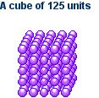

The Pentagon (o) = 125 = 5 x 5 x 5

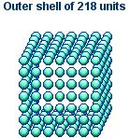
The World Trade Centre (o) = 218
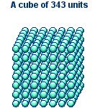
The World Trade Centre (o) + The Pentagon (o) = 343 = 7 x 7 x 7
Therefore the three buildings involved in the 9/11 tragedy encode the number 343. The separate numerical values obtained from the names of the two targeted buildings, ‘the World Trade Centre’ and ‘the Pentagon’, are derived from the internal structure of cube 343, indicating that the object of our attention should be the cube itself. As implied above, the cube can be separated into two parts by removing the outer shell to reveal a smaller cube within, an action which is the first step to uncovering a hidden message about the true meaning of the 9/11 event.
A hollow cube made from paper can be unfolded and laid flat to reveal a cross, as shown.
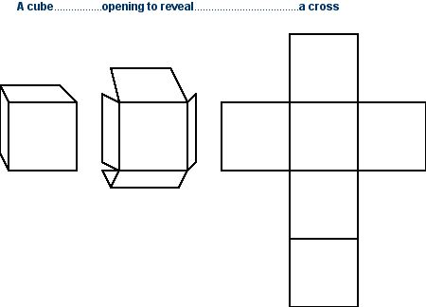
The outer shell of 218 units can similarly be opened out to reveal a cross. This number is the ordinal value of ‘The World Trade Centre’, the twin towers of which were both hit and destroyed by airplanes. The twin towers resemble the stake and crossbeam of a cross, therefore these buildings represent, through their shape and through gematria, the cross on which Jesus was crucified.
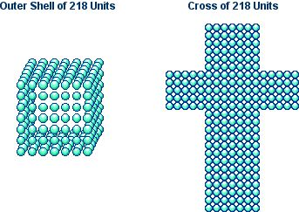
The World Trade Centre (o) = 218
As if to underline the point that the twin towers represented the cross, the summed ordinal values of the individual names for the towers, ‘the north tower’ and ‘the south tower’, give the exact number of units required to surround cube 343 to create a larger shell—which also opens out to form a cross.
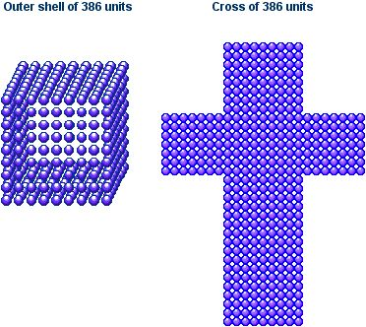

The North Tower + The South Tower (o) = 386
Therefore the World Trade Centre and, in particular, the twin towers can be correlated with the cross shape through gematria.
The Two Criminals
In 9/11:Luke, I show evidence that an additional function of the twin towers was to represent the two criminals crucified either side of Jesus. Here is Luke’s mention of the criminals, which I found to be encoded with the number 11, the key that unlocks the meaning of 9/11.
Luke 23:32 (NIV)
32. Two other men, both criminals, were also led out with him to be executed.
Luke 23:32 (o) = 693 = 11 x 63
Eleven (o) = 63
The chapter and verse numbers, read as a single number, give 2332:
2332 = 11 x 212
This is significant, because in Luke’s mention of the criminals both the verse itself and the number derived from the chapter and verse are multiples of 11—in the other gospel accounts, neither are. This is an example of a statistically-unlikely confluence of numbers from independant sources.
Jesus Christ
The cube remaining when the outer shell is removed from cube 343 is cube 125, representing the Pentagon.
The Pentagon (o) = 125 = 5 x 5 x 5
Note that 125 is the cube of 5 and therefore the triple expression of ‘fiveness’. As I showed in the 9/11 web page, the Pentagon building is watermarked with the number 5, both through the gematria of its name and through the features of its design.
The Pentagon and 5
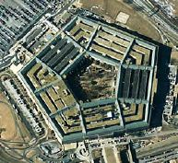
1. The Pentagon building, seen from above, is a perfect pentagon, a regular five-sided figure.
2. As can be seen from the picture, the Pentagon building is made of five concentric pentagons.
3. The Pentagon has five floors.
4. The ordinal value of the word ‘Pentagon’ is a pentagonal (five-sided) number:
Pentagon (o) = 92, the 8th pentagonal number.

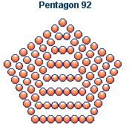
5. The ordinal value of the words ‘the Pentagon’ is the cube of 5:
The Pentagon (o) = 125 = 5 x 5 x 5
There can be little doubt, therefore, that the Pentagon (work on which officially began on September the 11th, 1941) is encoded with the number 5 and its geometric expressions and that this is an integral part of the symbolic message that has been woven into 9/11. What does the Pentagon symbolise?
The Stigmata
The pentagon and related pentagram have many symbolic associations. For instance, in Pythagorean mysticism the pentagram represented the human being, with five points: the head, arms and legs, a relationship famously depicted by Leonardo da Vinci, in The Vitruvian Man. However, in Christian symbolism, the pentagon and pentagram are further associated with the five wounds (stigmata) received by Jesus Christ as he was crucified. These were the wounds to his head, back, wrists, feet and the final wound to his side. Wikipedia has this to say about the pentagram (see note 1):
“Christians once commonly used the pentagram to represent the five wounds of Jesus, and it also has associations within Freemasonry.”
If 9/11 did indeed represent the crucifixion, the attack on the Pentagon itself, which produced partial rather than total destruction, would symbolise the wounding of Christ on the cross by the soldier’s spear. The Bible’s single mention of this incident is John 19:34.
John 19:34 (NIV)
Instead, one of the soldiers pierced Jesus’ side with a spear, bringing a sudden flow of blood and water.
John 19:34 (o) = 911
This is stunning confirmation of the true significance of the strike on the Pentagon.
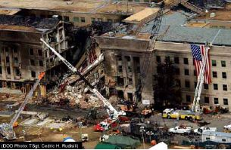
Jesus Christ is also linked to Venus, known as the Morning Star, as is Christ (Rev. 22:16). The pentagram and pentagon are strongly associated with Venus. Every four years the movements of Venus against the Zodiac describe a pentagram. Similarly, a pentagon is described after eight years. Venus is often represented, therefore, as a five-pointed star (see note 2).
Jesus Christ and the Pentagon
However, the association of Jesus Christ with the pentagon and pentagram is most clearly viewed through the lens of gematria.
1. The standard value of ‘Jesus Christ’, as well as being a diamond number, is also a pentagonal number.
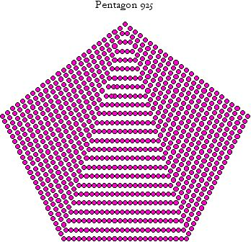

Jesus Christ (s) = 925
2. In the Hebrew system of numeration, the value of the word transcribed as ‘Yehoshua’, which is also the standard value in English of the words ‘Second Coming’ and ‘star’, is a centred pentagonal number.
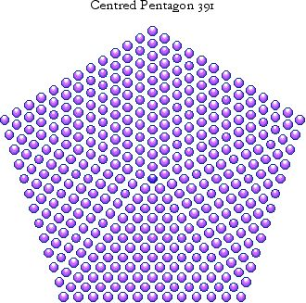

Star (s) = 391
Second Coming (s) = 391
3. The fractal snowflake form of the number 151, the ordinal value of the name ‘Jesus Christ’, has already been shown to play an integral part in the New Bible Code. However, the number 151 can also be displayed as a centred pentagram.
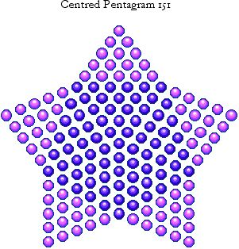

Jesus Christ (o) = 151
Interestingly, the numbers 11 and 911 are also centred pentagram numbers! 11 is the 2nd member of this series, 151 is the 6th member and 911 is the 14th member.
In 9/11 I show that the pentagon and the twin towers served as pictograms for the numbers 5 and 11, and that the summed ordinal values of the three individual targets was 511. The digits of 5 and 11 also create the number 151. If the twin towers, in addition to representing the cross, symbolise the two criminals crucified alongside Jesus, 151 is then revealed as a kind of ideogram representing this idea.
Note that the central pentagon is surrounded by five star points. These are triangles of 15 units, this being the 5th member of the triangle series. Pentagram 151 is therefore particularly associated with the number 5, as it is the only pentagram with this property.
This figure has the same relationship to the centred pentagon, from which it is derived, as the hexagram to a hexagon. The pentagon from which pentagram 151 is derived is pentagon 276.
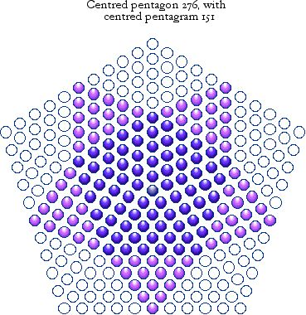
The key numbers 5 and 11 are to be found within the structure of this figure. Firstly, pentagon 391 is the 11th in its geometric series, with side 11. Secondly, the remainder when 151 is subtracted from 391 is 125 (5 x 5 x 5), split into five irregular rhombii of 25 ( 5 x 5) units, which can be seen surrounding the pentagram.
Now, we have already met the number 125, as the ordinal value of the Pentagon! Therefore 276 is the sum of the ordinal values of ‘Jesus Christ’ and ‘the Pentagon’, both of which are implied by its internal structure.
Jesus Christ + the Pentagon (o) = 276
The number 276 is found in Acts 27:37, as the number of souls saved from a shipwreck.
Acts 27:37 (NIV)
Altogether there were 276 of us on board.
The chapter and verse numbers are exactly the same as those of the verse in Matthew that gives us the first version of the Superscription, the charge written above the cross. Here are those words, as recorded in the NIV:
Matt.27:37 (NIV)
THIS IS JESUS, THE KING OF THE JEWS
Superscription in Matthew 27:37 (o) = 343
Incredibly, this is where we began: with cube 343, the number encoded in the gematria of the 9/11 targets! Moreover if we read the chapter and verse numbers as 2737, we note that this is 391 x 7, 391 being the centred pentagonal number featured above (see note 3).

The Rose
The centred pentagram above has slightly foreshortened points and thus resembles the physical form of a particular flower that has long been associated with the number 5 and its geometry: the rose. This has five petals at its base and in outline resembles a pentagon or pentagram. The ‘fiveness’ characteristic of all roses is best displayed in the wild rose, which generally has only five petals (see note 4).
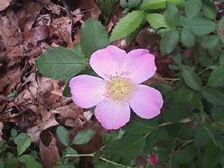
Christian symbolism associates the five petals of the rose with the stigmata of Christ—the rose carrying precisely the same as symbolic meaning as the pentagram, which early Christians used as a symbol of the crucified Lord, before it was dropped in favour of the cross. For instance, Subrata Mukherjee writes:
“The early Christians saw the five wounds of Christ in the five petals of the Rosa sancta. However, in view of the decadence connected with the Roman rose, the official Christian Church was reluctant to consider the rose a religious symbol. Only after much hesitation was the red rose declared a symbol of the blood of the martyrs.”
In fact, the link between the rose and the crucified Christ is so strong that two well-known societies have combined the rose and cross to create distinctive emblems.
The Rosy Cross
The Rosicrucians have as their major symbol a rose flower superimposed upon a cross. The Rosicrucian Society Of The United States have this to say about the multilayered symbolism of the rose cross (see note 5).
“In a Christian sense the cross signifies acceptance of sacrifice, suffering, and death as well as immortality.”
“The rose....is at once a symbol of purity and a symbol of passion, heavenly perfection and earthly passion; virginity and fertility; death and life. The rose is the flower of the goddess Venus but also the blood of Adonis and of Christ.”
“Numerologically, the rose represents the number 5. This is because the wild rose has 5 petals. And the petals on roses are in multiples of five. Geometrically, the rose corresponds with the pentagram and pentagon.”
The basic rose cross symbol is that of a rose appended to the junction of the two lines of the cross - the center point. But the traditional Rosicrucian symbol is a cross of 6 squares whereon is a red rose of five petals. The cross is of 6 squares for a number of reasons. It relates the cross to the number six which is the number of the Tree of rife Sphere to which it corresponds....also known as the Sphere of the Sun. The cross of six squares is also the unfolded cube of six faces.”
The cross, therefore, is a potent symbol of sacrificial suffering and death. The rose represents 5 and the pentagon or pentagram—and for Christians the red rose represents the blood of Christ. These ideas are strikingly reminiscent of this interpretation of the 9/11 event.
Another organisation well known for utilising the combined rose and cross in its symbolism is freemasonry. Degrees 15 to 18 (southern jurisdiction) or 17 and 18 (northern jurisdiction) of Scottish rite freemasonry comprise a separate chapter known as the Rose Croix degrees. Degree 18 is called the ‘Knight Of The Rose Croix’ and its emblem features a rose growing out of a cross, with a pelican feeding its young on its own blood, and an eagle at the foot of the cross (all three symbolise Christ). The number 18 may be significant here, given that 9/11 was marked with the number 666, 18 is three sixes and Rev. 13:18 carries the infamous number. The degree represents a very significant stage in the spiritual growth of the freemason (see note 6).
“This important Degree, of all the higher Degrees, is said to be the most widely diffused, being found in numerous Rites other than the Scottish....The name "Rose Croix" is derived from the emblems of the Rose and Cross.”
“The passage in the Song of Solomon which reads the "Rose of Sharon" is applied to Christ, symbolizing especially that through him "life and immortality were brought to light." Thus we have explained the origin of the Rose Croix as the name of the Degree which centers in and around Christ. The rose as a symbol of Christ and the cross as an emblem of his death untied on the Jewel of the Rose Croix point to the truth that through Christ the secret of immortality is revealed and through his death an immortal life of purity and happiness is made available.”
Again we see that the rose is Christ himself and that therefore the Rose Croix represents the crucified Lord. Although neither masonic or Rosicrucian tradition limits itself to purely Christian interpretations, both view the rose cross, at least in part, as symbolic of the Crucifixion of Jesus Christ and pointing towards the mystery of the Resurrection.
The Crucifixion Of Jesus Christ
I would like to summarise all that has gone before in a series of illustrations that show how the New Bible Code links the destruction of the twin towers and the damage to the Pentagon with the crucifixion of Jesus Christ, which it reenacted.
The ‘Crucified’ Pentagon and Twin Towers

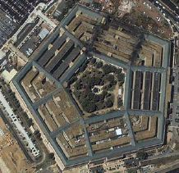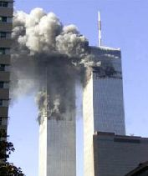

The Pentagon (o) = 125
The World Trade Centre (o) = 218

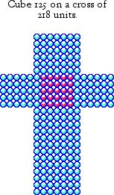

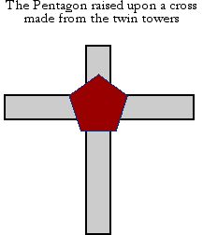
The Rose Cross
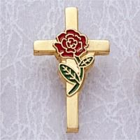

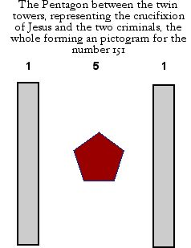
Jesus Christ (o) = 151

Crucifixion, by Antonello da Messina
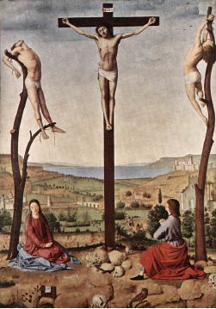
Bill Downie
24/7/06
Last Revised
4/1/07
The Resurrection of Christ
Home

Notes
1. http://en.wikipedia.org/wiki/Pentagram
2. For instance, see http://www.symbols.com/encyclopedia/28/2822.html
3. 391 is 17 x 23. The 17th and 23rd triangular numbers are 153 and 276, which are specifically mentioned in the New Testament: in John 21:11 there is a catch of 153 fish; in Acts 27:37 276 people are saved from a shipwreck. Both stories are metaphors for the idea of salvation.
4. The apple is of the same family as the rose and, cut cross-wise, will show the same pentagonal pattern in the arrangement of its pips. Interestingly, New York is called ‘The Big Apple’. The apple is also an emblem of man’s fall (eating from the tree of knowledge) and his redemption, and as such is also represented in pictures of Mary and Jesus.
5. See A Brief Study Of The Rose Cross Symbol, http://www.geocities.com/athens/2092/index2.htm. This article is worth reading in full.
6. See http://www.phoenixmasonry.org/masonicmuseum/sr_rose_croix_18th_degree_jewel.htm
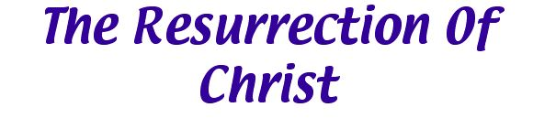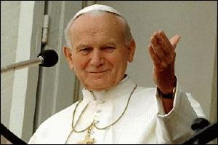
Pope John Paul II, the head of the Roman Catholic church from 1978 until 2005, was a remarkable figure and the facts concerning his long and fruitful papacy are the stuff of legend. He drew some of the largest crowds and was probably seen in person by more people than anyone in history. He also inspired an entire generation of men into the Roman Catholic priesthood and engendered a huge renewal in Catholic Christian faith. Widely recognised to have been the greatest spiritual leader of our time, John Paul II was perhaps the most influential pope since Saint Peter himself.
Being the reigning head of the Roman Catholic Church at the time of 9/11 would have been enough to ensure for him at least a peripheral role in the huge cluster of synchronicities surrounding 9/11. This is in fact the case. For instance, he was the 264th Pope, 264 being 11 x 24. He was also the 110th Pope from Celestine II to "the end of the world", according to the prophesies of St. Malachy. Both numbers encode the ubiquitous eleven, a number also alluded to by the use of the Roman ‘II’ for ‘the Second’. However, it seems that the part played by this particular pope was central to the entire drama, which was in two acts, with a three-and-a-half year interlude.
9/11 and the Funeral Of Pope John Paul II
Soon after the funeral of Pope John Paul II, I noted a fascinating connection between the date of his funeral, April 8th, 2005, 9/11 and two important numerical values related to Jesus Christ. 9/11 occurred on the 254th day of the new millennium (which began on 1/1/2001, not 1/1/2000). The funeral of Pope John Paul II occurred 1559 days into the new millennium.
Our Lord Jesus Christ (o) = 254
Our Lord Jesus Christ (s) = 1559
Recall that the ordinal and standard value systems of English gematria are the principal vehicles for conveying the message of the New Bible Code; many of the numbers encoded in the NIV Bible were encoded as ordinal values but take on meaning as standard values. Therefore to find these two world-changing events encoding the ordinal and standard values for such an important title must be highly significant.
The Three-and-a-Half Years
There were 1305 days between 9/11 and the funeral of Pope John Paul II. This is almost exactly three-and-a-half years, a period of time reiterated in various ways throughout the books of Daniel and Revelation, in connection with end-time prophecy. 1305 days equates to about 3.57 years, slightly over but still very close to the prophesised period of time, which, in any case, is stated in rather vague terms (see note 1). Here are most (but not all) of the relevant passages. Note that “2300 evenings and mornings” means 1150 days. The periods “time, times and half a time”, “forty-two months” and the periods from 1150 days to 1335 days all mean three-and-a-half years.
Daniel 8:13-14
13Then I heard a holy one speaking, and another holy one said to him, “How long will it take for the vision to be fulfilled—the vision concerning the daily sacrifice, the rebellion that causes desolation and of the host that will be trampled underfoot?” 14He said to me, “It will take 2300 evenings and mornings; then the sanctuary will be reconsecrated.”
Daniel 12:7
The man clothed in linen, who was above the waters of the river, lifted his right hand and his left hand towards heaven, and I heard him swear by him who lives for ever, saying, “It will be for a time, times and half a time. When the power of the holy people has been finally broken all these things wll be completed.”
Daniel 12:11
From the time that the daily sacrifice is abolished and the abomination that causes desolation is set up, there will be 1290 days. Blessed is the one who waits for and reaches the end of the 1335 days.
Revelation 11:2
And I will give power to my two witnesses, and they will prophesy for 1260 days, clothed in sackcloth.”
Revelation 13:5
The beast was given a mouth to utter proud words and blasphemies and to exercise his authority for forty-two months.
So the Bible impresses upon us that the “end times” are associated with a particular period of time: three-and-a-half years. Could the attacks of September the 11th, 2001 and the funeral of arguably the most influential and important pope the world has ever known, both watershed events, be the markers for this period?
The Three Days
Another period of time repeatedly given in the Bible, reminiscent of the three-and-a-half years, is the three days between the crucifixion and resurrection of Jesus Christ.
Matthew 27:63
“Sir,“ they said,“ we remember that while he was still alive that deceiver said, ‘After three days I will rise again.’
John 3:19-22
19 Jesus answered them, “Destroy this temple, and I will raise it again in three days.” 20 The Jews replied, “It has taken forty-six years to build this remple, and you are going to raise it in three days?” 21 But the temple he had spoken of was his body. 22 After he was raised from the dead, his disciples recalled what he had said. Then they believed the Scripture and the words that Jesus had spoken.
As I showed in the first part of this page, 9/11 reenacted the Crucifixion of Jesus Christ. The twin towers could be seen to represent the beams of the cross itself or, alternatively, the two criminals crucified alongside Jesus. The Pentagon would in both cases correspond to Jesus himself, wounded by a spear, as, symbolically, was the Pentagon building. The five points of the Pentagon represent the five stigmata received by Jesus and the five apendages (two arms, two legs and the head) of the human body. For Freemasons and Rosicrucians, the cross is paired with a rose, itself associated with the number 5 and the pentagon. The Knight Rose Croix degree symbolises (among other things) the passion and resurrection of Christ.
Could 9/11 and Pope John Paul II’s funeral, taken together, provide a re-enactment of Christ’s crucifixion, death, burial and resurrection?
The Funeral Of Pope John Paul II and the Resurrection of Jesus Christ
As with 9/11, the funeral of Pope John Paul II was an extraordinary, watershed event. First of all Pope John Paul II was undoubtedly the most successful Pope in modern times, the end result of his remarkable papacy being a huge renewal of Catholic Christian faith. Secondly, Pope John Paul II died just after Easter 2005, Easter being the celebration of Christ’s resurrection. Thirdly, for the Roman Catholic Church, the funeral liturgy and committal—both of which took place on April the 8th, 2005—have a special significance, focusing on the death and resurrection of Jesus Christ.
On its website, the Catholic Archdiocese of Boston makes the following statements about the Christian funeral liturgy and committal (see note 2):
The Roman Catholic Funeral Liturgy is not a memorial service about the deceased. During the Funeral Liturgy, the focus is on one person: Jesus Christ. The Funeral Liturgy centers entirely on the truth that Jesus Christ defeated the power of sin and death through his passion and resurrection.
For us Catholics, the Committal has deep spiritual significance. We recall the important facts of the disposition of the body of Jesus: Joseph of Arimathea's pleading for Jesus' body from Pilate and giving his own tomb, the women's consigning in haste Jesus' broken body, and their amazement at the rolling away of the stone and the garment of death's having been cast aside. It is specifically in the context of the death, burial, and resurrection of Jesus that we bring the bodies of our loved ones for the Committal.
The Catechism of the Catholic Church contains the following statements on the meaning of death to Christians. The word “Paschal” refers to the “Paschal lamb”, Jesus Christ (see note 3):
1681 The Christian meaning of death is revealed in the light of the Paschal mystery of the death and resurrection of Christ in whom resides our only hope. The Christian who dies in Christ Jesus is "away from the body and at home with the Lord."
1682 For the Christian the day of death inaugurates, at the end of his sacramental life, the fulfillment of his new birth begun at Baptism, the definitive "conformity" to "the image of the Son" conferred by the anointing of the Holy Spirit, and participation in the feast of the Kingdom which was anticipated in the Eucharist—even if final purifications are still necessary for him in order to be clothed with the nuptial garment.
Finally, there is extraordinary significance in the funeral of a pope. The Pope is, for Roman Catholics, Christ’s representative on earth (see note 4):
The Bishop of Rome is the bishop of the Holy See and is more commonly referred to as the Pope[....]Roman Catholic tradition holds that the Bishop of Rome is the successor to the primacy of Simon Peter and thus the "Vicar of Christ" for the entire world.
Therefore, no event could more fully symbolise the death and resurrection of Jesus Christ than the death and funeral of Pope John Paul II.
As if to emphasise this connection, English gematria provides the following identities between Pope John Paul II, the Vicar of Christ and Jesus Christ, the Sacrificial Lamb.
Jesus Christ (o) = 151
Pope John Paul II (o) = 151
Vicar of Christ (o) = 151
the Sacrificial Lamb (o) = 151
Recall that 5 and 11 are the two numbers depicted by the twin towers and the Pentagon, whose destruction represented the crucifixion of Jesus Christ.
The New Beginning
The book of Genesis starts with an account of our origins, appropriately entitled ‘The Beginning’ in many versions of the Bible. The first twenty-four words of the NIV Bible are the setting for a beautiful set of encodings of numbers that are standard values for the words ‘Jesus’, ‘Second Coming’, ‘Messiah’, ‘word’ and ‘Yehoshua’. These encodings are summarised below.
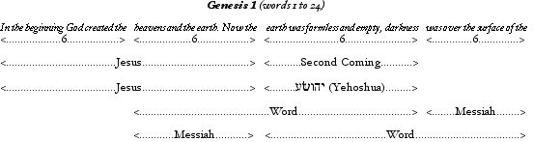
For details of these encodings, see The Signature of Christ and The Creation Snowflake.
The numbers are derived by calculating the ordinal values of strings of six or twelve words formed by cutting the first twenty-four words into four segments of six words. The pattern ends there, so these encodings form a self-contained whole, sitting at the very apex of the NIV bible.
Another way of dividing the block of twenty-four words is by trisecting them into three segments of eight words (this is particularly significant because 888 is the number of the Greek word for Jesus). When this is done, then the ordinal values of the blocks are calculated, the following numbers are obtained.
Words 1 to 8 of Genesis (o) = 345
Words 9 to 16 of Genesis (o) = 391
Words 17 to 24 of Genesis (o) = 433
The ordinal value of middle segment is 391, which, as we have already seen, is the standard value of the Hebrew word transliterated as ‘Yehoshua (Jesus) and the English words ‘Second Coming’. Now, if we sum the first two segments then all three segments to obtain the ordinal values of the first sixteen words and the entire string of twenty-four words, we obtain the standard values of the name of the person whose funeral represented the resurrection of Jesus Christ, this event completing the announcement of the Second Coming of Jesus Christ.
Words 1 to 16 of Genesis (o) = 736
Words 1 to 24 of Genesis (o) = 1169
Pope John Paul II (s) = 736
Pope John Paul the Second (s) = 1169

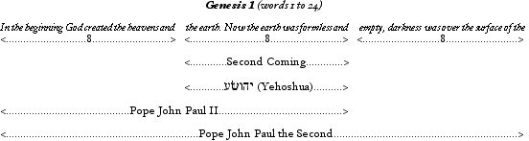

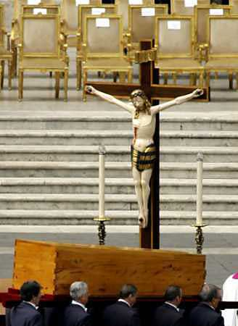
Bill Downie
24/7/06
Last Revised
4/1/07
Home

Notes
1. Three-and-a-half years is 1278 days. Interestingly, The Creation Snowflake has 1279 units. Moreover, I published my page on the snowflake exactly 1279 days after 9/11, something I had no conscious intention of doing.
2. See http://members.aol.com/maryimmoflourdes/funerals.htm
3. See http://en.wikipedia.org/wiki/Bishop_of_Rome
4. Wikipedia


Introduction
Even in our frenetic twenty-first century world, the number thirteen has the stopping power of a primitive taboo. Much of thirteen's negative aura emanates from the pages of the bible, where it is popularly associated with the events of the last Supper, at which thirteen people sat. This view is augmented by biblical numerics, which finds thirteen to be connected with man's rebellion and apostasy. But in this article you will discover that thirteen's fearful reputation is based on a misperception of its full biblical significance. It is in fact at the centre of a mystery that is far more engaging, and infinitely more revealing about the nature of reality, than any superstition.
The Bible began life as the Torah, which had taken shape by the 3rd or 4th century BC, evolving into the Hebrew Bible by 100AD. The Christian Bible was compiled by the 4th century AD, but without chapters or verses: these were incorporated in the 13th and 16th centuries, respectively. In fact, it could be argued that the first recognisably modern bible was the Geneva Bible of 1560, which is little different from the Bible of today. But as our modern Bible took shape, certain architectural features were built into its structure, a phenomenon that suggests design, rather than happenstance. One of these features is based on the number thirteen.
Note: All references are to the standard sixty-six book bible, without the Apocrypha (Deuterocanonical scriptures). However, it should be noted that many of the patterns I reveal are found in all bibles.
The Foundations
The number thirteen is built into the very foundations of the modern Bible.
1. The Bible’s 103rd chapter is Leviticus 13.
2. The Bible’s 130th chapter is Numbers 13.
3. The New Testament’s 130th chapter is Romans 13.
4. The Bible’s 1030th chapter is Acts 12. The New Testament’s 103rd chapter is Acts 14. Sandwiched between these chapters is Acts 13, the Bible’s 1031st chapter.
Note that these foundations were laid down several centuries ago - at least as far back as the Geneva Bible of 1560. This has crucial bearing on any discussion as to the origin of the New Bible Code. Whoever created the code has been at work for hundreds of years. Indeed, other parts of the code were incorporated at least a thousand years ago.
Some Structural Details
This emerging thirteen pattern, so far common to nearly all modern bibles, reaches its full expression in the NIV Bible.
Genesis 1 (NIV) - First 13 words
1. In the beginning God created the heavens and the earth. 2. Now the earth...
Ordinal value of the first 13 words = 567
Thirteen (s) = 567
Remarkably, when we subdivide these first thirteen words into strings of thirteen letters, we see that these are also watermarked with the number thirteen.
Genesis 1:1-2 (NIV)
1. In the beginning God created the heavens and the earth. 2. Now the earth...
1. Ordinal value of the first 13 letters = 130 (13 x 10)
2. Ordinal value of the first 26 (13 x 2) letters = 247 (13 x 19)
3. Ordinal value of the first 39 (13 x 3) letters = 373
373 is not a multiple of 13. However it is the value of the Greek word logos, meaning ‘Word’. See The Creation Snowflake.
4. Ordinal value of the first 52 (13 x 4) letters = 520 (13 x 40)
The 52nd letter happens to be the 1st letter of the 13th word. This is 'earth', with a gematria of 52 (13 x 4). So we have three multiples of the number 13 converging on the 13th word!
The confluence of 4 and 40 about the word 'earth' is appropriate. In bible numerics, the number 4 is associated with the earth or a place. For instance, Jesus was tempted by the devil in the desert for 40 days. This link between the devil, the earth and the number 4 is confirmed in English gematria.
The Devil (r) = 40
Devil (o) = 52 = 13 x 4
earth (o) = 52 = 13 x 4
Matthew 6:9-13 (NIV)
9. Our Father in heaven, hallowed be your name, 10. your kingdom come, your will be done on earth as it is in heaven. 11. Give us today our daily bread. 12. Forgive us our debts as we also have forgiven our debtors. 13. And lead us not into temptation, but deliver us from the evil one.
1. The number of letters is 208 (13 x 16).
2. The number of words is 52 (13 x 4).
3. The number of letters in verse 13 is 52 (13 x 4), split into two clauses of 26 (13 x 2) letters.
4. The number of words in verse 13 is 13.
1 Corinthians: 13:1-13
1. If I speak in the tongues of men and of angels, but have not love, I am only a resounding gong or a clanging cymbal....
13. And now these three remain: faith, hope and love. But the greatest of these is love.
Another important encoding of 13 is found in 1 Corinthians, which contains an essay on the subject of love. Here, Paul's inspiring words encompass the 13 verses of chapter 13! In the NIV Bible, verse 13 has 65 ( 13 x 5) letters and a gematria for the first 13 letters of 156 (13 x 12).
Why would 13 be associated with the idea of love? I think the answer is to be found in Hebrew gematria, in the standard value for the word AHaVaH, which means ‘love’.
1 Corinthians: 13:10
10. but when perfection comes, the imperfect disappears.
The link between 13 and love is strengthened by the encryption of the standard value for the word ‘love’ within verse 10 of I Corinthians 13.
Ordinal value of I Cothinthians 13:10 = 495
Love (s) = 495
This verse is the 312th in I Corinthians, 312 being 13 x 24.
Let’s return now to Genesis 1, where the encoded thirteens I detailed earlier can be seen in a new light.
Genesis 1 (NIV) - First 13 words
1. In the beginning God created the heavens and the earth. 2. Now the earth...
Ordinal value of the first 13 words = 567

Thirteen (s) = 567
Love (c) = 567

The Geometry of Love
The numbers 13 and 567 have geometric properties, which add another dimension to this discussion.
The Hexagram
13 is the second hexagram number.
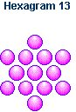
The hexagram is better known as the Star of David, the modern symbol of Judaism, and the ancient symbol of Jesus Christ, the personification of love. This link between Jesus Christ and the Star of David find remarkable expression in Pascal's triangle. Superimposing hexagram 13 upon the triangle, as close to the apex as possible, gives us the combined figure illustrated below.
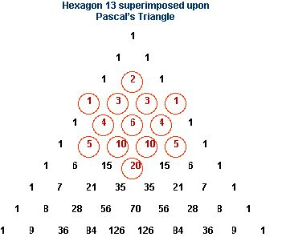
1. The total value of the superimposed numbers is 74.
Jesus (o) = 74
Recall that hexagram 13 is the 2D projection of star pyramid 43, this being the reduced value of ‘Jesus Christ’.
2. The gematria of 'hexagram' is 77.
Christ (o) = 77
3. The hexagram is centred on the first 6 to appear on the triangle. The central 6 is the 13th number, counting from the apex.
4. The total value of the numbers to the central 6 is 26 (13 x 2).
God (o) = 26
5. The sum of the ordinal values of each number to the central 6, starting from the apex, is 91 (13 x 7).
Spirit (o) = 91
The Diamond
13 is also the third diamond number (a rotation of the centred square).
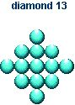
The diamond reflects many images of perfection and value, and is the gem of choice for wedding rings. Therefore this is another potent symbol of love.
The Star Pyramid
13 is the 2D projection of the second star pyramid number, 43. This is formed by the self intersection of a pyramid 30. All three figures are shown below (the hexagram is slightly flattened).
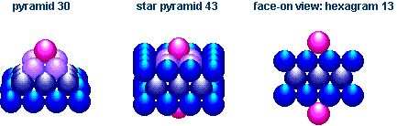
Appropriately, 43 is the reduced value of this very stellar name:
Jesus Christ (r) = 43
567 is another star pyramid number, the fourth in its series. The 2D projection of this figure is a slightly flattened hexagram of 73 units.
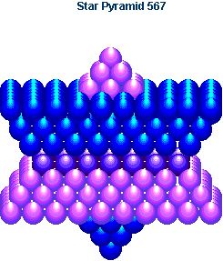
I said that 43 is the reduced value of the name of our Lord. 73 is the reduced value of this related phrase:
The Second Coming (r) = 73

The Heart Of The Structure
The Bible, because of its two testament structure, has three centres: that of the Old Testament, that of the New Testament and that of the Bible itself. The central chapters are identified below.
1. The central chapter of the New Testament is Romans 13.
2. The central chapter of the Old Testament is Job 29.
3. The central chapter of the entire Bible is Psalm 117.
Romans 13
The halfway point in the NT is just after Romans 13, the 130th chapter. This has already been identified above and is common to all bibles.
Job 29 (NIV)
13. The man who was dying blessed me; I made the widow's heart sing.
1. The central verse of Job 29 is verse 13.
2. This verse has 13 words.
3. The first clause has 26 (13 x 2) letters.
4. The central letter, M (within the first 26-letter clause), has a gematria of 13.
We now enter the very heart of the structure and the Bible itself, where an incredible message has been placed.
Psalm 117 (NIV)
1. Praise the Lord, all you nations; extol him, all you peoples. 2. For great is his love towards us, and the faithfulness of the Lord endures for ever.
Praise the Lord.
1. The Psalm number, 117, is 13 x 9.
2. Psalm 117 and Job 29 are the bible's 595th and 465th chapters, with 130 chapters between them. In addition, both 465 and 595 are triangular numbers.
3. The three sentences of the verse contain seven clauses, four of which contain 13 letters, and one of which contains 26 (13 x 2) letters! These are highlighted below.
1. Praise the Lord, all you nations; extol him, all you peoples. 2. For great is his love towards us, and the faithfulness of the Lord endures for ever.
Praise the Lord.
This is highly unlikely: the simple odds of five out of seven clauses containing multiples of thirteen letters are calculated as follows:
P(5) = 7!/5!(7-5)! x 1/13 x 1/13 x 1/13 x 1/13 x 1/13 x 12/13 x 12/13 = 0.00005
This equates to a chance of 1 in 20 000 that this phenomenon occured randomly. Indeed the calculated odds do not take account of the fact that four of the clauses contain exactly 13 letters, not simply multiples of 13. The odds against this event will be even higher. Of course, a book as large as the bible will contain a run of thirteens somewhere. There are 31101 verses in the Bible, so one would expect perhaps two of these verses to exhibit this phenomenon. But Psalm 117 is no ordinary location: it is the bible's central chapter, and also its shortest chapter, at the hub of an encoded pattern of thirteens.
4. Psalm 117 contains thirty words, therefore the central two words are the 15th and 16th, within a clause of 26 (13 x 2) letters. This is highlighed below.
1. Praise the Lord, all you nations; extol him, all you peoples. 2. For great is his love towards us, and the faithfulness of the Lord endures for ever. Praise the Lord.
Halving the Psalm bisects this clause into two equal parts of 13 letters, the split coming between these same two words, which are 'his' and ' love'.
For great is his love towards us
At the heart of the bible is God’s love!
his love (o) = 90 = one three (o)
God's love (o) = 99 = thirteen (o)
5. The number 117 is the reduced value of the phrase, the ordinal value of which is also the ordinal value of the NIV Bible’s first six words.
The Second Coming of Christ (r) = 117
A Visual Metaphor
The total number of letters in Psalm 117 is 127. The last sentence - Praise the Lord - contains 13 letters and is separated from the rest of the Psalm, which has 114 letters. This division is shown here.
Psalm 117 (NIV)
1. Praise the Lord, all you nations; extol him, all you peoples. 2. For great is his love towards us, and the faithfulness of the Lord endures for ever.
Praise the Lord.
These very numbers can be found in Pascal's triangle.
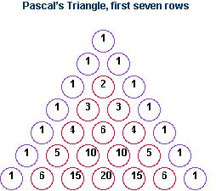
Total sum of all the numbers = 127 = number of letters in Psalm 117
Sum of purple-circled outer units = 13 = AHaVaH (‘love’ in Hebrew) = number encoded within Psalm 117.
Sum of red-circled inner units = 114 = God (c) = number of letters in first part of Psalm 117.
Total number of units = 28 = man
The three words whose gematria are encoded are love, God and man. 'For great is his love towards us'.
The Architect
A kind of signature has been placed within the structure, revealing the identity of the architect. This is found in each of the bible’s three centres.
The Three Centres
The number 26 has been encoded within all three centres of the Bible:
1. The central point by chapter of the Old Testament is within a clause of 26 letters.
2. The central point by chapter of the Bible bisects a clause of 26 letters.
3. The central point by chapter of the New Testament bisects its 260 chapters.
The determiner 'his' in the phrase 'his love' refers to the Lord, the Hebrew word for whom is 'YaHWeH',
This is also the ordinal value of 'God' in English.
God (o) = 26
Looking more closely at the centres, we see further evidence of the Divine Hand at work.
Job 29:13 (NIV)
13. The man who was dying blessed me; I made the widow's heart sing.
The thirteen words of the central verse in the central chapter of the Old Testament require 49 letters, The central letter, 'm' (the thirteenth letter), is within the first clause of 26 letters.
Lord (o) = 49
God (o) = 26
Psalm 117 (NIV)
1. Praise the Lord, all you nations; extol him, all you peoples. 2. For great is his love towards us, and the faithfulness of the Lord endures for ever.
Praise the Lord.
As I stated earlier four of the seven clauses within the Bible's central chapter contain 13 letters and one clause contains 26 letters. The other two clauses are highlighted in blue above. These have 8 and 41 letters.
Lord (o) = 49 = 8 + 41
Psalm 117 (NIV)
1. Praise the Lord, all you nations; extol him, all you peoples. 2. For great is his love towards us, and the faithfulness of the Lord endures for ever.
Praise the Lord.
The gematria of Psalm 117 contains yet another signature, signed off with a final flourish.
Ordinal value Psalm 117 = 1576
The number 1576 is the sum of two triangular numbers, 351 and 1225.
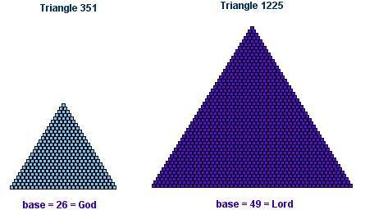
Love is, of course, synonymous with God Himself.
The Lord God (r) = 54
love (o) = 54
The Lord God (o) = 108 = 54 x 2
God is love (o) = 108 = 54 x 2
Bill Downie
22/5/04
Revised: 22/3/05
Revised: 17/10/05


Introduction
As explained in About Numbers, English gematria is a modern relative of Hebrew gematria and its Greek equivalent. Gematria is an esoteric technique by which the written word can be numerated and analysed, based on numerical substitution schemes used in biblical times. This analysis reveals that biblical Hebrew, biblical Greek and modern English are structured, so that words and phrases that are meaningfully related are also connected through their numerical properties. Here, English and Hebrew gematria join forces to create a modern miracle in the encoding of three irrational numbers and one physical constant...
If the absolute value of the Masoretic Genesis 1:1 (see note 1) is divided by the ordinal value of the NIV Genesis 1:1 (see note 2), a fair approximation of pi is obtained. The performance of similar calculations with the NIV Genesis 1:1 and other significant passages from within the NIV bible, yields fair estimates of Phi and e. The three approximations sum to a number which differs from the true sum of pi, Phi and e by the phenomenally small margin of one part in five million.
I have also found an encoding of alpha, the fine structure constant, involving the NIV Genesis 1:2. This approximation is in error of the most recent estimate of alpha by only one part in five hundred thousand.
The Derivations Of Pi, Phi and e
The Irrational Numbers
Pi, Phi and e are known as irrational numbers (see note 3) and are the three most valuable numbers in mathematics, supporting the entire edifice of science and technology. The numbers are introduced below.
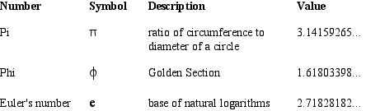
The Biblically-Derived Numbers
The biblical passages from which the irrational numbers can be derived are given below, along with their numerical values. Note that these are some of the most theologically-significant verses in the whole of scripture.
1. Absolute value Genesis 1:1 (Masoretic)
Masoretic Genesis 1:1 (a) = 2701 = G1:1 (Mas)
2. Ordinal value Genesis 1:1 (NIV)
In the beginning God created the heavens and the earth.
NIV Genesis 1:1 (o) = 430 = G1:1 (NIV)
3. Ordinal value John 1:1 (NIV)
In the beginning was the word, and the word was with God, and the word was God.
NIV John 1:1 (o) = 695 = J1:1 (NIV)
4. Summed ordinal values of the four versions of the Superscription (NIV)
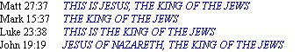
Four NIV Superscriptions (o) = 1170 = SI (NIV)
The Calculations
Now we come to the calculations themselves, which are simple divisions of one of the derived numbers by another. A unifying feature of these encodings is the use of the NIV Genesis 1:1 as the denominator in every calculation, which I discuss later.
Note that in the calculation if pi a factor of 2 has been inserted into the formula to obtain the approximation. This is the only time such an adjustment is required.
1. The Approximation of Pi
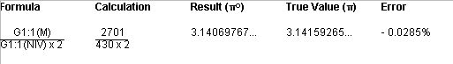
2. The Approximation of Phi
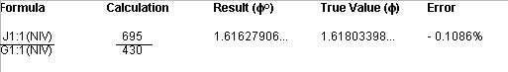
3. The Approximation of Euler’s number
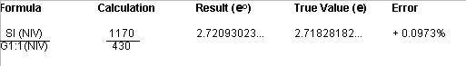
All of the derived numbers are within +/- 0.11% of the correct values. In fact, they could easily substitute for these values in many calculations (see note 4). However, it should be noted that it is fairly easy to obtain this level of accuracy, even with small whole numbers. For instance, 22/7 is almost as close an approximation of pi as is obtained with the biblical numbers. Therefore it could reasonably be argued that these results are not quite spectacular enough to be convincing evidence of intelligent design.
Because two of the errors are underestimates and the third error is an overestimate, a cancelling effect will be evident when the values are added together. To measure this effect the approximations are summed and the result compared with the true sum of pi, Phi and e. This procedure is also implied by the use of Genesis 1:1 in all three calculations, suggesting the numbers are linked in some way. When the approximations are duly summed, something spectacular does command our attention...
4. The Approximation of The Combined Values Of pi, Phi and Euler’s number
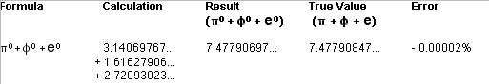
The sum of the three approximations is in error of the true value by the fabulously small margin of 0.00002%, or one part in five million (see note 5). This is about 4000 times smaller than the average magnitude of the individual errors, 0.078%. How much would the error be expected to cancel out? The simple arithmetic mean of the errors (which ignores the individual weighting effects of the three numbers) is 0.013%, about 6 times smaller than the average magnitude of the individual errors. Empirical work indicates that this is about the expected cancelling effect. However, the observed error is 700 times smaller than this—well beyond any expected reduction.
The three separate calculations can be reduced to a single pair of numbers:
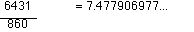
Here, another startling fact emerges: no two whole numbers below 8000 give a more accurate estimation of the combined value of pi, Phi and e than this pairing. This is another piece of evidence that strongly suggests the biblically derived numbers were deliberately encoded.
The Signature
The first four digits of the combined approximation we just calculated are as follows:
7.477...
If we calculate the ordinal values of the two words 'Jesus' and 'Christ', we obtain:
Jesus = 74
Christ = 77
Placing the two numbers side by side, instead of summing them as we would normally do, we obtain these same four digits.
7477
Consider:
1. We find apparent encodings of the three most important numbers in mathematics.
2. The numbers are encoded in such a way as to suggest that they are somehow linked.
3. When these numbers are summed, the individual errors, already small, almost completely cancel out.
4. This leaves a number, the first two pairs of digits of which are the ordinal values of 'Jesus' and 'Christ'.
I think the digits 7477 are a kind of numerical signature, revealing to us the identity of the author.
As an aside, the number 7477 is the 946th member of the prime number sequence. Now 946 is a rare trifigurate number: 11th in the series of hexagonal pyramidal numbers, 22nd in the series of hexagonal numbers and 43rd in the series of triangular numbers.
Lord (r) = 22
Jesus (r) = 11
Jesus Christ (r) = 43
Discussion
Could mere chance explain these results? The text of the bible is a large data set from which to derive numbers, and pseudo-encodings could easily be found from selected portions of texts. However, I think that there are very significant mitigating factors against a chance hypothesis.
1. The approximations of pi, Phi and e are fairly accurate - all fall within the range +/- 0.11% - and are of similar magnitude.
2. The individual errors almost completely cancel each other out, to leave an extremely precise value for the combined irrational numbers. The huge difference in magnitude between the errors in the weighted and unweighted averages would be very unlikely to have happened by chance, although further work is needed to quantify this statement.
3. Pi, Phi and e are not obscure numbers. They are the three most famous absolutes in mathematics, supporting the entire edifice of science and technology.
4. The Bible is no ordinary book. It is the most influential written document in existence. Furthermore, the NIV Bible is the most popular modern English translation of the Christian Bible and the Masoretic Text is the standard text of the Hebrew Bible.
5. The selected portions of text are either whole verses or significant statements within verses (the inscriptions are in fact, capitalised for emphasis), which are, of the Bible's sixty-six books, five of the most theologically significant for Christians. Furthermore, the verses themselves could scarcely have greater import, especially in connection with the status of Jesus Christ and His last days on earth.
a) Genesis 1:1 (pi, Phi and e), a sweeping statement of our origins, is the most important single sentence in the bible.
b) John 1:1 (Phi) introduces the Word, present with God in the beginning, and identified with Jesus Christ.
c) The four versions of the Superscription are within verses that are integral to the drama of The Crucifixion, which, along with The Resurrection, was the fulfillment of Christ's Incarnation.
6. There is a high degree of relatedness between the verses. John 1:1 mirrors Genesis 1:1 in subject matter (the beginning of Creation) and placing (the start of each prologue). The four versions of the Superscription are obviously related and are found in the four gospels, no less. These facts answer any suggestion of 'cherry picking' to obtain suitable numbers.
7. The NIV Genesis 1:1 provides the number for the denominator in every division, and so a common thread links each calculation. In the derivation of pi, Genesis 1:1 provides the numerator (Masoretic) and the denominator (NIV). It is singularly appropriate that pi, perhaps the brightest jewel in the crown of mathematics, should be woven like a sequin into these historic versions of the bible's first verse.
8. Finally, and perhaps most tellingly, very good approximations of pi and e have already been found within Genesis 1:1 (pi again) and John 1:1 (e), as originally penned in Hebrew and Greek (see note 6). These results support the new findings, and are in turn upheld by them.
9. Intriguing evidence of a link between Jesus Christ and the encoded numbers is found in the gematria of the name 'Jesus Christ' itself. The first four digits of the combined value of pi, Phi and e are 7477, which embodies the ordinal values of 'Jesus' and 'Christ' and the numerico-geometric properties of which link it to the reduced values of names for our Lord.
For the reasons given above, I would suggest that chance is not a tenable explanation for this phenomenon and that these numbers have been deliberately woven into the biblical verses.
The Fine Structure Constant
Alpha, the fine structure constant is a physical constant, the coupling constant for the interaction of photons with electrons (see note 7). Put more simply, alpha quantifies the strength of the interaction between light and matter. It is important to be aware of the nature of alpha, because its encoding in the NIV involves two numbers, one related to light, the other to matter.
The Calculated Value
The most recent calculated value for alpha, the electromagnetic fine structure constant, is shown below.
The Biblically Derived Numbers
1. The ordinal value of 'light'.
Light (o) = 56
2. The ordinal value of Genesis 1:2 (NIV). This describes the earth (matter) in a state of darkness (without light).
Now the earth was formless and empty, darkness was over the surface of the deep, and the Spirit of God was hovering over the waters.
NIV Genesis 1:2 (o) = 1279 = G1:2 (NIV)
The Approximation of alpha
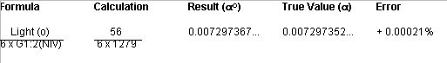
The error here is just under 1 part in 500000, a fabulously small deviation from the most recent estimate of alpha. The added factor of 6 may seem arbitrary, but 6 is related to the number 1279 in a geometric setting that is central to the New Bible Code (see below).
The Geometric Connection With Six
In The Creation Snowflake I show how gematria associated with Jesus Christ is related to a fractal snowflake created by a process mimicking the growth of real snowflakes. The fifth generation of the snowflake requires snowflake 3517 to be surrounded by an outer ring, comprising six snowflakes of 1279 units. This outer ring,which is the denominator in the calculation of alpha, is shown below.
Snowflake Ring of 7674 (6 x 1279) Units

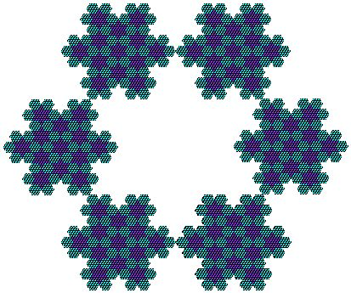
Bill Downie
31/5/04
Latest revision:
29/10/05
Home
Notes
1. Masoretic text. This is the standard text of the Hebrew Bible.
2. Holy Bible: New International Version (2001). This particular piece of the New Bible Code is also found in the New King James Version, the English Standard Version and the Revised Standard Version, which have the same wordings.
3. Irrational numbers are those numbers that can never be precisely calculated by the division of one whole number by another. Pi and e are also transcendental numbers.
4. If the derived value of pi were used to calculate the volume of water needed to fill a circular pond 3 metres in diameter and 0.5 metres deep, the calculated addition would be just 1 litre short of the required volume of 3534 litres.
5. If an error of -0.00002% were made in the calculation of the earth's circumference, the answer would be a mere 8 metres short of the true value.
6. A good approximation of pi has been found within the Masoretic Genesis 1:1 by Vernon Jenkins and coworkers. This is obtained by multiplying the product of the numerical values of the characters by the number of characters, multiplying the product of the numerical values of the words by the number of words, then dividing the first total by the second. This gives the number 3.14155...x 10E17, which, ignoring the factor of 10E17, is out by just 0.001%. An equally good approximation of e (2.71831...x 10E40) obtained by the same method, has been found within the Greek John 1:1 by Bevan Williams. As with the NIV encodings, these errors cancel out when the numbers are summed, to give a combined error of about one part in a million.
7. Alpha is a measured physical constant, as opposed to pi, Phi and e, which are mathematical absolutes.



Introduction
Those prepared to view the NIV Bible through the window of the New Bible Code see delicate frost patterns, created by a natural Intelligence who winks at us through the glass. These patterns accompany some of the Bible’s most important themes. For instance, the word ‘Immanuel’ (NIV spelling) appears three times in the Bible. Twice as a prophecy in Isaiah and once in Matthew, who informs us that the prophesy was fulfilled in the birth of Jesus Christ. Here we see how this assertion has been underlined by the judicious choice of chapter and verse numbers and English spellings.
The Immanuel Verses
Isaiah 7:14 (NIV)
'Therefore the Lord himself will give you a sign: the virgin will be with child and will give birth to a son, and will call him Immanuel.'

Isaiah 8:8 (NIV)
'and sweep on into Judah, swirling over it, passing through it and reaching up to the neck. Its outspread wings will cover the breadth of your land, O Immanuel!'

Matthew 1:23 (NIV)
'The virgin will be with child and will give birth to a son, and they will call him Immanuel - which means, "God with us."'
Chapters were added to the Bible in the 13th century, verses in the 16th century. However, despite the time lapses between the writing of these texts, chapterisation, versification and the various translations into the English language at different points in time, the entire effort was somehow coordinated by a force which was able to crystallise meaningful patterns into the structure of the NIV Bible.
1. By reading the chapter and verse indicators as a single number, we obtain 714, 88 and 123.
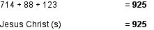
2. Note that the central number of the three is 88. This is the ordinal value of ‘Immanuel’.
Immanuel (o) = 88
3. To see more of the frosting, we simply sum each digit of the numbers:
7 + 1 + 4 + 8 + 8 + 1 + 2 + 3 = 34
Immanuel (r) = 34
4. If we now sum the given chapter and verse numbers in Isaiah, then do the same with Matthew we obtain these totals:
7 + 14 + 8 + 8 = 37
1 + 23 = 24
These multiply to yield 888. In the Greek numeration scheme 888 is the value of the word transliterated as ‘Ihsous’ (Jesus).
24 and 37 are also the reduced values of the words ‘Holy’ and ‘Spirit’.
Holy (r) = 24
Spirit (r) = 37
These two numbers are found together in hexagram 37, the seed figure for the Creation Snowflake, from which so many numerical values related to the Trinity are derived.
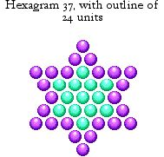

Holy (r) = 24
Spirit (r) = 37

The Eightfold Way
As stated above, the ordinal value of the English word ‘Immanuel’ is 88, this being two thirds of the digit sequence 888, the value under the Greek numeration scheme of the Greek word for ‘Jesus’. The visual semblance between these two numbers is reflected in the number of units constituting the volume and each face of cube 512.
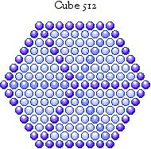

The number of units comprising the outer shell of cube 512 is 296. This number is an important factor of 888 (= 296 x 3) and is also a factor of the numbers 1480 and 2368, the values under the Greek numeration scheme of ‘Christos’ (Christ) and ‘Ihsous Christos’ (Jesus Christ).
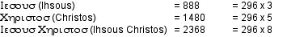
We find further evidence that these numerical values have been designed with cube 512 in mind, when we project the cube onto a surface along one of its diagonals, to create its 2D diagonal projection: hexagon 169.
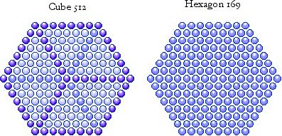

Using the iterative procedure described in About Numbers, triangle 253 can be taken two steps towards the Koch Snowflake. The first step creates hexagon 169. The second step creates snowflake 151, the ordinal value of ‘Jesus Christ’ and ‘Holy Spirit’. This figure sits comfortably inside hexagon 169 as shown below.
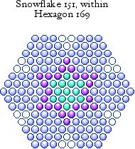

Jesus Christ (o) = 151
Holy Spirit (o) = 151
Nested inside snowflake 151 we find the seed figure for the Creation Snowflake, hexagram 37, with its highlighted outline of 24 units. As shown above, these are factors of 888 (Ihsous) and the reduced values of ‘Holy’ and Spirit’.
For further information on this remarkable geometric confluence, go to The Key.
Star Of David
I would like to round off this page by showing you another geometric link between the names ‘Immanuel’ and ‘Jesus Christ’ in which hexagram 37, the seed figure for the Creation Snowflake, is again involved. The standard value of the word ‘Immanuel’ is 475, and this number can be factorised as 19 x 25. Now 19 is the third hexagonal number and 25 is a diamond number, therefore the number 475 can be illustrated as a compound figure: a hexagon of diamonds.
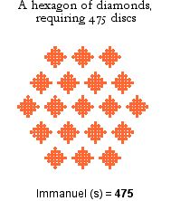
As shown in About Numbers, a hexagon/hexagram pair is formed from a triangle after the first iteration of the Koch snowflake process or by the self-intersection of two triangles. In numerical geometry, every third triangle will self-intersect in this way. The third such triangle is triangle 28, which intersects as shown below to form hexagon 19 and the aforementioned hexagram 37.
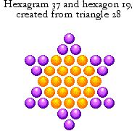
The hexagram of diamonds that complements the compound figure of 475 discs is constructed from 925 (37 x 25) individual discs. But this number, as I showed above, is the standard value of the name ‘Jesus Christ’! This striking relationship in gematria is symbolised by the compound Star of David we create by highlighting the internal hexagram within the hexagram. The Star of David is of course the perfect symbol of Jesus Christ, who was a Jew from the line of David.
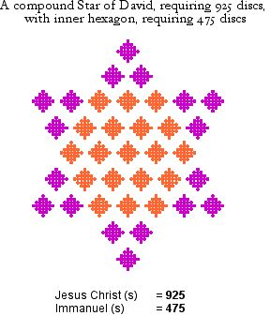
Bill Downie
5/7/06



Introduction
If English gematria and the New Bible Code are real phenomena, we might expect that the name ‘Jesus Christ’ would produce a rich harvest of meaningful numbers. This is in fact the case. Here I will show how this name has been crafted to encode a number with highly-integrated geometric properties, skillfully woven into the tapestry of the New Bible Code. This number is the standard value of the name ‘Jesus Christ’, which is 925.
Bear in mind, though, that the numbers obtained under other systems of numeration are also of considerable interest, as are those obtained for alternative names and titles for our Lord. These are dealt with in other pages on this website, particularly, The Signature of Christ, Immanuel and the Creation Snowflake.
Compound Star
In the webpage ‘Immanuel’ I showed how 925, the standard value of the name ‘Jesus Christ’, is encoded within the Christian Bible, over the three verses in which the name ‘Immanuel’ is given. Here again is the encoding.
Isaiah 7:14 (NIV)
'Therefore the Lord himself will give you a sign: the virgin will be with child and will give birth to a son, and will call him Immanuel.'

Isaiah 8:8 (NIV)
'and sweep on into Judah, swirling over it, passing through it and reaching up to the neck. Its outspread wings will cover the breadth of your land, O Immanuel!'

Matthew 1:23 (NIV)
'The virgin will be with child and will give birth to a son, and they will call him Immanuel - which means, "God with us."'
By reading the chapter and verse indicators as a single number, we obtain 714, 88 and 123.
I also showed how the number 925 is integrated with the standard value for the word ‘Immanuel’, 475, in a compound Star of David, where each ‘unit’ is a diamond of 25 units. This figure is illustrated below.

Diamonds Are Forever
The number 925 is also figurate in its own right. Firstly, 925 is the 22nd member of the diamond series. The diamond is identical to the centred square, which is obtained by rotating the diamond by 45 degrees. However, it is the diamond form we will be discussing here. The figure is illustrated below.
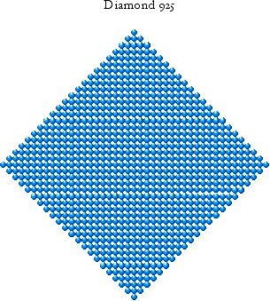
This figure relates the standard value of 'Jesus Christ' (925) to the reduced value of ‘Jesus Christ’ (43) because diamond 925 fits perfectly inside square 1849, which has a side of 43 units.
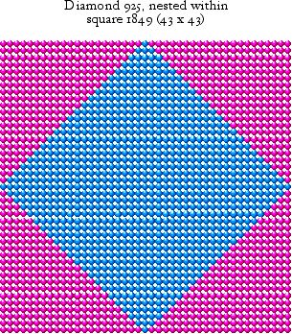

Jesus Christ (s) = 925
Jesus Christ (r) = 43

The Pentagon
The number 925 can take on more than one geometric form. It is also the 25th pentagonal number, as illustrated below.
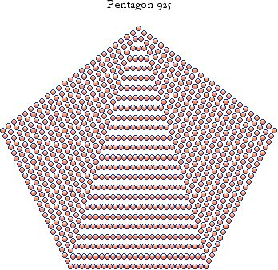
The number of units difference between this pentagon and the previous member of the series is 73, which is also the base of the 73rd triangle, with 2701 units. We are now on the brink of a fascinating correlation between the name ‘Jesus Christ’ and the Hebrew Bible’s opening verse. Firstly, note that under the Hebrew system of numeration, the Masoretic Genesis 1:1 sums to the triangular number 2701.

Genesis 1:1 (Mas)
Masoretic Genesis 1:1 (s) = 2701

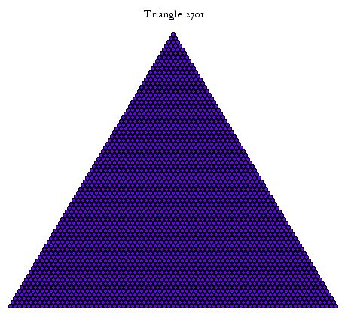
Triangle 2701 has the feature of having a central unit, as has every third triangle. Inside triangle 2701 we find a series of concentric triangles, nested inside each other like Russian dolls, all the way down to this central unit. This internal structure is illustrated below.
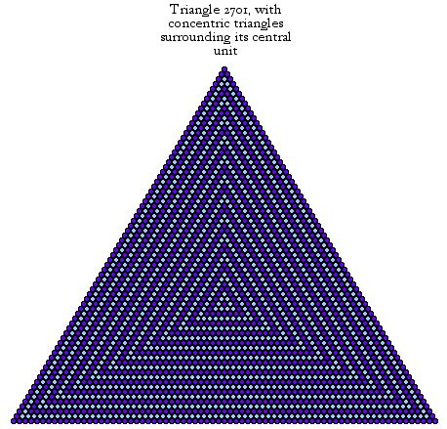
Summing the bases of all of these triangles gives us the series of pentagonal numbers. This can easily be seen with triangle 55 and its enclosed triangles, 1, 10 and 28. The bases of these four triangles can be folded to create the fourth pentagon in its series, pentagon 22.
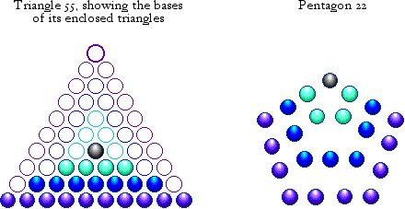
Now, from the bases of the triangles enclosed within triangle 2701, we can create pentagon 925!
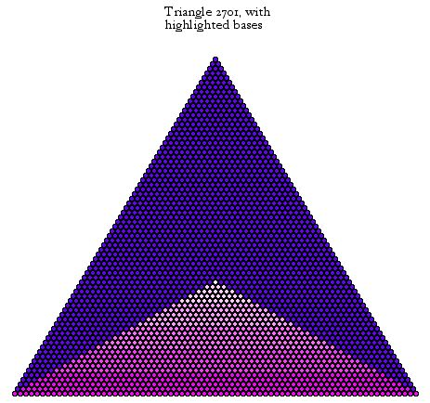
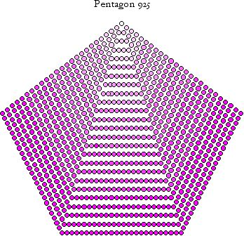
Jesus Christ (s) = 925
Finally, when 925 is subtracted from 2701, the remainder is 1776, or 888 x 2. 888 is, of course, the value under the Greek system of numeration of the Greek word transliterated as ‘Ihsous’ (Jesus)! So triangle 2701, representing the opening words of Genesis in the Masoretic Hebrew Bible, can be trisected to yield three numbers representing Jesus Christ.
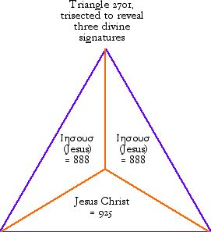
Bill Downie
8/7/06

Introduction
The New Testament is headed by four Gospels that tell us almost everything we know of the life and ministry of Jesus Christ. The first three of these books—Matthew, Mark and Luke—are known as the synoptic Gospels, because they give very similar accounts of Jesus’ life (it is thought that Matthew and Luke used Mark’s book as a source for their own accounts). The Gospel of John, however, has its own distinctive style and content and consequently stands apart from the synoptic Gospels.
The fundamental distinction between John and the other three Gospels appears to be highlighted by the encoding of two triangular numbers, one the sum of the ordinal values of the opening verses the Synoptic Gospels, the other the sum of the ordinal values of all four opening verses (see note 1). A study of the structural properties of these numbers reveals numerical links to the subject of all four Gospels: Jesus Christ.
The Synoptic Gospel Verses
The first verses of the three synoptic Gospels are as follows:
Matt. 1:1 (NIV)
A record of the genealogy of Jesus Christ, the son of David, the son of Abraham:
Mark 1:1 (NIV)
The beginning of the gospel about Jesus Christ, the son of God.
Luke 1:1 (NIV)
Many have undertaked to draw up an account of the things that have been fulfilled among us,
NIV Matt 1:1 + Mark 1:1 + Luke 1:1 (o) = 669 + 580 + 831 = 2080
The number 2080 is the 64th triangular number, as illustrated below.
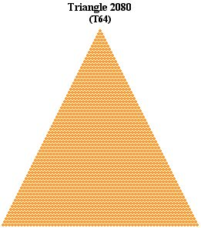
This is a fairly unlikely event: the chance of 2080 being triangular is only 1 in 64 and the chances of it having any figurate properties, whilst higher, is still much less than evens. Moreover, the triangle is a potent symbol of the divine, embodying the concept of the Trinity.
The Four Gospel Verses
Adding the first verse of John to the synoptic verses we can find the ordinal values of all four Gospels.
Matt. 1:1 (NIV)
A record of the genealogy of Jesus Christ, the son of David, the son of Abraham:
Mark 1:1 (NIV)
The beginning of the gospel about Jesus Christ, the son of God.
Luke 1:1 (NIV)
Many have undertaked to draw up an account of the things that have been fulfilled among us,
John 1:1 (NIV)
In the beginning was the word, and the word was with God, and the word was God.
NIV Matt 1:1 + Mark 1:1 + Luke 1:1 + John 1:1 (o) = 669 + 580 + 831 + 695 = 2775
Amazingly, 2775 is also a triangular number, the 74th in its series! Again, few numbers of this magnitude have any geometric properties. Its triangular form is illustrated below.
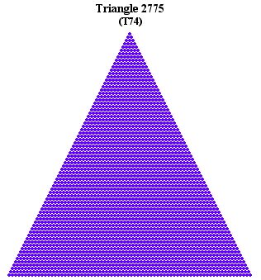
The place value of this triangle, which happens to be the number of units along its base, is 74. This number also happens to be very strongly linked with the name and person of Jesus through gematria!
Jesus (o) ...................= 74
Messiah (o) ..............= 74
Cross (o) ..................= 74
Gospel (o) ................= 74
So 74 is the ordinal value of the name of the man whose life, mission, death and resurrection are so carefully recorded in the four Gospels. Note that the word ‘Gospel’ itself has an ordinal value of 74, as does the word ‘Messiah’, the Hebrew equivalent of ‘Christ’. The triangularity of this number again reflects the Christian concept of the Trinity, which was no doubt the intention.
The Gospel Triangles
If we now superimpose triangle 2080 upon triangle 2775 we see a natural division between the triangle representing the synoptic Gospels and the remainder, a trapezium, representing the fourth Gospel. The trapezium extends the triangle, just as John is an extention and completion of the Gospels.
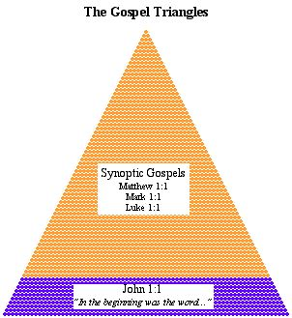
Triangle 2775 itself has further features of interest for us, to which we will now turn.
From Triangle To Trapezium
Two out of every three triangular numbers (those with three and six units at their centre) are divisible by 3. 2775 is such a number and division of 2775 by 3 gives 925. This is the standard value of the name ‘Jesus Christ’!
Jesus Christ (s) .......= 925
925 x 3...................= 2775
This leads us to a natural trisection of triangle 2775 and a third geometric form for 925, already known to us as a diamond and a pentagon. The form this time is a trapezium.
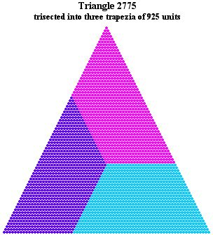

Jesus Christ (s) .......= 925
The three trapezia are identical in every respect and show that the number 925 is very naturally derived from the second Gospel triangle.
Triangle 3003
Finally, the study of triangular numbers, to which the discovery of such a number encoded within the Gospels leads, reveals a startling geometrical link between the triangular extentions of the numbers 74 and 77, the ordinal values of ‘Jesus’ and ‘Christ’. The 77th triangular number is 3003, which is illustrated below.
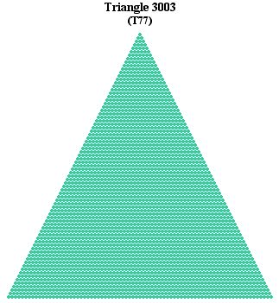
Triangle 3003 is the smallest triangle that can completely enclose triangle 2775. This relationship is a consequence of the fact that they are the 77th and 74th triangles in the series: a difference of three in ordinal values is the minimum requirement for triangle nesting.
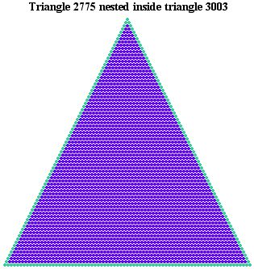
Triangle 5778
Triangle 3003 can also form a trapezium on which triangle 2775 can sit to yield a larger triangle, the 107th in the series, with 5778 units. Of the first 100 triangular numbers about 4% will create another triangular number when paired in this way. Therefore this phenomenon is statistically unlikely.
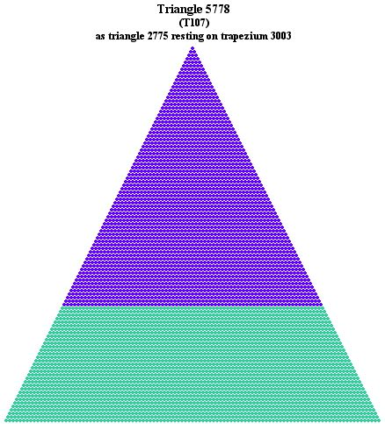
Such an uncommon geometric feature is evidence of prior planning, rather than random action, a hypothesis that is greatly strengthened when we discover that the geometric connection between these numbers is implied by the ordinal values of some phrases directly related to Jesus Christ.
Jesus (o) ...................= 74
Christ (o) ..................= 77
The Messiah (o) ........= 107
The Cross (o) ............= 107
God the Son (o) .........= 107
Summary
The Gospel triangles are stunning evidence that the natural division of the four Gospels into the three synoptics and John has been consciously reflected in the numerical values of their opening verses. The internal structures of these triangles provide numbers that, via gematria, have primary links with Jesus Christ, the subject of the Gospels. The triangles are therefore further evidence that both the translation of the NIV bible and the evolution of the English language have been guided by a divine hand, and appear to be hallmarks of divine approval on the Gospels themselves.
Bill Downie
29/4/07
Home
Notes
1. The method of combining the numerical values of verses from widely spaced but otherwise related biblical locations is well-established, having revealed encoded numbers elsewhere in the NIV Bible. For example, see From The Beginning.
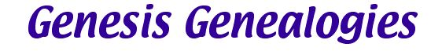
Introduction
The Book of Genesis chronicles the lives of Adam and his descendants, beginning with the creation of Adam in chapter 2 and ending with the death of Joseph in the book’s final chapter. For the particular genealogical line ending with Joseph we are told the lifespan of each male, which usually includes their age at the birth of their first son and either the years they lived afterwards or their total lifespan. Consequently, an unbroken genealogical record exists stretching from Adam to Joseph.
The genealogical line includes Noah, who survived the Flood by building an ark on the instructions of God, Abraham, the first of the three Patriarchs, who led his people to the land of Canaan on the instructions of God, and Joseph, the dreamer, who was sent to Egypt by his brothers, became a powerful man there and later called his family down from Canaan to save them from the seven-year famine. One great theme runs through the lives of these three men: they lead God’s people through an important transitional period in their history. For Noah it was escape from the Flood, for Abraham emigration to a new land and for Joseph escape from a great famine. These facts have some bearing on what is to follow.
Having found encoded numbers within biblical lists in Numbers, Ezra/Nehemiah and other books, I have long suspected that the genealogical list in Genesis could also be profitably mined. Initially I concentrated on Genesis 5 and 11, where most of the lifespans were found, finding tantalising but incomplete glimpses of a hidden code. However, I was unaware that this genealogical list actually threaded its way through the rest of Genesis. On discovering the rest of the list I was quickly able to find the treasure within, and with it final confirmation of the reality of the Lord’s Second Coming, encoded hundreds of years before the Incarnation.
The Genealogies
The genealogical list from Adam to Joseph is tabulated below. Each row represents the biblical location of each piece of genealogical information, this location given in the left-hand column. The second column from the left shows the place value of selected verses—only those of interest here are shown. The next column gives the names of each male in the generational line from Adam to Joseph, the three columns after it (A, B and C) showing the details of their lifespans—note that this three-column layout is based on the biblical format. The right-hand column shows the running totals of all the numbers in the three columns at selected points—again, only those of direct interest are shown.
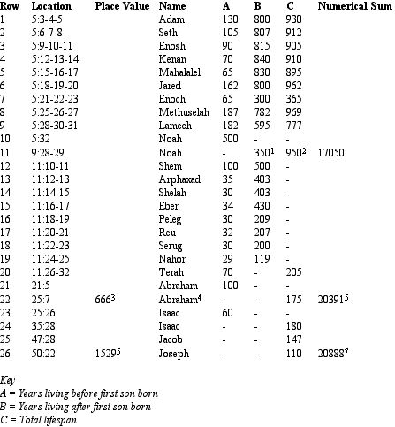
Eight notable features of this list are discussed below. Note that there are other points of interest, but their discussion would obscure the more important features I want to communicate.
1. Genesis 9:28 states that this is the years Noah lived after the flood, rather than after the birth of his first son. This is the only time that the father’s age when his oldest son is born is not directly stated. I have added the number written in the Bible rather than calculating Noah’s age at his son’s birth, as past experience has shown that the biblical number is always the one to be used.
2. There is a confluence of elevens here. A + B + C = 17050, which is 11 x 5 x 5 x 62. In addition, the subtotals B and (consequently) A + C are themselves multiples of 11. This is also the 11th row. Note that the chapter here is 9, also suggesting 9/11.
As shown elsewhere on this site, the number 11 and (to a lesser extent) the number 5 are the key numbers for unlocking the meaning behind the 9/11 event. In this respect it is interesting to note that most of the lifespans are recorded in chapters 5 and 11. The chapter 5 total is 15750, a triple multiple of 5. The total for chapter 11 is 3066, or 511 x 6.
3. Genesis 25:7 is the Bible’s 666th verse. As I have shown, 666 is encoded into 9/11. This is also the 22nd set of ages, as set out (22 = 11 x 2).
4. The sum of the ordinal values of the names to here, as laid out, is 1111 (11 x 101). Like row 11, row 22 seems to be suggesting 9/11 to us.
5. 20391 is the first of a pair of encoded numbers, referring to the Second Coming through English, Hebrew and Greek gematria:
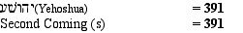
This encoding is found on row 22, the same row as the 666th verse, producing a meaningful confluence of numbers: 666 and 391 are encoded elsewhere within the NIV Bible and within the 9/11 event itself, as detailed in 9/11.
If this encoding is real then the digit 2 in the number 20391 must refer to the Second Coming.
6. Genesis 50:22 is the Bible’s 1529th verse. This number is not as immediately compelling as 666. However, it assuredly points us in the same direction:
Jesus Christ + The Second Coming (s) = 1529
Completing the confluence of 11s found in the list, 1529 is also a multiple of 11.
7. 20888 is the grand total for the entire list of lifespans and the second encoded number. Taking the last three digits, as before, we obtain a number that restates the first message:
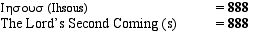
As before, this encoding is found in the same row as a significant chapter, this time the 1529th. Since both numbers are related to the Second Coming through gematria, this is a second meaningful confluence of numbers.
Again, the 2 in 20888 must refer to the Second Coming.
In addition, the highest prime factor of 20888 is a number surely confirming that this is no random collection of lifespans but one that was carefully designed to reveal the Word of God to us.
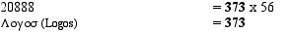
8. There is a correspondance between the encoded numbers and the narrative within Genesis, through the three focal points of these encodings, rows 11, 22 and 26. In row 11 we find Noah, who built the ark that preserved a remnant of God’s people and earth’s flora and fauna. In row 22 we find Abraham, the first of the three Patriarchs, who led his people to Canaan. In row 26 we find Joseph, who called his family down to Egypt and saved them from the famine. These people created the definitive events in the Genesis narrative.
Summary
All the significant numbers associated with the New Bible Code—2, 5, 11, 373, 391 and 888—are found together in this elegant numerical weave. The numbers 391 and 888 in particular could almost be called the New Bible Code in miniature, as they embody its essential message:
a) Their sum is 1279, the number of units in the third generation of The Creation Snowflake. 373 is the number of units in the second generation of this figure.
b) They feature in the multilayered encodings revealed in From The Beginning and The Signature Of Christ.
c) They form a cross embedded into the chapters of the Bible, as described in 9/11: Amos. This marks the site of a major 9/11 prophecy.
d) They are the numerical values of the Hebrew and Greek words for Jesus and of the English phrases ‘Second Coming’ and ‘The Lord’s Second Coming’, which perfectly summarise the message of the code.
Finally, 888 is the standard value of ‘The New Bible Code’. This was assuredly not by my own design!
The confluence of names associated with the transitional periods in Genesis, significant chapter place values and encoded numbers surely makes the authenticity of these encodings beyond reasonable doubt. They also reveal the significance of the Second Coming itself, as another great period of transition, which this time will be the salvation of not just a few middle eastern tribes, but of all of God’s people.
Bill Downie
2/5/07

