Torah
http://en.wikipedia.org/wiki/Torah
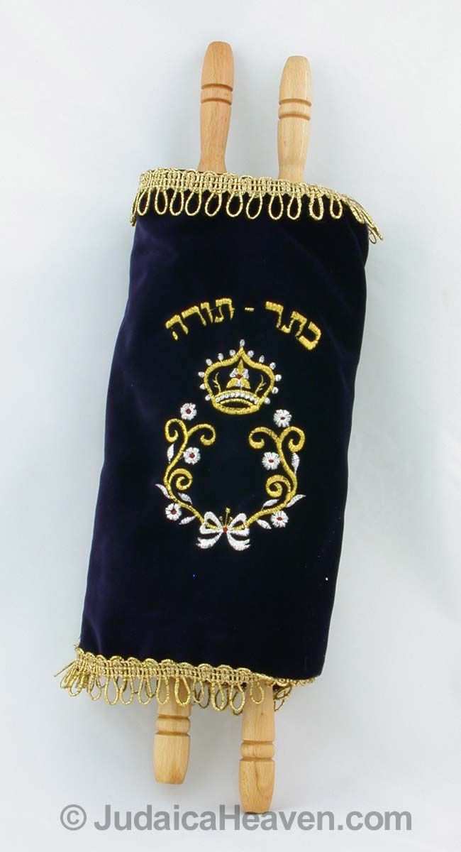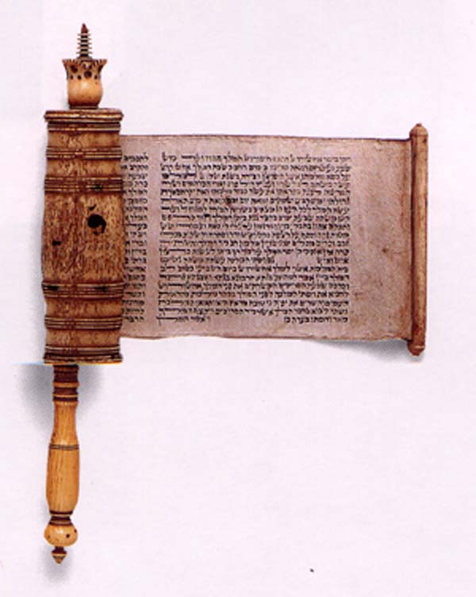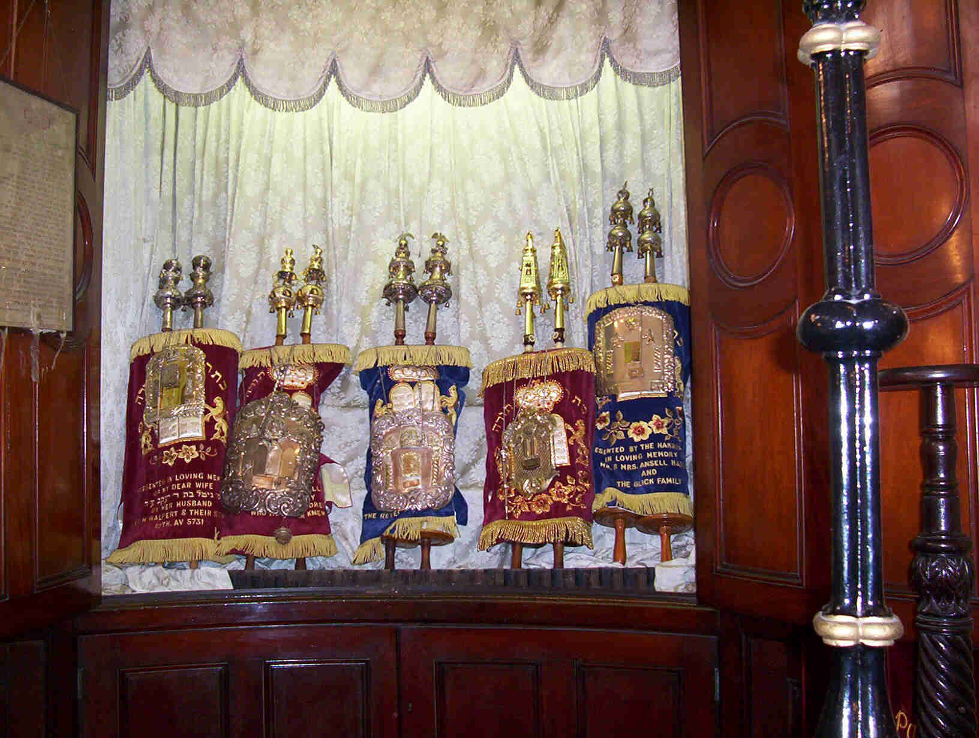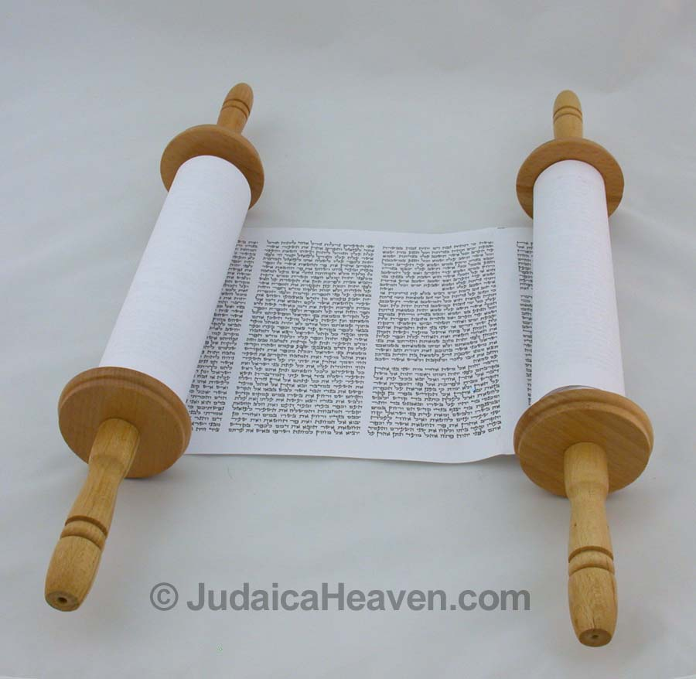
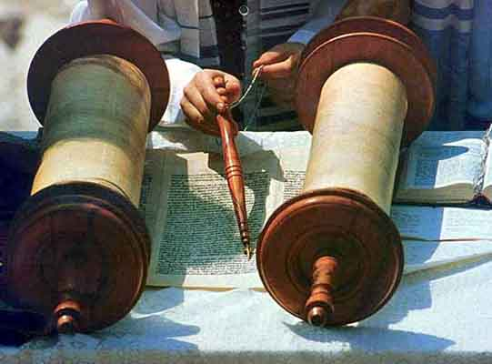

Torah (תּוֹרָה) is a Hebrew word meaning "teaching," "instruction," or "law". It is the central and most important document of Judaism revered by Jews through the ages. It is written in Hebrew, the oldest Jewish language. It is also called the Law of Moses (Torat Moshe תּוֹרַת־מֹשֶׁה). Torah primarily refers to the first section of the Tanakh–the first five books of the Tanach. The term is sometimes also used in the general sense to also include both Judaism's written law and oral law, encompassing the entire spectrum of authoritative Jewish religious teachings throughout history, including the Mishnah, the Talmud, the Midrash, and more.
The five books and their names and pronunciations in the original Hebrew are as follows:
- Genesis (בראשית, Bereshit: "In the beginning...")
- Exodus (שמות, Shemot: "Names")
- Leviticus (ויקרא, Vayyiqra: "And he called...")
- Numbers (במדבר, Bammidbar: "In the desert..."), and
- Deuteronomy (דברים, Devarim: "Words", or "Discourses")
(The Hebrew names are taken from initial words within the first verse of each book. See, for example, Genesis 1:1.)
The Torah is also known as the Five Books of Moses or the Pentateuch (Greek for "five containers," which refers to the scroll cases in which books were being kept). Other names include Hamisha Humshei Torah (חמשה חומשי תורה, "[the] five fifths/parts [of the] Torah") or simply the Humash (חומש "fifth"). A Sefer Torah is a formal written scroll of the five books, written by a Torah scribe under exceptionally strict requirements.
For Jews, the Torah was traditionally accepted as the literal word of God as told to Moses. For many, it is neither exactly history, nor theology, nor legal and ritual guide, but something beyond all three. It is the primary guide to the relationship between God and man, and the whole meaning and purpose of that relationship, a living document that unfolds over generations and millennia.

Contents
- 1 Structure
- 2 Production and usage of a Torah scroll
- 3 The Torah as the core of Judaism
- 4 The divine meaning of even individual words and letters
- 5 The Torah and the Oral Law
- 6 Other views of the Torah
- 7 See also
- 8 Further reading
- 9 External links

Structure

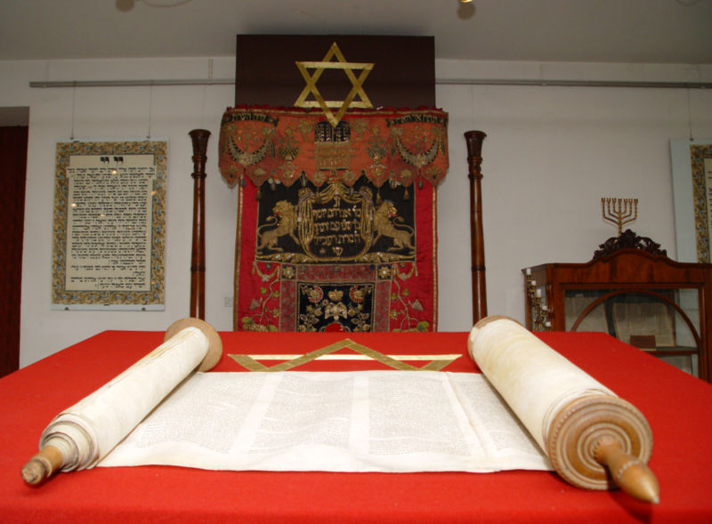
A Sefer Torah opened for liturgical use in a synagogue service

The five books contain both a complete and ordered system of laws, particularly the 613 mitzvot (613 distinct "commandments", individually called a mitzvah), as well as a historical description of the beginnings of what came to be known as Judaism. The five books (particularly Genesis, the first part of Exodus, and much of Numbers) are, primarily, a collection of seemingly historical narratives rather than a continuous list of laws; moreover, many of the most important concepts and ideas from the Torah are found in these stories. The book of Deuteronomy is different from the previous books; it consists of Moses' final speeches to the Children of Israel at the end of his life.
According to the classical Jewish view, the stories in the Torah are not always in chronological order. Sometimes they are ordered by concept (Talmud tractate Pesachim 7a) -- Ein mukdam u'meuchar baTorah "[There is] not 'earlier' and 'later' in [the] Torah". This view is accepted by Orthodox Judaism. Non-Orthodox Jews generally understand the same texts as signs that the current text of the Torah was redacted from earlier sources (see documentary hypothesis, a view rejected by Orthodoxy).

[] Production and usage of a Torah scroll
Manuscript Torah scrolls are still used, and still written, for ritual purposes (i.e. religious services); this is called a Sefer Torah ("Book [of] Torah"). They are written using a painstakingly careful methodology by highly qualified scribes, and copies of the text that are centuries or millennia old have come down to us with almost unchanged wording as a result of this system. The reason for such care is it is believed that every word, or marking, has divine meaning, and that not one part may be inadvertently changed lest it lead to error. The text of the Torah can also be found in books, which are mass-printed in the usual way for individual use, often containing both the Hebrew text and a translation in the language of publication (English, French, Russian etc). For more details on production of ritual scrolls, see the article Sefer Torah.
Printed versions of the Torah in normal book form (codex) are known as a Chumash (plural Chumashim) ("[Book of] Five or Fifths"). They are treated as respected texts, but not anywhere near the level of sacredness accorded a Sefer Torah, which is often a major possession of a Jewish community. A chumash contains the Torah and other writings, usually organized for liturgical use, and sometimes accompanied by some of the main classic commentaries on individual verses and word choices, for the benefit of the reader.
All Torah scrolls are stored in the holiest part of the synagogue in the Ark known as the "Holy Ark" (אֲרוֹן הקֹדשׁ aron hakodesh in Hebrew.) Aron in Hebrew means cupboard or closet and Kodesh is derived from 'Kadosh', or 'holy'.
Torah Shebiktav, or Written Torah

[] The Torah as the core of Judaism
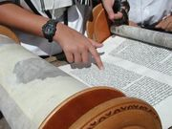
Ashkenazi Torah scroll

The Torah is the primary document of Judaism. According to Jewish tradition it was revealed to Moses by God.
Classical rabbinic writings offer various ideas on when the entire Torah was revealed. The revelation to Moses at Mount Sinai is considered by many to be the most important revelatory event. According to datings of the text by Orthodox rabbis this occurred in 1280 BCE. Some rabbinic sources state that the entire Torah was given all at once at this event. In the maximalist view, this dictation included not only the "quotes" which appear in the text, but every word of the text itself, including phrases such as "And God spoke to Moses...", and included God telling Moses about Moses' own death and what would happen afterward.
Other classical rabbinic sources hold that the Torah was revealed to Moses over many years, and finished only at his death. Another school of thought holds that although Moses wrote the vast majority of the Torah, a number of sentences throughout the Torah must have been written after his death by another prophet, presumably Joshua. Abraham ibn Ezra and Joseph Bonfils observed that some phrases in the Torah present information that people should only have known after the time of Moses. Ibn Ezra hinted, and Bonfils explicitly stated, that Joshua (or perhaps some later prophet) wrote these sections of the Torah. Other rabbis would not accept this view.
The Talmud (tractate Sabb. 115b) states that a peculiar section in the Book of Numbers (10:35 — 36, surrounded by inverted Hebrew letter nuns) in fact forms a separate book. On this verse a midrash on the book of Mishle (also called Proverbs) states that "These two verses stem from an independent book which existed, but was suppressed!" Another (possibly earlier) midrash, Ta'ame Haserot Viyterot, states that this section actually comes from the book of prophecy of Eldad and Medad. The Talmud says that God dictated four books of the Torah, but that Moses wrote Deuteronomy in his own words (Talmud Bavli, Meg. 31b). All classical views, nonetheless, hold that the Torah was entirely or almost entirely Mosaic and of divine origin.
For more information on these issues from an Orthodox Jewish perspective, see Modern Scholarship in the Study of Torah: Contributions and Limitations, Ed. Shalom Carmy, and Handbook of Jewish Thought, Volume I, by Aryeh Kaplan.
In contrast, modern historians conclude that the origin of the Torah indeed came from this time-frame, but developed in different strands, which were eventually redacted together sometime around 400 BCE, the time of Ezra the scribe. These views are accepted as correct by Conservative, Reform and Reconstructionist Judaism. Rabbis in these denominations have developed a number of theories about God and revelation which reject a secular interpretation of the documentary hypothesis, accept that the Torah was written by Moses and later prophets under divine inspiration, and which also strive to be in accord with historical consensus.
There is very little support for higher biblical criticism in Modern Orthodox Judaism, and absolutely none in Haredi Judaism and Hasidic Judaism. Applying the techniques of higher criticism to books of the Bible other than the Torah is frowned upon, but applying these techniques to the Torah itself is usually considered to be both mistaken and heretical. As such, the overwhelming majority of Orthodox Judaism views the documentary hypothesis to be heretical. Orthodox rabbis well-known for taking issue with documentary hypothesis include Meir Leibush Malbim and Samson Raphael Hirsch.

[] The divine meaning of even individual words and letters
The Rabbis hold that not only are the words giving a Divine message, but indicate a far greater message that extends beyond them. Thus they hold that even as small a mark as a kotzo shel yod (קוצו של יוד), the serif of the Hebrew letter yod (י), the smallest letter, or decorative markings, or repeated words, were put there by God to teach scores of lessons. This is regardless of whether that yod appears in the phrase "I am the Lord thy God," or whether it appears in "And God spoke unto Moses saying." In a similar vein, Rabbi Akiva, who died in 135 CE, is said to have learned a new law from every et (את) in the Torah (Talmud, tractate Pesachim 22b); the word et is meaningless by itself, and serves only to mark the accusative case. In other words, the Orthodox view is that even apparently contextual text "And God spoke unto Moses saying..." is no less important than the actual statement.
One kabbalistic interpretation is that the Torah constitutes one long name of God, and that it was broken up into words so that human minds can understand it. While this is effective since it accords with our human reason, it is not the only way that the text can be broken up.
The Biblical Hebrew language is sometimes referred to as "the flame alphabet" because many devout Jews believe that the Torah is the literal word of God written in fire.

[] The Torah and the Oral Law
See also: Oral Torah
Many Jewish laws are not directly mentioned in the Torah, but are derived from textual hints, which were expanded orally, and eventually written down in the Mishnah and Talmud.
Torah She'Bal Peh, or Torah of the Mouth
Jewish tradition holds that the Torah has been transmitted in parallel with an oral tradition. Jews point to texts of the Torah, where many words and concepts are left undefined and many procedures mentioned without explanation or instructions; the reader is required to seek out the missing details from the oral sources. For example, many times in the Torah it says that/as you are/were shown on the mountain in reference of how to do a commandment (Exodus 25:40).
According to classical rabbinic texts this parallel set of material was originally transmitted to Moses at Sinai, and then from Moses to Israel. At that time it was forbidden to write and publish the oral law, as any writing would be incomplete and subject to misinterpretation and abuse. However, after persecution and exile, this restriction was lifted when it became apparent that in writing was the only way to ensure that the Oral Law could be preserved.
Around 200 CE, Rabbi Judah haNasi took up the compilation of a nominally written version of the Oral Law, the Mishnah. Other oral traditions from the same time period not entered into the Mishnah were recorded as "Baraitot" (external teaching), and the Tosefta. Other traditions were written down as Midrashim. Over the next four centuries this small, ingenious record of laws and ethical teachings provided the necessary signals and codes to allow the continuity of the same Mosaic Oral traditions to be taught and passed on in Jewish communities scattered across both of the world's major Jewish communities, (from Israel to Babylon).
After continued persecution more of the Oral Law had to be committed to writing. A great many more lessons, lectures and traditions only alluded to in the few hundred pages of Mishnah, became the thousands of pages now called the Gemara. Gemara is Aramaic, having been compiled in Babylon. The Hebrew word for it is Talmud. The Rabbis in Israel also collected their traditions and compiled them into the Jerusalem Talmud. Since the greater number of Rabbis lived in Babylon, the Babylonian Talmud has precedence should the two be in conflict.
Orthodox Jews and Conservative Jews accept these texts as the basis for all subsequent halakha and codes of Jewish law, which are held to be normative. Reform and Reconstructionist Jews deny that these texts may be used for determining normative law (laws accepted as binding) but accept them as the authentic and only Jewish view of understanding the Bible and its development throughout history. (Reform and Reconstructionist, although they reject Jewish law as normative, do not accept the religious texts of any other faith.)

[] Other views of the Torah
- Christian view of the Torah
- Islamic view of the Torah
- Samaritan Pentateuch for the Samaritan view of the Torah.
- Documentary Hypothesis for an academic view of the Torah.
- Kabbalah for the kabbalist view of the Torah

[] See also
- Bible
- Moses
- Sefer Torah
- Tanakh
- Torah reading
- Parsha
- Judeo-Christian tradition
- Comparing and contrasting Judaism and Christianity
- Quran

[] Further reading
- Robert Alter, The Five Books of Moses. New York: W.W. Norton & Co., 2004.
- Shalom Carmy, Ed. Modern Scholarship in the Study of Torah: Contributions and Limitations, Jason Aronson, Inc., 1996.
- Charles B. Chavel, Ramban: Commentary on the Torah. 5 vols. New York: Shilo Publishing House, Inc., 1971.
- A. Cohen, The Soncino Chumash. London: Soncino Press, 1956.
- William G. Dever, Who Were the Early Israelites?. Grand Rapids, MI: William B. Eerdmans Publishing Co., 2003.
- Harvey J. Fields, A Torah Commentary for Our Times. 3 vols. New York: Union of American Hebrew Congregations, 1998. ISBN 0-8074-0530-2
- Israel Finkelstein & Neil A. Silberman, The Bible Unearthed. New York: Simon and Schuster, 2001. ISBN 0-684-86912-8
- Everett Fox, The Five Books of Moses. Dallas: Word Publishing, 1995.
- Richard Elliott Friedman, Commentary on the Torah. San Francisco: HarperSanFrancisco, 2003. ISBN 0-06-050717-9
- J.H. Hertz, The Pentateuch and Haftorahs. London: Soncino Press, 1985.
- Samson Raphael Hirsch, Isaac Levy (or), The Pentateuch. 7 vols. London: Judaica Press, 1999.
- Aryeh Kaplan, Handbook of Jewish Thought, Volume I, Moznaim Pub.
- Lawrence Kushner & Kerry M. Olitzky, Sparks Beneath the Surface; A Spiritual Commentary on the Torah. Northvale, NJ: Jason Aronson, 1992. ISBN 1-56821-016-7
- David Lieber, Etz Hayim: Torah and Commentary. Philadelphia: Jewish Publication Society, 2001. (a Conservative standard)
- Nehama Leibowitz, New Studies in the Weekly Sidra. 7 vols. Jerusalem: Hemed Press.
- Elie Munk, The Call of the Torah: An Anthology of Interpretation and Commentary on the Five Books of Moses. 5 vols. Brooklyn: Mesorah Publications Ltd., 1994.
- W. Gunther Plaut, Bernard Bamberger, William W. Hallo, The Torah: A Modern Commentary. New York: Union of American Hebrew Congregations, 1981. (a Reform standard)
- Jean-Marc Rouvière, Brèves méditations sur la création du monde, L'Harmattan Paris 2006
- Nahum M. Sarna & Chaim Potok (ors), JPS Torah Commentary. Philadelphia: Jewish Publication Society, 1996. ISBN 0-8276-0331-2
- Nosson Scherman, The Chumash: Stone ion of the Artscroll Chumash. Brooklyn: Mesorah Publications Ltd., 1994. (an Orthodox standard)

[] External links
- The Torah
- Jewish Encyclopedia: Torah
- The Judaica Press Complete Tanach with Rashi
- Torah.Org
- Torah Studies
- Rebbi Adin Steinsaltz talks about the Torah to BBC
- Lidrosh Institute of Torah Education MP3 Audio
- YUTorah, Torah archive of Yeshiva University
- Torah study with Rashi
- ParshaParts Weekly Parsha commentaries in English
Kabbalah
Retrieved from "http://en.wikipedia.org/wiki/Torah"
Categories: Articles lacking sources from December 2006 | All articles lacking sources | Abrahamic texts | Hebrew words | Old Testament topics | Torah | Year of work unknown | Religious texts
================================================================================================================================
END

