Autobiography of a Yogi - Illustrations

by Paramhansa Yogananda
Original First Edition, Copyright 1946,
by Paramhansa Yogananda
http://www.crystalclarity.com/yogananda/index.html

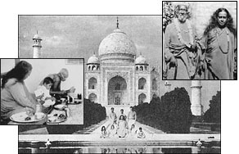
Ananda and Crystal Clarity Publishers are pleased to announce the online publication of the complete first edition of Autobiography of a Yogi. Through this online version, we hope to make Yogananda's spiritual classic freely available to seekers throughout the world. The print version of the 1946 Autobiography is available direct from Crystal Clarity Publishers through secure online ordering. See Our Guarantee and Secure Ordering information. We hope you enjoy this free gift of the first online edition.
Ananda was founded by Swami Kriyananda, a direct disciple of Yogananda. Kriyananda was inspired by his guru to start 'World Brotherhood Colonies'. Ananda, and its sister colonies throughout the world, are the fulfillment of Yogananda's dream. See Chapter 48, in this 1946 edition, to read Yogananda's own words on World Brotherhood Colonies.
Autobiography of a Yogi is not an ordinary book. It is a spiritual treasure. To read its message of hope to all truthseekers is to begin a great adventure.
This is a verbatim reproduction of the original 1946 edition, complete with the original photos, many of them not seen since earlier editions. Although subsequent printings, reflecting revisions made after the author's death in 1952, have sold over a million copies and have been translated into more than 19 languages, the few thousand of the original have long since disappeared into the hands of collectors.

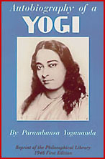

-Map of India
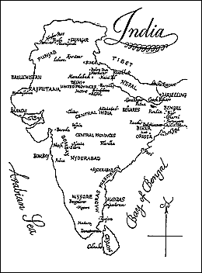

MY FATHER
Bhagabati Charan Ghosh
A Disciple of Lahiri Mahasaya

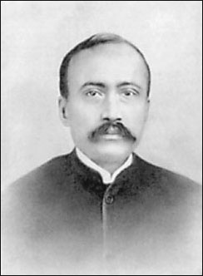

MY MOTHER
A Disciple of Lahiri Mahasaya

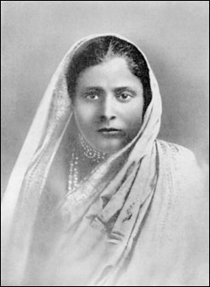

AMI PRANABANANDA
"The Saint With Two Bodies"
An Exalted Disciple of Lahiri Mahasaya

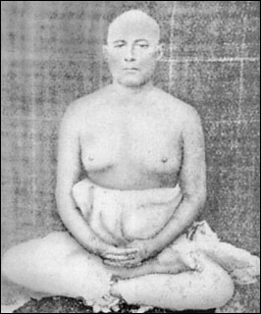

I stand behind my elder brother, Ananta.

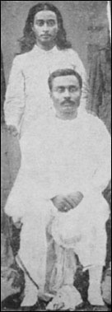

Last Solstice Festival celebrated by Sri Yukteswar, December, 1935. My Guru is seated in the center; I am at his right, in the large courtyard of his hermitage in Serampore.

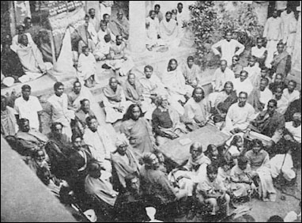

BHADURI MAHASAYA
"The Levitating Saint"
"Sir," I inquired, "why do you not write a book on yoga for the benefit of the world?"
"I am training disciples," He replied. "They and their students will be living volumes, proof against the natural disintegrations of time and the unnatural interpretaations of the critics."

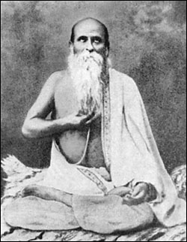

JAGADIS CHANDRA BOSE
India's great physicist, botanist, and inventor of the Crescograph

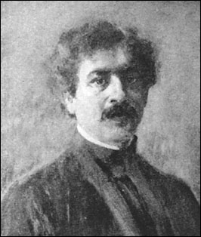

TWO BROTHERS OF THERESE NEUMANN
I stand with them in Konnersreuth, Bavaria

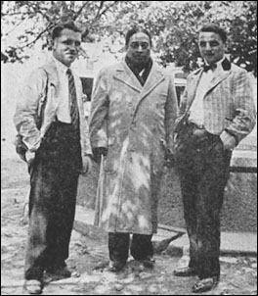

MASTER MAHASAYA
Ever engrossed in his blissful cosmic romance.

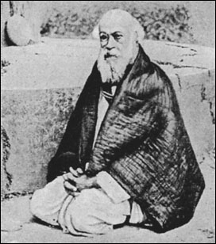

(Left to Right) Jitendra Mazumdar, my companion on the "penniless test" at Brindaban; Lalit-da, my cousin; Swami Kebelananda ("Shastri Mahasaya"), my saintly Sanskrit tutor; myself, as a high school youth

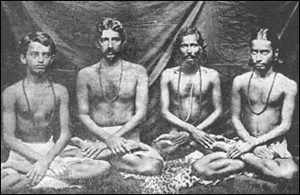

Ananda Moyi Ma, the Bengali "Joy-Permeated Mother."

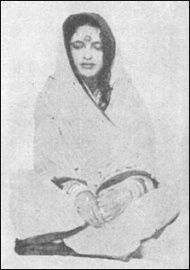

One of the caves occupied by Babaji in the Drongiri Mountains near Ranikhet in the Himalayas. A grandson of Lahiri Mahasaya, Ananda Mohan Lahiri (second from right, in white), and three other devotees are visiting the sacred spot.

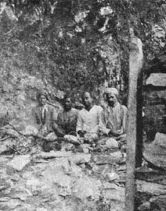

MY MASTER, SRI YUKTESWAR
Disciple of Lahiri Mahasaya

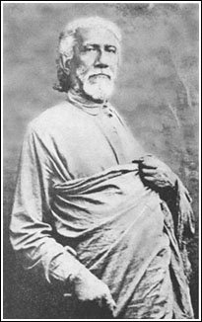

Main building at the Mount Washington Estates in Los Angeles, established in 1925 as American headquarters for the Self-Realization Fellowship.

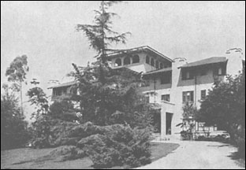

Self-Realization Church of All Religions, Hollywood, California.

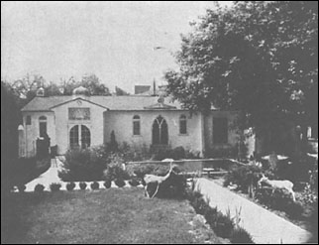

MY GURU'S SEASIDE HERMITAGE AT PURI
A steady stream of visitors poured from the world into the hermitage tranquillity. A number of learned men came with the expectation of meeting an orthodox religionist. A supercilious smile or a glance of amused tolerance occasionally betreayed that the newcomers anticipated nothing more than a few pious platitudes. Yet their reluctant departure would bring an expressed conviction that Sri Yukteswar had shown precise insight into their specialized fields of knowledge.
My guru always had young resident disciples in his hermitage. He directed their minds and lives with that careful discipline in which the word "disciple" is etymologically rooted.
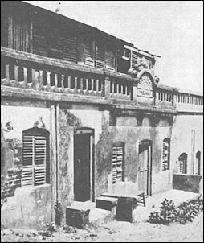

I stand with my two sisters, Roma (at left) and Nalini

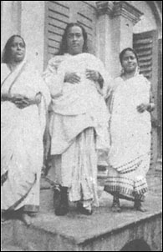

Self-Realization Church of All Religions, San Diego, California
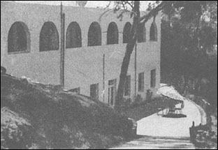

THE LORD IN HIS ASPECT AS SHIVA
Not a historical personage like Krishna, Shiva is the name given to God in the last aspect of His threefold nature (Creator-Preserver-Destroyer). Shiva, the Annihilator of maya or delusion, is symbolically represented in the scriptures as the Lord of Renunciates, the King of Yogis. In Hindu art He is always shown with the new moon in His hair, and wearing a garland of hooded snakes, ancient emblem of evil overcome and perfect wisdom. The "single" eye of omniscience is open on His forehead.
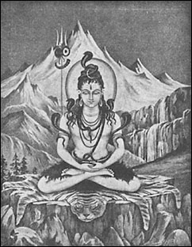

Yogoda Math, beautiful hermitage of Self-Realization Fellowship at Dakshineswar on the Ganges. Founded in 1938 as a yoga retreat for students of East and West.
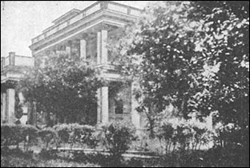

Kashi, lost and rediscovered
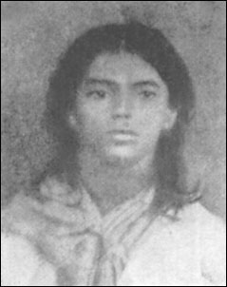

My brother Bishnu; Motilal Mukherji of Serampore, a highly advanced disciple of Sri Yukteswar; my father; Mr. Wright; myself; Tulsi Narayan Bose; Swami Satyananda of Ranchi
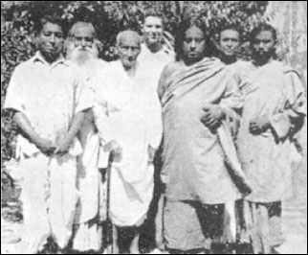

A group of delegates to the 1920 International Congress of Religious Liberals at Boston, where I gave my maiden speech in America. (Left to Right) Rev. Clay MacCauley, Rev. T. Rhondda Williams, Prof. S. Ushigasaki, Rev. Jabez T. Sunderland, myself, Rev. Chas. W. Wendte, Rev. Samuel A. Eliot, Rev. Basil Martin, Rev. Christopher J. Street, Rev. Samuel M. Crothers.
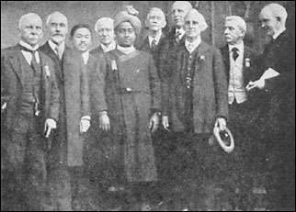

A GURU AND DISCIPLE
Forest hermitages were the ancient seats of learning, secular and divine, for the youth of India. Here a venerable guru, leaning on a wooden meditation elbow-prop, is initiating his disciple into the august mysteries of Spirit.
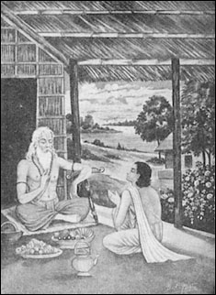

BABAJI, THE MAHAVATAR
Guru of Lahiri Mahasaya
I have helped an artist to draw a true likeness of the great Yogi-Christ of modern India.
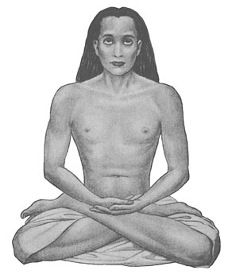

LAHIRI MAHASAYA
Disciple of Babaji and Guru of Sri Yukteswar
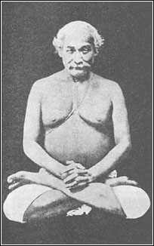

Luther Burbank, beloved friend, poses with me in his Santa Rosa garden.
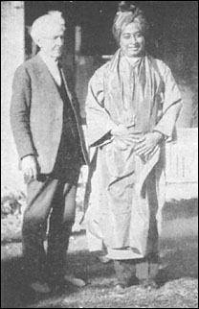

LUTHER BURBANK
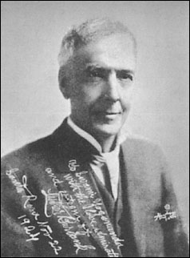

THERESE NEUMANN
Famous Catholic Stigmatist who inspired my 1935 pilgrimage to Konnersreuth, Bavaria
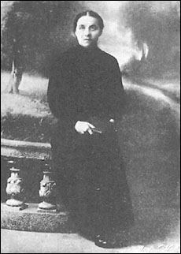

My companions and I pose before the "dream in marble," the Taj Mahal at Agra.
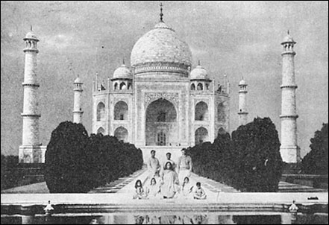

The woman yogi, Shankari Mai Jiew, only living disciple of the great Trailanga Swami. The turbaned figure seated directly beside her is Swami Benoyananda, a director of our Ranchi yoga school for boys in Bihar. The picture was taken at the Hardwar Kumbha Mela in 1938; the woman saint was then 112 years old.
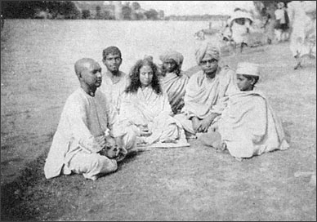

Krishnananda, at the 1936 Allahabad Kumbha Mela, with his tame vegetarian lioness.
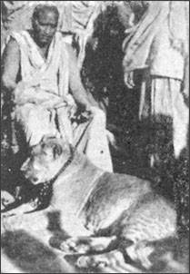

Second-floor dining patio of Sri Yukteswar's Serampore hermitage. I am seated (in center) at my guru's feet.
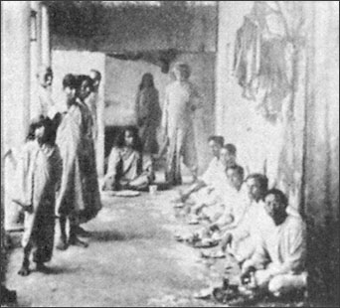

Mr. Wright, myself, Miss Bletch -- in Egypt
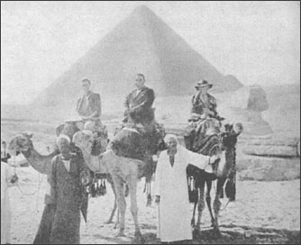

Rabindranath Tagore, inspired poet of Bengal, and Nobel Prizeman in literature
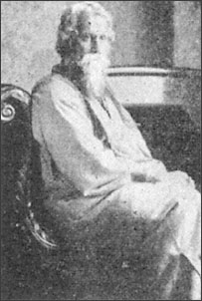

Mr. Wright and I pose with the venerable Swami Keshabananda and a disciple at the stately hermitage in Brindaban
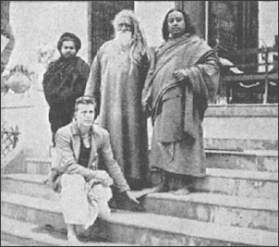

RISHNA, ANCIENT PROPHET OF INDIA
A modern artist's conception of the divine teacher whose spiritual counsel in the Bhagavad Gita has become the Hindu Bible. Krishna is portrayed in Hindu art with a peacock feather in his hair (symbol of the Lord's lila, play or creative sport), and carrying a flute, whose enrapturing notes awaken the devotees, one by one, from their sleep of maya or cosmic delusion.
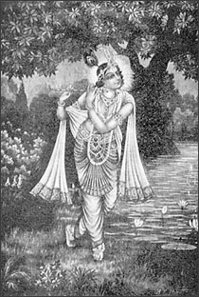

MAHATMA GANDHI
I enjoy a quiet lunch with India's political saint at his hermitage in Wardha, August, 1935.
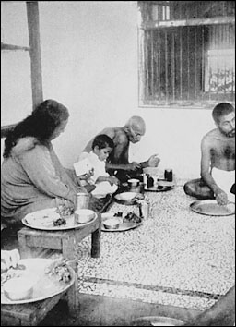

GIRI BALA
This great woman yogi has not taken food or drink since 1880. I am pictured with her, in 1936, at her home in the isolated Bengal village of Biur. Her non-eating state has been rigorously investigated by the Maharaja of Burdwan. She employs a certain yoga technique to recharge her body with cosmic energy from the ether, sun, and air.
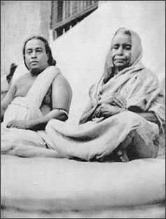

A group of Ranchi students and teachers pose with the venerable Maharaja of Kasimbazar (at center, in white). In 1918 he gave his Kasimbazar Palace and twenty-five acres in Ranchi as a permanent site for my yoga school for boys.
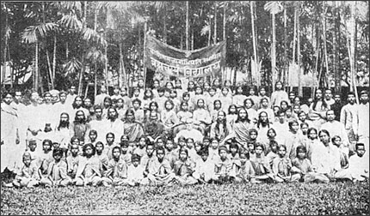

Sri Yukteswar and myself in Calcutta, 1935. He is carrying the gift umbrella-cane
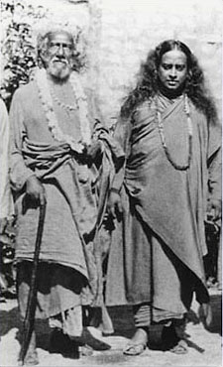

Mr. E. E. Dickinson of Los Angeles; he sought a silver cup
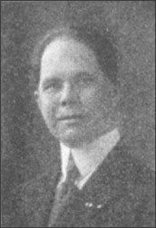

Encinitas, California, overlooking the Pacific. Main building and part of the grounds of the Self-Realization Fellowship
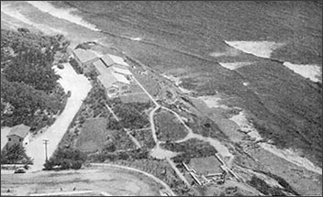

My venerable father, seated in the tranquil lotus posture, Calcutta, 1936
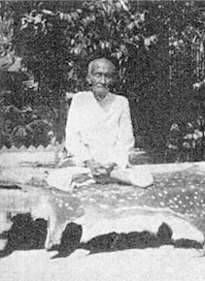

The Self-Realization Church of All Religions in Washington, D.C., whose leader, Swami Premananda, is here pictured with me
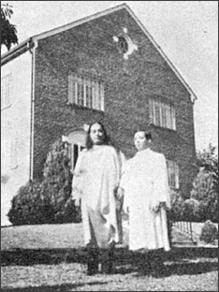

Speakers at a 1945 Interracial Meeting in San Francisco during the convening of the Peace Conference. (Left to right) Dr. Maneck Anklesaria, John Cohee, myself, Hugh E. MacBeth, Vince M. Townsend, Jr., Richard B. Moore




