

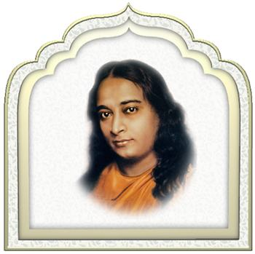

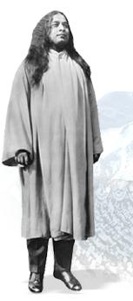 | 

n the hundred years since the birth of Paramahansa Yogananda, this beloved world teacher has come to be recognized as one of the greatest emissaries to the West of India's ancient wisdom. His life and teachings continue to be a source of light and inspiration to people of all races, cultures and creeds.

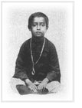
Paramahansa Yogananda was born Mukunda Lal Ghosh on January 5, 1893, in Gorakhpur, India, into a devout and well-to-do Bengali family. From his earliest years, it was evident to those around him that the depth of his awareness and experience of the spiritual was far beyond the ordinary. In his youth he sought out many of India's sages and saints, hoping to find an illumined teacher to guide him in his spiritual quest.
It was in 1910, at the age of 17, that he met and became a disciple of the revered Swami Sri Yukteswar Giri. In the hermitage of this great master of Yoga he spent the better part of the next ten years, receiving Sri Yukteswar's strict but loving spiritual discipline. After he graduated from Calcutta University in 1915, he took formal vows as a monk of India's venerable monastic Swami Order, at which time he received the name Yogananda (signifying bliss, ananda, through divine union, yoga). His ardent desire to consecrate his life to the love and service of God thus found fulfillment.

Yogananda began his life's work with the founding, in 1917, of a "how-to-live" school for boys, where modern educational methods were combined with yoga training and instruction in spiritual ideals. Visiting the school a few years later, Mahatma Gandhi wrote: "This institution has deeply impressed my mind."

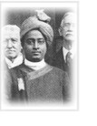
In 1920, Yogananda was invited to serve as India's delegate to an international congress of religious leaders convening in Boston. His address to the congress, on "The Science of Religion," was enthusiastically received. That same year he founded Self-Realization Fellowship to disseminate worldwide his teachings on India's ancient science and philosophy of Yoga and its time-honored tradition of meditation.
For the next several years, he lectured and taught on the East coast and in 1924 embarked on a cross-continental speaking tour. The following year, he established in Los Angeles an international headquarters for Self-Realization Fellowship, which became the spiritual and administrative heart of his growing work.

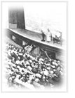
Over the next decade, Yogananda traveled and lectured widely, speaking to capacity audiences in many of the largest auditoriums in the country -- from New York's Carnegie Hall to the Los Angeles Philharmonic. The Los Angeles Times reported: "The Philharmonic Auditorium presents the extraordinary spectacle of thousands....being turned away an hour before the advertised opening of a lecture with the 3000-seat hall filled to its utmost capacity."
Yogananda emphasized the underlying unity of the world's great religions, and taught universally applicable methods for attaining direct personal experience of God. To serious students of his teachings he introduced the soul-awakening techniques of Kriya Yoga, a sacred spiritual science originating millenniums ago in India, which had been lost in the Dark Ages and revived in modern times by his lineage of enlightened masters.
Among those who became his students were many prominent figures in science, business, and the arts, including horticulturist Luther Burbank, operatic soprano Amelita Galli-Curci, George Eastman (inventor of the Kodak camera), poet Edwin Markham, and symphony conductor Leopold Stokowski. In 1927, he was officially received at the White House by President Calvin Coolidge, who had become interested in the newspaper reports of his activities.

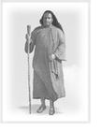
In 1935, Yogananda began an 18-month tour of Europe and India. During his yearlong sojourn in his native land, he spoke in cities throughout the subcontinent and enjoyed meetings with Mahatma Gandhi (who requested initiation in Kriya Yoga), Nobel-prize-winning physicist Sir C. V. Raman, and some of India's renowned spiritual figures, including Sri Ramana Maharshi and Anandamoyi Ma. It was during this year also that his guru, Swami Sri Yukteswar, bestowed on him India's highest spiritual title, paramahansa. Literally supreme swan (a symbol of spiritual discrimination), the title signifies one who manifests the supreme state of unbroken communion with God.

During the 1930s, Paramahansa Yogananda began to withdraw somewhat from his nationwide public lecturing so as to devote himself to the writings that would carry his message to future generations, and to building an enduring foundation for the spiritual and humanitarian work of Self-Realization Fellowship (known in India as Yogoda Satsanga Society).
Under his direction, the personal guidance and instruction that he had given to students of his classes was arranged into a comprehensive series of Self-Realization Fellowship Lessons for home study.
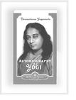
Yogananda's life story, Autobiography of a Yogi, was published in 1946 and expanded by him in subsequent editions. A perennial best seller, the book has been in continuous publication since it first appeared and has been translated into 18 languages. It is widely regarded as a modern spiritual classic.
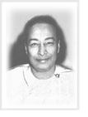
On March 7, 1952, Paramahansa Yogananda entered mahasamadhi, a God-illumined master's conscious exit from the body at the time of physical death. His passing was marked by an extraordinary phenomenon. A notarized statement signed by the Director of Forest Lawn Memorial-Park testified: "No physical disintegration was visible in his body even twenty days after death....This state of perfect preservat Paramahansa Yogananda:
A Yogi in Life and Death
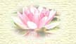
Paramahansa Yogananda entered mahasamadhi (a yogi’s final conscious exit from the body) in Los Angeles, California, on March 7, 1952, after concluding his speech at a banquet held in honor of H.E. Binay R. Sen, Ambassador of India.
The great world teacher demonstrated the value of yoga (scientific techniques for God-realization) not only in life but in death. Weeks after his departure his unchanged face shone with the divine luster of incorruptibility.
Mr. Harry T. Rowe, Los Angeles Mortuary Director, Forest Lawn Memorial-Park (in which the body of the great master is temporarily placed), sent Self-Realization Fellowship a notarized letter from which the following extracts are taken:
"The absence of any visual signs of decay in the dead body of Paramahansa Yogananda offers the most extraordinary case in our experience....No physical disintegration was visible in his body even twenty days after death....No indication of mold was visible on his skin, and no visible desiccation (drying up) took place in the bodily tissues. This state of perfect preservation of a body is, so far as we know from mortuary annals, an unparalleled one....At the time of receiving Yogananda’s body, the Mortuary personnel expected to observe, through the glass lid of the casket, the usual progressive signs of bodily decay. Our astonishment increased as day followed day without bringing any visible change in the body under observation. Yogananda’s body was apparently in a phenomenal state of immutability....
"No odor of decay emanated from his body at any time....The physical appearance of Yogananda on March 27th, just before the bronze cover of the casket was put into position, was the same as it had been on March 7th. He looked on March 27th as fresh and as unravaged by decay as he had looked on the night of his death. On March 27th there was no reason to say that his body had suffered any visible physical disintegration at all. For these reasons we state again that the case of Paramahansa Yogananda is unique in our experience."
If you would like to know more about the life of Paramahansa Yogananda, we invite you to browse our book and recording recommendations.

WHEN I AM ONLY A DREAM
BY PARAMAHANSA YOGANANDA

I come to tell you all of Him,
And the way to encase Him in your bosom,
And of the discipline that brings His grace.
Those of you who have asked me
To guide you to my Beloved’s presence—
I warn you through my silently talking mind,
Or speak to you through a gentle significant glance,
Or whisper to you through my love,
Or loudly dissuade you when you stray away from Him.
But when I shall become only a memory, or a mental image, or silently speaking voice,
When no earthly call will ever reveal
My whereabouts in unplumbed space,
When no shallow entreaty or stern stentorian command will bring from me an answer—
I will smile in your mind when you are right,
And when you are wrong I will weep through my eyes,
Dimly peering at you in the dark,
And weep through your eyes, perchance;

And I will whisper to you through your conscience,
And I will reason with you through your reason,
And I will love all through your love.
When you are able no longer to talk with me,
Read my Whispers from Eternity;
Eternally through it I will talk to you.
Unknown I will walk by your side
And guard you with invisible arms.
And as soon as you know my Beloved
And hear His voice in silence,
You will know me again more tangibly than you knew me on this earth plane.
And yet when I am only a dream to you,
I will come to remind you that you too are naught
But a dream of my Heavenly Beloved;
And when you know you are a dream, as I know now,
We will be ever awake in Him.

===================================================================END

