Paramahansa Yogananda 1893-1952
http://en.wikipedia.org/wiki/Paramahansa_Yogananda
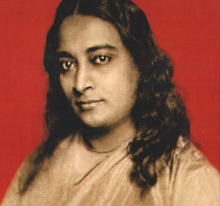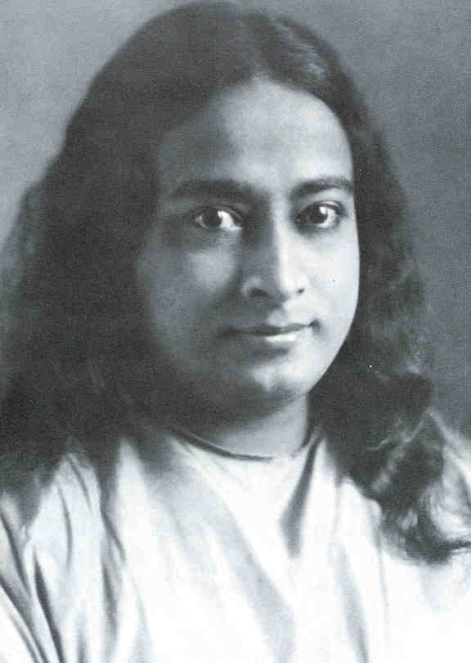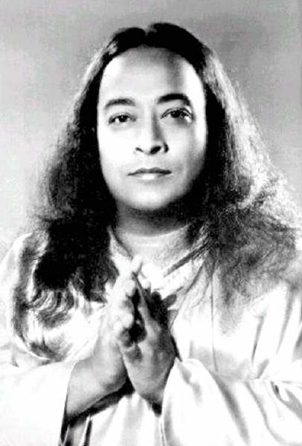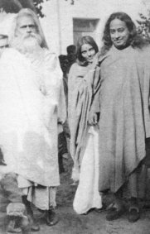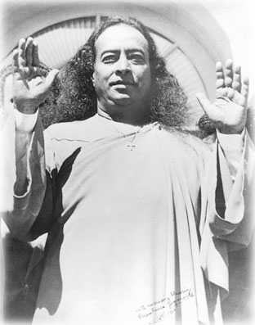
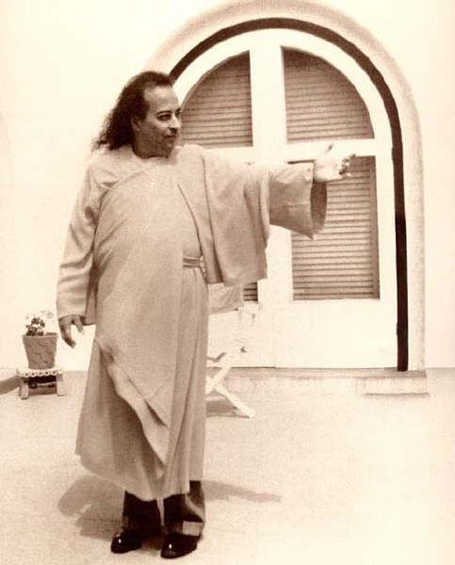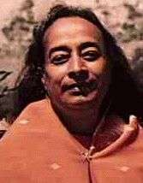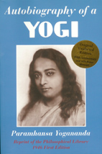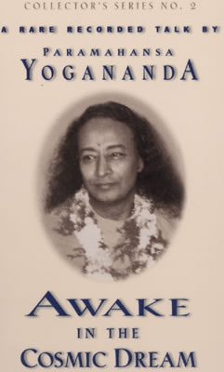

Paramahansa Yogananda (Bengali: পরমহংস যোগানন্দ Pôromôhongsho Joganondo, January 5, 1893–March 7, 1952), was an Indian yogi and guru. He was instrumental in bringing Kriya Yoga to the West.

Contents
- 1 Life
- 2 Legacy
- 3 Kriya Yoga
- 4 Autobiography of a Yogi
- 5 Claims of bodily incorruptibility
- 6 Notes
- 7 See also
- 8 External links

Life
Yogananda was born Mukunda Lal Ghosh in Gorakhpur, Uttar Pradesh, India into a devout Bengali family. From his earliest years, his awareness and experience of the spiritual was far beyond the ordinary. In his youth he sought out many of India's Hindu sages and saints, hoping to find an illuminated teacher to guide him in his spiritual quest.
Yogananda met his guru, Swami Sri Yukteswar Giri, in 1910, at the age of 17. After passing his Intermediate Examination in Arts from the Scottish Church College, Calcutta, he did his graduation in religious studies from the Serampore College, a constituent college of the University of Calcutta and in 1915, he took formal vows into the monastic Swami Order and became Swami Yogananda. In 1917, Yogananda began his life's mission with the founding and running of a school for boys in a remote hamlet of Bengal, called Dihika, by the side of river Damodar, that combined modern educational techniques with yoga training and spiritual ideals. A year later, the school was shifted to Ranchi. This school would later become Yogoda Satsanga Society of India, the Indian branch of Paramahansaji's American Organization.
In 1920, he went to the United States as India's delegate to an International Congress of Religious Liberals convening in Boston. That same year he founded Self-Realization Fellowship to disseminate worldwide his teachings on India's ancient practices and philosophy of Yoga and its tradition of mation. For the next several years, he lectured and taught on the East coast and in 1924 embarked on a cross-continental speaking tour. The following year, he established in Los Angeles an international headquarters for Self-Realization Fellowship, which became the spiritual and administrative heart of his growing work.
After fifteen years of his services in the West, Sri Yukteswar conferred upon him the title Paramahansa, which means "supreme swan."

[] Legacy
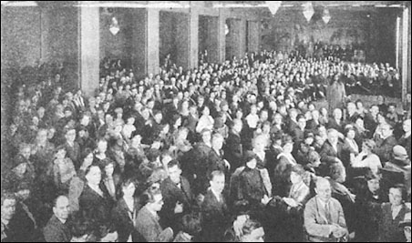
Paramahansa Yogananda during a yoga class in Washington, D.C.

Yogananda taught his students the need for direct experience of truth, as opposed to blind belief. He said that “The true basis of religion is not belief, but intuitive experience. Intuition is the soul’s power of knowing God. To know what religion is really all about, one must know God.” ^{[1]}
Yogananda, echoing traditional hindu teachings, taught that the entire universe was created for the entertainment of Brahman, that everything is simply God's cosmic "movie show", and that individuals are merely actors in the "divine play" who change "roles" through reincarnation. Yogananda advised against taking this "divine delusion" any more seriously than a movie theatre or television presentation. Good and evil exist in the divine play just as they exist in all "screen" plays. There wouldn't be a "play" without them.
To that end, he taught certain yoga techniques that he believed would help the student achieve Self-realization. He said that “Self-Realization is the knowing in all parts of body, mind, and soul that you are now in possession of the kingdom of God; that you do not have to pray that it come to you; that God’s omnipresence is your omnipresence; and that all that you need to do is improve your knowing.” ^{[2]}
Yogananda's work is continued by several organizations. Self-Realization Fellowship, which he founded, is headquartered in Los Angeles and has mation centers and temples across the world. The current head is Sri Daya Mata, a direct disciple of Yogananda.
Ananda, near Nevada City, California, was founded by Swami Kriyananda, a direct disciple of Yogananda. Ananda is unique in that it expresses an aspect of Yogananda's vision for world brotherhood colonies. Ananda Village is located in Nevada City, California, with six other Ananda "colonies" worldwide. Ananda also has centers and mation groups throughout the world.
Song of the Morning Retreat Center, near Vanderbilt, Michigan, was founded by Yogacharya Oliver Black, a direct disciple of Yogananda. As of September 2004 work is continuing on building the Clear Light Community on the 800 acre (3 km²) retreat property. The retreat center offers classes on yoga and mation and hosts programs featuring visiting spiritual teachers.
The Center for Spiritual Awareness, located in Lakemont, Georgia, was founded by Roy Eugene Davis, a direct disciple of Yogananda. The CSA publishes books and audio cassettes, and offers mation seminars at its retreat center headquarters on a voluntary donation basis.
The Puri, India, ashram of Yogananda's guru Sri Yukteswar Giri continues to this day.

[] Kriya Yoga
Yogananda's guru lineage was responsible for providing him with a central discipline of his teachings. Sri Yukteswar was the disciple of Lahiri Mahasaya, in turn the disciple of the mythical guru Mahavatar Babaji, who had revived and through his disciples begun the spread of Kriya Yoga, described as a "spiritual science of Self realization." It was through Yogananda that Kriya Yoga was brought to the West.

[] Autobiography of a Yogi
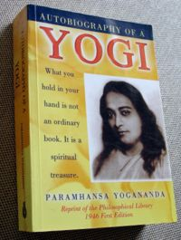

In 1946, Yogananda published his life story, Autobiography of a Yogi [1], which was instrumental in introducing vedic philosophy to the West. It has since been translated into eighteen languages and remains a best seller. It includes Yogananda's and Sri Yukteswar's attempts to explain certain verses and events of the Bible such as the Garden of Eden story, and descriptions of Yogananda's encounters with leading spiritual figures such as Therese Neumann, the Hindu saint Sri Anandamoyi Ma, Mohandas Gandhi, Nobel laureate in literature Rabindranath Tagore, noted plant scientist Luther Burbank (the book is 'Dedicated to the Memory of Luther Burbank, An American Saint'), famous Indian scientist Sir Jagadish Chandra Bose and Nobel Prize winning physicist Sir C. V. Raman.
Note: The 1946 ed. of Autobiography of a Yogi is in the Public Domain and can be downloaded from: Gutenberg

[] Claims of bodily incorruptibility
Some of Yogananda's followers have made claims of his bodily incorruptibility. As reported in Time Magazine on August 4, 1952, Harry T. Rowe, Los Angeles Mortuary Director of the Forest Lawn Memorial Park Cemetery in Glendale, California where he is interred, stated in a notarized letter:
The absence of any visual signs of decay in the dead body of Paramahansa Yogananda offers the most extraordinary case in our experience.... No physical disintegration was visible in his body even twenty days after death.... No indication of mold was visible on his skin, and no visible drying up took place in the bodily tissues. This state of perfect preservation of a body is, so far as we know from mortuary annals, an unparalleled one.... No odor of decay emanated from his body at any time....
Skeptics point to Yogananda's death certificate, which indicates his body was embalmed. They claim the full text of Rowe's letter, as included in a memorial booklet put out by the SRF, indicates his surprise that the described effect was based merely on the lack of use of special creams in addition to the embalming fluid.

[] Notes
- ^ Yogananda, Paramhansa. The Essence of Self-Realization
- ^ Yogananda, Paramhansa. The Essence of Self-Realization

[] See also
- Samadhi, poem by Yogananda
- Survey of Hindu organisations

External links
- Self-Realization Fellowship (SRF) website
- Yogananda Rediscovered website
- Ananda - Swami Kriyananda (J. Donald Walters) - Yogananda disciple
- Center for Spiritual Awareness - Rev. Roy Eugene Davis - Yogananda disciple
- Solar Logos - Norman Paulsen - Yogananda disciple
- Yogoda Satsanga Society of India (YSS) Official Website
- Works by Paramahansa Yogananda at Project Gutenberg
- Autobiography of a Yogi by Paramahansa Yogananda, available freely at Project Gutenberg
- Yogananda's Autobiography of a Yogi - Complete Online public domain version of the 1946 first ion
- Yogananda's Whispers from Eternity - Complete online ion of Yogananda's Prayer-Poems
- Poems from Yogananda's Songs of The Soul
- Yogananda SRF Devotee Message Board
- A Place for Paramahansa Yogananda Devotees Message Board
- Paramhansa Yogananda-A Different Light A dissident-disciple site
- Yogananda's interpretation of genesis
===============================================================================================================================
END

