Swami Vivekananda 1863-1902
http://en.wikipedia.org/wiki/Swami_Vivekananda
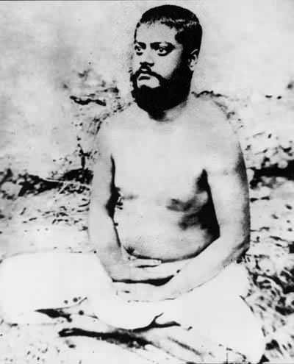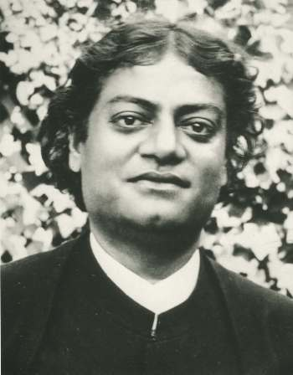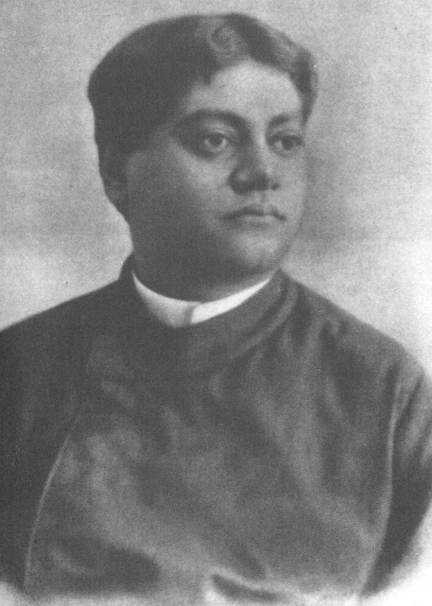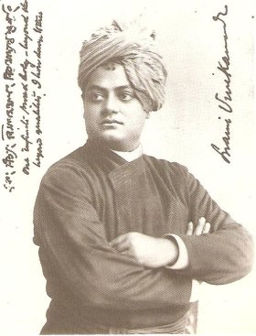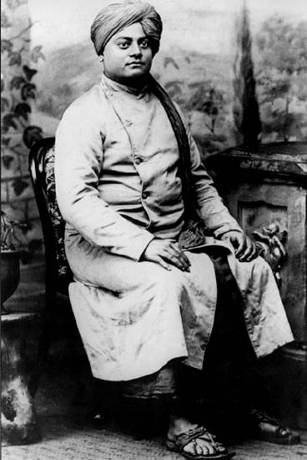

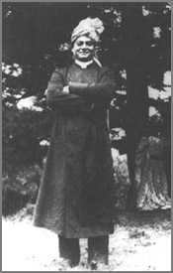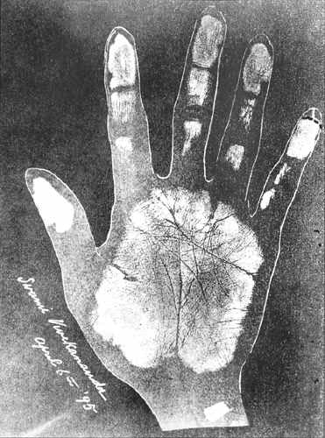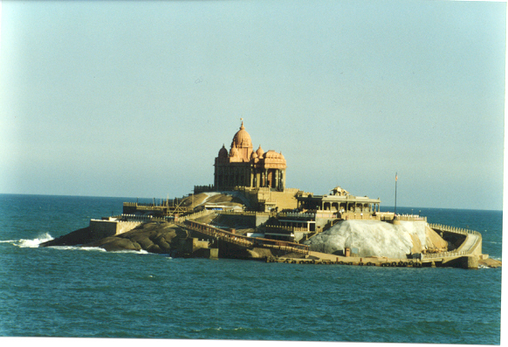
Swami Vivekananda's hand

Swami Vivekananda Bengali: স্বামী বিবেকানন্দ Shami Bibekanondo), whose pre-monastic name was Narendranath Dutta (নরেন্দ্রনাথ দত্ত Nôrendronath Dotto) and was affectionately known to some as Naren (January 12, 1863 - July 4, 1902) was one of the most famous and influential spiritual leaders of the philosophies of Vedanta and Yoga. He was the chief disciple of Ramakrishna Paramahamsa and was the founder of Ramakrishna Math and Ramakrishna Mission. Many consider him an icon for his fearless courage, his positive exhortations to the youth, his broad outlook on social problems, and countless lectures and discourses on Vedanta philosophy.

Contents
- 1 Biography
  - 1.1 Birth and early life
  - 1.2 With Ramakrishna
  - 1.3 Wanderings in India
  - 1.4 In the West
  - 1.5 Back in India
  - 1.6 Death
- 2 Principles and philosophy
- 3 Interaction with notable contemporaries
- 4 Works
- 5 Books on and by Swami Vivekananda
- 6 Quotes
- 7 Miscellaneous
- 8 Trivia
- 9 See also
- 10 References
- 11 External links

Biography

Birth and early life
Narendranath Dutta was born in Shimla Pally, Kolkata, West Bengal, India on January 12, 1863 as the son of Viswanath Dutta and Bhuvaneswari Devi. Even as he was young, he showed a precocious mind and keen memory. He practiced mation from a very early age. While at school, he was good at studies, as well as games of various kinds. He organised an amateur theatrical company and a gymnasium and took lessons in fencing, wrestling, rowing and other sports. He also studied instrumental and vocal music. He was a leader among his group of friends. Even when he was young, he questioned the validity of superstitious customs and discrimination based on caste and religion.
In 1879, Narendra entered the Presidency College, Calcutta for higher studies. After one year, he joined the Scottish Church College, Calcutta and studied philosophy. During the course, he studied western logic, western philosophy and history of European nations.
Questions started to arise in young Narendra's mind about God and the presence of God. This made him associate with the Brahmo Samaj, an important religious movement of the time, led by Keshab Chandra Sen. But the Samaj's congregational prayers and devotional songs could not satisfy Narendra's zeal to realise God. He would ask leaders of Brahma Samaj whether they have seen God. He never got a satisfying answer. It was during this time that Professor Hastie of Scottish Church College told him about Sri Ramakrishna of Dakshineswar.

[] With Ramakrishna
Narendra met Ramakrishna for the first time in November 1881. He asked Ramakrishna the same old question, whether he had seen God. The instantaneous answer from Ramakrishna was, "Yes, I see God, just as I see you here, only in a much intenser sense." Narendra was astounded and puzzled. He could feel the man's words were honest and uttered from depths of experience. He started visiting Ramakrishna frequently.
Though Narendra could not accept Ramakrishna and his visions, he could not neglect him. It had always been in Narendra's nature to test something thoroughly before he could accept it. He tested Ramakrishna to the maximum, but the master was patient, forgiving, humorous, and full of love. He never asked Narendra to abandon reason, and he faced all of Narendra's arguments and examinations with infinite patience. In time, Narendra accepted Ramakrishna, and while he accepted, his acceptance was whole-hearted. While Ramakrishna predominantly taught duality and Bhakti to his other disciples, he taught Narendra the Advaita Vedanta, the philosophy of non-dualism.
During the course of five years of his training under Ramakrishna, Narendra was transformed from a restless, puzzled, impatient youth to a mature man who was ready to renounce everything for the sake of God-realization. Soon, Ramakrishna's end came in the form of throat cancer in August 1886. After this Narendra and a core group of Ramakrishna's disciples took vows to become monks and renounce everything, and started living in a supposedly haunted house in Baranagore. They took alms to satisfy their hunger and their other needs were taken care of by Ramakrishna's richer householder disciples.

[] Wanderings in India
Soon, the young monks of Baranagore wanted to live the life of a wandering monk with rags and a begging bowl and no other possessions. On July 1890, Vivekananda set out for a long journey, without knowing where the journey would take him. The journey that followed took him to the length and breadth of the Indian subcontinent. During these days, Vivekananda assumed various names like Vividishananda, Satchidananda, etc., It is said that he was given the name Vivekananda by Maharaja of Khetri for his discernment of things, good and bad.
During these wandering days, Vivekananda stayed on king's palaces, as well as the huts of the poor. He came in close contact with the culture of different regions of India and various classes of people in India. Vivekananda observed the imbalance in society and tyranny in the name of caste. He realised the need for a national rejuvenation if India was to survive at all. He reached Kanyakumari, the southernmost tip of the Indian subcontinent on 24 December 1892. There, he swam across the sea and started mating on a lone rock. He thus mated for three days and said later that he mated about the past, present and future of India. The rock went on to become the Vivekananda memorial at Kanyakumari.
Vivekananda went to Madras and spoke about his plans for India and Hinduism to the young men of Madras. They were impressed by the monk and urged him to go to the United States and represent Hinduism in the World Parliament of Religions. Thus, helped by his friends at Chennai, Bhaskara Sethupathi, Raja of Ramnad and Maharajas of Mysore and Khetri, Vivekananda set out on his journey to the USA. The invite of the conference was actually given to Bhaskara Sethupathi, Raja of Ramnad to attend the World Parliament of Religions at Chicago. But he decided and encouraged Swami Vivekananda was the right person to participate and represent the views of Hinduism in the Parliament of World Religions.

[] In the West
Vivekananda was received well at the 1893 World Parliament of Religions in Chicago, where he delivered a series of lectures. He also earned wild applause for beginning his address with the famous words, "Sisters and brothers of America." Vivekananda's arrival in the USA has been identified by many to mark the beginning of western interest in Hinduism not as merely an exotic eastern oddity, but as a vital religious and philosophical tradition that might actually have something important to teach the West. Within a few years of the Parliament, he had started Vedantic centres in New York City and London, lectured at major universities and generally kindled western interest in Hinduism. His success was not without controversy, much of it from Christian missionaries of whom he was fiercely critical. After four years of constant touring, lecturing and retreats in the West, he came back to India in the year 1897.

[] Back in India
Admirers and devotees of Vivekananda gave him an enthusiastic reception on his return to India. In India, he delivered a series of lectures, and this set of lectures known as "Lectures from Colombo to Almora" is considered to have uplifted the morale of the then downtrodden Indian society. He founded the Ramakrishna Mission. This institution is now one of the largest monastic orders of Hindu society in India.
However, he had to bear great criticism from other orthodox Hindus for having travelled in -- what they perceived to be -- the impure West. His contemporaries also questioned his motives, wondering whether the fame and glory of his Hindu evangelism compromised his original monastic vows. His enthusiasm for America and Britain, and his spiritual devotion to his motherland, caused significant tension in his last years.
He once again toured the west from January 1899 to December 1900.

[] Death
On July 4, 1902 at Belur Math near Kolkata, he taught Vedanta philosophy to some pupils in the morning. He had a walk with Swami Premananda, a brother-disciple and gave him instructions concerning the future of the Ramakrishna Math. The same day, Vivekananda died of heart failure at the young age of 39.

[] Principles and philosophy
Vivekananda was a renowned thinker in his own right. One of his most important contributions was to demonstrate how Advaitin thinking is not merely philosophically far-reaching, but how it also has social, even political, consequences. One important lesson he claimed to receive from Ramakrishna was that "Jiva is Shiva " (each individual is divinity itself). This became his Mantra, and he coined the concept of daridra narayana seva - the service of God in and through (poor) human beings. If there truly is the unity of Brahman underlying all phenomena, then on what basis do we regard ourselves as better or worse, or even as better-off or worse-off, than others? - This was the question he posed to himself. Ultimately, he concluded that these distinctions fade into nothingness in the light of the oneness that the devotee experiences in Moksha. What arises then is compassion for those "individuals" who remain unaware of this oneness and a determination to help them.
Swami Vivekananda belonged to that branch of Vedanta that held that no one can be truly free until all of us are. Even the desire for personal salvation has to be given up, and only tireless work for the salvation of others is the true mark of the enlightened person. He founded the Sri Ramakrishna Math and Mission on the principle of Atmano Mokshartham Jagad-hitaya cha (आत्मनॊ मोक्षार्थम् जगद्धिताय च) (for one's own salvation and for the welfare of the World).
However, Vivekananda also pleaded for a strict separation between religion and government ("church and state"). Although social customs had been formed in the past with religious sanction, it was not now the business of religion to interfere with matters such as marriage, inheritance and so on. The ideal society would be a mixture of Brahmin knowledge, Kshatriya culture, Vaisya efficiency and the egalitarian Shudra ethos. Domination by any one led to different sorts of lopsided societies. Vivekananda did not feel that religion, nor, any force for that matter, should be used forcefully to bring about an ideal society, since this was something that would evolve naturally by individualistic change when the conditions were right.
Vivekananda made a strict demarcation between the two classes of Hindu scriptures : the Sruti and the Smritis. The Sruti, by which is meant the Vedas, consist of eternally and universally valid spiritual truths. The Smritis on the other hand, are the dos and donts of religions, applicable to society and subject to revision from time to time. Vivekananda felt that existing Hindu smritis had to be revised for modern times. But the Srutis of course are eternal - they may only be re-interpreted.
Vivekanda advised his followers to be holy, unselfish and have shraddha (faith). He encouraged the practise of Brahmacharya (Celibacy). In one of the conversations with his childhood friend Sri Priya Nath Sinha he attributes his physical and mental strengths, eloquence to the practice of brahmacharya.
Vivekananda didn't advocate the emerging area of parapsychology, astrology (one instance can be found in his speech Man the Maker of his Destiny, Complete-Works, Volume 8, Notes of Class Talks and Lectures) saying that this form of curiosity doesn't help in spiritual progress but actually hinders it.

[] Interaction with notable contemporaries
Many years after his death, Rabindranath Tagore (a prominent member of the Brahmo Samaj) had said: If you want to know India, study Vivekananda. In him everything is positive and nothing negative. Incidentally, in the earlier years Tagore did not have much respect for Swami Vivekananda for his idol-worshipping. On the other hand, Vivekananda was not particularly impressed by Tagore, though he had been interacting with Tagore's father Maharshi Debendra Nath. Vivekananda was a very good singer and used to sing lots of Bhajans, including about twelve written and composed by Tagore.
Mahatma Gandhi who strived for a lot of reform in Hinduism himself, said: Swami Vivekananda's writings need no introduction from anybody. They make their own irresistible appeal.
Though it may not be obvious, Swami Vivekananda inspired India's freedom struggle movement. His writings inspired a whole generation of freedom fighters, in Bengal in particular and India at large. Most prominent among them are Bagha Jatin and Subhash Chandra Bose:
I cannot write about Vivekananda without going into raptures. Few indeed could comprehend or fathom him even among those who had the privilege of becoming intimate with him. His personality was rich, profound and complex... Reckless in his sacrifice, unceasing in his activity, boundless in his love, profound and versatile in his wisdom, exuberant in his emotions, merciless in his attacks but yet simple as a child, he was a rare personality in this world of ours... Subhash Chandra Bose,^{[1]}
Aurobindo Ghosh, actually considered Swamiji as his mentor. While in Alipore Jail, Sri Aurobindo used to be visited by Swami Vivekananda in his mation. Swamiji guided Sri Aurobindo's yoga.
Vivekananda was a soul of puissance if ever there was one, a very lion among men, but the definitive work he has left behind is quite incommensurate with our impression of his creative might and energy. We perceive his influence still working gigantically, we know not well how, we know not well where, in something that is not yet formed, something leonine, grand, intutive, upheaving that has entered the soul of India and we say, "Behold, Vivekananda still lives in the soul of his Mother and in the souls of her children. --Sri Aurobindo--1915 in Vedic Magazine.
Vivekananda inspired Jamshedji Tata^{[2]} to set up Indian Institute of Science, one of India's finest Institutions.
Abroad, he had some interactions with Max Mueller. Nikola Tesla was one of those influenced by the Vedic philosophy teachings of the Swami Vivekananda.

[] Works
His books (compiled from lectures given around the world) on the four Yogas (Raja Yoga, Karma Yoga, Bhakti Yoga, Jnana Yoga) are very influential and still seen as fundamental texts for anyone interested in the Hindu practice of Yoga. His letters are of great literary and spiritual value. He was also a very good singer and a poet. He had composed many songs including his favorite Kali the Mother. He used humor for his teachings and was also an excellent cook. His language is very free flowing. His own Bengali writings stand testimony to the fact that he believed that words - spoken or written should be for making things easier to understand rather than show off the speaker or writer's knowledge.

[] Books on and by Swami Vivekananda
- The complete Works of Swami Vivekananda ISBN 81-85301-46-8
- Jnana Yoga by Swami Vivekananda ISBN 0-911206-21-3
- Raja Yoga by Swami Vivekananda ISBN 0-911206-23-X
- Karma Yoga and Bhakti Yoga by Swami Vivekananda ISBN 0-911206-22-1
- Life of Vivekananda by Romain Rolland ISBN 81-85301-01-8
- Vivekananda: A Biography by Swami Nikhilananda ISBN 0-911206-25-6
- The life of Swami Vivekananda by his eastern and western disciples ISBN 81-7505-044-6
- Swami Vivekananda: A Reassessment by Narasingha P. Sil ISBN 0-945636-97-0
- The Master As I Saw Him by Sister Niva
- Notes of Some Wanderings With the Swami Vivekananda by Sister Niva
- Swami Vivekananda in the West: New Discoveries by Marie Lousie Burke
- Comprehensive Biography of Swami Vivekanandaby Shailendranath Dhar
- A Short Life of Swami Vivekananda by Swami Tejasananda
- Vivekananda, World Teacher: His Teachings on the Spiritual Unity of Humankind" by Swami Adiswarananda
- Swami Vivekananda Natun Tathya Natun Alo by Shankari Prasad Basu
- Vivekananda Charit by Satyendranath Majumder

[] Quotes
"Each soul is potentially divine. The goal is to manifest this divinity within, by controlling nature, external and internal. Do this either by work, or worship, or psychic control, or philosophy - by one, or more, or all of these - and be free. This is the whole of religion. Doctrines, or dogmas, or rituals, or books, or temples, or forms, are but secondary details."
"The one theme of the Vedanta philosophy is the search after unity. The Hindu mind does not care for the particular; it is always after the general, nay, the universal. "what is it that by knowing which everything else is to be known." That is the one search."
"Look upon every man, woman, and everyone as God. You cannot help anyone, you can only serve: serve the children of the Lord, serve the Lord Himself, if you have the privilege."
"It may be that I shall find it good to get outside of my body -- to cast it off like a disused garment. But I shall not cease to work! I shall inspire men everywhere, until the world shall know that it is one with God."
"Mankind ought to be taught that religions are but the varied expressions of THE RELIGION, which is Oneness, so that each may choose the path that suits him best."
" So long as even a single dog in my country is without food, my whole religion will be to feed it."
"This is the gist of all worship - to be pure and to do good to others. He who sees Siva (God) in the poor, in the weak, and in the diseased, really worships Siva, and if he sees Siva only in the image, his worship is but preliminary. He who has served and helped one poor man seeing Siva in him, without thinking of his caste, creed, or race, or anything, with him Siva is more pleased than with the man who sees Him only in temples."
"Aye , who ever saw money make the man? It is man that always make money. The whole world has been made by the energy of man, by the power of enthusiasm, by the power of faith."
"It is a tremendous error to feel helpless. Do not seek help from anyone. We are our own help. If we cannot help ourselves, there is none to help us."
" All power is within you, you can do anything and everything. Believe in that, do not believe that you are weak... You can do anything and everything, without even the guidance of any one. All power is there. Stand up and express the divinity with you... Arise, awake, sleep no more. With each of you there is the power to remove all wants and all miseries. Believe in this, that power will be manifested. "
""Allow me to call you; brethren, by that sweet name - heirs of immortal bliss - yea,.... Ye are the children of God, the sharers of immortal bliss, holy and perfect beings. Ye divinities on earth - sinners! It is a sin to call a man so; it is standing libel on human nature."
"On this basic - being right and doing right the whole world can unite."
"We put our hands over our eyes and weep that it is dark."
"He alone lives who lives for others. The rest are more dead than alive."

[] Miscellaneous
The turban that Vivekananda used to wear is generally believed to be suggested by Maharaja of Khetri. It is also said that while he was a child, he was impresssed by the turban of the horse cab driver, who used to ferry his father on his daily work. Subsequently when he renounced the world and took to sanyasa, he started using one himself.

[] Trivia
- Swami Vivekananda was the first Indian to be invited to accept the chair of Oriental Philosophy at Harvard University.
- India celebrates National Youth Day on his birthday
- Vivekananda Vidyapith Academy of Indian Philosophy and Culture in NJ, USA, is named after him.
- The Swami Vivekananda International Convention Centre, inaugurated in April 2005 in Pailles, Mauritius, is also named after him.

[] See also
- Ramakrishna
- Ramakrishna Math
- Ramakrishna Mission
- Sister Niva
- Sri Aurobindo
- Sri Sarada Devi
- Vedanta Society
- Vivekanandar Illam

[] References
- ^ http://kaustubh88.tripod.com/
- ^ IISC

[] External links
- Comprehensive biographical data, complete works, all known pictures, letters, newspaper reports, reminiscences, new findings and more, researched and compiled by noted Vivekananda scholar Frank Parlato Jr.
- Advaita Ashrama
- more about Swami Vivekananda on www.belurmath.org
- The complete works of Swami Vivekananda online
- Vivekananda's biography
- Swami Vivekananda, the Educationist Par Excellence
- Sri Ramakrishna Math.org
- Swami Vivekananda - Biography, Talks and Quotes of Vivekananda
- List of books on and by Swami Vivekananda
- Poetry of Swami Vivekananda
- A Selection of Quotes from Swami Vivekananda
- Highly reverential biography of Swami Vivekananda
- A Chronological Record of Swami Vivekananda in the West
- Photographs of Swami Vivekananda
- Links on Swami Vivekananda
- Vivekananda--His Gospel of Man-making
- Swami Vivekananda and Christianity Article by Sita Ram Goel
- Swami Vivekananda (in Turkish)
- Swami Vivekananda given at World Parliament of Religion in 1893 - 3 famous speeches in Text + Audio version.
- Grotz, Toby, "The Influence of Vedic Philosophy on Nikola Tesla's Understanding of Free Energy".
=================================================================================================================================
END

