Mahābhārata
http://en.wikipedia.org/wiki/Mahabharata

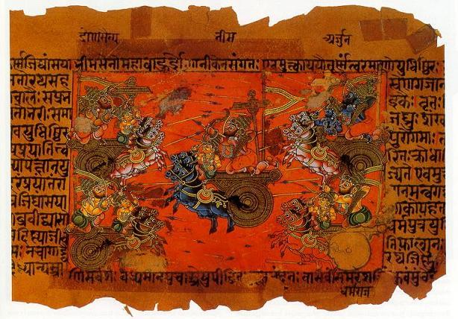
Manuscript illustration of the Battle of Kurukshetra

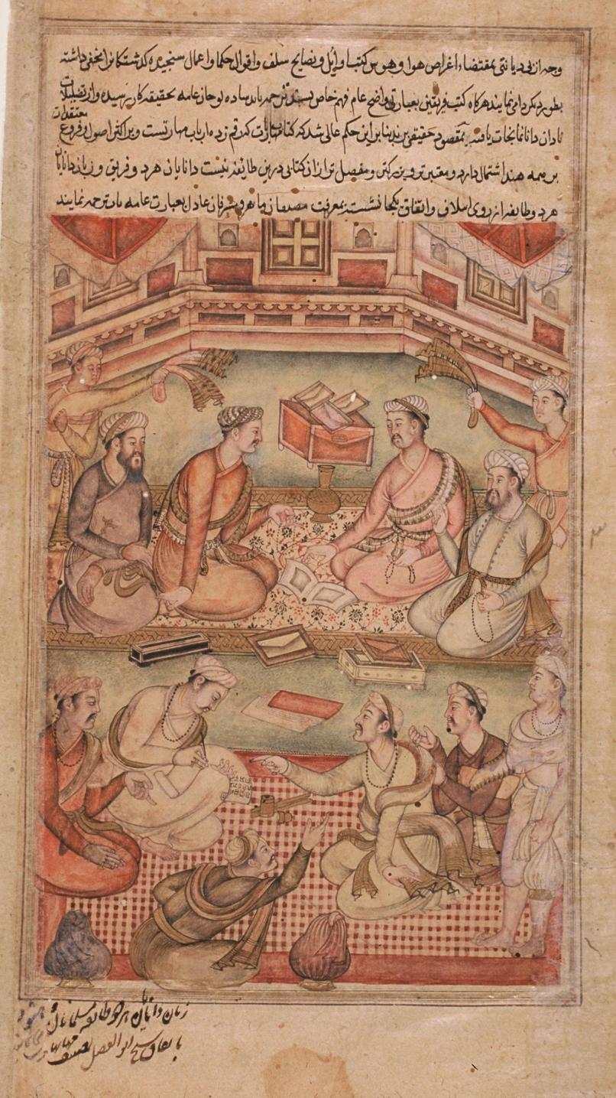
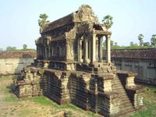

The Mahābhārata (Devanagari: महाभारत), is one of the two major Sanskrit epics of ancient India, the other being the Rāmāyaṇa. With more than 74,000 verses, plus long prose passages, or some 1.8 million words in total, it is one of the longest epic poems in the world.^{[1]} Taken together with the Harivamsa, the Mahabharata has a total length of more than 90,000 verses.
It is also of immense religious and philosophical importance in India, in particular for including the Bhagavad Gita, an important text of Hinduism.
The title may be translated as "Great India", or "the great tale of the Bharata Dynasty", according to the Mahabharata's own testimony extended from a shorter version simply called Bhārata of 24,000 verses^{[2]} The epic is part of the Hindu itihāsas, literally "that which happened", along with the Ramayana and the Purāṇas.
Traditionally, the Mahabharata is ascribed to Vyasa. Due to its immense length, its philological study has a long history of attempting to unravel its historical growth and composition layers. In its final form, it was completed by the first century, with its central core Bharata (consisting of 24,000 verses) dating back to the 6th century BCE, and some parts possibly dating back as far as the 8th century BCE. The events depicted in the Mahabharata are thought to have taken place around the 12th century BCE.

Contents
[hide]
- 1 Influence
- 2 Textual history and organization
- 3 Historicity
- 4 Synopsis
  - 4.1 Authorship
  - 4.2 Bhishma
  - 4.3 The Pandavas
  - 4.4 The House of Wax
  - 4.5 City of Ekchakra
  - 4.6 Draupadi
  - 4.7 Indraprasth
  - 4.8 The Rajsuya Yagna
  - 4.9 "The House of Illusion"
  - 4.10 Duryodhana's game
  - 4.11 The Years in Exile
  - 4.12 The battle at Kurukshetra
  - 4.13 The end of the Pandavas
- 5 Modern Interpretations
- 6 Critical Edition
- 7 English Translations
- 8 See also
- 9 Notes
- 10 References
- 11 External links

[edit] Influence
With its philosophical depth and sheer magnitude, a consummate embodiment of the ethos of not only India but of Hinduism and Vedic tradition, the Mahabharata's scope and grandeur is best summarized by one quotation from the beginning of its first parva (section): "What is found here, may be found elsewhere. What is not found here, will not be found elsewhere." This quotation rightly sums up Mahabharata, within which one finds myriads of relationships, stories and events.
In its scope, the Mahabharata is more than simply a story of kings and princes, sages and wisemen, demons and gods; its author, Vyasa, says that one of its aims is elucidating the four goals of life: kama (pleasure), artha (wealth), dharma (duty) and moksha (liberation). The story culminates in moksha, believed by Hindus to be the ultimate goal of human beings. Karma and dharma play an integral role in the Mahabharata.
The Mahabharata includes large amounts of Hindu mythology, cosmological stories of the gods and goddesses, and philosophical parables aimed at students of Hindu philosophy. Among the principal works and stories that are a part of the Mahabharata are the following (often considered isolated as works in their own right):
- Bhagavad Gita (Krishna instructs and teaches Arjuna. Anusasanaparva.)
- Damayanti (or Nala and Damayanti, a love story. Aranyakaparva.)
- Krishnavatara (the story of Krishna, the Krishna Lila, which is woven through many chapters of the story)
- Rama (an abbreviated version of the Ramayana. Aranyakaparva.)
- Rishyasringa (also written as Rshyashrnga, the horned boy and rishi. Aranyakaparva.)
- Vishnu sahasranama (the most famous hymn to Vishnu, which describes His 1000 names; Anushasanaparva.)

[edit] Textual history and organization
It is undisputed that the full length of the Mahabharata has accreted over a long period. The Mahabharata itself (1.1.61) distinguishes a core portion of 24,000 verses, the Bharata proper, as opposed to additional "secondary" material, while the Ashvalayana Grhyasutra (3.4.4) makes a similar distinction. According to the Adi-parva of the Mahabharata (shlokas 81, 101-102), the text was originally 8,800 verses when it was composed by Krishna Dwaipayana Vyasa and was known as the Jaya ("Victory"), which later became 24,000 verses in the Bharata recited by Vaisampayana, and finally over 90,000 verses in the Mahabharata recited by Ugrasravas.^{[3]}
Not unlike the field of Homeric studies, research on the Mahabharata has put an enormous effort into recognizing and dating various layers within the text. Oldenberg (1922) stipulated that the supposed original poem once carried an immense "tragic force", but dismissed the full text as a "horrible chaos".^{[4]}
The earliest known references to the Mahabharata and its core Bharata date back to the 6th-5th century BCE, in the Ashtadhyayi (sutra 6.2.38) of Pāṇini (c. 520-460 BCE), and in the Ashvalayana Grhyasutra (3.4.4), while various characters from the epic are also mentioned in earlier Vedic literature.^{[3]} This indicates that the core 24,000 verses, known as the Bharata, as well as an early version of the extended Mahabharata, were composed by the 6th-5th century BCE, with parts of Jaya's original 8,800 verses possibly dating back as far as the 9th-8th century BCE.^{[5]} However, the earliest testimony of the existence of the full text of the Mahabharata is by the Greek Sophist Dion Chrysostom (c. 40-105), who mentions that "the Indians possess an Iliad of 100,000 verses".^{[3]} The later copper-plate inscription of the Maharaja Sharvanatha (533-534) from Khoh (Satna District, Madhya Pradesh) also describes the Mahabharata as a "collection of 100,000 verses" (shatasahasri samhita). The redaction of this large body of text was carried out after formal principles, emphasizing the numbers 18^{[6]} and 12. The addition of the latest parts may be dated by the absence of the Anushasana-parva from MS Spitzer, the oldest surviving Sanskrit philosophical manuscript dated to the first century, that contains among other things a list of the books in the Mahabharata. From this evidence, it is likely that the redaction into 18 books took place in the first century. An alternative division into 20 parvas appears to have co-existed for some time. The division into 100 sub-parvas (mentioned in Mbh. 1.2.70) is older, and most parvas are named after one of their constituent sub-parvas. The Harivamsa consists of the final two of the 100 sub-parvas, and was considered an appendix (khila) to the Mahabharata proper by the redactors of the 18 parvas.
The division into 18 parvas is as follows:
parva | title | sub-parvas | contents
1 | Adi-parva | 1-19 | Introduction, birth and upbringing of the princes.
2 | Sabha-parva | 20-28 | Life at the court, the game of dice, and the exile of the Pandavas. Maya Danava erects the palace and court (sabha), at Indraprastha.
3 | Aranyaka-parva (also Vanaparva, Aranyaparva) | 29-44 | The twelve years in exile in the forest (aranya).
4 | Virata-parva | 45-48 | The year in exile spent at the court of Virata.
5 | Udyoga-parva | 49-59 | Preparations for war.
6 | Bhishma-parva | 60-64 | The first part of the great battle, with Bhishma as commander for the Kauravas.
7 | Drona-parva | 65-72 | The battle continues, with Drona as commander.
8 | Karna-parva | 73 | The battle again, with Karna as commander.
9 | Shalya-parva | 74-77 | The last part of the battle, with Shalya as commander.
10 | Sauptika-parva | 78-80 | How Ashvattama and the remaining Kauravas killed the Pandava army in their sleep (Sauptika).
11 | Stri-parva | 81-85 | Gandhari and the other women (stri) lament the dead.
12 | Shanti-parva | 86-88 | The crowning of Yudhisthira, and his instructions from Bhishma
13 | Anusasana-parva | 89-90 | The final instructions (anusasana) from Bhishma.
14 | Ashvamedhika-parva^{[7]} | 91-92 | The royal ceremony of the ashvamedha conducted by Yudhisthira.
15 | Ashramavasika-parva | 93-95 | Dhritarashtra, Gandhari and Kunti leave for an ashram, and eventual death in the forest.
16 | Mausala-parva | 96 | The infighting between the Yadavas with maces (mausala).
17 | Mahaprasthanika-parva | 97 | The first part of the path to death (mahaprasthana "great journey") of Yudhisthira and his brothers.
18 | Svargarohana-parva | 98 | The Pandavas return to the spiritual world (svarga).
khila | Harivamsa-parva | 99-100 | Life of Krishna.
The Adi-parva is dedicated to the snake sacrifice (sarpasattra) of Jayamejaya, explaining its motivation, detailing why all snakes in existence were intended to be destroyed, and why in spite of this, there are still snakes in existence. This sarpasattra material was often considered an independent tale added to a version of the Mahabharata by "thematic attraction" (Minkowski 1991), and considered to have particularly close connection to Vedic (Brahmana literature), in particular the Panchavimsha Brahmana which describes the Sarpasattra as originally performed by snakes, among which are snakes named Dhrtarashtra and Janamejaya, two main characters of the Mahabharata's sarpasattra, and Takshaka, the name of a snake also in the Mahabharata. The Shatapatha Brahmana gives an account of an Ashvamedha performed by Janamejaya Parikshita.
According to Mbh. 1.1.50, there were three versions of the epic, beginning with Manu (1.1.27), Astika (1.3, sub-parva 5) or Vasu (1.57), respectively. These versions probably correspond to the addition of one and then another 'frame' settings of dialogues. The Vasu version corresponds to the oldest, without frame settings, beginning with the account of the birth of Vyasa. The Astika version adds the Sarpasattra and Ashvamedha material from Brahmanical literature, and introduces the name Mahabharata and identifies Vyasa as the work's author. The redactors of these additions were probably Pancharatrin scholars who according to Oberlies (1998) likely retained control over the text until its final redaction. Mention of the Hunas in the Bhishma-parva however appears to imply that this parva may have been edited around the 4th century.

[edit] Historicity
For historical context of the tale, see Kingdoms of Ancient India
The historicity of the Mahabharata war is unclear. The epic's setting certainly has a historical precedent in Vedic India, where the Kuru kingdom was the center of political power in the late 2nd and early 1st millennia BCE.
Ancient Indian scholars have calculated chronologies for the Mahabharata war, the 5th century mathematician Aryabhatta arriving at an approximate date for the Kurukshetra battle of 3137 BCE.^{[8]} The Aihole inscription of Pulakesin II (7th century CE) dates the Kurukshetra War to 3102 BCE.^{[9]} Vriddha-Garga, Varahamihira and Kalhana dated the War to 653 years after 3102 BCE.^{[10]}
Contentious and disputable attempts to date the events of the Mahabharata with the help of archaeoastronomy have claimed dates in the 6th millennium BCE.^{[11]}.
According to Varahamihira, Yudhisthira lived 2526 years before the beginning of the Saka era (Brhatsamhita 13.3).^{[12]}
According to the Puranas^{[13]}, there is a time gap of 1015 or 1500 years between Parikshit's birth during the Mahabharata war and the coronation of king Mahapadma Nanda (ca. 364-382 BCE).^{[14]} Between Mahapadma Nanda and the last Andhra king Pulomavi, the Puranas count 836 or 829 years.^{[15]} Vayu Purana has the Saptarsi in Magha when Yudhisthira lived, in Purvasadha when Nanda lived and in Satabhisaj at the end of Andhra rule. This could correspond to a difference of 1000 (or more) years between Pariksit (seven generations after Pratipa) and Nanda, and 400 (or more) years between Nanda and the end of Andhra rule.^{[16]} The Brhadaranyaka Upanisad has eight generations between Pariksit and Yaska.^{[17]} Pargiter remarked that the Great Bear (the rksas or the Saptarsi) "was situated equally with regard to the lunar constellation Pusya while Pratipa was king."^{[18]} The Puranas list a number of kings between the Mahabharata War and Mahapadma Nanda which indicates that 1451 or 1503 years could have passed between them.^{[19]} Pargiter has argued that there were 26 kings between Adhisimakrishna and Mahapadma Nanda.^{[20]}

[edit] Synopsis
Main article: Kurukshetra war

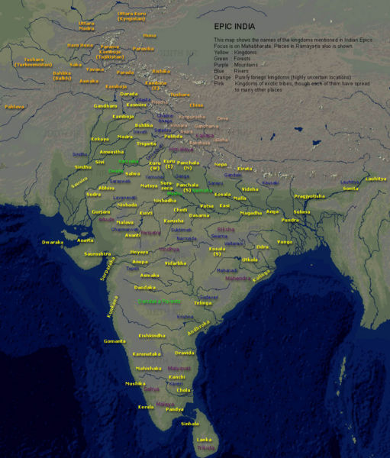
Map of "Bharatvarsha" (Kingdom of India) during the time of Mahabharata and Ramayana. (Title and location names are in English.)

The epic employs the story within a story structure popular in many Indian religious and secular works. It is recited to the King Janamejaya by Vaisampayana, a disciple of Vyasa.
The core story of the work is that of a dynastic struggle for the throne of Hastinapura, the kingdom ruled by the Kuru clan. The two collateral branches of the family that participate in the struggle are the Kauravas, the elder branch of the family, and the Pandavas, the younger branch.
The struggle culminates leading to the Great battle of Kurukshetra, and the Pandavas are ultimately victorious. The Mahabharata itself ends with the death of Krishna, and the subsequent end of his dynasty, and ascent of the Pandava brothers to Heaven. It also marks the beginning of the Hindu age of Kali (Kali Yuga), the fourth and final age of mankind, where the great values and noble ideas have crumbled, and man is speedily heading toward the complete dissolution of right action, morality and virtue. Some of the most noble and revered figures in the Mahabharata end up fighting on the side of the Kauravas, due to conflicts of their dharma, or duty. For example, Bhishma had vowed to always protect the king of Hastinapura, whoever he may be. Thus, he was required to fight on the side of evil knowing that his Pandavas would end up victorious only with his death.

[edit] Authorship
The epic is traditionally ascribed to Maha Rishi Veda Vyasa, who is one of the major dynastic characters within the epic. The first section of the Mahabharata states that it was Ganesha who, at the behest of Vyasa, fixed the text in manuscript form. Lord Ganesha is said to have agreed, but only on condition that Vyasa never pause in his recitation. Vyasa then put a counter-condition that Ganesha understand whatever he recited, before writing it down. In this way Vyasa could get some respite from continuously speaking by saying a verse which was difficult to understand. This situation also serves as a popular variation on the stories of how Ganesha's right tusk was broken (a traditional part of Ganesha imagery). This version attributes it to the fact that, in the rush of writing, the great elephant-headed divinity's pen failed, and he snapped off his tusk as a replacement in order that the transcription not be interrupted.

[edit] Bhishma
Janamejaya's ancestor Shantanu, the king of Hastinapura has a short-lived marriage with the goddess Ganga and has a heroic son, Devavrata (later to be called Bhishma). Devavrata, a young man already with a reputation as a fearsome warrior, is the heir apparent to the throne.
Many years later, when the king goes hunting, he spots Satyavati, the daughter of a fisherman, and wants to marry her. Eager to secure his daughter's and her children's future happiness, the fisherman refuses to consent to the marriage unless Shantanu promises to make the future son of Satyavati the king upon his death, instead of Devavrata. To solve the king's dilemma, Devavrata agrees to that. Finding that the fisherman, though convinced of Devavrata's commitment, is not sure about the prince's children honouring the promise, Devavrata makes a severe vow of lifelong celibacy to guarantee his father's promise. Hearing such a vow, unheard of amongst warriors, the heavens bestow Devavrata with the name Bhishma, 'the person of the terrible oath'.
When King Shantanu is on his deathbed, his concern for his children and the stability of the kingdom delays his death. To ease the king's pains Bhishma promises to stay alive until the kingdom is safe and secure. Again, an awesome promise as all kingdoms are under constant threat. This promise was to cost him dearly, giving him a long life with constant tribulations and battles. Later, though seriously wounded, Bhishma could not give up his soul until the final battle resulted in the rule of the righteous Pandavas.

[edit] The Pandavas
Unfortunately Satyavati's sons die young and her grandson Pandu ascends the throne as his elder brother Dhritarashtra is blind. Pandu whilst out hunting deer, is however cursed by a sage (whom he accidentally kills while he is having sex with his wife, mistaking their moans of pleasure to be the sounds of a deer) that he can never engage in sexual act with any woman. He retires to the forest along with his two wives. Kunti, using a boon granted by another sage whom Kunti, tended and cared for with great dilligence to summon the gods Dharma, Vayu, and Indra, his elder queen Kunti gives birth to three sons Yudhishthira, Bhima, and Arjuna through their respective "fathers". The sons of course inherit the primary character of their respective father.Kunti shares her boon with her "sister" queen Madri, who bears the twins Nakula and Sahadeva through the Ashwini twins. However Pandu and Madri cannot resist temptation,indulge in sex and die in the forest and Kunti returns to Hastinapura with her sons. The rivalry between the Pandavas and the Kauravas starts from childhood itself. Dhritarashtra’s sons, the Kauravas, led by the eldest Duryodhana, detest their cousins the Pandavas. However, they were the favorite of their teacher Drona and (the Pandavas) grow up to be exceptional. Each one of the Pandavas is said to have one exceptional strength or virtue - Yudhishthira is the most virtuous, Arjuna the bravest warrior, Bhima the strongest, Nakula the most handsome and Sahadeva wise and able to predict the future. When the princes of Hastinapur come of age, a tournament is held to display their strength and skill. When Arjuna was hailed as a master of archery, a young man challenges him for a duel. He declares his name is Karna, and he is the son of a charioteer. When asked to prove that he is of royal birth, which is the criterion for joining the tournament, Duryodhana, spotting a potential ally, jumps over to his side and gives his kingdom of Anga. Karna is forever grateful for this act. Because of this, he becomes Duryodhana's closest friend and plays a crucial role in the war.

[edit] The House of Wax
Meanwhile Duryodhana plots to get rid of the Pandavas and tries to kill the Pandavas secretly by burning their palace which is made of lac. However, the Pandavas are warned by their uncle, Vidura who sends them a miner to dig a tunnel. Therefore, when Duryodhana's servants set the house on flames, they will be able to escape in safety. After escaping from the tragedy, the Pandavas arrive in a forest and rest. Bheema and Arjuna want to confront the Kauravas, but Kunti and Yudhishthira decide against it. Bheeshma goes to the river Ganga to perform the last rites of the Pandavas. Vidura then informs him that the Pandavas are alive and to keep the secret to himself.

[edit] City of Ekchakra
The Pandavas stay in the city of Ekchara in the guise of Brahmans. Kunti and Bhima then learn of a cruel and terrible rakshasa named Bakasura who has made a deal with the villagers that if he receives 1 villager a month to eat, he will not harm the villagers. Bhima sets out to eliminate this rakshasa. A great fight arises and Bhima with his might kills him. In order to avoid being caught by the villagers, the Pandavas leave the City of Ekchakra and move on.

[edit] Draupadi
In course of this exile the Pandavas are informed of a "competition" called a swayamvar taking place with the prize being the hand of the Panchal princess and the daughter of King Drupad, Draupadi. The Pandavas enter the competition in disguise as Brahmans, the task being to string a mighty steel bow and shoot with a steel arrow the eye of a rotating fish on the ceiling while concentrating on the reflection underneath. No king manages to come close to do so. They fail to even pick up the bow! Karna, the only one who picks up the bow, is about to try is halted by Draupadi by the excuse that he is the son of a charioteer and may not participate. Arjuna becomes successful and manages to complete the task. When he returns with his bride, Arjuna goes to his mother to show her his prize, exclaiming, "Mother, I have brought you a present!". Kunti, not noticing the princess, tells Arjuna that whatever he has won must be shared with his brothers. To ensure that their mother never utters a falsehood even by mistake, the brothers take her as a common wife. All of the Pandavas love Draupadi dearly. In some interpretations, Draupadi alternates months or years with each brother. At this juncture they also meet Krishna who would become their lifelong ally and guide.

[edit] Indraprasth
Duryodhan and Shakuni are furious when they learn that the Pandava brothers are alive and that King Dhritrashtra has sent Vidur to call them back to Hastinapur. Karna, as usual, is ready to fight them, but Shakuni realizes that with King Drupad and Krishna on the side of the Pandavas it would be difficult to defeat them. Dhritrashtra consoles Duryodhan and assures him that his rights as the Heir Apparent to the throne of Hastinapur will be fully protected. In Kampilya, King Drupad and Shri Krishna advise Yudhishthir to fight for his right to the throne of Hastinapur. Just then Vidur arrives and tells the Pandava brothers that they have been invited back to Hastinapur along with their bride. The Pandavs and Draupadi return to Hastinapur. Dhritrashtra conceals his disappointment and orders everyone to welcome them. Determined to establish peace between the Kauravas and the Pandavas, Bheeshma suggests giving half the Kingdom to Yudhishthir. Dhritrashtra agrees to this suggestion. Krishna and Balram, also give their consent and it is decided that Yudhisthira's coronation as King of Indraprasth be held in Hastinapur. This land given to them again becomes another unjustice to the Pandavas as it neither has any agricultural soil neither any buildings nor people. Krishna consolidates the Pandavas saying that Indraprasth is not a waste but instead a Land of Action. Taking the advice of Krishna, the Pandavas make Indraprasth a beautiful town where justice is always met and the inhabitants are happy.

[edit] The Rajsuya Yagna
Shortly after this, Arjuna and Subhadra (Krishna's sister) get married and return to Indraprastha to be welcomed by Draupadi. Here, Yudhishthira seeks Sri Krishna's advice on performing the Rajsuya Yagna which will make him the emperor of India. Krishna advises him that Jarasandha who has imprisoned 86 kings must be killed as he may interfere in the ceremony. Hence Yuddhisthira decides to send Krishna, Bheema and Arjuna to challenge Jarasandh for combat. Jarasandh chooses to fight with Bheema. Bheema and Jarasandh were so equally matched in strength that they fought for nearly fourteen days without rest. When Jarasandha finally showed signs of exhaustion, Krishna prompted Bheema to make an end of him. After Jarasandha had been destroyed, Jarasandha's son was crowned King of Magadh. The Rajsuya Yagna is celebrated and Yudhishthira is recognized as an Emperor.

[edit] "The House of Illusion"
Duryodhan is unhappy about the prosperity of the Pandavs, Shakuni consoles him and later loses in a game of dice to Yudishthir. Duryodhan walks around Yudhishthir's 'Maya Mahal" ("The House of Illusion") and falls into one of the pools. Draupadi calls him the "blind son of a blind father." Duryodhan, Karna and Shakuni plan to avenge Draupadi for her taunting remarks.

[edit] Duryodhana's game
Duryodhana, who now has a friend in the peerless warrior Karna becomes aware of Yuddhisthira becoming the emperor. This proves too much for Duryodhana who feels death would be better than watching one's foes prosper. His maternal uncle Shakuni, convinced that however brave his nephew may be, he was no match for his cousins, decides to use a ruse to destroy the Pandavas. He forces Dhritarashtra to invite the Pandavas for a game of dice in which he wins everything from Yudhishthira, including himself, his brothers and Draupadi through the use of a trick. The jubilant Kauravas insult them in their helpless state and even try to disrobe Draupadi in front of the entire court. Her honour is saved by the grace of Krishna. When the elders intervene and Dhritarashtra has to restore everything to the Pandavas, Shakuni forces another game of dice which he again wins. The Pandavas are required to go into exile for 13 years, and on the 13th year they must remain hidden. If discovered by the Kauravas, they will be forced into exile for another 12 years.

[edit] The Years in Exile
The Pandavas having lost the game of dice go on exile for 12 years and a year of hiding. During the period of exile, they visit many religious places and are often visited by Krishna. Draupadi who has been insulted by Dushasana (Duryodhan's brother), takes a vow never to tie up her hair until she had blood from Dushasana's thigh to wash her hair with. This constantly reminds her husbands of how war was inevitable. Krishna advises Arjuna that since war was inevitable, he should enter heaven to seek the divine weapons held by Gods and that he who is favored by Lord Indra would be able to do so. Through the prayer of Lord Indra, Arjuna gains access to heaven from where he obtains the divine weapons and also learns how to use them. Finally, Lord Indra advises Arjuna to learn the art of dance as it would come to his aid in the 13th year of hiding. It is during this time that the Pandavas get to face a demon called Hidumba. Bheema kills him and marries his sister, Hidumbi. With her, he begets a son called Ghatothkacha.

[edit] The battle at Kurukshetra

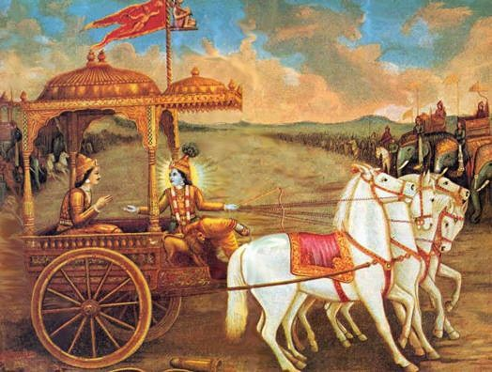
Shown here is the scene when Arjuna stops Krishna from attacking Bhishma during the Kurukshetra war.

When the Pandavas return from their exile after many hardships, they request for a peace treaty with the Kauravas to gain Indraprastha back. However, Duryodhan disagrees and argues that since the Pandavas where "caught" in their year of hiding, they must go into another 13 years of exile before they can have Indraprastha. The Pandavas on Krishna's advice again ask for a peace treaty asking for at least five villages for the five brothers, from the Kauravas' vast kingdom. Duryodhana refuses to give in. Krishna intervenes to mediate peace but is unsuccessful. War becomes inevitable.
The two sides summon vast armies to their help and line up at Kurukshetra for a war. The Kingdoms of Dwaraka, Kasi, Kekaya, Magadha, Matsya, Chedi, Pandya and the Yadus of Mathura and some other clans like the Parama Kambojas from Transoxiana were allied with the Pandavas; the allies of the Kauravas comprised the kings of Pragjyotisha, Anga, Kekaya (Kekaya brothers who were enemies of the Kekeya brothers on the Pandava side), Sindhudesa (including Sindhus, Sauviras and Sivis), Mahishmati, Avanti in Madhyadesa, Madras, Gandharas, Bahlikas, Kambojas (with Yavanas, Sakas, Tusharas etc) and many others. Prior to war being declared, Krishna's brother, Balarama, had left to go on pilgrimage, thus he does not take part in the battle itself.
Arjuna, seeing himself facing grandsire Bhishma and his teacher Drona on Duryodhana's side due to their vow to serve the state of Hastinapur is heartbroken and at the idea of killing them he fails to lift his Gandiva bow. Krishna who has chosen to drive Arjuna's chariot wakes him up to his call of duty in the famous Bhagavad Gita section of the epic. Though initially sticking to chivalrous notions of warfare, the Kauravas and Pandavas soon descended into dishonourable warfare. At the end of the 14 days slaughter only the Pandavas and Krishna survive with a few old warriors from the Kaurava side.

[edit] The end of the Pandavas
Beholding the carnage, the noble mother of the Kauravas, Gandhari who had lost all her sons, curses Krishna to be a witness to a similar annihilation of his family, for though divine and capable of stopping the war, he had not done so. Krishna who had incarnated precisely to destroy the wicked kings accepts the curse, which bears fruit 36 years later. He then departs from the world and the Pandavas who had ruled righteously all along, now tired, decide to renounce everything. Clad in skins and rags they retire to the Himalayas and ascend the peaks towards heaven in their bodily form. Legend reveals that a mangy, stray dog travels along with them. One by one the Pandavas and Draupadi fall on their way. As each one stumbles, Yudhishtra gives the rest the reason for their fall (Draupadi was partial to Arjuna, Nakula and Sahadeva were vain and proud of their looks, Bhima and Arjuna were proud of their strength and archery skills, respectively). Only the virtuous Yudhisthra who had tried everything to prevent the carnage and the dog remain. The dog reveals himself to be the god Dharma, who reveals the nature of the test and assures Yudhishtra that his fallen siblings and wife are in heaven. Yudhistra alone transcends to heaven in his bodily form for being just and humble.
Arjuna's grandson Parikshita rules after them and dies bitten by a snake. His furious son, Janamejaya, decides to perform a snake sacrifice (sarpasattra) in order to destroy the snakes. It is at this sacrifice that the tale of his ancestors is narrated to him.

[edit] Modern Interpretations
In the late 1980s, the Mahabharata TV series ^{[21]} was televised and shown on India's national television (Doordarshan). The series was written by Dr. Rahi Masoom Reza and directed by B. R. Chopra and his son Ravi Chopra. It became a highly popular TV series. It was also shown in the UK by the BBC, where it achieved audience figures of 5 million, unheard of for a subtitled series being aired in the afternoon.^{[22]}
In the West, the most acclaimed and well known presentation of the epic is Peter Brook’s nine hour play premiered in Avignon in 1985 and its five hour movie version (1989) ^{[23]}, which was shown on other TV networks, including PBS (through the "Great Performances" show) and Danmarks Radio (credited in the movie's credits).
However, there have been film versions of the Mahabharata long before these two versions, the earliest of which was shown in 1920.^{[24]}.

[edit] Critical Edition
Between 1919 and 1966, the scholars at the Bhandarkar Oriental Research Institute, Pune, compared the various manuscripts of the epic from India and abroad and produced the Critical Edition of the Mahabharata, on 13,000 pages in 19 volumes, followed by the Harivamsha in another 2 volumes and 6 index volumes. This is the text that is usually used in current Mahabharata studies for reference.^{[25]}

[edit] English Translations
A poetic translation of the full epic into English, done by the poet P. Lal is complete, and in 2005 began being published by Writers Workshop, Calcutta. The P. Lal translation is a non-rhyming verse-by-verse rendering, and is the only edition in any language to include all slokas in all recensions of the work (not just those in the Critical Edition). It is both poetic and swift to read, and is oriented to the oral/musical tradition in which the work was originally created. The completion of the publishing project is scheduled for 2008. Six of the eighteen volumes are now available:
Vol 1: Adi Parva, 1232 pages, 2005, ISBN 81-8157-370-6
Vol 2: Sabha Parva, 520 pages, 2005, ISBN 81-8157-382-X
Vol 3: Vana Parva, 1580 pages, 2005, ISBN 81-8157-448-6
Vol 4: Virata Parva, 400 pages, 2006
Vol 5: Udyoga Parva, 970 pages, 2006, ISBN 81-8157-530-X
Vol 17: Mahaprasthana Parva, 30 pages, 2006 ISBN 81-8157-552-0
A project to translate the full epic into English prose, translated by various hands, began to appear in 2005 from the Clay Sanskrit Library, published by New York University Press. Currently available are portions of Parvas two, three, four, seven, eight, and nine.
Another English prose translation of the full epic is also in progress, published by University Of Chicago Press, initiated by Chicago Indologist J. A. B. van Buitenen (Parvas 1-5) and, following a 20-year hiatus caused by the death of van Buitenen, is being continued by D. Gitomer of DePaul University (Parvas 6-10), J. L. Fitzgerald of Tennessee University (Parvas 11-13) and W. Doniger of Chicago University (Parvas 14-18):
Vol. 1: Parva 1, 545 pages, 1980, ISBN 0-226-84663-6
Vol. 2: Parvas 2-3, 871 pages, 1981, ISBN 0-226-84664-4
Vol. 3: Parvas 4-5, 582 pages, 1983, ISBN 0-226-84665-2
Vol. 4: Parva 6 (forthcoming)
Vol. 7: Parva 11, first half of parva 12, 848 pages, 2003, ISBN 0-226-25250-7
Vol. 8: Second half of Parva 12 (forthcoming)
Until these three projects are available in full, the only available complete English translation remains the Victorian prose version by Kisari Mohan Ganguli, published between 1883 and 1896. The complete text is available online (see External Links).

[edit] See also
- Aiyush - This epic is the source of this given name
- Ramayana
- Kurukshetra war
- Kakawin Bhāratayuddha
- Kingdoms of Ancient India

[edit] Notes
- ^ Roughly 10 times the size of the Iliad and Odyssey taken together, and about 4 times the size of the Ramayana. Epics that can be argued as being longer include the Tibetan Epic of King Gesar and the Kyrgyz Manas.^{[citation needed]} .
- ^ bhārata means the progeny of Bharata, the king believed to have founded the Indian kingdom of Bhāratavarsha.
- ^ ª ^{b} ^{c} Subhash Kak. The Mahabharata and the Sindhu-Sarasvati Tradition (pg. 4-5).
- ^ The judgement of other early 20th century Indologists was even more condemning, Winternitz (Geschichte der indischen Literatur 1909) opted that "only unpoetical theologists and clumsy scribes" could have lumped the various parts of disparate origin into an unordered whole.
- ^ Brockington (1998, p. 26)
- ^ 18 books, 18 chapters of the Bhagavadgita and the Narayaniya each, corresponding to the 18 days of the battle and the 18 armies (Mbh. 5.152.23)
- ^ The Ashvamedhika-parva is also preserved in a separate version, the Jaimini-Bharata (Jaiminiya-ashvamedha) where the frame dialogue is replaced, the narration being attributed to Jaimini, another disciple of Vyasa. This version contains ar more devotional material (related to Krishna) than the standard epic and probably dates to the 12th century. It has some regional versions, the most popular being the Kannada one by Devapurada Annama Lakshmisha (16th century).^{[citation needed]}
- ^ Placing the Kurukshetra battle at 3137 BCE and the death of Krishna and the beginning of the Kali Yuga at 3102 BCE. Kak 1994:60
- ^ R. C. Majumdar and A. D. Pusalker (editors): The history and culture of the Indian people. Volume I, The Vedic age. Bombay : Bharatiya Vidya Bhavan 1951, p.272
- ^ R. C. Majumdar and A. D. Pusalker (editors): The history and culture of the Indian people. Volume I, The Vedic age. Bombay : Bharatiya Vidya Bhavan 1951, p.272. Brihat-Samhita. Rajatarangini.
- ^ For example 16 October, 5561 BCE, calculated by V.Vartak; The Scientific Dating of the Mahabharat War
- ^ Varahamihira referred to an earlier astronomer Vrddha Garga. Kak 1994:60
- ^ e.g. Vayu 99, Matsya 73
- ^ K.D. Sethna. Problems of Ancient India, 2000, p. 58, New Delhi: Aditya Prakashan. ISBN 81-7742-026-7. Kak 1994:58
- ^ Kak 1994:58-59
- ^ Kak 1994:59
- ^ Kak 1994:62
- ^ Kak 1994:58-59
- ^ Kak 1994:59-60
- ^ R. C. Majumdar and A. D. Pusalker (editors): The history and culture of the Indian people. Volume I, The Vedic age. Bombay : Bharatiya Vidya Bhavan 1951, p.273
- ^ Mahabharata at the Internet Movie Database (1988-1990 TV series)
- ^ Epic Hindi Language Series Mahabharat Launches Exclusively on Rogers OMNI Television Channels In Ontario and British Columbia
- ^ Mahabharata at the Internet Movie Database (1989 mini-series)
- ^ Mahabharata at the Internet Movie Database (1920 film)
- ^ Bhandarkar Institute, Pune—Virtual Pune
The latest translation published in 2006 by R.V. Bhasin (national publications) who also authored "Essence of Hinduism" (Jaico publications).

[edit] References
- J. Brockington, The Sanskrit Epics, Leiden (1998).
- E. W. Hopkins, The Great Epic of India, New York (1901).
- H. Oldenberg, Zur Geschichte der Altindischen Prosa, Berlin (1917)
- Th. Oberlies, 'Ritual an und unter der Oberfläche des Mahabharata', in: Neue Methoden der Epenforschung (ed. H. L. C. Tristram), Freiburg (1998).
- H. Oldenberg, Das Mahabharata, Göttingen (1922).
- M. Mehta, The problem of the double introduction to the Mahabharata, JAOS 93 (1973), 547-550.
- C. Z. Minkowski, Janamehayas Sattra and Ritual Structure, JAOS 109 (1989), 410-420.
- C. Z. Minkowski, 'Snakes, Sattras and the Mahabharata', in: Essays on the Mahabharata, ed. A. Sharma, Leiden (1991), 384-400.
- N. B. Utgikar, The mention of the Mahabharata in the Ashvalayana Grhya Sutra, Proceedings and Transactions of the All-India Oriental Conference, Poona (1919), vol. 2, Poona (1922), 46-61.
- M. Witzel, Epics, Khilas and Puranas: Continuities and Ruptures, Proceedings of the Third Dubrovnik International Conference on the Sanskrit Epics and Puranas, ed. P. Koskiallio, Zagreb (2005), 21-80.
- Mahabharat Yuddhakal (14th sept 3009BC Greg): Prafulla Mendki

[edit] External links
Original text online (Sanskrit)
- MahabharataOnline.com - Mahabharata Translations, Simple narrations, Stories and Scriptures
- Mahabharata major ancient Sanskrit epics of India
- [1] (transliterated) at Goettingen State and University Library
- [2] (parallel in Devanāgarī and transliterated) at The Internet Sacred Text Archive
Kisari Mohan Ganguli translation (English)
- at sacred-texts.com
- at bharatadesam.com
Articles on the Mahabharata
- Mahabharata and Sindhu- Sarasvathi tradition, a paper by Subhash kak (pdf)
- The Date Of The Mahabharata War
- Vivekananda on the Mahabharata
- WMBlake on the Mahabharata
Audio Narration
- Mahabaratham Pesukiradhu - Narration of the great epic Mahabarath in Tamil
Other resources
- Reading Suggestions J. F. Fitzgerald, University of Tennessee
- Clay Sanskrit Library publishes classical Indian literature, including the Mahabharata and Ramayana, with facing-page text and translation. Also offers searchable corpus and downloadable materials.
- Mahabharata Resources Page at its new home Resources on Mahabharata
- Google Directory: Mahabharata
Movies
- The Mahabharata at the Internet Movie Database 1989 movie directed by Peter Brook
- Kalyug at the Internet Movie Database 1980 movie directed by Shyam Benegal. The movie is loosely based on the story of the Mahabharata and reinterprets the struggle for the kingdom in an industrial age, with two family factions fighting for the control of an industrial conglomerate.
==================================================================================================================================
END

