Hare Krishna
http://en.wikipedia.org/wiki/Hare_Krishna
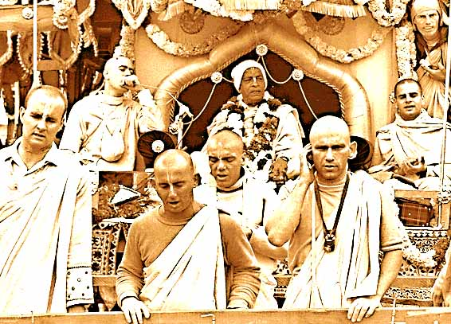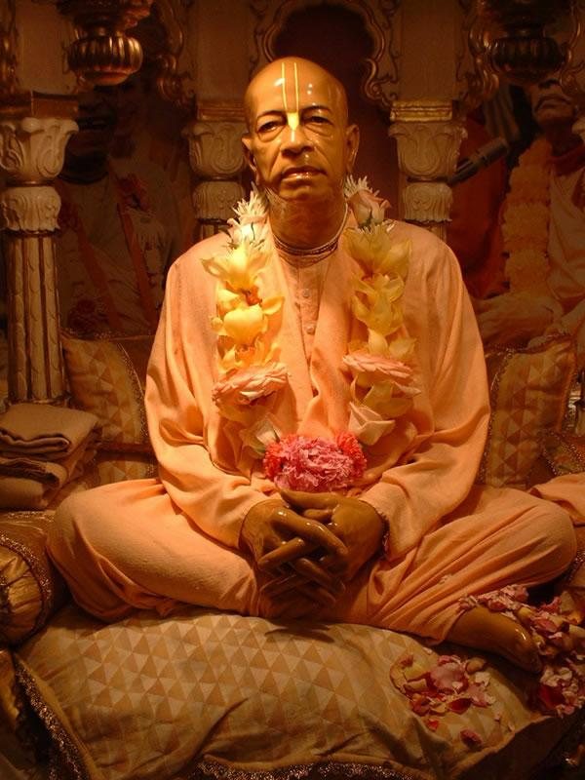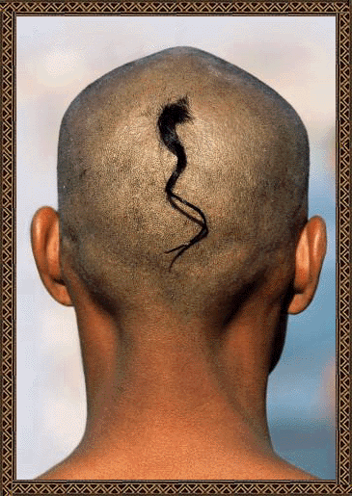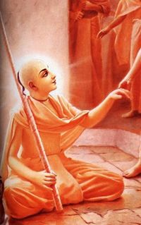
. 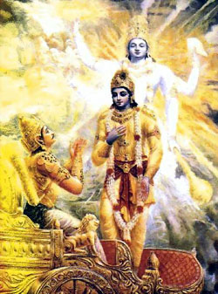 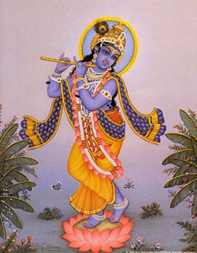 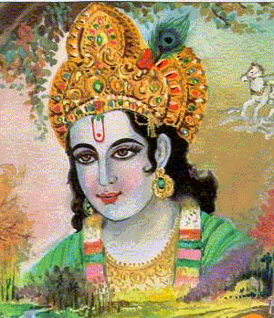

The Hare Krishna , also referred to as the Maha Mantra ("Great Mantra"), is a sixteen-word Vaishnava mantra, made well known outside of India by the International Society for Krishna Consciousness (commonly known as 'the Hare Krishnas'). It is believed by practitioners to bring about a higher state of consciousness when heard, spoken, mated upon or sung out loud. According to Gaudiya Vaishnava theology this higher consciousness ultimately takes the form of pure love of God (Krishna). ^{[1]}

Contents
- 1 The mantra
- 2 History
- 3 The "Hare Krishna" movement
- 4 Hippie culture
- 5 Hare Krishna in popular culture
- 6 Other scriptural references
- 7 Notes
- 8 Reference
- 9 See also
- 10 External links

The mantra
The words "Hare Krishna" are part of a mantra comprising three Sanskrit names of God (Vishnu)--Hari, Krishna and Rama--in the vocative case. All three names are in the Vishnu sahasranama. Rama and Krishna are the 7th and 8th Maha Avataras of Vishnu. As names, Hari translates to "golden one", Krishna translates to "black". Hare may also be interpreted as the vocative of the female name Harā (unrelated to Hari), a name of Rādhā, Krishna's eternal consort. The words of the Maha Mantra, or "Great Mantra," are (in Anglicized spelling, the IAST of the three vocatives is hare, kṛṣṇa and rāma; roughly pronounced IPA: ['hɐre:], ['kɹ̩ʂɳɐ], ['ra:mɐ], see Sanskrit for pronunciation details):
Hare Krishna Hare Krishna
Krishna Krishna Hare Hare
Hare Rama Hare Rama
Rama Rama Hare Hare
According to A.C. Bhaktivedanta Swami Prabhupada, Krishna and Rama refer to God himself, meaning "He who is All-Attractive" and "He who is the Source of All Pleasure," while Harā refers to "the energy of God".^{[2]}.
The mantra is repeated, either out loud (kirtan), softly to oneself (japa), or internally within the mind. Srila Prabhupada describes the process of chanting the Maha Mantra as follows:
"Krishna consciousness is not an artificial imposition on the mind; this consciousness is the original energy of the living entity. When we hear the transcendental vibration, this consciousness is revived ...[]... This chanting of 'Hare Krishna, Hare Krishna, Krishna Krishna, Hare Hare / Hare Rama, Hare Rama, Rama Rama, Hare Hare' is directly enacted from the spiritual platform, and thus this sound vibration surpasses all lower strata of consciousness - namely sensual, mental, and intellectual ...[]... As such anyone can take part in the chanting without any previous qualification." ^{[3]}

[] History
The mantra is first attested in the kalisaṇṭāraṇopaniṣad (Kali Santarana Upanishad), a Vaishnava Upanishad associated with the Black Yajurveda. In this Upanishad, Narada is instructed by Brahma (in the translation of K. N. Aiyar):
"Hearken to that which all Shrutis (the Vedas) keep secret and hidden, through which one may cross the Samsara (mundane existence) of Kali. He shakes off (the evil effects of) Kali through the mere uttering of the name of Lord Narayana, who is the primeval Purusha".
Narada asks to be told this name of Narayana, and Brahma replies
"Hare Krishna Hare Krishna, Krishna Krishna Hare Hare, Hare Rama Hare Rama, Rama Rama Hare Hare; These sixteen names are destructive of the evil effects of Kali. No better means than this is to be seen in all the Vedas."
The mantra was popularized by Chaitanya Mahaprabhu roughly around 1500 CE when he began his mission to spread this mantra publicly to 'every town and village' in the world, travelling exstensively throughout India, especially in the southern regions. Some versions of the Kali Santarana Upanishad give the mantra with Hare Rama preceding Hare Krishna, and others with Hare Krishna preceding Hare Rama (as quoted above). The latter format is by far the more common within the Vaishnava traditions, within which it is a common belief that the mantra is equally potent when spoken either way.
In the 1960's an elderly monk known as A.C. Bhaktivedanta Swami Prabhupada, on the order of his guru, Srila Bhaktisiddhanta Sarasvati Thakura, brought the teachings of Sri Chaitanya from India and single-handedly took the responsibility of spreading them around the Western world. Beginning in New York, he encircled the globe fourteen times in the final eleven years of his life, thus making 'Hare Krishna' a well-known phrase in many parts of the world.

[] The "Hare Krishna" movement
Main article: ISKCON
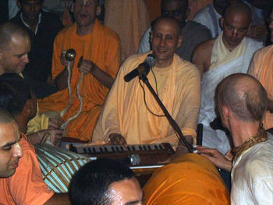
Devotees singing the Hare Krishna mantra

"Hare Krishna" brings to mind, to many, the famous Hare Krishna devotees, who first hit the streets of Western cities in the 1960s and 1970s, dancing and chanting with drums and cymbals, wearing saffron dhotis or colourful saris, and selling Bhagavad Gita As It Is and other books. These devotees were members of the International Society for Krishna Consciousness (ISKCON), founded by A.C. Bhaktivedanta Swami Prabhupada. ISKCON was the first organised Vaishnava group to make a large impression outside of India. Now a number of such Vaishnava groups are actively preaching within the Western world, such as the Sri Krishna Chaitanya Mission and other lineages of the Gaudiya Math.
From an academic perspective Hare Krishna devotees are classified as practitioners of Bhakti Yoga. They are also referred to as Gaudiya Vaishnavas because they follow a line of gurus descending from Chaitanya Mahaprabhu, who appeared in Bengal (Gauda is an old name of Bengal). Vaishnavism comes under the general banner of being a Hindu religion.
Most serious 'Hare Krishna' practitioners live according to strict rules. For example, initiates take vows to abstain from all forms of recreational drugs and intoxicants (including caffeine), from eating meat, fish and eggs, from gambling, and from all sexual relations except for purposes of procreation within marriage. For non-initiates how many of these rules to follow is left to one's own discretion, but these four 'regulative principles' remain the agreed standard to aim towards.

[] Hippie culture
In the 1970s, Hare Krishnas became confused with the hippie subculture. The 1971 Hindi film Hare Rama, Hare Krishna, written and directed by Dev Anand, was shot with many real-life hippie extras. To this very day, as a result of this classic movie, young Western travelers are greeted with mocking renditions of the film’s hit title song, "Hare Krishna, Hare Ram," more generally known by its opening line, "Dum maro dum" ("Take another toke!"). But in fact the genuine Hare Krishna followers were a far cry from hippies. Although Prabhupada was open to anyone, members had to follow the 4 regulative principles, one of which is "no intoxicants." Elevation and joy were to be derived from chanting God's holy names.

[] Hare Krishna in popular culture
The Hare Krishna mantra appears in a number of famous songs and has been at the number-one spot in the UK singles charts on more than one occasion.
Further information: Hare Krishna in popular culture

[] Other scriptural references
The practice of chanting the Hare Krishna mantra is recommended in the Puranic, the Pañcaratra, and throughout Vaishnava literature in general. For example:
- "All the grievous sins are removed for one who worships Lord Sri Hari, the Lord of all lords, and chants the holy name, the Maha-mantra."—Padma Purana; Svarga Khanda 50.6
- "Hare Krishna Hare Krishna, Krishna Krishna Hare Hare: Whoever chants this mantra, even neglectfully, will attain the supreme goal of life. Of this there is no doubt."— Agni Purana
- "This sixteen-name, thirty-two syllable mantra is the Maha-mantra in the Age of Kali by which all living beings can be delivered. One should never abandon chanting this mahamantra."—Ananta-samhita
- "About this divinely spiritual Maha-mantra, which delivers one from material existence, the original guru, Lord Brahma, has said 'The srutis have declared this mantra to be the best means of deliverance in the Age of Kali'. Having all heard this from Brahma, the sons and disciples of Brahma, beginning with Narada, all accepted the Hare Krishna Maha-mantra and, having mated on it, attained perfection."—Ananta-samhita
- "When the sixteen names and thirty-two syllables of the Hare Krishna mantra are loudly vibrated, Krishna dances on one's tongue"—Stava-mala-vidyabhusana-bhasya; Baladeva Vidyabhusana in Bhaktisiddhanta's Gaudiya Kanthahara 17:30

[] Notes
- ^ Caitanya Caritamrta Ml.20.340
- ^ "The word Harā is a form of addressing the energy of the Lord, and the words Krishna and Rama (which mean "the highest pleasure eternal") are forms of addressing the Lord Himself." - A.C. Bhaktivedanta Swami Prabhupada. See Krishna.com article.
- ^ For the original text, see this Krishna.com article.

[] Reference
- an English translation of the Kali Santarana Upanishad

[] See also
- International Society for Krishna Consciousness
- Gaudiya Math
- Sri Krishna Chaitanya Mission
- Vaishnavism
- Krishnology

[] External links
The Mantra
- Hear the Hare Krishna Mantra
- On Chanting the Hare Krishna Mantra
- Download the Hare Krishna mp3
ISKCON
- ISKCON main website
- ISKCON UK website
- ISKCON youth
- HARE KRISHNA & ISKCON (religioustolerance.org)
- VEDA - Vedic Knowledge Online
Other Gaudiya Vaishnava groups
- World Vaishnava Association
- Gaudiya Vedanta Samiti
- Gaudiya Kutir
- Srila Bhakti Vaibhav Puri Maharaj website
- Sri Chaitanya Saraswat Math
Books
- Krishna.com - Information & Books
- Srimad-Bhagavatam (Bhagavata Purana)
Articles
- Hare Krishna's Feed the World (1996)
- The Hare Krishna movement comes of age (2005)
==========================================================================================================================
END

