THEY HAVE ARRIVED
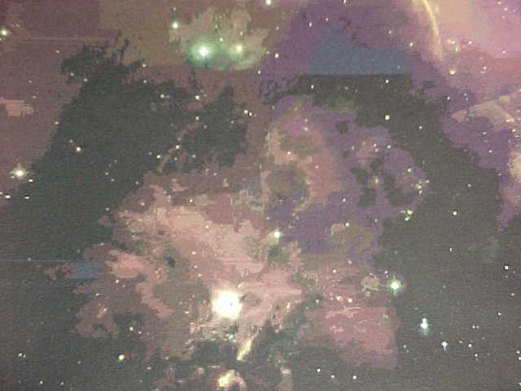
ORION
Because of the discoveries made of an essence from another world in Orion by science, it is now time to begin the watch and establish a scientifically based page to track developments and prepare for what the Bible calls face to face.
ALIENS HAVE FINALLY BEEN SEEN !
The news release is in the March 5 2000 edition of the New York Times. Correspondent is George Johnson. Located as NGC 1999, a nebula in the constellation Orion has revealed the existence of some kind of unworldly dark matter.
Dr. Lawrence Krauss chairman of the physics department at Case Western University in Cleveland said, “The actual universe is far more interesting then the universe of science fiction.
According to the article the matter appears to be trapped in another dimension or stuck in a parallel universe in Orion.
If you would like to read this article in it's entirety for yourself I have provided a link here. At the bottom of the page of the article you will find a link that will bring you right back here.
Link to dark matter discovery
Passover To A New Consciousness
Alien Energy Trapped In Orion
The Alien Has Been found In Dark Matter
Is This The Great Day of Pentecost
The Aliens Are Wimps
The have Been Spotted On The Earth
A Wind Of Wimps
Face To Face Will Be Very Soon
Mirror Matter
Can Alien Particles Communicate With Each Other
Is This The Second Coming ?
The Seventh Angel Touches Earth
Eleven Billion Year Old Gamma Ray Burst
It Came From Eta Carina
Proof That This Is The Seventh Angle (Or Is That Angel)
Orion and The Angel
The Angels Of The Invisible One

IS THIS THE PASSOVER TO A NEW CONSCIOUSNESS
In the Bible Jesus is asked for a sign that Passover is taking place.
His answer is found in Luke 22:10 A man will meet you bearing a pitcher of water. Follow him into the house where he enters.” The house of the man bearing the pitcher of water is Aquarius. The time is now.

ALIEN ENERGY TRAPPED IN ORION
The New York Times article states that this invisible dark matter is either trapped in another dimension or stuck in a parallel universe in Orion.
Job 38:31 asks, Can you loose the bands of Orion ?.
Consider that. Science has found other worldly or alien energy trapped in another dimension in Orion and the scripture asks if you can loose the bands of Orion. Does it mean freeing the energy so it may descend to you.

THE ALIEN HAS BEEN FOUND IN DARK MATTER
The New York Times article states , It now appears more certain then ever that most of the universe is made from some kind of unworldly dark matter that can pass right through ordinary matter barely leaving a trace.
Empty space is pervaded by a mysterious dark energy, a kind of anti gravitational umph that is accelerating the cosmic expansion.
And the Bible joins to this exciting news as it says, Psalms 18:11 He made darkness his secret place. Amos 5:18 The day of the Lord is darkness and not light. Amos 5:20 The day of the Lord is very dark with no brightness in it.

IS THIS THE GREAT DAY OF PENTECOST ?
In the New York Times article it says that scientists have named this other worldly energy quintessence because as they say “the heavens are more alien and wondrous then meets the earthly eye.
Look up the word quintessence in your dictionary. You will find an important derivative to the word Pentecost. The arrival of the Holy Spirit or other worldly energy.

THE ALIENS ARE WIMPS
The New York Times article questions, What is this barely existing substance. The theorists needed to come up with particles that were massive enough to balance the scales of nature, and yet interacted very weakly with ordinary matter. Tailor made for this purpose is the Weakly Interacting Massive Particles or Wimp.

ARE THEY HERE TO CLAIM THEIR INHERITANCE ?
The scientists have spotted this weak energy on the earth. Is that what Psalm 37:11 means when it says the meek shall inherit the earth..

THEY HAVE BEEN SPOTTED ON THE EARTH.
The New York Times article of March 5 2000 states the following.
To separate itself from theology , science must find evidence that its creations are real.
Now here we go. First we learned that this dark matter was found in Orion. Next we find it labeled as Wimp. Some life form that we do not understand. Some life form that is weak or meek and dwells in the sub atomic, invisible realm of the dark.

Now the most amazing statement .
At a recent conference held in Marina Del Rey CA, astronomers from the University of Rome defended a dramatic claim that they had detected a wind of wimps blowing through the earth as it moves across the sky.

A WIND OF WIMPS
Consider that this other worldly or alien energy first spotted in Orion has now been seen on the earth flowing in the winds. Then consider that the scientists had termed this energy quintessence which is connected by dictionary definition to the word Pentecost.
Next consider that Pentecost is the descent to the earth of the Holy Spirit or other worldly energy. Now consider how the Bible describes the descent of that other worldly energy.
Acts2:2 And suddenly there came a sound from heaven as of a rushing mighty wind, and it filled all the house where they were sitting.

PHYSICAL CONTACT WILL BE VERY SOON
The New York Times article goes on to consider other elements of this other worldly energy and describes it thusly. Experts are also looking for other candidates like a lightweight weakly interacting particle ghostlier then the ghostly neutrino.
Even farther out into the speculative realm is a heavy version of the Wimp called Wimpzilla, and farthest out of all is the so called mirror matter. While Wimps would react very reluctantly with ordinary matter, mirror matter would be even more aloof.

MIRROR MATTER
And the scripture is clear.
1 Corinthians 13:12, For now we see through a glass darkly but then face to face.
I have brought you step by step over the years to a point of anticipation of the arrival of light beings to bring us to a Cosmic Passover. Now they have been seen riding on the wings of the wind.

CAN ALIEN PARTICLES
COMMUNICATE WITH EACH OTHER ?
Could there possibly be a logical explanation as to how this could happen. Is there a logical explanation as to how a control center or headquarters could communicate with these alien particles. Is there a logical explanation as to how these particles could communicate with each other ?
Amazingly the answer is yes !
I am going to have you look at an article from the University of California at Berkeley called Smart Dust. Right now science is perfecting dust sized particles that can respond to directions from headquarters and can actually communicate with each other. You have to see this for yourself to believe it so here it is.
Click on the link. When you are finished there is a link at the bottom of the smart dust page to take you back here.

IS THIS THE SECOND COMING ?
Have they touched down on earth before ? Remember the initial sighting was in NGC1999 a nebula in Orion. Orions most prominent stars are the three in the belt.
The BBC (British Broadcasting Company) released a report on August 9 2000 that a star map had been discovered in the famous painted caves of Lascaux in central France. The map which dates back to 16,500 shows three bright stars. A map of the Pleiades star cluster was also found. Were the 3 bright stars the sign of those from Orion ?

THE SEVENTH ANGEL TOUCHES EARTH
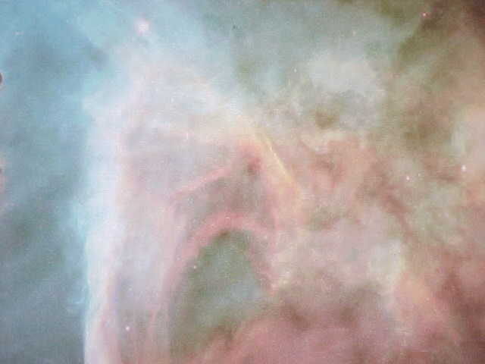
ETA CARINA
But
ORION WAS FIRST
Last month I covered with you the March 5 2000 edition of the New York Times article by correspondent George Johnson. Located as NGC 1999, a nebula in the constellation Orion has revealed the existence of some kind of unworldly dark matter. This was the first evidence of something from another dimension or parallel universe not only existing in space, but as the article went on to note, also observed flowing in the winds of the earth by University of Rome astronomers.

THE SEVENTH ANGEL
I have proposed to you that Eta Carina is the Seventh Angel of Revelation. The word Eta means Seven. Eta Carina in the Keyhole Nebula shows in the Hubble Picture the great wings picturing the traditional concept of an angel. Revelation connects the Seventh Angel with the Son of David and the astrophysicist in charge of the Eta Carina project is Kris Davidson.
Eta Carina is pumping out DNA from its core at a rate of one and a half million miles per hour. So is this the Seventh Angel of Revelation which has unsealed the mystery of God which is the human genome, DNA ?. If it is, something spine tingling has happened.

11 BILLION YEAR OLD GAMMA RAY BLAST FOUND IN SPACE
That is the headline that appeared via Reuters News Service on October 18 2000. Dateline Washington D.C. The afterglow from a cosmic explosion that occurred 11 billion years ago could give scientists a new way to measure the age of heavenly objects, astronomers reported on Wednesday. Can you imagine this. A cosmic explosion that occurred 11 BILLION years ago.
If you would like to read this article in its entirety I have provided a link here. At the bottom of the article you will find a link so you may return here and continue this page.
A GAMMA BURST
The article states :The explosion known as a gamma ray burst was spotted last January and it took investigators eight months to figure out where it came from. Observations by a cluster of space probes indicated the blast was from a monstrous dying star more then 30 times as massive as the sun. These are the most powerful explosions in the known universe said Kevin Hurley a physicist at the University of California at Berkeley. The light from this gigantic flash had traveled 11 billion years before reaching earth. Gamma ray bursts cannot be seen from Earth because the atmosphere absorbs them but special spacecraft can detect them and determine which direction they came from.

WHERE DID THIS COME FROM ?
THE ORIGIN OF THIS LATEST TOUCHDOWN
The Reuters article spells it out. The explosion known as a gamma ray burst was spotted last January but it took investigators eight months to figure out where it came from.
GRB 000131 as it is known, came from THE SOUTHERN CONSTELLATION CARINA (THE KEEL)
Your ship has come in folks. The Argo has docked on planet earth. And consider this. What did Jason bring with him aboard the Argo. The Golden Fleece. And what did the Golden Fleece do to those it touched. It healed them ! And now the Argo has arrived.
THE SEVENTH ANGEL OF REVELATION IS NOW ON PLANET EARTH.

MORE PROOF THAT THIS IS INDEED
THE SEVENTH ANGEL
Thanks to Tony Marino for providing this information. From Science News, Volume 158 , October 14 2000. The Headline:
COSMIC AFTERGLOW STEALS THE LIMELIGHT.
SOMETHING IS MAKING ANGLES OF LIGHT (OR IS THAT ANGELS OF LIGHT)
A chance cosmic alignment may have led astronomers to a clearer picture of gamma ray bursts, flashes of high energy radiation that rank as the most powerful explosions known in the universe. As we now know the gamma ray burst is exactly what the scientists tell us has arrived from Eta Carina after an 11 Billion year journey to the planet earth.

HERES THE PROOF
The article goes on. Even though its parent gamma ray burst erupted halfway across the universe, thanks to some gravitational slight of hand researchers last March were treated to a magnified view of a gamma ray burst.
According to general relativity a massive object that lies between a more distant body and earth, can act as a gravitational lens, bending and magnifying light from the distant body. The visible light afterglow appears to have passed through such a lens. The afterglow fits the curve predicted for the effect of the gravitational lens.
What it is saying is that gamma ray bursts first encounter a massive body on their way to earth and arrive on earth curved or on an angle. An angle of light. An angel of light. An angle of light from Eta Carina which would make it the Seventh Angel and fulfill the prophecy of the Book of Revelation that we are excitedly experiencing now.
To read this article in its entirety click this link. At the bottom of the article is a link back

ORION AND THE ANGEL
The great cosmic electronic gate is Orion and as we discussed last month, energy from an other world has passed through the gate as NGC Nebula 1999 and arrived on earth. Now angles of light have arrived from Eta Carina. My friends if I were to make this up I could not make it more dramatic then it actually is.

THE ANGELS OF THE INVISIBLE ONE
THE INVISIBLE ONE
If I were to ask you to identify the invisible power of the universe which is the creator and ruler of all things, what would your answer be? Probably G O D ? Of course. Well consider , if you will, identifying this invisible one without referring to the word G O D. Suddenly you are coming face to face with a power that is making itself known to the earth, a power that controls and creates the universe, a power that creates angels and directs their descent to earth. But you have not used the word G O D, so there is no religious group to demand their version as the only explanation , no cults or organizations to require special faith. Now you have a contact with the supreme power in all creation and it is reaching out to touch all life without regard to traditional affiliation..
THE AQUARIAN CURTAIN PARTS
It was several years ago that science first began to take notice of dark matter and dark energy. Something very strange that made up 90-95% of the universe. Something that impacted on everything in creation. Something that actually created and controlled everything and yet, something that in the realm of perception was not there. In other words, we could see that IT was doing something, but IT really was not there. Planets and constellations were being moved by IT, angles of light were being skewed or bent by IT, but IT was not there, not there at all. Yet it had to be there.
WHAT SHALL WE CALL IT ?
Science had to come up with a hypothetical term. After all, it was obvious that something was there because you could see things move and light bend from its power. We had to call it something so we could discuss it. We called it dark matter, and dark energy. One creates from the center of a body, the other controls so that the spinning motion of the universe does not cause celestial things to go flying away. The originator and controller of the universe. Not really black, and not really matter, but who knows. Maybe it is matter. But whatever it is, it is totally invisible.
HUNDREDS OF INVISIBLE GALAXIES !!!!
Can you imagine a celestial city, with buildings and people and yet totally invisible.? Robert Britt lead science writer for Science.Com, writes Galaxies Made of Nothing ? Near every galaxy there may be 100 small invisible galaxies clustered around. Galaxy UGC102414 has a stream of material flowing away as if interacting with another galaxy. But the material seems to flow toward nothing.
IT’S NOT MATTER AS WE KNOW IT
From Science Daily this comment from Max Tegmark, assistant professor of physics and astronomy at the University of Pennsylvania. The 95% of the universe that’s not matter like we see around us, is matter that can’t be seen at all-matter of a type that still mystifies astronomers and cosmologists.
WHAT IS THIS MATTER THAT HIDES IN THE DARK
AND CANNOT BE SEEN ?
And now we turn to the Bible. For maybe the supreme power of the universe has chosen to make itself known during this age of great change .
Psalms 18:11 He made darkness his secret place
Amos 5:20 The day of the Lord is darkness and not light,
even very dark with no brightness in it.
How interesting is that scripture when you consider that science says that this strange invisible matter does not contain or reflect any light. The invisible power that is creating and is ruling the universe and the scripture says :
John 1:18 No man has seen God at any time
THE ANGELS ARE CREATED BY THE INVISIBLE ONE
From the Hearst Science Publication comes a story of an experiment conducted by J Anthony Tyson of Bell Labs in Murray Hill New Jersey. Tyson and his colleagues began with an image of a single galaxy whose light was bent by the gravity of an intervening cluster. The cluster could not be seen. As scientists attempted to measure the mass of the cluster, strangely, the light distorting mass in the cluster was nowhere to be seen in the original image, not in the stars and not in the galaxies either. It simply was not there.
Something had changed the angle of light. Something that had the power to actually bend cosmic light, yet that something was nowhere to be found.
Science has found an invisible force in the universe that changes the angle of light. In other words light coming down to the earth is changed by the invisible one.
THE LIGHT STOPS AND CONTAINS A MESSAGE
January 21, 2001 Lene Hau of Harvard University, The Rowland Institute of Science,Ronald Walsworth and Mikhail Lukin of Harvard Smithsonian Center for Astrophysics. These two teams brought light traveling at 186,000 miles per second to a screeching halt. Totally stopped . Seth Lloy associate professor at Massachusetts Institute of Technology said , This is a beautiful way of catching bits of information stored in light particles and storing them in another medium.
THE ANGEL FROM THE INVISIBLE ONE STOPS AND SPEAKS WITH YOU
If this dark matter is the dwelling place of God. Then it is God changing the angle of light. The angle of light which is a Photon (messenger particle) becomes Gods Angel, Gods messenger. And now science proves that within the particles of light, a message can be contained. And science has proved that the light can stop. The angel can stay with you for a time and the message from God can be yours. See how important it is to do the watching meditation so you can collapse the wave to a particle and receive what is yours.

