THE SEDONA VORTEX
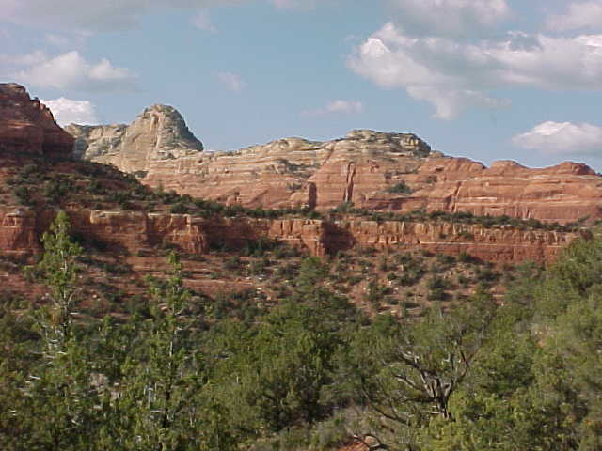
MY IMPRESSION
Joan and I just finished a trip out west which included a visit to Sedona Arizona. We spent two days there and of course were interested in trying out the much advertised Sedona Vortex experience.
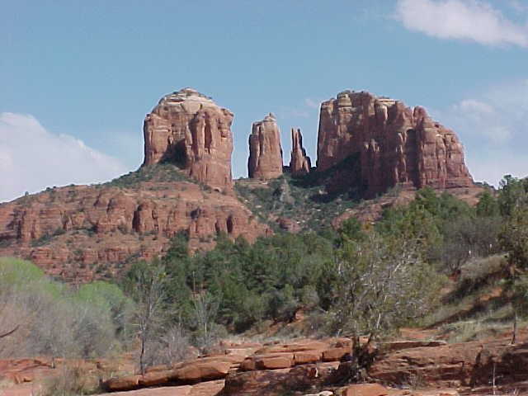
As we arrived at the motel I had an opportunity to talk to a young man who was working there and I asked him if he knew about the vortex activity in Sedona. He said that he has lived all of his life at the place where there is supposed to be the most active and biggest vortex.
I asked him what his experience was from the vortex. He said. Nothing, I have never experienced anything. But he said, its good for the tourists. We hear a lot from them about experiences.
So that was interesting to me. Someone living in the center of a vortex for years and finding nothing.
A trip down the main street of Sedona provided one explanation for the vortex activity. It’s good business. Shops abound with T Shirts and models of aliens and all the rest. People are walking around with cameras strapped around their neck and little jeeps are heading out to the vortex area with loads of anticipating vortex people.
So Joan and I took two tours. In a jeep, out into the back country. It is one of the most beautiful places on the face of the earth. It is awesome. The read cliffs, the trails, the beautiful quiet. It is awesome. Did I feel any whirlpool of energy, no.
On one tour we had a guide who was into this as deep as you can get. He wore an Indian head band and western clothes. He sat by the water and played a flute. He stood on rocks at the top of a mountain and called out to the spirit of the Great God and also prayed incantations in Indian.
He took us to a prayer wheel on top of a mountain and he placed herbs and powders in our hand so that we might pray and receive from God in the holy place of the mountain. This guy was into this big time.
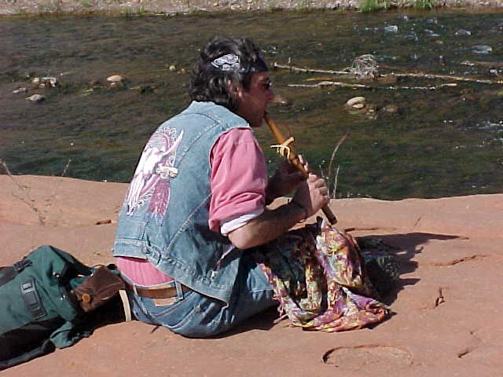
But, he said something that revealed a deep sense of reason and understanding. He said. You know, I believe that vortexes are everywhere.
So my advice is , if you wish to go to a place of absolute beauty, if you wish to experiencethe depth of nature in all it’s grandeur, go to Sedona.
If you wish to experience tourism in all of its gift shop and restaurant activity, go to Sedona. If you wish to explore the legends of the American Indians and American West. Go to Sedona.
If you wish to experience energy that whirls and lifts you to heavenly heights, go within yourself, wherever you are. You do not have to go to Sedona.
There is a web site newspaper called Open Mind Magezine written by Haizen Paige. An artice in it is titled, The Invasion of the Vortex People.
The article talks about the fact that tourists coming to Sedona are coming in surprisingly large numbers to visit the energy vortexes. It then goes on to say “What is a vortex. Standing in one is somewhat like the sensation Marilyn Monroe might have felt with her dress swirling up. Remember that famous publicity shot from The Seven year Itch. On the other hand some people don’t feel anything that thats just fine too. Either way, people are wanting to find out for themselves.
Perhaps most of all the vortex people experience an awakening to wonder. As they stand in a vortex not only do they feel the wonder and indescribably beauty of their surroundings but even more significantly they begin to feel the wonder and eternal mystery of themselves.
So you see what the mystery of Sedona is all about. It is a fantastically beautiful place of nature, filled with the mystery and legends of the American West and its Indian inhabitants, and totally conduscive to meditation.
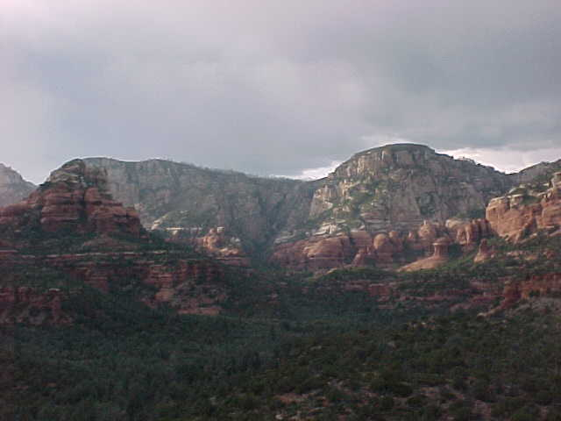
You stand among the red cliffs and listen to the silence. An occasional cry of a bird or a gentle breeze and you sink within yourself and meditate. And the vortex energy actually wells up from within you. The vortex is a Kundalini or electrical energy that is in your own body and travels up the spine in a serpentine motion.
You have experienced vortex energy in Sedona but if you are open you can experience the very same vortex energy in Jersey City.
This is not unlike hypnotism which causes people to see and feel things that are not really there. Not really there for you and me but really there for them when they openly and freely succumb to the suggestion of the hypnotist.
In Sedona the hypnotist is nature, the mountains. The suggestion is that there are vortexes of tremendous energy and if you open yourself to them you will have an experience. The rest is totally dependent on the individual. If you wish an experience, the combination of being in this magnificent setting, and the suggestion of power will cause you to experience within yourself the very same thing that many people get from sitting in this room.
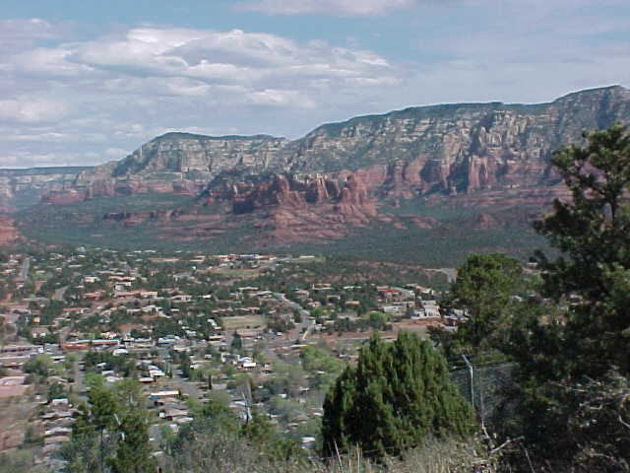
Is it more romantic, and more beautiful in the mountains of Sedona, of course. Is it any more powerful or meaningful, of course not.
Do crystals or rocks have power. No. But if you hold one and are told that it does, and you function within yourself that what you are holding has a power, the rock or crystal becomes a hypnotist and your belief becomes the suggestion.
Can it work and heal. Of course. But remember, the power is not in the stone, or the crystal or Sedona. Its in you.
A vortex is a whirlwind, a whirlpool, a circular motion. All the universe is a vortex. But to locate one in the ground is something that I have been unable to document. Does the earth give off energy, yes. Does the universe yes. Drive up to New York. When you come out of the Lincoln Tunnel you can feel this sudden flow of energy. I feel it there but not in Sedona.
You do not have to go anywhere to experience the energy of nature. You simply go within yourself.
BUT WHAT ARE WE WAITING FOR ?
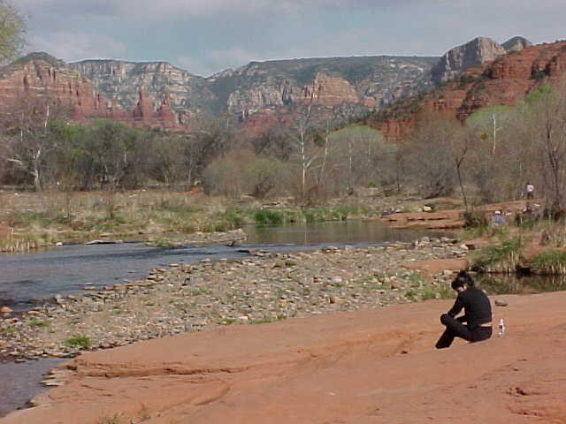
Let us address those who still feel that there is a special magnetism at certain places and you can experience that energy. After all it is true that the earth is filled with energy. The question is, if you find a place of great energy, do you really want to experience it.?
Is it possible that the energy that is external to your body could harm you. I mean is there ever more energy apparent to a human being then in a thunder storm ?. Do you want to get hit by lightning. That’s energy. Is it good for you. It is good for life as electromagnetism but it is not good for you personally. It will kill you instantly.
Do you want to personally feel the energy of the invisible. The power of nature which cannot be seen but does exist.? Stick your finger in an electric socket. You wouldn’t do that would you. Of course not, why, because that invisible power of nature is not good for you to touch.
The universe has everything set up to accomodate individual needs. The energy inside of your body is perfect for your body, the energy inside of the earth is perfect for the earth, the energy inside of a tree is perfect for the tree, the energy inside of a hurricane is perfect for the hurricane, but the energy inside of a hurricane would be destructive to you.
Therefore one cannot say that because there is energy somewhere they want to expose themselves to it and come away with the idea that they have prospered because of that energy. That energy may have given them cancer.
Thus what energy is it that heals and brings you to a higher realm of consciousness. It is solely the energy within yourself. It is the vortex of DNA. The spiral motion within you that is a proper frequency for you to endure. Not a frequency that is too high or too low.
So indeed it is wonderful to bring your vortex to Sedona or to the ocean, or to the bay, or here, or to your bathroom or wherever it is where you can experience the spiral within you.
It is that energy that takes you up winding stairs via the spine to the holy room on the right side. Have you ever read about it in the Bible as it refers to the temple, which is your mind.
1 Kings6:8 The door for the middle chamber was in the right side of the house: and they went up with winding stairs into the middle chamber, and out of the middle into the third.
The middle chamber is the area of the Pineal which leads to Fornix and the hippocampus etc. The right side is symbolic for the right hemisphere , beyond the realm of human thought. The winding stairs is your vortex which rises up the spine and the third is the third ventricle where all of this exists within you.
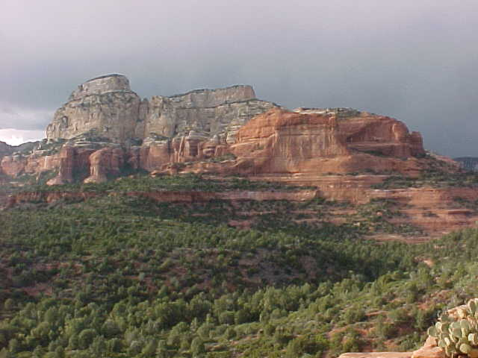
May I suggest that you are undercutting the very power of God which is within you when you feel that you have to go somewhere to find the power. If you want to go somewhere fine, but do it so as to bring your power there. Experience your power in different settings.
You don’t need a change of scenery, you need a change of mind.
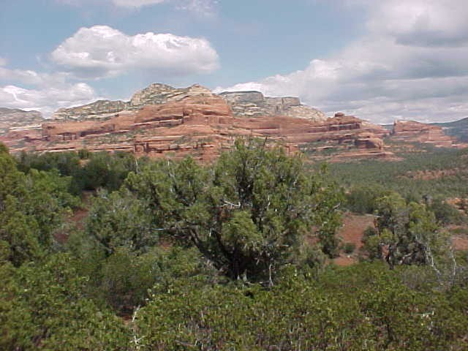
Now let me move in a different direction. What do I think of people going to Sedona or anywhere else to find peace, and love and holiness in nature. I think it is wonderful. It is bringing forth from within themselves a new communion with nature and with the life of nature including its animals. It is wonderful and it is part of Aquarius, the new consciousness.
So I am not putting this down. I extol people to go to Arizona or Alaska or Florida or wherever, with the purpose of becoming one with nature. If you cannot find it home then definely go forth into the mountains or the desert or wherever and make your peace with nature and its animals and its life.
There is much that is coming forth in this way and if Sedona helps bring it out, more power to it. For we are also looking at the other spectrum that we have embraced all of our lives, once again on the loose in Kosovo. The power of the mind to kill, and hurt, and torture others not because of what they have done but simply because of who they are.
Hitler had it with the Jews. Muslims and Jews have it with one another. In Ireland, Protestants had it with Catholics. Wherever you may look, tribes hate each others beliefs and wind up swining out against others, not because of what they have done but simply because of who they are.
Such is the state of the terrible evil that roams the earth and hates Sedona and everything connected with it. The terrible evil is religion, that gives justification for a Serbian Christian to drive from their country an Albanian Muslim just because of who they are.
And then the others try to intervene as the US has by dropping bombs. And others jump in and you have a macrocosm of a barroom brawl. People are swinging at one another just because they are there. A free for all breaks out, a wild melee. All because of religion.
And when you consider how violent it has been throughout history in all parts of the world, you can see why so many are abandoning orthodox religion and looking for a lonely red rocked mountain in Sedona where they can sit in a wilderness setting and speak with the mother and her animal children and make peace.
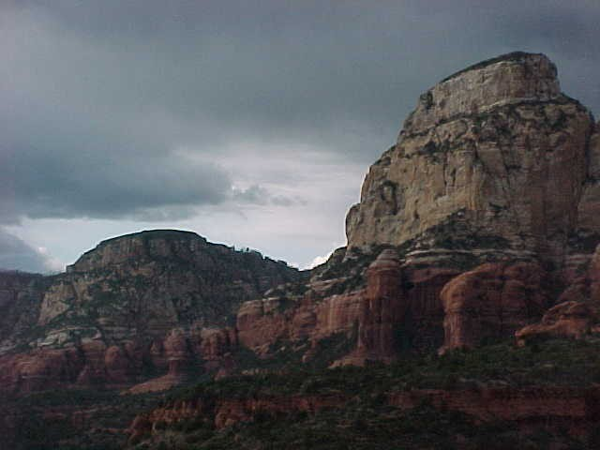
So the question is not why people are experiencing things in Sedona. The question is why are people going to Sedona in the first place. To understand that , one has to consider the ultimate Vortex which now is called Aquarius. A dramatic change in the electro magnetism that is effecting the world.
The spiral magnetism coming off of Uranus that makes the Aquarian age what it is. A time of a great change in consciousness. To many people it opens gates that they have yearned to have opened. Gates in the brain that sets them free from religion, and cults, and government oppression and sends them off looking to find peace within themselves.
To others however it causes a need to defend mother cult at all costs. The idea of communing with nature and finding the true essence of Christ within ones self and to be guided from within instead of from a church or religion is the very essense of evil and something that must be destroyed from the minds of young and old alike.
And so some people institute meditation classes in schools and others come against the schools as fostering demonic religions and Eastern cultism. Even though it was Jesus Christ who said , the Kingdom of God is within you and you should practice the single eye.
And so the great struggle for the liberation of the human mind from the clutches of religion is on. People climbing mountains in Arizona to get away from the system and feel the inner power of the sacred.
There is confusion abounding as people are pulled by the forces of nature which is God to a higher place away from the Jerry Falwells of the world, and at the same time feel the heavy tug of traditionalism and family warning them not to leave the fold.
And leading up to the time of the great liberation, religions fought against one another with swords, and shields, and bullets and bombs. Jews and Muslims in the Holy Land, Protestants and Catholics in Ireland, Hiter and Jews in Europe, Serbs and Muslims in Kosovo. Catholics and Muslims in the Crusades. The bloody torture of the Inquisition. Jews battling their way across the mythical deserts of the Bible trying to take over their promised land which belonged to someone else and so had to be taken by force and blood.
And now when much of the world is climbing the mountain to get away from Jews, and Catholics, and Protestants, and Buddhists, and Muslims, and Hindus, and vegetarians, and fundamentalists, and Americans, and foreigners, and New Age, and corporations and any other group that looms its giant horned head down on the innocent with threats of hell if one does not conform, we search here for words of wisdom that came from a different place in a different time to give us direction.

