THE HUMAN BRAIN
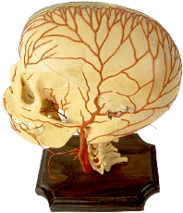
&
THE UNIVERSE
ARE

THE SAME ???
The Kingdom of God The Spiders Web
The Brain Universe Universal Brain Parts
Watching Little People
Molecules That Make A Man
Constellations In Your Head The Brain and the Sky

THE KINGDOM OF GOD

I guess if I was to consider one statement of Jesus Christ that is most meaningful to me and forms the foundation of our work here at Hidden Meanings it would be this.

Luke 17:21 The Kingdom of God is within you.

This doesn’t mean then, that the Kingdom of God is a matter of kidneys, or livers, or teeth. It means the Kingdom of God is a matter of consciousness. And not on just the basis of some kind of religious or spiritual perspective but physically, for real.

Some time ago I shared with you a strange but beautiful comparison between the human brain and the universe.

This picture of the human cerebral cortex comes from the book, The Three Pound Universe by Judith Hopper and Dick Teresi published by Tarcher Purnam. The picture is found on page 33 of the book.

We look at the human cerebral cortex. The part of your brain showing the circuits that carry the electrical signals so you can think what you think and do what you do.
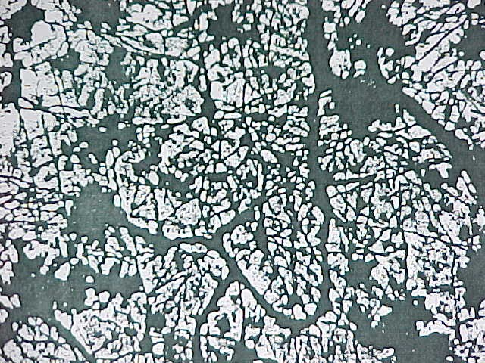

Using a very special camera, the Canada France Hawaii Telescope was able to get a picture of dark matter. That which makes up 90% of the universe and when we looked at this it became amazingly clear as to what we were seeing.

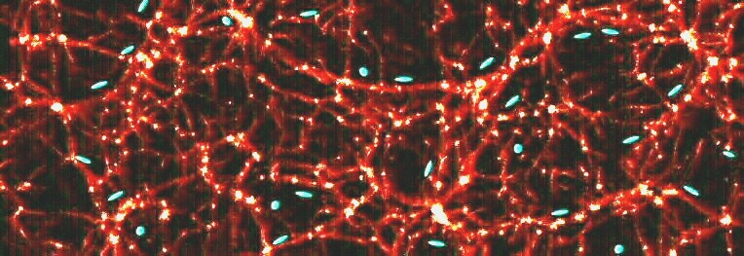
Click here to visit the site and then click your back button to return here.
Canada-France-Hawaii Telescope
As we placed the universe picture of dark matter alongside the picture of the circuitry of the human brain, We see that indeed the universe is a cosmic brain or the human brain is a miniature universe. The circuit pathways are the same. Conveying signals point to point.

So then you see that if the Kingdom of God is the cosmos, the universe, then it appears to have been duplicated within us, just as Jesus said.

We now have additional support for this proposal coming to us from the European Southern Observatory.

You are about to see the universe 2 billion years after the Big Bang. It is a computer animation based on the programming placed into it by scientists and look what comes out. It is a duplicate of the human cerebral cortex.

Indeed the Kingdom of God is within us as a miniature universe. Just as Jesus said and do you see why contact with the supreme light is so obviously possible and important for you to pursue ?

FROM THE EUROPEAN SOUTHERN OBSERVATORY
YOU MAY FIND THEIR SITE AT http://WWW.eso.org

A computer animation of what the universe looks like 2 Billion years after the Big Bang
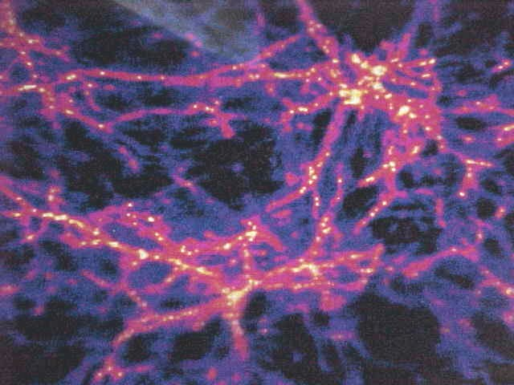

As I look at those lines which make up the circuits in the cosmos and the circuits of the brain carrying information and messages of the great light I think of the scripture in Psalm 19:4

Their line is gone out through all the earth and their words to the end of the world. In them has he set a tabernacle for the sun. Truly the kingdom of God is within us.

Now I am not the only one proposing a connection between the structure of the universe and the structure of the human brain . I want to look at text that goes with the universe picture we showed a moment ago.

THE SPIDERS WEB

THE FOLLOWING IS FROM THE EUROPEAN SOUTHERN OBSERVATORY TELESCOPE LOCATION AT PARANAL OBSERVATORY IN CHILE

Paragraph 3. All recent computer simulations of the early universe have one prediction in common. The first large scale structures to form in the young universe are long filaments connected at their ends in nodes. The models typically look like a three dimensional spiders web and resemble the neural structure of the brain.

Paragraph 4 The first galaxies or rather the first galaxy building blocks will form inside the threads of the web. When they start emitting light they will be seen to mark out the otherwise invisible threads much like beads on a string.

And so we see that as in the neural structure of the human brain, the cosmic filaments start emitting light or electrical impulses. These are the light beings we speak of here and these are the light beings that we seek to draw to us in our meditation.

The last paragraph. If a very distant hydrogen cloud emits Lyman alpha radiation then this spectral line will be red shifted from the ultraviolet into the blue, green or red region of the spectrum.

So again we see the possibility of green light that we have addressed previously. In considering contact with higher forces and UFO’s etc.

But what we are considering here is the brain of God. And we being made in the image and likeness of the supreme light being. And we see the pathways of light in the form of cosmic neurons and within us in the form of neural structures of the cerebral cortex.

You cannot minimize what we are discussing here. What we are discussing is looking up into the sky and actually looking at the inside of the brain of God. In other words are we thought patterns in Gods brain.

Now let’s follow this because of its implications as the brain of God together with the brain of us.

THE FOLLOWING IS FROM SCIENCE AND ASTRONOMY. YOU CAN VISIT THEIR WEB SITE BY GOING TO HTTP://WWW.SPACE.COM/SCIENCEASTRONOMY

MAY 23 2001

Our tangled Universe, How the first Galaxies were born.

Were Sherlock Holmes a cosmologist he might have said. Its filamentary my dear Watson. The acute Watson might have argued however that its more like a spider web. And if word of Holmes theory got around other big thinkers might have insisted no, its spongy just like your brain.

So again we see the cosmos as a brain that is not unlike ours in fact appears to be more like a duplicate of ours.

Paragraph 3

That the early universe contained a series of threads and clumps not unlike a spider web dappled with water droplets.

Paragraph 6

Using the European Southern Observatory's very large telescope they spotted a string of dense clumps of hydrogen etc. They were found to lie within a tubular region of space, a filament supporting a popular theory of the cosmic web.

Paragraph 7

This discovery certainly bolsters the concept of the cosmic web.

Page 2 Paragraph 2

Computer models (of the universe) see these variations as leading to the first large scale architectural components of the universe, long filaments connected at nodes. The spider web.

Ok, so we have seen and compared the neurons of the universe to our brain and they look the same. Scientists are speaking of the universe as resembling the human brain and now we see that the universe is like the spider web.

Why this is so critical is because we are looking for contact. If there is not a connection between the brain and the universe that’s one thing but if they are the same then there is no reason why we cannot make contact.

The scientists find the universe as a Spider Web.

THE SPIDERS WEB IN THE HUMAN BRAIN

The outermost layer of the human brain is called called dura mater, hard mother. The innermost layer of the human brain is called pia mater (tender mother). Between the outer dura mater and the inner pia mater lies a reticulated layer of tissue the arachnoid whose appearance reminded another now anonymous anatomist of a spiders web.

So now science sees that the cosmos is like a spiders web and we see that arachnoid lies between the coverings of the brain appearing as a spiders web.

So now let us go to the dictionary and see the definition of arachnoid which is part of your brain

Dictionary Definition: Arachnoid

Arachnoid, Delicate membrane enclosing the spinal cord and brain. Soft entangled hairs or fibers resembling those of a cobweb or spiders web. Between the pia mater and dura mater. From Greek arakhnoeides, arakhne spider.

So science is showing us that there is little to doubt that the universe is a cosmic brain which aligns with the human brain. Spider web like are both.

So you see that it is same to same. Like to like. Brain to brain. You are not trying to make contact with a stone, you are trying to make contact with another brain. As it is in heaven so it is on earth.

The more we study these things the more we understand that all scripture is referencing contact between the cosmic brain and the human brain.

People who may not understand this see astrology as something evil when in fact the parts of the cosmos used in professional astrology are actually organs of the cosmic brain just as each one of us have organs such as Fornix or Arachnoid in the human brain.

So when someone who understands works with cosmic things they are actually directing attention to part of a brain. The cosmic brain. If someone directs one to part of the human brain there is no problem. So why should there be a problem with someone directing attention to parts of the cosmic brain as is the case for professional astrologers.

Now lets just follow this a moment longer looking at something from a site called

THE BRAIN UNIVERSE

Located at : Brain and Mind

Just click the above to see for yourself and then click you back button to return here.

If you don't want to make the trip I can recap it for you. The text goes as follows:

Not only stars in the universe fascinate man with its impressive numbers. In another universe, our own biological one, a gigantic galaxy with billions of small neural cells forms our brain and the rest of the nervous system and communicate among themselves by means of flashes of electrochemical pulses.

Without them it would be impossible to achieve our rich internal world and to communicate with the surrounding environment by means of sound, smell, taste ,touch, and light, including that of the stars in our universe.

The writer compares the outer cosmic universe with the inner brain universe. Notice how the writer describes the human brain as a galaxy. Electrochemical pulses described as flashing neural cells. The same galactic activity that fascinate us so, going on in our heads and being the catalyst of our existence.

Now let's look at little further.

Again we talk about neurons as we did in the beginning of this message.

Neurons are specialized cells. They are made to receive certain specific connections and pass their decision to other neurons. These specializations include a cell membrane which is specialized to convey nerve signals as electrochemical pulses.

The dendrite from the Greek dendron or tree, which gets and delivers the signals.

Most signals are delivered to dendrites.

So a part of the brain that gets and delivers the electrical signals is dendrite which means tree.

We suddenly are realizing that the part of the brain that provides the information is called dendrite or tree, now maybe we can understand the Old Testament admonition not to partake of the tree of the knowledge of good and evil.

How do you avoid taking from the tree of the knowledge of good and evil. You shut down the thoughts of the mind. You obey Jesus and take no thought. You meditate. Exactly what we doat the Hidden Meanings Conference Center. .

Now let us go to a definition of the word dendro or dendrite.
dendro- or dendri- or dendr- pref. Tree; treelike: dendrochronology. [From Greek dendron, tree. See deru- below.]deru-. Important derivatives are: tree, truce, true, truth, trust, tray, trough, trim, tar1, endure, druid.
deru-. Also dreu-. To be firm, solid, steadfast; hence specialized senses "wood," "tree," and derivatives referring to objects made of wood. 1. Suffixed variant form *drew-o-. a. TREE, from Old English tr¶ow, tree, from Germanic *trewam; Germanic *trum-. 6. Variant form *derw-. TAR1, from Old English te(o)ru, resin, pitch (obtained from the pine tree), from Germanic *terw-. 7. Suffixed variant form *dr¿-ro-. DOUR, DURAMEN, DURESS, DURUM; (DURA MATER), ENDURE, INDURATE, OBDURATE, from Latin d¿rus, hard (many of whose English derivatives represent a semantic cross with Latin d¿r³re, to last long; see deu…-). . DENDRO-, DENDRON; PHILODENDRON, RHODODENDRON, from Greek dendron, tree.

We see the word dendro dendr tree treelike. From Greek dendron. We then look at important derivatives, tree. . And then we find the word connected to pine tree which takes us to the pineal gland of the brain which means pine cone. And we see the word connected to dura mater which is the outer part of the brain.

Now what is it in the sky that is an organ of the cosmic brain. Connected to the human brain.

How about Pegasus. The White Horse Constellation. Pegasus father was Poseidon the God of the Sea making Pegasus a white sea horse. Sacred to the Goddess Mnesomyne the Goddess of Memory. White sea horse Memory.

The hippocampus of the brain is the place of memory. The word hippocampus means sea horse. Now let us look at Stedmans Medical Dictionary

The hippocampus major or cornu Ammonis is a white eminence.

So the white sea horse in the sky Pegasus, is the white sea horse in the brain, Hippocampus. And both are connected to memory.

In your brain is an organ called fornix.

We understand that Eta Carina is a hypernova in the sky. But we also have a carina in the brain. We not only have a carina, but we have a carina fornicis which is defined as:

A ridge running along the undersurface of the fornix of the brain.

UNIVERSAL BRAIN PARTS

So in the brain we have Carina .

In the cosmic brain, the universe we have

ETA CARINA
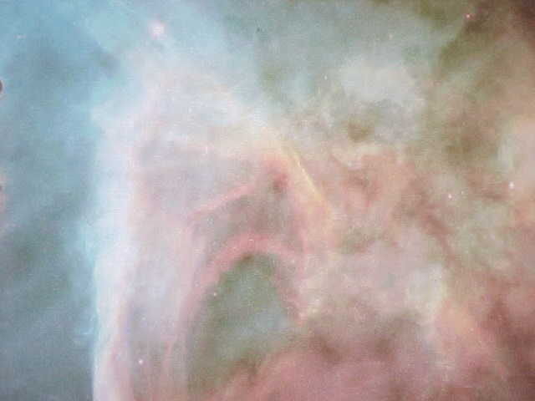
In the human brain we have an organ called Fornix. In the cosmic brain, the universe, we have a constellation called Fornax.

What I am showing you is that there are organs in the human brain that match up with organs in the cosmic brain. For a purpose .

In your head there is a single eye which can be ignited and it is situated between the two outer eyes. It is the Pineal Gland of the brain.

In the cosmic brain, the universe is Supernova 1987a .It is the single eye in the center of the two outer eyes. It is on fire.
Supernova 1987a
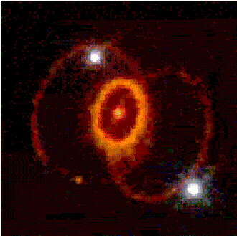

So the universe is a brain that aligns with the physical brain.

LITTLE PEOPLE INSIDE OF YOU

I believe we have presented here significant evidence that the human brain is a duplicate of the universe. In other words the significant evidence indicated that when we look up into the sky we are actually looking up into a brain. The brain of God?

Imagine inside of your body. The little people who live in there. Cells in your body. They have lives and things they need to do to. And if they did not do their jobs properly you would get sick and even die. And as we know sometimes these little people (cells) do not do their jobs properly.

OH WHAT A BEAUTIFUL EVENING

You look up at the sky and you see Pegasus, and Supernova, and Fornax, and Carina. Its so beautiful. You stand with your loved one hand in hand and look up at all of those exciting displays in the night sky..

Could there be little people inside of you standing cell to cell and looking up into the brain at all of those exciting displays?

But you say , you cant compare human beings with little cells. We are sophisticated. We do special things. They are just cells.

You might say, I work with lasers and electronics, or I work for the post office and send messages all over the place. I have an important job.

All kinds of cells are inside of you creating large molecules called proteins. They fire impulses from one part of you far away to the other part. They send messages too.

You might say, I work in aerobics, I work in a gym. There are cells that actually squeeze muscles in your body . They seem to work in a gym too . You might say, I work in fire prevention, there are cells in your body that work in fire prevention too.

I work in a museum you say. There are cells working in the hippocampus which is the memory bank of your brain. You might say they are also working in a museum. I work for an optometrist you say. There are cells that work in caring for your eyes. I guess you could kind of say, the work for an optometrist.

But what ever you do for a living, there are little people (cells), inside of you doing the same thing. They do it inside of you and they look up into your brain. You do it outside of them and you look up into the sky brain.

And so two little people place their cell hands in one anothers and look up at the night brain sky. Hey look, you can hippocampus. Wow look over there whats that, that’s Fornix. I think I can see carina. Isn't thalamus beautiful tonight. Look over there, its Ventricle. Beautiful !
What they look at inside of your human brain, you look at inside of the cosmic brain. The universe. But it is all the same thing, just on small or larger dimensions.

WATCHING

Basically the concept returns to the reality of observation, of watching. Someone inside of you is watching. Cells, little people. They watch, they read the genetic code like you read instructions with an appliance and they follow the instructions as you do.

And you are watching. You read directions and Bibles, and books, and you observe other things and you act accordingly.

Which means that someone in the sky is also watching. And they are watching what is beyond the sky. It is observation, both sight and sound, and concentration of mind, that creates life , existence, and all circumstances.

Your health, your feelings, your happiness, or sadness are totally dependent on external stimuli. What has stimulated cellular and neural activity inside of you , has had its origin outside of you.

Everything that goes on inside of you is the result of a stimulation of some kind from the outside even your genetic makeup at the time of gestation.
And so we are a cell inside of a cosmic brain in the same way that there are cells inside of the human brain, in the same way that there are molecules inside the cells. It is like peeling an onion until you come to nothing which is everything.

SCIENCE AND TECHNOLOGY

Unfortunately this article is no longer available however if you would wish to visit their web site you may do so by CLICKING HERE. You can return by hitting your back button.

The headline. This is the molecule that maketh the man. Here is a scientific document using language that is similar to traditional religious language. maketh the man.

Researchers have revealed the workings of a machine, the ribosome that helps turn genes into flesh and blood.

Within each of your cells the molecular equivalent of a tape player is ceaselessly translating your genetic code. When this complex molecule was first glimpsed under an electron microscope it looked somewhat inconsequential.

But the talents of this tiny blob put the best efforts of scientists to shame. ---this tiny machine measuring one millionth of an inch across routinely helps turn genes into flesh and blood.

We talked earlier about little people inside of us and we as cells inside of a higher brain. Listen to this.

This machine is called ribosome and scientists have now glimpsed it in action to reveal how within every cell tens of thousands work with mind boggling

The report goes on.

Precision. Armies of them toil in all living things creating large molecules called proteins that build and operate cells, some catalyse chemical reactions, other send signals , act as hormones even squeeze muscles.

So you see . We may all go to work for a large company. Everyone working doing something to achieve the goal of that particular company. It is the same thing in your body. Many little people working creating proteins, catalyzing reactions, sending signals, squeezing muscles. They have their careers just as you do.

The report goes on.

As one scientist wrote in the journal of Science the new research is like uncovering an ancient drawing depicting in exquisite detail a universal mechanism for one of the original steps in the evolution of life.

The ribosome works like a tape reader, threaded through it is the chainlike messenger RNA, a sequence of 4 chemical letters A G C U that spells out the recipe of a protein. The ribosome reads this sequence three letters at a time and matches it to three letters on each transfer RNA lining up their cargo in proper order.

You may work for federal express, or UPS or the post office and have jobs that are very similar to what the little people in their societies do inside of you.

When I call them little people inside of you it might be difficult to consider but look at this.

The report goes on.

This year Prof. Harry Noller of the University of California Santa Cruz pictured the entire ribosome shown here, revealing how the ribosomes brain and heart bind to each other as molecular bridges form and fall during its operation.

You see what is going on here is a proposal that everything must work exactly the same from the sub atomic invisible life through us, the visible live, through the greater universe visible and invisible .

The point being made here is that the universe is a brain. The things we see as planets and constellations etc are actually parts of the brain as the ventricles, and thalamus etc are parts of your brain. There is a connection between the two. As the little cells work inside of your brain, so you work inside the cosmic brain.

Thus Eta Carina is not simply a nebula or sun or star. It is an organ of the cosmic brain.

CONSTELLATIONS IN YOUR HEAD

You have a carina in your brain. You also have a fornicis which is Fornix. The cosmic brain or universe, has a Carina and a Fornix. So the cosmic brain or the universe has the same things in it as your human brain has.

And that is important because we see the little people or cells working inside of your brain doing the same things that you do working inside of the cosmic brain. Do they have families inside of you, do they go home after work, inside of you.

LETS LOOK AT RIBOSOME

Let's break down the word Ribosome which we have just studied. As part of that word ribosome you can see the words rib and the word some.

Why that is important is because of Eta Carina. There is a carina inside of you and the word rib connects to the words ridge or sternum which connects to the definition of carina. It also connects to the description of the keel of a ship which Carina means in the universal definition of Eta Carina. The keel of the ship Argo.

And of course what is important here is Ribosome manufacturers protein and is connected to DNA. Eta Carina is formed of highly structured molecular gas which is DNA. So there is a connection there as well.

Carina is the Keel of the Ship Argo which carried the healing golden fleece. I am saying that DNA is the healing Golden Fleece that Carina is carrying now. In other words , what I am proposing to you is that the golden fleece was a mythological symbol of DNA and the ship Argo which carried that fleece was a mythological symbol of Eta Carina.

So if we connect the Keel of the Ship Argo to Eta Carina, we then connect Eta Carina to the brains Carina and the word Ribosome which manufactures DNA and protein. The two become connected, inner brain and cosmic brain.

And I will show you how mythological symbols work in deep detail. As the story of the Argo is written. If it is speaking of Eta Carina in the cosmos and carina in the brain as healing DNA factors, then you would write the story consistent with the molecular break down .

Ribosome manufactures DNA, protein.

Rib, =Carina in the brain.

Rib=Keel of the Ship Carina in the Universe.

Carina in the universe =the Ship Argo= Ribosome.

THE SHIP HAD 50 OARS

The ship Argo had 50 oars. That is spelled out in the myth. There must be a reason. Why does a mythological story which by its very nature is a symbol of something else, specify 50 oars.

We again look at the definition of the word Ribosome and may find a curious answer.

The ribosome now looks more of a factory then a machine. Each one is composed of 3 different RNA molecules and more then 50 different proteins. In the watery interior of the cells thesepieces form two parts called the 30S and 50S sub units which drift apart and together during its operation.

The small 30S unit is the brain of the ribosome which reads the genetic code. The bigger 50S is its heart where proteins are made.

Argo had 50 oars. And that is the way that symbols are studied and discerned in this work. Every item that matches is a clue that must be placed in the picture as part of the puzzle. Unless you match every part you will never see the finished picture.

As the bible says,now we look through a glass darkly but then face to face.

Now as we showed last week it is not just the similiarity in words that brings us to the point of considering the universe as a cosmic brain that is constructed the same as the human brain. We can see it with our own eyes and consider the comments of scientists studying the universe.

THE BRAIN AND THE SKY

Here we see inter connected neurons in the human cerebral cortex. The brain. Neuros are the parts that fire electrical impulses that are your thoughts and your movements. That is the electrical circuitry of the human brain.

Next we look at dark matter. Dark matter makes up 90% of the universe . It creates and controls the universe.

Strange the dark matter is formed exactly as the circuitry of the human brain. It certainly must give evidence of a cosmic brain duplicating the human brain.

Next we look at a computer animation of the appearance of the universe 2 billion years after the big bang.

There is little that can be concluded but that the universe and the human brain are one in the same and what is being carried out inside of our brain by living things, we are carrying out inside of the cosmic brain as living things.

Now there is another piece of evidence that shows that the organs of the cosmic brain match the organs of the human brain. I use the word organ rather then the word part .

