THE COSMIC CONNECTION
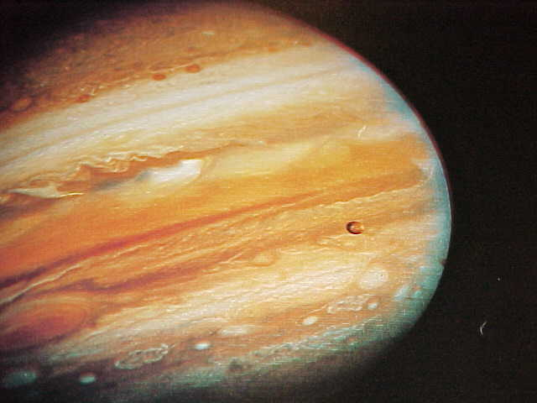
COSMIC THINGS THAT HAVE IMPLICATIONS THROUGH THE BIBLE ,
THROUGH YOUR LIFE ,AND
OTHER ANCIENT DOCUMENTS.
URANUS OURANUS IS URANUS IS HEAVEN !
UFO'S AND EXTRA TERRESTRIALS IS 4555 THE GALAXY OF GOD
EL NINO IS AQUARIUS !! THE SACRIFICE LAMB
SIN IS THE MOON THE STORY OF JESUS IS THE STORY OF THE SUN
IS IT THE STAR OF DAVID, ? OR THE STAR OF DELTA ?
Trajectory of the Sun Written in the Stars
Of Space and Time Ezekiel And The UFO !

URANUS, FATHER OF THE EYE
As you know by now Hubble has found Supernova 1987a, the Single Eye in the Sky. This fantastic Supernova can be seen on the Planet Page.
Not only has the eye been seen ,but on February 8th 1998 it was announced that the center eye was on fire.
We showed you how the eye was seen in the sky just after the discovery of the 7 new planets found in constellations from Virgo to Leo. Exactly as experienced as energy moves up the spine, and exactly as written in the Bible. We suggested that the universe was experiencing a cosmic Kundalini and that this certainly would herald tremendous changes upon the earth.

Well there is more to consider. Especially when thinking of change.
We are in the age of Aquarius. The ruling planet is the Green Planet Uranus. The Planet of Change.
The myth of Uranus must make us all take pause and consider. Uranus is the father of the Cyclops. The Cyclops are the Titans who have the third eye. They provided the lightening bolts to Zeus.
Isn't it amazing that in the Age of Aquarius ruled by Uranus, we suddenly see in the sky. Supernova 1987a which displays the third eye. The father of the single eye rules, and the single eye appears to look down upon us.
_
The Cyclops providing lightening to Zeus makes the total message of the Eye in the Sky apparent. Uranus brings forth the power of the single eye which brings enlightenment from God.
There is no more important time in history to be active in meditation then now. Raise the energy to the single eye and flow in a cosmic harmony with this new energy coming down from the Eye of God.
The father of the eye has come. The eye has opened. As shown in the picture it is green. It looks down upon the whole world. Now it is on fire. The time is at hand for a cosmic Kundalini. It is truly a wonderful time to understand and be part of the new universe of light.

URANUS, THE KINGDOM IS
AT HAND !
Uranus is the ruling planet of the age of Aquarius that we are entering at the present time. As we look around we can see that Uranus is true to it's reputation.

It's characteristic is that it shakes traditional aspects of life and causes things to turn upside down. That is attributed to it's own erratic behavior. It sure is right on schedule isn't it.
A most interesting aspect of Uranus. In the Bible Jesus says, " The Kingdom of Heaven is at hand." The New Testament was written in Greek and the Greek word for heaven is Ouranos. Uranus.

What was actually being said was, " The Kingdom Of Uranus is at hand"., and we are witnesses to it's changing power.
Keep watching.

UFO'S AND EXTRA TERRESTRIALS
Suppose I tell you that the Bible provides very graphic accounts of UFO's and alien abductions. The whole bit.
I take you to 2 Kings 2:11. The same people who have told us of Nuclear Fission. The Speed of Light, The Pineal Gland, The Human Brain etc, now tell us that a being named Elijah had a prearranged time to be at a certain place, at certain time, when he would be lifted off from the earth, and taken upward into space until he faded out of sight from those on the ground watching. And thousands of years ago, the craft which took him into space was called, "A fiery chariot". Who was he , where did he go ?
What about the EXTRA TERRESTRIAL ?
Get this . In the New Testament, Jesus points over to John the Baptist and says, "do you see that guy ?" (or words to that effect).,
THAT'S ELIJAH !
HE'S BAAACK !!

4 5 5 5 THE GALAXY
The ancient Coptics of Egypt believed that you were saved by knowledge , not faith. They followed a monophysite doctrine which aligns with present day physics and quantum.
Two thousand plus years ago, they wrote in the Book of IEOU of a strange number and and instructed others to hold it close to them. The number was 4555.
In the book of Daniel, in Daniel Chapter 5 a strange thing occurs. A hand without an arm enters a room and begins to write on a wall. The words are Mene Mene which means number, number. In Hebrew and Greek each letter has a numerical value. The value of the word Mene is 4555
In Daniel the number 4555 appears between the stories of Shedrach, Mesach, and Abednigo (the three who were put in the furnace), and Daniel who was thrown to the Lions. As you study Supernova 1987a on this page you will find that both stories have connections to Supernova 1987a the eye in the sky. Thus 4555 becomes extremely important being connected with Supernova 1987a which is supposed to bathe the earth with electro magnetic light around the year 2000. Please study Supernova 1987a on this page.

NOW PLEASE LISTEN CLOSELY
4555 is an unnamed galaxy, with a bright center in the constellation Coma, (mother & child), in the Zodiacal sign Virgo. It gives a whole new meaning to the scripture that says, "behold the Lord will give a sign, a virgin shall conceive".
IS 4555 THE GALAXY FROM WHERE
HE/SHE/THEY WILL COME ?

EL NINO--AQUARIUS
The fact that this El Nino would be extreme was written in the stars as well as in the myths of long ago.

This El Nino is born under the controlling planet Uranus which brings forth the revolution. There is a revolution in all things. In the sky, in the weather and in the human mind.

El Nino means little boy. The little boy was Ganymede who was the cup bearer . Zeus brought him to heaven to be the water bearer for the Gods. He did so well that he was made into a mighty constellation, the water bearer Aquarius.

In this cosmic age of change, El Nino the water bearer has appeared in Aquarius. The evidence all around us is testimony that the time of the great change is at hand.

By the way. In the Bible, Jesus is quoted as saying, "The Kingdom of Heaven is at Hand." This passage was written in Greek. The Greek word for Heaven is Ouranos. Translated it says. " The Kingdom of Uranus is at hand". May we all look up and in meditation seek harmony with this Green Planet who's magnetism will disturb all that we have known as tradition, for indeed it must be disturbed.
And the water bearer will have his way for he has grown into Aquarius.

THE SACRIFICIAL LAMB
The Question: Why was a lamb sacrificed at Passover. The rules were that a lamb had to be roasted at Passover, why ?

To understand the sacrifice, we have to first understand Passover. It is the passing over from the Winter to the Spring. In order for this to occur, the Sun must enter the Lamb/Ram, Aries. The Lamb Aries is roasted by the Sun and we Passover from winter to spring.

In you the Lamb Aries is the Pineal Gland of the brain. When the solar plexus, Sun energy rises to consume the Lamb/Pineal you passover from the cold winter of your life to the springtime, where all things become new.

Meditation brings you out of the winter of your soul that you may passover to the calm . Such is the purpose of the sacrifice lamb.

SIN IS THE MOON
Did you know that the word Sin referred to the Moon Goddess of the ancient Ur of the Chaldees ?. The moon was a symbol of the emotions because it reflected whatever was shone on it. Thus sin is actually being controlled by the emotions instead of the mind. So you can see how truly sinful religion really is.

THIS IS THE SUN STORY
The sun is born out of the constellation Virgo, the virgin. This happens in the 9th month, September . According to the scriptures Jesus is born of a Virgin.
December 21st, the shortest day of the year, the Sun apparently moves to it's most southerly point in Capricorn. The ancients attached it's southernmost position to Crux, the constellation the Southern Cross located in the most southerly position, Thus the sun was considered crucified on December 21st, the shortest day. The day with more darkness then any other. According to the scriptures, Jesus is crucified.
The sun is then entombed in the bowels of the earth,3 days and 3 nights, December 22, 23, and 24. It is the winter solstice. Scripture says Jesus was in the tomb 3 days and 3 nights.
The sun is then reborn out of the solstice on December 25th. Tradition celebrates the birth of Jesus on December 25th.
Thirty days after December 25th the sun moves into the sign of the waterman Aquarius. Thirty years after his birth Jesus enters the water of the waterman John.

The sun them moves into the sign of the fish, Pisces. Jesus selects his disciples from among the fishermen.

The sun then moves into the sign of the Ram Aries that takes away the cold of the winter. Scripture calls Jesus the Lamb of God that takes away the sins of the world
In the Northern Hemisphere the sun moves to the Eastern sky or the right side and summer comes. It is called astronomically, celestial right ascension. Scripture says that Jesus ascends to sit at the right hand of the father.
The sun concludes its journey in August in the sign of Leo the Lion. Jesus concludes his journey in the book of Revelation as he is called the Lion of Judah.
So who is the Sun and who is his father .

THE STAR OF DAVID ?
In the human brain at the point of the hippocampus (area responsible for memory), is an organ called The Fornix. The word means vault. It is the tomb of Christ, it is the tomb of the King of the Pyramid. It is the place where Christ consciousness awakes.

If you look in Stedman's medical dictionary you will see that it is called Delta Fornicis. It is shaped like Delta. Thus we have the symbol of Delta in you with the point looking up

In the universe is a constellation called Fornax. It is the furnace where the sacrifice is consumed. It is the place of the Sun resurrection, the place of fire. From here the fire comes down to the tomb, (fornix), which causes the Christ consciousness in you to resurrect from the dead.
The bright star in Fornax is called Delta Fornax. Thus we have the symbol of Delta in the sky with the point looking down.
When we bring together Delta Fornix in you looking up, with Delta Fornax in the sky looking down, what do we get ?. 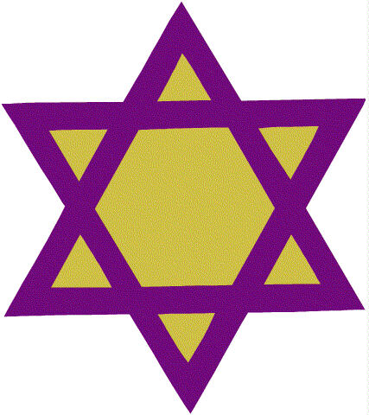
In your meditation you reach it by reaching Delta Brain waves. Four cycles per second. So remember, Delta is ready when you are. !

TRAJECTORY OF THE SUN
In the Book of Revelation, Jesus Christ refers to himself as the Amen (Rev 3:14. ) Amen Ra is the name of the Egyptian Sun God. The life of Jesus duplicates the trajectory of the Sun. Coming down from Aries the Ram (The Highest Point), Crucified on the constellation "The Southern Cross" on Dec. 21st, entombed in the bowels of the earth, 3 days and 3 nights on Dec, 22, 23 and 24 (Winter Solstice), Born Again on Dec 25th.
Out of the constellation Virgo (The Virgin) returning to the highest point Aries ( Spring Equinox), in the northern sky sitting at the right hand (Eastern Sky) and summer comes.
In addition, in the Bible, Jesus dies and there is an eclipse and he rises at Sun Rise and his day is Sun Day. He is the Sun God .

WRITTEN IN THE STARS
Ursa Major is the Big Bear. In it's right rear leg is a star called " daughter of the assembly". In the right front leg is a star called " Talitha". Therein lies an amazing story of the origin of the Bible. In Mark 5:22&23, Jairus one of the rulers of the synagogue (assembly), comes to Jesus and says " my little daughter is at the point of death". So here we have the " daughter of the assembly". (The star in Ursa Major).
Now Jesus goes to the house of the daughter and in Mark 5:41 he takes her hand and says " Talitha Cumi" daughter arise. So what's being said. The star in the right rear leg of Ursa and the star in the front leg of Ursa is used as the basis of this story of healing and compassion. It is written in the stars and one must consider, is the power in the stars as well.?

OF SPACE AND TIME
It is important to remember something. What we are looking at in the universe as Hubble sends us pictures daily of cosmic wonders, are things that have already happened and are no longer there. Those things we are looking at now happened thousands of years ago. Now we see them because the light from them has finally reached the earth.
The implications here are tremendous. People who live on other planets and have experienced these things before us would be able to communicate to us what to expect. We call these prophecies. It is as if you lived from June through February and were able to communicate with people who were seeing their first June. You would be able to tell them of the snows to come that they had never experienced before because you had already passed through that time.
We are seeing the wonders in the sky that others have seen and experienced thousands of yeas ago. And still others who live elsewhere will experience the same wonders thousands of years from now and we will be the aliens of outer space to guide them.

EZEKIEL AND THE UFO
EZEKIEL, THE UFO, THE CHERUBIM & YOU
In Ezekiel 1, a whirlwind appears from out of the North. (A whirlwind is a vortex). Out of that whirlwind is seen a UFO. It is an object, it is unidentified, and it is flying. As flashes of fire come out from the craft, it darts back and forth. It lands and it has wheels. When it lifts off it makes a tremendous roar. This is a Biblical record of a sighting of a UFO. And it gets better.
THE CRAFT LANDS, THE MAN IN WHITE LINEN, IT LIFTS OFF AND
HOVERS OVER A MOUNTAIN
In Ezekiel 10 the craft lands. A man in a white linen suit is seen standing near the craft. A voice is heard directing the man to go between the wheels of the craft. Between the wheels of the craft the earth is scorched. Then the man gets back into the craft and there is a tremendous roar, and there is a cloud that covers everything. The craft fly's toward a mountain in the East and hovers there. Read about it. How do I know, ? The Bible tells me so.
CHERUBIM'S
Now the kicker. Remember when I told you of Dura Mater and Pia Mater. Remember how we showed that the tabernacle was a pattern of the human brain, the human mind. Well in Exodus 25 there is something else that has to be included in the construction of the tabernacle. There must be Cherubim's. In other words, in some way the word Cherubim's is connected to the human mind. Remember we previously showed that cherubim and cerebrum , the human skull were the same. And what do you think Ezekiel concludes in his UFO sighting ?. Ezekiel concludes in chapter 10 that the UFO's are Cherubim's. Thus the Bible graphically connects the human mind, UFO's, and aliens who fly them and , are taken up in them, and who are seen walking and standing by them. Remember, all of this is in the Bible. The word of God. And as you know it is scientifically very very credible.
SO WHAT DOES IT MEAN
It means that the Bible hides behind religious words, that which is scientific fact. The words are written thousands of years ago by an intelligent civilization who by the knowledge they demonstrate in the Bible are thousands of years ahead of us. It also means that the things we see in the sky and are afraid to talk about, are talked about in the Bible . They are UFO's and they are UFO's complete with aliens and graphic descriptions of the power of jet propulsion. I leave the rest to you. Think about it. By the way, Elijah who flew off in the UFO. He returned as John the Baptist in the book of Matthew. The return of the Jedi.

