STRANGE SUBJECTS

There really is some strange stuff, when you consider all of the things we were told to believe from childhood. Now we find out that the guy who produced the Bible was Gay ?, now we have proof of the Bible writers degrading women, ?, and the savior of Israel was a fortune teller. I thought religion was against such stuff. My my. This is some strange stuff. Take a look and see what you think. !

THE FORTUNE TELLER THAT SAVED ISRAEL
THE KENNEDY - LINCOLN COINCIDENCE ?
BIBLE PRODUCER WAS GAY HOLY ROLLERS WITH REAL DICE !
JOSEPHS COAT OF MANY COLORS
WHY WAS PAULS NAME CHANGED FROM SAUL TO PAUL ?
OUT OF BODY EXPERIENCE BIBLICAL DEGRADING OF WOMEN
THY KINGDOM HAS ALREADY COME
WHY WAS THE BUILDER OF THE BIBLICAL TEMPLE NAMED SOLOMON ?

FORTUNE TELLER
Did you know that the 12 tribes of Israel were saved from extinction by a fortune teller ? It's true, Joseph (of the coat of many colors), was a diviner. He would put dye in a cup of water and read fortunes by the colors.
Cup, cup, what's up ?

BIBLE PRODUCER WAS GAY !
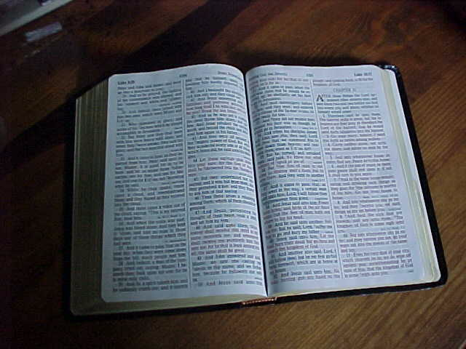
News Item: Southern Baptists boycott Disney for what they call "Gay friendly policies".
Hasn't anybody ever told these people that the Bible they use, the King James Version, was put together by King James 1 who was a homosexual.?

It is the Southern Baptists who teach that the writing of the Bible was directly inspired by God. If we follow that teaching then we would have to conclude that it was God who selected a person who was Gay to put together the most magnificent version of the Bible ever penned. Do they disagree with God's choice ?.
And if indeed as they believe, God inspired the writing of the Bible, wouldn't you say that means that God must have had a "Gay friendly policy"?.
Two books that document that King James was gay. The Wisest Fool in Christendom, by William McElwee, & King James, by Antonia Frazier

HOLY ROLLERS !
Did you know that Moses never allowed the High Priest to enter the Holy Place without the Urim and Thummin, so they could tell God's will. The Urim and Thummin were dice

JOSEPH'S COLOR COAT
Joseph like Jesus is a symbol of the sun. Jesus born of the Virgin womb of Mary, Joseph born of the barren womb of Rachel . Both represent the birth of the Sun out of Virgo.
Jesus has 12 disciples, Joseph has 12 brothers and 1 sister. Simeon and Levi are twins and represent Gemini. The sister Dinah is Virgo. The 12 represent the signs of the Zodiac surrounding the sun ,and the 12 cranial nerves of the human brain.

Both Joseph and Jesus are betrayed. Joseph by his brothers, Jesus by his disciple. This represents the Sun's prelude to crucifixion or death during the winter solstice. Jesus rises from the tomb to sit at the right hand of the father. Joseph rises from the pit to sit at the right hand of Pharoah.
This represents the culmination of the Sun's rise to the summer solstice. In the Northern Hemisphere it appears to move to the Eastern sky or right side. It is called celestial right ascension.
Joseph's coat of many colors is the many colored spectrum of the Sun. The father gives his only Sun a coat of many colors.

BIBLICAL BIBLE BUILDER WAS SOLOMON, WHY ?
Inside of you, it is the Solar Plexus or Sun area that sends the energy upward through the spine to the Pineal gland to create the temple of consciousness. The Solar Plexus or Sun energy is the source.
SOLOMON BUILT THE TEMPLE OF THE BIBLE
SOL= SUN
OM= THE MOVEMENT OF SOLAR ENERGY THROUGH THE CHAKRAS
ON= THE ANCIENT CITY OF THE SUN NEAR MEMPHIS EGYPT
SOLOMON = THE SUN ENERGY WHICH CREATES THE HOLY TEMPLE

BIBLICAL DEGRADING OF WOMEN
Was there an attempt by a Bible writer to change scripture so as to portray women in a negative light ?. Would you like to see proof that there was ?
Old Testament Law: Exodus 13:2 Sanctify unto me all the firstborn, whatsoever openeth the womb among the children of Israel, both of man and of beast: it is mine.
Notice, all the first born whatsoever. Now let us look at the reference to this law in the New Testament.
You will immediately see the change that was made to degrade women. Luke 2:23 (As it is written in the law of the Lord, Every male that openeth the womb shall be called holy to the Lord;)
Every male. Somebody was messing with the book.

THY KINGDOM HAS TRULY COME
We are living in the new age of Aquarius. The ruling planet of Aquarius is Uranus.
In the Bible, Jesus makes the following statement. Matthew 10:7 And as ye go, preach, saying, The kingdom of heaven is at hand.
The New Testament was written in Greek. The Greek word for heaven is Ouranus, Uranus. The prophecy has been fulfilled, the kingdom of Uranus is truly at hand.

OUT OF BODY EXPERIENCE
So many in religious circles are afraid of the " out of body experience". They look down upon it as something of the devil. But what do we see in the Bible ?
2 Corinthians 12:2 " I know a man above 14 years ago (whether in the body or out of the body I cannot tell,) such a one caught up to the third heaven."
Well it seems that Paul finally did realize that it was the out of body experience that caught him up to the third heaven. In 2 Corinthians 5:8 he says " we are confident and willing to be absent from the body and to be present with the Lord."
Yes indeed, Paul realized that the catching up (rapture), into glory, occurs through the meditative process when one is taken to the third heaven. The third state of consciousness known as Air.
Keep that in mind. Paul speaks of being taken to the third heaven. The third state of consciousness in Greek is called Air. It is the place of separation from thought. Jesus speaks in Matthew 6:25 to 6:33 of taking no thought.
So let's put all of this together. We meditate. We take no thought. We have an out of body experience and rise to the third heaven or third stage of consciousness called Air.
We then clearly understand the Biblical statement made in 1 Thessalonians 4:17, " Then we which are alive and remain shall be caught up together with them in the clouds (clouds is unseen spirit), to meet the lord in the AIR.
Whenever you want to meet the Lord in the air, simply close your eyes, rise above the thoughts of the mind and there you will find.............

WHY WAS PAULS NAME CHANGED
FROM SAUL TO PAUL ?
Paul is the Biblical spokesperson. P is from the Hebrew letter PE which means "to speak". S is the 21st letter of the Hebrew alphabet and means " to fall short of completeness".The reason S means to fall short is because it is the 21st letter in the Jewish alphabet which has 22 letters. Thus Saul falls short , but Paul becomes the preacher or the voice after the conversion.

THE KENNEDY-LINCOLN COINCIDENCE ?
Abraham Lincoln's successor was Andrew Johnson born in 1808
John Kennedy's successor was Lyndon Johnson born in 1908
*****
Lincoln's assassin John Wilkes Booth was born in 1839
Kennedy's assassin Lee Harvey Oswald was born in 1939
*****
Booth shot Lincoln in a theater and fled to a warehouse
Oswald shot Kennedy from a warehouse and fled to a theater
*****
Lincoln had a secretary named Kennedy who told him not to go to the theater
Kennedy had a secretary named Lincoln who told him not to go to Dallas
*****
Both Kennedy and Lincoln were shot in the back of the head in the presence of their wives
*****
Ecclesiastes 1:9 " The thing that has been, it is that which shall be, and that which is done is that which shall be done, and there is no new thing under the sun."

