SCIENCE
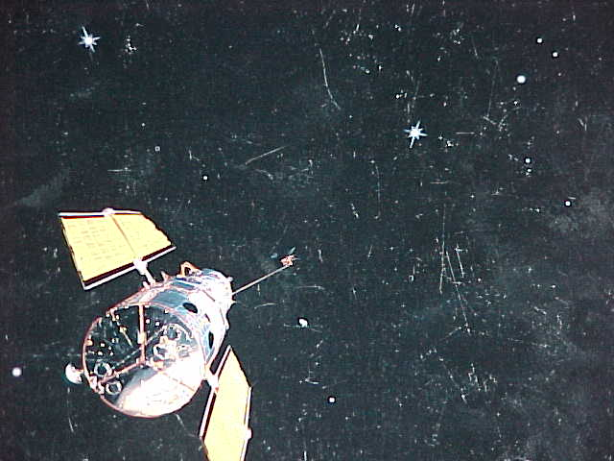
SCIENCE PROVES LIFE AFTER DEATH WHO CREATED US REALLY ?
SPEED OF LIGHT IN THE BIBLE COMPUTERS TRANSFORMATION
THE WISDOM OF THE ANCIENTS RENE DESCARTES
EARTHQUAKES

LIFE AFTER DEATH !
I have been sharing with you over the past weeks via video tapes etc, concepts on what occurs at the time of death. What happens to the human personality etc.
I have suggested that light which is Photon and is human consciousness, leaves the body via the Pineal gland at the time of death.

Well here is the first proof that life exists after death. Photon is energy from an Atom. Scientists destroyed, killed, a photon and it reappeared three feet away.
If you haven't seen it, here is the Associated Press release dated December 11 1997. It was in all of the major newspapers and has been on tv and radio news programs.

This is the headline:
EXPERIMENT WITH LIGHT EVOKES IMAGES
OF STAR TREK.

The first paragraph stated " Scientists have pulled off a startling trick that looks like Beam Me Up Scotty technology of science fiction."
In an Austrian laboratory scientists destroyed bits of light in one place and made perfect replicas appear about 3 feet away. This supports the concept that when your dwelling place is destroyed by death, your perfect replica appears outside of your body and leaves via the light receptor which is the Pineal Gland.

According to the article this was done by transferring information about a crucial physical characteristic of the original light bits called Photons. (Remember Photons which are visible light waves appear when the Atom has been stimulated by heat. You throw a switch, electricity heats the filament , Atoms get excited and you have Photon.
You meditate. Solar energy rises to the Pineal. The heat stimulates the Atom and you have Photon. Atom being God in religious terms and Photon being Jesus or the Son of God.
If you want more detail of this, please order video tape 311. It will be on the second half of the tape.

Here is a brief technical review and then a breakdown in spiritual terms so you can understand what the scientists have just discovered.
You have 3 Photons., A B and C. The idea is to transmit A to C. The researchers created B and C as entangled photons. Entangled photons become one but are opposites They then entangled B with A. The second step destroyed A but not before B took on the opposite of A's original characteristic. The change meant that C had to change polarization to remain the opposite of B. So C's polarization ended up the same as A. A and C became one.
What the heck is that all about ?

Consider this. A is you. The Photon inside of your head. The part that goes on forever. B is Jesus and C is God. B and C are entangled. God and Jesus are one but opposite. God is super. Jesus human.
B (Jesus) comes within us and entangles with A (us). We become one with Jesus. This destroys our original state. (As the Bible says it is no longer I who live but the Christ in me) Now since Jesus or B is part of you, God C has to change polarization to remain an opposite of Jesus-B.
The opposite of B now is A. So Gods polarization changes to A. Thus we become one with God. We move out of the human body to the realm of light.

Interesting and now proved. Also think of the scripture that has Jesus saying, no one can come to the father but by me. The A photon cannot get to the C photon except by the B photon.
This is amazing and true. More to come I'm sure. It really makes you wonder who really wrote the Bible doesn't it.?

WERE WE CREATED BY GOD ?
Of course not. You are the sum of 46 chromosomes. Twenty three contributed by your father from his sperm, and twenty three contributed by your mother from her egg. Those chromosomes take care of what you look like, the color of your skin, hair and eyes, the shape of your nose and even your intelligence.
You are born with the genetics which are the result of the chromosomes, and added to that are, the traditions of your family, your church, your friends, your job, your school, the government, and social institutions you were raised in, and by the time the neurons fire in your brain to respond to all of these, you are finally a creature of the earth.
God had nothing to do with it.

If your mother or father married someone else, you could have never existed on this earth because only the combination of their chromosomes could make you. Just think of that, if either one of them changed their mind about their marriage you could never have happened.

No other couple in the world could have contributed the chromosomes in the exact order that made you. So God has nothing to do with creating us. We are created by the people and the institutions of the earth.

This is a very important point when we move to consider what happens after we die. It is also important in considering who we really are, and what is the purpose for our being here. As you can see if our bodies and actions are of the earth, what part of us is not and what is the purpose for that parts existence.???

THE SPEED OF LIGHT
In the Bible, the tribe of Judah was positioned in the desert at the East, at the point of the rising Sun. ( Numbers 2:2).
They were the tribe of light. ( 2 Kings 8:19).
The Bible states the number of people in that tribe. (Numbers 2:9) The number is 186,400. The constant speed of light.!
So who wrote that ?. Certainly not sheep herders. No, it was a civilization very wise who knew of the speed of light 5000 years ago

COMPUTERS
The heart of a computer is the logic circuits called gates. All of the problem solving is done within the gates. In the Torah, Moses was given 49 gates. The 50th gate belonged to God. The 50th gate is the ability to comprehend and understand. It is the place of enlightenment which one must seek through meditation.
Stedmans Medical Dictionary tells us that gating is a process in which electrical signals are selected by a gate which passes only signals that have certain characteristics. That is in the human brain.
The gate of the brain, the place of understanding, is only found in meditation. Jesus put it this way in Matthew 7:14, " strait (small) is the gate and narrow is the way that leads to life and few there be that find it."
The gates open into the circuit which is the electrical energy of the human brain. When they came to find Jesus at the tomb the angel told the seekers, " you wont find him here, you will find him in Galilee".
The word Galilee means circuit. He has left the tomb of the lower flesh and can now be found in the place of the higher mind. The circuit. Through meditation the gate will open wide to you.

TRANSFORMATION
When we discuss life after death, it is very hard for the average person to conceive that it could be possible for a human being to be transformed into another life form and continue on. There is no proof that this is possible.
Oh yes there is !
An Atom of Uranium becomes an Atom of Thorium by emitting an Alpha Particle. Don't worry about what Uranium is or what Thorium is. Consider that when Uranium emits or sends out something from itself it immediately changes into a whole new life form.
So if it is possible for a certain chemical form to transform itself into another chemical form, why is it not possible for us to emit light via the Pineal Gland at the time of death, and instantly transform into a new life form ?
We have shown that scientifically it happens within the Atom, and we are totally Atom. Thus transformation to a new life form is not only possible, it is a scientific fact in the chemical world ,now to be rationalized as a distinct possibility in the life world.

WISDOM FROM AN ADVANCED CIVILIZATION:
The Hidden Meanings in the Bible and myths point to obvious knowledge of an advanced civilization who wrote these things in a coded way to await the time when we had evolved to a point of understanding.
We have Hubble and rocket ships and all kinds of advanced technology. We cannot conceive how it would be possible for the ancient ones to know of the things of science which show up in the Bible, such as the splitting of the Atom, or the speed of light.
Look at this scripture from Eccliastes and understand.
Eccliastes 1:9 The thing that hath been, it is that which shell be, and that which is done is that which shall be done and there is no new thing under the sun. Imagine, there is no new thing under the sun, yet we feel we are so advanced .

RENE DESCARTES
Rene Descartes of France is the father of modern philosophy. He said that the place in the human brain where God meets us is at the Pineal Gland. The bodies light receptor. Do you suppose that Mr. Descartes was qualified to make such a statement 200 years ago.?
Rene Descartes discovered the fundamental law of reflection in optics. He also discovered the scale of incidence of angle and the law of refraction. He paved the way for the discovery of the theory of light.
Indeed he seemed eminently qualified to speak of the Pineal Gland of the brain. Of course Jacob in the book of Genesis did also. In Genesis 32:30 he said, " I have seen God face to face and I will call the place Peniel."

EARTHQUAKES
For those who take the Bible literally, every time there is an earthquake it seems to be fulfilling Jesus Biblical words that the end times would be ushered in by earthquakes in diverse places.
For those who do not take the Bible literally, this statement is known to refer to a shaking down of old traditional ways of thought. Exactly what we are seeing today. To prove this point I refer to an interesting fact printed in USA today.
HOW OFTEN DO EARTHQUAKES OCCUR ?
Measuring 8 or higher on the Richter scale...............1 per year
Measuring 7.0-7.9 on the Richter scale...............18 per year

