PUT A GREEN LIGHT AT YOUR HOUSE
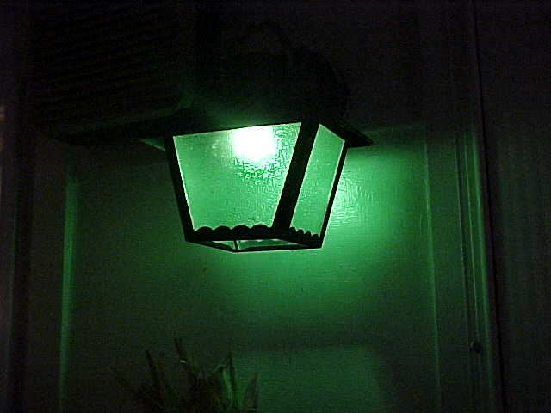

PUT A GREEN LIGHT AT YOUR HOUSE
NASA AND GREEN LIGHT
BEAUTIFUL GREEN LIGHT
I am asking you to place a green light at your home. We have reached a point in this age when we must prepare for the cosmic change that is about to come upon the earth.
CAUTION: I am not preparing you for Marshall Applewhite phase two. I am not asking you to place the green light so as to signal UFO's, I am asking you to place the green light, to signal God. Of course if God chooses to come in a UFO, so be it.

Before you can understand why I am asking you to do this, you must completely read, The Universe Page of this web site. Everything on that page is scientifically documented. There you will find that the Universe has moved through the seven seals or chakras as is described for us in the scriptures of the East as well as the Bible in Revelation 5:1.
After a planetary discovery was made in Corona Borealis, the crown, Hubble showed us a picture of Supernova that we clearly see as the
explosion of the third eye. 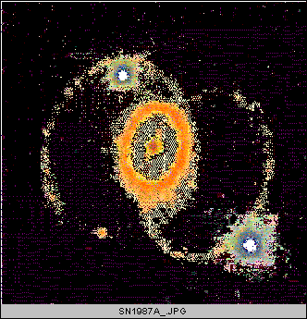
If this is correct, then the universe is on the verge of Passover. The change that will come upon the earth can be measured by considering the Passover the earth experiences when moving from winter to spring. As different as February is from June, such will be the change that is about to happen.

In the Bible the people who were aware, were instructed to place blood on the doorpost of their home to signal God that the occupants of the house were aware and expecting the Passover and the move to a new energy form called the promised land.
I am asking you to place a green light at your house. Why ?. When angles of light from the universe touch the green earth they create a process called photosynthesis. The term green light actually represents the light from above in the blue and red spectrum coming down to touch the green organisms of earth.

This process creates ATP, adenosine triphosphate which is found in all living organisms and is the main immediate source of usable energy for the activities of living cells. Nothing can live without ATP. Nothing can live without green light. The angles of light that will be impacting the earth from above are known in religious literature as Angels of Light.
By placing a green light in your home you are signaling this cosmic intelligence called God, that you are aware of what is about to take place, and that you understand that this new light force touching the earth will bring about a whole new energy for all life.

The light that comes down to the earth is known as Zodiacal light which is also known as "green flash". Also know that your body contains hemoglobin which is part of the heme group chemically related to chlorophyll the green pigment of plants. Also understand that the bright nebulae emits gasses mainly in the red or green part of the spectrum.
I was initially instructed to tell you to place the green light at the back of your house since the human energy flows from the sacrum up the spine. This is not practical in all cases, thus even a small green light in a window will do.

Now what do you tell your friends who will be sure you have fallen into the clutches of a dangerous cult ?. You simply tell them that the green light reminds you that it is light from above touching the green earth that brings new energy, and that we are not at the top of the chain as we like to make ourselves believe. For the trees can get along fine without us, but we could not exist a minute without them.
Finally. Jesus said in the Bible that the Kingdom of Heaven is at hand. The Bible was written in Greek. The Greek word for heaven is Ouranos. The ruling planet of this Aquarian age is Uranus, and Uranus is the Green planet.

The mythology is that Uranus was married to the planet earth, Gaea. They were separated by Cronus or Saturn, or Satan. Now Uranus is returning in Aquarius to reclaim his bride.
Now please go and read the Universe Page carefully. Then place the green light at your house and prepare to Passover to a new age of cosmic energy. A new age of light. A new earth, a new you, a new hope, a new life. For as the Bible says in Revelation "around the throne of God it is as emerald. "
And when you look at the eye in the sky of the Nebulae which Hubble showed us in the April 1997 edition of National Geographic, you will see that God's eye is bright green.

MAY THE FORCE BE WITH YOU
Our myth is currently consuming the minds of just about everybody. Star Wars. We realize now that we are all awaiting the return of the Jedi. Awaiting Luke Skywalker to return and overcome the forces of darkness.
And what do the Jedi use to overcome the forces of darkness. Lightsabers of GREEN LIGHT
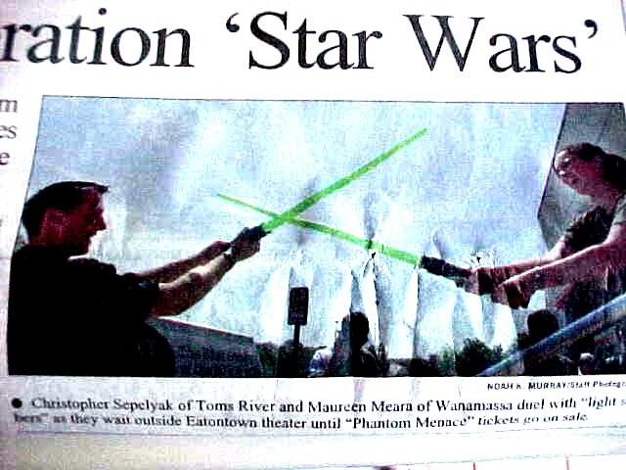

Take a Look At This From NASA
  Space Science News home | The Green Party  Powerful Plants Have Changed The World


May 10, 1999: Biologists conducting Space Shuttle experiments may be one step closer to shedding light on the biggest power booster on the planet: a protein in green plants called Photosystem I.
A German research team recently presented the results of their Space Shuttle experiment designed to crystallize Photosystem I molecules. According to the researchers, "This experiment has yielded the best data set thus far obtained from Photosystem I crystals."
Right: Photo credit: Department of Energy, Daniel Peck

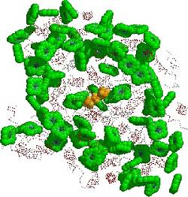
During photosynthesis, the cells in green plants undergo two simultaneous reactions, both of which rely on a separate kind of protein. Photosystem I protein molecules use the trapped energy in sunlight to convert carbon dioxide into carbon and oxygen. This provides the plant food in the form of carbohydrates, lipids, proteins and nucleic acids - the building blocks of life. Photosystem II protein molecules use light energy to split water into hydrogen and oxygen for plant respiration.
Left: The complex protein map of atomic positions in a Photosystem I molecule, from Brookhaven National Laboratory Protein Databank, and Image Library of Biological Macromolecules, Jena, Germany.
Scientists crystallize protein molecules in order to study their complex internal structures. Because the molecules are too small to study directly under a microscope, scientists use X-ray diffraction to get a picture of the molecule.

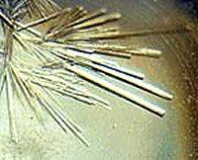
Shining X-rays through a crystal produces a scattering pattern, which is a type of blueprint. Think of a shadow cast through a picket fence - the shape of the shadow would tell you that the fundamental building block of the fence is a rectangular board. Shining X-rays through a protein crystal indicates the protein's shape, where it's located, and ultimately how it may work.
Left: In the microgravity environment of the Space Shuttle, scientists have shown some improved capability to grow macromolecular crystals with a higher degree of order. Using a process called "X-ray crystallography," they can map the structure of proteins and advance the fundamental understanding of how they work.
High quality crystals - composed of ordered and repeating units of a particular protein - are required for X-ray diffraction. Some of the crystals grown in the microgravity conditions of space are more perfectly ordered than crystals grown on Earth. Microgravity can also affect the rate at which the proteins initiate new growth. Space crystals have shown a 10 to 20-fold larger volume compared to the Earth-grown counterparts.
The Photosystem I protein molecule, sometimes called "the Earth's power station," was analyzed by a scientific team representing the Max Volmer Institute for Biophysical Chemistry and Biochemistry in Berlin, Germany. The team reported their results in their Final Report published from the Life and Microgravity Spacelab (LMS) mission. The team hopes these results will give scientists a more detailed knowledge of the Photosystem I molecule's shape, exact atomic positions, and biological functions. And by using the results of the experiments on the space shuttle, scientists can improve the crystallization conditions here on Earth.
Right: Green plants use Photosystem proteins to capture and use energy from sunlight. Photo credit: Department of Energy, Daniel Peck.


The Earth's environments - from forests to grasslands to the oceans - are direct products of the Photosystem protein molecules. From the beginning of life, Photosystem processes in algae completely altered the atmosphere, transforming the carbon dioxide environment into an oxygen-rich one.
Left: Algae in the early Earth's oceans transformed the atmosphere. Photo credit: Department of Energy, David Parsons.
The two Photosystem proteins underlie the Earth's balance between water and heat and between oxygen and carbon dioxide. They ultimately supply the nutrients for almost every living thing on the planet, as well. Most of the organisms on Earth receive their sustenance directly or indirectly from photosynthetic vegetation. Without the Photosystem molecules, life as we know it would cease to exist.
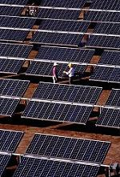
The space experiments were performed on ancient organisms called cyanobacteria, formerly known as blue-green algae or blue-green bacteria. As a family, these organisms form the fundamental basis of the entire marine food web and are often called "the grass of the sea." These early ancestors of modern plant cells (chloroplasts) were the first oxygenic organisms to convert light to energy on Earth. The cyanobacterium protein used in the space investigation, from the species Synechococcus elongatus, is found abundantly today. It represents more than half of the total biomass productivity in all open ocean environments and may process up to 50 percent of the excess carbon dioxide greenhouse gasses implicated in the current global warming debate.
Burning carbon fuel such as oil and coal produces most of this excess carbon dioxide. This process currently supplies much of the world's power needs, but the fuel reserves are rapidly running out. Nonpolluting alternative fuel sources are being developed to take the place of oil and coal. In the 1970s, solar power - a clean and unlimited power source - seemed to be the most promising alternative. Harnessing the power of the Sun to power the Earth, however, has been plagued with difficulties. To generate a lot of power, you need extremely large solar panels. And what do you do for power when the sun sets?
Right: A 210-kilowatt crystalline silicon photovoltaic system provides solar power to Sacramento, Calif. Photo credit: Department of Energy/Sacramento Municipal Utility District.

The Space Shuttle investigation is trying to discover what features of photosynthetic proteins allow for solar energy conversion. While humans have only been developing solar power technology for a few decades, plants have been evolving for billions of years to perfect their photosynthetic technique. By studying how plants accomplish this remarkable feat, scientists hope to someday also develop systems that use light as a power source. Identifying and studying characteristics of the protein's metabolism may someday also be used for applications in pollution prevention and environmental clean-ups.

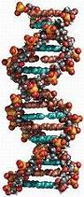
Knowing the Code
Many essential biology questions depend on knowing the structure of proteins and enzymes. By charting their shape, scientists can determine how the molecules work. But these molecules may also change shape when performing important functions, like carrying oxygen in blood hemoglobin. In photosynthesis, there are many energy producing conversion steps from sunlight to plant development and growth.
Some estimates suggest that human biology depends on the action of nearly half a million different enzymes and proteins. But we only have a three-dimensional picture of shape and function for fewer than 1 in 100 of these complex chemicals. Since 1984, the Space Shuttle has carried experiments to determine the structures of large, biologically important molecules. This research has compiled results for a host of human diseases ranging from insulin for the control of diabetes, to the reverse transcriptase enzyme that, when blocked, inhibits HIV infection.
Just as in human cells, the Photosystem proteins inside a plant cell are translated from amino acids. Amino acids have a 20 letter alphabet for each of the 20 naturally occurring amino acids (shown below as AAs). These amino acids are in turn translated from the complex array of nucleic acids in DNA (coded as the letters A,G,T and C). A description of the molecular code reads like an encrypted message:
Much work remains to be done in uncovering the shape and detailed way the Photosystem power-converting molecules achieve their efficiency. By using the results from space shuttle experiments, someday we may understand how that transformation happens in detail. Such experiments make possible the study of proteins that had once proved too difficult to dissect at the molecular or atomic size.

