IS ETA CARINA
GOD ?!?!?!?!?!?
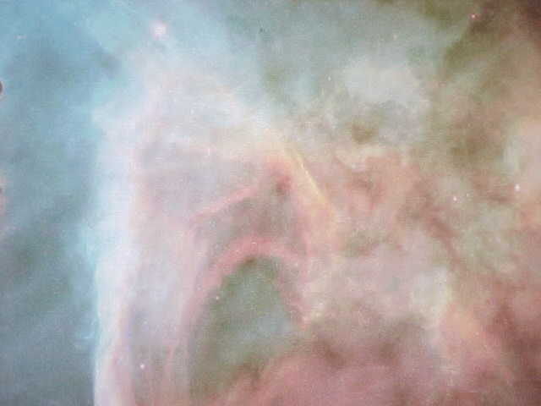
Before you run for your stones, please hear me out. Listen and look at what I am trying to propose to you.
Lay aside what you consider God to be. Think instead of what those who wrote the scriptures were trying to convey to us of the great light being in the sky that would bring wrath and healing upon the earth.
Think of your God somewhere else. But think of the great light being referred to in scriptures as a mythological symbol of awesome energy and light never seen yet in front of us all.
Would you like to hear more ? Let's go.
INDEX
WHAT IS GOD
WHAT IS LIGHT
GOD-INVISIBLE LIGHT-ETA CARINA
THE GREAT LIGHT HIDING IN THE CLOUD
IS THERE ONE STAR THAT WE CANNOT UNDERSTAND ?
HEALING IN THE WINGS
WHAT IS HAPPENING ON PLANET EARTH ?
THE SUN AND THE SON

QUESTION: WHAT IS GOD ?
Our premise here is not to render an opinion as to what we may consider God to be, but to look at the writers of ancient scriptures such as the Bible and suggest what they have meant in referring to God.
Now please bear with me. I want to share some Bible scriptures with you and I want you to look at them. In them we should be able to see what the writers were referring to when they spoke of God. I think the references are specific and will be the first evidence for us to consider a heavenly light or a cosmic light as God.
Numbers23:19 God is not a man
1 John1:5 This then is the message which we have heard of him, and declare unto you, that God is light, and in him is no darkness at all
So is this saying that the power that we perceive as God is found in light? Is this saying that light itself manifests the qualities of God ? Creation, Healing, Destruction?
Job25:3 Is there any number of his armies? and upon whom doth not his light arise?
Job37:21 And now men see not the bright light which is in the clouds: but the wind passeth, and cleanseth them.
Psalms27:1 The LORD is my light and my salvation;
Psalms36:9 For with thee is the fountain of life: in thy light shall we see light
Isaiah9:2 The people that walked in darkness have seen a great light: they that dwell in the land of the shadow of death, upon them hath the light shined
Isaiah60:1 Arise, shine; for thy light is come, and the glory of the LORD is risen upon thee.
Daniel2:22 He revealeth the deep and secret things: he knoweth what is in the darkness, and the light dwelleth with him.
Habakkuk3:4 And his brightness was as the light; he had horns coming out of his hand: and there was the hiding of his power
Notice that above reference in Habakkuk that says, there was the hiding of his power. This is interesting when considering Eta Carina as God since that awesome power is totally hidden.
John1:5 And the light shineth in darkness; and the darkness comprehended it not.
John1:9 That was the true Light, which lighteth every man that cometh into the world
John12:36 While ye have light, believe in the light, that ye may be the children of light.
1 Thessalonians5:5 Ye are all the children of light
1 Timothy6:16 Who only hath immortality, dwelling in the light which no man can approach unto; whom no man hath seen, nor can see
Now here we see another reference to the light that no one can see and that no one has seen. Remember Eta Carina is the brightest known light in the universe and no one has ever seen it. It is a 4 million times brighter then the sun and it has never been seen.
1 Peter2:9 But ye are a chosen generation, a royal priesthood, an holy nation, a peculiar people; that ye should show forth the praises of him who hath called you out of darkness into his marvellous light
So we have ample scripture to justify our premise of considering God as Eta Carina in the eyes of those who wrote the scriptures. They obviously were referring to a heavenly light that was extremely bright. So bright that no one could look upon it and in fact a light that no one has ever seen. So far that picture points to Eta Carina.
Now we have determined that there is evidence to suggest that the writers in speaking of God were actually talking of light. So let us now consider what is light .

WHAT IS LIGHT ?
Let us look at the dictionary.
light1 (lºt) n. 1. Physics. a. Electromagnetic radiation that has a wavelength in the range from about 4,000 (violet) to about 7,700 (red) angstroms and may be perceived by the normal unaided human eye. b. Electromagnetic radiation of any wavelength. The pathway or route of such illumination to a person: You're standing in his light.
Now of course there are those who would say that the light means enlightenment, understanding. Taken out of darkness or ignorance. I am not going there because that would mean that Gods power would depend on a persons intelligence. On the other hand if we are talking about light as light then it would be the power of the light that would effect the change and not the power of an individual mind.
So let's consider light as light. Notice above that there are two categories of light. 4,000 to 7,700 angstroms that can be seen and electromagnetic radiation of any wavelength, or invisible light. Why should we consider invisible light.?
1 Timothy6:16 Who only hath immortality, dwelling in the light which no man can approach unto; whom no man hath seen, nor can see
No one has seen or can see this light. So if you are with me, we are pursuing the concept of God as invisible light.

GOD IS INVISIBLE LIGHT
WHAT DO WE FIND WITH ETA CARINA
From Astronomy Picture of the Day you will find a NASA artists drawing of lasers coming from Eta Carina. I suggest that you go there and then hit your back button and return here. I want you to see this magnificent drawing of Eta by the NASA artist.
If you choose to simply read the account of the Eta Carina lasers, it follows here. Please read it carefully.
Lasers in Eta Carinae
Explanation: Have you heard about the great LASER light show in the sky? A team led by K. Davidson (U. Michigan) and S. Johansson (U. Lund) discovered that the chaotically variable star Eta Carinae emits ultraviolet light in such a narrow band that it is most probably LASER light! This artist's vision depicts a model that could account for their Hubble Space Telescope observations. In this model, Eta Carinae emits many LASER beams from its surrounding cloud of energized gas. Infrared LASERS and microwave MASERS are extremely rare astrophysical phenomena, but this natural ultraviolet LASER is the first of its kind to be discovered.
Notice particularly the reference to the type of laser coming from Eta Carina. Ultraviolet. Also notice that this type of laser has never been recorded before. It is totally new !
LET'S GO TO THE DICTIONARY AND LOOK UP ULTRAVIOLET
ul·tra·vi·o·let (¾l”tr…-vº“…-l¹t) adj. Abbr. UV, U.V. 1. Of or relating to the range of invisible radiation wavelengths from about 4 nanometers, on the border of the x-ray region, to about 380 nanometers, just beyond the violet in the visible spectrum. --ul·tra·vi·o·let n. Ultraviolet light or the ultraviolet part of the spectrum.
So we have made a connection haven't we.? We find in the Bible that God is light. Light that has never been seen and cannot be seen. From Eta Carina we find that the light has never been seen and cannot be seen because it is invisible. And not only that, but consider that this natural ultraviolet laser is the first of its kind to be discovered. Never encountered before.

THE GREAT LIGHT HIDING IN THE CLOUD
Again the ancient writings point us to a bright light hiding in the clouds.
Job37:21 And now men see not the bright light which is in the clouds
Exodus16:10 And it came to pass, as Aaron spake unto the whole congregation of the children of Israel, that they looked toward the wilderness, and, behold, the glory of the LORD appeared in the cloud.
Exodus19:9 And the LORD said unto Moses, Lo, I come unto thee in a thick cloud, that the people may hear when I speak with thee, and believe thee for ever.
Numbers11:25 And the LORD came down in a cloud, and spake unto him,
Job22:13 And thou sayest, How doth God know? can he judge through the dark cloud?
Job37:15 Dost thou know when God disposed them, and caused the light of his cloud to shine?
Luke21:27 And then shall they see the Son of man coming in a cloud with power and great glory
So you say , what cloud. And I say this cloud. The cloud of Eta Carina, the Keyhole Nebula
Guarded by the Angel . Is this the Holy Place
I recommend that you read for yourself the article concerning Eta Carina becoming a Hypernova. It is at Explorezone.com. After you have read through, please hit your return button and come back to continue our search.
Explorezone: Eta Carina, Possible Hypernova Could Affect Earth
If you prefer to read on here, I have highlighted some areas that assist in our search. Visit Explorezone though. It is an excellent site.
So here we go as we again peer above at the scripture talking of the bright light in the clouds
Possible hypernova could affect Earth
By Wil Milan for explorezone.com
Southern skywatchers this time of year can look up and see the most interesting and enigmatic star in the sky -- a star of a type so remarkable that only a few dozen examples are known. That star is Eta Carinae, and it may also be the most dangerous star in the sky.
The reason for the danger is that Eta Carinae is like a nearby volcano waiting to explode, but we don’t know when. In the last few months, however, it has shown signs of new activity and it has astronomers riveted on its every move.
What is interesting here is the fact that science does consider Eta Carina as dangerous. We know that DNA is coming from Eta Carina and we consider it responsible for the current genetic revolution. That is the healing part. Obviously however changes upon the earth are going to come from its power. This can be the wrathful or dangerous part.
To astronomers there are two things immediately obvious about Eta Carinae: It is amazingly, almost impossibly bright, shining 4 million times brighter than our sun. It is also wildly unstable, being prone to huge flares, outbursts and dizzying swings in brightness that give the impression of something on the verge of self-destruction – which it may well be.
Can you imagine this. Eta Carina is 4 million times brighter then our sun. That is why I suggested that Eta Carina could certainly be the father and our Sun actually the Son. Jesus the Son/Sun and Eta Carina the father , 4 million times brighter.
At the time, no one understood what could possibly cause such strange behavior in a star, and it wasn’t until 1994 that the Hubble Space Telescope first revealed what had happened 150 years before: Eta Carinae had blasted out an enormous two-lobed bubble of hot, glowing gas. Even today it can be seen racing outward at one and a half million miles per hour (2.4 million kilometers per hour). The amount of material blasted out was enough to make several of our suns, but for Eta Carinae it was just the latest outburst in its short and violent life.
Let's stop here. Notice that hot glowing gas is spewing out of Eta Carina at one and a half million miles per hour. What is that gas ?
Please go to the Astronomy Picture of the Day and look at the Keyhole Nebula created by Eta Carina. I am not so interested that you look at the picture as that you read the last sentence in the text. It says , The Keyhole Nebula was recently discovered to contain highly structured clouds of molecular gas. CLICK HERE After you have seen this, hit your back button to return here.
Consider. Molecular gas is pouring out of Eta Carina at 1 and a half million miles per hour. Molecular gas is DNA. Molecular gas or DNA pouring out of Eta Carina at a million and a half miles per hour to bring healing to planet earth.
That’s how most supermassive stars end, but Eta Carinae is such an extreme case that another possibility exists: It could end as a hypernova, a super-supernova that at its peak will outshine the entire galaxy.
Is this amazing or what. A hypernova that at its peak will outshine the entire galaxy. More and more this appears to be the great light that the ancients were referring to as the wrathful, healing, all powerful supreme light in the heavens.
The blazing violence of such an event is difficult to describe. Were it much closer it could even wipe out all life on Earth, eradicating our thin biosphere just like an ultraviolet lamp kills microbes. Fortunately it’s not that close, but at 7,500 light-years it’s still close enough to do some damage.
But what if it is just the right distance, not to do damage but to make change. To heal incurable disease with an influx of corrected DNA and to change consciousness by its electromagnetic force.
Current warning signs
What now has astronomers thinking again about Eta Carinae's ultimate end is what has happened since 1998: It has suddenly started brightening again, more than doubling in brightness in the last 18 months.
THIS IS THE PART I REALLY WANTED YOU TO SEE AS WE CONSIDER THIS SCRIPTURE.
Job37:21 And now men see not the bright light which is in the clouds
Back to Explorezone.com
The star we’ve never seen
What makes the puzzle particularly difficult is that we have never actually seen Eta Carinae. When we look toward Eta Carinae or photograph it, what appears is not the star itself, but the huge shroud of glowing gas and dust it has thrown up around itself.
The glowing shroud around Eta Carinae has led some to speculate that behind the shroud lies not one star, but two or more massive stars combining to shine so brightly. But that still doesn’t explain the burning question of the moment: What has happened to Eta Carinae in the last few months, and what will happen next?
No one really knows. Like geologists watching a trembling volcano, all we can do is watch and wait.
Eta Carinae could blow anytime, or it could continue rumbling and spewing gas until the day, perhaps tomorrow, perhaps thousands of years from now, when it will suddenly let go with the most phenomenal display of violence ever witnessed by humans. It is now being watched almost around the clock, as much for the fascination as the science.
What more can anyone say. The magnificent light, 4 million times as bright as the Sun, yet hidden in the clouds and as the scripture says Job37:21 And now men see not the bright light which is in the clouds

IS THERE ONE STAR THAT
WE CANNOT UNDERSTAND ?
I am grateful for your patience with scriptures. I am trying to suggest to you that the ancient words were actually those of an advanced civilization suggesting that the power we understand as God would come to us in the form of electro magnetism via celestial bodies.
I have listed some scriptures from the Book of Job. This is the oldest Oriental text known to the earth. Nothing of this kind is older. It challenges us to realize that the one above is beyond understanding. Please read these scriptures. Then I have provided for you the CNN Interactive release from astrophysicist Kris Davidson about Eta Carina. It is Eta Carina that supports this ancient text because it is only Eta Carina that is beyond understanding.
Job28:20 Whence then cometh wisdom? and where is the place of understanding?
Job36:29 Also can any understand the spreadings of the clouds, or the noise of his tabernacle?
Job36:30 Behold, he spreadeth his light upon it, and covereth the bottom of the sea.
Job37:5 God thundereth marvellously with his voice; great things doeth he, which we cannot comprehend.
Job37:15 Dost thou know when God disposed them, and caused the light of his cloud to shine?
Job37:16 Dost thou know the balancings of the clouds, the wondrous works of him which is perfect in knowledge?
Job:21 And now men see not the bright light which is in the clouds: but the wind passeth, and cleanseth them.
Job38:19 Where is the way where light dwelleth? and as for darkness, where is the place thereof
Job38:33 Knowest thou the ordinances of heaven? canst thou set the dominion thereof in the earth?
What I am driving at here is if Eta Carina fits the above scriptures then it will stand out as the strangest of celestial lights. Does it.? What follows is from CNN Interactive. It is about Eta Carina.
Astronomers perplexed by star's weird behavior
June 3, 1999
CHICAGO (AP) - A star that erupted in a famous stellar observation 150 years ago has suddenly brightened again and astronomers are watching closely for what may be another celestial fireworks show.
Eta Carinae once was one of the brightest stars in the Southern night sky, but then it dimmed for decades. Now instruments monitoring the star have detected a doubling and tripling of energy, mostly in invisible light.
What puzzles astronomers is that Eta Carinae was not supposed to do this.
"Occasionally something happens in astronomy that is so bewildering that it makes astronomers nervous," said Kris Davidson, a University of Minnesota astrophysicist. "This is weird. We don't understand."
Eta Carinae has a prominent place in astronomy lore because of its history, its size and what experts believe eventually will happen to it.
The star, about 7,500 light-years from Earth, is among the most massive and energetic in the known universe, equal in size to 100 suns.
Eta Carinae was a routine part of the sky in the Southern Hemisphere until the 1840s when it was observed to erupt with a massive outflow of energy, dust and gas. For awed watchers on Earth, it was as if a light bulb in the heavens was suddenly turned on.
'There is no explanation'
Astronomers expected the star to slowly brighten until, sometime in the next century, it again would become one of the a most prominent features in the Southern sky.
But Eta Carinae surprised the experts. Over a matter of months, telescopes detected the star spewing out vast amounts of energy in all bands of the electromagnetic spectrum. The star's image reached a visible brightness unequaled since 1864.
Astronomers had not expected such energy burst for many decades and, when it came, it was expected that the star would first emit cooler radiation, sort of as a warning of a coming violence. That didn't happen.
"There are about 6,000 stars in the sky visible to the naked eye," said Davidson. "We understand them all with the sole exception of Eta Carinae. There is no theoretical explanation for it."
And so I place this under the microscope as another piece of evidence that Eta Carina is the light that the ancients were referring to when they spoke of God, the heavenly light that no one can approach and that no one has ever seen and obviously that no one can understand.

HEALING IN THE WINGS
If we are to consider Eta Carina as God and also as the most brilliant Sun hiding within the wings of the Keyhole Nebula then we must find coming from Eta Carina the source of all healing.
Malachi4:2 But unto you that fear my name shall the Sun of righteousness arise with healing in his wings
How can we show the evidence of universal healing coming from Eta Carina. ?
I invite you to visit the Astronomy Picture of the Day. There you will see the Keyhole Nebula. I call your attention to the last line in the text. It says that the Keyhole Nebula formed by Eta Carina was recently discovered to contain highly structured clouds of molecular gas.
If you would like to go and see this for yourself just CLICK HERE
After you have visited that site please hit the back button and return here
If you would wish to stay here and see the text , it follows.
The Keyhole Nebula
Explanation: The dark dusty Keyhole Nebula gets its name from its unusual shape. Officially designated NGC 3324, the Keyhole Nebula is a smaller region superposed on the larger Eta Carina Nebula. These nebulae were created by the dying star Eta Carina, which is prone to violent outbursts during its final centuries. Noted and discussed as early as 1840 when a spectacular explosion became visible, the Eta Carina system now appears to be undergoing an unusual period of change. An emission nebula that contains much dust, the Keyhole Nebula is roughly 9,000 light years distant. This photogenic nebula can be seen in the south with even a small telescope. The Keyhole Nebula was recently discovered to contain highly structured clouds of molecular gas.
Notice that last sentence. Molecular gas is DNA. The Keyhole Nebula formed by Eta Carina contains highly structured clouds of DNA.
Indeed this Sun has healing in its wings. And you say, what wings ?
Look
THE KEYHOLE NEBULA OF ETA CARINA
shall the Sun of righteousness arise with healing in his wings
You May Continue By Scrolling Down Or

WHAT IS HAPPENING ON PLANET EARTH ?
The great light hiding behind the wings of the angel in the Keyhole is pouring out DNA. And just by coincidence look what is happening on space ship earth.
7/16/99 London (Reuters) Gene therapy may improve brain cancer treatment.
7/16/99 Associated Press: Mutant Gene May Cause Back Pain
7/30/99 Associated Press: Science creates cancerous cell with genetic flaws. Could one day wipe out cancer
8/6/99 Associated Press: Genetic flaw may trigger sleep disorder
8/13/99 Health and Fitness: Genetic blueprint causes sudden heart attacks
8/3/99 Associated Press: Gene regulates good cholesterol
8/31/99 USA Today: Genetic Defect repaired. Could permanently correct hemophilia
8/99 Time Magazine Adding more of single gene to correct Alzheimer's
9/13/99 Time Magazine Using genetics to make people brainier
10/6/99 San Francisco (Reuters) Researchers identify two asthma causing genes
10/12/99 London (Reuters) Scientists find genes vital for tumor growth to combat cancer
10/14/99 Associated Press Cancer resistant mice bred
10/22/99 London Associated Press, Team close to solving mystery of DNA
10/22/99 New York Times Scientists find enzyme gene linked to Alzheimers
11/7/99 KRT News Service Genetics Revolution: Secrets of life become unlocked
2/25/2000 Associated Press Researchers make bionic chip for humans
2/7/2000 New York Magazine Sloan Kettering Cancer Inst. We are going to see a global conquering of cancer in 5 to 10 years.
Shall the Sun of righteousness arise with healing in his wings
Is there a connection. Is this tremendous advent of healing coming from the great light hiding within the angels wings ? Is Eta Carina indeed God preparing for the great touchdown on planet earth to bring forth all things new ? Or is it all just a coincidence ?

THE SUN AND THE SON
So we have developed some evidence that possibly the writers of Biblical text were referring to celestial bodies when they spoke of God . But where is there some deeper evidence to support such a supposition.?
What about Jesus. Gods only Son/Sun. Yes could Son be Sun ? And if we can show that for this little corner of this universe Jesus was a mythological figure of the Sun, could we not also consider that Eta Carina is a mythological figure of God. ?
First consider the name Jesus. In Greek as in Hebrew each letter of the alphabet has a numerical value. As you can see below the numerical value of the name Jesus in Greek is 888.
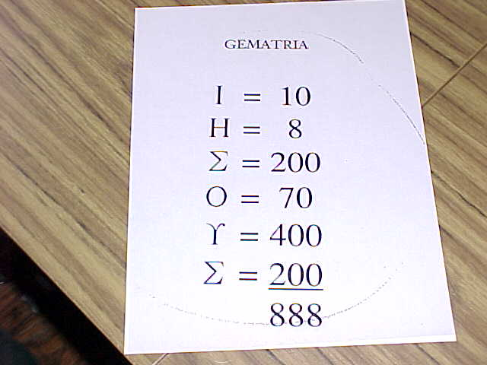
In Greek the number 888 is the number of the mythical Sun.
So there is the first hint that ancient writers when naming characters in the scriptures were actually penning mythological symbols of celestial bodies. In this case. Jesus as the Sun. Gods Sun/Son

THE TRAJECTORY OF THE SUN/SON
Well actually what we see is the movement of the earth creating an illusion of the movement of the Sun. But let us follow the scriptures and the apparent movement of the Sun and see if this equates to Jesus.
The scripture says Jesus the Son is born of a virgin.
Astronomically this is true. The Sun is born in the ninth month of September in the sign Virgo.
The scripture says Jesus the Son is crucified.
Astronomically this is true. On December 21st the shortest day of the year, the Sun appears in the southern hemisphere in the vicinity of the constellation The Southern Cross
The scripture says Jesus the Son is confined to the tomb three days and three nights
Astronomically this is true. December 22,23, and 24 is the winter solstice. The Sun is actually confined in the bowels of the earth during these three days and nights in the winter solstice.
Tradition holds that Jesus the Son is born on December 25th.
Astronomically this is true. On December 25th the Sun rises out of the solstice and is literally born again.
The scripture says that at age 30 Jesus the Son enters the water of the waterman John
Astronomically this is true. Thirty days after December 25th the Sun enters the sign of the waterman Aquarius.
The scripture says that Jesus the Son then selected his disciples and made them fishers of men
Astronomically this is true. The Sun moves from Aquarius into the sign of the fish Pisces
The scripture says that Jesus the Son then became the Lamb of God that takes away the sins of the world
Astronomically this is true as the Sun enters the sign of the Lamb / Ram Aries which takes away the cold of the winter and brings forth all that is new
The scripture says that Jesus the Son ascends to sit at the right hand of the father
Astronomically this is true as the Sun celestially right ascends in the Northern Hemisphere and sits at the East or right side on June 21st the longest day of the year, the Summer Solstice
The scripture says that Jesus the Son concludes his ministry as the Lion of Judah
Astronomically this is true as the Sun concludes its apparent journey in August in the sign of Leo the Lion
There is substantial evidence to conclude that the story of Jesus in the Bible is a mythological symbolism of the life giving power of the Sun.
And if indeed Jesus is the Sun who is the father?
If the writers were mytholgically writing in deep symbols that God is a bright light that no one can approach, that no one has ever seen or can see.
Would not Eta Carina fit that exactly ? The brightest light in the known universe pouring out ultraviolet lasers at one and a half million miles per hour. Ultraviolet light that is invisible. That cannot be seen and has never been seen.
Would not Eta Carina fit that exactly.? The great light that hides itself in a thick cloud guarded by the angels wings.
The great light that is dispersing molecular material DNA into the universe to correct the mutants that have been created by people.?
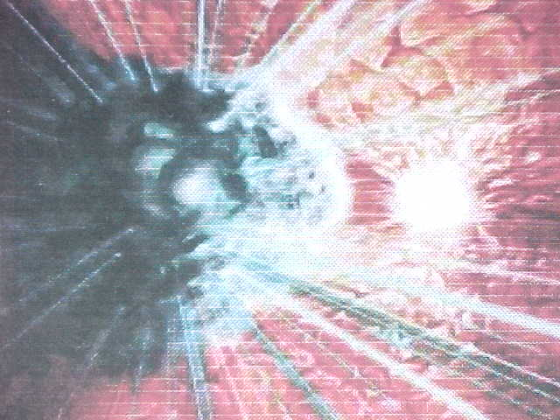
If Jesus is the Sun , would it be unreasonable given the descriptions in the Bible, to consider Eta Carina as the father. After all, we have learned that Eta Carina is 4 million times as powerful as the Sun. And if so, is it not apparent that God the Father is about to touch the earth in an amazingly powerful way of healing, restoration, and change. I would think so.

