ATOMIC ENERGY IN THE BIBLE
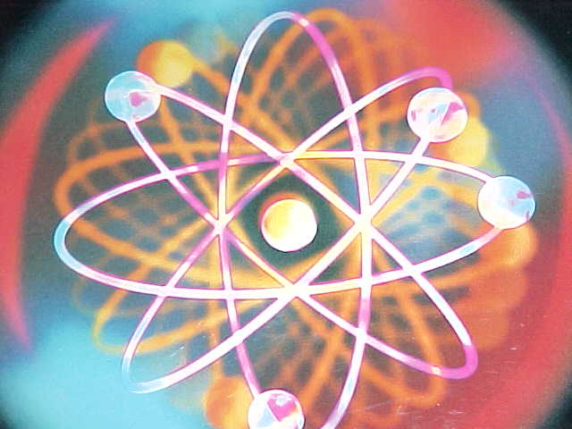
IS ADAM REALLY ATOM ?
WHY WAS A RIB REMOVED FROM ADAM TO MAKE EVE ?
ADAM AND EVE TRANSFORMATION
NUCLEAR FISSION IN THE BIBLE

ATOM & EVE
Consider the story. God takes a rib from Adam and makes Eve. Of course that's silly. But, if we take an electron from Atom we cause a new action of creation. Is the Bible saying that all life began with the splitting of the Atom/Adam.?.
The scientific process is called Ionic Bonding. Atoms that have gained or lost electrons are called ions. Because each electron has a negative charge, the gain of electrons creates a negative ion and the loss of electrons creates a positive ion. The attraction between negative and positive ions results in strong bonds called ionic bonds that hold the ions together.
To form sodium chloride an electron from a sodium atom is transferred to a chlorine atom. Thus something new is formed. An electron from an Adam/Atom is transferred to an Eve/Atom and what do you know. Something new is formed.

WHY DID GOD TAKE A RIB FROM ADAM ?
Consider the story. God takes a rib from Adam and makes Eve. Of course that's silly. But, if we take an electron from Atom we cause a chain reaction of creation. Is the Bible saying that all life began with the splitting of the Atom/Adam.?.
The scientific process is called Ionic Bonding. Atoms that have gained or loss electrons are called ions. Because each electron has a negative charge, the gain of electrons creates a negative ion and the loss of electrons creates a positive ion. The attraction between negative and positive ions results in strong bonds called Ionic bonds that hold the ions together.
To form sodium chloride an electron from a sodium atom is transferred to a chlorine atom. Thus something new is formed. An electron from an Adam/Atom is transferred to an Eve/Atom and what do you know. Something new is formed.

ADAM AND EVE
The Bible says that God took a rib from Adam and made Eve. Since we know that women are not made out of spare ribs, we realize that what is being said is that all life came from the splitting of the Atom/Adam.
Logical ?
A neutron (God) impacts the nucleus of an Atom /Adam and fission occurs and now we have Atom and Eve.! Or are women made of spare ribs?

NEW LIFE TRANSFORMATION
When we discuss life after death, it is very hard for the average person to conceive that it could be possible for a human being to be transformed into another life form and continue on. There is no proof that this is possible. Oh yes there is !
An Atom of Uranium becomes an Atom of Thorium by emitting an Alpha Particle. Don't worry about what Uranium is or what Thorium is. Consider that when Uranium emits or sends out something from itself it immediately changes into a whole new form.
So if it is possible for a certain chemical form to transform itself into another chemical form, why is it not possible for us to emit light via the Pineal Gland at the time of death, and instantly transform into a new life form ? We have shown that scientifically it happens within the Atom, and we are totally Atom. Thus transformation to a new life form is not only possible, it is a scientific fact in the chemical world ,now to be rationalized as a distinct possibility in the life world.

