Images with colored boarders were grouped together to show their similarities. | More soon... |  | More soon... |  | 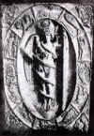 | 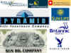
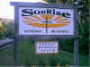 |   Mayan Sun Calender |  | 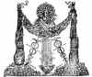 |  | 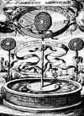 | 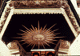  Sun face in the pulpit of a church in Scandinavia.
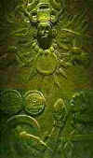  Ancient pagan civilizations like those of Mexico would cut the heart out of a living victim and offer it as a sacrifice to the sun. | 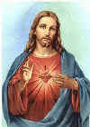 |  | 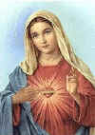 |  | 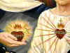 | 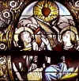
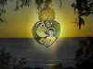 | 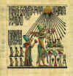 |  | 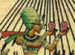 |  | 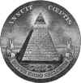 | 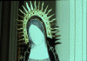  The solar blaze behind Mary's head, is made of a combination of straight lines (male, phallic) and wavy lines (female, yonic) symbols, representing sexual conception.
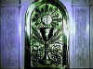 | 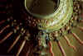 |  | 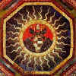  A ceiling decoration in the Sala delle Arti Liberali...coat of arms for the Borgia Pope |  | 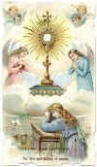 | 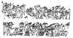  Sun Worship in Egypt
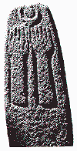  A pagan Canaanite cultic pillar from the city of Hazor, showing hands raised in praise to the sun disk, portrayed within the crescent moon. |  |  |  |  |   This is the general sunburst pattern used to symbolize the host in Catholicism, the supposed "true body" of Christ. This design has also been adopted by the Jesuits as their symbol. The IHS is thought by some to represent the first letters of each word in the Greek name Iesus Hominum Salvator (Jesus Savior of Men), although according to the Catholics themselves they actually represent the first three letters of the name "Jesus" in Greek. The pagan though, would quickly see the pagan trinity of Egypt - Isis, Horus, and Seb. In Egyptian mythology Seb (Geb) was the father of the goddess Isis (Aset), the mother and protectress of her divine son Horus (Harpocrates).  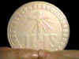 | 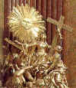  FIDES as portrayed over the pulpit of the Benedictine Melk Monastery on the Danube in Austria, built in the early 18th century. In FIDES' left hand is the golden cup (in front of the cross), and behind her right shoulder is the pagan sunburst image.
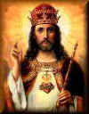 |  | 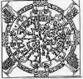  THE TEMPLE OF DENDERAH, UPPER EGYPT, c. 26,000 BC |  | 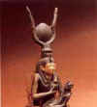  Sun Worship in Egypt | 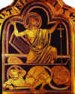  JESUS CHRIST | 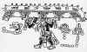  QUETZALCOATL. MAYAN PEACEMAKER C. 3113 B.C.
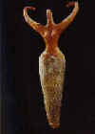  Sun Worship in Egypt |  | 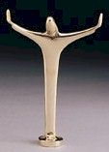  Christianity |  | 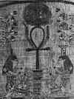  Sun Worship in Egypt | 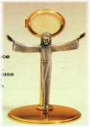  Christianity | 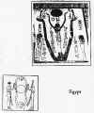  Sun Worship in Egypt
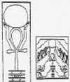  Sun Worship in Egypt |  | 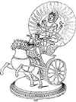 |  | 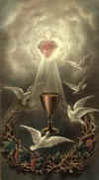 | 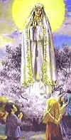  Our Lady of Fatima | 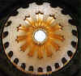
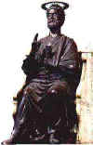  Statue in St. Peter's Cathedral in Rome  It is supposedly a statue of Peter enthroned. Notice the pagan solar wheel above his head? This statue is reported to actually be a pagan statue of Jupiter that was removed from the Pantheon in Rome (a pagan temple), moved into St. Peter's and renamed Peter. |  | 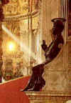  Statue in St. Peter's Cathedral in Rome  The foot of this statue has been nearly worn away from the many pilgrims who kiss it's foot in homage. |  | 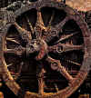  Pagan solar wheel | 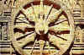  A pagan solar wheel in the temple at Kararak, India | 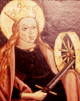  Madonna with solar disc behind head, holding solar wheel - symbol of solar power and fertility.
  Catholic Logo |  | 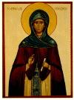 |  | 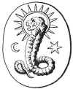 | 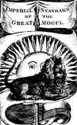 | 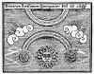
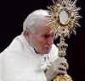 |  | 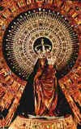  A statue of Mary and the Christ child is in the Church of the Virgin of the Pillar, Zaragoza, Spain. |  | 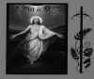  Right on the horizon too! | 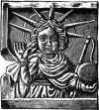  Mithraic Sun God - Sol | 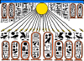
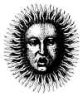 |  | 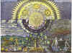 |  | 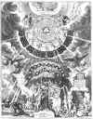 | 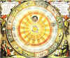 | 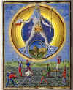
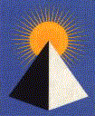  American Institute of Pyramidology |  | 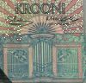  Bank of Estonia |  | 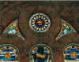 | 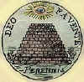  Barton's proposal for the reverse side of the U.S. Great Seal  (William Barton Third Committee - 1782) | 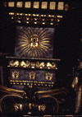  Face in the sun at the top of one of the giant serpentine pillars of Bernini's canopy in St. Peter's Basilica, at the Vatican.
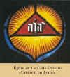  Jehovah Witnesses  Watchtower Symbols |  | 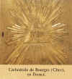  Jehovah Witnesses  Watchtower Symbols |  | 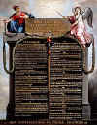  French "Declaration des Droits de l'Homme et du Citoyen" First institutional & founder text. You can note the masonic all-seeing-eye, phrygian cap, broken tins, pike. | 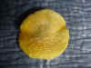  Hebrews 12 29 -  for our God is a consuming fire. | 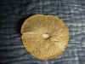  Deuteronomy 4:24 -  For the LORD your God is a devouring fire, a jealous God



 |  |  | 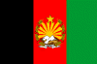 | 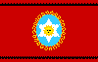 | 
 | 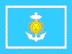 |  |  | 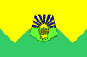 | 
 | 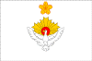 |  | 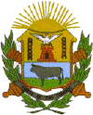 | 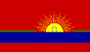 | 
 | 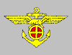 |  | 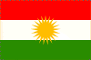 |  | 
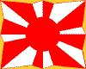 |  |  | 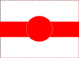 | 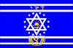 | 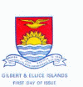
 |  |  | 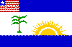 | 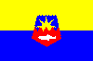 | 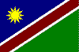
 | 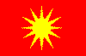 |  |  |  | 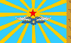
 | 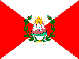 |  |  |  | 
 |  |  | 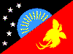 |  | 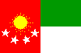
 | 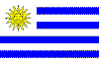 |  |  | 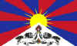  Flag of Tibet

