Nostradamus 1503-1566

http://en.wikipedia.org/wiki/Nostradamus

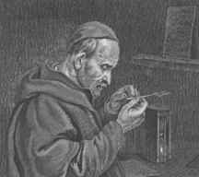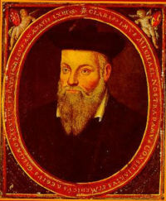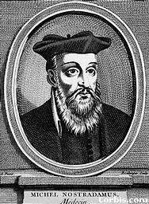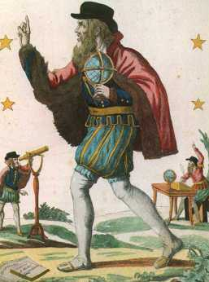

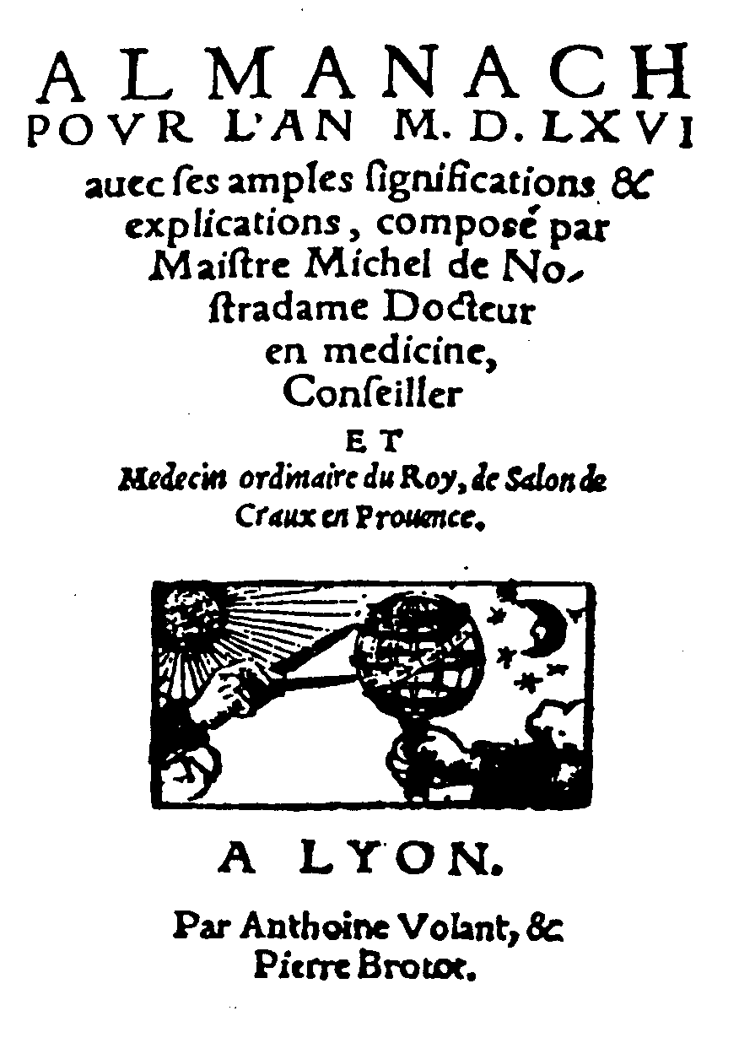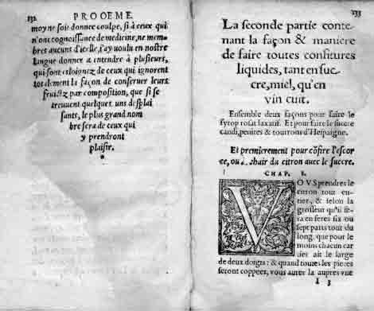

Nostradamus (December 14, 1503 – July 2, 1566), Latinised name of Michel de Nostredame, was one of the world's most famous publishers of prophecies. He is best known for his book Les Propheties, the first edition of which appeared in 1555.
Since the publication of this book, which has rarely been out of print since his death and has always been hugely popular throughout the world, Nostradamus has attracted an almost cult following. His many enthusiasts, to say nothing of the popular press, credit him with predicting numerous major world events.
In contrast, most of the academic sources listed below maintain that the associations made between world events and Nostradamus' quatrains are largely the result of misinterpretations or mistranslations (sometimes deliberate) or else are so tenuous as to render them useless as evidence of any genuine predictive power. Moreover, none of the sources listed offers any evidence that anyone has ever interpreted any of Nostradamus' quatrains specifically enough to allow a clear identification of any event in advance.^{[1]}
Nevertheless, interest in the work of this prominent figure of the French Renaissance is still considerable, especially in the media and in popular culture, and the prophecies have in some cases been assimilated to the results of applying the alleged Bible Code, as well as to other purported prophetic works.

Contents
[hide]
- 1 Biography
  - 1.1 Childhood
  - 1.2 Student years
  - 1.3 Marriage and healing work
  - 1.4 Seer
  - 1.5 Final years and death
- 2 Works
- 3 Literary sources
- 4 Interpretations
- 5 Alternative views
- 6 Popular culture
- 7 See also
- 8 Sources
- 9 External links
- 10 Notes

[edit] Biography

[edit] Childhood
o

