Avro Manhattan 1914–1990 Wikipedia Oct 25 2015

https://en.wikipedia.org/wiki/Avro_Manhattan

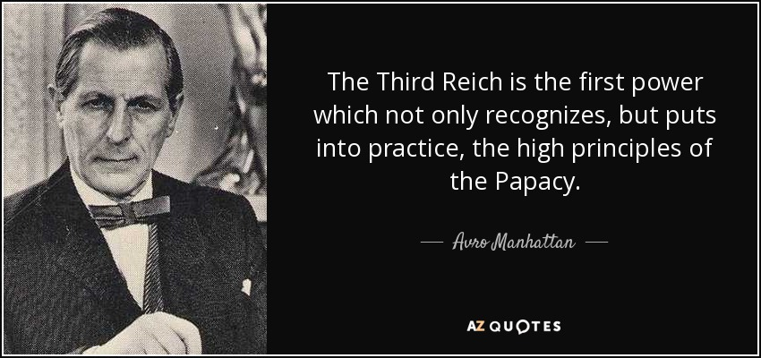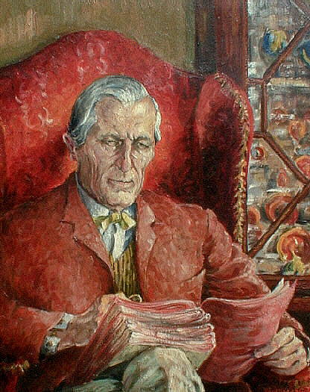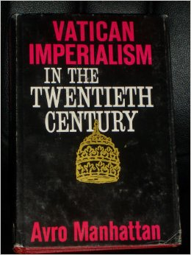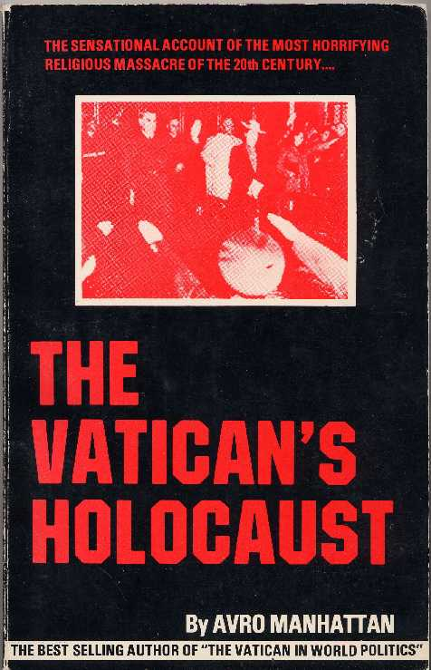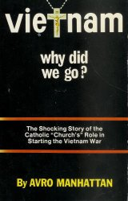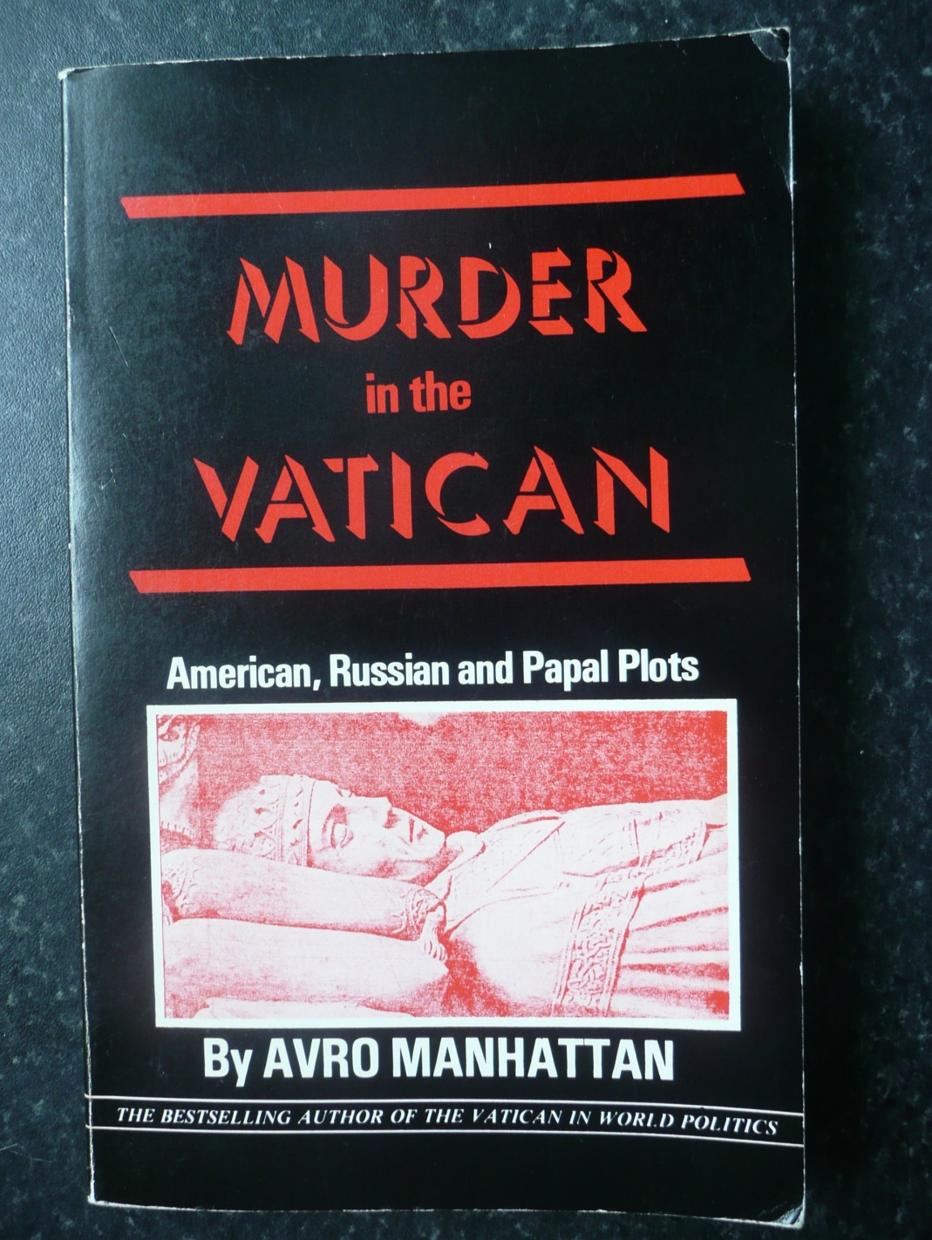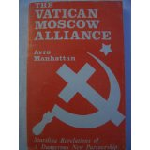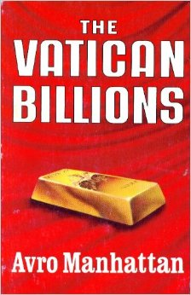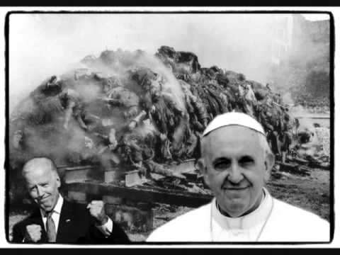

**Avro Manhattan** (1914–1990)[[1]](https://en.wikipedia.org/wiki/Avro_Manhattan#cite_note-1) was a writer, primarily known for his [criticisms](https://en.wikipedia.org/wiki/Criticism_of_the_Catholic_Church) of the [Roman Catholic Church](https://en.wikipedia.org/wiki/Roman_Catholic_Church). Having covered various political topics throughout his career, Manhattan is perhaps best remembered as the author of several works discussing the [Vatican's](https://en.wikipedia.org/wiki/Vatican_City) role in world politics and global affairs.

**Contents**

* [1 Life](https://en.wikipedia.org/wiki/Avro_Manhattan#Life)
* [2 Works](https://en.wikipedia.org/wiki/Avro_Manhattan#Works)
* [3 References](https://en.wikipedia.org/wiki/Avro_Manhattan#References)
* [4 External links](https://en.wikipedia.org/wiki/Avro_Manhattan#External_links)

**Life**

Born in [Milan](https://en.wikipedia.org/wiki/Milan), [Italy](https://en.wikipedia.org/wiki/Italy) on April 6, 1914 to [American](https://en.wikipedia.org/wiki/United_States) and [Swiss](https://en.wikipedia.org/wiki/Switzerland)/[Dutch](https://en.wikipedia.org/wiki/Netherlands) parents of Jewish extraction, Manhattan was educated at the [Sorbonne](https://en.wikipedia.org/wiki/University_of_Paris) and the [London School of Economics](https://en.wikipedia.org/wiki/London_School_of_Economics).

During [World War II](https://en.wikipedia.org/wiki/World_War_II), Manhattan was jailed in Italy for refusing to serve in [Benito Mussolini](https://en.wikipedia.org/wiki/Benito_Mussolini)'s fascist army. Later during the war, he operated a radio station called "Radio Freedom" broadcasting to nations occupied by the [Axis Powers](https://en.wikipedia.org/wiki/Axis_Powers).

His friends included [H G Wells](https://en.wikipedia.org/wiki/H_G_Wells), [Pablo Picasso](https://en.wikipedia.org/wiki/Pablo_Picasso), [George Bernard Shaw](https://en.wikipedia.org/wiki/George_Bernard_Shaw) and scientist [Marie Stopes](https://en.wikipedia.org/wiki/Marie_Stopes).

Manhattan spent much of his later life after 1979 at the ornately decorated home of his wife's late mother in [South Shields](https://en.wikipedia.org/wiki/South_Shields), [North East England](https://en.wikipedia.org/wiki/North_East_England).

He is buried in Blackhill cemetery in [Consett](https://en.wikipedia.org/wiki/Consett), England.

**Works**

Manhattan authored more than 20 books, including *The Vatican in World Politics*. It has been translated into most major languages, including Chinese, Russian and most recently, Korean. Some of his other popular works include *The Vatican Billions*, *The Vatican's Holocaust*, and *Vatican Moscow Alliance*. Some of his books which are especially critical of the Vatican and of Roman Catholicism.

The following is a list of Avro Manhattan's most notable works, ordered chronologically:

* The Rumbling of the Apocalypse (1934)
* Towards the new Italy (Preface by H.G. Wells) (1943)
* [Latin America and the Vatican](https://archive.org/details/MN5008ucmf_1) (1946)
* The Catholic Church Against the Twentieth Century (1947; 2nd edition 1950)
* The Vatican in Asia (1948)
* Religion in Russia (1949)
* [Vatican in World Politics](https://archive.org/details/TheVaticanInWorldPolitics%7CThe) (1949)
* [Catholic Imperialism and World Freedom](https://archive.org/details/catholicimperial027917mbp) (1952; 2nd edition 1959)
* Terror Over Yugoslavia, the Threat to Europe (1953)
* The Dollar and the Vatican (1956)
* Vatican Imperialism in the Twentieth Century (1965)
* Vatican Moscow Alliance (1982)
* [The Vatican Billions](http://www.cephas-library.com/catholic/catholic_vaticans_billions_1.html) (1983)
* Catholic Terror in Ireland (1988)
* [Vietnam ... why did we go?](https://archive.org/details/Vietnam...WhyDidWeGo) (1984)
* Murder in the Vatican, American Russian and Papal Plots (1985)
* The Vatican’s Holocaust (1986)
* The Dollar and the Vatican (1988)

**References**

* 1. [*"Baron and friend of Picasso spent years living in modest South Shields terraced house"*](http://www.telegraph.co.uk/news/newstopics/howaboutthat/11116434/Baron-and-friend-of-Picasso-spent-years-living-in-modest-South-Shields-terraced-house.html)*.* [*http://www.telegraph.co.uk/*](http://www.telegraph.co.uk/)*. The Telegraph. Retrieved 23 September 2014.*

**External links**

* The entire text of [*The Vatican's Holocaust*](http://www.reformation.org/holocaus.html) provided on-line by Reformation.org
* The entire text of [*Vietnam ... why did we go?*](http://www.reformation.org/vietnam.html) provided on-line by Reformation.org
* The entire text of [*The Vatican in World Politics*](http://www.cephas-library.com/catholic/catholic_vatican_in_world_politics_introduction.html) provided on-line by cephas-library.com
* Excerpts from [*Vatican Imperialism in the 20th Century*](http://www.reformation.org/vatican_against_the_orthodox_chu.html), provided on-line by Reformation.org
* [Biography on Avro Manhattan](http://www.srpska-mreza.com/library/facts/Baron-Manhattan.html)

======================================================================================================================================================================================