Emanuel Swedenborg 1688–1772
http://en.wikipedia.org/wiki/Emanuel_Swedenborg
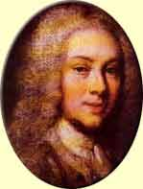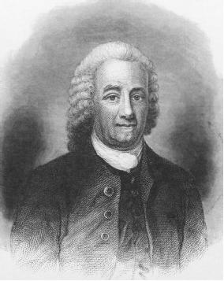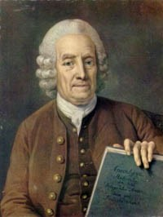
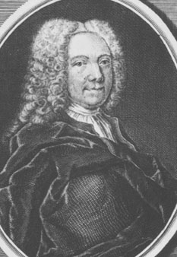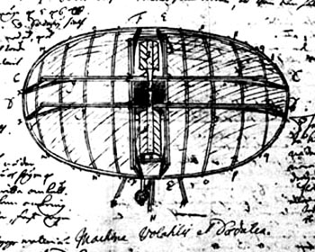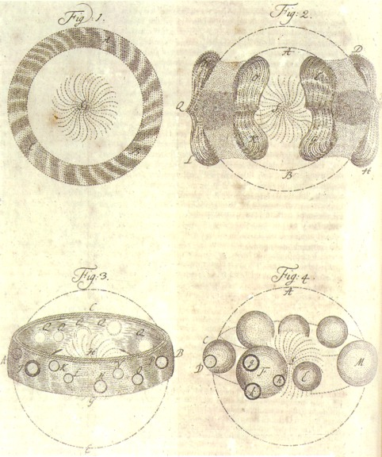

Emanuel Swedenborg (help·info) (born Emanuel Swedberg; January 29,^{[1]} 1688 – March 29, 1772) was a Swedish scientist, philosopher, Christian mystic,^{[2][3]} and theologian. Swedenborg had a prolific career as an inventor and scientist. At the age of fifty six he entered into a spiritual phase, in which he experienced dreams and visions. This culminated in a spiritual awakening, where he felt he was appointed by the Lord to write a heavenly doctrine based on a reformed Christianity. He claimed that the Lord had opened his eyes, so that from then on he could freely visit heaven and hell, and talk with angels, devils, and other spirits. For the remaining 28 years of his life, he wrote and published 18 theological works, of which the best known was Heaven and Hell (1758) ^{[4]}, and several unpublished theological works.
Swedenborg's theological writings have ellicited a range of responses. Toward the end of Swedenborg's life, small reading groups formed in England and Sweden to study the truth they saw in his teachings and several writers were influenced by him, including William Blake, August Strindberg, Charles Baudelaire, Balzac and Carl Jung. ^{[5]}
In contrast, one of the most prominent Swedish authors of Swedenborg's day, Johan Henrik Kellgren, called Swedenborg "nothing but a fool", a view shared by the establishment.^{[6]} And a heresy trial was initiated in Sweden in 1768 against Swedenborg's writings and two men who promoted these ideas. ^{[7]}
In the 250 years since Swedenborg's death, various interpretations of Swedenborg's theology have been made (see: Swedenborgian Church), and he has also been scrutinized in biographies and psychological studies.^{[8]}

Contents
- 1 Biography
  - 1.1 Early life
  - 1.2 Scientific period
  - 1.3 New direction of studies
  - 1.4 Crisis
  - 1.5 Visions and spiritual insights
  - 1.6 Scriptural commentary and writings
- 2 Veracity
- 3 Scientific beliefs
- 4 Psychic accounts
- 5 Theology
  - 5.1 Marriage
  - 5.2 Trinity
  - 5.3 Sola fide (Faith Alone)
- 6 Bibliography
- 7 See also
- 8 Notes and references
- 9 Further reading
- 10 External links

Biography
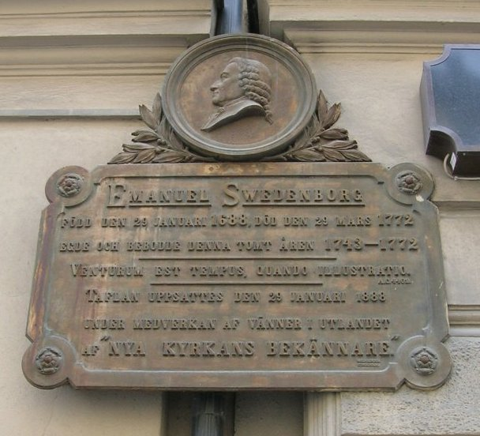
Memorial plaque at the former location of Emanuel Swedenborg's house at Hornsgatan on Södermalm, Stockholm.

Early life
Swedenborg's father Jesper Swedberg (1653–1735) had a modest background, but after studying theology and travelling abroad he was eloquent enough to impress the Swedish King Charles XI with his sermons in Stockholm. Through the King's influence he would later become professor of theology at Uppsala University and Bishop of Skara.^{[9][10]}
Jesper took an interest in the beliefs of the dissenting Lutheran Pietist movement, which emphasised the virtues of communion with God rather than relying on sheer faith (sola fide).^{[11]} Sola fide is a tenant of the Lutheran Church, and Jesper was charged with being a pietist heretic. While controversial, the beliefs were to have a major impact on his son Emanuel's spirituality. Jesper furthermore held the unconventional belief that angels and spirits were present in everyday life. This also came to have a strong impact on Emanuel. ^{[9][10][12]}
Emanuel completed his university course at Uppsala, and in 1710 made his Grand tour through the Netherlands, France, and Germany, before reaching London, where he would spend the next four years. At this time London was the largest city in the world, and the most liberal place in Europe for philosophical discussion and freedom of speech.^{[citation needed]} It was also a flourishing center of scientific ideas and discoveries. Emanuel studied physics, mechanics, and philosophy, read and wrote poetry. He wrote to his benefactor and brother-in-law Eric Benzelius that he believed he might be destined to be a great scientist. In one of his letters he includes, somewhat boastfully, a list of inventions he claims to have made, including a submarine and a flying machine.^{[13][5]}

[] Scientific period

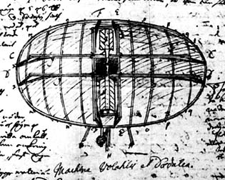

Flying Machine, sketched in a notebook in 1714. The operator would sit in the middle, and paddle himself through the air.

In 1715 Swedenborg returned to Sweden, where he was to devote himself to natural science and engineering projects for the next two decades. A first step was his noted meeting with King Charles XII of Sweden in the city of Lund, in 1716. The Swedish inventor Christopher Polhem, who became a close friend of Swedenborg's, was also present. Swedenborg's purpose was to persuade the king to fund an observatory in northern Sweden. However, the warlike king did not consider this project important enough, but did appoint Swedenborg assessor-extraordinary on the Swedish board of mines (Bergskollegium) in Stockholm. ^{[14]}
From 1716 to 1718 Swedenborg published a scientific periodical entitled Daedalus Hyperboreus ("The Nordic Deadalus") which was a record of mechanical and mathematical inventions and discoveries. One notable description was that of a flying machine, the same he had been sketching on a few years earlier (see Flying Machine (Swedenborg).^{[5]}
Upon the death of Charles XII, Queen Ulrika Eleonora ennobled Swedenborg and his siblings. It was common in Sweden during the 17th and 18th centuries for the children of bishops to receive this honour as a recognition of the services of the father. The family name was changed from Swedberg to Swedenborg. ^{[15]}
In 1724 he was offered the chair of mathematics at Uppsala University, but he declined, saying that he had mainly dealt with geometry, chemistry and metallurgy during his career. He also noted that he did not have the gift of eloquent speech because of a speech impediment. The speech impediment in question was stuttering, noted by many acquaintances of his, and it forced him to speak slowly and carefully, and there are no known occurrences of him speaking in public.^{[16]} It has been proposed that he compensated for his poor speech by extensive argumentation in writing.^{[17]}

[] New direction of studies
In the 1730s Swedenborg became increasingly interested in spiritual matters and was determined to find a theory which would explain how matter relates to spirit. In Leipzig, 1735, he published a three volume work entitled Opera philosophica et mineralis ("Philosophical and mineralogical works"), where he tries to conjoin philosophy and metallurgy. The work was mainly appreciated for its chapters on the analysis of the smelting of iron and copper, and it was this work which gave Swedenborg international reputation. ^{[18]}
The same year he also published the small manuscript de Infinito ("On the Infinite"), where he attempted to explain how the finite is related to the infinite, and how the soul is connected to the body. This was the first manuscript where he touched upon these matters. He knew that it might clash with established theologies, since he presents the view that the soul is based on material substances. ^{[19][20]}
During the 1730s Swedenborg undertook many studies of anatomy and physiology. He also conducted dedicated studies of the fashionable philosophers of the time John Locke, Christian von Wolff and Leibnitz, as well as returning to earlier thinkers Plato, Aristotle, Plotinus, Augustine, Descarte and others. ^{[21]}
In 1743, at the age of 55, Swedenborg requested a leave of absence to go abroad. His purpose was to gather source material for Regnum animale (The Animal Kingdom, or Kingdom of Life), a subject on which books were not readily available in Sweden. The aim of the book was to explain the soul from an anatomical point of view. He had planned to produce a total of seventeen volumes. ^{[22]}

[] Crisis
By 1744 he had traveled to the Netherlands. Around this time he began having strange dreams. Swedenborg carried a travel journal with him on most of his travels, and did so on this journey. The whereabouts of the diary were long unknown, but it was discovered in the Royal Library in the 1850s and published in 1859 as Drömboken, or Journal of Dreams. It provides a first-hand account of the events of the crisis. ^{[23]}
He experienced many different dreams and visions, some greatly pleasurable, other highly disturbing. ^{[24]}The experiences continued as he travelled to London to continue the publication of Regnum animale. This cathartic process continued for six months. It has been compared to the Catholic concept of Purgatory. ^{[25]} Analyses of the diary have concluded that what Swedenborg was recording in his Journal of Dreams was a battle between the love of his self, and the love of God. ^{[26]} The hallucinatory state is often described as a state of trance and is encountered among most mystics. ^{[27]}

[] Visions and spiritual insights
In the last entry of the journal from October 26-27 1744, Swedenborg appears to be clear as to which path to follow. He felt he should drop his current project, and write a new book about the worship of God. He soon began working on De cultu et amore Dei, or The Worship and Love of God. It was never fully completed, but Swedenborg still had it published in London in June 1745. ^{[28]}
One explanation why the work was never finished is given in a well known and often referenced story. In April 1745, Swedenborg was dining in a private room at a tavern in London. By the end of the meal, a darkness fell upon his eyes, and the room shifted character. Suddenly he saw a person sitting at a corner of the room, telling Swedenborg: "Do not eat too much!". Swedenborg, scared, hurried home. Later that night, the same man appeared in his dreams. The man told Swedenborg that He was the Lord, that He had appointed Swedenborg to reveal the spiritual meaning of the Bible, and that He would guide Swedenborg in what to write. The same night, the spiritual world was opened to Swedenborg.^{[29]}

[] Scriptural commentary and writings

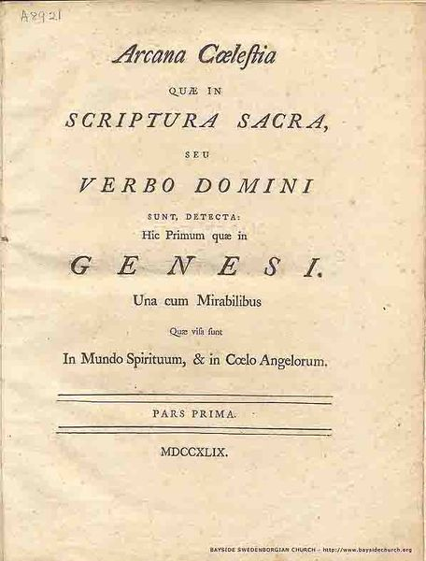
Arcana Caelestia, first ion (1749), title page

In June 1747, Swedenborg resigned his post as assessor of the board of mines. He explained that he was obliged to complete a work he had begun, and requested to receive half his salary as a pension. ^{[30]} He took up afresh his study of Hebrew and began to work on the spiritual interpretation of the Bible with the goal of interpreting the spiritual meaning of every verse. From sometime between 1746 and 1747, and for ten years henceforth, he devoted his energy to this task. This work, usually abbreviated as Arcana Caelestia ("Heavenly Secrets"), was to become his magnum opus, and the basis of his further theological works. ^{[31]}
The work was anonymous and Swedenborg was not identified as the author until the late 1750s. It consisted of eight volumes, published between 1749 and 1756. It attracted little atttention, as few people could penetrate its meaning. ^{[32][33]}
His life from 1747 until his death in 1772 was spent in Stockholm, Holland, and London. During these twenty five years he wrote another fourteen works of a spiritual nature of which most were published during his lifetime. Freedom of the press was not allowed for religious works at the time, which is why they were all printed in either London or Holland. ^{[34]}
Throughout this period he was befriended by many people who regarded him as a kind and warm-hearted man. When in the company of others, he was jovial, and conversed about whatever subject was discussed. Those who talked with him understood that he was devoted to his beliefs. He never argued matters of religion, except when ridiculed, when he replied sharply, so that the ridicule would not be repeated. ^{[35][36]}
In July, 1770, at the age of 82, he traveled to Amsterdam to complete the publication of his last work. The book, Vera Christiana Religio (The True Christian Religion), was published in in Amsterdam in 1771 and was one of the most appreciated of his works. Designed to explain his teachings to Lutheran Christians, it was the most concrete of his works.^{[37]}
In the summer of 1771, he travelled to London. Shortly before Christimas he suffered a stroke and was partially paralyzed and confined to bed. His health improved somewhat, but he died on March 29, 1772. There are several accounts of his last months, made by those he stayed with, and by a pastor of the Swedish Church in London who visited him several times. [
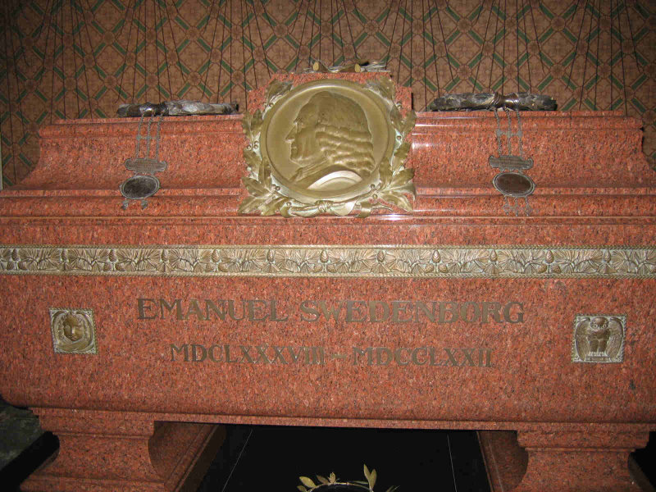
Swedenborg's crypt in Uppsala Cathedral

He was buried in a church in London. On the 140th anniversary of his death, in 1912/1913, his earthly remains were transferred to Uppsala Cathedral in Sweden, where they now rest in close proximity to the grave of the botanist Carolus Linnaeus.

[] Veracity
Swedenborg's transition from scientist to mystic has fascinated many people ever since it occurred;including such people as; Immanuel Kant, William Blake, Goethe, Arthur Conan Doyle, Balzac, Jorge Luis Borges, August Strindberg, Ralph Waldo Emerson and Carl Jung, just to mention a few.^{[citation needed]}
Some assert that Swedenborg lost his mind, suffering some sort of mental illness or nervous breakdown.^{[8]} While this idea was not uncommon during Swedenborg's own time, it is disproven by the fact that during the main part of his life he was active in the Swedish Riddarhuset (The House of the Nobility), the Riksdag (the Swedish parliament), and the Royal Swedish Academy of Sciences. Additionally, the system of thought in his theological writings is remarkably coherent.^{[39]}
A lot of scholarly literature regards Swedenborg's conclusions as natural developments of his inquiring mind. This was the stand taken by the Swedish writer Martin Lamm, who wrote a highly regarded biography of Swedenborg in 1915, which is still in print.^{[40]} Olof Lagercrantz, a noted Swedish critic and publicist, looked at it from a different view, calling Swedenborg's theological writing "a poem about a foreign country with peculiar laws and customs".^{[41]}

[] Scientific beliefs
Swedenborg proposed many scientific ideas, both before his crisis and after. In his youth, his ambitions were boundless, and he wanted to present a new idea every day, as he wrote to his brother in law Erik Benzelius in 1718. Around 1730, he had changed his mind, and instead believed that higher knowledge is not something that can be acquired, but that it is based on intuition. After his crisis in 1745, he instead considered himself receiving scientific knowledge in a spontaneous manner from angels. ^{[42]}
From 1745, when he considered himself to have entered a spiritual state, he tended to phrase his "experiences" in empirical terms, claiming to report accurately things he had experienced on his spiritual journies.
One of his pseudoscientific ideas that is considered most crucial for the understanding of his theology is his notion of correspondences. But in fact, he first presented the theory of correspondences in 1744, before his crisis, in the first volume of Regnum Animale dealing with the human soul. ^{[5]}
The basis of the correspondence theory is that there is a relationship between the natural ("physical"), the spiritual, and the divine worlds. The foundations of this theory can be traced to Neoplatonism and the philosopher Plotinus in particular. With the aid of this scenario, Swedenborg now interpreted the Bible in a different light, claiming that even the most apparently trivial sentences could hold a profound spiritual meaning. ^{[43]}

[] Psychic accounts
There are three well known incidents of psychic ability reported in literature about Swedenborg.^{[44]}The first was from July 29, 1759, when during a dinner in Gothenburg, he excitedly told the party at six o' clock that there was a fire in Stockholm (405 km away), that it consumed his neighbour's home and was threatening his own. Two hours later, he exclaimed with relief that the fire stopped three doors from his home. Two days later, reports confirmed every statement to the precise hour that Swedenborg first expressed the information. ^{[45]}
The second occured was in 1758 when Swedenborg visited Queen Louisa Ulrika of Sweden, who asked him to tell her something about her deceased brother Augustus William. The next day, Swedenborg whispered something in her ear that turned the Queen pale and she explained that this was something only she and her brother could know about. ^{[46]} The third was a woman who had lost an important document, and came to Swedenborg asking if a recently deceased person could tell him where it was, which he did the following night.^{[47]}
Immanuel Kant, then at the beginning of his career, was impressed by these in 1763, and made inquiries to find out if they were true. He also ordered all eight volumes of the expensive Arcana Caelestias. In 1766 he published Träume eines Geistersehers (Dreams of a Seer) where he concluded that Swedenborg's accounts were nothing but illusions. He could however not give a scientific explanation for Swedenborg's description of the fire in 1759. ^{[48]}
Swedenborg himself did not put much weight in such events. He several times explained that God did not perform miracles any longer, or manifest Himself in people's dreams. ^{[49]}

[] Theology
Swedenborg considered his theology a revelation of the true Christian religion that had become obfuscated through centuries of theology. However, he did not refer to his writings as theology since he considered it based on actual experiences, unlike theology.^{[5]} Neither did he wish to compare it to philosophy, a science he in 1748 discarded because it, quote, "darkens the mind, blinds us, and wholly rejects the faith".^{[50]}
The foundation of Swedenborg's theology was laid down in Arcana Caelestia, or Heavenly Secrets, published in eigth volumes from 1749 to 1756. In a significant portion of that work, he interprets Biblical passages. Most of all, he was convinced of how the Bible described a human's transformation from a materialistic to a spiritual being. He begins his work by outlining how the creation myth was not an account of the creation of Earth, but an account of man's rebirth in six steps. Everything related to mankind could also be related to Jesus Christ, and how Christ freed himself from materialistic boundaries. Swedenborg examined this idea by an exposition on Genesis and Exodus.^{[51]}

[] Marriage
One aspect of Swedenborg's writing that is often discussed is his ideas of marriage. Swedenborg himself stayed a bachelor all his life, but that did not hinder him from writing voluminously about the subject. His work Conjugal love (1768) was dedicated to this purpose. A righteous marriage, he argues, is intended to be a continuous spiritual refinement of both parties, and such a union would be maintained in the afterlife.^{[52]}
He regarded marriage as being fundamentally about the union of wisdom — physically represented in the man — and love — physically represented in the female. This dualism can be traced throughout Swedenborg's writings. Faith, he writes, is a union of the two qualities of reason (represented by the man) and intention (represented by the female). And, similarly, the wisdom of God has its corresponding part in the love from the Church. ^{[53]}

[] Trinity
Swedenborg was sharply opposed to the Christian doctrine of the Trinity as three Persons, the concept of One God being three separate Persons: the Person of the Father, the Person of the Son, and the Person of the Holy Spirit.
Instead he claimed that the three were different aspects of the one God, one Person, in whom is the Divine Trinity, and that divinity is impossible if divided into three Persons. Swedenborg spoke sharply against the Trinity of Persons in virtually all his works, and taught that the Divine Trinity exists in One Person, the Lord Jesus Christ, as a trinity of the soul, body, and spirit exists in each person. ^{[54]} The Divine Trinity in the Lord Jesus Christ is the Divine called the Father as the Soul, the Divine Human called the Son as the Body, and the proceeding Divine called the Holy Spirit as the Spirit. The Divinity or Divine essence of the three is one, as the Person is one. According to Swedenborg, Muslims, Jews and people of other religions are mainly opposed to Christianity because its doctrine of the Trinity of Persons makes One God into three Gods. He considered the separation of the Trinity into three separate Persons to have originated with the First Council of Nicaea in 325 CE and the Athanasian Creed, circa 500. ^{[55]} For example:
From a Trinity of Persons, each one of whom singly is God, according to the Athanasian creed, many discordant and heterogeneous ideas respecting God have arisen, which are phantasies and abortions. [..] All who dwell outside the Christian church, both Mohammedans and Jews, and besides these the Gentiles of every cult, are averse to Christianity solely on account of its belief in three Gods.
—Swedenborg, True Christian Religion, section 183 [1]

[] Sola fide (Faith Alone)
He also spoke sharply against the tenet called Sola fide, which means that salvation or righteousness before God is achievable through faith alone, irrespective of the person's deeds in life. This belief was a core belief in the theology of the Lutheran reformers Luther and Melanchthon. Swedenborg instead held that salvation is only possible through the conjunction of faith and charity in a person, and that the purpose of faith is to lead a person to live according to the truths of faith, which is charity. He further states that faith and charity must be exercised by doing good out of willing good whenever possible, which are good works or good uses, otherwise the conjunction perishes. In one section he wrote:
It is very evident from their Epistles that it never entered the mind of any of the apostles that the church of this day would separate faith from charity by teaching that faith alone justifies and saves apart from the works of the law, and that charity therefore cannot be conjoined with faith, since faith is from God, and charity, so far as it is expressed in works, is from man. But this separation and division were introduced into the Christian church when it divided God into three persons, and ascribed to each equal Divinity.
—True Christian Religion, section 355 [2]

[] Bibliography
List of referenced works by Swedenborg and the year they were first published.^{[56][57]}
Within paranthesis, the common name used in text, based on the New Church online bookstore. Then follows the name of the original title in its original publication.^{[58]}. Various minor reports and tracts have been omitted from the list.
- 1716-1718, (Deadalus Hyperboreus) Swedish: Daedalus Hyperboreus, eller några nya mathematiska och physicaliska försök. (English: The Northern inventor, or some new experiments in mathematics and physics)
- 1721, (Principles of Chemistry) Latin: Prodromus principiorum rerum naturalium : sive novorum tentaminum chymiam et physicam experimenta geometrice explicandi
- 1722, (Miscellaneous Observations) Latin: Miscellanea de Rebus Naturalibus
- 1734, (Principia) Latin: Opera Philosophica et Mineralia (English: Philosophical and Mineralogical Works), three volumes
  - (Principia, Volume I) Latin: Tomus I. Principia rerum naturlium sive novorum tentaminum phaenomena mundi elementaris philosophice explicandi
  - (Principia, Volume II) Latin: Tomus II. Regnum subterraneum sive minerale de ferro
  - (Principia, Volume III) Latin: Tomus III. Regnum subterraneum sive minerale de cupro et orichalco
- 1734, (The Infinite and Final Cause of Creation) Latin: Prodromus Philosophiz Ratiocinantis de Infinito, et Causa Finali Creationis; deque Mechanismo Operationis Animae et Corporis.
- 1744-1745, (The Animal Kingdom) Latin: Regnum animale, 3 volumes
- 1745, (The Worship and Love of God) Latin: De Cultu et Amore Dei, 2 volumes
- 1749-1756, (Arcana Caelestia, or Heavenly Secrets), Latin: Arcana Caelestia, quae in Scriptura Sacra seu Verbo Domini sunt, detecta. , 8 volumes
- 1758, (Heaven and Hell) Latin: De Caelo et Ejus Mirabilibus et de inferno. Ex Auditis et Visis.
- 1758, (The Last Judgment) Latin: De Ultimo Judicio
- 1758, (The White Horse) Latin: De Equo Albo de quo in Apocalypsi Cap.XIX.
- 1758, (Earths in the Universe) Latin: De Telluribus in Mundo Nostro Solari, quæ vocantur planetæ: et de telluribus in coelo astrifero: deque illarum incolis; tum de spiritibus & angelis ibi; ex auditis & visis.
- 1758, (The New Jerusalem and Its Heavenly Doctrine) Latin: De Nova Hierosolyma et Ejus Doctrina Coelesti
- 1763, (Doctrine of the Lord) Latin: Doctrina Novæ Hierosolymæ de Domino.
- 1763, (Doctrine of the Sacred Scripture) Latin: Doctrina Novæ Hierosolymæ de Scriptura Sacra.
- 1763, (Doctrine of Life) Latin: Doctrina Vitæ pro Nova Hierosolyma ex præceptis Decalogi.
- 1763, (Doctrine of Faith) Latin: Doctrina Novæ Hierosolymæ de Fide.
- 1763, (Continuation of The Last Judgement) Latin: Continuatio De Ultimo Judicio: et de mundo spirituali.
- 1763, (Divine Love and Wisdom) Latin: Sapientia Angelica de Divino Amore et de Divina Sapientia. Sapientia Angelica de Divina Providentia.
- 1764, (Divine Providence) Latin: Sapientia Angelica de Divina Providentia.
- 1766, (Apocalypse Revealed) Latin: Apocalypsis Revelata, in quae detegunter Arcana quae ibi preedicta sunt.
- 1768, (Conjugial Love, or Marital Love) Latin: Deliciae Sapientiae de Amore Conjugiali; post quas sequumtur voluptates insaniae de amore scortatorio.
- 1769, (Brief Exposition) Latin: Summaria Expositio Doctrinæ Novæ Ecclesiæ, quæ per Novam Hierosolymam in Apocalypsi intelligitur.
- 1769, (Intercourse of the Soul and the Body) Latin: De Commercio Animæ & Corporis.
- 1771, (True Christian Religion) Latin: Vera Christiana Religio, continens Universam Theologiam Novae Ecclesiae 2 volumes
- 1859, Drömboken, Journalanteckningar, 1743-1744
- 1983-1997, (Spiritual Diary) Latin: Diarum, Ubi Memorantur Experiantiae Spirituales.

[] See also
- The New Church
- Swedenborgianism
- Flying Machine (Swedenborg)
- List of Christian thinkers in science

[] Notes and references
- ^ January 29 according to the Julian calendar. In the Gregorian calendar, the date would be February 8
- ^ He is called a mystic by many sources, including the Encyclopædia Britannica online version, Swedenborg, Emanuel, retrieved November 8, 2006, and the Encyclopedia of Religion (1987) which starts its article with the description that he was a "Swedish scientist and mystic" .
- ^ Swedenborg referred to himself as an initialis, in Greek μυστικός (mystikos), "an initiate" (Bergquist, 1999, p.451; in turn based on Arcana Caelestia §4099)
- ^ Bergquist, Preface (p. 15-16)
- ^ ª ^{b} ^{c} ^{d} ^{e} Jonsson, Inge, Swedenborg och Linné, in Delblanc & Lönnroth
- ^ Johan Henrik Kellgren published an often quoted satirical poem entitled Man äger ej snille för det man är galen ("You Own Not Genius For That You are Mad") in 1787. See Jonsson, Inge, Swedenborg och Linné, in Delblanc & Lönnroth (1999). (Link to the full poem, in Swedish)
- ^ The trial in 1768 was again Gabrial Beyer and Johan Rosén and essentially concerned whether Swedenborg's writings were consistent with the Christian doctrines. A royal ordinance in 1770 declared that Swedenborg's writings were "clearly mistaken" and should not be taught even though his system of theological thought was never examined. Swedenborg then begged the King for grace and protection in a letter from Amsterdam. The investigation against Swedenborg stalled and was eventually dropped in 1778. (1999), pp.453-463
- ^ ª ^{b} This subject is touched on in the preface of Bergquist (1999), who mentions the biography by Martin Lamm (originally published 1917) and its focus on the similiarities of Swedenborg's scientific and theological lives. He mentions an earlier biography by the Swedish physician Emil Kleen who concluded that Swedenborg was blatantly mad, suffering "paranoia and hallucinations". A similar conclusion was made recently by phychiatrist John Johnson in Henry Maudsley on Swedenborg's messianic psychosis, British Journal of Psychiatry 165:690-691 (1994), who wrote that Swedenborg suffered hallucinations of "acute schizophrenia or epileptic psychosis."
- ^ ª ^{b} (Swedish) Nordisk familjebok, 2nd ion (Ugglan) article Svedberg, Jesper (1918)
- ^ ª ^{b} Encyclopeaedia Britannica, 1911 ion. article Emanuel Swedenborg
- ^ Svedberg's pietistic interests are described in Bergquist (1999), p.230-232
- ^ Martin Lamm (1978 [1915]; pp.1-19) notes how all Swedenborg biographies at that draw similiarities between the beliefs of Jesper and Emanuel. Lamm himself partially agrees with them, but he maintains that there were marked differences between them too.
- ^ Lagercrantz, preface. For more information about the flying machine, see Flying Machine (Swedenborg).
- ^ The meeting between the King, Polhelm and Swedenborg is described in detail in Liljegren, Bengt, Karl XII i Lund : när Sverige styrdes från Skåne, (Historiska media, Lund, 1999). ISBN 91-88930-51-3
- ^ Bergquist (1999), pp.114-115
- ^ Berquist (1999), pp.118-119
- ^ Proposed by Lagercrantz, also mentioned by Bergquist (1999), p.119
- ^ Bergquist (1999), pp. 142-155
- ^ Lamm (1987), pp.42-43, notes that by assuming that the soul consists of matter, as Swedenborg did, one becomes a materialist. He further notes that this was also noted by contemporaries.
- ^ Jonsson, Inge, Swedenborg och Linné, in Delblanc & Lönnroth, p.321
- ^ Bergquist (1999), pp.165-178
- ^ Jonsson, Inge, Swedenborg och Linné, in Delblanc & Lönnroth, p.325
- ^ Bergquist, pp.195-196
- ^ Bergquist, p.200-208
- ^ Bergquist (p.207) makes the comparisment to Purgatory
- ^ Analysis by Bergquist, p.209. Bergquist has previously published a separate book commenting on the Journal called Swedenborgs drömbok : glädjen och det stora kvalet (Stockholm, Norstedt, 1988)
- ^ Lamm (1989), pp.110-135. Lamm bases his analysis on Etudes d'histoire et de psychologie du mysticisme:, by Henri Delacroix (1908).
- ^ Bergquist (1999), pp.210-211
- ^ This account is based in Bergquist (1999), pp.227-228. The story was much later told by Swedenborg to Carl Robsahm (see Robsahm, #15)
- ^ Bergquist (1999),pp.286-287
- ^ Bergquist (1999), p.287
- ^ Bergquist (1999), p.288
- ^ Jonsson, Inge, Swedenborg och Linné, in Delblanc & Lönnroth, p.316
- ^ Bergquist (1999),p.477-478
- ^ Robsahm, #38
- ^ Bergquist (1999), p.475, quotes a letter from the pastor of the Swedish Church in London, Ferelius, in 1780, first published in Tafel II:I, p.560.
- ^ Bergquist (1999), p.464
- ^ Bergquist (1999), 471-476. Accounts of Swedenborg's last days were collected and published in Tafel II:1, pp.577 ff, 556 ff, 560 ff.
- ^ Bergquist (1999), p.474
- ^ Bergquist (1999), p.15
- ^ en dikt om ett främmande land med sällsamma lagar och seder. Largercrantz (1996), backpage
- ^ Bergquist (1999), p.364-365
- ^ Lamm (1987 [1915]), dedicates a chapter to the correspondence theories, p.85-109
- ^ Bergquist (1999), p.312
- ^ The accounts are fully described in Berquist, pp. 312-313. The primary source for these accounts is a letter from Immanuel Kant in 1768 and the Swedenborg collection by Tafel (see references).
- ^ According to Bergquist (1999), p.314-315, There are several different accounts of the events which makes it difficult to conclude the exact details of the event. Carl Robsahm (see references) reports the story in this way.
- ^ According to Bergquist (1999), p.316, there are some ten different reports of this event. Including two trustworthy descriptions, one by Robsahm (writing down Swedenborg's own description) and one by a priest who enquired of the woman in a letter fifteen years later.
- ^ Bergquist (1999), pp. 313, 319. Kant presents a report of this event in a letter to Charlotte von Knoblauch, 1768 (sometimes given as 1763). This letter is further discussed in Laywine, Alison, Kant’s Early Metaphysics. North American Kant Society Studies in Philosophy, volume 3 (Atascadero, California: Ridgeview Publishing Company, 1993), pp.72-74.
- ^ Bergquist (1999), p.316-317
- ^ Quoted by Bergquist (1999), p.178, based on Swedenborg's Spiritual experiences (1748), §767
- ^ Bergquist (1999), p.286-309
- ^ Bergquist (1999), p.431-446
- ^ Bergquist (1999), p.431-446
- ^ Bergquist (1999), p.301.
- ^ True Christian Religion, sections 163-168
- ^ Latin booktitles, The Swedenborg Society, accessed November 21, 2006.
- ^ The original title, and year of publication is based on Bergquist (1999), Litteraturförteckning (pp.525-534).
- ^ Emanuel Swedenborg Bibliography, New Church website, accessed November 14, 2006
- Benz, Ernst, Emanuel Swedenborg: Visionary Savant in the Age of Reason (Swedenborg Foundation, 2002) ISBN 0-87785-195-6, a translation of the thorough German language study on life and work of Swedenborg, Emanuel Swedenborg: Naturforscher und Seher by the noted religious scholar Ernst Benz, published in Munich in 1948.
- Bergquist, Lars, Swedenborg's Secret, (London, The Swedenborg Society, 2005) ISBN 0-85448-143-5, a translation of the Swedish language biography of Swedenborg, Swedenborgs Hemlighet, published in Stockholm in 1999. ISBN 91-27-06981-8
- Lamm, Martin, Swedenborg: En studie (1987; first ed. 1915). A popular biography that is still read and quoted. It is also available in English: Emanuel Swedenborg: The Development of His Thought, Martin Lamm (Swedenborg Studies, No. 9, 2001), ISBN 0-87785-194-8
- Lagercrantz, Olof, Dikten om livet på den andra sidan (Wahlström & Widstrand 1996), ISBN 91-46-16932-6. In Swedish.
- Leon, James, Overcoming Objections to Swedenborg's Writings Through the Development of Scientific Dualism An examination of Swedenborg's discoveries. The author is a professor of psychology and an avid reader of Swedenborg. (1998; published in New Philosophy, 2001)
- Robsahm, Carl, Hallengren, Anders (translation and comments), Anteckningar om Swedenborg (Föreningen Swedenborgs Minne: Stockholm 1989), ISBN 91-87856-00-X. Hallengren writes that the first complete publication of the Robsam manuscript was in R.L. Rafel's Documents, Vol. I, 1875 (see section "#further reading")
- Sigstedt, C.,The Swedenborg Epic. The Life and Works of Emanuel Swedenborg (New York: Bookman Associates, 1952). The whole book is available online at Swedenborg Digital Library
- Toksvig, Signe, Emanuel Swedenborg: Scientist and Mystic, Yale University Press, (1948), and Swedenborg Foundation, (1983), ISBN 0-87785-171-9
- This article incorporates text from the Encyclopædia Britannica Eleventh ion, a publication now in the public domain.

[] Further reading
Newer material:
- Swedenborg and His Influence, ed. Erland J. Brock, (Bryn Athyn, Pennsylvania: The Academy of the New Church, 1988), ISBN 0-910557-23-3.
- Jonathan S. Rose, ed. Emanuel Swedenborg: Essays for the New Century ion on His Life, Work, and Impact (West Chester, Pennsylvania: Swedenborg Foundation, 2002), ISBN 0-87785-473-4. 580 pages. Multiple scholars contributed to this collection of excellent information on Swedenborg, his manuscripts, and his cultural influence. Republished in 2004 under new title, Scribe of Heaven: Swedenborg's Life, Work, and Impact ISBN 0-87785-474-2.
Older material of importance, some of it not in print:
- The most extensive work is: RL Tafel, Documents concerning the Life and Character of Swedenborg, collected, translated and annotated (3 vols., Swedenborg Society, 1875—1877);
- J Hyde, A Bibliography of the Works of Emanuel Swedenborg (Swedenborg Society).
- Kant's Träume eines Geistersehers (1766; the most recent ion in English is from 1975, ISBN 3-7873-0311-1 );
- J. G. Herder's "Emanuel Swedenborg," in his Adrastea (Werke zur Phil. und Gesch., xii. 110-125).
- Transactions of the International Swedenborg Congress (London, 1910), summarized in The New Church Magazine (August, 1910).
- Swedenborg and Esoteric Islam (Swedenborg Studies, No 4) by Henry Corbin, Leonard Fox

[] External links
- Works by Emanuel Swedenborg at Project Gutenberg.
- The Swedenborgian Church is the original Swedenborgian denominational body in North America.
- The New Church or the General Church of the New Jerusalem is the largest Swedenborgian denomination in North America and worldwide.
- The Lord's New Church Which Is Nova Hierosolyma is a North American and International Swedenborgian Church that accepts the Theological Writings of Emanuel Swedenborg as the Lord's Word, The Word of The Third Testament, Which contains all the Divine Truth of the Lord's Divine Human.
- Information Swedenborg Inc The mission of Information Swedenborg Inc. is to raise awareness of the life and work of Emanuel Swedenborg. Sells books by, about and related to Swedenborg, world wide but especially within Canada.
- The Swedenborg Foundation is a non-profit publisher, book seller, and educational organization which publishes the theological works of Swedenborg, contemporary books and videos on spiritual growth, offers lectures and workshops, and maintains a library of Swedenborgian literature.
- The Heavenly Doctrines, a searchable library of Swedenborg's "revelatory phase" theological writings.
========================================================================================================
END

