Alvin Boyd Kuhn 1880-1963

http://en.wikipedia.org/wiki/Alvin_Boyd_Kuhn

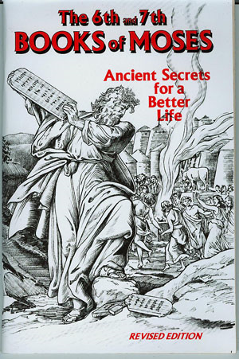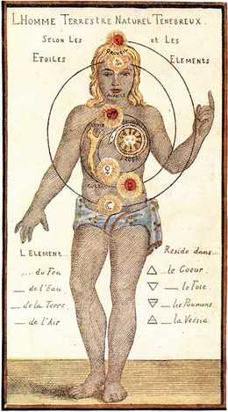

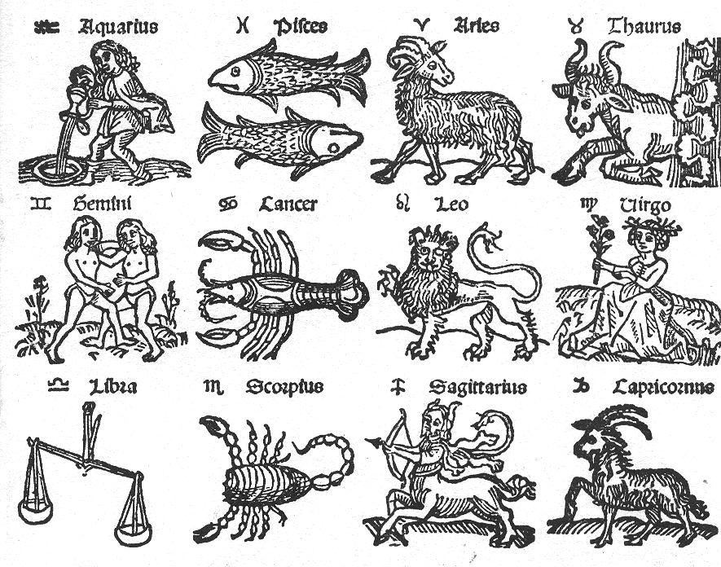
Alvin Boyd Kuhn (September 22, 1880 - September 14, 1963) was a scholar of comparative religion, mythology, linguistics and language.
Born in Franklin County, Pennsylvania, Kuhn studied the Ancient Greek language at university.^{[1]} He started his career working as a language teacher in high schools. He later enrolled at Columbia University to work on his PhD on Theosophy. His thesis, Theosophy: A Modern Revival of the Ancient Wisdom was, according to Kuhn, the first instance in which an individual has been "permitted" by any modern American or European university to obtain his doctorate with a thesis on Theosophy. Kuhn later expanded his thesis into his first book of the same name in 1930.
Highly influenced by the work of Gerald Massey and Godfrey Higgins, Kuhn contended that the Bible derived its origins from other Pagan religions and much of Christian history was pre-extant as Egyptian mythology. He also proposed that the Bible was symbolic and did not depict real events, and argued that the leaders of the church started to misinterpret the bible at the end of the third century. Many authors including Tom Harpur and John G. Jackson were influenced by the works of Kuhn. His final book, A Rebirth for Christianity, was completed shortly before his death on 14 September 1963.^{[2]}

Contents
[hide]
- 1 Selected bibliography
- 2 See also
- 3 References
- 4 External links

Selected bibliography
- Theosophy: A Modern Revival of Ancient Wisdom (1930)
- The Lost Light: An Interpretation of Ancient Scriptures (1940)
- Who is this King of Glory? (1944)
- Sex as Symbol (1945)
- The Tree of Knowledge (1947)
- The Shadow of the Third Century: A Revaluation of Christianity (1949)
- India's True Voice (1955)
- A Rebirth for Christianity (1963)

See also
- Gerald Massey
- Kersey Graves
- E. A. Wallis Budge
- Godfrey Higgins

References
- ^ Kuhn bio.
- ^ Alvin Boyd Kuhn, Ph.D. A Biographical Sketch of his life and work, by Richard Alvin Sattelberg, B.A., M.S..

External links
- Archive of many of Kuhn's works
- The Leading Religion Writer in Canada ... Does He Know What He's Talking About?
- Tom Harpur's response
Retrieved from "http://en.wikipedia.org/wiki/Alvin_Boyd_Kuhn"
Categories: 1880 births | 1963 deaths | Religious comparison | Theosophy | Christ myth

==================================================================================================================================

