Jakob Böhme 1575–1624

http://en.wikipedia.org/wiki/Jakob_B%C3%B6hme

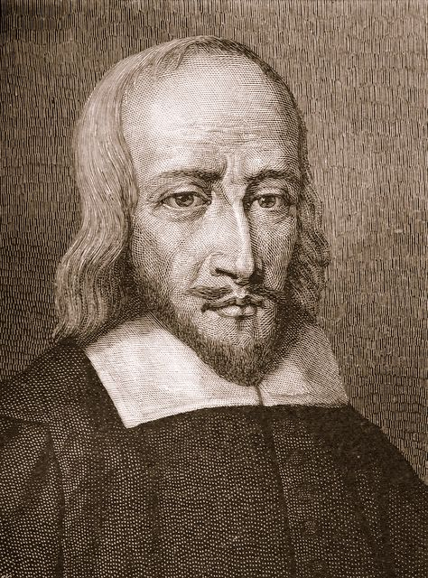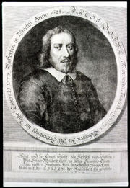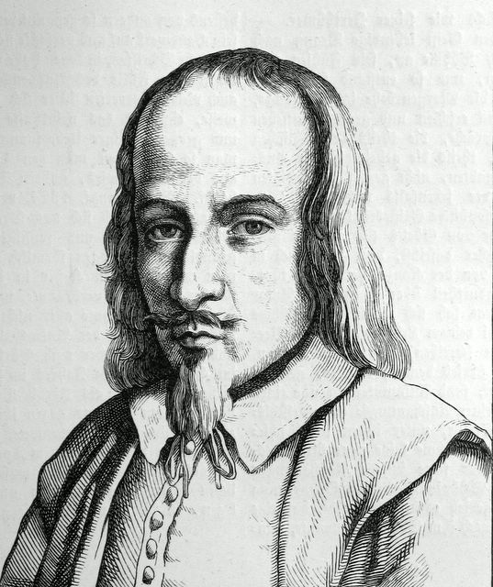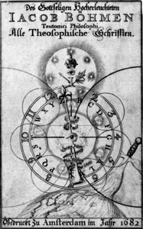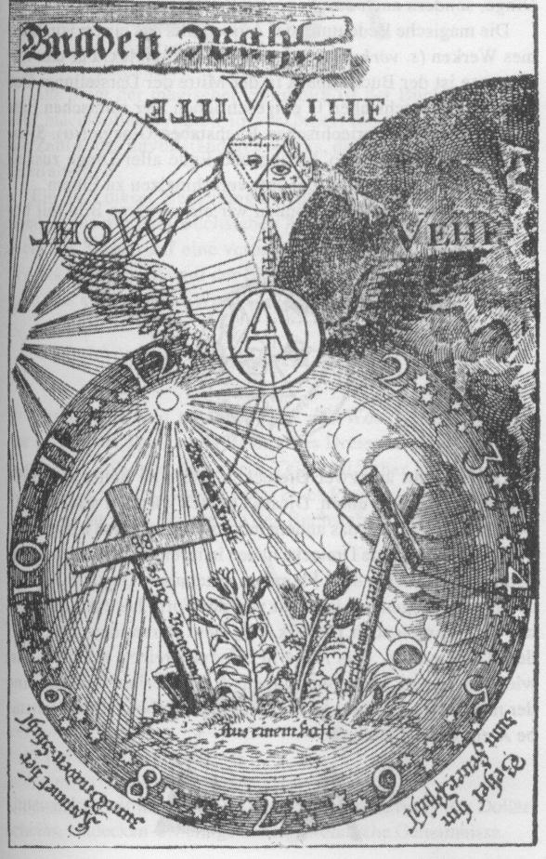

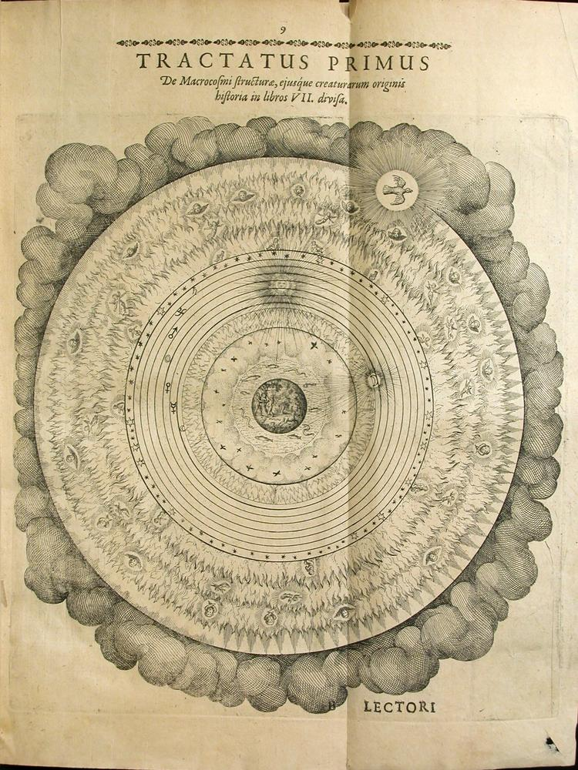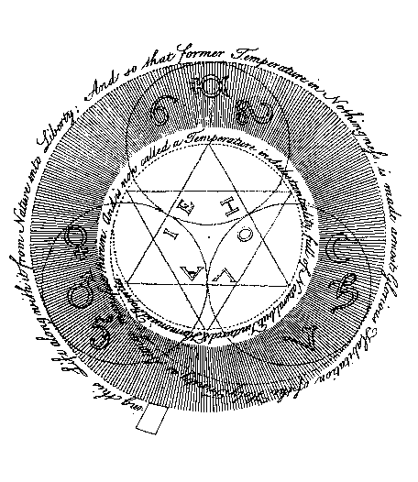

Jakob Böhme was born in eastern Germany, near Görlitz in Upper Lusatia. He grew up as a Lutheran, and worked as a shoemaker in Görlitz.
Böhme had mystical experiences throughout his youth, culminating in a vision in 1600 that he said he received through observing the exquisite beauty of a beam of sunlight reflected in a pewter dish. He believed this vision revealed to him the spiritual structure of the world, as well as the relationship between God and man, and good and evil. At the time he chose not to speak of this experience openly, preferring instead to continue his work and raise a family. Then after another vision in 1610, he began writing his first treatise, Aurora, or Die Morgenroete im Aufgang. Aurora was circulated in manuscript form until a copy fell into the hands of Gregorious Richter, the chief pastor of Görlitz, who considered it heretical and threatened Böhme with exile if he did not stop writing. After years of silence, Böhme's friends and patrons persuaded him to start again, and circulated his writings in handwritten copies. His first printed book, Weg zu Christo (The Way to Christ, 1623), caused another scandal; he spent the last year of his life in exile in Dresden, returning to Görlitz only to die. In this short period, Böhme produced an enormous amount of writing, including his major works De Signatura Rerum and Misterium Magnum. He also developed a following throughout Europe, where his followers were known as Behmenists.
The son of Böhme's chief antagonist, the pastor primarius of Görlitz Gregorius Richter, edited a collection of extracts from his writings, which were afterwards published complete at Amsterdam in the year 1682. Böhme's full works were first printed in 1730.
The chief concern of Böhme's writing was the nature of sin, evil, and redemption. Consistent with Lutheran theology, Böhme preached that humanity had fallen from a state of divine grace to a state of sin and suffering, that the forces of evil included fallen angels who had rebelled against God, and that God's goal was to restore the world to a state of grace. Where Böhme appeared to depart from accepted theology (though this was open to question due to his somewhat obscure, oracular style) was in his description of the Fall as a necessary stage in the evolution of the universe.
In Böhme's cosmology, it was necessary for humanity to depart from God, and for all original unities to undergo differentiation, desire, and conflict -- as in the rebellion of Satan, the separation of Eve from Adam, and their acquisition of the knowledge of good and evil -- in order for creation to evolve to a new state of redeemed harmony that would be more perfect than the original state of innocence, allowing God to achieve a new self-awareness by interacting with a creation that was both part of, and distinct from, Himself. Thus, free will was the most important gift God gave humanity, allowing us to seek divine grace as a deliberate choice while still allowing us to remain individuals. Böhme saw the incarnation of Christ not as a sacrificial offering to cancel out human sins, but as an offering of love for humanity, showing God's willingness to bear the suffering that had been a necessary aspect of creation. He also believed the incarnation of Christ conveyed the message that a new state of harmony is possible. This was somewhat at odds with Lutheran dogma, and his suggestion that God would have been somehow incomplete without the Creation was even more controversial, as was his emphasis on faith and self-awareness rather than strict adherence to dogma or scripture.
Böhme's writing shows the influence of Neoplatonist and alchemical writers such as Paracelsus, while remaining firmly within a Christian tradition. He has in turn greatly influenced many anti-authoritarian and mystical movements, such as the Religious Society of Friends, the Philadelphians, Martinism and Theosophy. Böhme was also an important source of German Romantic philosophy, influencing Schelling in particular. In Richard Bucke's 1901 treatise Cosmic Consciousness, special attention was given to the profundity of Böhme's spiritual enlightenment, which seemed to reveal to Böhme an ultimate nondifference, or nonduality, between human beings and God.

Quote
"When thou art gone forth wholly from the creature [human], and art become nothing to all that is nature and creature, then thou art in that eternal one, which is God himself, and then thou shalt perceive and feel the highest virtue of love. Also, that I said whosoever findeth it findeth nothing and all things; that is also true, for he findeth a supernatural, supersensual Abyss, having no ground, where there is no place to dwell in; and he findeth also nothing that is like it, and therefore it may be compared to nothing, for it is deeper than anything, and is as nothing to all things, for it is not comprehensible; and because it is nothing, it is free from all things, and it is that only Good, which a man cannot express or utter what it is. But that I lastly said, he that findeth it, findeth all things, is also true; it hath been the beginning of all things, and it ruleth all things. If thou findest it, thou comest into that ground from whence all things proceed, and wherein they subsist, and thou art in it a king over all the works of God." [The Way to Christ, 1623]

See also
- German mysticism - a pre-Reformation mystical movement
- Christian mystics

Works
- Aurora: Die Morgenröte im Aufgang (unfinished) (1612)
- The Three Principles of the Divine Essence (1612)
- The Threefold Life of Man (1620)
- Answers to Forty Questions Concerning the Soul (1620)
- The Treatise of the Incarnations: (1620)
  - I. Of the Incarnation of Jesus Christ
  - II. Of the Suffering, Dying, Death and Resurrection of Christ
  - III. Of the Tree of Faith
- The Great Six Points (1620)
- Of the Earthly and of the Heavenly Mystery (1620)
- Of the Last Times (1620)
- De Signatura Rerum (1621)
- The Four Complexions (1621)
- Of True Repentance (1622)
- Of True Resignation (1622)
- Of Regeneration (1622)
- Of Predestination (1623)
- A Short Compendium of Repentance (1623)
- The Mysterium Magnum (1623)
- A Table of the Divine Manifestation, or an Exposition of the Threefold World (1623)
- The Supersensual Life (1624)
- Of Divine Contemplation or Vision (unfinished) (1624)
- Of Christ's Testaments (1624)
  - I. Baptism
  - II. The Supper
- Of Illumination (1624)
- 177 Theosophic Questions, with Answers to Thirteen of Them (unfinished) (1624)
- An Epitome of the Mysterium Magnum (1624)
- The Holy Week or a Prayer Book (unfinished) (1624)
- A Table of the Three Principles (1624)
- Of the Last Judgement (lost) (1624)
- The Clavis (1624)
- Sixty-two Theosophic Epistles (1618-1624)

External links
- Jacob Boehme Resources
- The Way to Christ in English translation
- A Modern Gnostic from Paul Carus' History of the Devil (1900).
- Jakob Bohme at the Rotten Library

