Ananda Kentish Coomaraswamy 1877 - 1947

http://en.wikipedia.org/wiki/Ananda_Coomaraswamy

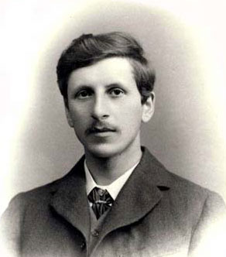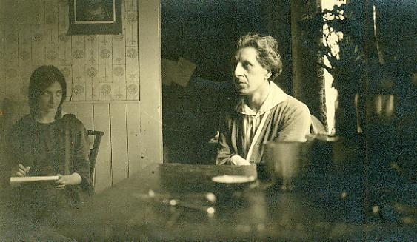

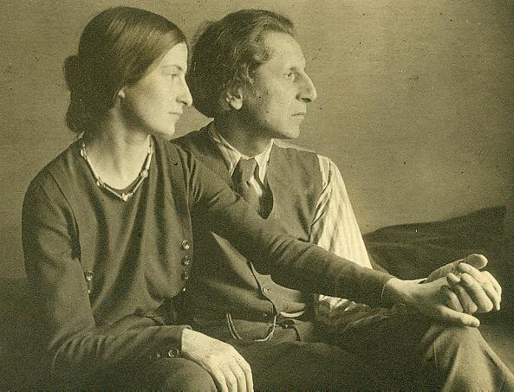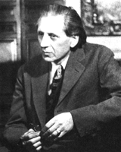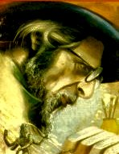

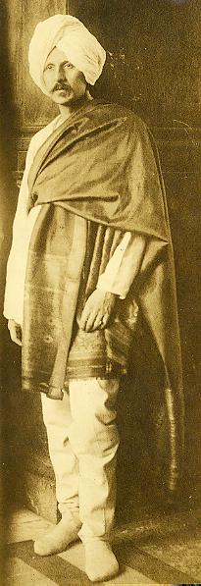

Ananda Kentish Coomaraswamy (22 August 1877, Colombo - 19 September 1947, Needham, Massachusetts) was foremostly, as he said he would like to be remembered, a Metaphysician, but he was also a pioneering historian and philosopher of Indian art, especially art history and symbolism, and early interpreter of Indian culture to the West.

Contents
[hide]
- 1 Early life
- 2 His contributions
- 3 The Perennial Philosophy
- 4 Works of Coomaraswamy
- 5 References
- 6 See also
- 7 External links

Early life
Ananda Kentish Coomaraswamy was the son of the famous Sri Lankan Tamil legislator and philosopher Sir Mutu Coomaraswamy and his English wife Elizabeth Beeby. He became a pioneering historian and philosopher of Indian art, and a great interpreter of Indian culture to the West. He was also a tireless campaigner for the regeneration of Hinduism. In 1917, he became the first Keeper of Indian art in the Museum of Fine Arts in Boston. He stressed the spiritual element in Indian art.
Born in Ceylon, he was educated in his mother’s homeland England, at Wycliffe College (Gloucestershire) ^{[1]}. He became one of the world’s greatest art historians and scholars of traditional iconography. He settled in Broad Campden in the Cotswolds in rural Gloucestershire, the friend and collaborator of the romantic socialist and Utopian designer, Charles Robert Ashbee. He served as curator in the Boston Museum of Fine Arts until his death, having been the first Oriental to make the meaning of oriental art understood in the West. He played an important role in the collection of Persian Art for the Freer in Washington, D.C. and the Boston Museum of Fine Art as well.

His contributions
What made him a qualified as well as an acclaimed interpreter was his extensive knowledge, love, and understanding of the world’s diverse cultures, sacred scriptures, and languages. Coomaraswamy was credited with knowledge of thirty-six languages, as well as familiarity with the literature, poetry, and music of those languages. ^{[citation needed]}. He once remarked I actually think in both Eastern and Christian terms—Greek, Latin, Sanskrit, Pali, and to some extent Persian and Chinese. For this reason, he had access to deeper levels of meaning found in language which made it possible for him to interpret symbols and mythologies within the context of the literature in which they are found.
Coomaraswamy died in Needham, Massachusetts in 1947.

The Perennial Philosophy
He was described by Heinrich Zimmer as That noble scholar upon whose shoulders we are still standing^{[citation needed]}. While serving as a curator to the Boston Museum of Fine Arts in the latter part of his life, he devoted his work to the explication of traditional metaphysics and symbolism. His writings of this period are filled with references to Plato, Plotinus, Clement, Philo, Augustine, Aquinas, Shankara, Eckhart, Rhinish and other Asian mystics. He was responsible for creating the collections of oriental art for the Freer Museum, Washington D.C., as well as for the Boston Museum of Fine Arts. When asked what he was, foremostly Dr. Coomaraswamy referred to himself as a Metaphysician, referring here to the concept of perennial philosophy or Sophia Perennis.
Along with René Guénon, and Frithjof Schuon, Coomaraswamy is regarded as one of the three founders of Perennialism, also called the Traditionalist School.
Although he agrees with Guénon on the universal principles, his works are very different in form from Guénon's. By vocation, he was a scholar, who dedicated the last decades of his life to searching the Scriptures. He offers a perspective on the tradition which complements well that of Guénon. He had a very highly active aesthetic perceptiveness and he wrote dozens of articles on traditional arts and mythology. His works are also intellectually more balanced. Although born in the Hindu tradition, he had however a deep knowledge of the Western tradition and had also a great expertise and love for Greek metaphysics, especially that of Plotinus, the founder of Neoplatonism.
He built a bridge between East and West that was designed to carry a two-way traffic: his metaphysical writings aimed, among other things, at demonstrating the unity of the Vedanta and Platonism. His works also rehabilitated original Buddhism, a tradition that Guénon has for a long time limited to a rebellion of the Kshatriyas against Brahmin authority.

Works of Coomaraswamy
(partial list)
- The Dance of Siva (1918), Munshiram Manoharlal Publishers, 1997 edition: ISBN 81-215-0153-9
- History of Indian and Indonesian Art (1927), Dover Publications 1985 edition: ISBN 0-486-25005-9 Kessinger Publishing 2003 edition: ISBN 0-7661-5801-2
- Hinduism and Buddhism,
- The Living Thoughts of Gotama the Buddha, Dover Publications 2000 edition: ISBN 0-486-41439-6
- Am I My Brothers Keeper?,
- Figures of Speech or Figures of Thought, South Asia Books, 1981 edition: ISBN 81-215-0178-4
- What is Civilization,
- Time and Eternity, South Asia Books, 1993 edition: ISBN 81-215-0059-1
- The Transformation of Nature in Art (1934). South Asia Books, 1994 edition: ISBN 81-215-0325-6
See also his work of technical art history "The Technique and Theory of Indian Painting" in Technical Studies in the Field of the Fine Arts vol. 3:1 (1934-5): 58–89, which includes extracts from Indian artists' technical recipe texts.
His two works
- Origin of the Buddha Image, Munshirm Manoharlal Pub Pvt Ltd, 1980 edition: ISBN 81-215-0222-5 and
- Elements of Buddhist Iconography,
still stand today as a remarkable achievement in the scholarly and metaphysical explanation of earliest Buddhist symbolism and theirs roots in Vedic and Upanishadic thought.
A representative anthology of his work is to be found in the Princeton University Press Bollingen series (1977) collected by Roger Lipsey:
- Traditional Art and Symbolism
- Ananda Kentish, Coomaraswamy (1978) ISBN 0-691-09931-6
- Metaphysics, 1987 edition: ISBN 0-691-01873-1
- Roger Lipsey, His Life and Work
Some of the very last unpublished works of Coomaraswamy, mostly on Greek philosophy, were only released in 2004 by Fons Vitae, called
- Guardians of the Sun-Door: Late Iconographic Essays, ISBN 1-887752-59-5

References
- An essay on AKC philosophy of art
- Ananda Coomaraswamy in One Hundred Tamils of 20th Century
- ^ ODNB Article by G. R. Seaman, ‘Coomaraswamy, Ananda Kentish (1877–1947)’, Oxford Dictionary of National Biography, Oxford University Press, 2004 [1], accessed 8 Oct 2007.

See also
- Sophia Perennis  - Perennial philosophy  - Study of Traditionalism  - Comparative Religion  - Esoterism  - Advaita Vedanta | - Traditionalist School  - René Guénon  - Frithjof Schuon  - Martin Lings  - Huston Smith | - Seyyed Hossein Nasr  - Titus Burckhardt  - Ivan Aguéli  - Michel Valsan

Buddhist writers: B. R. Ambedkar • Lokesh Chandra • Edward Conze • Alexandra David-Néel • Kelsang Gyatso • Dalai Lama • Walpola Rahula • C.A.F. Rhys Davids • T.W. Rhys Davids • Seongcheol • Sogyal Rinpoche • Robert Thurman • Richard Gombrich • Chah Subhatto • Thanissaro Bhikkhu • Bhikkhu Bodhi • Nyanaponika Thera • Jack Kornfield • Gil Fronsdal • Seongcheol • Seung Sahn • Nishida Kitaro • Scott Shaw • D.T. Suzuki • Paul Reps • Alan Watts • Thich Nhat Hanh • Yin Shun
Hindu writers: Aurobindo • A. Coomaraswamy • Bankim • Alain Daniélou • Dayananda • Sita Ram Goel • The Mother • Prabhupada • Sivananda • Ram Swarup • Tilak • Vivekananda • Yogananda
Jain writers: Satish Kumar • Claudia Pastorino • Yashodev Suri • Jayantsain Suri
Sikh writers: Bhai Vir Singh • Harjot Oberoi • G.S. Talib • Khushwant Singh
Other/Syncretic: Gurumaa • Annie Besant • Ram Dass • Eknath Easwaran • Sathya Sai Baba • Georg Feuerstein • Benjamin Hoff • H. S. Olcott • Meher Baba • Osho • Ken Wilber • Nirmala Srivastava

External links
- Many free complete books by Ananda Coomaraswamy in PDF format
- Books by Ananda Coomaraswamy - Fons Vitae Series
- The 1999 Coomaraswamy lecture by Sandrasagra
- Works of Ananda Kentish Coomaraswamy in Hungarian
- A website on the Traditionalist/Perennialist School
- Short biography and list of titles
Retrieved from "http://en.wikipedia.org/wiki/Ananda_Coomaraswamy"
Categories: Articles with unsourced statements since September 2007 | All articles with unsourced statements | Articles with unsourced statements since February 2007 | 1877 births | 1947 deaths | 20th century philosophers | Tamil scholars | Traditionalism | Museum of Fine Arts, Boston | Tamil Sri Lankans | Eurasians | Sri Lankan Americans | American Hindus | Pāli | Hindu writers | Perennial Philosophy
========================================================================================================================

