The Diamond Sutra

http://en.wikipedia.org/wiki/Diamond_Sutra

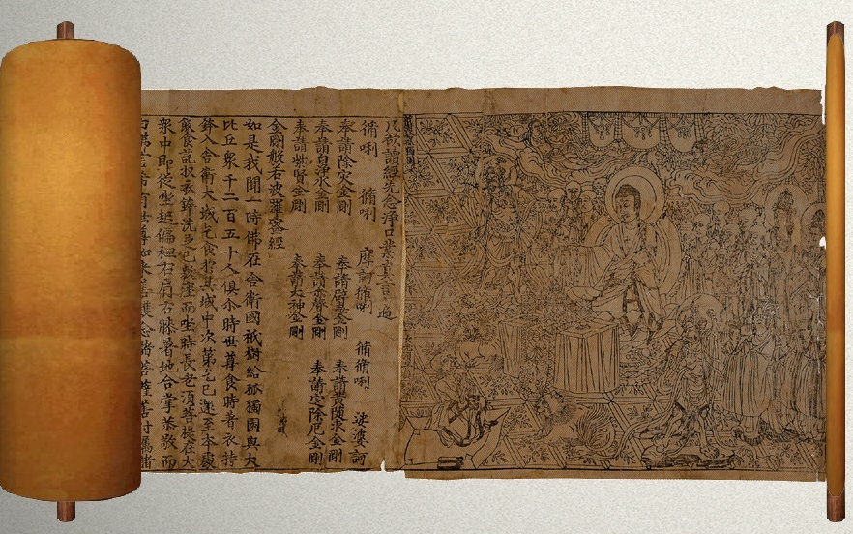

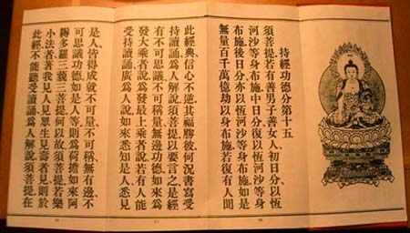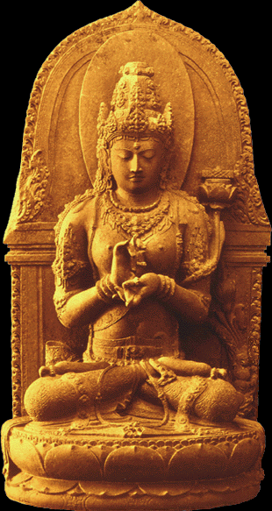

The Diamond Sutra Vajracchedika-prajñāpāramitā-sūtra, Chinese: 金剛經, Pinyin: jin gang jing, Japanese: kosan-kongyō), or "The Sutra of the Perfection of Wisdom of the Diamond that Cuts Through Illusion," is a short Mahayana sutra of the Perfection of Wisdom genre, which teaches the practice of the avoidance of abiding in extremes of mental attachment. A copy of the Diamond Sutra, found sealed in a cave in China in the early 20th century, is the oldest known dated printed book, with a printed date of 868 CE.
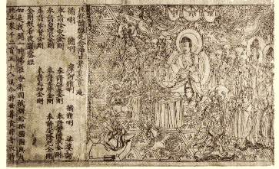
A page from the Diamond Sutra, printed in the 9th year of Xiantong Era of the Tang Dynasty, i.e. 868 CE. Currently located in a museum in London.

Since it can be read in approximately forty minutes, the Diamond Sutra is often memorized and chanted in Buddhist monasteries. This sutra has retained a high degree of popularity in the Mahāyāna Buddhist tradition for over a millennium, especially in East Asia, and most importantly within the East Asian mation (Chan/Seon/Zen/Thien) school, where it is recited, taught, and commented extensively, even today. The text resonates with a core aspect of Chan doctrine/praxis: the theme of "non-abiding."
There is a wood block printed copy in the British Library which, although not the earliest example of block printing, is the earliest example which bears an actual date. The copy is a scroll, about 16 feet long, found in 1907 by the archaeologist Sir Marc Aurel Stein in the walled-up Mogao Caves near Dunhuang, in northwest China. The caves are known as the "Caves of the Thousand Buddhas." The colophon, at the inner end, reads: Reverently [caused to be] made for universal free distribution by Wang Jie on behalf of his two parents on the 13th of the 4th moon of the 9th year of Xiantong (i.e. 11th May, CE 868). This is about 587 years before the Gutenberg Bible.

Contents
- 1 Contents
- 2 References
  - 2.1 Notes
  - 2.2 Bibliography
- 3 External links

Contents
The Diamond Sutra, like many sutras, begins with the famous phrase "thus have I heard" (एवं मया श्रुतम्, evam maya shrutam). In this sutra the Buddha has finished his daily walk with the monks to gather offerings of food and sits down to rest. One of the more senior monks, Subhuti, comes forth and asks the Buddha a question.
What proceeds from there is a lengthy, and oftentimes repetitive, dialogue regarding the nature of perception. The Buddha often uses paradoxical phrases like "what is the highest teaching is in fact not the highest teaching; thus it can be called the highest teaching".^{[1]}
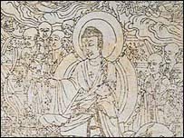
Image from Diamond Sutra - Oldest Dated Printed Book

The Buddha is trying to help Subhuti unlearn his preconceived, and limited, notions of what reality is, the nature of Enlightenment, and compassion.
A particularly noteworthy part is when the Buddha teaches Subhuti that what makes a Bodhisattva so great is that the Bodhisattva does not take pride in his/her work to save others, nor is their compassion calculated or contrived. They practise sincere compassion that comes from deep within, without any sense of ego or gain.
In another section, Subhuti expresses concern that the Diamond Sutra will be forgotten 500 years after it is taught (alternatively, during the last 500 years of this era). The Buddha assures Subhuti that well after he is gone, there will still be some who can grasp the meaning of the Diamond Sutra and put it into practice. This sections seems to reflect a concern found in other Buddhist texts that the teachings of the Buddha would eventually fade and become corrupted. A popular Buddhist concept, known as mappo in Japanese, also reflects this same anxiety.
It is often said in the Diamond Sutra that if a person can even commit four lines of the Sutra into practice, they will be greatly blessed.

[] References

[] Notes
- ^ Diamond Sutra, Sec. 8, Subsec. 5 金剛經，依法出生分第八，五：結歸離相

[] Bibliography
- Thich Nhat Hanh: The Diamond that Cuts Through Illusion: Commentaries on the Prajñaparamita Diamond Sutra. Berkely, CA, USA: Parallax Press, 1992 ISBN 0-938077-51-1

[] External links
- Diamond Sutra: English Translation, by Charles Muller
- Diamond Sutra: English Translation, by A. F. Price and Wong Mou-Lam
- Diamond Sutra - images of the original printed ion
- Streaming Audio of the Diamond Sutra Sung in English
====================================================================================================================================
END

