Bahá'u'lláh 1817-1892
http://en.wikipedia.org/wiki/Bah%C3%A1'u'll%C3%A1h
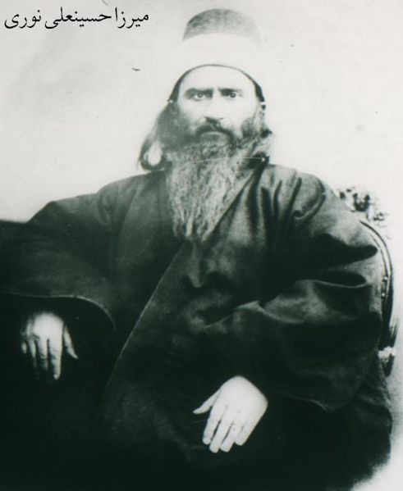
There are two known photographs of Bahá'u'lláh. This photo was taken while he was in Adrianople (reproduced in William Miller's book on the Bahá'í Faith). Copies of both pictures are at the Bahá'í World Centre, and one is on display in the International Archives building, where the Bahá'ís view it as part of an organized pilgrimage. Outside of this experience Bahá'ís prefer to not view this photo in public, or even to display it in their private homes,[3] and Bahá'í institutions have requested the press not to publish the image in the media.[4]
Bahá'u'lláh's image is not, itself, offensive to Bahá'ís. However, Bahá'ís are expected to treat the image of any Manifestation of God with extreme reverence. According to this practice, they avoid depictions of Jesus or Muhammad, and refrain from portraying any of them in plays and drama. For example, copies of the photographs are displayed on highly significant occasions, such as six conferences held in October 1967 commemorating the centenary of Bahá'u'lláh's writing of the Suriy-i-Mulúk (Tablet to the Kings), which Shoghi Effendi describes as "the most momentous Tablet revealed by Bahá'u'lláh" (God Passes By, pp. 171). After a meeting in Edirne (Adrianople), Turkey, the Hands of the Cause travelled to the conferences, 'each bearing the precious trust of a photograph of the Blessed Beauty, which it will be the privilege of those attending the Conferences to view.' (Marks, Geoffry W. (Ed.) (1986). Messages of The Universal House of Justice 1963 to 1986, p. 105.)
The official Bahá'í position on displaying the photograph of Bahá'u'lláh is:
"There is no objection that the believers look at the picture of Bahá'u'lláh, but they should do so with the utmost reverence, and should also not allow that it be exposed openly to the public, even in their private homes."
(From a letter written on behalf of Shoghi Effendi to an individual believer, December 6, 1939)
(Compilations, Lights of Guidance, p. 540)
While the above passage clarifies that it is considered disrespectful to display his photograph to the public, regarding postings on websites the Bahá'í World Centre has written:
"For Bahá'ís, the photograph of Bahá'u'lláh is very precious and it should not only be viewed but also handled with due reverence and respect, which is not the case here. Thus, it is indeed disturbing to Bahá'ís to have the image of Bahá'u'lláh treated in such a disrespectful way. However, as the creator of the site is not a Bahá'í, there is little, if anything, that can be done to address this matter. We hope these comments have been of assistance."
(Office for Public Information, 1999 Sept 04, Photo of Bahá'u'lláh on Web Site)

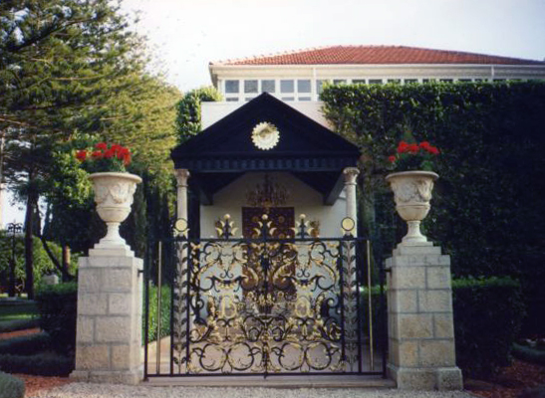
Shrine of Bahá'u'lláh

Bahá'u'lláh (ba-haa-ol-laa Arabic: بهاء الله‎ ​ "Glory of God") (1817 - 1892), born Mírzá Ḥusayn-`Alí (Persian: میرزا حسین علی‎ ​), was the founder and prophet of the Bahá'í Faith.
He claimed to fulfill the Bábí prophecy of "He whom God shall make manifest", but in a broader sense he also claimed to be the "supreme Manifestation of God".^{[1]}, referring to the fulfillment of the eschatological expectations of a prophetic cycle beginning with Adam, and including Abrahamic religions, as well as Zoroastrianism, the great Dharmic religions, and others. Bahá'ís see Bahá'u'lláh as the initiator of a new religion, as Jesus or Muhammad — but also the initiator of a new cycle, like that attributed to Adam.
Bahá'u'lláh authored many religious works, most notably the Kitáb-i-Aqdas and the Kitáb-i-Íqán. He died in Bahjí, Palestine, present-day Israel, and is buried there.
Note: A photograph of Bahá'u'lláh can be found at the end of this article.

Contents
- 1 Early life
  - 1.1 Background
  - 1.2 Marriage and family
- 2 Bábí movement
  - 2.1 Acceptance of the Báb
  - 2.2 Attempt on the life of the Shah
  - 2.3 Revelation in the Síyáh-Chál
- 3 Baghdad
  - 3.1 Banishment from Persia
  - 3.2 Kurdistan
  - 3.3 Return to Baghdad
  - 3.4 Declaration in the Garden of Ridvan
- 4 Imprisonment
  - 4.1 Constantinople (Istanbul)
  - 4.2 Adrianople (Edirne)
  - 4.3 Letters to the Leaders of the World
  - 4.4 `Akká
- 5 Final years
  - 5.1 Bahjí
  - 5.2 Succession
- 6 Works
- 7 See also
- 8 Notes
- 9 References
- 10 External links
- 11 Photograph

Early life

Background
Bahá'u'lláh was born on November 12, 1817, in Tehran, the capital city of Persia, in present-day Iran. His mother was Khadíjih Khánum and his father was Mírzá Buzurg of Núr (in the province of Mazandaran), a distinguished nobleman from the court of Fatḥ-`Alí Sháh, the king of Persia.
As a young child, Bahá'u'lláh was privately tutored and was known for his intelligence. He was a devout Muslim, and by the age of 13 or 14 he discussed intricate religious matters with leading ulema.
Bahá'u'lláh's father, Mírzá Buzurg served as vizier to Imám-Virdi Mírzá, the twelfth son of Fatḥ-`Alí Sháh of the Qajar tribe. Mírzá Buzurg was later appointed governor of Burujird and Lorestan,^{[2]} a position that he was stripped of during a government purge when Muhammad Shah came to power. After his father died, Bahá'u'lláh was asked to take a government post by the new vizier Haji Mirza Aqasi, but he declined the position.^{[3]}

Marriage and family
Main article: Bahá'u'lláh's family
Bahá'u'lláh had three concurrent wives by the names of Navváb, Fatimih and Gawhar. Bahá'u'lláh had fourteen children, only seven of whom lived to adulthood.
Bahá'u'lláh and his first wife Navváb were known as the Father of the Poor and the Mother of Consolation for their extraordinary generosity and regard for the impoverished. ^{[4]}

[] Bábí movement
Main article: Bábism
In 1844 a 25 year old man from Shiraz, Siyyid Mírzá `Alí-Muḥammad, who took the title of The Báb (Arabic; meaning "The Gate"), claimed to be the promised Mihdi of Islam.^{[5]} The movement quickly spread across the Persian Empire and received widespread opposition from the Islamic clergy. The Báb himself was executed in 1850 by firing squad at the age of 30 and the community was almost entirely exterminated in 1852-3.

[] Acceptance of the Báb
At the age of 28, Bahá'u'lláh received a messenger telling him of the Báb, whose message he accepted, becoming a Bábí. Bahá'u'lláh began to spread the new cause, especially in his native province of Núr, becoming recognized as one of its most influential believers. (Dawnbreakers)
The accompanying government suppression of the Báb's religion resulted in Bahá'u'lláh's being imprisoned twice and and enduring bastinado torture once.

[] Attempt on the life of the Shah
As the result of the Báb's execution in 1850 by a firing squad in Tabriz, an assassination attempt was instigated on the King of Persia, Nasser-al-Din Shah, two years later by a handful of angry Bábís. Although the assassins claimed they were working alone, the entire Bábí community was blamed, and a slaughter of several thousand Bábís followed. Many of the Bábís who were not killed, including Bahá'u'lláh, were imprisoned in the Síyáh-Chál (Black Pit), an underground dungeon of Tehran.^{[6]} Bahá'u'lláh himself was found to be innocent of complicity in the assassination plot,^{[3]} but remained in the Síyáh-Chál over four months.^{[7]}
An Austrian officer, Captain von Goumoens, working in the court of the Shah at the time, gave the following account after signing his resignation:
"[I saw] ones who, with gouged-out eyes, must eat, on the scene of the deed, their own amputated ears; or whose teeth are torn out with inhuman violence by the hand of the executioner; or whose bare skulls are simply crushed by blows from a hammer..."
"As for the end itself, they hang the scorched and perforated bodies by their hands and feet to a tree head downwards, and now every Persian may try his marksmanship to his heart’s content... When I read over again, what I have written, I am overcome by the thought that those who are with you in our dearly beloved Austria may doubt the full truth of the picture, and accuse me of exaggeration. Would to God that I had not lived to see it!... At present I never leave my house, in order not to meet with fresh scenes of horror... I will no longer maintain my connection with the scene of such crimes.”^{[8]}
See also: Persecution of Bahá'ís

[] Revelation in the Síyáh-Chál
According to Bahá'u'lláh, it was during his imprisonment in the Síyáh-Chál that he received a vision of a Maiden from God, through whom he received his mission as a Messenger of God and as the One whose coming the Báb had prophesied.^{[6]} After four months in the Síyáh-Chál, owing to the insistent demands of the Ambassador of Russia ^{[9]}, and after the person who tried to kill the Shah confessed and exonerated the Bábi leaders, the authorities released him from prison. Bahá'u'lláh refers to the assistance of the Russian ambassador when he wrote to the Czar Alexander II of Russia:
"Whilst I lay chained and fettered in the prison, one of thy ministers extended Me his aid. Wherefore hath God ordained for thee a station which the knowledge of none can comprehend except His knowledge."^{[10]}
The authorities then banished Bahá'u'lláh from Persia, and he chose to go to Baghdad, then a city in the Ottoman Empire.

[] Baghdad

[] Banishment from Persia
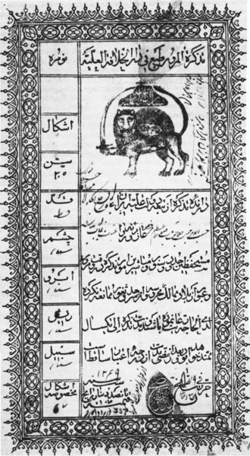
Bahá'u'lláh's passport, dated January 1853

, with limited supplies and food, and through the cold of winter, Bahá'u'lláh and his family travelled from Persia to Baghdad.
Mírzá Yaḥyá had been appointed by the Báb to lead the Bábí community, and had been travelling around Persia in disguise. He decided to go to Baghdad and join the group using funds given to him by Bahá'u'lláh.
An increasing number of Bábí's considered Baghdad the new center for leadership of the Bábí religion, and a flow of pilgrims started coming there from Persia. However, as time went on, people began to look to Mírzá Yaḥyá for leadership less and less, and instead saw Bahá'u'lláh as their leader.^{[11]}
Mírzá Yaḥyá, as the appointed leader of the Bábís, started to try to discr Bahá'u'lláh and further divided the community.^{[11]} The actions of Mírzá Yaḥyá drove many people away from the religion and allowed its enemies to continue their persecution.^{[3]}

[] Kurdistan
On April 10, 1854 Bahá'u'lláh, without telling anyone his purpose or destination, left with one companion to the mountains of Kurdistan, north-east of Baghdad, near the city Sulaymaniyah.^{[3]} He later wrote that he left so as to avoid becoming the source of disagreement within the Bábí community.
For two years Bahá'u'lláh lived alone in the mountains of Kurdistan.^{[6]} At one point someone noticed his remarkable penmanship, which brought the curiosity of the instructors of the local Sufi orders.^{[3]} As he began to take guests, he became noted for his learning and wisdom. Shaykh `Uthmán, Shaykh `Abdu'r-Rahmán, and Shaykh Ismá'íl, undisputed leaders of the Naqshbandíyyih, Qádiríyyih, and Khálidíyyih Orders respectively, began to seek his advice and admire him. It was to the second of these that the Four Valleys was written. Several other notable books were also written during this time.^{[6]}
In Bagdad, given the lack of firm and public leadership by Mirza Yahya, the Babi community had fallen into disarray.^{[3]} Some Babis, including Bahá'u'lláh's family, thus searched for Bahá'u'lláh, and when news of a wise man living in the mountains under the name of Darvish Muhammad spread to neighbouring areas, Bahá'u'lláh's family pleaded with him to come back to Baghdad, which he did.^{[3]}

[] Return to Baghdad
When Bahá'u'lláh returned to Baghdad he saw that the Bábí community had become disheartened and divided. In the time of Bahá'u'lláh's absence, the Baghdad community had become alienated with the religion since Mirza Yahya had proceeded to marry the widowed wife of the Báb against the clear instructions left by him ^{[3]} and dispatched followers to the province of Nur for the second attempt on the life of the Shah.^{[12]} A few Babis went so far as refuting Mirza Yahya's claims to successorship, advancing counter-claims, and disseminating their own writings.^{[13]}
Bahá'u'lláh remained in Baghdád for seven more years. During this time, while keeping his perceived station as the Manifestation of God hidden, he taught the Báb's teachings. He published many books and verses, which he called revelations, including the Book of Certitude and the Hidden Words.
Bahá'u'lláh's rising influence in the city, and the revival of the Persian Bábí community gained the attention of his enemies in Islamic clergy and the Persian government. ^{[14]} They were eventually successful in having the Ottoman government exile Bahá'u'lláh from Baghdad to Constantinople.^{[14]}

[] Declaration in the Garden of Ridvan
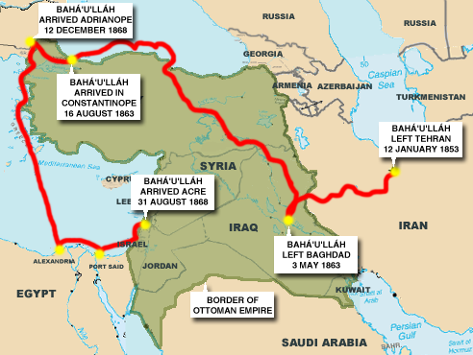
Map of Bahá'u'lláh's banishments

On April 22, 1863, Bahá'u'lláh left Baghdad and entered the Garden of Ridván near Baghdad. Bahá'u'lláh and those accompanying him would stay in the garden for twelve days before departing for Constantinople. It was during his time in the Garden of Ridván that Bahá'u'lláh declared to his companions his perceived mission and station as a Messenger of God.^{[6]} Today Bahá'ís celebrate the twelve days that Bahá'u'lláh was in the Garden of Ridván as the festival of Ridván.
The eleven years of messianic secrecy that passed between when Bahá'u'lláh claimed to have seen the Maiden of Heaven in the Síyáh-Chál and this declaration are referred to by Bahá'í chroniclers and by Bahá'u'lláh himself as ayyam-i butun ("Days of Concealment"). Bahá'u'lláh stated that this period was a "set time of concealment". It was during this period that Bahá'u'lláh wrote his primary eschatological work the Kitáb-i-Íqán.

[] Imprisonment

[] Constantinople (Istanbul)
As mentioned previously, Bahá'u'lláh was given an order to relocate to the Ottoman capital of Constantinople. Although not a formal prisoner yet, the forced exile from Baghdad was the beginning of a long process which would gradually move him into further exiles and eventually the penal colony of Akka.
Bahá'u'lláh and his family, along with a small group of Bábís, stayed in Constantinople for only four months. (One source ^{[15]} states there were seventy-five people all together.) During this time the Persian Ambassador in the court of the Sultan mounted a systematic campaign against Bahá'u'lláh. He was thus exiled to Adrianople, but before leaving he wrote a Tablet to the Sultan, the contents of which are unknown, but Shamsi Big, who delivered the letter, gave the following report:
“I know not what that letter contained, for no sooner had the Grand Vizir perused it than he turned the color of a corpse, and remarked: ‘It is as if the King of Kings were issuing his behest to his humblest vassal king and regulating his conduct.’”^{[16]}

[] Adrianople (Edirne)
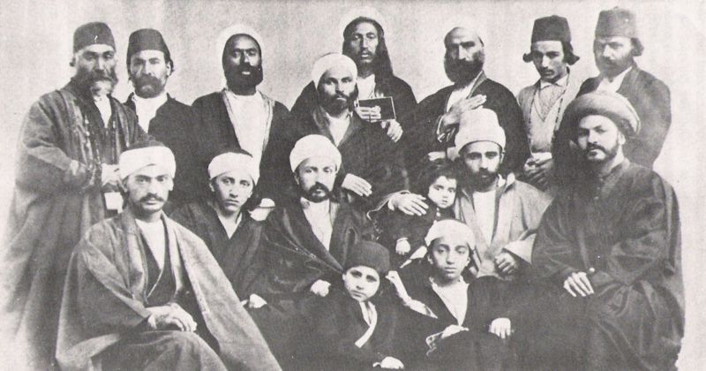
`Abdu'l-Bahá in Adrianople with his brothers and companions of Bahá'u'lláh

During the month of December, Bahá'u'lláh and his family embarked on a twelve-day journey to Adrianople. Bahá'u'lláh stayed in Adrianople for four and a half years. Mirza Yahya, upon hearing Bahá'u'lláh's words in a Tablet read to him, challenging him to accept Bahá'u'lláh's Revelation, offered a counter-claim that he was the one whom the Báb had prophesied about. This caused a break within the Bábí community, and the followers of Bahá'u'lláh became known as Bahá'ís, while the followers of Mirza Yahya, also known as Subh-i-Azal ("Morning of Eternity") became known as Azalís. See Bahá'í/Bábí split. While in Adrianople, Bahá'u'lláh was poisoned and nearly died. His hand was left shaking for the rest of his life. Bahá'í historical texts, and contemporary accounts, report that Subh-i-Azal was directly behind the poisoning. ^{[17]} ^{[18]} Later, followers of Azal made the counter-claim that Bahá'u'lláh had accidentally poisoned himself while trying to poison others. ^{[19]}

[] Letters to the Leaders of the World
Also, while in Adrianople, Bahá'u'lláh proclaimed the Bahá'í Faith further by addressing Tablets to the kings and rulers of the world asking them to accept his revelation, renounce their material possessions, work together to settle disputes, and endeavor towards the betterment of the world and its peoples. Some of these leaders include:
- Pope Pius IX
- Emperor Napoleon III of France
- Czar Alexander II of Russia
- King Wilhelm I of Prussia
- Queen Victoria of Great Britain and Ireland
- Emperor Franz Joseph of Austria-Hungary
- Sultan ‘Abdu’l-‘Azíz of the Ottoman Empire
- Násiri’d-Dín Sháh of the Persian Empire
- Rulers of America and the Presidents of the Republics therein

[] `Akká
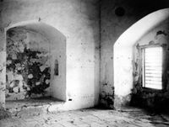
Prison Cell of Bahá'u'lláh, Akká

The disagreements between the Bahá'ís and the Azalís allowed the Ottoman and Persian authorities to exile Bahá'u'lláh once again. One morning, without any notice, soldiers surrounded Bahá'u'lláh's house and told everyone to get ready to depart to the prison-city of `Akká, Palestine. Bahá'u'lláh and his family left Adrianople on August 12, 1868 and after a journey by land and sea arrived in `Akká on August 31. The inhabitants of `Akká were told that the new prisoners were enemies of the state, of God and his religion, and that association with them was strictly forbidden.
The first years in `Akká imposed very harsh conditions on, and held very trying times for, Bahá'u'lláh. Mirzá Mihdí, Bahá'u'lláh's son, was suddenly killed at the age of twenty-two when he fell through a skylight while pacing back and forth in prayer and mation. After some time, the people and officials began to trust and respect Bahá'u'lláh, and thus the conditions of the imprisonment were eased and eventually, after Sultan `Abdu'l-`Aziz's death, he was allowed to leave the city and visit nearby places.

[] Final years

[] Bahjí
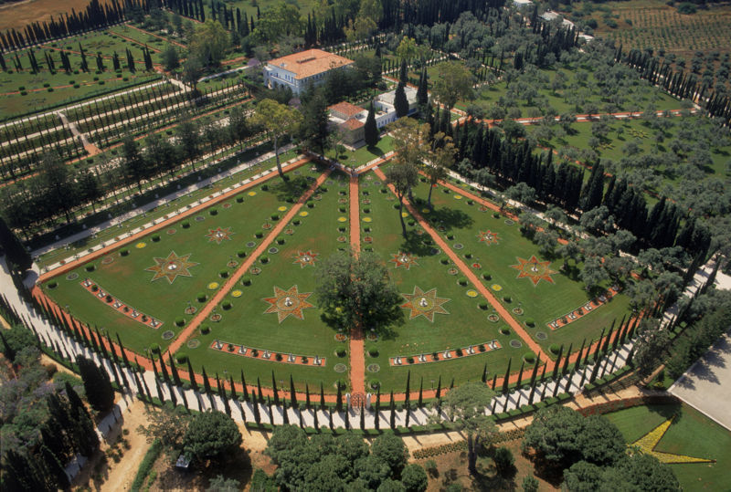
The shrine where Bahá'u'lláh is buried, from above.

The final years of Bahá'u'lláh's life were spent in the Mansion of Bahjí, just outside `Akká, even though he was still formally a prisoner of the Ottoman Empire. During his years in `Akká and Bahjí, Bahá'u'lláh produced many volumes of work including the Kitáb-i-Aqdas.
In 1890 the Cambridge orientalist Edward Granville Browne had an interview with Bahá'u'lláh in this house. After this meeting he wrote his famous pen-portrait of Bahá'u'lláh:
"In the corner where the divan met the wall sat a wondrous and venerable figure, crowned with a felt head-dress of the kind called táj by dervishes (but of unusual height and make), round the base of which was wound a small white turban. The face of him on whom I gazed I can never forget, though I cannot describe it. Those piercing eyes seemed to read one's very soul; power and authority sat on that ample brow; while the deep lines on the forehead and face implied an age which the jet-black hair and beard flowing down in indistinguishable luxuriance almost to the waist seemed to belie. No need to ask in whose presence I stood, as I bowed myself before one who is the object of a devotion and love which kings might envy and emperors sigh for in vain!"^{[20]}
On May 9, 1892 Bahá'u'lláh contracted a slight fever which grew steadily over the following days, abated, and then finally took his life on May 29, 1892. He was buried in a Shrine located next to the Mansion of Bahjí.

[] Succession
When Bahá'u'lláh died, he left a Will and Testament, which stated the following in regard to succession:
"The Will of the divine Testator is this: It is incumbent upon the Aghsan, the Afnan and My Kindred to turn, one and all, their faces towards the Most Mighty Branch... Verily God hath ordained the station of the Greater Branch [Muhammad ‘Alí] to be beneath that of the Most Great Branch [‘Abdu’l-Bahá]. He is in truth the Ordainer, the All-Wise. We have chosen ‘the Greater’ after ‘the Most Great’, as decreed by Him Who is the All-Knowing, the All-Informed."^{[21]}
The favor given to `Abdu'l-Bahá was a cause of jealousy within Bahá'u'lláh's family. Muhammad `Alí insisted that he should be the one to lead the Bahá'í community. This period is considered by Bahá'ís as one of the most difficult tests of the early years of the Faith.
Due to the conflict with his half brother, `Abdu'l-Bahá ex-communicated him as a Covenant-breaker. The division was not long lived. After being alienated by the Bahá'í community, Muhammad Ali died in 1937 with only a handful of followers.

[] Works
See also: List of writings of Bahá'u'lláh
Bahá'u'lláh wrote many books, tablets and prayers, of which only a fraction has been translated into English until now. He revealed thousands of tablets with a total volume more than 70 times the size of the Qur'an and more than 15 times the size of the Old and New Testaments of the Bible. ^{[22]},^{[23]},^{[24]} Below are some that have been translated to English:
- Epistle to the Son of the Wolf
- The Four Valleys
- Gems of Divine Mysteries
- Gleanings from the Writings of Bahá'u'lláh
- The Hidden Words
- The Kitáb-i-Aqdas
- The Kitáb-i-Íqán
- Prayers and Mations
- The Seven Valleys
- The Summons of the Lord of Hosts
- The Tabernacle of Unity
- Tablets of Bahá'u'lláh Revealed After the Kitáb-i-Aqdas
Jináb-i-Fádil-i-Mázindarání, analyzing Baha'u'llah's writings, states that he wrote in the following list of styles or categories:^{[25]}
- Interpretation of religious Scripture.
- Writings containing laws and ordinances.
- Mystical writings.
- Writings about government and world order, and letters to the kings and rulers of the world.
- Writings about knowledge, philosophy, medicine, alchemy etc.
- Writings calling for education, good character and virtues.
- Writings with social teachings.

[] See also
- The Báb
- Apostles of Bahá'u'lláh
- List of founders of major religions

[] Notes
- ^ Bahá'u'lláh (1976). Gleanings from the Writings of Bahá'u'lláh. Wilmette, Illinois, USA: Bahá'í Publishing Trust, pp. 151. ISBN 0-87743-187-6.
- ^ Balyuzi, Hasan (2000). Bahá'u'lláh, King of Glory, Paperback, Oxford, UK: George Ronald. ISBN 0853983283.
- ^ ª ^{b} ^{c} ^{d} ^{e} ^{f} ^{g} ^{h} Cole, Juan. A Brief Biography of Baha'u'llah. Retrieved on 2006-06-22.
- ^ *Blomfield, Lady (1956). The Chosen Highway. Bahá'í Publishing Trust, London. ISBN 0-87743-015-2.
- ^ There is some debate about what the Báb claimed and when. It wasn't until 1848 that his followers declared independence from Islam.
- ^ ª ^{b} ^{c} ^{d} ^{e} Hutter, Manfred. (2005). "Bahā'īs". Encyclopedia of Religion (2nd ed.) 2: p737-740. Ed. Ed. Lindsay Jones. Detroit: Macmillan Reference USA. ISBN 0028657330.
- ^ Bahá'u'lláh [1892] (1988). Epistle to the Son of the Wolf, Paperback, Wilmette, Illinois, USA: Bahá'í Publishing Trust, p. 20. ISBN 0877431825.
- ^ Quoted in Effendi, Shoghi (1944). God Passes By. Wilmette, Illinois, USA: Bahá'í Publishing Trust, p. 65. ISBN 0877430209.
- ^ [1]
- ^ Súriy-i-Haykal, Bahá'u'lláh (2002). The Summons of the Lord of Hosts. Haifa Israel: Bahá'í World Centre, p. 83. ISBN 0853989761.
- ^ ª ^{b} Ma'sumian, Bijan (1993 Fall). "Baha'u'llah's Seclusion in Kurdistan". Deepen Magazine 1: pp. 18-26.
- ^ Smith, Peter (1987). The Bábí & Bahá'í Religions: From Messianic Shí'ism to a World Religion. Cambridge: The University Press, pp. 60. ISBN 0521301289.
- ^ Taherzadeh, Adib (1976). The Revelation of Bahá'u'lláh, Volume 1: Baghdad 1853-63. Oxford, UK: George Ronald. ISBN 0853982708.
- ^ ª ^{b} "The Bahá'í Faith". Britannica Book of the Year. (1988). Chicago: Encyclopaedia Britannica. ISBN 0852294867.
- ^ [2]
- ^ Quoted in Effendi, Shoghi (1944). God Passes By. Wilmette, Illinois, USA: Bahá'í Publishing Trust, p. 160. ISBN 0877430209.
- ^ Mírzá Muhammad Jawád of Qazvín (1904). An epitome of Bábí and Bahá'í history to A.D. 1898.
- ^ Cole, Juan R.I.. Baha'u'llah's Surah of God: Text, Translation, Commentary. Retrieved on 2006-11-24.
- ^ Mirza Aqa Khan Kirmani made this claim later in his Hasht-Bihisht. This book is abstracted in part by E.G. Browne in "Note W" of his translation of A Traveller's Narrative, (Browne, E.G. (1891). A Traveller's Narrative, An epitome of Bábí and Bahá'í history to A.D. 1898, p. 359.). However, contemporary historians recognize that: "The Azali Babis and in particular Mirza Aqa Khan Kirmani and Shaykh Ahmad Ruhi showed little hesitation in alteration and falsification of Babi teachings and history in their works." (Manuchehri, Sepehr (September, 1999). "The Practice of Taqiyyah (Dissimulation) in the Babi and Bahai Religions". Research Notes in Shaykhi, Babi and Baha'i Studies Vol. 3 (no. 3). Retrieved on 2007-11-27.)
- ^ Introduction by E.G. Browne, p.XXXIX-XL. A Traveller's Narrative. Cambridge (1891). Retrieved on 2006-06-22.
- ^ Bahá'u'lláh [1873-92] (1994). Tablets of Bahá'u'lláh Revealed After the Kitáb-i-Aqdas. Wilmette, Illinois, USA: Bahá'í Publishing Trust, p. 221. ISBN 0877431744.
- ^ BWNS. A new volume of Bahá'í sacred writings, recently translated and comprising Bahá'u'lláh's call to world leaders, is published. Retrieved on 2006-11-24.
- ^ Archives Office at the Bahá'í World Centre, Haifa, Israel. Bahá'í Archives - Preserving and safeguarding the Sacred Texts. Retrieved on 2006-11-24.
- ^ Universal House of Justice. Numbers and Classifications of Sacred Writings texts. Retrieved on 2006-11-24.
- ^ Fádil-i-Mázindarání, Asadu'lláh (1967). Asráu'l-Áthár, Vol.I. Bahá'í Publishing Trust, Tehran, p.453.

[] References
- British Broadcasting Corporation (2002). BBC Religion and Ethics Special: Bahá'í. Retrieved January 15, 2005.
- `Abdu'l-Bahá, (Browne, E.G., Tr.) (1891). A Traveller's Narrative: Written to illustrate the episode of the Bab. Cambridge University Press.
- `Abdu'l-Bahá, (Browne, E.G., Tr.) (1886). A Traveller's Narrative: Written to illustrate the episode of the Bab, 2004 reprint, with translator's notes, Los Angeles, USA: Kalimát Press. ISBN 1890688371.
- Effendi, Shoghi (1944). God Passes By. Wilmette, Illinois, USA: Bahá'í Publishing Trust. ISBN 0877430209.
- Nabíl-i-Zarandí [1890] (1932). Shoghi Effendi (Translator): The Dawn-Breakers: Nabíl’s Narrative, Hardcover, Wilmette, Illinois, USA: Bahá'í Publishing Trust. ISBN 0900125225.
- "The Kitab-i Iqan:An Introduction to Bahá'u'lláh's Book of Certitude with Two Digital Reprints of Early Lithographs" by Christopher Buck in Occasional Papers in Shaykhi, Bábi and Bahá'í Studies, Vol. 2, No. 5 (June, 1998) Available online here.
- Balyuzi, Hasan (2000). Bahá'u'lláh, King of Glory, Paperback, Oxford, UK: George Ronald. ISBN 0853983283.
- Blomfield, Lady (1956). The Chosen Highway. Bahá'í Publishing Trust, London. ISBN 0-87743-015-2.
- Taherzadeh, Adib (1976). The Revelation of Bahá'u'lláh, Volume 1: Baghdad 1853-63. Oxford, UK: George Ronald. ISBN 0853982708.
- Taherzadeh, Adib (1977). The Revelation of Bahá'u'lláh, Volume 2: Adrianople 1863-68. Oxford, UK: George Ronald. ISBN 0853980713.
- Taherzadeh, Adib (1984). The Revelation of Bahá'u'lláh, Volume 3: `Akka, The Early Years 1868-77. Oxford, UK: George Ronald. ISBN 0853981442.
- Taherzadeh, Adib (1987). The Revelation of Bahá'u'lláh, Volume 4: Mazra'ih & Bahji 1877-92. Oxford, UK: George Ronald. ISBN 0853982708.

[] External links
- Bahá'u'lláh: Manifestation of God, biography from bahai.org
- A Brief Biography of Baha'u'llah, from University of Michigan Department of History.
- Materials for the Study of the Babi Religion, by E. G. Browne
- The Works of Bahá'u'lláh, Writings of Bahá'u'lláh in English, Persian and Arabic
- Works by Bahá'u'lláh at Project Gutenberg
- Bahá'u'lláh's official Iranian passport dated January 12, 1853 -- See the English translation here
- Baha'u'llah A web site on the life and teachings of Bahá'u'lláh. Includes a history and selected Writings.

