
The Silent Language Exhibition, The symbols of Hermetic Philosophy
http://www.xs4all.nl/~bph/silent.html
Foreword by J. R. Ritman
Preface by F.A. Janssen
Introduction by Adam McLean
Bibliography
The 58 items in the exhibition

Foreword
by J. R. Ritman

‘Panta rei’. All life is movement and the symbol is her witness
The exhibition ‘The silent language. The symbols of Hermetic Philosophy’, which has been put together from the rich sources of the Bibliotheca Philosophica Hermetica, is, as far as I know, the first exhibition which demonstrates an integral relationship in the language of symbols used in hermetic philosophy, in mysticism, in alchemy and in the Rosicrucian movement.
These four main areas into which hermetic-Christian philosophy has been gathered within the Bibliotheca Philosophica Hermetica have, each in their separate way, produced a Silent Language, a Lingua Muta, which, in the form of the symbol, the hieroglyph, or other character, reflects a universal world of concepts, alive and directly accessible to all mankind, and as ancient as the road of humanity itself.
In his incomparable study Rivers of life, J.G.R. Forlong uncovers the history of the growth of the great spiritual movements of mankind, which go back over 10,000 years before our Christian era. The primal aspects of the major spiritual movements are represented by him in five symbols.
First of all there is the symbol of the sun as the wheel of life, explaining the sun mysteries of Mithra. Secondly, there is the symbol of fire, the so-called Aesch Majim, the fire-water principle in which the primal wisdom, as it is also visible in the Jewish Kabbala, finds its origin. Thirdly, there is the symbol of the tree, also called the tree of life and the tree of the knowledge of good and evil, in which both the life-creating principle, as well as the polarity of life manifesting itself within it, are brought to life, an image which in many successive spiritual movements has been each time explained anew. Fourthly, there is the symbol of the phallus, as the bearer of the life-giving principle itself, the seminal principle, which lies at the basis of the procreation, continuation, multiplication and fertility of life, and expresses itself in the human, animal, vegetable and mineral world. Finally, the symbol of the snake appears, a reference on the one hand to the paradisical myth, the Fall of Man, but in its most sublimated form the symbol of wisdom, the fullness of the pleroma, the reality of the gnosis, the knowledge of God, which has come about through Him, in Him and by Him, the All-One.
The force of the symbol lies in her practical allusion to the ancient principle ‘panta rei’: all life is movement. As the bird is an emblem of the sky, the fish an emblem of the water and the four-footed animal an emblem of earth, the living nature, so man has been placed by his creator, the cosmo-creator, as a microcosm in the centre of His creation, this being the symbol of an originally conceived place for the micro-creator - the little creator - to live and to exist in the world of the perennial continuation of life.
In the approximately sixty works in which the symbols of the hermetic philosophy are presented in this exhibition the focal role is revealed of the hermetic philosopher, the candidate in the mysteries, in his encounter with the fullness of the mystery, which is enacted as in a process. The candidate is placed before the age-old hermetic axiom: "Visita Interiora Terrae Rectificando Invenies Occultum Lapidem": Visit the Innermost of the Earth and by Rectifying you will find the Hidden Stone.
This hidden stone, referred to in the above axiom, in which the Latin initial letters acrostically form the word ‘vitriol’, is a symbolical allusion to obtaining the tincture of life, which has been held out to the candidate in the mysteries as a promise, so that, like a crown on his path of initiation, he may receive and apply it as a spiritual force, as the Philosophers’ Stone.
The old alchemists speak of the four elements of earth, water, air and fire, of the three principles salt, sulphur and mercury, of the two aspects of life, the male and female, and finally of the one principle, the tincture. Pythagoras already expressed this thousands of years ago in the symbol of the triangle in which this principle is at the same time a reflection of the ten prime numbers one to ten.
•
• •
• • •
• • • •
If we really wish to enter the world of symbols, we must also accept that each symbol has three aspects. There is the visible symbol, in itself a living, active force. Then there is the meaning of the symbol, the symbol’s allusion to a process of transfiguration, a process of transformation of inherently inspired life. Lastly, the symbol teaches us to understand the spiritual principle which motivates all forms of life. It is the spiritual world, the spiritual creative force itself, the All-One, through whom, by whom and for whom everything has come about.
That is why we have to view the world of symbols in the first place in her concrete and actual meaning, secondly as part of a process of inner gestation and growth, in order finally to break through to the origin itself, the pneuma out of which all life comes forth.
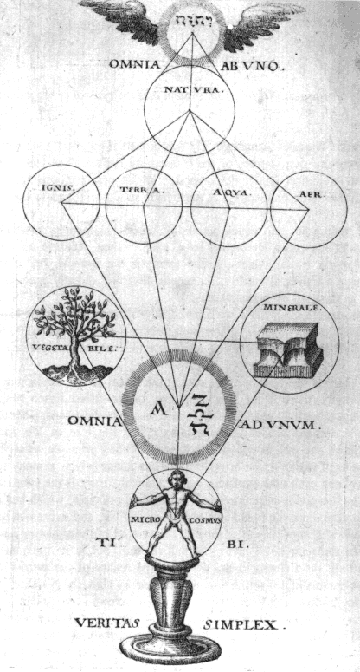
If we take a closer look at the catalogue which has been prepared for this exhibition, and also when we are able to study the symbols themselves when visiting the exhibition, we can experience how tremendously important the great influence of the symbol and the language of imagery is for the works collected in the Bibliotheca Philosophica Hermetica. It is a direct confrontation with the meaning of the symbol and also with the autonomous place which it occupies side by side with the written word. By means of a selection of works from the collections of the Bibliotheca Philosophica Hermetica, a period of three hundred years has been covered in which the symbol acts as the spritual carrier of the text.
From the opening work in the catalogue, Heinrich Suso’s work Das Buch genannt Seuse, printed in 1482, in which we see an image of Christ crucified on the tree of life with its blossoming roses, referring to the many works of Christ, through to the apotheosis of this exhibition, the Geheime Figuren der Rosenkreuzer, printed in Altona in 1785-88, containing an image of the tree of the knowledge of good and evil, we can find numerous expressions of the hermetic-Christian tradition.
It is the testimony of the living stream of knowledge and wisdom which came to the interpreters of this symbolic language as an exalted inspiration. It is at the same time the key to the Bibliotheca Philosophica Hermetica and her basic principle, ‘Ad fontes’, to the source.
We are standing in the middle of a historical development in which the meaning and the function of the symbol once again make themselves known to the communal consciousness, and in which man, as seeker, as candidate in the mysteries, must come to the Knowledge of the Heart, indeed, to Gnosis itself.
That is why the act of seeing and understanding the symbol is sometimes also explained as looking with the eyes of the heart. If we can come to the insight that an intellectual and rational approach to life can also turn us into the prisoners of our sensory perceptions, the moment has arrived for us to aspire, with the powers of the living, witnessing soul, to the meeting with the spiritual force of the divine creator, the source, the origin of life itself. This is the wish and the task which, like a key formula, informs this exhibition.
J.R. Ritman
Founder Bibliotheca Philosophica Hermetica

Preface
by F.A. Janssen

Symbols, authors, publishers and engravers
The occasion for the summer exhibition in the Bibliotheca Philosophica Hermetica, of which this is the accompanying catalogue, is formed by two summer courses which the Amsterdam Summer University is offering in August 1994. At the request of the organisers of these courses, the Bibliotheca Philosophica Hermetica will receive the participants of the course "Gnosis and Hermeticism from Antiquity to Modern Times" and the course "Symbolism in Art: in search of a definition" in the library, where a special exhibition has been mounted showing hermetic and spiritual books from the perspective of the visual symbols contained in them.
The cover of this catalogue features the title engraving of one of the works on display, the Tableau des riches inventions, which is the French translation of the famous Hypnerotomachia Poliphili, which appeared in Paris in 1600. These symbols all refer to the spiritual processes of alchemy and thus point to one of the sources of inspiration of this major work, which was first printed in 1499. Here it may be noted that the BPH’s copy of this first edition once belonged to the sixteenth-century French alchemist Oronce Finé. However, this work, written by Francesco Colonna, must also be seen within the context of the symbolical meanings with which the Egyptian hieroglyphs were at that time invested. This hermetic world picture finds its origin in the Renaissance with the discovery, at the beginning of the fifteenth century, of Horapollo’s Hieroglyphica, printed for the first time in 1505, but circulating in manuscript copies prior to that time.
The sub-title of this exhibition, "The symbols of Hermetic Philosophy" is an allusion to the Secret symbols of the Rosicrucians (Geheime Figuren der Rosenkreuzer), a compilation printed in the years 1785-1788, in which German Freemasons provided a summary of the symbolical language of images used by hermeticists, mystics, alchemists and Rosicrucians in the past centuries. The collections of the BPH, divided in these very four areas, can form a basis for tracing the symbolic forms in this book to their sources, whether manuscript or printed - an interesting task for the compiler of a future exhibition.
This exhibition brings together illustrated works by hermeticists and kabbalists such as Lull, Paracelsus, Bruno and Fludd, of mystics such as Suso, Weigel and Boehme, of alchemists such as Bonus, Khunrath and Stolcius, of Rosicrucians such as Maier and Mögling. The symbols which the representatives of these four collection areas of the BPH employ - and their internal connections - form a world of their own, which cannot be approached merely on the strength of our twentieth-century notions. It will not do to employ a modern interpretative apparatus for the symbols of past times, to force the past into the confines of modern terminology. Rather, one should let the symbolic language of the past speak out, one must learn to look with the eyes of the contemporary reader. One must draw away the cloak which time has laid over the symbols, one must, as a modern appraiser of past symbols, in the words of Samuel Johnson, carry not the sceptre but the torch: one must not judge, but illuminate. This is the objective of this exhibition.
The metaphor of the light pervades hermetic symbolism. A very special use of this light metaphor can be found in the frontisipiece of one of the most interesting of alchemical treatises, Siebmacher’s Wasserstein der Weisen: God’s torch kindles the fire in the human heart. Here the connection between Christianity and alchemy is made and the Philosophers’ Stone becomes symbolic for Christ.
Printed symbols are executed in woodcut initially, later also, and even later mainly, in copper engravings. The identity of the designers of these illustrations, the printers, publishers and engravers is a long-standing question. I should here like to confine myself to two groups of publications: those around 1620, concerning works of Maier, Fludd and others, and those later in the seventeenth century concerning illustrations to the works of Boehme.
Between 1615 and 1625 a flood of hermetic, alchemist and Rosicrucian works appeared in the cities of Oppenheim and Frankfurt, generally lavishly illustrated with copper engravings. The majority of these works was published by Lucas Jennis and Johann Theodor de Bry; the engravings are mostly by Mattheus Merian. These three names dominated the production and distribution of hermetic literature in the early seventeenth century. Jennis was active as publisher between 1616 and 1631; he employed others to print his works; it is assumed that in most cases Merian was the engraver of the illustrations. De Bry, too, was active exclusively as a publisher until his death in 1623, and had his works often printed by the same printers Jennis employed, and he, too, favoured Merian as engraver. Both publishing houses developed family ties in 1607 when Jennis’s mother re-married Johann Theodor de Bry’s brother. Merian became related to Johann Theodor de Bry by marriage in 1618 when he married the latter’s daughter; after de Bry’s death it was Merian who actually ran the firm. These three book producers were behind the splendid productions of works of hermeticists, alchemists and Rosicrucians such as Maier, Mylius, Stolcius and Fludd.
In the second group of works, mainly published in Amsterdam between ca 1660 and 1682, we also find book producers with a more than usual intrinsic interest in and knowledge of the texts they publish. Henricus Betkius produced illustrated editions of works of Jacob Boehme from 1658. These engravings influenced the illustrations in the famous first edition of the collected works of Boehme, which appeared in 1682 under the editiorial and financial guidance of Johann Georg Gichtel. The illustrations from the English collected works, edited by William Law and printed in London between 1764 and 1781, have been inspired in places by the Amsterdam edition of 1682.
If we look at the copper engravings in the works belonging to both categories here discussed, we see first of all a number of symbols for which the makers followed a certain tradition, enabling them to hark back to concrete examples, either printed or drawn. This is for instance the case with the engravings used in Stolcius’s Lustgärtlein, for which Merian relied amongst others on the symbols in the classical Rosarium philosophorum. These engravings prove that the symbolic language used was part of a broad tradition in iconography; the makers (author, publisher or editor) could supply the engraver with concrete models.
The case is altogether different when new elements are added to this symbolic language or when entirely new symbols are presented. These engravings do not fall back on any tradition; they do not belong to the iconographical code of the moment, they have been newly invented (although later, through imitation, they become part of that same code). A case in point are the engravings to Maier’s Atalanta fugiens and the illustrations in the works of Fludd, in which Merian (assuming that he was indeed the engraver) opened up a completely new world of symbols. The same also holds for the engravings which were executed especially for the works of Boehme, both those published by Betkius as well as those edited by Gichtel and Law. Here, however, we are confronted with the question who was responsible for these rich inventions, who actually conceived them. The author supplies the publisher with a text which must be set up for print and then put through the press, but it is open to question who supplied the ideas for the illustrations. These representations, so charged with symbolism, cannot possibly have been the work of an outsider, or simply derived from the contents of the work: these are not mere esthetic additions, or simple embellishments, but an essential dimension added to the message. It would seem obvious to assume that authors such as Maier, Fludd or Gichtel acquainted their publishers with their ideas concerning the illustrations, who in turn would have instructed the engravers. (There are later examples of such instructions by an author to his publisher.) In some of the cases mentioned above it is not unthinkable that either publisher or engraver was so familiar with the matter in hand, that the inventions may well be attributed to them. This could have been the case for Mattheus Merian, who, as is evidenced by his correspondence, was a follower of the spiritualists Schwenckfeld and Weigel. In the case of the Boehme illustrations it is impossible to positively identify any engravers; for the attribution of the engravings in the 1682 edition to Jan Luyken there is no conclusive proof. However, we do know that both Betkius and Gichtel (the latter himself the focus of a Boehmist circle) felt an affinity with the works of the great German theosopher to such a degree that they would certainly have been able to provide their engravers with directions for the language of symbols. With relation to the English edition of the collected works from 1764-1781 the case is clearer: it was Dionysius Andreas Freher who conceived the illustrations and had them executed by his friend and engraver J.D. Leuchter.
The founder of the Bibliotheca Philosophica Hermetica, Mr J.R. Ritman, and myself owe thanks to Adam McLean, associate researcher of the library, who selected the books for this exhibition (all of which come from the library’s own collections) and wrote the catalogue. He is also the editor of a number of English-language text editions, including Colonna’s The dream of Poliphilus, Trismosinus’s Splendor solis and Andreae’s The chemical wedding of Christian Rosencreutz.
F.A. Janssen
Director Bibliotheca Philosophica Hermetica

Introduction
by Adam McLean

Introduction
In preparing this exhibition we have attempted to explore the wealth of symbolic material in hermetic books and manuscripts by placing key items from the collection of the Bibliotheca Philosophica Hermetica in a historical perspective.
The hermetic philosophy which inspired the works gathered into the Bibliotheca Philosophica Hermetica has deep roots and although it is difficult to identify its origins precisely, during the late Italian Renaissance it blossomed through the translations of important hermetic and neoplatonic writings made by Marsilio Ficino (1433-99), under the patronage of Cosimo de Medici.
The hermetic philosophy was both existential and initiatory. It contained a picture of the place of the individual within the cosmic scheme and gave indications of how individuals could develop themselves within a spiritual view of the world. Because it satisfied such inner existential needs, this hermetic philosophy has been pursued in Europe for more than five hundred years, and although it has evolved, and absorbed various influences from parallel traditions, its core ideas remain essentially unchanged.
Hermeticism influenced alchemy (which was emerging in Europe during the twelfth to fourteenth centuries), driving it towards a spiritual and metaphysical perspective. The alchemical tradition began to gather to itself philosophers who sought to grasp the spiritual foundation of the world through working with matter (both practically and theoretically). In the early decades of the seventeenth century a group of hermetic students created a new synthesis of hermetic and alchemical ideas which has become known as Rosicrucianism. This Rosicrucian movement had from its inception a political and social dimension, and it gave birth to a chain-reaction explosion of interest in this spiritual philosophy, as is evidenced by the mass of publications that followed the initial announcement of the programme of the Rosicrucians in the Fama Fraternitatis published in 1614.
Simultaneous with the unfolding of Rosicrucianism, the stream of hermetic philosophy nourished a new vitalisation of mysticism, primarily through the works of Jacob Boehme, the ‘Teutonic Theosopher’. Boehme, being self-taught, was able to stand outside the theological speculations of his time, and by exploring his own inner mystical insights by means of hermetic ideas was able to construct an internally consistent new mysticism which fused hermeticism, alchemy and Christianity into a coherent and beautifully structured spiritual philosophy. Although only one of his works was published in his lifetime, Boehme’s mysticism was actively pursued by many individuals and small groups over the next two centuries. His restructuring of Western Protestant mysticism is indeed still relevant today and the philosophical foundations of his mystical ideas on the nature of the world and its creation sit very easily with modern scientific speculations concerning the origins of the cosmos.
These various elements - hermeticism, alchemy, Rosicrucianism and mysticism - are the four pillars upon which the collections of the Bibliotheca Philosophica Hermetica have been founded.
Hermetic philosophy in all its manifestations has used symbolism as a means of conveying philosophical ideas. This symbolism is perhaps quite restricted, using a small core group of images in a particular way, but it has given a coherence to the use of symbolism in hermeticism. As hermetic symbolism has deep philosophical roots, it was not easily moulded by fashions and changes in artistic styles. Although one can see some evolution in its use of symbolism, it never departs radically from an essential core of meaning, and consequently hermeticists of different centuries often used the same symbols consistently. It is therefore possible to see the symbolism of the hermetic tradition as an integrated whole, rather than being fragmented by the social and cultural currents of its time, as is the case with the general use of symbolism in Western visual art. Hermetic symbolism in a strange way seems to stand outside time, and it is possible to grasp it as a whole. Even although two hermetic diagrams may have been created three centuries or more apart, their symbolism coheres and can be read consistently.
Symbolism occurs in various ways in the hermetic tradition. The very language of hermetic texts is allegorical and symbolic, using metaphor to parallel outer events with inner spiritual content. Alchemical writings, in particular, use the device of allegories, in which the reader is led on a journey through a symbolic landscape, reflecting some metaphysical transformation process. There are many of these alchemical allegories, of which perhaps the best known, and the most elaborate, is the Chymische Hochzeit (the chemical wedding of Christian Rosenkreutz), which was published in 1616.
This exhibition, of course, focusses on visual symbolism, but it is important to bear in mind the existence of this allegorical tradition, as much of the visual material emerges out of these allegories, and can only be truly understood once one realises the source text for a particular cycle of symbolism. As the initiatory processes used in hermetic philosophy are often convoluted and elaborately detailed, it proved difficult for the devisors of illustrations to such texts to compress all the symbolism into one single figure, and so many works are illustrated with sequences of emblematic figures. This phenonenon was not something that evolved later in the tradition, as we find it among the earliest manuscripts. For example, emblematical sequences are found in the early fifteenth-century Buch der heiligen Dreifaltigkeit, the Aurora consurgens, the late fifteenth-century Ripley scrowle, and the early sixteenth-century Splendor solis.
Some of these manuscripts were roughly executed by authors or copyists who seem to lack artistic abilities, but there are also some manuscripts with exquisite and beautifully painted illustrations, which have not been sufficiently recognised as substantial works of art in themselves. The Splendor solis group of manuscripts in Berlin, Nuremberg, and London can hold their place besides many medieval books of hours, and even some of the later eighteenth-century manuscripts, such as those of the hieroglyphical figures of Nicolas Flamel, are very fine works of art. Their hermetic content, the anonymity of the authors and artists, together with the fact that they rarely entered the public arena, meant that they have been somewhat neglected by scholars, and failed in general to make any great impact upon art history.
Many of the symbolic sequences antedate printing, but during the sixteenth century, as the printed book became the major vehicle for disseminating hermetic ideas, the emblematic sequences in manuscripts were used as the basis for woodcut figures, and later in that century, the development of copperplate engraving provided a new medium for hermetic artists. The peak of the evolution of copperplate engraving coincided, in the early decades of the seventeenth century, with the explosion of hermetic publishing which paralleled the revelation of Rosicrucianism. A close-knit group of printers, the de Bry family, William Fitzer and Lucas Jennis of Frankfurt, issued a number of important works lavishly illustrated with engravings. Robert Fludd’s works, published by de Bry and his son-in-law Fitzer, contained more than 500 engravings, many by Johann Theodor de Bry. The firm of Lucas Jennis issued about 40 hermetic books between 1616 and 1630, about half of which featured very fine engravings, many undertaken by Mattheus Merian, perhaps the greatest of hermetic artists. (Examples of Merian’s work can be seen in items 18 and 25).
As for manuscripts containing symbolism, we can note two main groups - the original and unique material either produced by an individual writer or a secondary copy (examples already noted being the Buch der heiligen Dreifaltigkeit, Aurora consurgens, Splendor solis) - and copies made of printed books often enhanced with coloured-in illustrations. During the eighteenth century there was a rebirth of interest in hermetic ideas, especially in France, resulting in the production of many fine manuscript copies of earlier works, often beautifully illustrated (examples being the Figures hiéroglyphiques of Nicolas Flamel (item 57), the ‘Crowning of Nature’ series of 67 coloured figures (item 56) and the Rosarium Philosophorum (item 7).
A parallel rebirth of interest in hermetic material, which produced many beautiful manuscript copies and translations of hermetic works, occurred in Russia during the eighteenth and nineteenth centuries. During 1993 the Bibliotheca Philosophica Hermetica organised an exhibition in Russia entitled 500 years of Gnosis in Europe, which brought some of these manuscripts to public view for the first time. The librarian of the Bibliotheca Philosophica Hermetica, Dr Carlos Gilly, who uncovered these important hermetic manuscripts, describes them in some detail in the accompanying exhibition catalogue.
In this exhibition we have attempted to point out some of the more important influences upon the evolution of the use of symbolism in hermetic literature. Hermetic authors often referred to the Tabula Smaragdina, the ‘Emerald Table of Hermes Trismegistus’. This short poem expressed the key ideas of hermetic philosophy in an allegorical and symbolic form. It was most likely written during the second or third centuries A.D., but it gathered to itself a myth which makes it stand outside time. According to this legend, Hermes Trismegistus wrote the verses on a table of emerald, and secreted this in a cave, where it was discovered millenia later to inspire humanity to pursue its spiritual philosophy. This myth is thus an allegorical statement of the transmission of the ‘gnosis’, the ‘prisca theologia’ or ancient wisdom, down the centuries through the medium of hermetic philosophy. Indeed, the rediscovery and translation of the hermetic writings during the Renaissance directly nourished this spiritual current. It may be instructive to quote the text of the ‘Emerald Table’ in full:
It is true without lies, certain and most true;
That which is below is as that which is above, and that which is above is as that which is below, to accomplish the miracle of the one thing.
As all things came from One, through the contemplation of the One, so all things arise from this one thing by adaptation.
Its father is the sun, its mother the moon; the wind carries it in its belly, its nurse is the earth.
It is the father of all perfection throughout the whole world.
Its power is perfect if it is turned into earth.
Thou shalt separate the Earth from the Fire, the subtle from the gross, gently and with great sagacity.
It ascends from Earth to Heaven, then again descends to Earth, and unites the powers of things above with things below.
Thus thou shalt possess the glory of the whole world, and all obscurity shall flee from thee.
This is the power of all power, for it overcomes every subtle thing and penetrates every solid substance.
Thus was the world created.
Hence proceed wonderful adaptations, of which the means are here established.
Therefore I am called Hermes Trismegistus, having the three parts of the philosophy of the whole world.
That which I had to say regarding the operation of the sun is completed.
This text was available through the Arabs to medieval scholars, and its symbolic statement of the relationship between macrocosm and microcosm, the birth of the three-fold stone of wisdom from the four elements, proved an abiding image and inspiration for later authors and students of hermetic ideas to work creatively with symbolism.
Among the early influences upon hermetic ideas were the writings of Ramon Lull or Raymundus Lullius, (1232?-1315). His memory system, where key philosophical ideas were associated with a symbol placed upon a given structure (a tree, ladder or circular diagram for example) influenced the development of hermetic symbolism. These memory systems continued to unfold further and some three centuries later hermeticists such as Giordano Bruno (1548-1600) and Robert Fludd (1574-1637) were still evolving and reworking these ideas (items 12 and 20).
During the early sixteenth century, the emergence of emblem books influenced hermetic writings. The Hypnerotomachia of 1499, considered among the most beautiful of early printed books, demonstrated how powerful the integration of text and image could become. Although the emblem books which arose shortly after, with their epigrams, images and verse, usually expounded philosophical, moral or religious ideas, the format itself was quickly taken up by hermetic writers. Thus early on we see the Rosarium philosophorum (1550) with its sequence of 20 woodcuts, echoing the emblem books, and later with the ‘Book of Lambspring’ (item 25), or the ‘Twelve Keys of Basil Valentine’ (item 23), we clearly see the influence of emblem literature. Indeed, one of the most important of emblem books, Michael Maier’s Atalanta fugiens of 1617, is also a key work of the hermetic tradition (item 17).
In the medieval and Renaissance period hermetic philosophy was, of course, transmitted through the copying of manuscripts. During the early period of printing, hermetic literature still remained obscure and little was put into printed form. Although there are few early printed books reflecting hermetic symbolism, from about 1550 onwards a substantial number of hermetic works using symbolism were published, including the Rosarium philosophorum, Reusner’s Pandora (item 11), and the writings of Salomon Trismosin. At this time a number of works were printed which purported to have been written centuries earlier. The writings of Basil Valentine for example were ascribed to a fifteenth-century monk, though it seems most likely that they were written shortly before their initial publication in the 1590’s. Separating truth from myth-making in hermetic literature is often extremely difficult, as there were many purposive obfuscations as well as genuine errors in ascribing authorship.
The body of hermetic literature printed during the later sixteenth century provided a foundation for a new synthesis of the available material during the early decades of the seventeenth century. The reworking of hermetic ideas is associated outwardly with the Rosicrucian period, the second and third decades of the seventeenth century. During this period many works were published, often lavishly illustrated, attempting to synthesise hermetic philosophy with the newly emerging intellectual curiosity and methodology, which we now recognise as the beginnings of the modern scientific world view. Physics and metaphysics, astronomy and astrology, chemistry and alchemy, philosophy and religion, experimental methods and traditional knowledge, were held in a tense equilibrium, and the dynamics of this inner tension gave rise to an explosion of hermetic publishing. Robert Fludd, for example, was in a sense a traditionalist holding to the vision of the Earth-centred Ptolemaic cosmos, although, he was at the same time a radical physician, and one of the first to accept William Harvey’s theory of the circulation of the blood.
In this exhibition we show a number of examples of works from this period, such as those of the Rosicrucian apologists Robert Fludd and Michael Maier, Theophilus Schweighardt, Stephan Michelspacher and J. D. Mylius. During this period a number of collections of hermetic works were published, such as the Theatrum chemicum, 1602, the Musaeum hermeticum of 1625, and Grasshoff’s Dyas chemica tripartita, 1625 (item 23), showing the growing interest in these ideas among a wider readership.
The momentum of this rebirth of hermetic philosophy was somewhat dissipated during the descent of European culture into the chaos of the Thirty Years’ war, when there is a sharp drop in the publication of hermetic writings, but around the middle of the seventeenth century a new cycle of hermetic publishing began. In Britain, Elias Ashmole produced his compendium of early English alchemical poetry, the Theatrum Chemicum Britannicum, mostly drawing on writers from the fifteenth and sixteenth centuries, and the issuing in English of the important works of Thomas Vaughan and Eiraeneus Philalethes introduced a short span of increased publication of English hermetic books. Hermetic material in German and French also grew during this time and publications in Latin began to wane. The last half of the seventeenth century is characterised by the reworking of older material into new forms, and particularly by translations of important works from the Latin.
The mysticism of Jakob Boehme made a profound impact upon the hermetic symbolic tradition from the seventeenth century onwards, for the key ideas of Boehme’s mysticism, even when he dealt with deep abstractions, were expressed in a language full of imagery. This led to his followers picturing his ideas in symbols, and many Boehmist works were illustrated with diagrams which fuse an abstract geometry with powerful emotional symbols, such as the heart. Examples of this can be found in the works of Abraham von Franckenberg (item 35), Paul Kaim (item 39), D.A. Freher (item 46) and the Gichtel edition of Boehme’s works (item 40). Although these mystical diagrams borrowed from earlier hermetic symbolism, they had an integrity and coherent style of their own. The momentum of Boehmist publications continued well into the eighteenth century, and the so-called ‘William Law edition’ of the writings of Boehme contained a number of symbolic engravings based on drawings by D.A. Freher, an important commentator on Boehme, who above all others developed the method of expounding Boehme’s ideas through elaborate series of diagrams.
The eighteenth century saw a revival of hermeticism in both France and Germany. This was in part due to the development and popularisation of Freemasonry in these countries. Freemasonry, which had its birth in the early seventeenth century, used symbolism in its rituals, and though the earliest Freemasons kept to a simplicity of symbolic forms and degrees of initiation, in the eighteenth century this tradition expanded rapidly through the development of a multiplicity of degrees and orders. Many of these Masonic Orders were eclectic, drawing on many different traditions, and fused hermetic ideas with Christianity, classical mythology, architectural imagery, Judaism, Egyptology, mysticism and kabbalah. Some of these Masonic Orders even claimed to be descendants of the true Rosicrucians.
At this time Freemasonry permeated all levels of society and a large readership interested in hermetic philosophy developed. So the eighteenth century saw the republication of many important hermetic works, often in French or German translations. Compilations of hermetic texts were issued, including the Deutsches theatrum chemicum (1728-1732), Bibliothèque des philosophes chimiques (1740) and the Hermetisches A.B.C. (1778-1779). During this fertile period for hermetic philosophy, some important works emerged. Foremost amongst these is the Opus mago-cabalisticum of Georg von Welling (item 47), which evolved through a series of editions over fifty years, and had some Masonic resonances. This work incorporated a series of engravings with a geometric structure echoing the kabbalistic diagrams of Isaac Luria and the Boehmist use of geometric figures. In France a large plate of du Chenteau, the Carte philosophique (item 54), was published in 1775, being essentially a reworking of a 1620 engraving by Johann Theodor de Bry, but now incorporating imagery from Robert Fludd, Georg von Welling and with additional material explaining Hebrew references, important to its Masonic audience.
Our exhibition concludes with the Geheime Figuren der Rosenkreuzer, which in itself sums up, draws together and synthesises the various strands of the hermetic tradition at the close of the eighteenth century. It circulated in manuscript form for some years amongst followers of the ‘Rosae et Aureae Crucis’, a neo-Rosicrucian order with a Masonic structure, but was eventually printed in 1785-88. It brought together symbolic and allegorical material, some copied directly from works of Valentine Weigel, Hadrian à Mynsicht, Abraham von Franckenberg, Theophilus Schweighardt, and Basil Valentine amongst others, together with a considerable amount of new imagery creatively reworking key elements of the hermetic tradition.
This exhibition will hopefully serve to show something of the historical evolution of the symbolic tradition in hermeticism, and demonstrate how the symbolism remained coherent over many centuries. The symbolism did not just evolve at the creative whim of a particular artist or interpreter, but since it remained tied to the underlying hermetic philosophy which it sought to illustrate, it was constrained from the wilder flights of human imagination and instead retained a core of consistent symbolic meaning. This symbolism evolving over at least five centuries, has a foundation, a heart, rooted in the hermetic philosophy, which allows us to read the symbols coherently.
Although this exhibition includes only pre-1800 material (with a couple of exceptions), this stream of spiritual philosophy continued to inspire writers and artists throughout the nineteenth century down to our present time, and many works continue to be published in which core hermetic ideas are reinterpreted and expressed in modern terminology. As symbolism speaks so directly to our souls and resonates so harmoniously with our interior world, the hermetic philosophy remains as a living stream of wisdom which can still inspire us to seek, and nourish our inner hunger for, a spiritual dimension to our lives.
Adam McLean

Bibliography

Ferguson, John. Bibliotheca Chemica: A Catalogue of the Alchemical, Chemical and Pharmaceutical Books in the Collection of the late James Young of Kelly and Durris. Glasgow, 1906.
Ford, Margaret Lane. Christ, Plato, Hermes Trismegistus. The dawn of printing. Catalogue of the incunabula in the Bibliotheca Philosophica Hermetica. Amsterdam, 1990.
Geismar, Christoph. Bilder zu Jakob Böhme. [Ph.D. dissertation.] Hamburg, 1990.
Gilly, Carlos. / Afanasyeva, M. 500 years of Gnosis in Europe: Catalogue of printed books and manuscripts from the gnostic tradition. [Exhibition in Moscow and St. Petersburg.] Amsterdam, 1993.
Gilly, Carlos. Paracelsus in der Bibliotheca Philosophica Hermetica Amsterdam. Amsterdam, 1993.
de Jong, H.M.E. Les symboles spirituels de l’alchimie: Exposition à l’occasion du Festival International de l’Esotérisme Carcassonne 18-20 novembre 1988. Amsterdam, 1988.
Klossowski de Rola, Stanislas. The Golden Game: Alchemical Engravings of the Seventeenth Century. London, 1988.
Lennep, Jacques van. Alchemie. Bijdrage tot de geschiedenis van de alchemistische kunst. Brussels, 1984.
Pereira, Michela. The Alchemical Corpus Attributed to Raymond Lull. Warburg Institute Surveys and Texts XVIII. London, 1989.
Secret, François. Kabbale et philosophie hermétique: Exposition à l’occasion du Festival International de l’Esotérisme Carcassonne 17-19 novembre 1989. Amsterdam, 1989.
Splendor Solis: Een 16e-eeuwse alchemistische traditie verbeeld in 1992. Tekeningen door Laurie Lipton. Bronnenmateriaal uit de Bibliotheca Philosophica Hermetica. Amsterdam, 1992.
Weeks, Andrew. Boehme: An Intellectual Biography of the Seventeenth-Century Philosopher and Mystic. Albany, State University of New York Press, 1991.
Yates, Frances A. Giordano Bruno and the Hermetic Tradition. London, 1964.

The 58 items in the exhibition

1. SUSO, Henricus [c.1295-1366]
Das Buch genannt Seuse. Augsburg: Anton Sorg, 1482.
2°. 254 folios. 278 x 195 mm. 16 hand-coloured woodcuts.

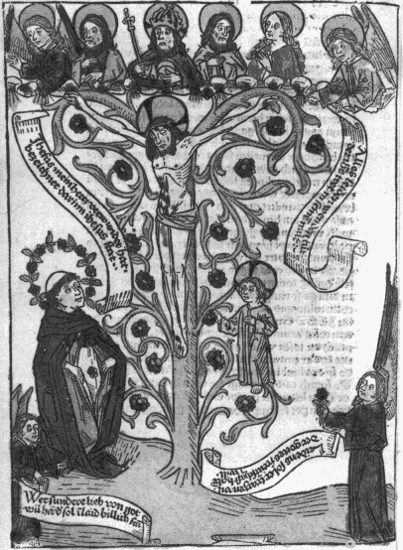
Along with Meister Eckhart and Johannes Tauler, Suso is considered one of the most important of the early German mystics. He entered the Dominican Order at Lake Constance at the age of 13 and in his late teens began to have mystical experiences. These led him to a period of asceticism, which he was later (in 1335) to abandon. Suso’s mystical visions were not abstract perceptions but richly symbolic, though in later life he wished to experience visions beyond the realm of imagery. The object of Suso’s spiritual quest was the eternal wisdom, which he identified with Christ, indeed he began to call himself "the servant of the Eternal Wisdom".
His poetic language, full of images and metaphor, led to Suso being called the troubadour among German mystics, as this example demonstrates:-
"I set before the eyes of my soul myself, all that I am, with body, soul and all my powers, and set around me all creatures which God ever created in heaven, in earth, and in all the elements, each with its name, were it birds of the air, beasts of the forest, fish of the waters, leaf and grass of the earth, and all the unnumbered sand of the sea, and therewith all the little motes which shine in the sunbeam, and all the little drops of water, of dew, and snow and rain, which ever fell or have fallen, and wished that each of them had a sweet instrument of music made ready out of my heart’s innermost chords, and thus forth-sounding from first to last, should bring to the beloved tender God new and glorious praise."
This book contains all his principal works in German, his autobiography ‘The Life of the Servant’, ‘The Book of Eternal Wisdom’, and ‘The Book of Truth’. In his autobiography, Suso uses the image that "God is the circle whose centre is everywhere, but whose circumference is nowhere" (see item 46). This was taken from the pseudo-hermetic Liber xxiv philosophorum.
The illustration shown here is of Christ crucified on the living rose tree, the rose being a particularly important symbol to Suso. It is thought that he was the first to introduce it as a symbol of Christ’s passion.

2. [AURACH, George]
Ortus diviciarum sapiencie dei. [Pretiosissimum Donum Dei.]
Begins "medicina nostra est solium composita ex natura est."
Manuscript. 4°. 24 folios. 202 x 144 mm. 16th century. 12 small coloured drawings in the text 55 x 75 to 90 x 90 mm on recto folios 1, 4, 6, 8, 9, 11, 13, 15, 17, 19, 21, 23. Text in Latin mostly on verso folios and German mostly on recto folios.

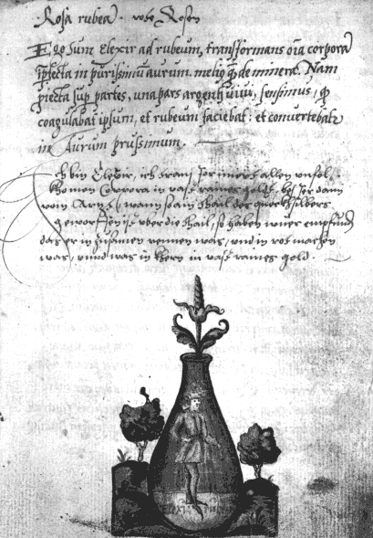
The Pretiosissimum Donum Dei as it is usually called is one of the most important and influential of alchemical works. There are over 40 manuscript copies in existence, the earliest probably being the 15th-century MS. Sloane 2560 in the British Library. Manuscript copies are found throughout the 16th, 17th and 18th centuries, demonstrating the continued interest in and relevance of this work for the hermetic tradition. The text and illustrations were also printed in compilations of works, such as Reusner’s Pandora, 1582, and Trismosin’s Aureum Vellus, 1598, while a beautiful engraved version is found in J.D. Mylius’ Anatomia auri, 1628. Although it has been ascribed to George Aurach, the authorship of this work is by no means clear.
The Donum Dei presents the alchemical process as a series of twelve events taking place in flasks. This begins with the conception and impregnation, which is a meeting of the initial elements needed in the transformation. The growth of the philosophical child, imperfectly formed as a hermaphrodite, comes to an end in a putrefaction or dying, the ‘Caput corvi’ or ‘head of the crow’, a phase of darkness or ‘nigredo’. A new synthesis is brought about, pictured by the appearance of snake forms in the darkness, which turn into a winged dragon. This regrowth reaches its perfection in the appearance of a tree bearing stars, leading to a final resurrection of the queen and king and the growth of white and red roses from the neck of the flask.
The Pretiosissimum Donum Dei demonstrates one of the archetypal processes of transformation in alchemy. This process was not merely a physical experiment enacted in the laboratory, but an inner soul process and mystical experience that the alchemist or hermetic scholar had to go through. The symbolic structure of this sequence influenced such works as the Splendor Solis (see item 26), the Rosarium philosophorum (see item 7) and the Crowning of Nature (see item 56).
The Bibliotheca Philosophica Hermetica also owns a French manuscript dated 1760 with coloured drawings but no text.

3. LULLIUS, Raymundus [1232?-1315]
Liber de secretis naturae seu de quinta essentia. Venice, 1498.
Manuscript. 4°. 182 folios. 164 x 118 mm. 13 drawings in text.

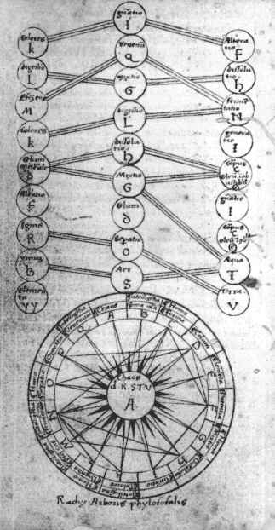
Ramon Lull or Raymundus Lullius, was a Catalan philosopher whose extensive writings had a wide influence, especially upon the development of the hermetic philosophy. Many of the works attributed to Lull are undoubtedly pseudonymous, and it is a difficult task to sort out the authorship of these writings. Lull used a number of symbolic structures around which to construct his philosophical ideas. Among these are elaborate circular diagrams, ladders or stairs which show a hierarchical arrangement of ideas, and tree diagrams. These were part of a hermetic memory system in which images are placed in a certain structure in order to aid the scholar to remember the ways in which various ideas are linked or associated. These memory systems were the inspiration for many later hermetic emblems, and they continued to be developed well into the 17th century. One of the best known constructors of hermetic memory systems was Giordano Bruno (see item 12).
This particular work, as is the case with most of the alchemical writings attributed to Lull, was probably not genuinely written by him. So great was Lull’s reputation that many works were attributed to Lull even centuries after his death. Liber de secretis naturae contains a description of the ‘philosophical tree’ whose roots, ‘radices arboris’, grow out of the wheel centred upon ‘chaos’. Each of the sixteen segments of this wheel plus the centre is associated with the letters A through Q and an alchemical principle - in sequence, Chaos, matter, form, heaven or our Mercury, the elements, mixture, dissolution, alteration, digestion, generation, colours, separation, power, operation, perfect being, fermentatio; perfect venom or tincture completing the work. Each branch of the tree has, in a similar manner, a letter and an alchemical process associated with it, and these branches are linked with each other in a particular pattern, like the kabbalistic ‘tree of life’ (see items 20 and 37), thus forming a memory system of correspondences.
This work was later issued in a number of editions during the 16th century, though some of these only contain parts of the text. Among the more complete printed editions are those of Nuremberg, 1546 and Cologne, 1567.

4. LULLIUS, Raymundus [1232?-1315]
Arbor scientiæ. [Lyon], 1515 [=1595?]
4°. [8] + 682 + [18] pages. 223 x 165 mm.16 woodcuts. 134 x 105 mm. Opus scientiae. Arbor elementalis. Arbor vegetalis. Arbor sensualis. Arbor imaginalis. Arbor humanalis. Arbor moralis. Arbor imperialis. Arbor apostolicalis. Arbor celestialis. Arbor eviternalis. Arbor materialis. Arbor christianalis. Arbor divinalis. Arbor exemplificalis. Arbor questionalis.

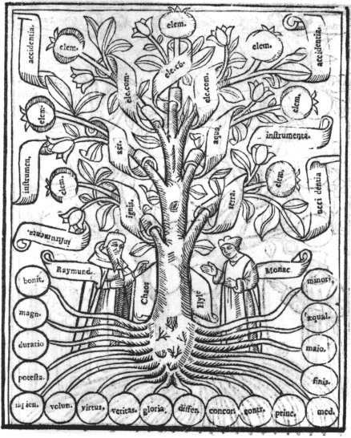
In this work Lull attempts to use the image of the tree to classify and analyse all human knowledge. His tree of science is divided into 16 special trees - the trees of the Elements, the Vegetable kingdom, the senses, the imagination, the human realm, morality, empire, the apostles, the heavenly world, the angelic world, the world of eternity, the tree of the mother aspect, the tree of the divine and human in Christ, and the tree of God. Then follows a tree of exemplification in which further aspects of the fourteen trees or domains of knowledge are revealed, and a long section, the tree of questions or disputed points about all the branches of science. Each of the trees has various parts - the roots, the trunk, the branches, the twigs or lesser branches, the leaves, flowers and fruits, and each of these can be further subdivided.

5. PARACELSUS, Theophrastus [1493-1541]
Prognosticatio... Anno 1536. n.p. [c.1560-1580]
4°. 39 folios. 202 x 140 mm. 32 engravings approximately 97 x 75 mm.

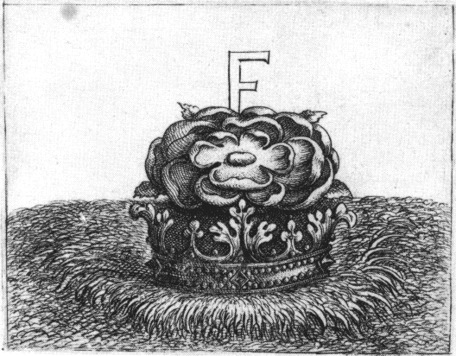
The Prognosticatio was first published in 1536. This present edition, though not dated, is thought to have been issued between 1560 and 1580. The first edition contained a series of primitive, though expressive, woodcuts, but in the present edition these have been replaced by rather fine engravings. The prognostications consist of 32 symbolic images each with a short Latin caption, printed on the recto folios only. There is a short preface and a brief exposition at the end.
This series of 32 images together with accompanying text is intended to prophesy world events during the subsequent 42 years, however, the manner in which they united a number of archetypal symbols together with the broad expression of the text, gave them an altogether more universal quality.
In the text, Paracelsus seems to address the world and its failings, and the most obvious interpretation of these prognostications is to identify the State, the Church, the avarice and ignorance of mankind, the power of armies, etc., as the target for a particular image and its text. The text does not give any hints to such an interpretation, preferring the direct form of address ‘thy’ and ‘thou’, and it uses such general and obscure expressions, that is is impossible to distil a simple unambiguous interpretation. It is thus possible to completely internalise the ‘Prognostications’, seeing them as speaking to some part of ourselves and it is this universal aspect of the symbolism that perhaps has given them a more abiding quality. Indeed, the 19th-century kabbalists (Sar Péladan and Stanislas de Guaita owed this copy) were so fascinated by the prognostications, that they needed to relate them to their own time, and thus they rather arbitrarily interpreted the 42 years as 420 in order to make them relevant to their own age.
It is, however, the power of the images, the simple placing of symbols in a landscape in a surreal manner - a bishop’s cross divided vertically in two, an upside-down chair - that made such an impact upon their time, together with the oblique text which often turns our naive interpretation of the meaning of the symbol upon its head.
Prophecy 26 shows a rose upon a crown. The text is as follows: "The Sybil hath been mindful of thee when she placed the ‘F’ and right well art thou now standing in the Rose; for thou art ripe and time hath brought thee. What the Sybil saith of thee shall be accomplished and even more shall be said of thee. The summer that bringeth roses is that contrary time wherein all things are divided: which is an indication that man was building on sand. This must pass away, and thou shalt set it upon the rock that many will be astounded. For when the time cometh, also there will come that wherefore the time hath come."
This work in places echoes the tone of the 17th-century Rosicrucian manifestos, and there could be a direct link as Carlos Gilly pointed out (in the exhibition catalogue Paracelsus in der Bibliotheca Philosophica Hermetica, 1994) that the text of the final two ‘prophecies’ contains a reference to the opening of a Golden Age, a theme of the early Rosicrucian authors. Paracelsus was of course named in the manifestos as one of those close to the Rosicrucian cause.

6. BONUS, Petrus [fl. 1330] [Edited by Janus Lacinius]
Pretiosa margarita novella. Venice: Aldus Manutius, 1546.
8°. [20] + 202 + [16] folios. 150 x 98 mm. 22 woodcuts. The first seven form a set of symbolic trees, the eighth is a cross of the elements (Earth, Water, Air and Fire), their qualities (hot, dry, moist, and cold) and four symbolic animals. Then follows a sequence of fourteen images showing the alchemical death of the King of the seven metals or planets and his resurrection.

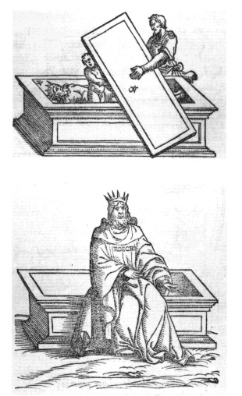
The ‘New Pearl of Great Price’ is ascribed to Petrus Bonus, sometimes called Bonus of Ferrara, who supposedly lived in the 14th century. The work was edited by Janus Lacinius and is one of the earliest and most beautifully printed of alchemical books, being issued by the press of Aldus Manutius in Venice. It greatly influenced and was quoted by later alchemical authors.
Prefixed to the work proper are two series of woodcuts, the first in the form of strange abstract trees of the metals, while the second is a series of fourteen small woodcuts which symbolically introduce one of the most important themes in alchemical and hermetic philosophy, the death and resurrection of the king. This can be seen as an external process in the refining of substances, or an internal mystical process through which the soul undergoes an inner death in order to be reborn into a spiritual state.
The sequence of images begins with the king seated on his throne. Before him kneel his son and five servants (together they make up the seven planets and metals), beseeching the king to bestow upon them a share of his power. The king, however, ignores their petition. The son, urged on by the servants, kills the king, and catches his blood in his robe. A grave symbolising the philosophic furnace is then dug. The son now intends to place his father into the grave or furnace so that his body can be transmuted, however, he himself also falls into the grave, and although he struggles to get out, the grave is sealed. During the sealing of the grave or vessel of transformation, the putrefaction occurs. After this has cooled, the grave is opened and the bones or ashes are removed from the tomb.
A lengthy process continues in which the ashes are divided into nine parts and during this time the classical colour changes of alchemy are seen: the descent into blackness - the ‘Nigredo’ stage - and the subsequent ‘Albedo’ or whitening. The five servants pray to God that the process may be successful, for alchemy is a spiritual work that requires connection with the highest spirit in order to achieve its ends. A succession of angels or emanations of the spiritual world are sent by God to aid the process. These initiate a sequence of colour changes, again classic in alchemy, in which the ashes become white, then yellow and finally a ruby red. Now the King rises respiritualised from the tomb, and having gone through this inner transmutation during which his being has encountered and become permeated with the sense of the spiritual, he is able to endow his son and servants with his new-found power, symbolised by their being crowned in the final woodcut.
The death and resurrection of the king is found in many hermetic works. As an example, the Chymische Hochzeit of 1616, a key work of Rosicrucianism, centres around the death and resurrection of the king and queen, in a wedding that is both a funeral and a process of spiritual integration.

7. [Rosarium philosophorum] [1550]
De alchimia opuscula complura veterum philosophorum. Rosarium Philosophorum. Secunda pars alchimiae de lapide philosophico vero modo praeparando. Frankfurt: Cyriacus Jacob, 1550.
4°. [3] + 168 + [96] folios. 185 x 130 mm. Woodcut on the title-page and series of 20 woodcuts in the text of the ‘Rosarium’.
7a. [Rosarium philosophorum].
Manuscript. 2°. 44 folios [23 blank]. 313 x 197 mm. 18th century. Circular cosmos, frontispiece from Rosarium and 19 figures from Rosarium, all coloured drawings. The second hermaphrodite figure (number 17 in the printed books series) is not included. On recto folios only with (for the most part) interleaved blank folios. Drawings are all approximately 150 x 170 mm. Most likely copied from the printed book.

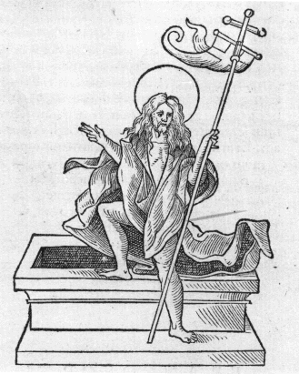
The Rosarium Philosophorum was first printed in this compendium of alchemical texts. It contained a famous series of twenty woodcuts, and the text consists primarily of a series of quotations from various authors arranged thematically to explain the alchemical process, which roughly link with the woodcut emblems. Most of these have a short German verse appended, which suggests a German original. (Joachim Telle in Sol und Luna, 1980, shows that its origin must be dated 1400-1450.) There are a number of beautiful hand-coloured manuscripts of the Rosarium Philosophorum, but it appears that all of these are later. This work is sometimes confused with the earlier Rosarium Philosophorum of Arnoldus of Villanova, and the Rosarius of John Dastin.
The emblem sequence has a definite link with the Pretiosissimum Donum Dei series (see item 2), and one of the emblems depicting a hermaphrodite figure closely parallels an image from the Buch der heiligen Dreifaltigkeit manuscript (see item 11). This particular sequence shows a process of transformation through two death and resurrection cycles, and corresponds closely with the Petrus Bonus emblem series published 4 years earlier (see item 6). In each of these, the male and female aspects fuse into a hermaphrodite which dies and is reborn. The rebirth process involves the separation of a soul aspect from the dead body in the grave. In the first cycle a male soul ascends and descends again, while in the second cycle it is a female soul form which ascends and descends to perform the resurrection. The final figure shows Christ rising from the tomb, thus drawing a parallel between the philosophers’ stone and Christ (see Stephan Michelspacher, item 15).

8. HORAPOLLO [1505]
De sacris notis & sculpturis libri duo. Paris: Jacques Kerver, 1551.
8°. [22] + 242 pages. 157 x 102 mm. 195 woodcuts approximately 50 x 50 mm.

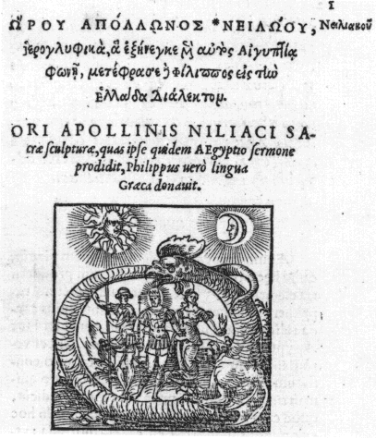
The first edition of this key work in the history of symbolism was issued at Venice in 1505 from the Aldine press. It continued to be printed well into the 18th century, going through at least twenty editions. It has been suggested that the original work was written by the 4th-century Horapollon Nilopolis. The first edition was in Greek, but later editions include a Latin translation. The work is supposed to have been recorded in Egyptian characters by the scribe Horapollo in an attempt to preserve knowledge of the symbolism of the hieroglyphs carved upon Egyptian temples and found in papyri, and later translated into Greek by one called Philip.
The work consists of descriptions of hieroglyphs and their meaning, and the earlier editions did not contain any pictures. The following editions did include a symbolic figure, usually a woodcut, with the text describing the hieroglyph. The style of these images is in no way Egyptian, but draws on the artistic conceptions of the early 16th century. However, in depicting these strange hieroglyphic images, the artists often produced evocative and sometimes surreal pictures, often using parts of the human body juxtaposed with other symbols. This way of depicting ideas influenced both the development of emblem books, which began shortly after Horapollo’s work was published, and the use of symbolism in hermetic books.
The first emblem, the ouroborus, or tail-biting snake, is of especial hermetic import, and often found in alchemical and hermetic symbolism. The text states "When they [the Egyptians] would represent the universe, they delineate a serpent bespeckled with variegated scales, devouring its own tail; by the scales intimating the stars in the universe. The animal is also extremely heavy, as is the earth, and extremely slippery, like the water: moreover, it every year puts off its old age with its skin, as in the universe the annual period effects a corresponding change, and becomes renovated. And the making use of its own body for food implies, that all things whatsoever, that are generated by divine providence in the world, undergo a corruption into it again."

9. BOCCHI, Achille [1488-1562]
Symbolicarum quaestionum... libri quinque. Bologna: Novae Academiae Bocchianae, 1560.
8°. [60] + [348] pages. 203 x 136 mm. 1 woodcut on page [57]. 151 emblems, 110 x 80 mm, engraved by Giulio Bonasone.

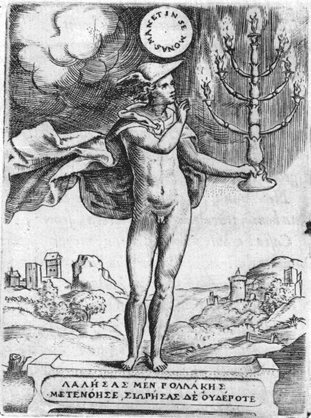
This is an important early emblem book. The engravings are particularly fine, and work with symbolism in new and exciting ways, as the emblems go beyond merely illustrating the mottos and ideas in the verses, but have an integrity of their own.
Emblem 62 has the motto ‘Worship God in silence’, and this emblem has been labelled by later commentators as extolling the ‘hermetic silence’. The verse states that one should remain silent in spiritual matters, that it never does harm to remain silent, while harm is often done through speaking out. The mind of man is the precious image of the divine mind, it cannot be revealed in an external show of emotion. He who wishes to get to know his innermost self, must call back his mind from outer emotions and remain in the peace of the spirit. The thrice great Hermes said that he who calls back the mind from the outer senses, and leads his thoughts away from habitual patterns, will find that the spirit will come alive in his thinking and will never be wretched again.
The image is of Hermes-Mercury holding a candelabra that brings light to the soul. He gestures with his finger upon his lips, signifying that the Monas, the oneness of the spirit, remains wrapped in itself and thus can only be known through inner silence. This image perhaps sums up the spiritual path of the hermeticist to be one which requires seeking the spirit in the inner work of the soul, rather than through outer knowledge or the rituals of religion. The hermetic wisdom, the philosophers’ certain stone, must be won through the silent inner work of meditation. This idea was pictured symbolically by Khunrath in his Amphitheatrum (see item 14).

10. NAZARI, Giovanni Battista [fl. 1572]
Della tramutatione metallica sogni tre. Brescia: Francesco and Pietro Maria Marchetti, 1572.
4°. [8] + 168 + 8 pages. 201 x 150 mm. 15 woodcuts in the text.

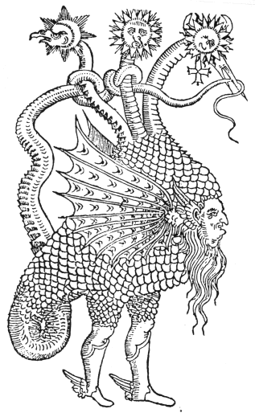
This is an allegorical work on the transmutation of metals and the human soul, divided into three ‘dreams’. It was very much influenced by the Hypnerotomachia Poliphili or Dream of Poliphilus, and contains fifteen woodcuts, some executed in a similar style. The first edition was published under the title Il metamorphosi metallico et humano, in 1564, and contained only two of the ‘dreams’. The author, who has a deep knowledge of alchemical ideas and literature, takes us upon an allegorical journey in which we experience various strange events and situations taken from Greek mythology, and at one point meet with the alchemist Bernard of Treviso and are instructed concerning the secrets of alchemical transformation. Later on in the journey we confront a strange winged dragon with a face in its belly and having three necks, one bearing the Moon, another the Sun and the third the symbol of Mercury.

11a. REUSNER, Hieronymus [1558-?]
Pandora, das ist, die edleste Gab Gottes. Basel: Samuel Apiarius, 1582.
8°. [16] + 309 pages. 152 x 95 mm. Two series of symbolic woodcuts in the text. The first series, ‘Pretiosissimum Donum Dei’, is presented on pages 22, 25, 27, 29, 32, 35, 37, 39, 40, 42, 45, and 48. The second series, ‘Buch der heiligen Dreifaltigkeit’, is on pages 211, 213, 215, 217, 219, 221, 223, 225, 227, 229, 231, 235, 236, 239, 241, 243, 245 and 247.
11b. [Four medieval alchemical miniatures]
3 coloured drawings on vellum [together with a photograph of another item from this series]. 120 x 85 mm. 15th century.

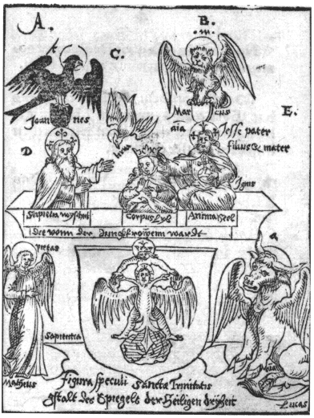
The printed book is an edition of various pieces which Hieronymus Reusner had seen in manuscript. The first is the sequence called Pretiosissimum Donum Dei, of which over 40 beautiful manuscript versions are still extant, consisting of twelve figures showing the alchemical work taking place in flasks, incorporating animal symbolism, dragons and snakes, the conception and gestation of a hermaphrodite, and culminating in the resurrection of a queen and king, the white and red philosophical stone (see item 2). At the end of this compilation is a second sequence, drawn from the earliest known German alchemical manuscript, Das Buch der heiligen Dreifaltigkeit, a number of early 15th-century examples of which survive. The Bibliotheca Philosophica Hermetica possesses three pages of coloured drawings presumably from a early version of Austrian provenance. Das Buch der heiligen Dreifaltigkeit, allegedly written by Frater Ulmannus, parallels the alchemical process with the life of Christ (see Siebmacher, item 29). It also uses symbolic references to heraldry (see item 27).
The plate from the Pandora chosen here shows the imbibition of the body. Above a heraldic shield, bearing the picture of a crowned woman supporting Christ crucified as a double headed eagle, a Christ figure holding an orb labelled ‘corpus’ (the body), places a crown upon the head of a woman, labelled ‘anima’ (the soul). Beside them watches an old man or Father figure, labelled ‘sapientia’ (wisdom). From above the Holy Spirit descends in the shape of the dove, bearing the name ‘terra’ (earth). At the four corners stand the winged symbols of the Evangelists: the eagle of John, the lion of Mark, the bull of Luke and the angel of Matthew.

12. BRUNO, Giordano [1548-1600]
De umbris idearum. Paris: Aegidius Gorbinus, 1582.
8°. [40] + 80 folios. 150 x 93 mm. 32 woodcuts in the text.

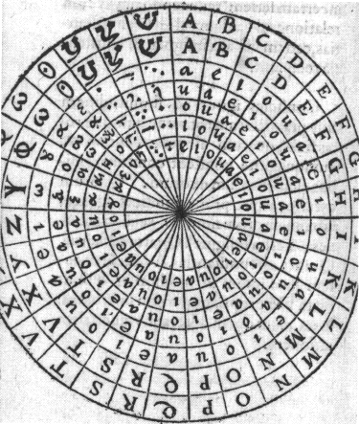
Giordano Bruno, the ‘Nolan’, was a remarkable man, whose uncompromising and fearless pursuit of truth led to his being burned at the stake in Rome for heresy in 1600. When he was 15 he entered the Dominican order, but as he matured intellectually and spiritually he came more and more into conflict with the Church authorities for entertaining heretical views, and was forced to leave the order in 1576. Thereafter he embarked upon a series of journeys around Europe, upon which he gave public lectures in which he expounded his radical ideas. Bruno was profoundly influenced by hermetic philosophy, however, he also embraced radical ideas of his time, especially the Copernican view of a sun-centred universe. He saw that there was no need to cling to the traditional earth-centred cosmology and that a spiritual philosophy could quite easily incorporate the new ideas on the structure of the cosmos. Indeed, he dared to contemplate the reality that there may be an infinity of worlds, each star having its own sphere of planets. He found no conflict with the traditional hermetic view that the Earth and humanity stood at the centre of the cosmos. Robert Fludd, on the contrary, found it impossible to follow this course, and held to the Earth-centred view (see item 20).
Bruno wrote a number of books, and through his lectures and debates stimulated and inspired the intellectuals of Europe to contemplate his fusion of radical new ideas with hermetic philosophy. He began by formulating a new memory system, echoing and extending the work of Ramon Lull (see item 3). His first work to be published was De umbris idearum, ‘on the shadows of ideas’.
Bruno extended the Lullist system by using circular memory wheels with 30 sectors, as opposed to 9 divisions in Lull’s memory system. In a Neoplatonic mystical sense the ‘ideas’ had their source in the spiritual world, and the human mind sits under the shadow of these ideas, sensing their forms. Bruno believed that he had uncovered the inner structure to this world of ideas and that by contemplating the world through his memory system one would become aware of the deeper underlying spiritual unity behind human thought. Here he drew upon his reading of Hermes, that that which lived below in our human thinking, was as that which was above in the thoughts of the spiritual world. In the opening section of the work, Bruno shows that the human mind reflects thoughts from the Divine intellect, just as we perceive shadows cast by the Sun, and he further believed that there was a thirty-fold system underlying the forms of ideas.
The figure shows one of Bruno’s memory wheels, divided into 30 segments, and 7 concentric rings. In each of these sectors an image was to be imagined, and these were carefully chosen to link and associate together symbolically. This memory system thus used complex layers of archetypal symbolism, charged with hermetic, mythological and spiritual meanings. This was not merely a technique for aiding memory, as in the classical memory systems, but a method for structuring one’s thoughts in a hermetic manner.

13. COLONNA, Francesco [1433-1527] [Translated by François Béroalde de Verville]
Le Tableau des riches inventions. Paris: Matthieu Guillemot, 1600 [=1610]
4°. [20] + 154 + 6 folios. 253 x 186 mm. Engraved title-page and 183 woodcuts in the text, some full page.

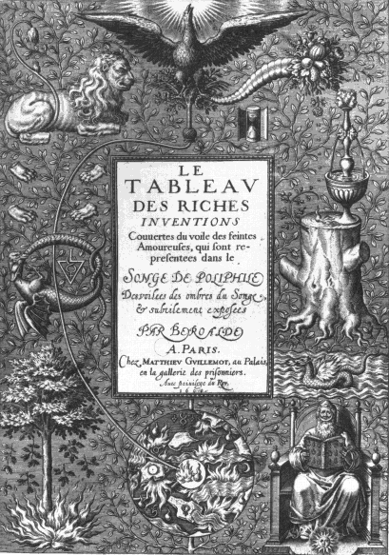
In 1499 the great publishing house of Aldus Manutius produced what is now recognised as one of the most beautiful of printed books, the Hypnerotomachia Poliphili sometimes known as the ‘Dream of Poliphilus’, which, barring the further results of modern research, is ascribed to Francesco Colonna. It was renowned for its typography and the 192 finely-detailed woodcut illustrations which adorn its pages. The work itself is an enigmatic extended allegory in which Poliphilus, in a dream, pursues his true love Polia, through a series of adventures in elaborate classical architectural landscapes and pavilions and meetings with archetypal figures. The allegory is thus a quest of the soul for the spirit, but it rises above mere didacticism especially through its subtle humour and the self-deprecating posture of the hero. The woodcuts aid us to visualise the elaborate descriptions of temples and gardens. The allegory at the heart of this work appealed strongly to people fascinated by symbolism and hermetic philosophy, and had a profound influence on the emblem books and hermetic literature in the late 16th and early 17th centuries. In particular, the allegorical tale of the Chymische Hochzeit (Chemical Wedding) published in 1616, which is a core work of Rosicrucianism, draws heavily on the style and content of the Hypnerotomachia.
In 1600 Beroalde de Verville’s new translation and commentary on the Hypnerotomachia was published. In his commentary ‘Recueil stégano-graphique’ prefaced to the text he especially emphasised the alchemical elements of the allegory, and commented particularly on the engraved title-page to this work "In the midst of the Chaos a small globe is happily indicated, and this is the supreme point of junction of all that is useful for our quest. This small space... on opening the store of its treasures, causes the two substances to appear which are but a single one... from which emerges the scroll of destiny, extending evenly beyond the Chaos, after which it advances in ordered fashion to its rightful end".
This complex of symbolism is placed upon the simple structure of a tree, which we see growing from the bottom centre and sending its branches throughout the space of the emblem. The symbol group at the bottom centre is a circle representing the chaos of the four elements and the planetary forces, at the centre of which are symbols for fire (flames) and water (the drops). A path leads on the left of the image from the flame/drop at the bottom centre to the phoenix that rises towards the light at the top, and touches three paradoxical symbols - the tree with fire at its roots, the dragon and snake devouring each other (the Ouroboros), and the lion with its paws removed. The latter can be seen as the green lion embodying the raw power of Nature, which links with the horn of plenty on the opposite side of the emblem. On the right a sequence of symbols reconciling fire and water is shown. A sage is seated upon a throne, holding a book which bears alternating symbols of flames and water drops. Above him a dragon with wings of fire is paradoxically placed in water. On the stump of a dead tree a little fountain continuously flows, heated by a flame. Alongside this is a water drop, and further to the left the seemingly dead tree sends forth a new, budding shoot. The cornucopia, of course, represents the abundance of the fruits of nature that comes with the completion of the alchemical work. A single rose falls from the horn and drops five petals towards the flame and water drop on the tree stump. The hourglass beside the cornucopia points to the fact that through all these cyclic processes - the self-consuming tree, the Ouroboros, and the perpetually circulating fountain - a time will be reached when the process comes to fruition.
Thus this emblem indicates that the alchemist must proceed by finding ways to reconcile the forces of fire and water. The meeting of these contradictory elements is expressed through these seemingly paradoxical symbols.

14a. KHUNRATH, Heinrich [1560-1605]
Amphitheatrum sapientiæ æternæ, solius ver, christiano-kabalisticum, divino-magicum, nec non physico-chymicum, tertriunum, catholicon. Magdeburg: Levin Braun, 1608. [Colophon: Hanau: Wilhelm Antonius, 1609.]
2°. [4] + 60 + [4] + 223 pages. 301 x 195 mm. Engraved title-page and 11 plates inserted, of which 9 are double-page 300 x 190 mm.
14b. KHUNRATH, Heinrich
Amphitheatrum sapientiæ æternæ. Lier, 1702.
Manuscript. 2°. [2] + 224 pages + [2] pages. 278 x 179 mm. One folding pen drawing inserted after page 210 and 3 folding pen drawings and one folding table inserted after page 222. Copy of printed edition with pen drawings of Oratory-Laboratory, Cosmic Rose, Three and Four, and hermaphrodite. "F. Bruno, eremita, calamo depinxit, anno 1702".

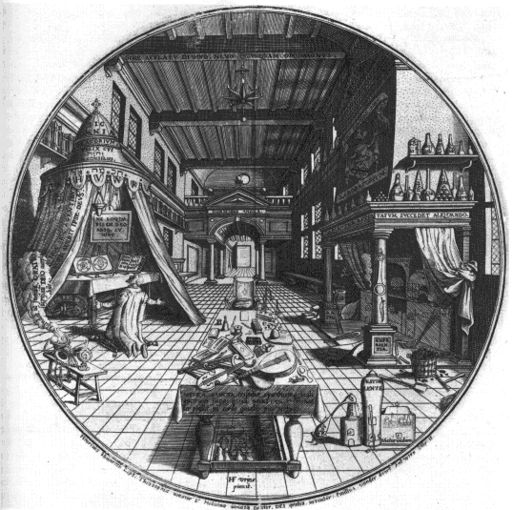
The Amphitheatrum of Khunrath was originally published in 1595, and probably in a very small edition, of which only three copies (one imperfect) seem to have survived. The work contains four very striking large circular engravings, which were substantially reworked, and reissued in 1609 with the addition of a long text serving as a preparation for studying the ‘Amphitheatre’, in the form of seven steps, and now with nine large plates, some derived from the original designs. The seven steps consist of 365 texts from the Biblical book of Proverbs, Ecclesiastes and the Wisdom of Solomon, together with Khunrath’s interpretations and annotations upon them. The reader was expected to work through, and meditate upon these texts, one for each day of the year.
One of the best known of the plates from the Amphitheatrum shows the Christian-kabbalistic-alchemist in his chamber. He kneels in his circular oratory, which is fashioned like a tented-tabernacle (see item 19). Within this a lamp shines, and the text states "Do not speak of God without Light". On the altar a book is open bearing symbolic diagrams, similar to those in two other plates in the Amphitheatrum, thus emphasising the importance of meditating upon symbolism. On the opposite side of his chamber is a laboratory, its square plan contrasting with the circular form of the oratory. Here the hermeticist must work to enoble matter in order to grasp its spiritual essence. He must ‘hasten slowly’, ‘neither rashly, nor timidly’ in order not to force the work to a premature failure. In the foreground is a table upon which lie a number of musical instruments, scores, etc. The text below reads "Sacred music puts melancholy and evil spirits to flight, for the spirit of Jehovah sings happily in a heart filled with joy".
On the ceiling, above a seven-branched candelabra, is the statement "no one is great, without divine inspiration."
The four circular plates, versions of which were used in the 1595 edition, were engraved by Paullus van der Doort of Antwerp. The title-page, portrait and five rectangular plates, not in the earlier edition, appear to have been engraved by Johan Diricks van Campen of Magdeburg. It is thought that the plate of the Oratory and Laboratory was drawn by Hans Vredeman de Vries, an architect and noted architectural painter. The Bibliotheca Philosophica Hermetica has in its collections an early 18th-century manuscript copy of the Amphitheatrum in which the pen drawing of the Oratory and Laboratory bears a complex net of construction lines and circles. Whether these geometric constructions were used in the original drawing of the figure is not certain, but this is an interesting example of someone deconstructing the geometry which underlies many hermetic emblems.

15. MICHELSPACHER, Stephan [fl. 1616]
Cabala, Speculum Artis et Naturae, in Alchymia. [Augsburg]: David Franck for Stephan Michelspacher, 1616.
8°. 8 folios. 193 x 149 mm. 4 folding plates at end. 1. 315x 245 mm. Spigel der Kunst und Natur. ‘Raphael Custodis scalpsit’, ‘Stephan Michelspacher. Ex: [-ornat]’. 2. 299 x 244 mm. Anfang: Exaltation. 3. 316 x 231 mm. Mittel: Coniunction. 4. 308 x 245 mm. Endt. Multiplication.

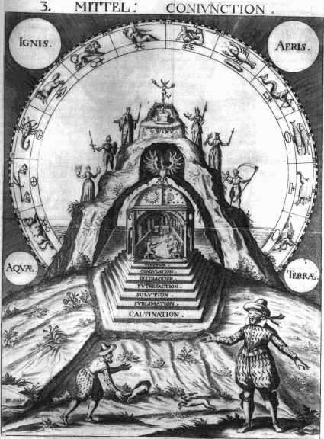
This short work is distinguished by its four large plates. It went through a number of editions in German and Latin. The German editions were issued in 1615, 1616, 1663 and 1690, while Latin versions appeared in 1616, 1654, 1667 and 1704. Despite the use of the work ‘Cabala’ in the title, the text which consists of some short poems, a preface and an explanation, is entirely alchemical in tone. Although the Latin versions have added to their titles an indication that they were published and dedicated to the Brotherhood of the Rosy Cross, there is nothing in the text which indicates any direct Rosicrucian connection, and it may be that this association was made after the issuing of the first German edition.
The author states in the explanation that he has found three mystical mirrors, associated with the Mercury, Sulphur and Salt of the Wise, and that in these lie the secret of the art. The adept must work through a series of spiritual alchemical processes in order to unite the three mirrors into a unitary experience. These stages or processes he outlined in the four figures.
The first plate is divided into three areas. In the lowest the alchemist is shown at work with material substances in his laboratory, the middle layer shows two diagrams which relate substances and metaphysical qualities, while the top section displays the whole work of alchemy through the meeting of polarities symbolised by eagle and lion, and the coat-of-arms of the alchemical work. Heraldic symbolism was sometimes used in hermetic works, for example the Buch der heiligen Dreifaltigkeit, or the Splendor Solis. (See also item 27).
The second plate represents the beginning of the work. Here a strange beast is shown bearing a flask upon its back. Within this flask the process of alchemy is shown proceeding through bird stages - cock and lion, black Crow, Peacock’s tail, Phoenix, leading to the solar rebirth. These symbols also appear on the large plate from Mylius’ Opus Medico-chymicum and in the ninth key of Basil Valentine (see items 18 and 23).
The third plate, which we here reproduce, shows the middle stage of the work, here called the ‘Conjunction’. It demonstrates that the integration of the work occurs in the interior of the earth, that is, the spiritual can only be found through looking into the material. The alchemist on the right is blindfolded and needs guidance in order to find his way. The shy and fleeting spirit is pictured as a rabbit. The alchemist seeks to grasp this inner essence from the outside, by ferreting out the rabbit which dives into its burrow at the base of a mystical cosmic mountain, on the various levels of which the seven planets are figured. We see the interior of this mountain revealed. Within the mountain is a temple of the Sun and Moon, which can be approached by a stairway of seven steps, each associated with an alchemical process. These lead one into a vaulted temple with seven windows in the centre of which sits a solar king with his sceptre and a lunar queen with a threefold plant. Behind them is an alchemical furnace, foursquare at the base and circular at the top. The roof of the temple has the symbols of Sun and day, with night, Moon and stars. High on the temple roof a crowned bird rises like a phoenix, showing that once one understands and inwardly experiences this complex of symbolism in all its aspects, one has completed this stage of the work, and has become reborn like a phoenix.
The final plate, the end of the work, or the ‘Multiplication’ brings this alchemical process into a Christian context, paralleling the blood shed by Christ on the cross with the spiritual tincture sought by the alchemists. The king and queen kneel before a fountain of light, within which is the resurrected Christ, offering the tincture of his blood, in a chalice, to the royal couple. This is an example of how alchemists often saw Christ as the Philosophers’ Stone, sometimes augmenting this with the idea of Christ as the Corner stone, the stone that the builders of the Temple rejected and despised.

16. MAIER, Michael [1566-1622]
Symbola aureæ mensæ duodecim nationum. Frankfurt: Antonius Humm for Lucas Jennis, 1617.
4°. [20] + 621 + [43] pages. 186 x 145 mm. Engraved title-page 172 x 133 mm. Page [8]. Portrait of Maier 141 x 95 mm. Series of 12 engravings all approximately 78 x 100 mm.

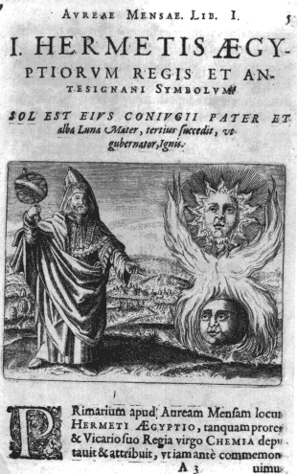
Michael Maier, a man of many facets - writer, diplomat, physician, poet, classical scholar, alchemist and Rosicrucian apologist - was born at Rendsburg, educated at the University of Rostock, and later received his doctorate of medicine at Basel. He lived for some years in Prague as physician and confidant of Emperor Rudolph II, an important patron of the arts, who had an especial interest in hermetic philosophy. Maier, in his position as Count Palatine, travelled extensively on diplomatic missions, and made many contacts with important and influential people sympathetic to his interests in hermetic and symbolical philosophy. After the death of Rudolph in 1612 Maier spent some years in Britain, and subsequently wrote a series of works - the Arcana arcanissima [‘the most secret secret’] of 1614, the Lusus serius [‘the serious past-time’] 1616, Examen fucorum [‘the detection of the falsifications of pseudo-alchemists’] 1617, the Jocus severus [‘the earnest jest’, the Silentium post clamores [‘the silence after the clamour of the announcement of the Rosicrucians’] 1617, Atalanta fugiens [‘Atalanta fleeing’] 1617, Themis aurea [‘golden Themis’] 1618, Tripus Aureus [‘the golden tripod’] 1618, Viatorium [‘the wayfarer’s guide’] 1618, and others - most of which were issued by the Oppenheim and Frankfurt firms of de Bry and Lucas Jennis with fine copperplate engravings.
Maier is at pains in his writings to support the sublime truths of alchemy and hermetic philosophy against its detractors, and especially to criticise the false alchemists, or deceiving rogues who were giving the art such a bad reputation during the first decades of the 17th century, as we see so well satirised in Ben Jonson’s play The Alchemist of 1610. In a number of works he also defends the Rosicrucians against calumny. It seems unlikely that he was actively involved in the early development of the Rosicrucian mythos during early years of the 17th century, but once it had become public through the publishing of the manifestos in 1614-1615, Maier is one of this movement’s staunchest defenders.
In the Symbola aureae mensae [‘the symbols of the golden table of the twelve nations’], Maier choses twelve key hermetic philosophers from various nations, who he claims have contributed most to the development of this spiritual philosophy - Hermes the Egyptian, Mary the Jewess, Democritus of Greece, Morienus of Rome, Avicenna the Arab, Albertus Magnus the German, Arnold of Villanova the Frenchman, Thomas Aquinas of Italy, the Spaniard Raymundus Lullius, Roger Bacon the Englishman, Melchior Cibinensis the Hungarian, and the anonymous Sarmatian. A chapter is devoted to the philosophy of each of these figures, and each is introduced by an allegorical engraving which to some extent reflects in its symbolism the essence of their philosophy. His aim in the text is to show the existence of an earlier age of hermetic wisdom, and to defend the noble virgin alchemy against her detractors and the posturings of false alchemists. He refers to the philosophy of the Rosicrucians and seeks to defend this against attacks.
The figure of Hermes, shown here in what was thought of in the early 17th century as the robes of an Egyptian priest, holds up a globe of the earth in his right hand while he gestures with his left to the symbols of sun and moon united in a fire. This contains an allusion to the ‘Emerald Table’ of Hermes, one of the key documents of alchemy, a short but so influential document, which few alchemical works fail to mention or quote from. The ‘Emerald Table’ states, in describing the fundamental principle sought by the alchemist "Its father was the Sun, its mother the moon, the Earth its nurse, and the wind carries it in its belly". Thus central to hermetic philosophy is the idea that the grand cosmic design "that which is above" is reflected and played out in the little world we inhabit "that which is below" - and thus the spiritual and the material are interwoven and must be pursued together.

17. MAIER, Michael [1566-1622]
Atalanta fugiens, hoc est, emblemata nova de secretis naturae chymica. Oppenheim: Hieronymus Galler for Johann Theodorus de Bry, 1618.
4°. 214 pages. 184 x 145 mm. Engraved title-page and 50 engravings.

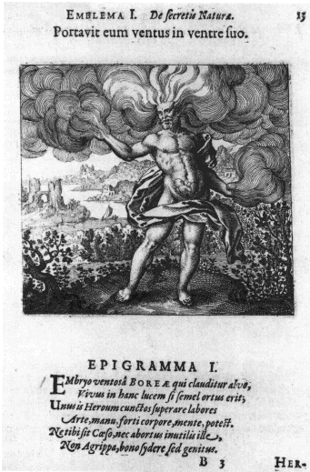
The Atalanta fugiens is a remarkable publication. It must be one of the first multimedia productions, as it is an attempt to fuse music, poetry, visual art, and prose into an unified experience. It takes the form of an emblem book with fifty emblems, but with the added dimension of music.
The title, ‘Atalanta fleeing’, indicates that the root of this book lies in Greek mythology. Maier uses the myth of the beautiful young woman Atalanta who, in order to avoid losing her own essence by being married to some unsuitable man, challenges each of her suitors to a race. She is an exceptionally fast runner and easily wins against all her pursuers, until the youth Hippomenes, following the advice of Venus, tricks her by dropping three golden apples which she cannot resist stopping to pick up, thus allowing Hippomenes to win the race.
Maier carries this mythological theme into the construction of the music. Thus he creates a ‘fugue’ to accompany each emblem, taking the form of a three-part canon, with a leading voice representing Atalanta, a pursuing voice Hippomenes and a simple base figure of three notes reflecting the golden apples. The music also is further elaborated by the fact that for certain emblems the music is a mirrored version, or inversion, (or sometimes places the notes in reverse order) of that found accompanying another emblem. Thus we have a complex musical interrelationship between emblems. It was always thought that such a cerebral plan must have led to rather contrived and consequently poor music, looking good on paper but sounding unpleasant to the ear, however, the recent recording of the complete piece reveals that the music has an integrity and can hold its own against minor compositions of the period.
The series of emblems each have a verse and an epigram associated with them, and further, a short prose discourse which in general elaborates a classical mythological interpretation of the symbolism in the emblem. The first emblem, for example, shows the wind as a bearded man carrying the fundamental principle of the alchemists, symbolised as a gestating child, in its belly. This image relates to the first figure of Maier’s Symbola aureae mensae (see item 16). The first emblem thus contains, appropriately for this work of symbolic alchemy, a reference to the ‘Emerald Table’ of Hermes.

18. MYLIUS, Johann Daniel [1585-1628]
Opus medico-chymicum. [In three volumes.] Tractatus III. Seu Basilica Philosophica Frankfurt: Lucas Jennis, 1618.
4°. [88] + 271 + [1] + 44 pages. 185 x 138 mm. 3 folding symbolic plates.
Page [8] Diagram of the five worlds Mundus Archetypus, Mundus Angelicus, Mundus Etherealis, Mundus Elementaris, and Mundus Infernalis. 148 x 96 mm.
Inserted after page [8] large plate of the macrocosm and microcosm, light and dark. ‘M. Merian fecit’ 342 x 260 mm.
Page 89 circles with sigils of Saturn, Jupiter, Luna, Mercury. 142 x 95 mm.
Inserted after page [44] of liber tertius,10 folios of engravings printed on rectos only. Each plate measures 162 x 127mm, and consists of sixteen circular emblems 31 mm in diameter, arranged in a matrix of four across and four down. Each emblem has a text around the circumference, the name of a famous alchemical philosopher below and the imagery is contained in circles having a diameter of 22.5 mm. There are thus 160 emblems in all [see item 24]. The second book contains a number of folding plates showing furnaces and other alchemical apparatus.

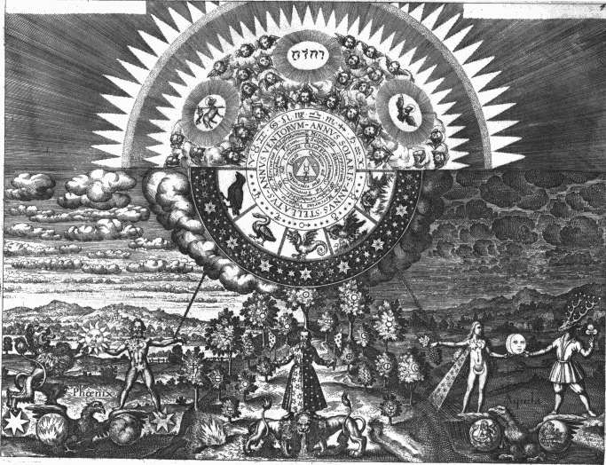
This is a vast work in three volumes on medicine, alchemy and hermetic philosophy. Contained in the third volume are a series of large plates, which expound in a very clear symbolic manner the core hermetic doctrine of the relationship of the above and the below, the interweaving of the Macrocosm and the Microcosm. These engravings were made by Mattheus Merian, who above all other engravers of the period seems to have been able to empathise with the essence of the hermetic philosophy he was called upon to illustrate, and thus produced works of great artistic merit, in which the symbolism rather than being merely didactic is integrated and woven into a total aesthetic conception.
The plate chosen here, the second of the three folding plates, shows the alchemist at the centre foreground standing upon a two-bodied but one-headed lion. He stands at the dynamic centre of the opposites which he must recognise and try to integrate within himself. Thus one half of his coat is dark and the other light. He stands between day and night, light and darkness, the masculine and the feminine, Sun and Moon, fire and water, the upward-tending elements (fire and air) and those downward-tending and subject to gravity (water and earth). He stands at the foot of a small hill, upon which are various trees bearing symbols of the key alchemical substances. In the skies above his head is a vast circle, the upper part of which reveals the spiritual world, the Father, Son and Holy Ghost together with the hierarchies of angels, instilling their influences in the world below. These spiritual impulses are mediated through the five birds, the crow, swan, winged dragon or cockerel, pelican and phoenix, which symbolise key processes in alchemy (see items 15 and 23).

19. SCHWEIGHARDT, Theophilus [Daniel Mögling]
Speculum sophicum rhodo-stauroticum. [Frankfurt]: 1618.
4°. 22 pages. 205 x 160 mm.
Engraved title-page. Three plates inserted at end: ‘Collegium Fraternitet vom Rosen Creutz’, ‘Ergon et Parergon’ and ‘Spiegel der Kunst unnd Natur’.

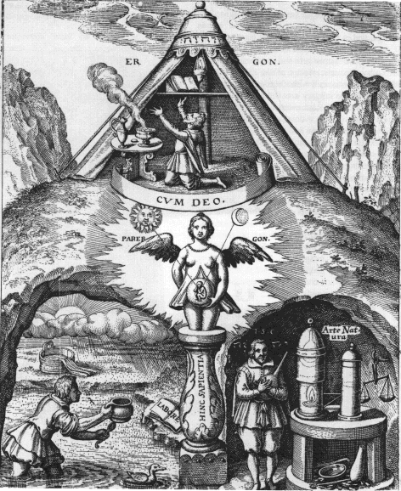
This is a short but important work promoting and extending the ideas presented in the Rosicrucian Manifestos, the Fama fraternitatis, 1614 and the Confessio, 1615. The illuminated title-page states: "The mirror of the wisdom of the Rosicrucians. The detailed unveiling of the college and axiomata of the specially illuminated fraternity of the Christian Rosy Cross to all those desirous of and expecting wisdom and to the further confounding of those readers who do not understand and to their inextinguishable shame and mockery".
The book consists of a preface and three chapters, each of which has a large engraving associated with it. In the preface the author despairs over the sad state of the world, but holds out hope to the reader that shortly the Rosicrucian brotherhood will provide the awakening to a new awareness of the spiritual foundation of the world, which will reform society. In the first chapter he reveals that the college of the Rose Cross is everywhere, "There is a building, a great building lacking windows and doors, a princely, aye imperial, palace, everywhere visible but hidden from the eyes of men". The famous first engraving shows this as a winged tower set upon wheels and guided round the world by the hand of God. The third figure shows the mirror of art and nature, revealing how nature emanating from God divides into the four elements, and the aminal, vegetable and mineral kingdoms. Within this stands the human being, "the visible transient body with an invisible imperishable soul". The art of perfecting the soul is the great work. The author refers to a statement of Thomas a Kempis that there are two eyes in the soul, the right eye can see into eternity but the left must be kept closed (see item 38). "Look first with the right eye into eternity, know God thy creator and thyself... and keep thy left eye shut the while. Afterwards climb down from the mountain and look with thy left eye into time and creatures."
The second figure which we display here shows the Ergon and Parergon, the greater and lesser ‘work’ of the Rosicrucian brotherhood. The greater or higher work is the task of developing a relationship to the spiritual, of being ‘with God’. This is shown by the figure kneeling in the oratory on top of the mountain. This image is obviously borrowed from Khunrath’s Amphitheatrum (see item 14). Below is symbolically depicted the lesser or subsidiary work, which begins with a symbolic reference to the ‘Emerald Table’, "The father is the Sun, the mother the Moon, the wind bore him in its belly, the nurse is the earth." There are two matters the hermeticist must work with - one from the heavens above, and one from the earth below. The task of working to perfect matter is shown in the two areas below. On the left the alchemist works to find the prima materia, while on the right he sets about the task in his laboratory, embracing the flask which contains his work to his breast. The little furnace with a lamp burning within it is patterned after a design by Heinrich Khunrath in his Athanore, 1603. These two references to the works of Khunrath show the importance this writer had for the Rosicrucian writers.

20. FLUDD, Robert [1574-1637]
[Utriusque cosmi... historia]. Tomi secundi, tractatus secundus, de praenaturalis utriusque mundi historia. Frankfurt: Erasmus Kempffer for Johann Theodor de Bry, 1621.
2°. [12] + 199 pages + [1] pages. 310 x 200 mm.
With six engravings and ten woodcuts in the text, plus one double-page engraving inserted after page 180. Page 217 the three worlds in the human mind.

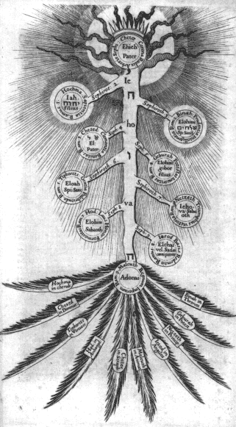
Robert Fludd was one of the most important of hermetic philosophers. In his vast output he allowed his hermetic insights to range over the whole of human knowledge, and in his Utriusque cosmi historia, 1617-1620, he created what is in effect a vast encyclopaedia of cosmology, the human arts and sciences. This work begins with a hermetic picture of the creation of the world, and continues with sections on music, arithmetic, even the military arts. Like Michael Maier, he also supported the Rosicrucians and wrote a work praising this movement, with which he may have had some direct contacts, as he had spent the early part of the 17th century studying on the continent. He was a physician, and although he stood outside the mainstream of medical practice of his time, he obtained good results especially through developing sympathetic relationships with his patients. Eventually he became a physician to King James I.
His books, most of which were published by de Bry or his son-in-law William Fitzer, are profusely illustrated with copperplate engravings of very high quality. A number of these are printed on folding double sheets. The imagery of these illustrations continues to fascinate people today, but it still catches us with surprise to see one of these diagrams used in present day advertising and popular art-forms.
This image shown here of the tree growing from above with its roots in heaven and its leaves and flowers in the earth, shows another facet of the use of the tree in hermetic symbolism (see Lull’s memory tree, item 1). Fludd’s tree is partly a memory tree as it incorporates the 10 sephiroth of the Kabbalah (see Knorr von Rosenroth, item 37). To a hermetic kabbalist, such as Fludd, the tree of life spanned the worlds, being rooted in the light-filled spiritual world of the angelic hierarchies, its trunk growing down through the denser worlds of creation and form. The sephiroth, the spheres, mirrors or vessels, catch and reflect the light in ever denser ways down into the material world, represented by the Sephira Malcuth at the lower part of his diagram where the trunk sends forth branches into the outer material world of substances, Assiah.

21. MYLIUS, Johann Daniel [1585-1628]
Philosophia reformata continens libros binos. Frankfurt: Johann Friedrich Weiss for Lucas Jennis, 1622.
4°. [40] + 703 + [34] pages. 228 x 170 mm.
Engraved title-page "Baltzer Schwan fecit".
Pages 96, 107, 117, 126, 167, 190 and 216 First series of 28 emblems 124 x 150 mm.
Pages 224, 243, 262, 281 and 300 Second series of 20 emblems 124 x 150 mm.
Page 316 Illustration of tree with seven circles of regeneration process 117 x 111 mm.
Page 354, 359 and 361 Third series of 12 emblems (numbered 2-13) 124 x 150 mm.
Page 365 Title-page of second book. Illustration of tree with seven circles of regeneration process, (as on page 316), 117 x 111 mm.

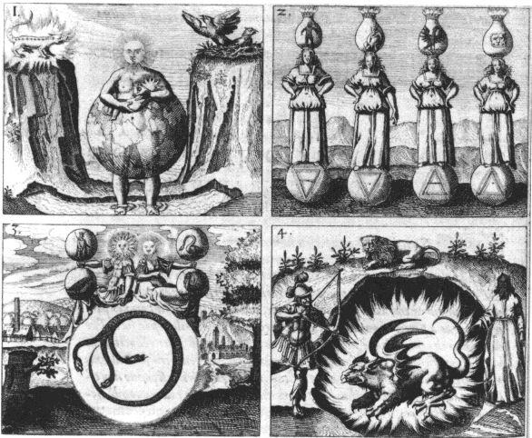
This important work of Mylius is profusely illustrated with three important sequences of imagery. The second sequence is a reworking of the Rosarium philosophorum emblem series of 20 images. This had been originally published in 1550 and there are a number of hand-coloured manuscripts of this series in public collections (see item 7). The third series is a reworking of the Basil Valentine ‘Azoth’ sequence, first published as Azoth, sive Aureliæ occultæ philosophorum, 1613. There is also an important alchemical tree (see items 3 and 31) which has seven roundels depicting a process of death and regeneration.
The first group of 28 images, unique to this work, is an extremely well-structured sequence. All the key symbols, such as Sun, Moon, lion, snake, fire, containers or vessels, etc., occur seven times across the sequence, and there is another group of symbols which occurs in three emblems. Each emblem brings together key symbols in an imaginative way, which has been thought of as almost surrealistic, however, there is no real link with the methods of the ‘Surrealists’, who opened themselves to the promptings of the unconscious, through active imagination and dream. Here in Mylius’ work one sees a much more contrived integration of symbolism, which has almost a formal mathematical structure lying behind the weird constellations of symbols.
The series opens with a symbolic quotation from the ‘Emerald Table’. "The Earth is the nurse" [of the philosophers’ stone]. We are then shown in symbols various methods for integrating the four elements and the three principles, followed by a journey through twelve alchemical processes, Calcination, Solution, Separation, Conjunction, Putrefaction, the four grades of heat, Congelation, Cibation, Sublimation, Fermentation, Exaltation and Multiplication. The series concludes with a further twelve emblems which symbolically describe the final process of projection, especially through the use of dualistic imagery.

22. STOLCIUS, Daniel [fl. 1620]
Viridarium chymicum figuris cupro incisis adornatum, et poeticis picturis illustratum. Frankfurt: Lucas Jennis, 1624.
obl 8°. 175 (of 220) folios. 88 x 128 mm.
107 emblems.

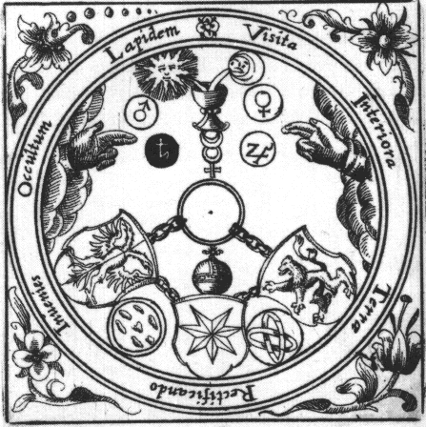
The ‘chemical pleasure-garden’, was devised by a disciple of Michael Maier and an ardent admirer of alchemy, the Czech Daniel Stolcius of Stolzenberg. During the course of his travels around Europe he called upon Lucas Jennis, who showed him a number of the plates he had used in illustrating the books of Maier and Mylius. They decided to reissue these in the form of an emblem book, with short verses added by Stolcius, and further to present this in the form of an oblong ‘Album amicorum’, which the possessors could use to record the people they met or particularly admired.
This work consists of 107 engravings on the recto of each alternative folio, with a six-line verse on the facing verso. Thus between each emblem are two blank facing pages for the ‘Album Amicorum’. The first 32 emblems are taken from Maier’s Tripus Aureus (the twelve keys of Basil Valentine), Lusus Serius, Symbola aureae mensae (see item 16), and Septimana Philosophica. The other 75 emblems are from the three series in Mylius’ Philosophia reformata (see item 21) and the Azoth series of Basil Valentine (see item 23).
The image we have chosen to display is the second in the Azoth series. According to Stolcius’ verse this symbolically demonstrates the ‘Emerald Table’. Here we see the sun and moon being poured into a chalice standing upon mercury. The lion, the eagle and the seven-pointed star of the planets are also integrated into the process through chains. Around the outside is the so-called ‘Vitriol’ acrostic. Alchemists often played with words, hiding their own identities in elaborate anagrams. Here, however, the word-play involves the acid Vitriol, sometimes symbolised as a green lion which eats into substances. ‘Visita Interiora Terrae Rectificando Invenies Occultum Lapidem’ - visit the interior of the earth, by rectifying you will find the hidden stone. For alchemists, such as Basil Valentine, if one searched deeply into the nature of substance one would find its hidden spiritual core, the philosophers’ stone.
Stolcius’ verse to this emblem reads:
Hermes says: What is above must correspond
To what is below,
If someone desires to accomplish
Such wonderworks, with art and might.
To moving planets may be seen
Standing in the heavens.
The earth with its precious metals
Resembles them exactly.
The father of this stone is the sun;
The mother is the moon;
The wind carried the reward in its body;
The earth has nourished it tenderly.

23. GRASSHOFF, Johann [?-1623]
Dyas chymica tripartita. Frankfurt: Lucas Jennis, 1625.
4°. 88 + 150 + [1] pages. 193 x 155 mm.
Second book: Twelve Keys.

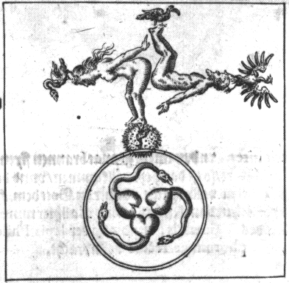
The present volume, another reworking of symbolic material from the press of Lucas Jennis (see item 22), has been included primarily because it contains ‘The Twelve Keys of Basil Valentine’ which is one of the most influential works on symbolic alchemy, having been published in at least 36 editions during the 17th and 18th centuries. It is distinguished by its series of emblems. These, however, did not appear in the 1599 first edition of the work, although primitive woodcuts were included in the second edition of 1602. Subsequent editions used copperplate engravings.
Basil Valentine was allegedly a monk living in the early 15th century, however, as no trace of him can be found in manuscripts earlier than the 17th century, it is usually supposed that the writings ascribed to him were written in the last decade of the 16th century, and the name and legend attached to them in order to give them a patina of antiquity. The legend grew that the texts of Basil Valentine were found by accident when a pillar of the Cathedral at Erfurt split open. This pretence, of hermetic manuscripts being discovered hidden in the walls of old buildings, was often used to give a later work a spurious pedigree. The ideas in the texts themselves show a definite influence of Paracelsus (1493-1541). Despite the deception surrounding the publication of the Basil Valentine writings, they are nevertheless of a high calibre and it is this, rather than the legend, that kept them at the forefront of alchemical publications for 200 years. Indeed even today illustrations from the ‘Twelve Keys’ are often used in books on symbolism to exemplify the use of symbols in alchemy.
The Ninth Key is displayed, as this brings together in one emblem an interesting synthesis of symbolism. The man and the woman stand above a circular space, their bodies forming a cross. At their head and feet are four birds symbolic of transformation processes (see items 15 and 18) - the black crow of putrefaction, the eagle or phoenix bird in its state of resurrection, the peacock with its resplendent tail of irridescent colours (often used in alchemical illustrations) and the white swan which represents the white stone, the calmness that arises during the development of the perception of the spiritual in the alchemical work. This complex of symbolism stands upon a circle within which are three hearts out of each of which grows a serpent. These snakes seem to be in the act of seizing one another’s tails, thus forming a complex ouroborus (see item 8). To the hermeticist of this period, all things, all beings were inwardly composed of three principles - salt, sulphur and mercury. In the human there are three hearts - a physical heart, a soul heart and a spiritual heart. These are united and linked by the serpents in an unbroken eternal unity. It is through the alchemist’s perception of these different facets of reality, both in the world outside, and within his innermost being, that he is able to transform himself. As Basil Valentine says in the text to this ‘Key’:
If the whole world’s nature
Were seen in one figure,
And nothing could be evolved by Art,
Nothing wonderful would be found in the Universe,
And Nature would have nothing to tell us,
For which let us laud and praise God.

24. STOLCIUS, Daniel [fl. 1620]
Hermetico-spagyrisches Lustgärtlein. Frankfurt: Lucas Jennis, 1625.
4°. 26 pages. 193 x 155 mm.
10 pages of 16 emblems in a matrix of (4 x 4). Four large folding plates at end.

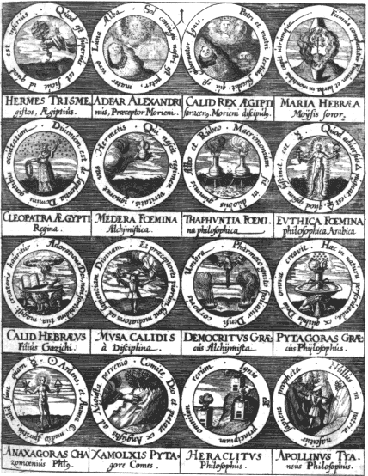
This series of 160 small emblems (the ‘seals of the philosophers’) were first included in the Opus medico-chymicum of J.D. Mylius, issued by Jennis in 1618 (see item 18) and later in Grasshoff’s Dyas chymica tripartita of 1625 (see item 23). Stolcius took these plates and used them as the basis for this book, which was later issued in Latin as the Hortulus Hermeticus, 1627, with the plates now cut down from their original matrix of (4 x 4) to (2 x 2).
These small emblematic seals are each associated with a hermetic philosopher, from Hermes through to Mylius. Each symbol has a Latin motto around it, and Stolcius has added a four-line verse, which attempts to reflect and explain the symbolism of the emblem.
Many of the images in these emblems are not original but have been taken from other printed works and manuscripts. We can recognize images from Michael Maier’s Symbola Aureae Mensae (see item 16), the Splendor Solis sequence (see item 26), Buch der heiligen Dreifaltigkeit from Reusner’s Pandora (see item 11), the Rosarium Philosophorum (see item 7), the Azoth series and the Twelve Keys of Basil Valentine (see 22 and 23), Mylius’ Philosophia reformata series (see item 21), among others. This work consequently provided an almost encyclopaedic survey of hermetic symbolism. It was later reprinted in Manget’s important collection Bibliotheca Chemica Curiosa, 1702.

25. LAMBSPRING
Libellus de lapide philosophico. Frankfurt: Lucas Jennis, 1625.
4°. 35 pages. 188 x 152 mm.
Engraving on title-page. 104 x 105 mm. Page 3: Engraving of coat of arms 83 x 67 mm. Fifteen engravings approximately 105 x 105 mm on pages 7, 9, 11, 13, 15, 17, 19, 21, 23, 25, 27, 29, 31, 33 and 35.

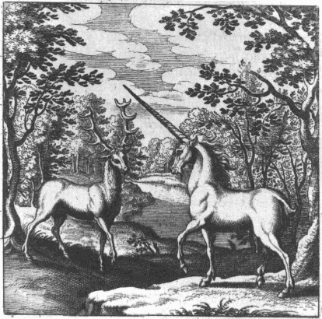
The ‘Book of Lambspring’ is a well-known series of fifteen engravings with a short text in verse. It was originally published without the emblems in Nicolas Barnaud’s Triga chemica, 1599, and there is a manuscript version containing coloured drawings in the Salzburg Universitätsbibliothek dated 1607. The present edition was the first to contain the finely executed plates by Mattheus Merian, which were so well regarded that they were included in a number of compilations. They form a tightly integrated symbolic series using animal forms, which concludes with a symbolic study of a process transforming the son of the alchemical king, who through the mediation of an angelic guide is led up a mountain, then is consumed by and eventually reborn from the body of his father the king. (See also items 6 and 26).
The first eight emblems of this series use animal symbolism to point to the relationship of soul and spirit dwelling in the body. Thus we have the image of two fishes swimming in the sea, a knight encountering a dragon in the forest, the deer and the unicorn meeting in the forest, two lions meeting and becoming joined together. A wolf and a dog then do battle, and are changed into one. Then is shown the serpent seizing its own tail, the ouroboros, a common hermetic symbol (see item 8). In the next figure two birds are depicted living in the forest. These struggle against each other and one is devoured, and they both become transformed into doves, then into a phoenix, the symbol of resurrection. The sequence of images continues with the process of the transformation of the son of the king.
The image shown here is the third figure, where the soul, represented as a deer, meets the spirit in the form of the unicorn, in the depth of the forest of the body. Those who have mastered the hermetic philosophy know how to guide the deer and unicorn, the interior soul and spirit, through the labyrinth of the forest, that is the body of their outward nature.

26a. TRISMOSIN, Salomon
Das gegenwärtige [buchlein] wird genandt Splendor Solis oder Sonnenglantz.
Manuscript. 2°. 82 pages. 335 x 213 mm. 17th century.
22 full-page water-colour drawings, approximately 270 x 170 mm, inserted.
26b. TRISMOSIN, Salomon
Splendor Solis.
A series of 22 coloured drawings made by Laurie Lipton in 1992, 420 x 300 mm.

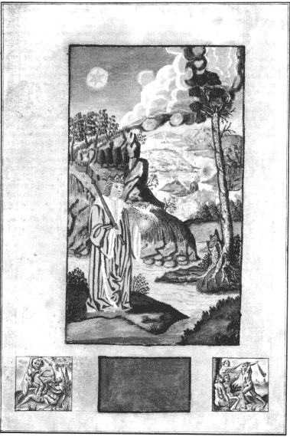
The Splendor Solis is one of the most beautiful of illuminated alchemical manuscripts. The earliest version, considered to be that now in the Kupferstichkabinett in the Prussian State Museum in Berlin, is dated 1532-35, and was made in the form of a medieval manuscript and illuminated on vellum, with decorative borders like a book of hours, beautifully painted and heightened with gold. The later copies in London, Kassel, Paris and Nuremberg are equally fine.
The example in the Bibliotheca Philosophica Hermetica is a later copy, probably made in the 17th century, of one of the earlier manuscripts. It is not quite so finely executed and regrettably the colours have faded and the paint in places has been worn off the paper, but, it still gives us a good impression of the quality of the original artwork.
The work itself consists of a sequence of 22 elaborate images, set in ornamental borders and niches. The symbolic process shows the classical alchemical death and rebirth of the king (see items 6 and 25), and incorporates a series of seven flasks, each associated with one of the planets. Within the flasks a process is shown involving the transformation of bird and animal symbols into the Queen and King, the white and the red tincture. This echoes the Pretiosissimum Donum Dei sequence (see item 2) which is probably earlier, dating from the 15th century. Although the style of the Splendor Solis illuminations suggest an earlier date, they are quite clearly of the 16th century. The figure displayed here is number seven, the death of the old king and the rebirth of the new.
The Splendor Solis was associated with the legendary Salomon Trismosin, allegedly the teacher of Paracelsus. The Trismosin writings were later published with woodcut illustrations, in the Aureum Vellus, oder Guldin Schatz und Kunst-kammer, 1598, which was reprinted a number of times. A French translation, entitled La Toyson d’or, ou la fleur des thresors was issued in Paris in 1612 with a number of very fine engravings, some copies of which were hand-coloured.
The Bibliotheca Philosophica Hermetica recently commissioned the artist Laurie Lipton to produce a version of the images from the Splendor solis in a series of coloured pencil drawings, one of which is displayed in our exhibition.

27. L’AGNEAU, David [fl. 1608-42]
Harmonie mystique. Paris: Melchior Mondiere, 1636.
8°. [26] + 482 + [14] pages. 168 x 106 mm. Folding plate inserted after page 482. 158 x 96 mm.

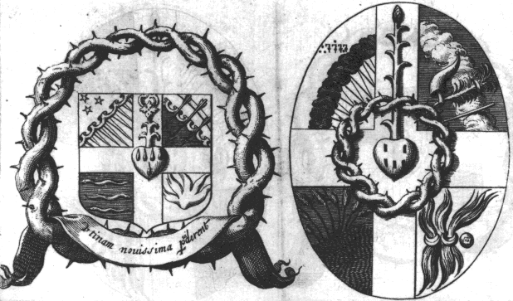
This is a standard work on alchemy of the early 17th century. It was first printed in Latin in 1611 at Paris under the title Harmonia seu consensus philosophorum chemicorum. The work is essentially a collection of short extracts from various hermetic philosophers gathered under 17 chapter headings which cover various aspects of alchemy, such as the various names for the philosophers’ stone, the number of materials from which the stone is made, the various operations necessary, the types of fire used, the colours which appear during the preparation, the method for multiplying the stone, and the projection. Each section of quotations is followed by a commentary by l’Agneau.
At the end of this work a very curious engraving is inserted of two hieroglyphic shields. This is of especial import as it uses alchemical imagery in a heraldic content. Heraldry uses several terms paralleled in alchemy, for example the silver and gold colours on a coat of arms are called ‘tinctures’, and animals forms such as the lion, griffin, and eagle are often used. Hermetic symbolists had used heraldry in their works, for example the Buch der heiligen Dreifaltigkeit has five figures with heraldic shields (see item 11), and the Splendor solis (see item 26) opens with a heraldic shield bearing the image of the sun.
The engraving in l’Agneau shows two hermetic escutcheons, at the centre of which is seen a heart, from which five drops of blood run down, and out of which a new growing shoot springs forth. This obvious Christian reference is further emphasised by the shield incorporating the crown of thorns. The four quarters of the shields show symbols of the four elements, indicating that for l’Agneau the passion of Christ should be paralleled with the transformations in the alchemical work.

28. ASHMOLE, Elias [1617-1692]
Theatrum Chemicum Britannicum. London: J. Grismond for Nathaniel Brooke, 1652.
4°. [18] + 486 + [8] pages. 188 x 135 mm.
Frontispiece 130 x 84 mm. "T. Cross sculp:’’. Small engraving on title-page of Serpent, Toad and Eagle. 56 x 41 mm. 6 plates (approximately 140 x 110 mm) in Norton’s Ordinall. ‘Ro: Vaughan sculp:’ on pages 13, 28, 44, 51, 91 and 102.
Folding plate of Ripley’s Wheel inserted before the text of Ripley’s ‘Twelve Gates’ on page 117. ‘John Goddard sculpsit’. Page 210 Preface to Hermes bird ( 152 x 121 mm.). Page 211 woodcut of two intertwined dragons between sun and moon. Page 231 engraving at beginning of Hermes bird. Page 226 engraving of Chaucer. Page 348 engraving of herb ‘Lunayrie’. Page 350 engraving of ‘Spiritus, Anima, Corpus’.

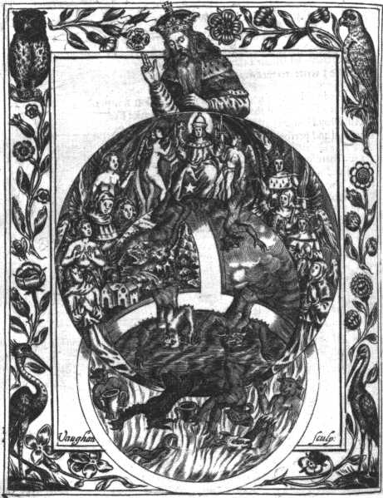
Elias Ashmole collected a mass of alchemical verse in English into this volume, most of it describing mystical and symbolic, rather than practical workings. It included the Ordinall of Alchimy by Thomas Norton, together with George Ripley’s Twelve Gates and some of his shorter works, John Dastin’s Dream, Thomas Charnock’s Breviary of Philosophy, Bloomfield’s Blossoms, and a number of shorter pieces. The engravings made for Norton’s Ordinall by Robert Vaughan, were in the style of a medieval manuscript book of hours, with ornate decorative borders incorporating plants and animals. It is likely that he worked from an early manuscript, probably the copy now in the British Library (MS Add. 10302.)
The engraving displayed is similar in style to the series illustrating Norton’s Ordinall. God creates the realm of the angels, and within it the globe of the earth. Through the earth globe the fallen angels descend into the sphere of hell below. The following verse is attached to this figure (in modernised English):
In the name of the holy Trinity,
Now send us grace, so it be:
First God made both Angel and Heaven,
Nay, also the World with planets seven;
Man and woman with great sensuality,
Some of estate, and others in their degree;
Both beast and worm for in the ground creep,
Every each in his kind to receive his meat.
Eagles and fowls in the air do fly,
And swimming of fishes also in the sea:
With vegetable moisture and of the red grape,
And also of the white can him take:
All mineral things that groweth in the ground,
Some to increase and some to make an end:
All these bringeth now to our house,
The mighty Stone that is so precious,
This rich ruby, that stone of price,
The which was sent out of Paradise:
Thus made the great God of heaven,
Which all be ruled under planets seven:
God send us part of this secret,
And of that heaven that is sweet.
Amen.

29. SIEBMACHER, Johann Ambrosius [?-1611]
Wasserstein der Weisen. Frankfurt: Christoph le Blon, 1661.
8°. [2] + 206 pages. 152 x 93 mm.
Engraved frontispiece 132 x 82 mm.

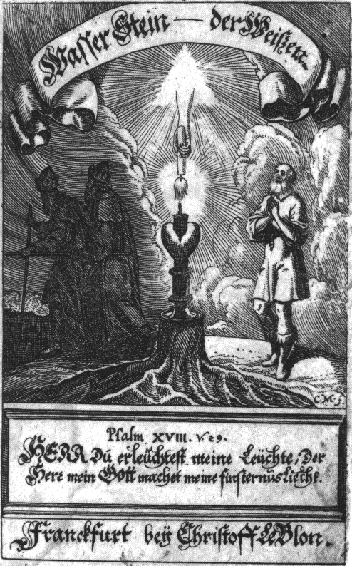
The ‘Waterstone of the Wise’, sometimes also called the ‘Sophic Hydrolith’, is an important text of spiritual alchemy. It clearly draws parallels between hermetic ideas on transmutation and the religious ideas at the heart of Christianity. It was a work much admired by 17th-century readers, and it was, consequently, often reprinted. It was translated into Latin and English, and included in some important compilations. The first edition of 1619 was commended by Jacob Boehme in his Epistles (number 23), as it paralleled his own system of mystical Christian alchemy.
The frontispiece illustration, which was not included in early editions, shows the hand of God descending from the radiant triangle of the Trinity, bearing a torch which sets alight a lamp in the heart. The text, taken from Psalm 28, verse 29, reads: "For thou wilt light my candle: the Lord my God will enlighten my darkness". The work is divided into three sections. The first short section deals with the best means of preparing oneself for the study of the great art. The second section contains a description in physical terms of the alchemical work. The third section, by far the longest in the book, and the one which made most impact, drew precise and clear parallels in symbolic terms between the life of Christ, his death and resurrection, with stages in the alchemical process.

30. [Chymica Vannus]
Reconditorium ac reclusorium opulentiæ sapientiæque numinis mundi magni. Amsterdam: Johannes Janssonius van Waesberge & Elizaeus Weyerstraet, 1666.
4°. 292 + [2] + 76 + [2] pages. 198 x 167 mm.
Frontispiece printed in red ink Character Adeptorum; repeated before page 1 of second treatise in black. 22 engravings. Page 5 Chorus Philosophorum. Page 30 Circus Magicus. Page 192 Strata & Prata Elysii. Page 249 Cavea Sibyllarum. Pages 251-270 14 diagrams. Orbis Solis. Orbis Lunae. Orbis Martis. Orbis Mercurii. Orbis Jovis. Orbis Veneris. Orbis Saturni. Pages 279-284 3 diagrams.

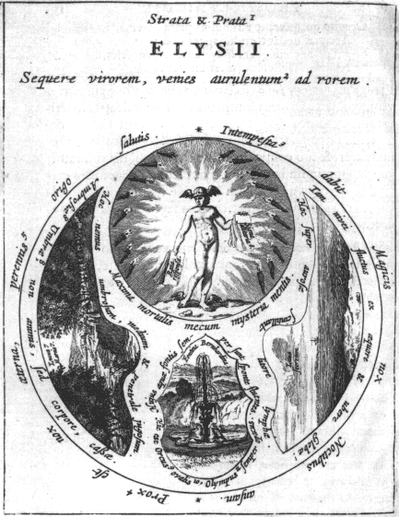
The ‘Vannus’ of the title is a winnowing fan for beating grain to free it from its husks, and also carries the meaning of a ritual mystical object used in the Dionysian mysteries. In this sense it is a hermetic tool for separating the true kernel of spirit from the husk of matter. This whole work is saturated in classical imagery. In a long introductory section the author draws parallels between classical mythology and hermetic ideas, using images such as the water of Lethe, Scylla and Charybdis, and the golden fleece. He quotes extensively from Latin poets. It has a rather fine series of seven engravings showing the planets as classical gods.
The plate depicting the Elysian plains and fields links together various hermetic symbols. In the ancient Greek mystery rites, initiates were introduced to a secret that would transform their lives. This same secret is shown in this plate as Hermes or Mercury, revealed in the blaze of the initiates’ torches, and holding out the promises of healing signs and considered responses or oracles. From the underworld below comes the ever flowing fountain of Bernard. This is a reference to an allegory of Bernard of Treviso in which the hermetic work is pictured as the taming of a fountain.

31. MONTE CUBITI, Vigilantius de
Dreyfaches hermetisches kleeblat. Nuremberg: Michael and Johann Friderich Endter, 1667.
8°. [22] + 448 + [32] pages. 157 x 90 mm.
Frontispiece and 16 engravings (approximately 135 x 75 mm) inserted after pages 210, 212, 218, 224, 226, 232, 240, 244, 248, 284, 288, 296, 298, 318, 354 and 354.

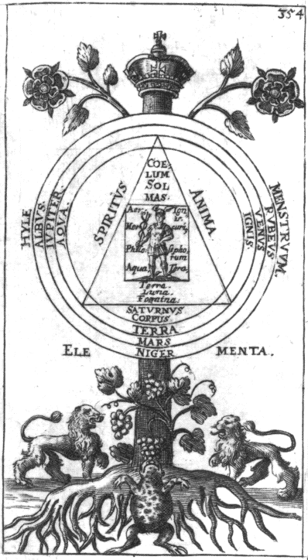
This book is a compendium of three tracts, one by Jacques de Nuysement on the philosophical salt, another by Marsilio Ficino on the philosophers’ stone, but it is included in this exhibition primarily because it contains a German translation of a rather rare work by Samuel Norton [1548-1604]. This latter work is a collection of eight short Latin tracts all printed at Frankfurt in 1630 by William Fitzer under the title Mercurius redivivus, actually one of the titles in the collection. A version in German was also included in C. G. H.’s compilation Eines wahren Adepti besondere Geheimnisse von der Alchymie, 1757.
Samuel Norton was the great-grandson of the English alchemist Thomas Norton, who wrote the long poem ‘Ordinall of alchemy’ included in Ashmole’s Theatrum Chemicum Britannicum, 1652 (see item 28) and translated into a Latin prose version by Michael Maier in his Tripus aureus, 1618.
Norton’s works are especially interesting for the series of original engravings, 14 of which take the form of strange abstract symbolic trees, relating in form to the ‘Arbor philosophiae’ of Raymund Lull (see item 3).
The tree diagrams are most interesting as they are devised to show the relationships between different alchemical operations. Norton’s work is not, however, merely concerned with physical alchemy. Though he outlines the physical process and the work with substance, his approach is thoroughly philo-sophical and allegorical in tone, yet refreshingly direct.
In the tree diagram at the end of one of the books in this collection, the Alchymiae complementum, we see a stylised tree topped with a crown. Set upon this tree is a circular space with a triangle and square, at the centre of which is the philosopher’s mercury, which unites in itself heaven and earth, sun and moon, masculine and feminine, with the four elements. This miraculous substance, which can also be understood as a state of mind in which one becomes aware of the spiritual aspect of all these facets of being, also bears within it the spirit, soul and body; the black, white and red stages of the work; hylè (or the primal substance), menstruum (the medium through which this is transformed) and the elements (in which it manifests itself). At the base of the tree are two lions, which are symbols often used in alchemy to signify the raw, untamed power of Nature. At the root of the tree is a toad nourishing itself upon a bunch of grapes. The toad was often symbolical of the stage of decay, or putrefaction, the breaking down that is necessary before the new synthesis which results in the embodiment of the spirit, i.e. the transmutation of spiritual alchemy, can come about.

32. VREESWYK, Goossen van [1626- after 1689]
De Groene Leeuw, of het licht der philosophen. Amsterdam: Johannes Janssonius van Waesberge for the author, 1674.
8°. [16] + 246 + [10] pages. 144 x 89 mm.
17 engravings, approximately 50 x 65 mm.

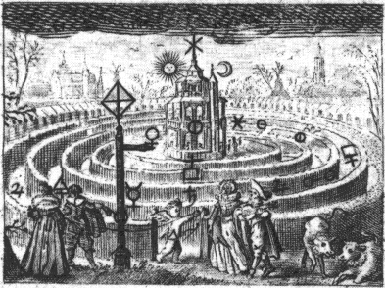
Goossen van Vreeswyk was a much-travelled expert on mining who had an extensive knowledge of minerals. In the 1670’s and 80’s he wrote nine alchemical works, which consist of alchemical philosophy, practical instruction and recipes for preparing extracts drawn from the animal, vegetable and mineral kingdoms. He was particularly inspired by the writings of Basil Valentine from which he continually quotes, and he also relies on Paracelsus as an authority. He also employs imagery from the Bible. Many of his works are illustrated with elaborate series of engravings which have a more symbolic and hermetic content. They often use an enigmatic juxtaposition of imagery - trees, vessels of liquid, fire, vegetation and animals - which have alchemical symbols of various substances, the metals, antimony, sal ammoniac, sulphur, tartar, etc., placed upon them. His works on the ‘Golden Lion’, 1671, has 16 engraved plates, the ‘Red Lion’, 1672, has a series of 15 emblems, the ‘Green Lion’ of 1674 has 18 emblematic figures, and the ‘Continuation of the Cabinet of Minerals’ issued in 1675 has a series of 17 engravings.
The engraving of the hermetic maze is among van Vreeswyk’s most interesting images. A winged cupid with bow and arrow, and marked with the sign of fire, is leading by a string a man and woman in courtly dress towards the entrance to a maze. These are serenaded by a pair of musicians, the man playing a guitar. A signpost at the entrance points the way, and cattle (perhaps a bull and a cow) play outside the maze. Those who enter the maze encounter various alchemical substances on their journey to the centre, where an elaborate triple tower is seen topped by the sun and moon. This symbolises an inner journey that must be undertaken in order for the hermeticist to experience the sun and moon within. Van Vreeswyk especially draws our attention at this point to the importance of the ‘Twelve Keys of Basil Valentine’ (see item 23).

33. BALDUIN, Christian Adolph [1632-1682]
Aurum superius & inferius aurae superioris & inferioris hermeticum. Amsterdam: Johannes Janssonius van Waesberge, 1675. Amsterdam: Johannes Janssonius van Waesberge for the author, 1674.
12°. [20] + 96 + [13] pages. 132 x 74 mm.
Extra engraved title-page 114 x 126 mm and two folding plates. The first inserted after page 42, 112 x 135 mm; the second after page 92, 114 x 134 mm, signed "S. decker. j.n.cl.f."

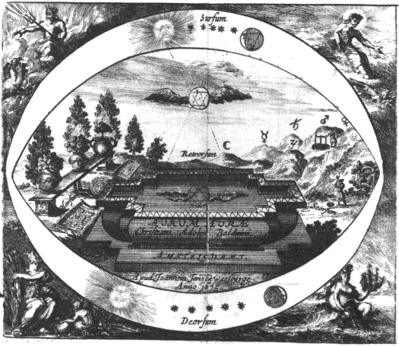
The emblem chosen from Balduinus’ book illustrates the hermetic maxim from the ‘Emerald Table’: "That which is above is as that which is below, and that which is below is as that which is above."
At the four corners are depicted the four elements - Fire, Air, Water and Earth - personified as Gods and Goddesses within their elemental kingdoms. In the heavens on high, ‘sursum’, we have Sun and Moon with upward and downward pointed triangles marked upon them, together with the five other planets. These triangles are conventional symbols for Fire and Water respectively. Down below, ‘deorsum’, we have a mirror image of the Sun, Moon and planets. On the plane of the earth we see a strange basin, above which hovers the conjoined triangles bearing wings. Rays descend from the heavens and in a way project this conjoined image into the water lying in the basin. This is labelled ‘retrorsum’, meaning reversed, or mirrored. The spiritual image from the heights of the cosmos has been reflected and projected into the substance in the vessel below. This is the view hermeticists had of the material world - that it was sustained and informed by the spiritual forces from the Macrocosm.
Human beings can work with matter in two ways. Either following the person on the right who seeks to divide and separate the spirit from matter -‘seorsum’, or enter upon the work of uniting and harmonising these forces - ‘horsum’, represented through the growing of plants in the garden.

34. FRANCKENBERG, Abraham von [1593-1652]
Raphael oder Artzt-Engel. Amsterdam: Jacob von Felsen, 1676.
4°. [2] + 47 pages. 225 x 173 mm.
Engraved extra title-page, 216 x 168 mm.

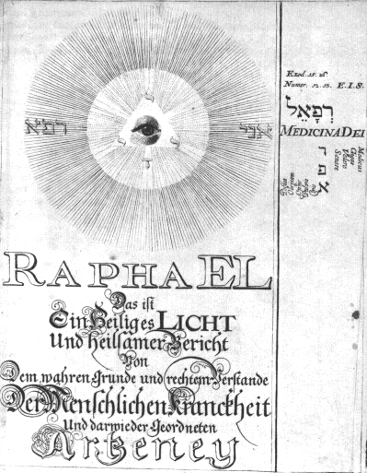
This work by Franckenberg is a synthesis of mystical, hermetic and Christian kabbalistic ideas. In the margins are numerous small kabbalistic diagrams and tables of correspondences. The work uses the theme of healing on different levels, for example using the metaphor of Jesus Christ healing the wound of the Fall in humankind, or the capacity of the philosophers’ stone to heal imperfect metals. The text is full of quotations of verses from the Old and New Testaments, and the author attempts to tease out hidden meanings from various key words. The marginal figures illustrate symbolically important philosophical points. An example, used a number of times in the book, is that of the cube, the hidden Stone of the Philosophers, which is simultaneously Jesus Christ, the Corner Stone, the Alpha and Omega of the work (see Michelspacher, item 15).
This work was reissued in 1687.

35. FRANCKENBERG, Abraham von [1593-1652]
Oculus æternitatis. Amsterdam: Henricus Betkius and others, 1677.
8°. [16] + 198 pages. 137 x 78 mm.
One engraving inserted after page 58, 222 x 167 mm, [the second missing].

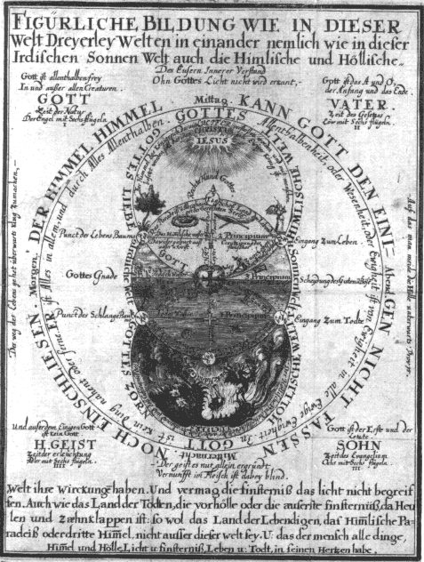
Abraham von Franckenberg was one of the most dedicated supporters of Jakob Boehme. He wrote a short biography of Boehme which served to promote him as a great mystic, and this did much to foster the development of Boehmist groups and the flowering of this stream of mysticism in the 17th and 18th centuries. Franckenberg, however, was not a mere follower of Boehme, but a thinker and mystic in his own right. Only a few of his works were printed in his lifetime but some fourteen titles appeared in print during the 30 years following his death. Among these is the Oculus Aeternitatis.
In this work is a fascinating complex diagram, which a century later was included in the Geheime Figuren (see item 58). This diagram was first used in the 1663 edition of Boehme’s Viertzig Fragen, also published by Betkius, and this plate was copied and used again by Betkius to illustrate this work of Franckenberg. It shows the three worlds, the heavenly, the earthly and the infernal realm (see Ashmole, item 28). The outer circle shows that God cannot be enclosed, for "in God is nothing, near or far; he is everything in everything and through everything, everywhere", which echoes the formula "God is the circle whose centre is everywhere but whose circumference is nowhere" (see items 1 and 46). The three worlds meet at one point in the human heart, showing that the human being bears within his heart heaven and hell, light and darkness, life and death. This echoes the symbolism found in the engraving to Gichtel’s edition of Boehme’s Von Christi Testamenten (see item 40).

36. ALTUS [Isaac Baulot]
Mutus liber. La Rochelle: Petrus Savouret, 1677.
2°. 17 folios. 315 x 212 mm.
Fifteen plates approximately 268 x 187mm, with a single folio at end with text entitled ‘Privilège du Roy’.

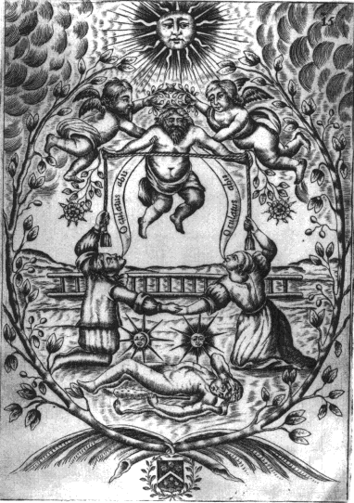
The Mutus liber, so called because it has no text, only pictures, is one of the classic works of alchemy. Its pictures are quite familiar as they have often been reproduced in present-day works on symbolism, but though these images seem clear and straightforward, they remain mysterious, have never been completely explained, and their underlying message has not been satisfactorily expounded. Although on the title-page the author hides behind the name ‘Altus’, the ‘high, deep or profound one’, the work itself is now thought, following the discovery of a signature on a manuscript in Marsh’s Library in Dublin, to have been devised by Isaac Baulot. It was first published in 1677, reprinted later in the 17th century and was included in the first volume of the great compilation, the Bibliotheca Chemica Curiosa of 1702.
The Mutus liber contains fifteen large plates, six of which (numbers 1, 2, 3, 8, 11 and 15) are essentially symbolic, featuring biblical and Greek mythological references (plate 1 has Jacob’s ladder, plate 3 shows Zeus-Juno-Neptune, and the final engraving depicts Hercules with his club and lion’s skin). The other nine plates seem to describe a physical alchemical process in a sequence of small detailed pictures, like a modern cartoon strip. This process, although seemingly well outlined in the images, remains, despite the continued interest of hermetic scholars, entirely cloaked and obscure. The first plate shows a man asleep on the ground at the foot of Jacob’s ladder. Through the alchemical transformation he is awakened to the spirit and in the final plate he is seen kneeling, gazing upwards and holding a cord let down from the heavens above, from which a rose descends above his head, symbolising that the philosophers’ tincture springs from and is rooted in the spiritual world.
In recent years the Bibliotheca Philosophica Hermetica commissioned the artist Laurie Lipton to produce a series of modern drawings of this sequence of emblems.

37. KNORR von ROSENROTH, Christian [1636-1689]
Kabbala denudata seu doctrina Hebræorum transcendentalis et metaphysica atque theologica. Sulzbach: Abraham Lichtenthaler, for Johann David Zunner, the younger. 1677-1684. 2 parts. Part 2: Frankfurt, Balthasar Christoph Wust for Johann David Zunner.
4°. Part 1,1: [26] + 740 pages. Part 1,2: 312 + 8 + 256 pages. Part 2,1: [2] + 38 + [2] + 598 pages. Part 2,2: 478 pages. 206 x 152 mm.
Part 1,1 Frontispiece 192 x 152 mm. (slightly trimmed) "J.C.S. Scul. 1676". Part 1,2 16 inserted plates. Part 2,1 Frontispiece. Part 2,2 one inserted plate.

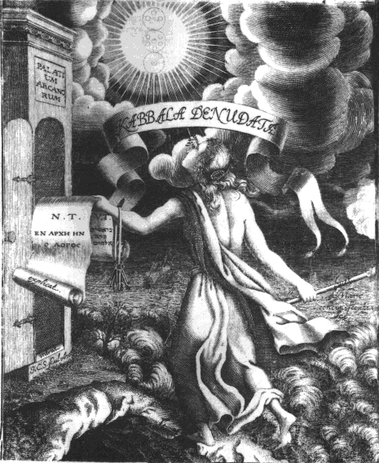
The frontispiece to this work shows a female figure undertaking a journey to find the spiritual. She has avoided the dark cave of matter beneath her left foot, but stands precariously on the shore of the tempestuous ‘Mare concupiscentiam’, the sea of unrestrained desires. Waves crash at her right foot but she overcomes this (‘domat’). The dangers of the sea are all too obvious as a ship is tossed uncontrollably on the waves, its masts broken. In her right hand she holds a torch, bearing the light against the darkness which surrounds her. In her left hand she holds a scroll which bears the Old Testament on one side in Hebrew and the New Testament on the other in Greek, which she can unroll, ‘explicat’, to read the words of the spirit. On her forearm she bears a bundle of keys. Her gaze is set upon the heights, ‘alta videt’, and in an opening through the dark clouds of the ‘Metaphisica gentilis’, the obscurities of the Gentile metaphysics, she can see clearly the image of the kabbalistic Tree of Life, with its ten sephiroth (see Robert Fludd, item 20). She approaches the Palace of the Mysteries, and as she bears the keys, the door is opened to her, ‘intrat’.
This frontispiece must parallel the experiences of Christian Knorr von Rosenroth as he wrote his two volume Kabbala Denudata. In this vast work he included Latin translations of such key mystical kabbalistic works as the Pardes Rimmonim of Moses Cordovero (1522-1570), the Schaare Orah of the 14th-century mystic Joseph Gikatilla, some extracts from the writings of the important mystical reformer Isaac Luria (1534-1572), especially a commentary on 16 kabbalistic diagrams, together with extracts from the Zohar and the Aesch-Mezareph (a kabbalistic alchemical work). Most of these writings had never been available outside the Jewish world, and Knorr von Rosenroth’s translations made the profound mystical ideas at the heart of the kabbalah available to the non-Jewish Christian world. Thus he had the intention of presenting a Christian interpretation of Jewish mysticism, as Johann Reuchlin (1455-1522) had done some two centuries earlier, and Heinrich Khunrath (1560-1605) at the end of the 16th century (see item 14). This had a lasting effect and various writers in the 19th century wholeheartedly accepted Knorr’s ‘Christian kabbalah’.

38. ISABELLA vom HL. GEIST [1606-1675]
Recreationen.
Manuscript. 4°. 62 folios. 290 x 220 mm. Vellum. Late 17th century. [Part 3 only.]
58 miniatures heightened with gold. In three sections. The first with 27 [actually 25] emblems. The second with 13 emblems. The third with 19 emblems.

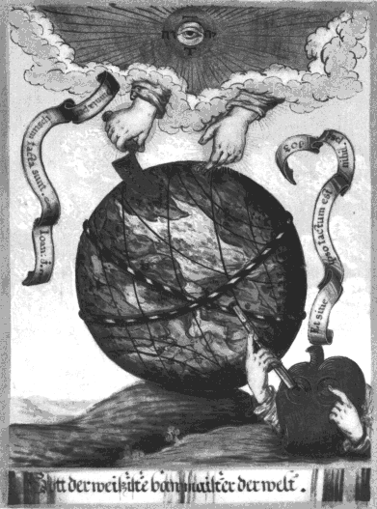
This beautiful illuminated manuscript on vellum was the work of Isabella of the Holy Ghost, a Carmelite nun at the convent in Cologne in the 17th century, whose original name was Charlinda of Urquine. She expressed her mystical visions through the form of a devotional emblem book. Our manuscript, containing the third part only, is an early copy of the original that was kept in Cologne but is now lost.
In her ‘Recreations’ Isabella shows the human soul in the form of a heart. It is doubtful that she was directly influenced by the protestant Boehmist stream of mysticism which also used the heart symbolism (see item 39), but instead we have a parallel mystical expression using the same symbol.
In the first section a heart depicted with two eyes, the right open and looking through a telescope, the left held closed by a finger, examines from the earth a golden circle in the heavens. Following Thomas a Kempis (1380-1471), Isabella shows the right eye as being able to see into eternity (see item 19). The golden circles have the name of God [YHVH] within them and various symbols appear there, for example, radiant light and fire, the book with seven seals. The opening section deals with the nature and attributes of God. In the second section, various winged forms representing angels appear in the globe of light in the heavens. This series shows amongst others the Heavenly city of Jerusalem, the fall of the rebel angels and their defeat by the Archangel Michael. The third section deals with the Creation of the world. The image shown here, of the hands of God emerging from a cloud in rays of light and fashioning the globe of the Earth with a trowel, is from the third section.

39. [KAIM, Paul]
Helleleuchtender Hertzens-Spiegel. Amsterdam and Gdansk: Henricus Betkius and others, 1680.
8°. [14] + 288 pages. 158 x 96 mm.
Frontispiece, three diagrammatic tables and 15 inserted engravings approximately 135 x 75 mm.

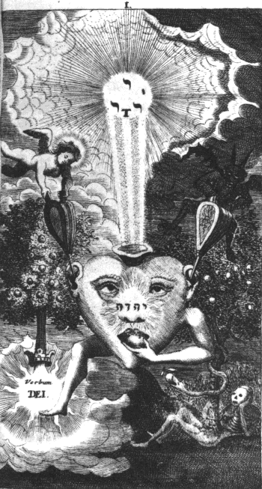
This work is thought to have been been compiled and edited by Paul Kaim from writings of Abraham von Franckenberg (see items 34 and 35). Although the title-page indicates that it is written following the deep principles and powerful doctrine of the highly illumined Johannes Tauler (the 14th-century German mystic), it owes much to the mystical philosophy of Jakob Boehme. Paul Kaim had written to Boehme in 1620 asking him about the ‘end of time’, and was answered in letters 8 and 11 of Boehme’s posthumously published Epistles. Kaim also wrote learned commentaries on the Song of Songs and the Book of Revelation. He was a chiliast, believing in an imminent end of the world, though he faced this calmly. He saw no place for the organised Church and the rituals of religion in the quest for God, believing that inward illumination was the only basis for spiritual growth. Thus he believed in internal absolution, inward Baptism, and inner union with the divine.
The Helleleuchtender Hertzens-Spiegel was a popular work, in which Kaim leads us upon a spiritual journey of the human heart and the obstacles it meets on its quest for spiritual enlightenment. The series of fifteen images were most likely engraved by Nicolaus Häublin, who illustrated a number of works for the German followers of Jakob Boehme.

40a. BOEHME, Jakob [1575-1624]
Von Christi Testamenten. Amsterdam: [Andries and David van Hoogenhuysen for Johann Georg Gichtel], 1682.
8°. [2] + 108 pages. 155 x 95 mm.
Frontispiece. 146 x 90 mm.
40b. BOEHME, Jakob
Opus mago-cabbalistico-philosophicum et Theosophicum.
Manuscript. 4°. [2] folios + 66 + 692 columns.
Drawings based on the engravings in the 1682 edition of Boehme’s works.

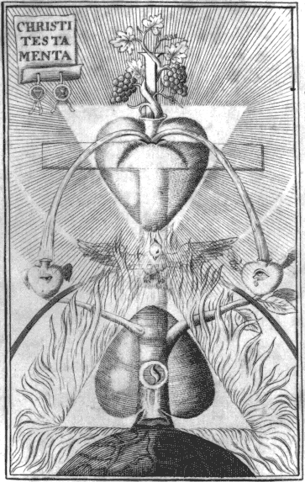
Jakob Boehme being a humble self-taught man, stood outside the learned theological circles of his time. During his early life he experienced profound mystical experiences which led him to contemplate the nature of the world in a new way. During 1612 he wrote down his visions in his Aurora, in which he promised to show the true roots of philosophy and theology. His ideas were revolutionary, as he had been able to solve the previously impossible problem of good and evil in protestant theology, by demonstrating how evil arises as part of the process of the emanation of God in creating the lower worlds. This idea arose from his understanding of hermetic philosophy, gained through his reading of Paracelsus and later mystical writers such as Weigel, and even alchemical works such as the ‘Waterstone of the Wise’, all of which he fused with a christian mysticism which also incorporated ideas from kabbalistic cosmology, and he may possibly have had access to the ideas of Isaac Luria on the emanation of the worlds. Boehme was able to make the struggle of good and evil an essential part of the dynamic of existence. His use of symbolism as a means for expressing mystical ideas allowed him to transcend the problems inherent in the theology of his time which was rooted more in logic and the spiritual barrenness of 17th-century Lutheran scholasticism.
His work was badly received by his local pastor when it was circulated in manuscript, and he was banned from further writing. However, his ideas became known to a circle of supporters, and he continued quietly to write, but not to publish his ideas.
Boehme only lived to see one of his works in print, Der Weg zu Christo (‘the Way to Christ’), and that only in the last year of his life. By then, he was already well known to a growing band of free-thinking mystical theosophers. Over the next fifty years many of his works were published piecemeal in German, Dutch and English, but in 1682 Johann Georg Gichtel, one of Boehme’s most ardent followers, edited his collected writings from original manuscript sources. Thus was issued the definitive version of Boehme’s vast works. Each of the titles in this collection was preceded by an engraved frontispiece illustrative of the content of the book. Despite much research, the engraver of these plates has not been identified.
We show here the frontispiece to Von Christi Testamenten. This illustration incorporates many of the symbolic themes of this exhibition. A tree grows up from the globe of the earth and is transformed in its upper part into a cross. Upon this cross a heart is crucified and two streams of blood descend from the heights upon two soul hearts, the one on the right having an open eye that can see into eternity, that on the left rests with its eye closed, unable to perceive the glory of the higher world of light (see items 38 and 39). The dove of the spirit hovers above the mirrored upside-down heart in the fiery triangle rooted in the outer material world, while the light-filled triangle is about to descend and unite itself through the holy spirit with the lower world. This is an image simultaneously reflecting the incarnation, passion and resurrection of Christ and the hermetic process of the transmutation of the soul.
The Bibliotheca Philosophica Hermetica also possesses a fine 18th century manuscript of Boehme’s works in German from the 1682 Gichtel edition. This manuscript contains fine drawings of the engravings.

41. COENDERS van HELPEN, Barend [1601-1678]
Escalier des sages ou la philosophie des anciens. Groningen: Charles Pieman, 1689.
2°. [8] + 240 + [3] pages. 318 x 196 mm.
Frontispiece and 17 engraved plates 286 x 184 inserted.
Frontispiece, ‘Escalier des Sages’. Before page 1, ‘Alchimia’. 5 small geometric diagrams inserted after pages 8, 10, 22 and 24].
Inserted before page 29, ‘Chaos’. Inserted before page 37, ‘Calor’. Inserted after page 88, ‘Amor’. Inserted before page 127, ‘Ignis’. Inserted after page 140, ‘Ignis Phm’ [Philosophorum]. Inserted before page 159, ‘Aer’. Inserted before page 169, ‘Aqua’. Inserted before page 177, ‘Terra’. Inserted before page 191, ‘Sulphur’. Inserted before page 199, ‘Mercurius’. Inserted before page 105, ‘Sal’.

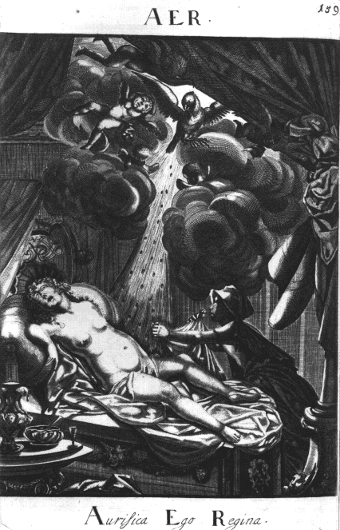
Escalier des Sages uses the stylised device, often found in hermetic texts and elsewhere, of a dialogue between two parties, in this case ‘Francois’ and ‘Vrederic’, whose discussions allow various points to be presented to the reader. The book is divided into four sections - the first dealing with the prime or first matter of the philosophers’ stone, the next with the two opposing qualities, the third with four elements, and the fourth deals with the three principles of Sulphur, Mercury and Salt. The one matter, two qualities, three principles and four elements constitute a ladder of ten steps or degrees. These are illustrated by large full-page engravings, most of which draw on classical mythology as well as hermetic ideas for their symbolic content. As an example we show here the figure for Air, which here does not stand for the common air, but for the Air of the Philosophers. This air is the medium for the light of the spirit. In this figure the word ‘Aer’ is expanded to mean ‘Aurifica Ego Regina’ - "I am the gold-bearing queen". The image of Danae being impregnated through the air in a shower of gold, by Zeus pictured as a eagle, and conceiving the hero Perseus who was to cut off the Gorgon’s head, is taken from classical mythology. This myth was quite popular in paintings and individual artists imbued it with all sorts of allegorical meanings, although in this work it must be seen in a purely alchemical and hermetic context.
The gold, or light of the spirit descends from above into the womb of the air. Coenders van Helpen quotes here from the ‘Emerald Table’ "the Wind carried it in its belly". The text gives a detailed analysis of various aspects of the air, its relationship to light and to fire, its three different types, and the ways in which it is used in the philosophical work. The book quotes extensively from such alchemical writers as Hermes, Petrus Bonus, Bernard of Treviso, Paracelsus, and Sendivogius.
This work was reissued in Paris later the same year with a new title-page, Introduction à la philosophie des anciens, and a third edition appeared in Cologne in 1693 as Thrésor de la philosophie des Anciens

42. WEIGEL, Valentin. [1533-1588]
Studium universale. [n.p.] 1695.
8°. [55] folios. 158 x 90 mm.
Frontispiece: engraving of tree 148 x 86 mm.

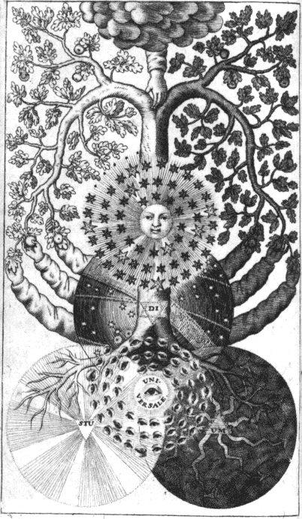
Valentin Weigel was a pastor in Zschopau, who wrote a number of mystical and philosophical works. Most of the writings published under his name circulated in manuscript copies but were not printed until after his death. In the early 17th century his ideas were taken up by people like Isaias Stiefel and Ezechiel Meth, who created an interest in Weigel through their own work, and developed a Weigelian movement or school. During this period a number of works were issued under his name which were obviously not written by Weigel, but it is difficult to untangle the ways in which his writings were published, or indeed whether the ideas in the later works were really representative of his thinking. Weigel was basically a neoplatonist and was deeply influenced by Eckhart, Tauler and German theology in general. Weigel was considered by some as a proto-Rosicrucian.
Weigel’s mystical philosophy, which draws to some extent on Paracelsus, must have had an influence on the writings of Jakob Boehme. Certainly, the 17th-century Weigelians allied them-selves closely with the Boehmists. Boehme even wrote a work (in 1622) in response to questions raised by an exposition of some Biblical texts by Isaias Stiefel. Although he corrected and distanced himself from the ideas in Stiefel’s text, it seems that Boehme still remained sympathetic to and well disposed towards Stiefel and other Weigelians.
The work displayed here is most probably not by Weigel, however, it contains a marvellous engraved frontispiece, which was later used in the Geheime Figuren, 1785 (see item 58). The tree of the knowledge of good and evil has its roots in the sphere of light on the left, and the realm of darkness on the right. The hand of God descending from a cloud above, cleaves the tree in two, one half bearing the apples of light, the other dark fruit. Three hands on each side reach out of the globe of the earth to touch leaves, fruit and branches.
Weigel, like Boehme after him, struggled with the problem of duality, with seeing the world as the battlefield of light against darkness, good against evil. However, Boehme was able to digest and synthesise the polarities into his theosophy and made this dualism the centre of the dynamic of creation - darkness becoming essential to the manifestation of light. This was something he gained from his understanding of alchemical transmutation and hermetic philosophy. For Boehme the intricate inner life of humanity arose from it being placed within this dynamic polarity, having to recognise the darkness within the soul and use this creatively in order to grow spiritually. This was a profound step, which has ensured Boehme’s continued relevance for our own times, as his theosophy resonates with our modern conceptions of the inner tensions within the psyche. Weigel’s views were a more naked form of dualism, and it is not surprising that the 17th-century Weigelians developed chiliastic and millenarian views.

43. LIMOJON de Saint-Didier, Alexandre Toussaint de [1630?-1689]
Le triomphe hermétique, ou la pierre philosophale victorieuse. Amsterdam: Henricus Wetstein, 1699.
8°. [14] + 153 + [1] pages. 166 x 95 mm.
Engraved plate inserted after the title-page. 170 x 127 mm.

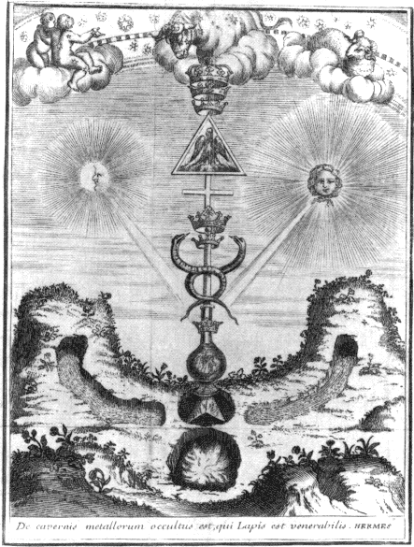
This alchemical work was one of the more popular texts in the late 17th and 18th centuries, going through many editions in French, English and German. It was included in some important compilations of alchemical works, and the survival of many copies in manuscript proves its continuing popularity. It consists of a pair of dialogues. The first, between Gold and the Philosophers, is called the ‘Ancient War of the Knights’, and in this both sides try to score points against each other as to which is the more perfect. The second dialogue or discourse is between two archetypal figures, named Eudoxus and Pyrophilus. In this discourse Pyrophilus takes the part of a sincere though rather argumentative enquirer, and Eudoxus takes the role of a patient though at times rather patronising teacher of the art of alchemy. Both of these dialogues, filled with allegory and hermetic philosophy, are saved from being tediously didactic by their humorous comments.
The ‘Hermetic Triumph’ is usually printed with a frontispiece illustration which reflects in symbolic form the philosophical points raised in the dialogues. The present illustration shows two rivers flowing from mountains on the right and left. These meet and give birth to the mysterious triangular stone or salt, appearing as a three-dimensional tetrahedron, which on being heated by the secret fire, sublimes and sends its vapours high into the flask. These vapours receive the essences of the Sun and Moon raying down upon them and thus the first stage is completed by the first crown being placed on the flask. In the next stage this is converted into the philosophical mercury, shown as the caduceus, which receives the second crown. The final spiritualisation of substance is achieved through the formation of the philosophic sulphur, here symbolised by the phoenix arising from the flaming ashes, and above we see the triple crown. The alchemists sought to redeem fallen matter and spiritualise it into an agent that could transform and give benefit to humankind. "In the caverns of the metals is hidden the stone of the venerable Hermes", states the caption. Thus the alchemists sought in the mundane for the principle that could spiritualise and transform their lives.

44. Drey curieuse chymische Tractätlein, betittelt: Ambrosii Müllers, Paradeis-Spiegel. Der teutschen Schützen-Hoff. Beschreibung des grossen Geheimnisses des Steins der Weisen. Frankfurt and Leipzig: Christian Albert Pfeiffer for Christian Liebezeit, 1704.
8°. 128 + 60 + 16 pages. 162 x 95 mm.
Two folding plates inserted between pages 16 and 17 of second book. 4 pages of engraved illustrations (printed on one side of the paper) are found at the end of the first book. These show a series of 28 small figures, in which various archetypal figures Adam, Eve, Cain, Christ and Mary, are drawn into a symbolic alchemical process.

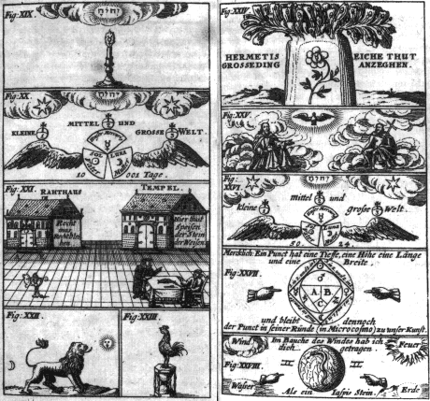
The first work in this collection of three treatises is the Paradise-mirror by Ambrosius Müller. This uses the imagery of the creation story from the Old Testament, fused with the idea of Christ as a second Adam, as a method for exploring symbolically the nature of the alchemical process. Various parallels and associations are drawn between the archetypal characters in this Christianised creation myth, Adam-Christ, Eve-Mary, the planetary metallic substances, and the processes of alchemical transformation.
The text comments upon a series of 28 figures. In this group we see first the artificial light of mercury reflecting the light of God or Jehovah in the heavens. The stone is threefold, having aspects in the three worlds, the Spiritual world of divine things, the outer material world, and the world of the soul. The material domain is reflected in the government of the outer world, whereas the inner world is nourished by the temple where one eats the Philosophers’ Stone, and attains wisdom of divine things. Next the lion and cockerel are shown, both symbolising processes in the transformation. Then we see how the hermetic plant inwardly nourishes the growth of outer nature. Our attention is drawn to the threefold structure of the world, in the highest spiritual world this is exemplified in the Trinity, which is in turn reflected in the three worlds and the triple stone.
The closing images show that this triplicity is in the one, and the unity is again threefold - a common hermetic formula, although it is here extended through the diagram of the manifestation of the point through the three, the triangle, through the one, the circle, into the fourfold square. This image is used often in hermetic works, see for example, Maier’s Atalanta fugiens, (see item 17, emblem 21), or Mylius’ Philosophia reformata, (see item 21, emblem 19). The series of images ends with the formation of the Jasper Stone, borne in the belly of the wind, pictured in the form of a snake.
This book is one among many which try to integrate the hermetic philosophy into a Christian context. Other works shown in this exhibition, which especially attempt the same synthesis, but in different ways, are Reusner’s Pandora, based on the Buch der heiligen Dreifaltigkeit manuscript (see item 11), Siebmacher’s ‘Waterstone of the Wise’ (see item 29), and Jacob Boehme’s Von Christi Testamenten (see item 40).

45. HERMES Trismegistus.
Erkäntnüß der Natur und des darin sich offenbahrenden grossen Gottes, begriffen in 17 unterschiedlichen Büchern... Verfertiget von Alethophilo. Hamburg: Samuel Heyl and Gottfried Leibezeit, 1706.
8°. [64] + 142 pages. 165 x 97 mm.
Frontispiece engraving 150 x 85 mm.

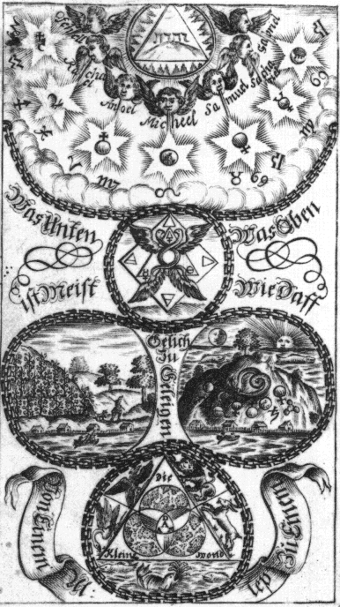
This is the first German translation of the Corpus Hermeticum, the key work of hermetic philosophy originally translated into Latin by Marsilio Ficino at the request of Cosimo de Medici in 1463. This edition consists of 17 books, opening with the Pymander, which introduced a new stream of neoplatonic and hermetic philosophy into European culture. The Corpus Hermeticum has shaped the expression of alchemical, hermetic, Rosicrucian and mystical ideas up to the present day.
This German translation has an interesting illustrated frontispiece, which shows the spiritual world at the top emanating from the Divine name of four letters raying out light. This is mediated through the seven archangels Ofehell, Rachael, Anoel, Michael, Samuel, Sachariel and Gabriel, who in turn manifest their energies down through the worlds by means of the seven planets and the zodiacal signs.
This illustration makes reference to the ‘Emerald Table’, "That which is above is like to that which is below", which is dicussed in the introduction in some detail, stressing the Egyptian origins of Hermes Trismegistus. We see the great chain of being descending through the worlds and ascending again to the spiritual on high. The lowest part of the diagram, ‘the little world’ is centred upon Adam, rather than on Jehovah, the Hebrew name of God. Adam is surrounded by the fish in the water, the animals of the earth and the birds of the air. Just below the world of the spirit is a figure containing the two winged serpents of duality, the salt, sulphur and mercury of the three Principles set in a triangle, and the four elements forming a square. Between this world of the spiritual principles and the outer world below, we have two visions. On the left, we see the ideal of man as custodian and steward of the earth, while on the left we see the planetary metals within the earth and a snake seizing its own tail (the ouroborus), showing the potential energies wrapped up in the cloak of outer substance.

46. FREHER, Dionysius Andreas [1649-1728]
Paradoxa, Emblemata, Ænigmata, Hieroglyphica, de Uno, Toto, Puncto, Centro.
Manuscript. 40 folios. 228 x 168 mm. Early 18th century.
153 emblems, for the most part two per page.

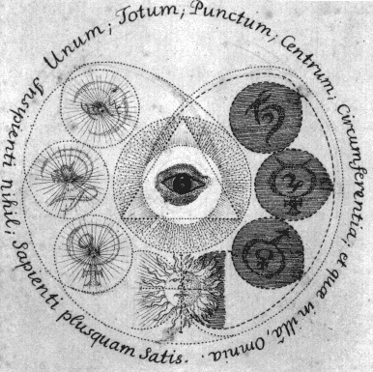
D.A. Freher was a German who settled in London shortly before 1698, and there produced a large volume of commentaries expounding the ideas of the mystical theosopher Jakob Boehme. Freher was a very private person, living a quiet, unobtrusive life, completely immersed in his mystical studies. Over a period of about thirty years he produced a number of works, in particular his Serial Elucidations of the Principles of Philosophy and Theology of Boehmius in 9 volumes, totalling nearly 3000 pages. None of his works were published, but a small group of supporters painstakingly copied his manuscripts and circulated them amongst the small group of English Boehmists.
Freher was especially interested in using symbolic diagrams to explain Boehme’s ideas. In one of his first works, the Three Tables, he resolves the two-dimensional limitation of diagrams on the page, by using opening-out sections, which reveal different layers, exterior and interior spaces. The diagrams in the Three Tables are probably derived from the illustrations used by Gichtel and Graber in Eine kurtze Eröfnung und Anweisung der dreyen Principien und Welten im Menschen (see item 48). In his Hieroglyphica Sacra, he pushes the medium even further, through devising diagrams on a series of consecutive right-hand leaves and by cutting holes through the pages, which allows the text from one diagram to run through the page to another in the sequence.
His Paradoxa was composed between 1717 and 1720, and is in the form of an emblem book of 153 mystical images. Five copies are known to have survived. This series begins with an empty space, "The Centre of Centres is everywhere, the circumference is nowhere" (see item 1), and ends with emblems 152-153 "All things were, are and will be, out of the One, through One and to One - The Kingdom, worship, glory to the One-Triune". Thus Freher begins from the point and its unity and completeness, adding the circumference and then the various relationships that arise from the interweaving and connection of the central point and the peripheral circumference, thereby developing a complex of symbols in the middle of his sequence of emblems, while towards the end we note a new synthesis and return to the simplicity of the One.
Emblem 100, chosen here, bears the text "One, the Whole, the Point, the Centre, the Circumference, and whatsoever is therein. Nothing to the unwise: to the wise, more than enough". This shows the eye in the triangle of light, around which are the ‘Seven Forms of Eternal Nature’ central to the mystical cosmology of Jakob Boehme.

47. WELLING, Georg von [Gregorius Anglus Sallwigt] [1652-1727]
Opus mago-cabalisticum et theologicum. Frankfurt: Anton Heinscheidt, 1719.
2°. [8] + 80 + [2] pages. 349 x 200 mm.
10 folios (some folding) of hand-coloured engravings.

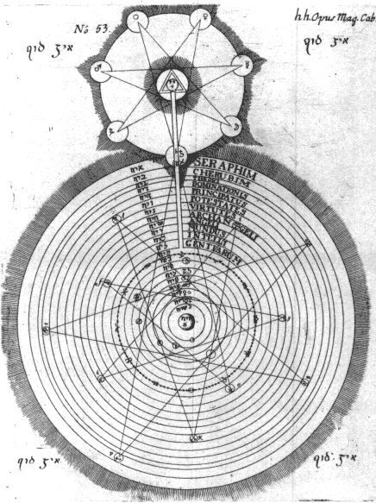
This work by Welling was extremely popular during the 18th century, and went through five editions (1719, 1729, 1735, 1760 and 1784). The Bibliotheca Philosophica Hermetica has copies of all these editions as well as a Dutch translation in manuscript. The work was augmented in the later editions, being extended to deal with the nature of Salt, Sulphur and Mercury in the scheme of Nature. The text is a mixture of precise details of working with physical substances and a deep philosophical and kabbalistic account of the principles of the world and its emanation in the Creation.
The series of diagrams is especially interesting as it uses complex circular figures linked with intricate geometrical patterns. The diagram chosen here is numbered 53 and refers to chapter four, ‘On the archetypal world’. The emanation of the physical world from the astral world of the spiritual archetypes of creation is here symbolically and kabbalistically described. The seven spirits before the throne of God are depicted in the seven spheres at the points of the heptagram rooted in the ‘Ain Soph’, the abyss of creation, in which the highest attribute of the divine has its being. This emanation of form descends from the fire of God in the central triangle, through the work of the nine spiritual hierarchies, from the Seraphim to the Angels, down through a series of increasingly dense spheres, through the spheres of the fixed stars, the zodiacal signs and the astronomical planets, until it finds its end in the outer earthly world marked ‘B’. There are 22 layers to this densification, each linked with a letter from the Hebrew alphabet.
Welling was influenced by his reading of Paracelsus (hence his focus on the three principles), the kabbalah (his figures were probably influenced by the Lurianic cosmological diagrams in Knorr von Rosenroth’s Kabbala denudata, see item 37) and the hermetic mysticism of Jakob Boehme (see item 40).

48. GICHTEL, Johann Georg [1638-1710] and GRABER, Johann Georg
Eine kurtze Eröfnung und Anweisung der dreyen Principien und Welten im Menschen. n.p. 1723.
8°. 175 pages. 186 x 110 mm.
5 inserted hand-coloured engravings.

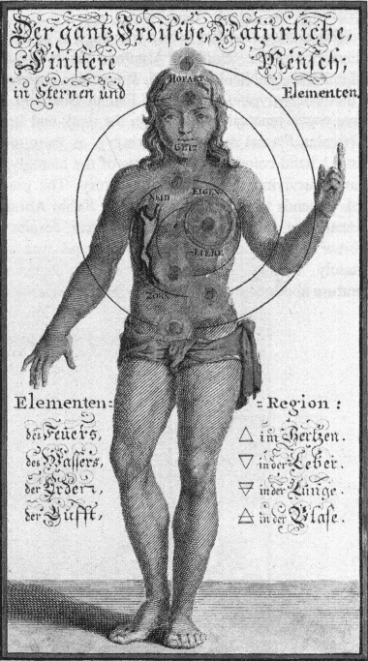
Gichtel was one of the most brilliant of the second generation of followers of Boehme. In the late 17th century he gained access to original manuscript copies of Boehme’s works and set about editing these into his collected works, which were eventually published in 1682. Gichtel was a mystic philosopher in his own right, and corresponded widely with people interested in Boehmist and mystical ideas. Some of this mass of correspondence he distilled into his lengthy Theosophia Practica, which was published in 1722.
This present volume is one of the few other works by Gichtel. It was reprinted in 1736 and 1779. In this work he collaborated with Johann Georg Graber, though it is likely that Graber only provided the illustrations. The imprint on the title-page indicates that this work was written in 1696, although it was not published until 1723. The series of four engravings, hand-coloured in most of the copies of this book, are especially interesting. They demonstrate the evolution of humankind from the spirit. The first state, displayed here, shows how the forces of the spiritual world have been woven into the human form, by means of an inward spiralling of energies through the planets (corresponding to Boehme’s seven forms of Eternal Nature) into the heart. The next two illustrations, the front and rear views of the same figure, show the present state of humanity, bearing a positive side, filled with light and the understanding of the Sophia, and the other darker side has the senses still linked with the hellish region. The last image is that of the regenerated man. This series of three facets of the human condition was taken up by Dionysius Freher (see item 46) in London, who reworked the series into what he called the Three Tables, with intricate layers of opening-out diagrams. An edition of Freher’s Three Tables will shortly be issued by the Bibliotheca Philosophica Hermetica.

49. ABRAHAM ELEAZAR [pseud.]
Uraltes chymisches Werck. [Second part] Donum Dei Samuelis Baruch, des Juden Rabbi, Astrologi und Philosophi... Erfurt: Augustinus Crusius, 1735.
8°. [30] + 122 + [14] pages; [4] + 87 + 26 pages. 171 x 101 mm.
Frontispiece 142 x 92 mm. "J.E. Boeck sculpsit Weÿmar".
Engravings inserted after pages 8, 26, 44, 62, 78, 94 and 108. There are numerous small woodcut illustrations in the text.
The ‘Donum Dei’ has engravings inserted after pages 2, 8, 10, 12, 50, 62, 74 and 82.

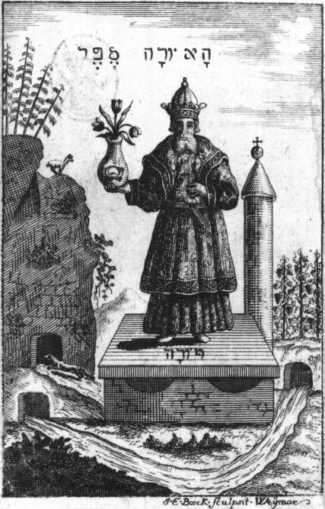
This work purported to be a true copy of an ancient manuscript of the ‘Book of Abraham the Jew’ which had enlightened Nicolas Flamel. It contains engravings of the ‘Hieroglyphic figures’ of Flamel (see item 57). There was a renewal of interest in the work and legend of Nicolas Flamel in the 18th century, as there are at least 11 hand-coloured manuscripts of the hieroglyphic figures surviving from the 18th century. The present book pretends to have been written by Rabbi Abraham Eleazar, but it has little Jewish content despite the Hebrew lettering on the frontispiece, and was most certainly written in the 18th century. Alchemical literature abounds in such falsifications, pseudonymous writings, or works ascribed to earlier authors, but these mystifications do not detract from the value of such texts.
The second work in this book is the Donum Dei of Samuel Baruch. This has no connection with the Pretiosissimum Donum Dei manuscripts (see item 2). It includes a sequence of fifteen engravings, in the same style and by the same artist, and the text was most probably written by the same author, as the work by Abraham Eleazar. This sequence primarily involves the metamorphosis of a serpent through various stages of the alchemical process.

50. VANDERBEEG, I.C. von
Manuductio Hermedico-philosophica. Hof: Johann Ernst Schultz, 1739.
4°. [6] + 312 + [6] pages. 209 x 167 mm.
Frontispiece 186 x 150 mm.

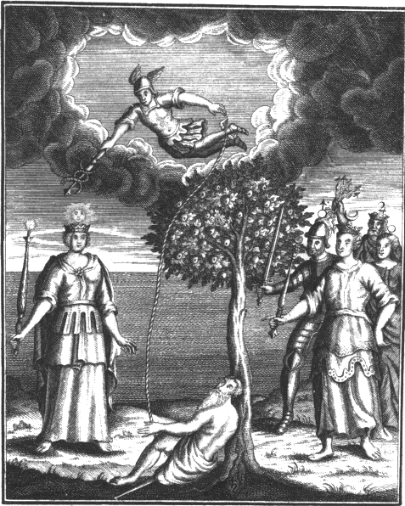
Although this work does have a philosophical content, it is primarily of a practical nature. Many detailed recipes are offered, some for augmenting precious stones, some for preparing important chemical substances, from vegetable or mineral sources, together with medical recipes. The author relies heavily upon writings of Theophrastus Paracelsus. The frontispiece is a fine 18th-century engraving which shows Saturn lying at the foot of a tree by the shore of a lake. He is approached by the Sun and four of the planets. Saturn is united by a cord to the winged Mercury with caduceus, who flies in the clouds above. This is a clear example of the often used image of the earthly substance being tied to the heavenly, based on a phrase from the ‘Emerald Table’ of Hermes: "Unite the subtle with the gross, gently and with great sagacity". This is sometimes symbolised by a toad or frog tied to an eagle, an example being found in the second figure of Michael Maier’s Symbola aurea mensae (see item 16).

51. Des aufrichtigen Hermogenis Apocalypsis spagyrica et philosophica. Leipzig: Johann Samuel Heinsius, 1739.
8°. 224 pages. 167 x 100 mm.
Frontispiece 136 x 79 mm. After page 8 is a large folding engraving 334 x 302 mm inserted, entitled ‘Tabula Aurea Salomonis et Hermetis’.

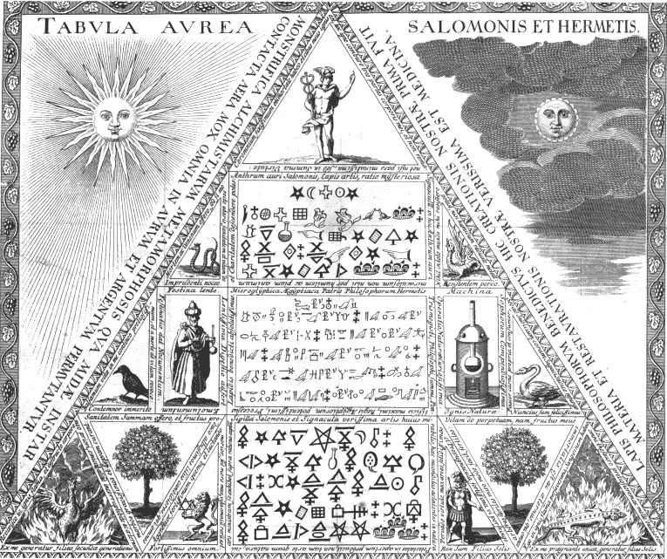
This work contains an intricate and detailed alchemical diagram, and it will be instructive to describe the elements which compose it and summarise the text associated with these individual symbols.
The ‘Golden Table of Solomon and Hermes’ claims to show us the astounding subject and wonderful instrument which will allow us to obtain every miracle heaven or earth has to offer. It symbolically describes the prima materia from which the philosophers’ stone is made, and indicates that once we possess this, then like Midas everything we touch will become like gold. He who has the secret of the philosophers’ stone comes to see the world as full of miracles and marvels, and everything becomes as a precious thing, charged with spirit.
The mysterious science and miraculous art of alchemy brings forth the miracles of the universal medicine, unequalled in the heavens or in Nature. The philosopher who seeks to obtain this must imitate the task of God in the Creation, dividing the chaos into the wonderful bounty of Nature’s things and separating the light and fire from the material of the work. Then through this play with Nature, he will be able to obtain the panacea or tincture, the smallest drop of which will bring forth many thousand times its weight of precious substance. Thus in seeking the spiritual core of matter, the hermetic philosopher gains a treasure far above all, a perception of the workings of Nature.
At the three corners of the triangle are symbols connected with fire in different ways. On the left is the phoenix, which is revived in the flames and its former body destroyed so it arises again in an incorruptible form, and on the right is the salamander, which perseveres in the flames and possesses a blood more precious than any treasure. At the apex of the triangle is Mercury who has possession of all, both fixed earthly things and those which are immortal. He is nourished by fire.
Mercury stands above three rectangular tables at the core of this triangle. The topmost is the golden ‘Anthrum’ of Solomon, showing mysterious symbols, the meaning of which one is not able to discern unless one has a humble and pious mind. Below this are the Egyptian hieroglyphs of the father of philosophers, Hermes Trismegistus, here probably intended to depict the ‘Emerald Table’. Lower down are the seals of Solomon and the truest signs of the art, the powers of which, concealed and latent in Nature, can be released through an understanding of these symbols.
The other symbols in this diagram are linked together in polarised pairs of opposites.
The tree on the left produces white fruits and gives health, while that on the right bears immortal fruits, and makes all things that are sterile to become fruitful.
The lion on the left is the bravest of all beings, the king of beasts. He attacks all things, and his death is the life of all things. The king on the right is the son of the Sun. He can pass through the most solid ramparts and through his force shatter the strongest defences.
The black crow on the left is undeservedly despised, but it holds the most precious balsam of life in itself, and can call back life from death. The swan on the right is a most fortunate messenger. It is being nourished with its own flesh, but will rise again.
The snake on the left harms the imprudent. Although it brings death and poison, if used rightly it will give health and life. The dragon on the right destroys those who resist. Indeed nothing can resist the power of this dragon except the humid root of the metals.
The alchemist on the left holding a flask tells us to hurry slowly, for to rush brings harm. The slowest digestion brings the result. On the left is a furnace, the device of the wise, which incorporates the fire of Nature, and enables one to mimic the curious operation of Nature.

52. WIENNER von Sonnenfels, Aloys [?-1768]
Splendor lucis, oder Glantz des Lichts. Vienna: Johann Joseph Pentz, 1747.
8°. [2] + 219 + [1] pages. 169 x 95 mm. [In German and Hebrew.]
Inserted after page 32 is large folding plate 204 x 153 mm.

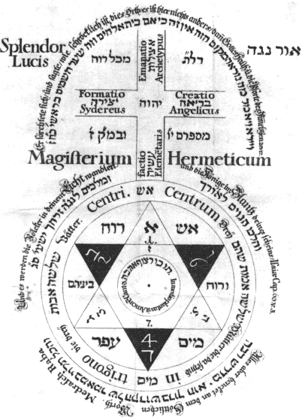
This work is an attempt to unite hermetic and kabbalistic ideas. Some of the chapters are also given in Hebrew. The diagram echoes the concerns of the book, as it uses a well-known hermetic symbol and fuses this with a kabbalistic diagram of the worlds. The diagram is entitled ‘the Splendor of the Light’, which calls to mind the kabbalist’s perception of the highest spiritual domain emanating from light. The top section shows an equal armed-cross (here without Christian context) with the Hebrew name of God YHVH at its center. Each arm of the cross is one of the four worlds which the kabbalists believe emerge from the godhead - Aziloth, the Archetypal World of Emanations; Briah, the Creative World of the Angels; Jezirah, the Starry World of Formation; and Asiah, the Created World of the Elements.
The lower part of this diagram is the ‘Centrum in trigono centri’, which occurs in a number of hermetic works, from the early decades of the 17th century. For example in Henricus Madathanus (or Hadrian à Mynsicht) Aureum Seculum Redivivum, 1621, in the Geheime Figuren of the Rosicrucians (see item 58), and was in the 17th century even carved into the lintel of a symbolic alchemical gate which can still be seen in Rome. The symbolism of this star of David or interwoven triangles, integrates the four elements Earth, Water, Air and Fire; the three Principles of Salt, Sulphur and Mercury, or Body, Spirit and Soul. The central circle suggests the hermetic maxim, that God is the circle whose centre is everywhere and whose circumference is nowhere. This was used by many writers but especially by the Boehmist mystics - Dionysius Freher uses this as the basis of his series of mystical emblems Paradoxa, emblemata, aenigmata, hieroglyphica de uno, toto, puncto, centro (see item 46).

53. Hermaphroditisches Sonn- und Monds-Kind. Mainz: Elias Peter Bayer for Johann Friederich Krebs, 1752.
8°. 70 pages. 159 x 96 mm.
13 inserted engravings cut by F.A. Krebs: "F.A. Krebs. del et sc. Mog". They are all approximately 130 x 87 mm. [Frontispiece missing in this copy.] Plates inserted before page 7, 11, after pages 16, 22, 28, before pages 31, 35, 39, after pages 44, 48, 54, before pages 57, 63. Plates 1, 2, 3, 4, 5, 6, 7, are hand-coloured.

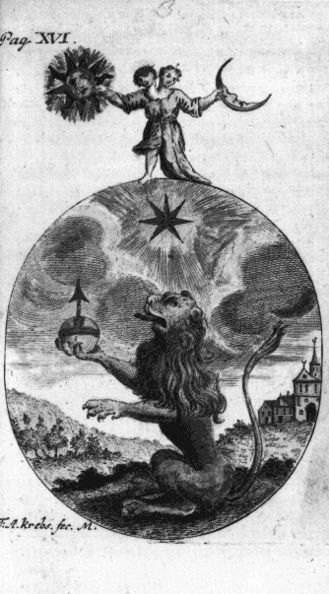
This work consists of twelve sections, each with a poem, connected with an emblematic figure, and a commentary or explanation of the symbolism. It shows how the hermaphoditic child of the Sun and Moon, the philosophic Adam, or first matter of philosophers, undergoes a transformation, through various stages, often pictured with bird or animal symbolism, to a state of perfection.
The author of the verses is said to be Hautnorton, a pseudonym for the 17th-century writer Johann Harprecht, who called himself the ‘son of Sendivogius’.

54. du CHENTEAU, Théodore
Carte philosophique et mathématique. Brussels: 1775.
Large roll (printed from five large plates and pasted together). 2995 x 855 mm.

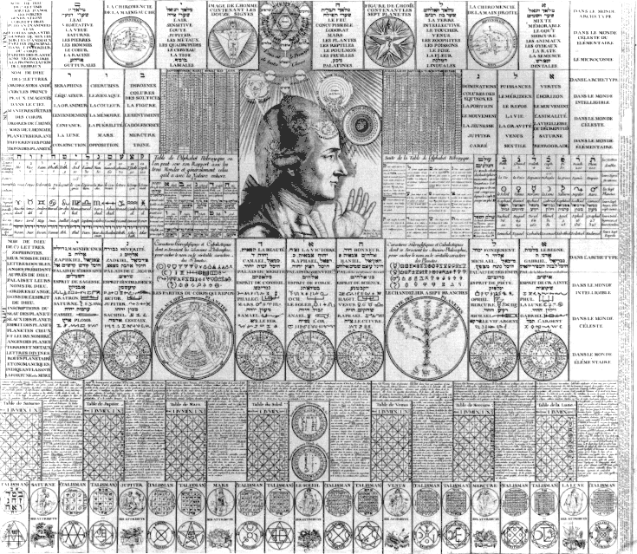
One section of this scroll was derived from the Calendarium Naturalium Magicum, a large engraving issued by Johann Theodor de Bry in 1620, and edited by J. B. Grosschedel von Aicha, which advertised itself as having been devised by Tycho Brahe, though there is no evidence he was associated with this in any way. The Calendarium Naturalium Magicum (also displayed in the exhibition) consists of a table of magical correspondences associated with the numbers one to twelve, for the most part copied from Henricus Cornelius Agrippa’s De occulta philosophia, first complete edition issued in 1533, but augmented by Grosschedel. The tables of correspondences together with symbolic material were all placed upon a large engraving. The Bibliotheca Philosophica Hermetica also possesses a manuscript copy of the Calendarium, in an 18th-century kabbalistic compilation of Rutilio Benincasa.
In the mid 18th century, the revival of interest in hermetic ideas in the context of the evolving freemasonry in France inspired this reworking of the 17th-century Calendarium into a new form by Du Chenteau. The correspondences are here translated into French, and joined by three diagrams copied from Georg von Welling’s Opus Mago-Cabbalisticum, 1719, a popular work for masons at this time (see item 47); and ten from Robert Fludd’s Utriusque cosmi historia, 1617-21 (see item 20), and some other engravings from 17th-century alchemical works. The engraving was given a masonic dimension by placing the two pillars of Jakin and Bohaz (Joachim and Boaz) on the top left and right. Around these columns grows a wreath of vegetation, on the right spiralling clockwise, and on the left anti-clockwise (see Der Compass der Weisen, item 55).
The tables of correspondences are headed with the names of God in one to twelve letters. The various things magically associated with each number, such as the elements, planets, angelical hierarchies, plants, minerals, animals, colours, precious stones, and others, are meticulously listed. These are for the most part derived from the earlier engraving, but du Chenteau has added much supplementary material, which he felt would be helpful to his masonic audience. For example, there is a table of the Hebrew alphabet together with the symbolic meaning of each letter, there is a whole new section of text explaining the tables of the planets, and some text is added explaining the seals under the number three. The Carte philosophique et mathématique continues to emphasise the supposed connection with Tycho Brahe.
At the centre is the famous diagram of the human mind and the reflection of the spiritual world in its inner structure, found in Robert Fludd’s great work on the Microcosm (see item 20). As can be seen, the illustration is adapted to the conventions of the 18th century.

55. JOLYFIEF, Augustin Anton Pocquières de [fl. 1750] [Edited by Adam Michael Birkholz 1746-1818]
Der Compaß der Weisen. Berlin and Leipzig: Christian Ulrich Ringmacher, 1779.
8°. [2] + [10] + 386 [=366] pages. 175 x104 mm.
Inserted folio 240 x 160 mm, with engraving 204 x 126 mm signed "fr. Hejonagogerus fec." Engravings at beginning of the Foreword page 19, at beginning of the Introduction page 113, and at end of book, page 386.

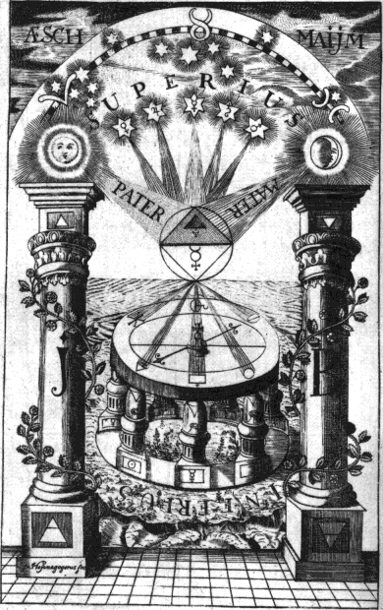
In the 18th century there was an explosion of interest in speculative freemasonry, especially in the German states, and a number of new orders were founded which had the pursuit of hermetic philosophy at their core. Masonic ritual had always incorporated an acting out of symbolic ideas on the floor of the lodge, and at this time these rituals were enriched by hermetic ideas. During this period a neo-Rosicrucian order was formed which called itself the Order of the Gold and Rosy Cross. The ‘Compass of the Wise’ was written to address such interests, indeed the introduction indicates that this book was written by a "Frater Roseae et aureae Crucis." The text extensively surveys alchemical and Rosicrucian writings, and to some extent attempts to make these comprehensible within the context of masonic ideas. The often reproduced frontispiece integrates some familiar alchemical symbolism and through the device of the two pillars upon the checkered floor integrates this into the world of Freemasonry. The ‘Compass’ meant here are not the masonic measuring compasses, but the guiding lodestone, which leads the seeker towards the spirit which rays down from the higher world, mediated through the planets, Sun and Moon, the Father and Mother at the head of the Joachim and Boaz pillars of the Masonic temple. These pillars are also seen in du Chenteau’s Carte philosophique of 1775 (see item 54), which had the same intention of presenting hermetic, alchemical and Rosicrucian philosophy to a masonic audience. The spiritual radiations are focussed in a symbol which integrates Salt, Sulphur, and Mercury, or body, spirit and soul, into a unity. If the seeker after enlightenment puts his trust in this symbolic compass, which brings together the ancient wisdom with Freemasonry, it will lead him surely to his goal.

56. [Crowning of Nature]
Sapientia veterum, sive doctrine eorundem, de summa et universali medicina.
Manuscript. 2°. 163 folios. 300 x 201 mm. 18th century.
51 coloured illustrations, 40 unique images from the first part of the ‘Crowning of Nature’, with figures 1-6, 9, 10, 11, 12, 13, doubled.

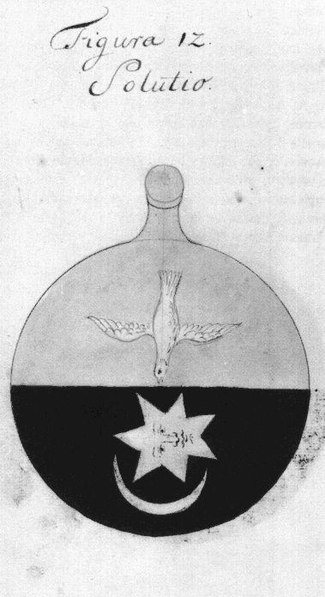
This important alchemical work circulated in manuscript from the late 16th through the 18th century. At least 35 manuscripts of this series of images are known. It was obviously a well-known work, five of its images appearing on the illustrated title-page of J.D. Mylius’ Anatomia auri of 1628, and it was quoted in the writings of John Heydon, the mid 17th-century English ‘Rosicrucian’. At the beginning of the 18th century, the images from its sequence were published as engravings in Johann Conrad Barchusen’s Elementa Chemicae, 1718.
The ‘Crowning of Nature’ manuscript was published under a number of titles - Coronatio Naturae, Sapientia veterum philosophorum sive doctrina eorundem de summa et universali medicina, Opus Angelorum and La Sagesse des anciens. It consists of a series of 67 figures, divided into two parts, 1-40 and 41-67. A number of the manuscripts, particularly the 18th-century French copies, only depict the first 40 images. The Bibliotheca Philosophica Hermetica also owns a manuscript under the title La Sagesse des anciens with 71 coloured drawings.
The inital group of seven takes the form of circular spaces, but the remaining 60 are flasks within which the transformative process is shown taking place through an elaborately worked out series of processes. The first part of the process involves cycles of spiritualisation and materialisation, or making the work alternatively subtle and gross, shown by a bird rising up and then descending in the flask. This has some parallels with the process symbolically described in the Rosarium Philosophorum series (see item 7) where a little soul figure rises and falls; indeed the text of the ‘Crowning of Nature’ often refers to the Rosarium. This links with the ‘Emerald Table’ of Hermes "It ascends from earth to heaven and agains descends to earth, to accomplish the miracle of the one thing". The elements Earth, Water, Air and Fire are turned inside out and transformed one into another.
The second part of the process numbers 41-67 and is obviously divided into three groups of seven flasks. In each of these sequences within the larger sequence, a snake or dragon enters the flask, unites itself with the material and is transformed and gradually spiritualised, until in the final figure perfection is achieved in the appearance of the image of a crowned and winged angel. This is similar to the process depicted in the Pretiosissimum Donum Dei series (see item 2), and the sequence of flasks in the Splendor Solis (see item 26).
The Crowning of Nature is one of the most complex and detailed symbolic descriptions of the transformative processes in alchemy. Its use of a simple set of archetypal symbols, which we follow through the sequence, simultaneously describes a physical and a spiritual process. Its simplicity and directness of expression maintained it as one of the most influential alchemical works during the 17th and 18th centuries, even though it was never printed and had a wide circulation in manuscript form only.

57. FLAMEL, Nicolas [1330-1418]
Livre des figures hyéroglyphiques.
Manuscript. 4°. 230 pages. 223 x 167 mm.
13 coloured drawings on vellum inserted after pages 8, 16, 20, 28, 44, 54, 64, 72, 130, 146, 162, 166 and 208.

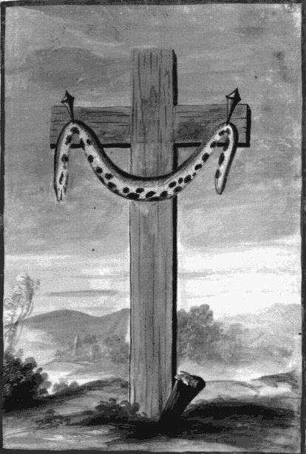
The story of Nicolas Flamel had a great impact upon the history of alchemy, and although certain material evidence from his life still remains, it is impossible now to disentangle fact from legend. It is, however, unimportant for us to try to discover the true Nicolas Flamel, for it is the legend that influenced and inspired subsequent generations of hermetic philosophers.
According to this legend, Flamel was a notary living in Paris, scratching a living copying documents. One day he acquired a curious manuscript, a ‘gilded book’ containing 21 leaves, entitled the ‘Book of Abraham the Jew’. This contained seven emblematic drawings which seemed to outline the process of alchemical transmutation. He could not understand the book and wasted much time puzzling over it. Eventually he took himself to Spain, in the hope of finding a Jewish adept who could explain the work to him. At Leon he found Master Canches, who was overcome with joy and astonishment at the sight of Flamel’s manuscript and agreed to translate it for him. However, on the journey back to Paris, Master Canches died without fully revealing the secret. Flamel had enough information to begin the work, and with the help of his wife Perrenelle he eventually (in 1382) achieved the transmutation of mercury into gold. He gave much of his new-found wealth to the poor and helped found hospitals, chapels and churches. The legend itself can thus be read as a kind of alchemical allegory.
Whatever the truth, the legend of Flamel came to be a central concern of hermetic students in the 16th and 17th centuries, and it was not long before manuscripts and books appeared which claimed to be the original ‘Book of Abraham the Jew’ (see Abraham Eleazar, item 49). During the 18th-century revival of interest in hermetic philosophy in France, many manuscript copies of the Figures hyéroglyphiques of Flamel were made, often with the series of thirteen allegorical emblems beautifully painted on vellum. At least fifteen of these coloured manuscripts have survived, two of which are in the Bibliotheca Philosophica Hemetica.
In this sequence of images the symbol of the snake appears in various forms. The caduceus of Hermes with its intertwined serpents is shown, and snakes also appear in another image as living energies in the earth. Among this series of emblematic figures one is especially striking for its bringing together of two powerful symbols, the cross and the serpent. This image of the crucified snake is a strong symbolic statement of the linking of hermeticism and Christianity. It is found in a number of symbolic figures influenced by the Figures hyéroglyphiques.

58a. [Geheime Figuren]
Die Lehren der Rosenkreutzer aus dem 16ten und 17ten Jahrhundert. Altona: Joh. Dav. Ad. Eckhardt, 1785-1788.
2°. 21 + 23 folios. 422 x 270 mm.
58b. [Geheime Figuren]
Die Lehren der Rosenkreutzer aus dem 16ten und 17ten Jahrhundert. 1943.
Manuscript. 2°. 78 folios. 348 x 251 mm.

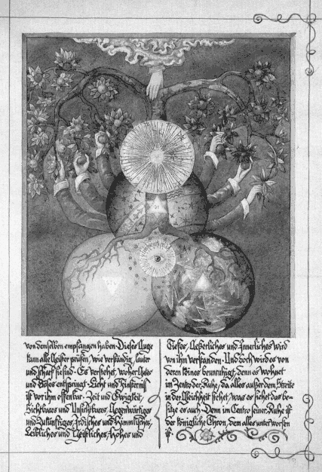
The Geheime Figuren, the ‘Secret symbols of the Rosicrucians’, was first printed in two books in 1785 and 1788, though it had circulated in manuscript for some years before this. The work consists of 36 pages with large woodcuts and one engraving together with 4 sections of text.
Among the texts are the alchemical allegory by Hadrian à Mynsicht Aureum seculum redivivum, first published in 1621, and the ‘Tractatus aureus de lapide philosophico’ contained in the Musaeum Hermeticum, 1625. The ‘Tractatus aureus’ incorporates another alchemical allegory, the ‘Parabola’. There is also included an extended verse interpretation and explanation of the ‘Emerald Table’.
Many of the images are directly borrowed from earlier works, the mystical writings of Jakob Boehme, Abraham von Franckenberg, and Valentin Weigel, and also from Rosicrucian writers such as Theophilus Schweighardt (see item 19). Although there appears to be no evidence to indicate a direct connection with the Order of the Gold and Rosy Cross, this work was certainly publicised and circulated within the order, and to many people has become associated with this neo-Rosicrucian and masonic order, which was very popular in Germany during the late 18th century.
It is fitting to include it as the last item in this catalogue, for this work gathered together and synthesised, in an original and beautiful form, most of the elements of the symbolic tradition in hermeticism. Its large diagrams incorporate aspects of the symbolism used throughout the history of hermeticism, from the ‘Emerald Table’ to the diagrams of Welling contemporary with this work (the most complete edition of Welling’s Opus mago-cabbalisticum was issued in 1784).
Shown are the second and third images, which are derived from Franckenberg’s Oculus Aeternitatis, 1677 (see item 35), and Weigel’s Studium Universale, 1695 (see item 42).
The Bibliotheca Philosophica Hermetica has a number of copies of this work, including four manuscripts, one of which probably predates the printed version. Among the manuscript collection is an extremely beautifully illustrated copy made in 1943 which is included in this exhibition to demonstrate the fascination and continued spiritual inspiration which hermetic symbolism can have upon us, even at the close of this materialistic and technologically-driven twentieth century.

END

