The Splendor Solis

26a. TRISMOSIN, Salomon http://www.xs4all.nl/~bph/silent-26.html
Das gegenwärtige [buchlein] wird genandt Splendor Solis oder Sonnenglantz.
Manuscript. 2°. 82 pages. 335 x 213 mm. 17th century.
22 full-page water-colour drawings, approximately 270 x 170 mm, inserted.
26b. TRISMOSIN, Salomon
Splendor Solis.
A series of 22 coloured drawings made by Laurie Lipton in 1992, 420 x 300 mm.

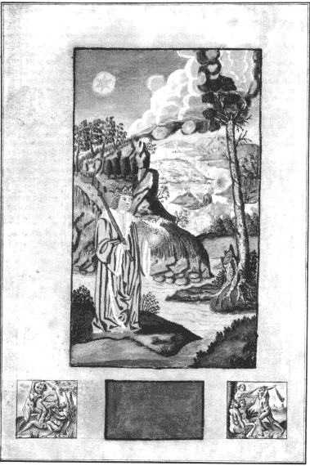
The Splendor Solis is one of the most beautiful of illuminated alchemical manuscripts. The earliest version, considered to be that now in the Kupferstichkabinett in the Prussian State Museum in Berlin, is dated 1532-35, and was made in the form of a medieval manuscript and illuminated on vellum, with decorative borders like a book of hours, beautifully painted and heightened with gold. The later copies in London, Kassel, Paris and Nuremberg are equally fine.
The example in the Bibliotheca Philosophica Hermetica is a later copy, probably made in the 17th century, of one of the earlier manuscripts. It is not quite so finely executed and regrettably the colours have faded and the paint in places has been worn off the paper, but, it still gives us a good impression of the quality of the original artwork.
The work itself consists of a sequence of 22 elaborate images, set in ornamental borders and niches. The symbolic process shows the classical alchemical death and rebirth of the king (see items 6 and 25), and incorporates a series of seven flasks, each associated with one of the planets. Within the flasks a process is shown involving the transformation of bird and animal symbols into the Queen and King, the white and the red tincture. This echoes the Pretiosissimum Donum Dei sequence (see item 2) which is probably earlier, dating from the 15th century. Although the style of the Splendor Solis illuminations suggest an earlier date, they are quite clearly of the 16th century. The figure displayed here is number seven, the death of the old king and the rebirth of the new.
The Splendor Solis was associated with the legendary Salomon Trismosin, allegedly the teacher of Paracelsus. The Trismosin writings were later published with woodcut illustrations, in the Aureum Vellus, oder Guldin Schatz und Kunst-kammer, 1598, which was reprinted a number of times. A French translation, entitled La Toyson d’or, ou la fleur des thresors was issued in Paris in 1612 with a number of very fine engravings, some copies of which were hand-coloured.
The Bibliotheca Philosophica Hermetica recently commissioned the artist Laurie Lipton to produce a version of the images from the Splendor solis in a series of coloured pencil drawings, one of which is displayed in our exhibition.

The Splendor Solis

By Salomon Trismosin

http://www.hermetics.org/solis.html

The 22 Colored Plates depicting the 22 Alchemical Stages of Salomon Trismosin's "Splendor Solis" are available for browsing from this page. The original manuscript of these plates is in the British Museum, and dated 1582. Though the earliest version is considered to be at Kupferstichkabinett in the Prussian State Museum in Berlin, and dated 1532-35. The text of this famous work have been translated by Joscelyn Godwin and printed by Phanes Press. A Yogi Publications edition also contains a biography of Trismosin, with his quest for and eventual attainment of the Philosopher Stone written in 1498. The only colored plates ever printed were by James Wasserman's fine work "Art and Symbols of the Occult", Greenwich Editions, London, 1993. More information on the Splendor Solis can be obtained from Adam MacLean's magnificent Virtual Alchemy site . The Virtual Alchemy also have the 22 color plates with comments, but the pictures at our site are of high resolution, they may take a long time to open, but will offer much detail detail for study and appreciation.
S.L. MacGregor Mathers is credited with an early work on the Splendor Solis, his notes on the obvious Kabbalistic and Arcana Major Tarot implications of 22, not to mentioned the alchemical symbolism, would have proved of interest had they survived. Ithell Colquhoun writes in the Sword of Wisdom, MacGregor Mathers and the Golden Dawn, G.P. Putnam's Sons, New York, 1975: " Besides Egyptian Symbolism, another book by Mathers which no one seems to have seen is his edition of the Splendor Solis by the fifteenth-century alchemist Salomon Trismosin, reputed occult teacher to Paracelsus. Edward Garstin valued this work highly and cited it several times in his own alchemical writings, especially the unpublished Alchemical Glossary. Trismosin was also the author of The Golden Fleece, one of the treasures of the British Museum’s manuscript library, its coloured illustrations even rivalling the miniatures of Les Très Riches Heures du Duc de Berry.
"Mathers passed his manuscript to F. L. Gardner, perhaps in part-payment of financial obligations, and Gardner published it about 1907 in the hope of recouping expense on some of Mathers’s other work for which he had agreed to be responsible. But he did not let Mathers know what he had done, and the latter (understandably) protested. It must have been a very small edition and copies are scarce—if Ellic Howe has not seen one, who has? Again, there is no trace of it in the British Museum catalogues. Mathers’s introduction and notes, if such there were, would be worth reading as his insight into alchemy is scarcely recorded elsewhere and would illuminate the Order’s teaching on the subject."
More information on G.D. affinities to the Splendor Solis can be obtained from Jean-Pascal Ruggiu's fascinating article "Rosicrucian Alchemy and the Hermetic Order of the Golden Dawn" at the Authentic Hermetic Order of the Golden Dawn website.
Below is the first plate of the Splendor Solis, to see the others please click the respective plate numbers, or "next" button below.

Splendor Solis Plate 1

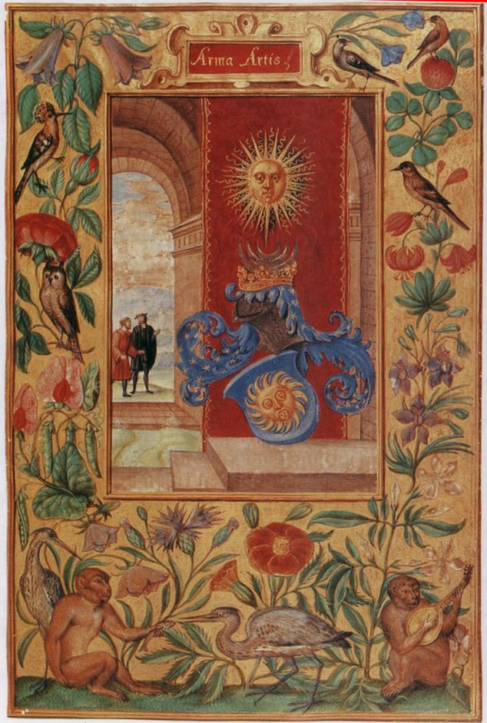

Splendor Solis Plate 2
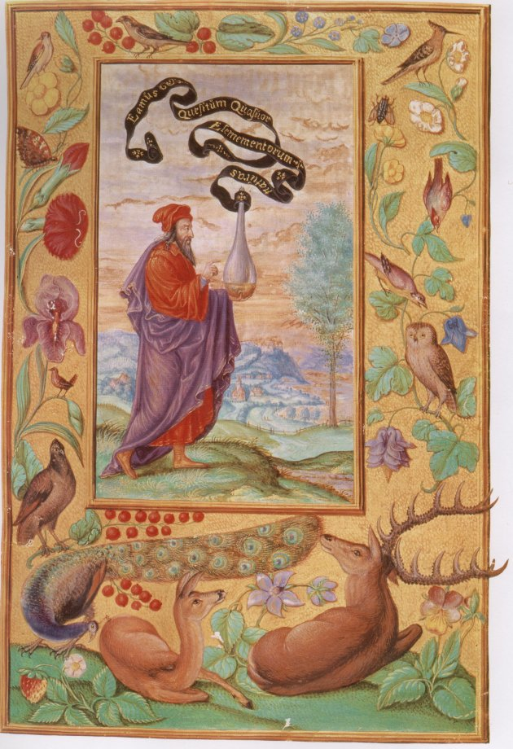

Splendor Solis Plate 3
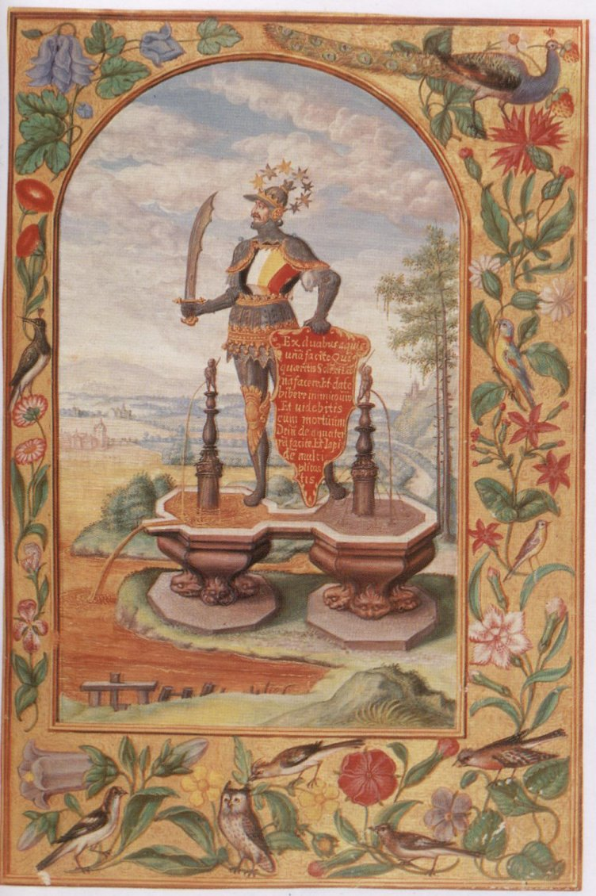

Splendor Solis Plate 4
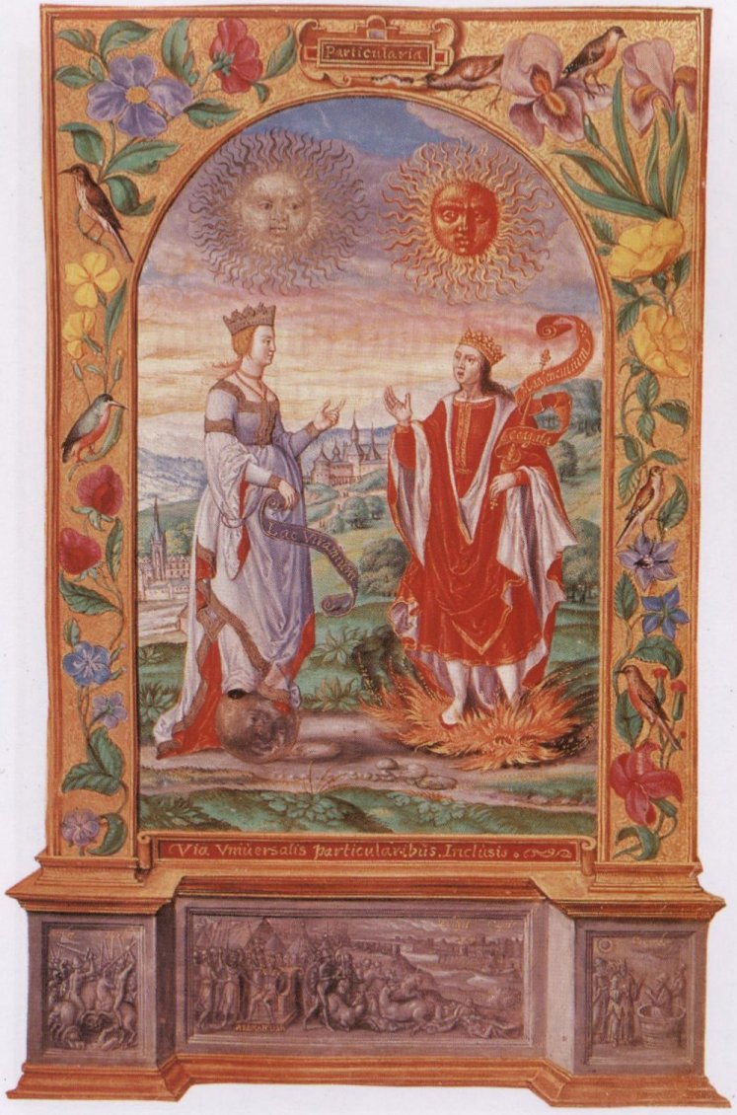

Splendor Solis Plate 5
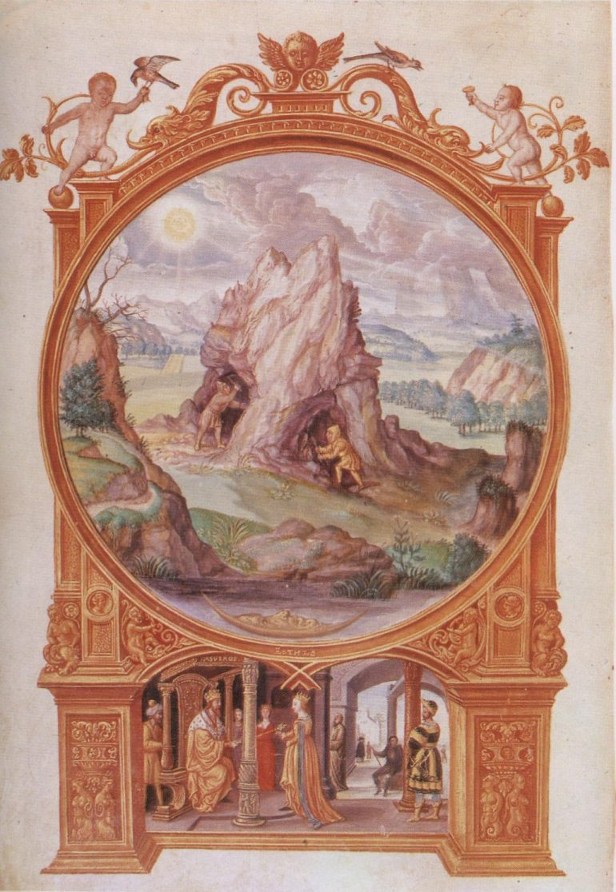

Splendor Solis Plate 6
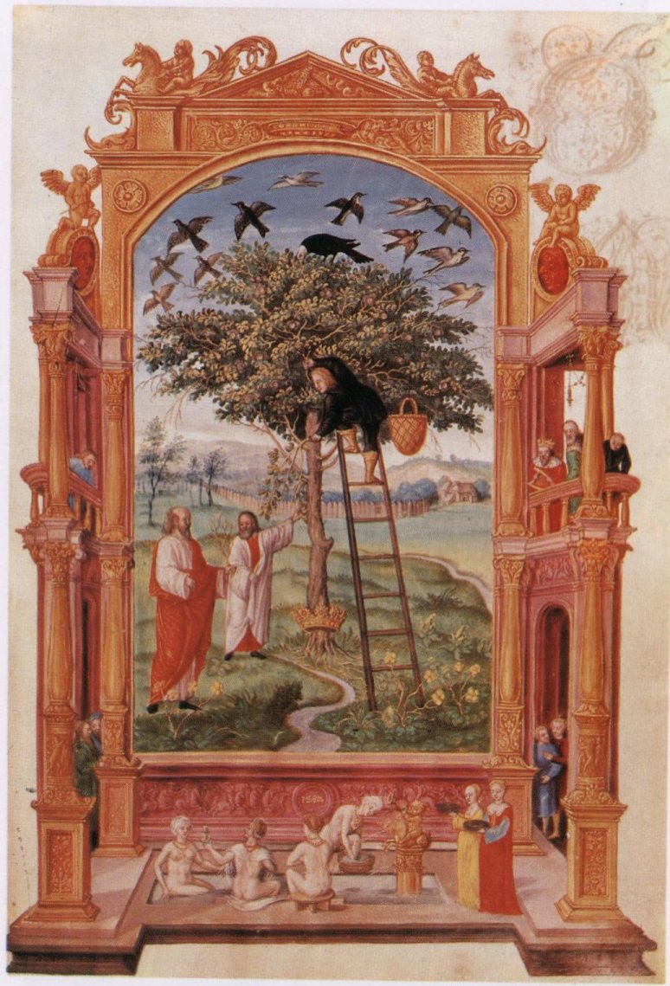

Splendor Solis Plate 7
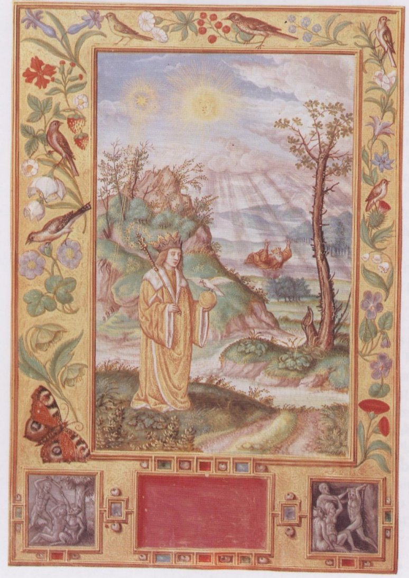

Splendor Solis Plate 8
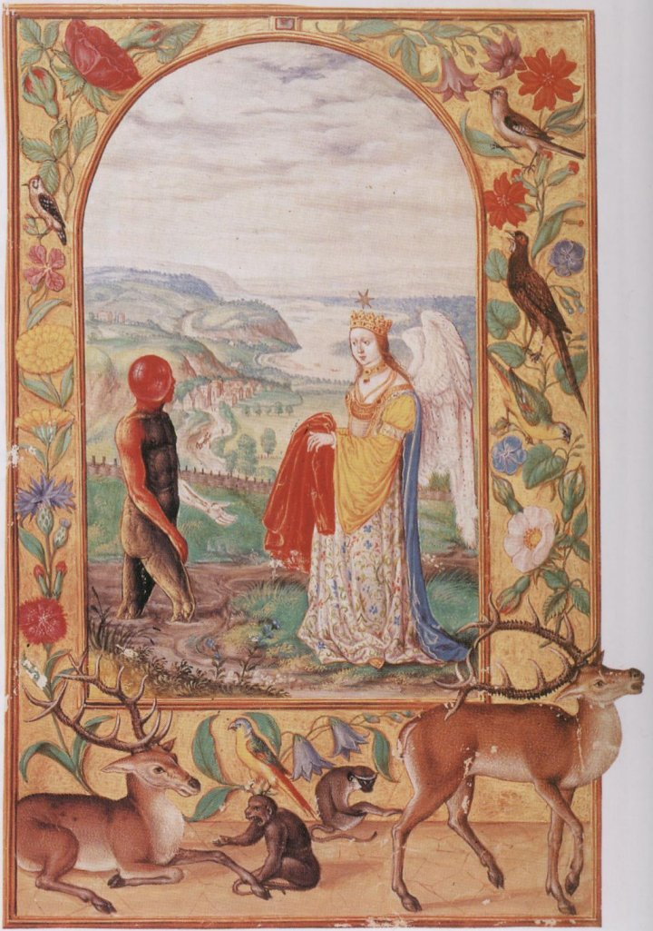

Splendor Solis Plate 9
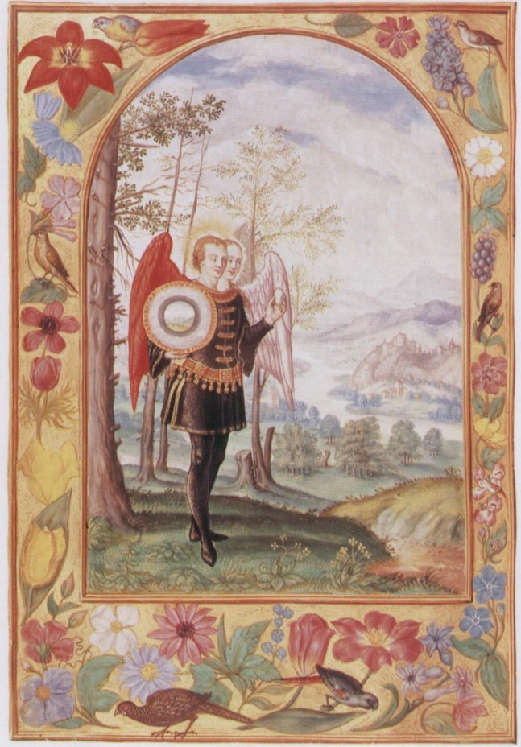

Splendor Solis Plate 10
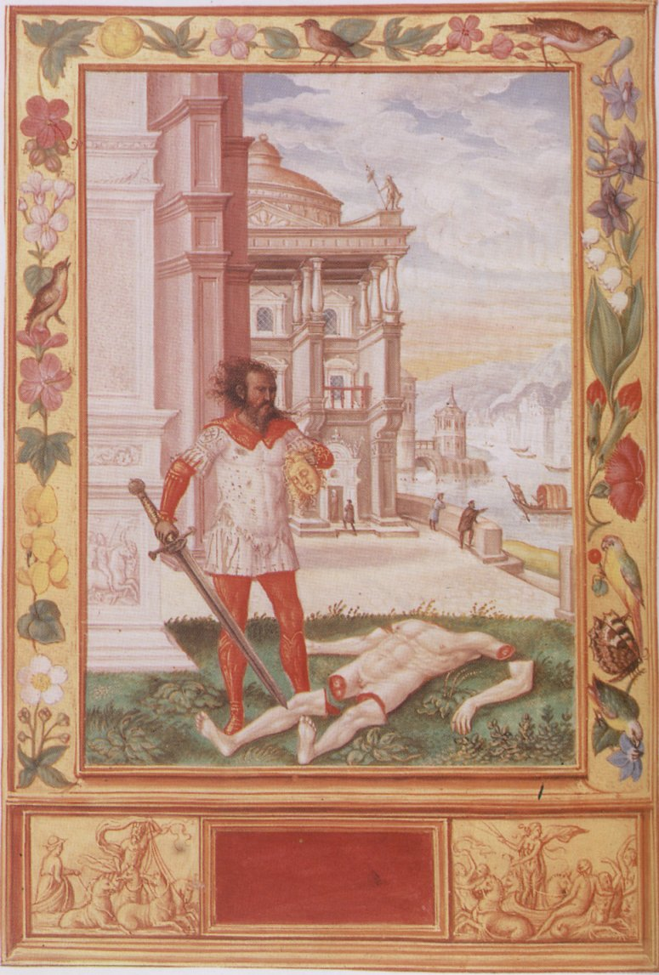

Splendor Solis Plate 11
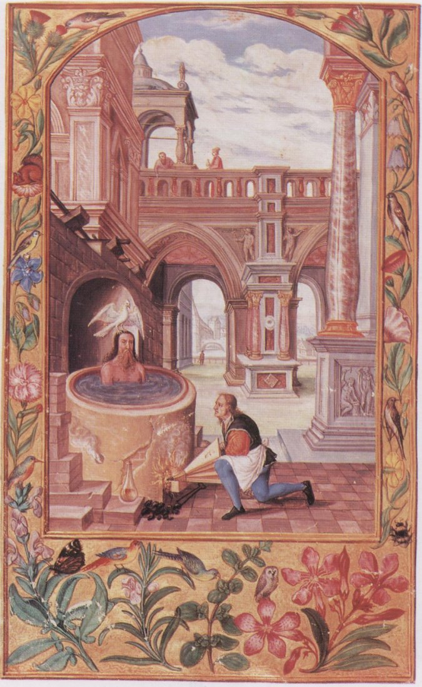

Splendor Solis Plate 12
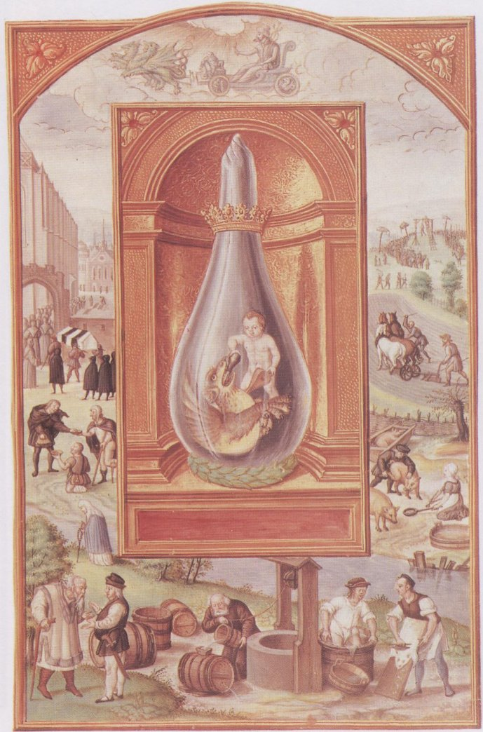

Splendor Solis Plate 13
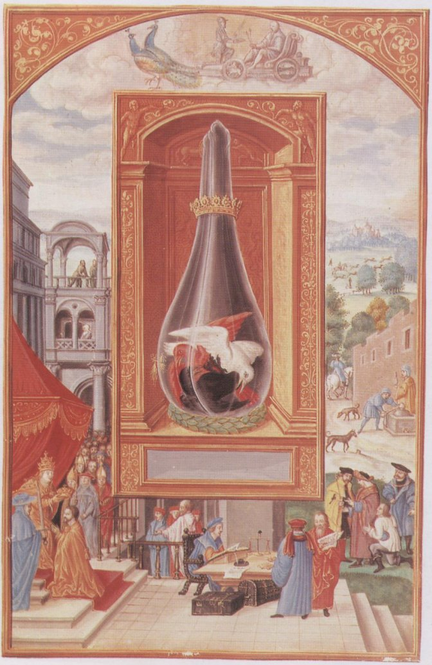

Splendor Solis Plate 14
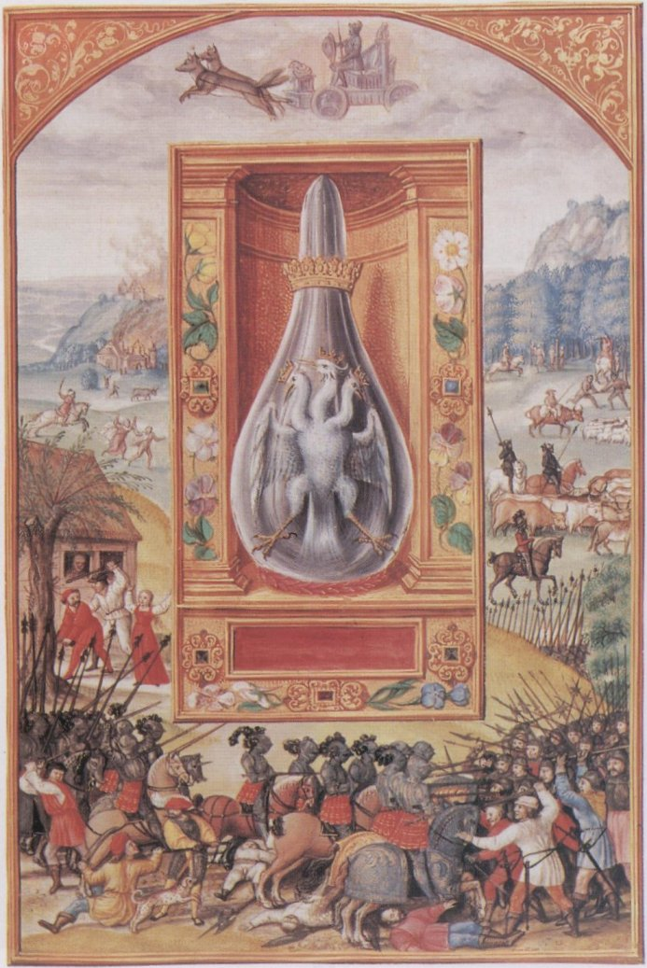

Splendor Solis Plate 15
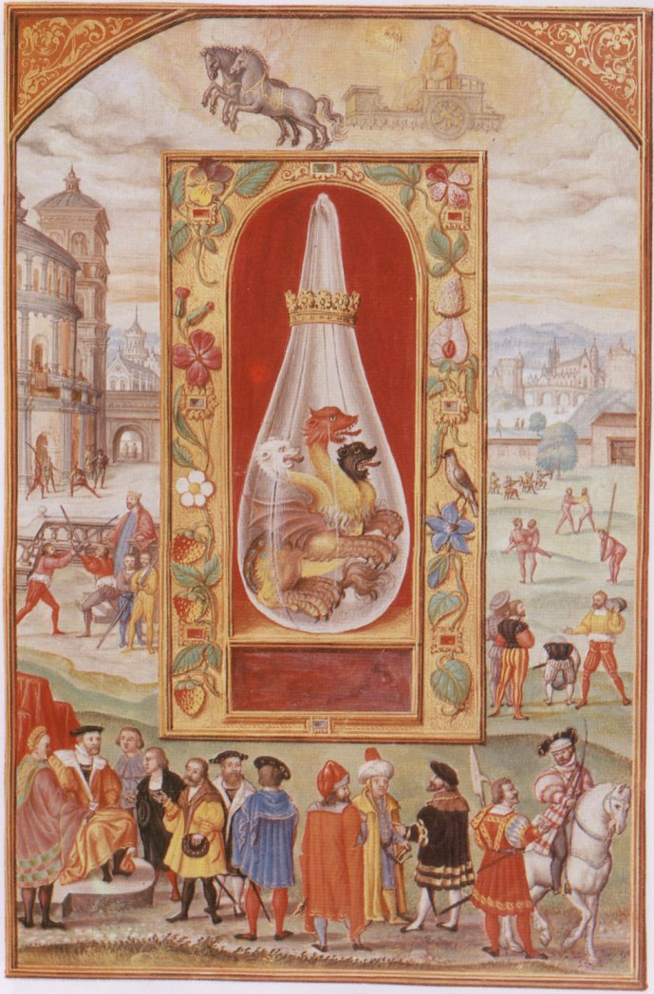

Splendor Solis Plate 16
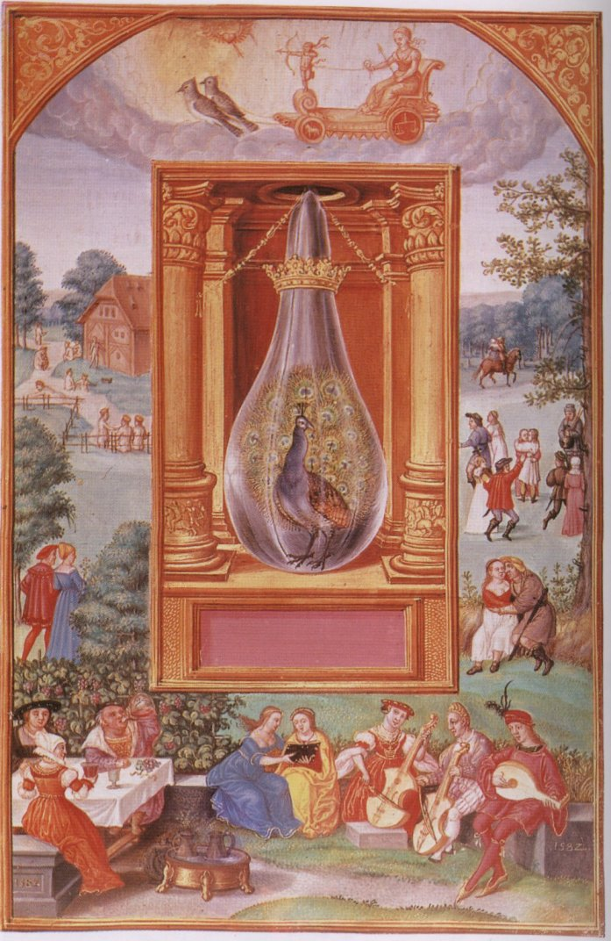

Splendor Solis Plate 17
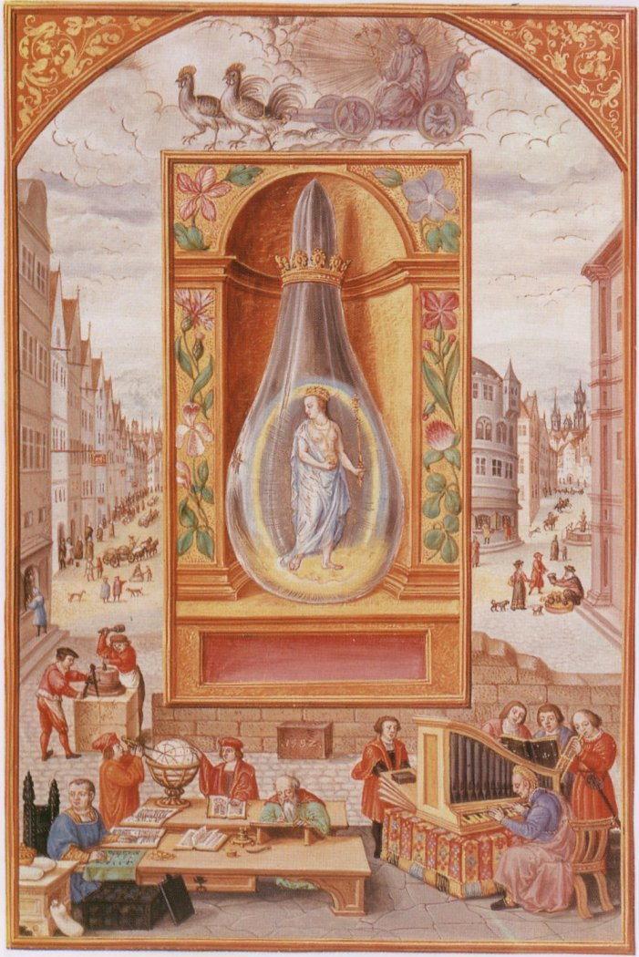

Splendor Solis Plate 18
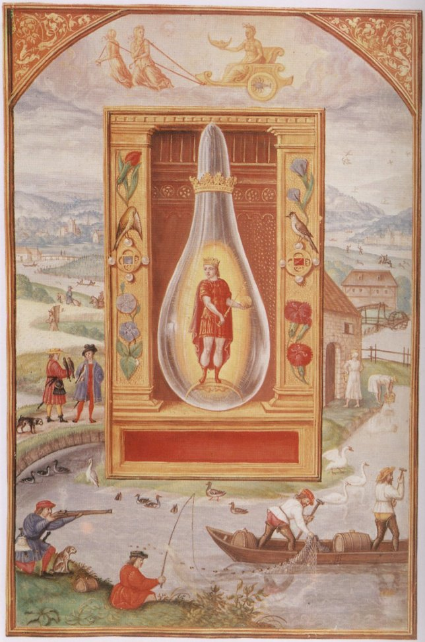

Splendor Solis Plate 19
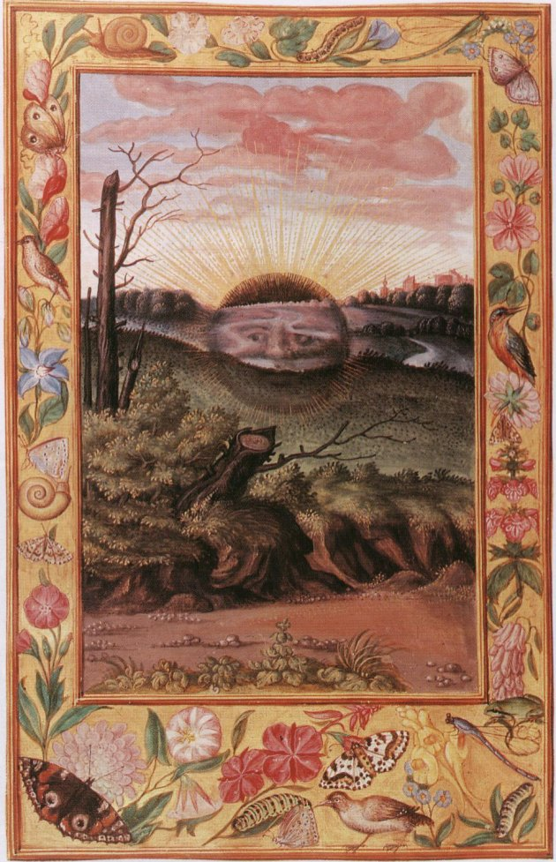

Splendor Solis Plate 20
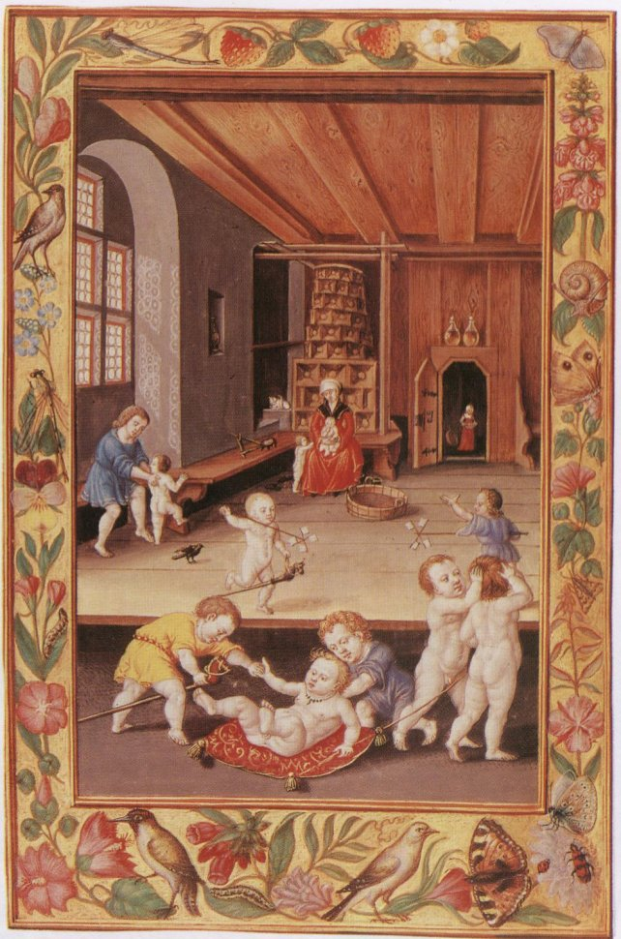

Splendor Solis Plate 21
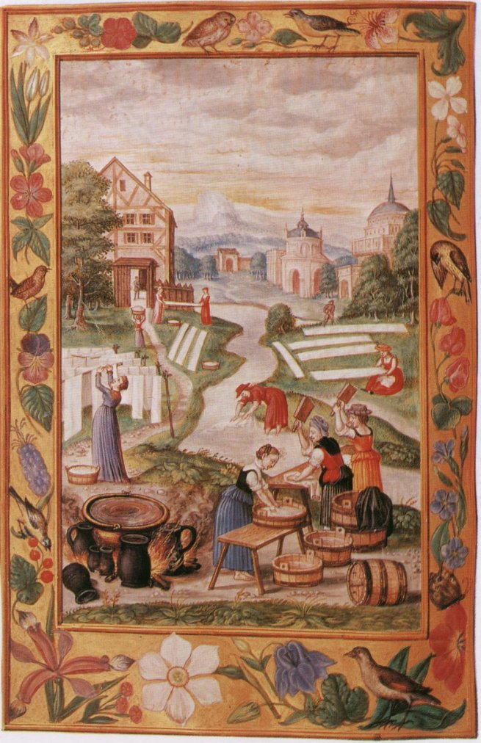

Splendor Solis Plate 22
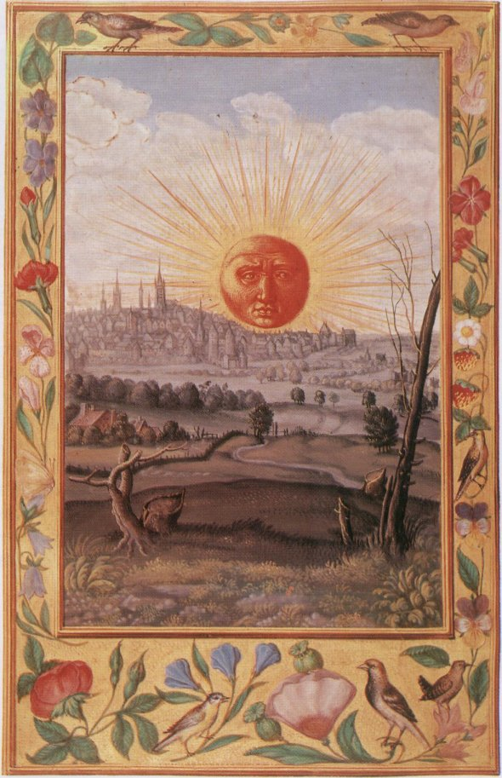

END

