Furnace and Fugue - Atalanta fugiens
https://furnaceandfugue.org/

From the moment the printer Hieronymus Galler lifted its pages from his press, Atalanta fugiens has been an intriguing, demanding book. With its multiple typefaces, music, and etchings, it is a virtuoso specimen of early modern print technology and a prime example of the beautiful engraved books produced by the renowned publisher Johann Theodor de Bry and illustrated by Matthäus Merian.
- List of Illustrations
- Works Cited
- Citation
- Author Biography
The book unfolds as a series of fifty emblems, each containing multiple parts: a motto and epigram in German and Latin, a copperplate etching, a fugue for three voices, and a Latin discourse that expands on the emblem’s themes. Atalanta fugiens presents an alchemical realm where deities, heroes, and mortals mingle within fantastic landscapes and elaborate interiors. Some of the emblems depict identifiable laboratory processes, encoding alchemical practice and the marvels of material transformations in allegorical images. The layout of the book itself is elegant in its symmetry. The musical scores on the left mirror the images on the right; together with the surrounding text and subsequent discourses, each emblem set makes a neat package of music, image, and text.
The content of Atalanta fugiens is no less masterful, invoking a kind of erudition that was prevalent enough among scholars in 1618 but is rare today. Maier’s title page gestures to an Ovidian legend — the tale of the fleet-footed huntress Atalanta, whom Hippomenes hopes to best in a race by dropping three distracting golden apples in her path.¹ In Maier’s hands, however, Ovid’s central characters become chymical materials,² while their interactions and transformations turn the ancient myth into a multimedia alchemical allegory designed to engage the ear, eye, and intellect. Only a reader equipped with a deep knowledge of classical myth, alchemy, natural history, music, mathematics, steganography, and medicine (not to mention the ability to read musical notation, German, and Latin) would have been up to the challenge of grasping the full significance of Maier’s clever text in 1618. As intimidating and kaleidoscopic as Atalanta fugiens may seem, however, its proposition is simple: all of the book’s parts are meant to work together, combining synergistically to reveal — or even produce — new insights into nature’s secrets. A shrewd reader could hope to acquire alchemical techniques for making powerful medicines or precious metals, and even knowledge about the origins and transformation of matter. In 1618, Maier offered his readers a puzzle, a game, a chance to test out their own virtuosity and to uncover nature’s secrets. In other words, Michael Maier invited his readers to engage with the text in ways that might today be considered playful — and they have been playing with Atalanta fugiens ever since.³
While we recognize and celebrate the fact that Atalanta fugiens has had an unusually long and rich afterlife as an intellectual, musical, and aesthetic object, the following essays approach Maier’s text first and foremost as a historical artifact whose playfulness must be understood in the intellectual, cultural, political, and religious context of early seventeenth-century Europe. Our exploration of Atalanta fugiens emerges out of an intentional multidisciplinary collaboration among scholars of early modern print, music, art, philosophy, mathematics, and alchemy. We explore how Atalanta fugiens both contributed to and was shaped by early modern debates about epistemology and the senses, cryptography, humor and ludic culture, and print as an instrument for producing knowledge, as well as debates about the status of alchemy in a period in which it was deeply contested.⁴ Our starting point is the assertion that if in 1618 Maier could reasonably expect a single reader to have the wide-ranging erudition and skill set to engage his book, then unpacking the riches of Atalanta fugiens today requires multidisciplinary collaboration. For example, some modern scholars may read Latin but not German (or vice versa), while others may understand the visual conventions Maier draws on in his emblem landscapes but be entirely unfamiliar with the Phrygian mode in early modern music. Anthropomorphized images of philosophical sulfur or mercury are old hat to historians of alchemy, while to others they might look like bizarre flights of fancy. In short, the fracturing of expertise into disciplinary bodies of knowledge means that scholars today can only grapple fully with the many dimensions of Maier’s ambitious text through multidisciplinary collaboration.
We view Atalanta fugiens, therefore, as an invitation and a challenge to reassemble collectively the expertise that Maier’s book demands. This approach departs from previous scholarship on Atalanta fugiens in several ways. First, this collection of essays is framed as a multidisciplinary conversation. Existing scholarly studies of Atalanta fugiens have tended to highlight a single element of the book. For example, the major English-language study, H. M. E. de Jong’s 1969 Michael Maier’s “Atalanta fugiens”: Sources of an Alchemical Book of Emblems, focuses primarily on the intertextuality of the book. De Jong’s crucial insight was to identify the corpus of alchemical, medical, mythological, and natural historical works from which Maier drew both explicitly and implicitly, and her study makes clear the extent to which Atalanta fugiens is a masterful work of textual synthesis. Maier’s authorship, she shows, lies primarily in his ability to weave together well-known alchemical aphorisms and to juxtapose them with new frameworks (not least the Ovidian tale of Atalanta and Hippomenes). De Jong’s attention to the literary elements of Atalanta fugiens, however, leaves open the relationship between Maier’s text and the book’s images and music. Meanwhile, other scholars have maintained a tight focus on the music, select images, or Maier’s philosophical commitments.⁵ All of these studies have advanced our understanding of Atalanta fugiens in important ways, and certainly deep disciplinary expertise is crucial for situating Maier’s project in specific philosophical, artistic, literary, or musical contexts; however, approaching Atalanta fugiens from the perspective of one or two disciplinary perspectives at a time also has its limits. Maier’s intention, after all, was to integrate sight, sound, and intellect, and so we, too, must grapple with the connections, synergies, and also tensions he laid out.
Earlier studies of Atalanta fugiens have also relied on an understanding of early modern alchemy that has been significantly challenged in recent decades. Once seen either negatively, as “superstition” or “pseudoscience,” or, more positively, as a primarily literary or philosophical project closely linked with hermeticism, Rosicrucianism, and other “occult” philosophies, early modern alchemy is now also recognized as a fundamentally material endeavor, a set of practices deeply engaged with understanding and enacting the transformation of matter and closely associated with early modern science and medicine.⁶ Informed by this new scholarly consensus in the history of alchemy, the following essays view Atalanta fugiens not only as a literary or philosophical text cleverly adorned with music but also as an invocation of actual laboratory technologies, potentially even a guide to the production of the philosophers’ stone.
The fact that Maier’s laboratory secrets are embedded in a such a virtuoso multimedia text, however, raises the question of its format even more urgently — and makes clear the need for a multidisciplinary approach. If Maier wanted to communicate something about chymical processes, then why not simply publish a more straightforward book of recipes? There are many possible answers to this question, of course. Perhaps he wanted to hide his most profound secrets from the untutored, unworthy, or lazy, even as he divulged them for all to see in print. Maier also sought to elevate alchemy above its grubby artisanal roots, establishing it as a humanist, philosophical, emblematic, courtly art with the potential to access nature’s arcana. On this count Atalanta fugiens certainly succeeds, demonstrating that alchemy offered not just precious medicines or metals but also fodder for mathematical games, musical riddles, artistic virtuosity, and classical erudition.
Maier’s insistence on representing his chymical secrets musically, visually, and textually suggests that the multimedia format of Atalanta fugiens is a clue to Maier’s broader arguments. The first two essays in this collection, from Tara Nummedal and Michael Gaudio, argue for new ways of understanding how Maier’s audience may have read or looked at Atalanta fugiens. Nummedal explores the experience and interpretation of Atalanta fugiens through an examination of multiple modes of reading. She reveals the structural framework that underpins Atalanta fugiens, showing how the design of this book adheres to both a horizontal and a vertical orientation. In one modality, the reader moves across Maier’s musical alchemical emblem book with the turn of each page; in the other, the individual emblem requires that the eye travel down the page, an action that invites lingering and contemplation of its textual and visual interplay in penetrating its hidden meaning. Maier’s musical alchemical emblem book is thus designed as both codex and scroll. At the same time, Nummedal argues that these reading practices also engage the reader’s body, making the act of reading Atalanta fugiens into an exploration of the relationship between intellect and senses and, ultimately, of the proper practice of chymistry. In turn, the essay by Michael Gaudio focuses on the captivating copperplate etchings by the artist Matthäus Merian that have assured the renown of Atalanta fugiens across the centuries. Noting Merian’s unusual concentration on landscape depiction in Atalanta fugiens, Gaudio situates this visual feature within a broader German landscape tradition. Moreover, he suggests, the “background” landscapes in Atalanta fugiens are a commentary on the act of seeing, representing, and measuring nature. This visual mode of engaging nature, Gaudio argues, was an important first step for Maier, preceding the more emblematic act of “looking more deeply” at the foreground images. Just as Maier offers multiple ways of reading Atalanta fugiens, according to Nummedal, so too does he encourage at least two different ways of seeing nature.
Essays by Eric Bianchi and Peter J. Forshaw deepen our understanding of how Maier conceptualized Atalanta fugiens by examining the set of classical and contemporary sources that informed Maier’s use of music and mythology. Eric Bianchi provides us with access to the intellectual context and social milieu of Maier’s musical world in a reconstruction of his musical philosophy. Atalanta fugiens evolved within a multifaceted cultural environment in which it participated in lofty mathematical abstractions about cosmic harmony even as it reflected commonplace professional music practices. Maier’s approach to music was thus speculative and performative, and Bianchi’s essay navigates between these seemingly opposed cultural forces. He discusses Atalanta fugiens as a work of music theory in terms of the relationship between its “sounded” music and the “silent” music of Maier’s later work Cantilenae intellectuales (Intellectual songs, 1622). As to the performative possibilities of Atalanta fugiens, Bianchi explores how the visual is rendered audible through the musical technique of text painting, or “madrigalisms.” This vocal feature of the music also constitutes an important element of Maier’s sensorial delivery of chymical arcana, pointing to underlying relationships among Maier’s music, image, and text — how the images influenced the fugues, for example, or vice versa. Maier’s use of personifications in his musical scores merge Ovidian characters with alchemical philosophy, and the essay by Peter J. Forshaw presents a rich intertextual examination of Maier’s use of myth in the context of alchemy. Forshaw elucidates a long tradition of alchemical interpretations of ancient myths, the literary genre known as mythoalchemy, which extends from the classical into the early modern period. This historiographical framework sheds new light on Maier’s adaptation of an Ovidian legend as the matrix for Atalanta fugiens. Maier understood hieroglyphs and myths to be transmissions of ancient knowledge and wisdom from the Egyptians to the Greeks, presenting a coded language in which chymical secrets were embedded. Forshaw’s essay places Maier’s use of emblems and the Atalanta story in relation to his earlier mythoalchemical work Arcana arcanissima (Most secret secrets, 1614), which Forshaw argues is the core of a mytho-chymical project that plays out across several of Maier’s published works. Atalanta fugiens is thus set within a wider alchemical program in which Maier uses myth and symbols to hide knowledge from the vulgar yet at the same time to reveal knowledge to the learned.
The final group of essays by Loren Ludwig, Richard Oosterhoff, and Donna Bilak explore Maier’s incorporation of music and mathematics into Atalanta fugiens. Loren Ludwig argues that Maier did not, in fact, compose forty of the fifty “fugues” in this musical alchemical emblem book. Ludwig’s musicological analysis of Atalanta fugiens reveals how Maier repurposed a printed collection of choir exercises by the English composer John Farmer, Divers & Sundry Waies (1591), thus connecting Atalanta fugiens to earlier English musical and liturgical traditions. Ludwig’s finding recalibrates our understanding of how the “fugues” in Maier’s book support its alchemical program. This raises important questions about authorship and intentionality, as Maier’s adaptation of Farmer’s waies in Atalanta fugiens reframes how we might interpret Maier’s curious integration of music in the book. The essay by Richard Oosterhoff explores Maier’s use of mathematics to support his alchemical agenda. Oosterhoff focuses on Emblem 21, which considers the ancient problem of squaring the circle, arguing that Maier dwells on this mathematical example as a sustained commentary on the creation and transformation of knowledge. According to Oosterhoff, Maier believed that if human knowledge could begin with the divine spark of inspiration, it must also be cultivated through the dedicated and sustained application of reason and experience, not through instinct, imagination, and phantasy. If squaring the circle was one of the most vexing mathematical problems, it was also, according to Oosterhoff, an example par excellence of knowledge that was possible even if not yet attained. In this sense, it became an important model for the possibility of metallic transmutation. At the same time, both desiderata also exposed the tensions, if not contradictions, between what might be possible in theory and what could be achieved in practice. The closing essay presents another viewpoint on Maier’s use of mathematics as a way to probe nature’s secrets. Donna Bilak takes up the question of why Maier configured Atalanta fugiens around fifty fugue-emblem sets, proposing that Maier may have engineered his musical alchemical emblem book around a concealed mathematical puzzle. Discovery of this puzzle lies in finding and solving clues, “secret signs,” that Maier embedded in the emblems, and doing so effects a numerical transmutation that reshuffles their order. Atalanta fugiens becomes a game based on the reader’s ability to attain new insights about chymical arcana that the contemplation of new emblem groupings prompt, with the book itself serving as an object that hides Maier’s secret game in plain view. Bilak’s analysis of Atalanta fugiens as a steganographic work invites a reading of Maier’s book in terms of cover text and ciphertext, opening up the study of alchemy to contemporary cryptographic practices.
Collectively, these seven essays reposition Atalanta fugiens as a blend of theoretical, performative, and practical engagements with nature. Maier is not the artist nor the musician, but he draws on sound and image, as well as mathematics and myth, to construct an alchemical allegory about the search for health and wealth. Moreover, by reordering, resequencing, or focusing on different elements of Atalanta fugiens each time they opened the book, Maier’s readers could use it to generate almost endless new insights into nature’s secrets. The multiple parts of Atalanta fugiens, as well as the numerous potential ways of reading, seeing, and hearing it, put the book in motion, setting up a hunt for meaning and a dynamic reading practice that transformed it into a complex epistemological tool.
At the same time, these essays suggest that Atalanta fugiens is more than an exploration of the synergies, tensions, and intersections among the languages of musical score, copperplate etching, and Latin discourse. Maier may also have intended his book to address shifting anxieties around the early modern disciplines that bridged sense and intellect, theory and practice, scholarship and craft in the early seventeenth century. Music, art, and alchemy grappled with a similar set of tensions. These arts were all framed by theoretical literatures that could be quite abstract and scholarly; as a set of practices, however, each also required knowledge of technique and the material world. The very nature of these mixed arts, therefore, raised questions about whether they were philosophies, crafts, or mixtures of the two, and about how these elements related to one another. These complexities of education, training, praxis, and expertise mirrored social concerns about the positions of the alchemist, the artist, and the musician between court, university, and workshop. Perhaps, these essays suggest, Atalanta fugiens placed art, alchemy, music, and, more subtly, mathematics in conversation because all of these arts grappled with a similar set of issues about the relationships among different forms of expertise, training, and practice in these mixed disciplines.
The essays collected here insist that Atalanta fugiens must be understood in its original historical context, as an artifact of its author and his early seventeenth-century world. The meaning of Atalanta fugiens, however, has always been in the hands of its readers, viewers, listeners, and singers. Indeed, it is impossible to ignore the fact that Maier’s contemporaries almost immediately seemed to want to amend, translate, and even disassemble Atalanta fugiens, thereby reimagining its message for new generations. In fact, a constellation of Atalanta-objects began to appear around Maier’s original book already in the seventeenth century, highlighting the desire not simply to sit down and read the text but rather to repurpose it for new contexts. Some individuals created their own customized copies, presumably for private use. The creators of the copies in the Bibliothèque nationale de France and the Donald F. and Mildred Topp Othmer Library of Chemical History, for example, had them hand-colored, turning black-and-white etchings into verdant landscapes, azure skies, glowing fires, and vibrant, multicolored costumes (figs. 1 and 2).⁷
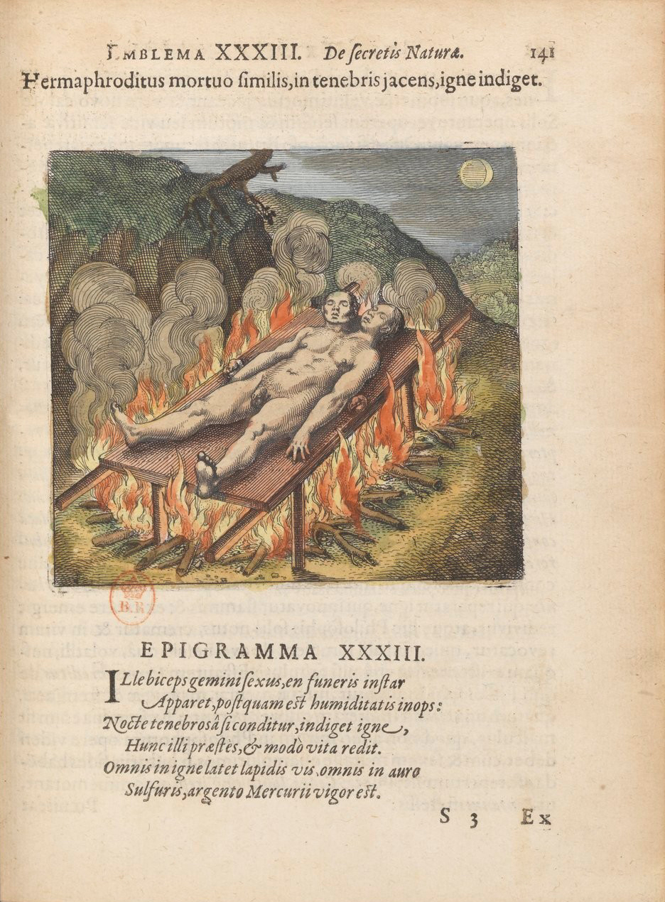Figure 1
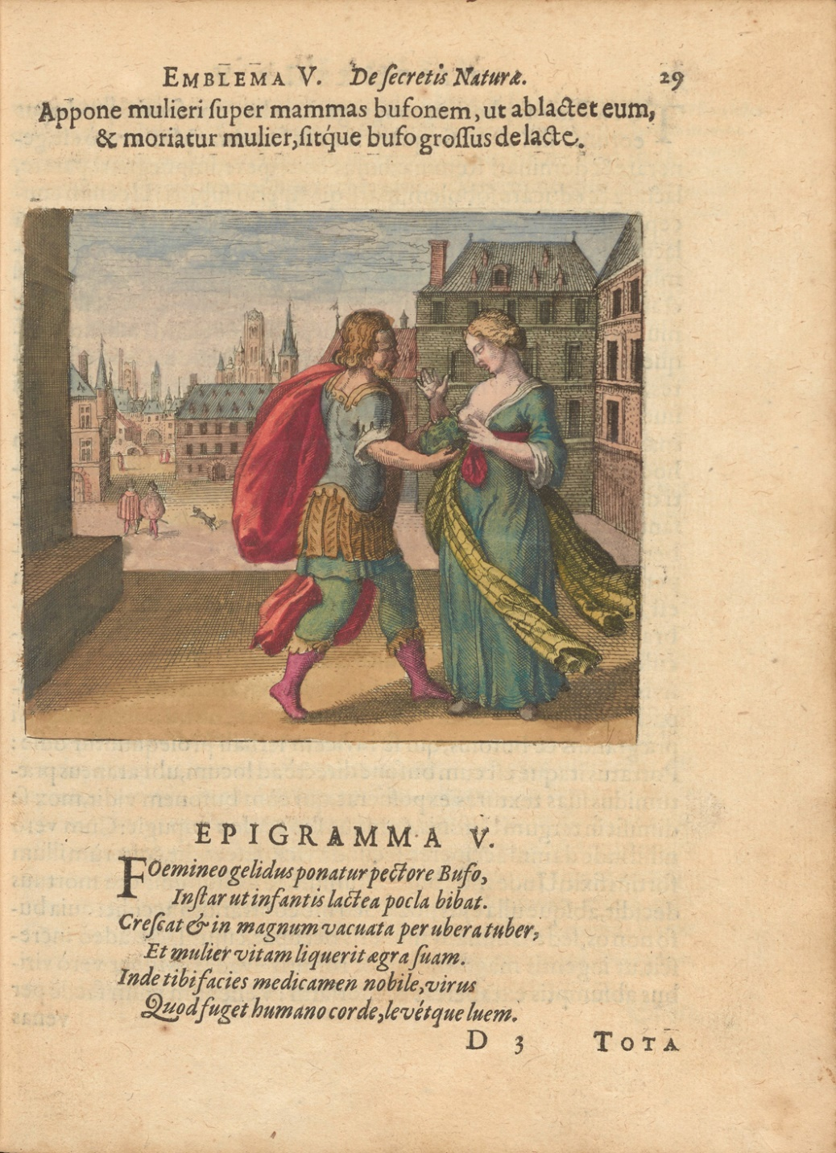Figure 2
Others replaced Maier’s Latin and German text with French or English translations, copying their new vernacular mottos, epigrams, and discourses — but not, notably, the fugues that originally accompanied them — into private miscellanies alongside other standard works from the centuries-old alchemical corpus (fig. 3).
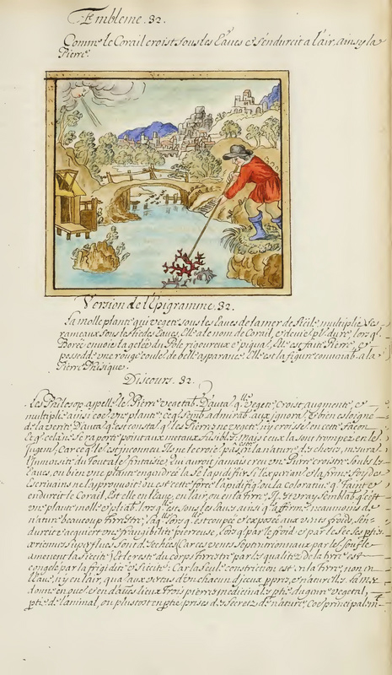Figure 3
One translator may have had a more public audience in mind for his English version, “Atalanta running, that is, new chymicall emblems relating to the secrets of nature,” which included the mottos, epigrams, and discourses, but not the images or the music (fig. 4). Now in the Beinecke Rare Book and Manuscript Library at Yale University, this manuscript looks as if it may have been a fair copy intended for the printing press rather than a manuscript for private use, and we use it here as the English translation in our digital edition.⁸
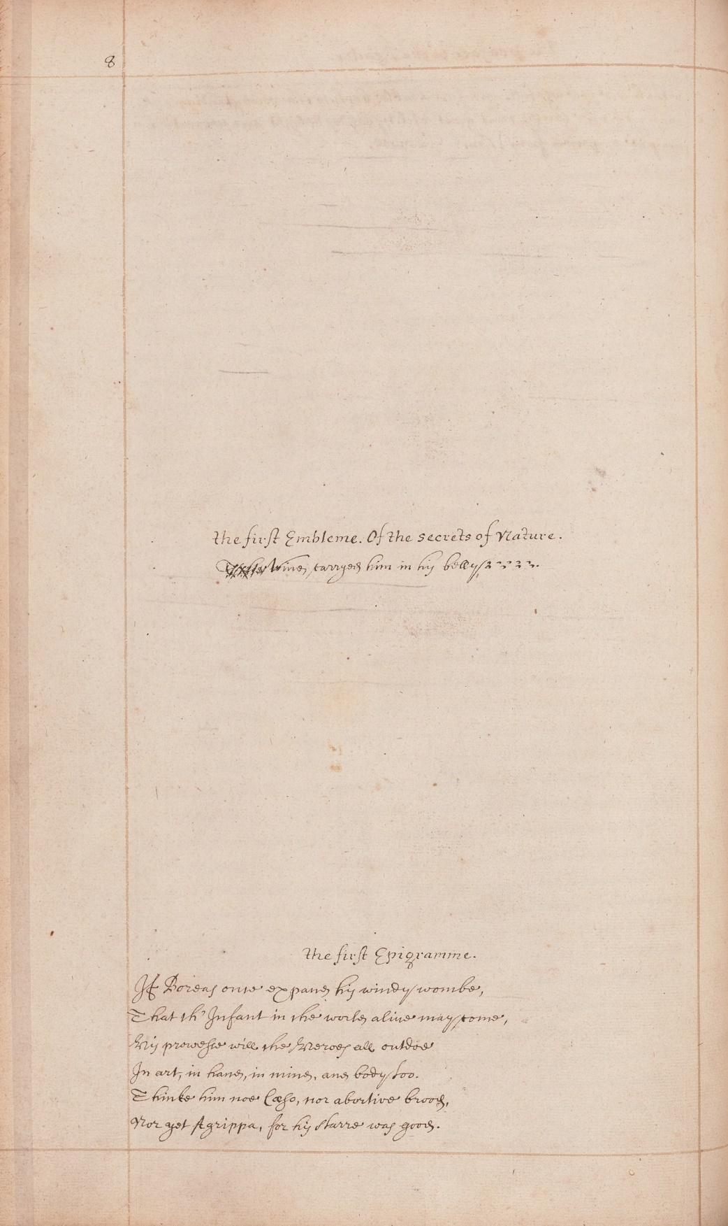Figure 4
Yet neither “Atalanta running” nor any of the other vernacular translations of Atalanta fugiens made it into print in the seventeenth century; instead, they remained in private manuscript collections or perhaps were exchanged among friends in the scholarly networks that extended across the early modern intellectual community known as the Republic of Letters.⁹ The fact that none of these manuscripts included the music suggests that they may date from the late seventeenth century, possibly modeled on a reconfigured printed version of Maier’s original that appeared in 1687 under a new title: Secretioris naturae secretorum scrutinium chymicum (The chymical investigation of the most secret nature of secrets). The publisher, Georg Heinrich Oehrling, dropped not only Maier’s original title page and the vignettes detailing scenes from the Ovidian Atalanta story that framed it but also one part of each emblem set: the page with the music and the German translations of the Latin mottos and epigrams.¹⁰ These changes radically transformed the book’s original program. In this 1687 edition, Atalanta fugiens was no longer about sound and sight; the reader was no longer also a listener. The removal of the music ended up placing greater emphasis on the emblems and discourses. Like the anonymous authors of the French and English manuscript variants, Oehrling may have had any number of reasons to make these changes, not least of which was the cost of printing music or duplicative German. It had also been about seventy years since Atalanta fugiens first appeared, and the social, intellectual, and political context that shaped Maier’s original book had changed, too. Natural philosophy was increasingly institutionalized in scientific societies and journals, which played a crucial role in determining how (and how not) to write about nature. At the same time, the alchemical middle ground between art, science, literature, and music that Atalanta fugiens occupied had also begun to pull apart. Parts of alchemy were increasingly being reframed as modern chemistry, while others were left behind or moved out of scientific and medical discourse altogether.
These early manuscript and print adaptations suggest that it was often Maier’s text that held the most appeal for his earliest readers, who could sometimes do without the music and even the images. In at least one instance, however, it was the images that held the most appeal. The Bibliotheca Hermetica Philosophica in Amsterdam holds three seventeenth-century oak panels with oil paintings depicting figures from Atalanta fugiens mingling with figures from two other early modern alchemical texts, Basil Valentine’s Practica cum duodecim clavibus (Twelve keys, 1677) and Johann Daniel Mylius’s Philosophia reformata (Philosophy reformed; 1622).¹¹ These intriguing objects allowed the images in these three well-known alchemical texts to float free entirely of the words that once accompanied them, creating new visual schemes that referenced their original contexts only enigmatically and underscored alchemy’s potential as a purely symbolic language.
Words without music, images without text. These seventeenth-century adaptations of Maier’s original point to a quality of the book that shaped the responses of even its first readers and that, we argue, has ensured that the book remains of interest today. Assembled out of discrete units of music, image, and text, Atalanta fugiens depends on its combination of media, its appeal to multiple senses, and its promise that only this particular assemblage can serve its aim: namely, to ponder the relationship between the senses and the intellect, and to reveal insights into nature both practical and philosophical. At the same time, the book also encourages its readers to take it apart, to reshuffle, select, and reimagine its elements. It was and is a book in parts, and this fundamental fact continues to inspire and interest users today. Modern readers continue to be drawn to Atalanta fugiens for these reasons, as well as for the book’s beauty, arresting images, music, and enigmatic content. Contemporary artists have reimagined the form of Maier’s book and its images,¹² while musicians continue to perform, record, and be inspired by the fugues.¹³ Browsing Apple’s iTunes Store or Bandcamp, one can find recordings of Maier’s music in period style as well as electronic and electroacoustic or metal versions. A search for #atalantafugiens on Instagram or Twitter reveals the book’s ongoing appeal to Rosicrucians, alchemists, and others who see it as an important repository of information about alchemical theories, imagery, and texts.¹⁴ The unusual longevity of Atalanta fugiens is certainly noteworthy, raising pressing questions about why and how particular elements of early modern culture continue to resonate with twenty-first-century audiences while others fade away. Our own digital edition is, in a sense, part of the long afterlife of Atalanta fugiens and should be understood in this context. These accompanying essays are meant to anchor the edition historically, to frame users’ explorations of Maier’s extraordinary book as a dialogue between Maier’s world and our own.
While alchemy is no longer part of modern science, perhaps, it continues to appeal to many as a world we have lost. Some today are drawn to alchemy as a scientific discourse unafraid of reaching for the most profound divine or cosmic wisdom, while others might value Atalanta fugiens for its elevation of play as a productive epistemology, in contrast to our more sober modern science. For our part, we appreciate Atalanta fugiens for the way that it invites readers, viewers, listeners, and singers into an early modern landscape of knowledge, where a singer and an alchemist might have more in common than we would think, and where a golden apple might cause us all to pause, to tarry, and to consider nature’s secrets.

Illustrations
- Figure 1
Emblem 33, Atalanta fugiens. (gallica.bnf.fr/Bibliothèque nationale de France)
- Figure 2
Emblem 5, Atalanta fugiens. (Science History Institute)
- Figure 3
Emblem 32, Atalanta fugiens. (Getty Research Institute and Palatino Press)
- Figure 4
“The first Embleme,” Atalanta fugiens. (Beinecke Rare Book and Manuscript Library, Yale University)

Works Cited
Primary Sources
Maier, Michael. “Atalanta fugiens, c. 1600.” Manly Palmer Hall collection of alchemical manuscripts, MS 170, Getty Research Institute. http://hdl.handle.net/10020/950053b27 (also available at http://www.palatinopress.com/atalanta-fugiens.html).
Atalanta fugiens, hoc est Emblemata nova de secretis naturae chymica. Oppenheim: Johann Theodor de Bry, 1618 [hand colored]. Bibliothèque nationale de France, département Réserve des livres rares, RES-R-1438. https://gallica.bnf.fr/ark:/12148/bpt6k850551g/f7.image.
Atalanta fugiens, hoc est Emblemata nova de secretis naturae chymica. Oppenheim: Johann Theodor de Bry, 1618 [hand colored]. Roy G. Neville Historical Chemical Library, Donald F. and Mildred Topp Othmer Library of Chemical History, Science History Institute. https://othmerlib.sciencehistory.org/record=b1035397~S6.
Chymisches Cabinet: derer grossen Geheimnussen der Natur. Frankfurt, 1708.
Mylius, Johann Daniel. Philosophia reformata. Frankfurt, 1622.
Ovid. Metamorphoses, Volume II: Books 9–15. Translated by Frank Justus Miller. Revised by G. P. Goold. Loeb Classical Library 43. Cambridge, MA: Harvard University Press, 1916. https://doi.org/10.4159/DLCL.ovid-metamorphoses.1916.
Rosarium philosophorum. Frankfurt, 1550.
Turba philosophorum. In Artis auriferae, quam chemiam vocant. Basel, 1572.
Valentine, Basil [pseud.]. Practica cum duodecim clavibus et appendice, de magno lapide antiquorum sapientum. Frankfurt, 1677.
Secondary Sources
Dackerman, Susan, ed. Prints and the Pursuit of Knowledge in Early Modern Europe. Cambridge, MA: Harvard Art Museums, 2011.
de Jong, H. M. E. Michael Maier’s “Atalanta fugiens”: Sources of an Alchemical Book of Emblems. Leiden: E. J. Brill, 1969.
Findlen, Paula. “Between Carnival and Lent: The Scientific Revolution at the Margins of Culture.” Configurations 6, no. 2 (1998): 243–67.
Fumaroli, Marc. The Republic of Letters. Translated by Laura Vergnaud. New Haven: Yale University Press, 2018.
Garber, Margaret D. “Untwisting the Greene Lyon’s Tale.” Historical Studies in the Natural Sciences 39, no. 4 (2009): 491–500.
Godwin, Joscelyn, ed. Atalanta fugiens: An Edition of the Fugues, Emblems, and Epigrams, by Michael Maier. Translated from the Latin by Joscelyn Godwin, with an introductory essay by Hildemarie Streich. Grand Rapids, MI: Phanes Press, 1989.
Hasler, Johann F. W. “Performative and Multimedia Aspects of Late-Renaissance Meditative Alchemy: The Case of Michael Maier’s Atalanta fugiens.” Revista de Estudios Sociales 39 (2011): 135–44.
Kusukawa, Sachiko. Picturing the Book of Nature: Image, Text, and Argument in Sixteenth-Century Human Anatomy and Medical Botany. Chicago: University of Chicago Press, 2012.
Martinón-Torres, Marcos. “Some Recent Developments in the Historiography of Alchemy.” Ambix 58, no. 3 (2011): 215–37.
Meinel, Christoph. “Alchemie und Musik.” In Die Alchemie in der europäischen Kultur- und Wissenschaftsgeschichte, edited by Christoph Meinel, 201–7. Wiesbaden: Harrassowitz, 1986.
Moran, Bruce, Lawrence M. Principe, William R. Newman, Tara E. Nummedal, and Ku-ming (Kevin) Chang. “Forum: Alchemy and the History of Science.” Isis 102, no. 2 (2011): 300–337.
Newman, William R., and Lawrence M. Principe. “Alchemy vs. Chemistry: The Etymological Origins of a Historiographic Mistake.” Early Science and Medicine 3, no. 1 (1998): 32–65.
Nummedal, Tara. Alchemy and Authority in the Holy Roman Empire. Chicago: University of Chicago Press, 2007.
Principe, Lawrence M. The Secrets of Alchemy. Chicago: University of Chicago Press, 2013.
Raasveld, Paul P. “Michael Maiers Atalanta fugiens (1617) und das Kompositionsmodell in Johannes Lippius’ Synopsis musicae novae (1612).” In From Ciconia to Sweelinck: donum natalicium Willem Elders, edited by Albert Clement and Eric Jas, 355–68. Amsterdam: Rodopi, 1994.
Schiltz, Katelijne, and Bonnie J. Blackburn. Music and Riddle Culture in the Renaissance. New York: Cambridge University Press, 2015.
Sherman, Bill. “The History of Cryptography.” In The Voynich Manuscript, edited by Ray Clemens. New Haven: Yale University Press, 2016.
Sleeper, Helen Joy. The Alchemical Fugues in Count Michael Maier’s “Atalanta Fugiens.” Easton, PA: Section of Chemical Education, American Chemical Society, 1938.
Smith, Pamela H. The Body of the Artisan: Art and Experience in the Scientific Revolution. Chicago: University of Chicago Press, 2004.
Szőnyi, G. E. “Occult Semiotics and Iconology: Michael Maier's Alchemical Emblems.” In Mundus Emblematicus: Studies in Neo-Latin Emblem Books, edited by Karl A. E. Enenkel and Arnoud S. Q. Visser. Turnhout: Brepols, 2003.
Tilton, Hereward. The Quest for the Phoenix: Spiritual Alchemy and Rosicrucianism in the Work of Count Michael Maier (1569–1622). Berlin: Walter de Gruyter, 2003.
Wels, Volkhard. “Poetischer Hermetismus. Michael Maier’s Atalanta fugiens (1617/18).” In Konzepte des Hermetismus in der Literatur der Frühen Neuzeit, edited by Peter-André Alt and Volkhard Wels. Göttingen: V&R Unipress, 2010.

Citation
Nummedal, Tara, and Donna Bilak. “Interplay: New Scholarship on Atalanta fugiens.” Furnace and Fugue: A Digital Edition of Michael Maier's “Atalanta fugiens” (1618) with Scholarly Commentary. Charlottesville: University of Virginia Press, 2020. https://doi.org/10.26300/bdp.ff.nummedal-bilak.

Author Biography
Tara Nummedal is Professor of History at Brown University, where she teaches courses in early modern European history and the history of science. She is the author of Anna Zieglerin and the Lion's Blood: Alchemy and End Times in Reformation Germany (University of Pennsylvania Press, 2019) and Alchemy and Authority in the Holy Roman Empire (University of Chicago Press, 2007). She is the coauthor, with Janice Neri and John V. Calhoun, of John Abbot and William Swainson: Art, Science, and Commerce in Nineteenth-Century Natural History (University of Alabama Press, 2019).
Donna Bilak holds a PhD from Bard Graduate Center: Decorative Arts, Design History, Material Culture. A historian of early modern alchemy, she specializes in the study of emblematics. Her research interests extend to jewelry history and technology, which draw upon her previous professional experience in Toronto's jewelry industry as a designer and wax model maker. Her scholarship centers on material practices of humanism both in the early modern period and in contemporary society — namely, how intersections of text, images, and the creative and experimental use of materials come together in the creation and application of knowledge.
Studies in Early Modern German History H. C. Erik Midelfort, Series Editor

