Thomas Vaughan 1621-1666
http://en.wikipedia.org/wiki/Thomas_Vaughan_%28philosopher%29
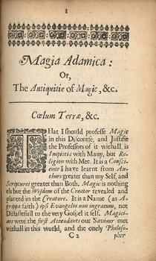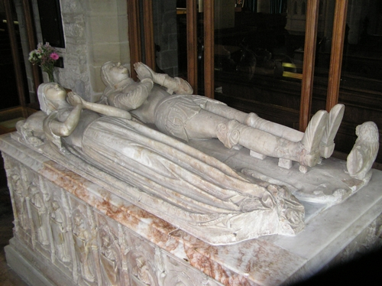

Thomas Vaughan (April 17, 1621 - 1666) was a Welsh philosopher.
A Royalist clergyman from Brecon in Wales, Thomas was the twin brother of the poet Henry Vaughan, both being born 'at Newton in the parish of St. Briget's in the yeare 1621'. Vaughan entered Jesus College, Oxford, in 1638, and remained there for a decade during the English Civil War. He became rector of the parish of Llansanffraid (St. Briget) Wales and took up medical studies, motivated by the lack of doctors in Wales. In 1650, he was evicted from the parish because of his Royalist sympathies. He married his wife Rebecca in 1651 and spent the next period of his life in London. His wife died in 1658.
Although he did not practice medicine, Vaughan sought to apply his chemical skills to preparing medicines in the manner recommended by Paracelsus. He corresponded with Samuel Hartlib, and established a reputation with his book Anthroposophia, a magico-mystical work.
Vaughan was unusual amongst alchemists of the time in that he worked closely with his wife Rebecca Vaughan, and valued and even saw as essential, their joint work.
Vaughan later became involved with a plan of Dr. Robert Child to form a chemical club, with a laboratory and library, the main aim being to translate and collect chemical works. In the course of litigation with one Edward Bolnest, Vaughan was accused of spending 'most of his tyme in the studdy of Natuall Philosophy and Chimicall Phisick'. He is reported as having confessed that he had 'long sought and long missed ... the philosopher's stone'.
It is possible that Thomas Vaughan was the author of tracts published under the pseudonym Eugenius Philalethes, although other Alchemists and Natural Philosophers could also have been the author. However it seems that Vaughan was the most likely contender.

