Jan Baptista van Helmont
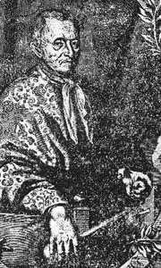
http://www.crystalinks.com/helmont.html

Helmont, Jan Baptista van, b. Jan. 12, 1580, [1579, Old Style], Brussels d. Dec. 30, 1644, Vilvoorde, Spanish Netherlands [now in Belgium] Jan also spelled JOANNES, Belgian chemist, physiologist, and physician who recognized the existence of discrete gases and identified carbon dioxide.
Helmont may be regarded as having bridged alchemy and chemistry.
Though mystically inclined and believing in the philosopher's stone, he was a careful observer and exact experimenter.
He was the first scientist to recognize the existence of gases distinct from atmospheric air.
In fact, he invented the word "gas," and he perceived that the spiritus sylvestre ("wild spirit"; actually carbon dioxide) given off by burning charcoal was the same as that produced by fermenting must, or grape juice. Helmont regarded water as the chief, if not the only, constituent of matter and "proved" his idea by growing a tree in a measured quantity of earth.
With the addition of water only, over a five-year period the tree increased in weight by 164 pounds, whereas the soil weight decreased by only a few ounces.
In his researches on digestion and nutrition, Helmont was one of the first to apply chemical principles to the study of physiological problems.
For this, he has been called the "father of biochemistry." In his speculations Helmont also introduced a system of supernatural agencies that preside over and direct the affairs of the body, however.
At the same time, chemical principles guided him in his choice of medicines--e.g., alkali to correct undue acidity of the digestive juices.
His collected works were published in 1648.

