Hermes Trismegistus
http://en.wikipedia.org/wiki/Hermes_Trismegistus
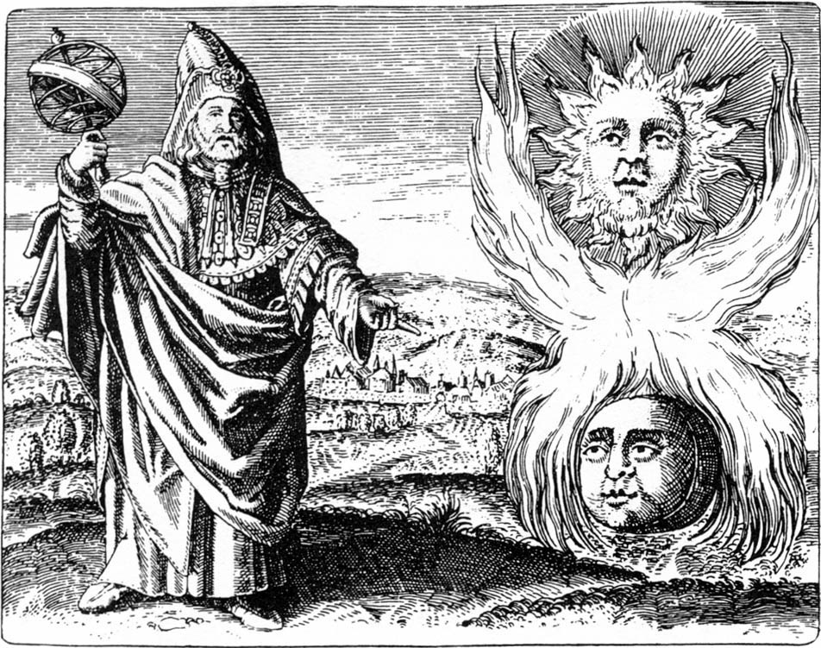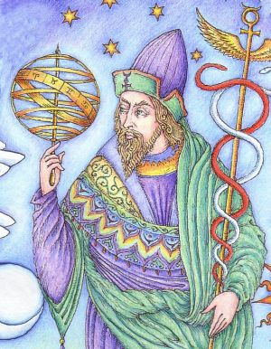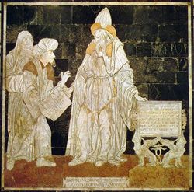

Hermes Trismegistus (Greek for "thrice-great Hermes", Greek: Ερμης ο Τρισμεγιστος) or Mercurius ter Maximus in Latin, is the syncretism of the Greek god Hermes and the Egyptian Thoth.^{[1]} In Hellenistic Egypt, the god Hermes was given as epithet the Greek name of Thoth. He has also been identified with Enoch. Other similar syncretized gods include Serapis and Hermanubis.
Hermes Trismegistus might also be explained in Euhemerist fashion as a man who was the son of the god, and in the Kabbalistic tradition that was inherited by the Renaissance, it could be imagined that such a personage had been contemporary with Moses, communicating to a line of adepts a parallel wisdom. A historian, however, would leave such speculation to the history of alchemy and the nineteenth-century history of occultism.
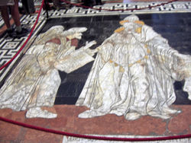
Hermes Trismegistus, floor mosaic in the Cathedral of Siena

Contents
[hide]
- 1 Origin
- 2 Hermetic revival
- 3 Hermes Trismegistus in Islamic tradition
- 4 New Age revival
- 5 Fictional references
- 6 See also
- 7 Source
- 8 References
- 9 External links

[] Origin
Both Thoth and Hermes were gods of writing and of magic in their respective cultures. Thus the Greek god of interpretive communication was combined with the Egyptian god of wisdom as a patron of astrology and alchemy. In addition, both gods were psychopomps, guiding souls to the afterlife.
The majority of Greeks, and later Romans, did not accept Hermes Trismegistus in the place of Hermes. The two gods remained distinct from one another. Cicero noted several individuals referred to as "Hermes" (De natura deorum III, 22, 56):
the fifth, who is worshipped by the people of Pheneus [in Arcadia?], is said to have killed Argus, and for this reason to have fled to Egypt, and to have given the Egyptians their laws and alphabet: he it is whom the Egyptians call Theyn [Thoth].
The Hermetic literature added to the Egyptian concerns with conjuring spirits and animating statues that inform the oldest texts, Hellenistic writings of Greco-Babylonian astrology and the newly developed practice of alchemy (Fowden 1993: pp65–68). In a parallel tradition, Hermetic philosophy rationalized and systematized religious cult practices and offered the adept a method of personal ascension from the constraints of physical being, which has led to confusion of Hermeticism with Gnosticism, which was developing contemporaneously Dan Merkur, "Stages of Ascension in Hermetic Rebirth".
As a divine fountain of writing, Hermes Trismegistus was cred with tens of thousands of writings of high standing, reputed to be of immense antiquity. Plato's Timaeus and Critias state that in the temple of Neith at Sais, there were secret halls containing historical records which had been kept for 9,000 years. Clement of Alexandria was under the impression that the Egyptians had forty-two sacred writings by Hermes, encapsulating all the training of Egyptian priests. Siegfried Morenz has suggested (Egyptian Religion) "The reference to Thoth's authorship...is based on ancient tradition; the figure forty-two probably stems from the number of Egyptian nomes, and thus conveys the notion of completeness." The Neo-Platonic writers took up Clement's "forty-two essential texts".
The so-called "Hermetic literature", the Hermetica, is a category of papyri containing spells and induction procedures. In the dialogue called the Asclepius (after the Greek god of healing) the art of imprisoning the souls of demons or of angels in statues with the help of herbs, gems and odors, is described, such that the statue could speak and prophesy. In other papyri, there are other recipes for constructing such images and animating them, such as when images are to be fashioned hollow so as to enclose a magic name inscribed on gold leaf.

[] Hermetic revival
For the main article, see Hermeticism. For the career of the Corpus Hermeticum, see Hermetica.
During the Middle Ages and the Renaissance, the writings attributed to Hermes Trismegistus known as Hermetica enjoyed great cr and were popular among alchemists. The "hermetic tradition" therefore refers to alchemy, magic, astrology and related subjects. The texts are usually distinguished in two categories the "philosophical" and "technical" hermetica. The former deals mainly with issues of philosophy, and the latter with magic, potions and alchemy. Among other things there are spells to magically protect objects; hence the origin of the term "Hermetically sealed".
The classical scholar Isaac Casaubon in De Rebus sacris et ecclesiaticis exercitiones XVI (1614) showed, by the character of the Greek, the texts that were traditionally written at the dawn of time, to be more recent: most of the "philosophical" Corpus Hermeticum can be dated to around AD 300. However, flaws in this identification were uncovered by the 17th century scholar Ralph Cudworth, who argued that Casaubon's allegation of forgery could only be applied to three of the seventeen treatises contained within the Corpus Hermeticum. Moreover, Cudworth noted Casaubon's failure to acknowledge the codification of these treatises as a late formulation of a pre-existing (possibly oral) tradition. According to Cudworth, the text must be viewed as a terminus ad quem and not a quo.

[] Hermes Trismegistus in Islamic tradition
Antoine Faivre, in The Eternal Hermes (1995) has pointed out that Hermes Trismegistus has a place in the Islamic tradition, though the name Hermes does not appear in the Qur'an. Hagiographers and chroniclers of the first centuries of the Islamic Hegira quickly identified Hermes Trismegistus with Idris, the nabi of surahs 19.57; 21.85, whom the Arabs also identify with Enoch (cf. Genesis 5.18-24). Indris/Hermes is called "Thrice Wise"—Hermes Trismegistus—because he was threefold: the first of the name, comparable to Thoth, was a "civilizing hero," an initiator into the mysteries of the divine science and wisdom that animate the world; he carved the principles of this sacred science in hieroglyphs. The second Hermes, in Babylon, was the initiator of Pythagoras. The third Hermes was the first teacher of Alchemy. "A faceless prophet," writes the Islamicist Pierre Lory, "Hermes possesses no concrete or salient characteristics, differing in this regard from most of the major figures of the Bible and the Quran." (Faivre 1995 pp.19-20)

[] New Age revival
Modern occultists continue to suggest that some of these texts may be of Pharaonic origin, and that "the forty two essential texts" that contained the core work of his religious beliefs and his life philosophy remain hidden away in a secret library.
In some of the readings of Edgar Cayce, Hermes or Thoth was an engineer from the submerging Atlantis and that he built or designed or directed the construction of the Pyramids of Egypt.
Within the occult tradition, Hermes Trismegistus is cred with several wives, and more than one son who took his name, as well as more than one grandson. This repetition of given name and surname throughout the generations may at least partially account for the legend of his longevity, especially as it is believed that many of his children pursued careers as priests in the religion he started.

[] Fictional references
In the Mage: The Ascension role-playing game, Hermes Trismegistus is held to be the founder of the faction of mages known as the Order of Hermes.
Tristram Shandy, the famous protagonist of Laurence Sterne, was to be named "Trismegistus" to counter the negative circumstances of his birth. He was instead named "Tristram", meaning "sad", further damaging his future.
Charles Baudelaire plays with the idea of 'Hermes Trismegistus' in Au Lecteur, the introduction to his poetry anthology Les Fleurs du mal, by referring to 'Satan Trismégistre' ('thrice-great Satan').
In Yu-Gi-Oh! GX, the character Lyman Banner uses three monsters named "Helios", the strongest of which is a pun on Hermes' name, "Helios Tris Megistus". Banner's deck focuses on alchemy and its relation to astronomy.
In Alan Moore's Promethea series, Hermes Trismegistus is cred with rescuing the child Promethea.
The book "Foucault's Pendulum" by Umberto Eco concerns a universal conspiracy theory which revolves around Hermetic tradition.

[] See also
- The Divine Pymander of Hermes Mercurius Trismegistus
- Alchemy
- Astrology
- Emerald Tablet
- Hermetic
- Hermetica
- Hermeticism
- Kybalion
- Occultism
- Herbert Silberer

[] Source
- Copenhaver, Brian P. 1995.Hermetica: the Greek Corpus Hermeticum and the Latin Asclepius in a new English translation, with notes and introduction, Cambridge; New York, NY, USA: Cambridge University Press, 1995 ISBN 0-521-42543-3.

[] References
- ^ (Budge The Gods of the Egyptians Vol. 1 p. 415)
- Festugière, A.-J.,La révélation d'Hermès Trismégiste. 2e éd., 3 vol., Paris 1981.
- Fowden, Garth, 1986. The Egyptian Hermes: A Historical Approach to the Late Pagan Mind. Cambridge: Cambridge University Press (Princeton University Press, 1993): deals with Thoth (Hermes) from his most primitive known conception to his later evolution into Hermes Trismegistus, as well as the many books and scripts attributed to him.)
- Merkel, Ingrid and Allen G Debus, 1988. Hermeticism and the Renaissance: intellectual history and the occult in early modern Europe Folger Shakespeare Library ISBN 0-918016-85-1
- CACIORGNA, Marilena e GUERRINI, Roberto: Il pavimento del duomo di Siena. L'arte della tarsia marmorea dal XIV al XIX secolo fonti e simologia. Siena 2004.
- CACIORGNA, Marilena: Studi interdisciplinari sul pavimento del duomo di Siena. Atti el convegno internazionale di studi chiesa della SS. Annunziata 27 e 28 settembre 2002. Siena 2005.

[] External links
- Hermes Trismegistus Gallery
- Hermetic Research is a Portal on Hermetic study and discussion.
- Dan Merkur, "Stages of Ascension in Hermetic Rebirth"
- Biography
- Asclepius - Latin text of the ion Paris: Henricus Stephanus 1505.
- Pimander - Latin translation by Marsilio Ficino, Milano: Damianus de Mediolano 1493.
===================================================================================================================================
END

