Thomas Aquinas 1225 –1274
http://en.wikipedia.org/wiki/Thomas_Aquinas
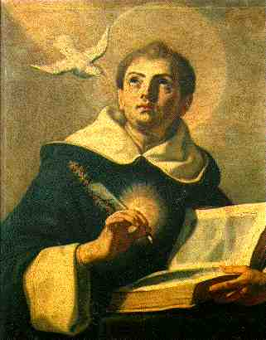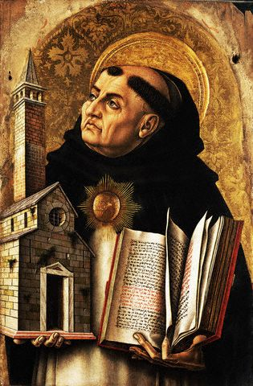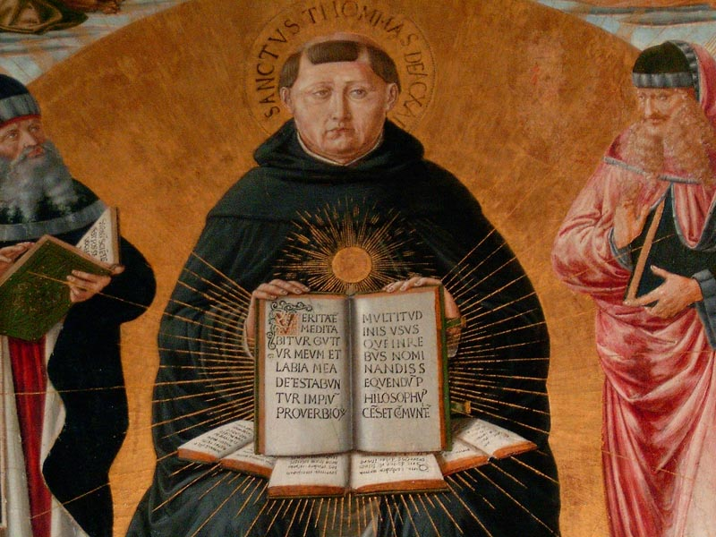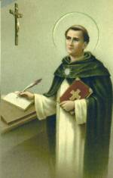
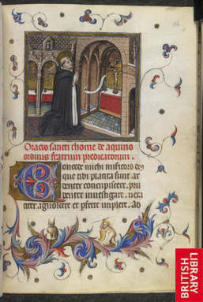

Saint Thomas Aquinas [Thomas of Aquin, or Aquino] (c. 1225 – 7 March 1274) was an Italian philosopher and theologian in the scholastic tradition, known as Doctor Angelicus, Doctor Universalis. He is the foremost classical proponent of natural theology, and the father of the Thomistic school of philosophy, which was long the primary philosophical approach of the Roman Catholic Church. The work for which he is best-known is the Summa Theologiae. One of the thirty-three Doctors of the Church, he is considered by many Catholics to be the Church's greatest theologian. Consequently, many institutions of learning have been named after him.

Contents
- 1 Biography
  - 1.1 Career
  - 1.2 Death and canonization
- 2 Philosophy
  - 2.1 Epistemology
    - 2.1.1 Revelation
    - 2.1.2 Analogy
  - 2.2 Ethics
- 3 Theology
  - 3.1 Nature of God
  - 3.2 Nature of the Trinity
  - 3.3 Nature of Jesus Christ
  - 3.4 Goal of human life
- 4 Modern criticism
- 5 See also
- 6 Notes
- 7 References
- 8 External links
  - 8.1 By Aquinas
  - 8.2 About Aquinas

Biography
Early years of his life=== Thomas Aquinas was born in about 1225 at his father Count Landulf's castle of Roccasecca in the kingdom of Naples. Today, this castle is in the Province of Frosinone, in the Regione Lazio. Through his mother, Countess Theadora of Theate, Aquinas was related to the Hohenstaufen dynasty of Holy Roman emperors.^{[1]} Landulf's brother Sinibald was abbot of the original Benedictine monastery at Monte Cassino. The family intended for Aquinas to follow his uncle into that position. This would have been a normal career path for a younger son of southern Italian nobility.^{[2]}
At five years of age, Aquinas began his early education at the monastery. When he was sixteen years old, he left the University of Naples, where he had studied for six years. Aquinas had come under the influence of the Dominicans, who wished to enlist the ablest young scholars of the age. The Dominicans and the Franciscans represented a revolutionary challenge to the well-established clerical systems of early medieval Europe.^{[3]} Aquinas's change of heart did not please his family. On the way to Rome, his brothers seized him and brought him back to his parents at the castle of San Giovanni. He was held a captive for a year or two so that he would relinquish his purpose. According to his earliest biographers, the family even brought a prostitute to tempt him, but he drove her away. Finally, Pope Innocent IV intervened, and Aquinas assumed the habit of St. Dominic in his seventeenth year.^{[4]}
His superiors saw his great aptitude for theological study. In late 1244, they sent him to the Dominican school in Cologne, where Albertus Magnus was lecturing on philosophy and theology. In 1245, he accompanied Albertus to the University of Paris, where they remained for three years. During this time, Aquinas threw himself into the controversy between the university and the Friar-Preachers about the liberty of teaching. Aquinas actively resisted the university's speeches and pamphlets. When the Pope was alerted of this dispute, the Dominicans selected Aquinas to defend his order. He did so with great success. He even overcame the arguments of Guillaume de St Amour, the champion of the university, and one of the most celebrated men of the day.^{[5]}
Aquinas then graduated as bachelor of theology. In 1248, he returned to Cologne, where he was appointed second lecturer and magister studentium. This year marks the beginning of his literary activity and public life.^{[6]} For several years, Aquinas remained with Albertus Magnus. Aquinas's long association with this great philosopher-theologian was the most important influence in his development. In the end, he became a comprehensive scholar who permanently utilized Aristotle's method.^{[7]}

[edit] Career
In 1252, Aquinas went to Paris for his master's degree. He had some difficulty because the professoriate of the university was attacking the mendicant orders, but ultimately, he received the degree. In 1256, Aquinas, along with his friend Bonaventura, was named doctor of theology, and he began to lecture on theology in Paris and Rome and other Italian towns. From this time onward, his life was one of incessant toil. He continually served in his order, frequently made long and tedious journeys, and constantly advised the reigning pontiff on affairs of state.^{[8]}
In 1259, Aquinas was present at an important meeting of his order at Valenciennes. At the solicitation of Pope Urban IV, he moved to Rome no earlier than late 1261. In 1263, he attended the London meeting of the Dominican order. In 1268, he lectured in Rome and Bologna. Throughout these years, he remained engaged in the public business of the church.^{[9]}
From 1269 to 1271, Aquinas was again active in Paris. He lectured to the students, managed the affairs of the church, and advised the king, Louis VIII, his kinsman, on affairs of state.^{[10]} In 1272, the provincial chapter at Florence empowered him to begin a new studium generale at a location of his choice. Later, the chief of his order and King Charles brought him back to the professor's chair at Naples.^{[11]}
All this time, Aquinas preached every day, and he wrote homilies, disputations, and lectures. He also worked diligently on his great literary work, the Summa Theologiae. The church offered to make him archbishop of Naples and abbot of Monte Cassino, but he refused both rewards.^{[12]}
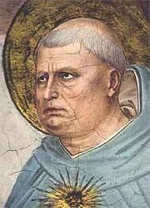
St. Thomas Aquinas, by Fra Angelico
Aquinas had a mystical experience while celebrating Mass on 6 December 1273. At this point, he set aside his Summa. When asked why he had stopped writing, Aquinas replied, "I cannot go on . . . All that I have written seems to me like so much straw compared to what I have seen and what has been revealed to me." Later, others reported that Aquinas heard a voice from a cross that told him he had written well. On one occasion, monks claimed to have found him levitating. The 20th century Roman Catholic writer/convert G. K. Chesterton describes these and other stories in his work on Aquinas, The Dumb Ox, a title that is based on early impressions that Aquinas was not proficient in speech. Albertus Magnus refuted these impressions: "You call him 'a dumb ox,' but I declare before you that he will yet bellow so loud in doctrine that his voice will resound through the whole world."^{[13]}
Aquinas was dark-complexioned, with a large head and receding hairline, of large stature and perhaps naturally corpulent; although he wrote insightfully of the sin of gluttony, he was said to be a great eater, and two versions of a probably apocryphal story have it that a semicircle was cut either out of an altar (according to Charles Van Doren) or out of a refectory table for his convenience. His manners showed his breeding, for people described him as refined, affable, and lovable. In arguments, he maintained self-control and won over his opponents by his personality and great learning. His tastes were simple. He impressed his associates with his power of memory. When absorbed in thought, he often forgot his surroundings. However, he was able to express his thoughts systematically, clearly, and simply. Because of his keen grasp of his materials, Aquinas does not, like Duns Scotus, make the reader his companion in the search for truth. Rather, he teaches authoritatively. On the other hand, he felt dissatisfied by the insufficiency of his works as compared to the divine revelations which he had received.^{[14]}

[edit] Death and canonization
In January 1274, Pope Gregory X directed Aquinas to attend the Second Council of Lyons. His task was to investigate and, if possible, to settle the differences between the Greek and Latin churches. Far from healthy, he undertook the journey. On the way, he stopped at the castle of a niece and there became seriously ill. Aquinas desired to end his days in a monastery. However, he was unable to reach a house of the Dominicans, so he was taken to the Cistercian monastery of Fossa Nuova. After a lingering illness of seven weeks, Aquinas died on 7 March 1274.^{[15]}
Dante (Purg. xx. 69) asserts that he was poisoned by the order of Charles of Anjou. Villani (ix. 218) quotes this belief, and the Anonimo Fiorentino describes the crime and its motive. But the historian Muratori reproduced the account of one of Aquinas's friends, and this version of the story gives no hint of foul play.^{[16]}
Aquinas made a remarkable impression on all who knew him. He received the title doctor angelicus (Angelic Doctor), which put him on a level with Saint Paul and Saint Augustine.^{[17]} In The Divine Comedy, Dante sees the glorified spirit of Aquinas in the Heaven of the Sun with the other great exemplars of religious wisdom. In 1319, the Roman Catholic Church began preliminary investigations to Aquinas's canonization. On 18 July 1323, Pope John XXII pronounced Aquinas's sainthood at Avignon.^{[18]} In 1567, Pope Pius V ranked the festival of St. Thomas Aquinas with those of the four great Latin fathers: Ambrose, Augustine, Jerome, and Gregory.
Aquinas's Summa Theologiae was deemed so important that at the Council of Trent, it was placed upon the altar beside the Bible and the Decretals.^{[19]} Only Augustine has had an equal influence on the theological thought and language of the Western Church. In his Encyclical of 4 August 1879, Pope Leo XIII stated that Aquinas's theology was a definitive exposition of Catholic doctrine. Thus, he directed the clergy to take the teachings of Aquinas as the basis of their theological positions. Also, Leo XIII decreed that all Catholic seminaries and universities must teach Aquinas's doctrines, and where Aquinas did not speak on a topic, the teachers were "urged to teach conclusions that were reconcilable with his thinking."
In 1880, Aquinas was declared patron of all Roman Catholic educational establishments. In a monastery at Naples, near the cathedral of St. Januarius, a cell in which he supposedly lived is still shown to visitors. Aquinas's feast day is celebrated on 28 January. Since 1974 his remains have rested in the Church of the Jacobins in Toulouse.

Philosophy
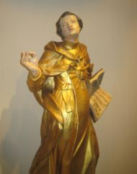
Thomas Aquinas 17th century sculpture
"Nihil est in intellectu quod non prius in sensu." (Nothing is in the intellect that was not first in the senses) – Aquinas' peripatetic axiom
The philosophy of Aquinas has exerted enormous influence on subsequent Christian theology, especially that of the Roman Catholic Church, extending to Western philosophy in general, where he stands as a vehicle and modifier of Aristotelianism. Philosophically, his most important and enduring work is the Summa Theologiae, in which he expounds his systematic theology.

[edit] Epistemology
Aquinas believed "that for the knowledge of any truth whatsoever man needs Divine help, that the intellect may be moved by God to its act." However, he believed that human beings have the natural capacity to know many things without special divine revelation, even though such revelation occurs from time to time, "especially in regard to [topics of] faith."^{[20]} Aquinas was also an Aristotelian and an empiricist. He substantially influenced these two streams of Western thought.

[edit] Revelation
Aquinas believed in two types of revelation from God: general revelation and special revelation.^{[21]} General revelation occurs through observation of the created order. Such observations can logically lead to important conclusions, such as the existence of God. Aquinas is well known for his quinquae viae, or five rational proofs for the existence of God.
Though one may deduce the existence of God and some of God's attributes through general revelation, certain specifics may be known only through special revelation. In Aquinas's view, special revelation is equivalent to the revelation of God in Jesus Christ. The major theological components of Christianity, such as the Trinity and the Incarnation, are revealed in the teachings of the Church and the Scriptures and may not otherwise be deduced.
Special revelation and natural revelation are complementary rather than contradictory in nature.

[edit] Analogy
An important element in Aquinas's philosophy is his theory of analogy. Aquinas noted three different forms of descriptive language: univocal, analogical, and equivocal.^{[22]} Univocality is the use of a descriptor in the same sense when applied to two objects. Equivocation is the complete change in meaning of the descriptor and is a logical fallacy. Analogy, Aquinas maintained, occurs when a descriptor changes some but not all of its meaning. Analogy is necessary when talking about God, for some of the aspects of the divine nature are hidden (Deus absconditus) and others revealed (Deus revelatus) to finite human minds. In Aquinas's mind, we can know about God through his creation (general revelation), but only analogically. We can speak of God's goodness only by understanding that goodness as applied to humans is similar to, but not identical with, the goodness of God.^{[23]}

[edit] Ethics
Aquinas's ethics is based on the concept of "first principles of action."^{[24]} In his Summa Theologiae, he wrote:
Virtue denotes a certain perfection of a power. Now a thing's perfection is considered chiefly in regard to its end. But the end of power is act. Wherefore power is said to be perfect, according as it is determinate to its act.^{[25]}
Aquinas defined the four cardinal virtues as prudence, temperance, justice, and fortitude. The cardinal virtues are natural and revealed in nature, and they are binding on everyone. There are, however, three theological virtues: faith, hope, and charity. These are supernatural and are distinct from other virtues in their object, namely, God:
Now the object of the theological virtues is God Himself, Who is the last end of all, as surpassing the knowledge of our reason. On the other hand, the object of the intellectual and moral virtues is something comprehensible to human reason. Wherefore the theological virtues are specifically distinct from the moral and intellectual virtues.^{[26]}
Furthermore, Aquinas distinguished four kinds of law. These are the eternal, natural, human, and divine law. Eternal law is the decree of God which governs all creation. Natural law is the human "participation" in the eternal law and is discovered by reason.^{[27]} Natural law, of course, is based on "first principles":
. . . this is the first precept of the law, that good is to be done and promoted, and evil is to be avoided. All other precepts of the natural law are based on this . . .^{[28]}
The desire to live and to procreate are counted by Aquinas among those basic (natural) human values on which all human values are based. Human law is positive law: the natural law applied by governments to societies. Divine law is the specially revealed law in the scriptures.
Aquinas also greatly influenced Roman Catholic understandings of mortal and venial sins.
According to Peter Singer, Aquinas denied that human beings have any duty of charity to animals, and he argued that "the only reason for us to avoid cruelty to them is the risk that cruel habits might carry over into our treatment of human beings."^{[29]}

Theology

Aquinas viewed theology, or the sacred doctrine, as a science, one whose raw material data consists of written scripture and the tradition of the church. These sources of data were produced by the self-revelation of God to individuals and groups of people throughout history. Faith and reason, while distinct but related, are the two primary tools for processing the data of theology. Aquinas believed that both were necessary, or, rather, that the confluence of both was necessary, for one to obtain true knowledge of God. The ultimate goals of theology, in Aquinas’s mind, are to grasp the truth about God and to experience salvation through that truth.

[edit] Nature of God
Aquinas felt that the existence of God is neither self-evident nor beyond proof. In the Summa Theologiae, he considered in great detail five rational proofs for the existence of God. These are widely known as the quinquae viae, or the "Five Ways."
Concerning the nature of God, Aquinas found that the best approach, commonly called the via negativa, is to consider what God is not. This led him to propose five positive statements about the divine qualities:^{[30]}
- God is simple, without composition of parts, such as body and soul, or matter and form.
- God is perfect, lacking nothing. That is, God is distinguished from other beings on account of God's complete actuality.
- God is infinite. That is, God is not finite in the ways that created beings are physically, intellectually, and emotionally limited. This infinity is to be distinguished from infinity of size and infinity of number.
- God is immutable, incapable of change on the levels of God's essence and character.
- God is one, without diversification within God's self. The unity of God is such that God's essence is the same as God's existence. In Aquinas's words, "in itself the proposition 'God exists' is necessarily true, for in it subject and predicate are the same."
In this approach, he is following, among others, the Jewish philosopher Maimonides.^{[31]}

[edit] Nature of the Trinity
Aquinas argued that God, while perfectly united, is also perfectly described by three interrelated persons. These three persons (Father, Son, and Holy Spirit) are constituted by their relations within the essence of God. The Father generates the Son (or the Word) by the relation of self-awareness. This eternal generation then produces an eternal Spirit "who enjoys the divine nature as the Love of God, the Love of the Father for the Word."
This Trinity does not exist in separation from the world. On the contrary, the Trinity serves to communicate God's self and God's goodness to human beings. This takes place through the Incarnation of the Word in the person of Jesus Christ and through the indwelling of the Holy Spirit (indeed, the very essence of the Trinity itself) within those who have experienced salvation by God.^{[32]}

Nature of Jesus Christ
In the Summa Theologiae, Aquinas begins his discussion of Jesus Christ by recounting the biblical story of Adam and Eve and by describing the negative effects of original sin. The purpose of Jesus Christ's Incarnation was to restore human nature by removing "the contamination of sin," which humans cannot do by themselves. "Divine Wisdom judged it fitting that God should become man, so that thus one and the same person would be able both to restore man and to offer satisfaction."^{[33]}
Aquinas argued against several specific contemporary and historical theologians who held differing views about Jesus Christ. In response to Photinus, Aquinas stated that Jesus was truly divine and not simply a human being. Against Nestorius, who suggested that God merely inhabited the body of Jesus, Aquinas argued that the fullness of God was an integral part of Jesus' existence. However, countering Apollinaris's views, Aquinas held that Jesus had a truly human (rational) soul, as well. This produced a duality of natures in Jesus, contrary to the teachings of Arius. Aquinas argued against Eutyches that this duality persisted after the Incarnation. Aquinas stated that these two natures existed simultaneously yet distinguishably in one real human body, unlike the teachings of Manichaeus and Valentinus.^{[34]}
In short, "Christ had a real body of the same nature of ours, a true rational soul, and, together with these, perfect deity." Thus, there is both unity (in his one hypostasis) and diversity (in his two natures, human and divine) in Jesus Christ.^{[35]}

Goal of human life
In Aquinas's thought, the goal of human existence is union and eternal fellowship with God. Specifically, this goal is achieved through the beatific vision, an event in which a person experiences perfect, unending happiness by comprehending the very essence of God. This vision, which occurs after death, is a gift from God given to those who have experienced salvation and redemption through Jesus Christ while living on earth.
This ultimate goal carries implications for one's present life on earth. Aquinas stated that an individual's will must be ordered toward right things, such as charity, peace, and holiness. This relationship between will and goal is antecedent in nature "because rectitude of the will consists in being duly ordered to the last end [that is, the beatific vision]." Those who truly seek to understand and see God will necessarily love what God loves. Such love requires morality and bears fruit in everyday human choices.^{[36]}

Modern criticism
Some of Aquinas' ethical conclusions are at odds with the majority view in the contemporary West. For example, he held that heretics "deserve not only to be separated from the Church by excommunication, but also to be severed from the world by death." Aquinas believed that heresy was much more severe than, for instance, money forgery, which was punishable by death in his time. Therefore, heretics deserved at least as severe a punishment (ST II:II 11:3). Aquinas also maintained woman's subjection to man "because in man the discretion of reason predominates"(ST I:92:1), which is one reason why he opposed the ordination of women (ST Supp. 39:1). Aquinas did say, however, that women were fit for the exercise of temporal power. He also held that "a parent can lawfully strike his child, and a master his slave that instruction may be enforced by correction" (ST II:II 65:2).
On the other hand, many modern ethicists (notably Philippa Foot and Alasdair MacIntyre), both within and outside of the Catholic Church, have recently commented on the possible use of Aquinas's virtue ethics as a way of avoiding utilitarianism or Kantian deontology. Through the work of 20th century philosophers such as Roman Catholic convert Elizabeth Anscombe (especially in her book Intention), Aquinas's principle of double effect specifically and his theory of intentional activity generally have been influential.
Modern readers might also find the method frequently used to reconcile Christian and Aristotelian doctrine rather strenuous. In some cases, the conflict is resolved by showing that a certain term actually has two meanings: the Christian doctrine referring to one meaning, the Aristotelian to the second. Thus, both doctrines can be said to be true. Indeed, noting distinctions is a necessary part of true philosophical inquiry. In most cases, Aquinas finds a reading of the Aristotelian text which might not always satisfy modern scholars of Aristotle but which is a plausible rendering of the Philosopher's meaning and is thoroughly Christian.
It is remarkable that Aquinas's aesthetic theories, especially the concept of claritas, deeply influenced the literary practice of modernist writer James Joyce, who used to extol Aquinas as being second only to Aristotle amongst Western philosophers. The influence of Aquinas's aesthetics can be also found in the works of the Italian semiotician Umberto Eco, who wrote an essay on aesthetic ideas in Aquinas (published in 1956 and republished in 1988 in a revised edition).
Many biographies of Aquinas have been written over the centuries, one of the most notable by G.K. Chesterton.

[edit] See also
Christianity Portal
Saints Portal
- Works by Thomas Aquinas
- Institutions named after Thomas Aquinas
- Thomism
- Aristotelianism
- School of Salamanca, 16th century Spanish Thomists
- Bartholomew of Lucca, Aquinas' friend and confessor
- Etienne Gilson, Jacques Maritain and Alasdair MacIntyre; all recent Thomists
- High Middle Ages
- Christian mystics

[edit] Notes
- ^ Philip Schaff, The New Schaff-Herzog Encyclopedia of Religious Knowledge (Grand Rapids: Baker Book House, 1953), vol. XI, p. 422.
- ^ Ibid.
- ^ Ibid.
- ^ Ibid.
- ^ Ibid.
- ^ Ibid.
- ^ Ibid.
- ^ Ibid.
- ^ Schaff, pp. 422-423.
- ^ "Aquinas, Thomas," Encyclopædia Britannica (1911), pg. 250.
- ^ Schaff, p. 423.
- ^ "Aquinas, Thomas," Encyclopædia Britannica (1911), pg. 250.
- ^ Fr. Placid Conway, O.P., Saint Thomas Aquinas (London: Longmans, Green and Co., 1911), chapter 2.
- ^ Schaff, p. 423.
- ^ Schaff, p. 423.
- ^ "Aquinas, Thomas," Encyclopædia Britannica (1911), pg. 250.
- ^ Schaff, p. 423.
- ^ Ibid.
- ^ Will Durant, The Age of Faith (Simon and Schuster, 1950), p. 978.
- ^ Summa Theologica, First Part of the Second Part, Question 109. Retrieved 26 August 2006.
- ^ Geisler, p. 725.
- ^ R. C. Sproul, Renewing Your Mind (Baker Books: Grand Rapids, MI, 1998), p. 33.
- ^ Geisler, p. 726.
- ^ Geisler, p. 727.
- ^ Summa, Q55a1.
- ^ Summa, Q62a2.
- ^ Louis Pojman, Ethics (Belmont, CA: Wadsworth Publishing Company, 1995).
- ^ Summa, Q94a2.
- ^ Peter Singer. "Animals" in The Oxford Companion to Philosophy.
- ^ Peter Kreeft, Summa of the Summa (San Francisco: Ignatius Press, 1990), pp. 74-77, 86-87, 97-99, 105, 111-112.
- ^ [http://www.jewishencyclopedia.com/view.jsp?artid=1678&letter=A Jewish Encyclopedia, Aquinas, Thomas
- ^ Aidan Nichols, Discovering Aquinas (Grand Rapids, MI: Eerdmans Publishing Company, 2002), pp. 173-174.
- ^ Thomas Aquinas, Aquinas's Shorter Summa (Manchester, NH: Sophia Institute Press, 2002), pp. 228-229.
- ^ Ibid., pp. 231-239.
- ^ Ibid., pp. 241, 245-249. Emphasis is the author's.
- ^ Kreeft, p. 383.

[edit] References
- "Bibliography of Additional Readings" (1990). In Mortimer J. Adler (Ed.), Great Books of the Western World, 2nd ed., v. 2, pp. 987-988. Chicago: Encyclopedia Britannica.
- Craig Paterson & Matthew S. Pugh (eds.) Analytical Thomism: Traditions in Dialogue. Ashgate, 2006.

[edit] External links

[edit] By Aquinas
Find more information on Thomas Aquinas by searching Wikipedia's sister projects:
Dictionary definitions from Wiktionary
Textbooks from Wikibooks
Quotations from Wikiquote
Source texts from Wikisource
Images and media from Commons
News stories from Wikinews
Learning resources from Wikiversity
- Summa contra Gentiles
- Summa Theologiae
- The Principles of Nature
- On Being and Essence (De Ente et Essentia)
- Catena Aurea (partial)
- Corpus Thomisticum - the works of St. Thomas Aquinas (Latin)
- Works by Thomas Aquinas at Project Gutenberg
- Bibliotheca Thomistica IntraText: texts, concordances and frequency lists

About Aquinas
- Catholic Encyclopedia article
- Article on Thomism by the Jacques Maritain Center of Notre Dame University [1]
- Biography of Aquinas by G. K. Chesterton (Warning: protected by copyright outside of Australia)
- On the legend of St. Albert's automaton
- Aquinas on Intelligent Extra-Terrestrial Life
- St Thomas of Aquinas Selected Prayers and poems
- Stanford Encyclopedia of Philosophy entry
- [2] bio and ideas at SWIF/University of Bari/Italy
- Aquinas' Moral, Political and Legal Philosophy
- Aquinas the Scholar from The Thirteenth, the Greatest of Centuries, ch. XVII. by James Joseph Walsh

END

