Alexandre Saint Yves d'Alveydre - Archeometre 1842 - 1909

http://en.wikipedia.org/wiki/Alexandre_Saint-Yves_d'Alveydre

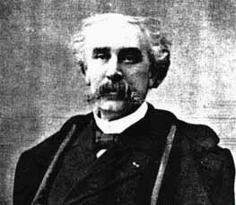
------------------------------------------------------------------------------------------------------------------------------------------------------------------------------------------------------
Alexandre Saint-Yves d'Alveydre 1842 - 1909 was a French occultist who adapted the works of Fabre d'Olivet and, in turn, had his ideas adapted by Papus. He coined the term Synarchy - the association of everyone with everyone else. His book the Mission des Juifs 1884 was favourable to Jews, but material from this was used for The Secret of the Jews an anti-semitic tract attributed to Yuliana Glinka.
He believed in the existence of spiritually superior beings. These beings could be contacted telepathically. According to Saint-Yves these masters with whom he claimed to be in contact lived in the mysterious underworld realm which is known as Agartha. Saint-Yves d'Alveydre was the man who introduced the concept of Agartha to the Western world.

