Elias Ashmole's Theatricum Chemicum Brittanicum (1652)

109. Elias Ashmole, Theatrum chemicum Britannicum. London, John Grismond for Nathaniel Brookes, 1652

http://www.xs4all.nl/~bph/treasures-109.html

In the wake of the compilations of alchemical texts printed and published on the Continent, Elias Ashmole added to the stock of alchemical lore by compiling a volume of British alchemical texts, noting that, although English alchemical authors were greatly esteemed on the Continent, they were neglected in their own country. Some 30 works are included, ranging chronologically from the works of Sir Thomas Norton and Sir George Ripley - among England's most famous medieval alchemists - to a work by William Backhouse, alchemist and tutor to Ashmole.
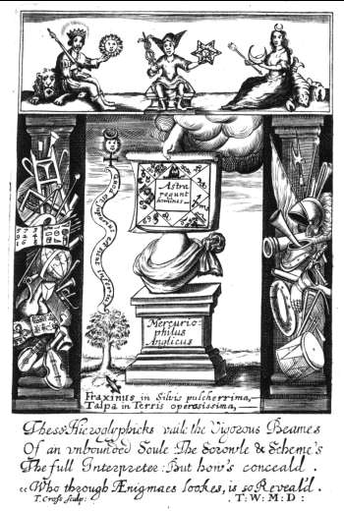

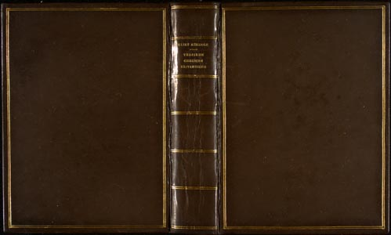 | 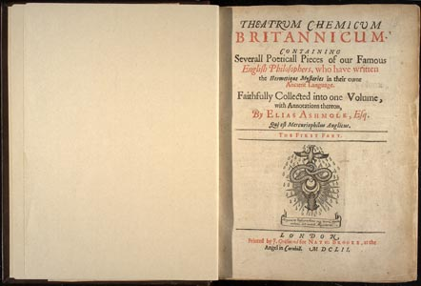
http://www.library.upenn.edu/etext/science/ashmole/
About Elias Ashmole's Theatrum Chemicum Britannicum

Table of Contents
- Title Page

To All Ingeniously Elaborate Students, In the most Divine Mysteries of Hermetique Learning
The Ordinall of Alchimy. Thomas Norton
Compound of Alchymie. George Ripley
the Figure conteying all the secrets of the Treatise both great & small
Liber Patris Sapientiae. Anonymous
Hermes's Bird. Anonymous
The Tale of the Chanons Yeoman. Geoffry Chaucer
Dastin's Dreame. John Dastin
Upon the Elixir. Pearce (the Black Monke)
The Hunting of the Greene Lyon. Abraham Andrewes.
The Breviary of Philosophie. Thomas Charnock
AEnigmaes. Thomas Charnock
Bloomefield's Bloosomes. William Bloomefield
Sir Edward Kelley's Worke.
Sir Edward Kelley to G.S. Gent.
Testament. John Dee
De Lapide Philosophorum. Thomas Robinson
Experience and Philosophy. Anonymous
The Magistery. W.B.
Anonymi, or Severall Workes of unknowne Authors.
Concerning the Philosopher's Stone. John Gower
The Vision of Sir George Ripley.
Verses Belonging to An Emblematicall Scrowle. George Ripley
The Mistery of Alchymists. George Ripley
A Short Worke. George Ripley
Secreta Secretorum. John Lydgate
Anonymi, or Severall Workes of unknowne Authors.
The Hermet's Tale. Anonymous
A Discription of the Stone. Anonymous
The Standing of the Glasse. Anonymous
AEnigma Philosophicum. William Redman
Fragments.
- Annotations and Discourses upon Some part of the preceding Worke.
- A Table of The Severall Treatises, with their Authors Names, contained in this Worke
- A Table explaining the Obscure, Obselete, and mis-spell'd words used throughout this Worke.

Elias Ashmole's Theatricum Chemicum Britannicum (1652)
Elias Ashmole (1617 - 1692) rose from humble origins to become a prominent antiquarian, mathematician, astrologer, and alchemist.
The son of a Lichfield saddler, Ashmole was originally earmarked for his father's trade. Through the intercession of a maternal cousin he moved to London and studied law, eventually establishing himself as a sollictor in 1638. A series of favorable marriages provided Ashmole with a measure of independence from his legal practice. In 1660, he abandoned his career entirely and accepted a post as Court Herald for Charles II, a position he received as a reward for his services to the Crown during the English Civil War.
Ashmole's passion for scholarship helped him to renew interest in the study of heraldry, and his love of arcane knowledge facilitated friendships with leading figures in other disciplines, such as astrology and alchemy. Ashmole collected many natural curiosities and historical artifacts, and later donated his entire collection to Oxford University, where it remains to this day. His wide-ranging interests included history, theology, natural philosophy, and the occult sciences.
Ashmole, himself a prolific writer on many topics, believed in the unity of all knowledge and therefore, did not perceive his various pursuits as intellectually distinct. His famous alchemical anthology, Theatrum Chemicum Britannicum (1652) demonstrates Ashmole's attempt to connect the spiritual and physical worlds. In the prolegomena, Ashmole lauds the true "philosopher" who loves wisdom more than gold, and inquires into the "excellent Operations" of Heaven and earth as an act of piety, rather than of personal gain. Ashmole believed that meticulous study and extensive meditation on the ancient alchemical treatises could uncover eternal truths that would ultimately bring one closer to God. This belief in the oneness of truth owed a great deal to the writings attributed to Hermes Trismegistus, the legendary tutor of Moses, whose wisdom had supposedly been lost through the ages. The figure of Trismegistus linked Revelation to the classical learning of Greco-Roman antiquity as equal parts of the same, universal truth.
Ashmole's veneration of the study of nature as a means of spiritual enlightenement appealed to many thinkers of his day, Sir Issac Newton, an admirer of Ashmole, spent most of his life searching for the Philosopher's Stone described in the prolegomena of the Theatrum. the following text is scanned from Newton's own copy of Theatrum Chemicum Britannicum, which belongs to Van Pelt Library, University of Pennsylvania.

--Dale Bowling

