The Crowning of Nature

http://www.levity.com/alchemy/crowning.html
The Crowning of Nature is one of the most important alchemical manuscripts, and contains a famous series of 67 illustrations of the alchemical work taking place in flasks. The following pages are based on the Magnum Opus Hermetic Sourceworks edition of 1980. The coloured figure included are my own redrawing of the coloured figures, based on a number of manuscripts.

Introduction by Adam McLean
List of manuscripts
The text and illustrations [divided into sections to make loading of the images more efficient]
Figures 1-7
Figures 8-17
Figures 18-27
Figures 28-40
Figures 41-49
Figures 50-57
Figures 58-67
Commentary by Adam McLean

Introduction
by Adam McLean
The impulse that led to my publishing this book began in the early 1970's, when I first noticed some enigmatic illustrations in John Read's Prelude to Chemistry. Some years later, when I saw a fuller set of these illustrations in Stanislas Klossowski de Rola's The Secret Art of Alchemy, I knew that here lay one of the most profound works of Alchemical symbolism.
The de Rola book reproduced part of the manuscript version of the Crowning of Nature, in the collection of the Bibliothèque de l'Arsenal, however it was not identified under this title. I worked with this version of the series for some time, and although I found great difficulty in comprehending it in its totality, I still felt strongly that here lay a most important alchemical item.
Inspired by the de Rola, I consulted again the Read book and identified the source of his illustrations. These turned out to be taken from Johann Conrad Barchusen's Elementa Chemicae, a late alchemical work of 1718, in which there is included a series of 78 engravings based on the Crowning of Nature manuscript. Contemplation of these illustrations gave new insights into the symbolism, though I was later to find that there were several defects in the symbolism in the engravings. These engravings, however, made such an impression upon me that I chose to use one of them for the cover symbol of the early issues the Hermetic Journal magazine, as I felt it encapsulated in symbolic form the essence of the alchemical process.
Next an amazing and most significant event occurred. While looking through the catalogue of the Ferguson Collection of alchemical manuscripts, I was intrigued by a mention of a particular manuscript containing 67 enigmatical figures, and some others mentioning hieroglyphic figures. There were no definite titles or other indications that might link the manuscripts together in any way, but I decided to investigate. Imagine my surprise when the four manuscripts the librarian placed before me turned out to be independent original copies of the series of symbols I had been seeking for so long. As I turned the pages of the manuscripts, and revealed each illustration in colour, I was profoundly moved. There lay before me the most amazing find, and I realised immediately that the minor imperfections and errors of copying inevitable in each manuscript could be resolved by comparing them directly with each other. The Ferguson Collection had given me the possibility of producing a complete and authoritative version of the work, and in that moment I knew that the task lay before me of publishing this work.
Two of the manuscripts (MSS. Ferguson 245 and 253) had Latin text associated with the illustrations, and as I set about the slow work of transliterating and translating this into English, the first thing to emerge was the true title of the series "The Crowning of Nature". Up until then I had called the work "the Barchusen series", or following de Rola the "de summa manuscript". It is also called in some versions the "Opus Angelorum".
During a further visit to the Ferguson Collection for the purpose of working upon the translation, ther unexpectedly turned up, under another entitlement altogether, a small manuscript in English (Ms. Ferguson 155) which on inspection proved to be a translation of the Latin text. Now the whole work was complete.
There were, however, still other finds to be made. The catalogue of the Sloane manuscripts in the British Library revealed a manuscript in English with the title of "The Crowning of Nature" (Ms. Sloane 12). I immediately requested a microfilm copy of this manuscript, and was most gratified to find that Ms. Ferguson 155 and Ms. Sloane 12 proved to be exact copies. There were minor omissions and errors of copying which seemed to indicate that Ms. Ferguson 155 was copied from the Sloane manuscript. At the same time I was also able to trace other manuscript versions, though I was not able to consult directly all these versions.
As not every version of the manuscript has the text, and from internal evidence it is obvious that the text does not discuss many facets of the symbolism unfolded in the figures, I believe we should see the text as a commentary on a work which primarily communicates through its symbolism. Indeed the text may not even be contemporary with the figures, and in any case is almost entirely derived from the Rosarium Philosophorum which it quotes extensively.
Through inwardly working with this series, contemplating its mystery, and meditating upon the complex structure of its symbolic figures, various patterns began to emerge out of a process of analysis and synthesis, a breaking down of the series into smaller units and building them up into a wholeness, and in this, I believe, lies the key to the Crowning of Nature, rather than in the text. It is this approach that I have taken in the commentary I have provided, which I present here as merely one interpretation of the symbolism, but perhaps one which can act as a foundation upon which others can create and build further interpretations of this multifaceted work.

The History of the Crowning of Nature
The various manuscripts of the Crowning of Nature, belong mostly to the late sixteenth or early seventeenth centuries (MS. Ferguson 245 has a note on the flyleaf "Franciscus Stewart in the 17th year of the reign of Queen Elizabeth").
The text itself quotes extensively from the Rosarium Philosophorum, one of the most important works of sixteenth century Alchemy. I believe we must begin to see the Crowning of Nature series as one of the formative works of the transition between the purely physical aspect of Alchemy, which had been quite well revealed in sixteenth century publications, and the inner soul aspect of the subject, which remained more esoteric and hidden from public view until the early seventeenth century, when writings of a more completely spiritual orientation appeared. The Crowning of Nature is grounded in both these realms of alchemy, first appearing towards the close of the sixteenth century, at a time when physical alchemy was approaching the summit of its achievement, it was the forerunner of the more spiritual and soul alchemical works of the Rosicrucian period in the early seventeenth century, as found in Michael Maier, Mylius, Fludd, Thomas Vaughan, etc. In this sense it also has a definite spiritual connection with the Rosarium Philosophorum, although this takes a different perspective on the Great Work, one which is difficult to directly parallel with the Crowning, nevertheless, both of these works have behind them the same impulse, that is, to reveal the spiritual and soul development aspects that complement the physical work of alchemy.
The Crowning describes in such close detail the alchemical process, that it seems likely that within it are hidden enough clues, to make it one day possible to rediscover this in physical terms. Then one could realise the physical process in parallel with the work of soul development, and perhaps in this lies much that is the key to alchemy.
The Crowning of Nature would have been the text book of a particular alchemical school, and the pupils of the particular master or group of masters would have been set the task of copying this work as part of their spiritual discipline. Indeed, in MS. Ferguson 8, the outlines of each of the figures have been pricked through with a pin, and obviously this was done to facilitate copying the images.
Some of the manuscripts are reputed to be as late as the eighteenth century, which indicates that the work had kept its reputation for a number of generations of alchemists. Indeed, in the latter part of the eighteenth century the sale of a copy seems to have raised some considerable interest and a high price. This sale took place in 1797, and MS. Ferguson 245 includes a cutting of the original advertisement appearing in the Morning Herald of November 24th, 1797.
"A valuable original Manuscript containing Sixty Seven Hieroglyphic paintings showing the Separation and Conjunction of the Elements, like the diversified colours in the approach to perfection of the Grand Philosophical Arcanum. To be disposed of for 200 Guineas, pecuniary embarrassment rendering it indispensible to the present possessor, who, with the deepest concern, is thus necessitated to expose to public view that which for ages has been kept secret. Yet to prevent as much as possible the intrusion of idle curiosity, half a Guinea will be demanded before the manuscript will be shown. Please to enquire at No 25 King Street, Gloucester Place, Portman Square."

The Crowning of Nature - Manuscripts

1. British Library, MS. Sloane 12.
2. British Library, MS. Sloane 1687.
3. British Library, MS. Kings 287.
4. Oxford, Bodleian Library, MS. Ashmole 1433.
5. Oxford, Bodleian Library, MS. Ashmole 1456.
6. Oxford, Bodleian Library, MS. Ashmole 1490.
7. Oxford, Bodleian Library, MS. Digby 127.
8. Oxford, Bodleian Library., St. Mary's Hall, Oriel College v.
9. Oxford, Bodleian Library., St. Mary's Hall, Oriel College vi.
10. London, Wellcome Institute, MS. 2456.
11. London, Wellcome Institute, MS. 3558.
12. London, Wellcome Institute, MS. 3561.
13. London, Wellcome Institute, MS. 4365.
14. London, Wellcome Institute, MS. 4366.
15. London, Wellcome Institute, MS. 4594.
16. London, Wellcome Institute, MS. 6072
17. Glasgow University Library, MS. Ferguson 8.
18. Glasgow University Library, MS. Ferguson 110.
19. Glasgow University Library, MS. Ferguson 155.
20. Glasgow University Library, MS. Ferguson 208.
21. Glasgow University Library, MS. Ferguson 230.
22. Glasgow University Library, MS. Ferguson 237.
23. Glasgow University Library, MS. Ferguson 245.
24. Glasgow University Library, MS. Ferguson 253.
25. Cambridge, University Library, MS. Gg. i. 8.
26. Alnwick Castle, MS. 572.
27. St. Andrews University Library, MS. 38190 [Read].
28. Manly Palmer Hall [P.R.S.], MS. 50.
29. Mellon Collection, Yale University Library, MS. 57.
30. Harvard University, MS. 24226.226 (MS. Typ. 86).
31. Paris, Bibliothèque Nationale, MS. Lat. 18512.
32. Paris, Bibliothèque L'Arsenal, MS. 974 (90 B.S.A.L.)
33. Rennes, MS. 159 (123).
34. Rome, Biblioteca Nazionale., MS. Gesuitico 473.
35. Venice, Biblioteca Marciana, MS. Lat. VI. 305. [2424.]
36. Rome, Biblioteca dell'Accademia dei Lincei., MS. Verginelli-Rota 37.
37. Biblioteca Philosophica Hermetica, MS. 189.
38. Biblioteca Philosophica Hermetica, MS. 305.
39. Biblioteca Philosophica Hermetica, MS. 324.
40. Biblioteca Philosophica Hermetica, MS. 327.
41. Jerusalem, The Hebrew University, Sidney Edelstein Foundation Library. MS. 3.

The Crowning of Nature

Introduction
The influence of the heavens by the will and command of God, descends from above and mixes with the virtues and properties of the Stars, and likewise in this manner is the first production of our seed.
You must not take it out of any combustible for it fights with it without being prejudiced, but is known out of a metallic root ordained by the Creator only for the generation of metals.
You must look [for] it in the seed of its proper nature from which nature may produce it.
Bernard Trevisan's books are writ true, right and once by circumstances to amuse souls.
The Elements are Water, Air, Earth, and Fire, which must be so applied and governed until such time they produce a soul.
We gather the four elements by a concordance of the Seven Planets.
All our work is to Congeal and Dissolve the body, and Congeal the Spirit.
God being before all things, when He was alone created one Substance, which He called the first matter and of that substance he created the Elements, and from them created all things.
Our Stone is the Quintessence of the Four Elements, separated from them and reduced into a fifth Essence, being extracted out of the body of the first matter. Nature created by God prepared with human artifice, then by the Conjunction and Union of the said elements after their perfect rectification, reduces them into a fifth, a glorious fifth Essence or Spirit called Quintessence, appearing in a glorified body which is found in one only thing created by God.
Wheresoever is found a metallic Spirit, a metallic Soul and a body metallic, there is also found infallibly Quicksilver, Sulphur and Salt, in which certainly will make a perfect metallic body.
We gather it from the most perfect Creature upon which the Sun ever set his eyes.
St Dunstan's work, De Occulta Philosophia E: G: I: A, calls it the food of Angels, the heavenly Viaticum, the Bread of Life, and it is undoubtedly next under God, the true Alchochodon or giver of years, and he does not so much admire the question whether any man can die that uses it, as to think why the possessors of it should desire to live, who have these manifestations of Glory and eternity represented to their fleshly eyes.
Our Stone is made or composed of Two, Three, Four, and Fire: of Five, that is the quintessence, of Four which are the Four Elements, of Three which is of three Principle natural things, of Two which signifies double mercury, and of One which is the first principle of all things, which was produced clean and pure from the Creation of the world, fiat – be it made.
There are Creatures created more noble than Gold and we must look [for] it where truth will find it, which so hath put in nature, and man cannot know it by sight, except he see the whole work.
Adam our first father was in his inward parts, or internal man, made according to the similitude of God of the same substance and matter which the Angels were made, though men (that the world hold great Doctors) say and tell it for truth that God made man out of a piece of mud, clay, or dust of the Earth, which is false, it was no such matter, but a quintessential Matter, which is called Earth but is no earth. Adam before his all had a far different body than what he had after, and so far different that if we should behold him as he was in his Innocency, we should admire the glory of him, and tremble at the sight, as at the sight of an Angel and such a body as our blessed Saviour brought from heaven with him, such a body shall we arise with, and with such bodies shall our souls be endued with flesh and blood. Otherwise Man would not differ from Angels, for this flesh and blood is put upon us by the Holy Ghost, that is by regeneration. I forebear to speak more of these mysteries known to few. But he that liveth to be blessed with this Art, shall glorify his Creator. Man the Microcosm or Little World, from the Stars received Spirit, from the Great World his body, and from God immediately his soul, so here is an illumination of the Blessed Trinity. Now let us say something of the production of the Great World out of nothing, when there were neither time or place, and God created a certain Chaos Invisible which the Philosophers call Hyle, the most remote matter. Out of this He made an extract or Second Matter Chaos, which the Philosophers know not by speculation, but since that matter was and is visible and tangible, in which were and are all the seeds and forms of all creatures Superior and Inferior, that ever were made. From this God divided the four Elements, in a word did make all things Celestial and Terrestrial, the Angels, Sun, Moon, and Stars. The knowledge and practice of the Philosophers upon this Chaos brought them to the knowledge of all wisdom, and from thence next [to] God, seek thou and find all wisdom, and indeed Angelical wisdom is attained by it.
Incredulity is given to the world as a punishment.
He that knoweth not what he seeketh, shall not know what he shall find.
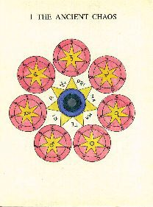
Concerning the Ancient Chaos
Chaos is the first beginning of the first created from an Uncreated Being, this God omnipotent created in the beginning, but before the work of the days it was without shape and also confused. But afterwards all the most sound Philosophers nominated that Essence, the Mother and the first matter of the world, for Hilon, and Nature, in whose bosom innumerable forms lay hid, which the Omnipotent Builder, that great Spagirus, appointed in his time to break forth, for he had first included a spirit in that Undigested Matter, Chaos, who some hath affirmed ought to be called the Soul of the World, some the Form of Forms, others the Proximate Instrument of the Creator. By the benefit of this spirit so included, there is at length by the most free will of God, providing for and overlooking all things, a separation is made of the waters from the waters, by which they were divided. But it is very remarkable, that at the separation of the Chaos, there was a just division, no deperdition, but every particle of the same being full of spirit and life, they are fit for that to which they were ordained, waxing strong and vegetating.
Hence the admirable strength of things, may by the sons of men be drawn forth and become a true metamorphosis, if they artificially search and handle them according to the nature of the Chemical Art, for the true Philosophers have considered of no other Mystery than Nature itself, and a possibility of Nature, which Natural simplicity may indeed suffice those that rely on it, for Nature doth work most of all from its aptness of its own virtue and beginning, as it doth demonstrate, only needing a little help of Art.
With the Cabalists this Chaos is twofold, to wit, Intelligibles and Visibles, the one proceeding from the immediate decree of God, the other is reported or declared to proceed immediately from the execution of the same decree.
Know further, that the point you see in the White, is put for the centre of the Earth, the whiteness doth signify the Earth itself, the crooked line signifies the flowing water, which in its own place would cover the Earth, but by the decree of the most bountiful Creator, it encompasses some part only. The white circle beset with little black spots, signifies the Air, as the sevenfold little points of a golden color denotes the Fire.
These things being thus expounded and declared, the next consideration shall be of the seven Planets punctually compassing the Chaos. The first of these is Saturn, and therefore is placed in the ascendant, but he contains all the other planets, as the others do the rest, but in a diverse order. From hence it is known that all things are in all things, according to the true philosophical intention. But Saturn himself is feminine and melancholy, Jupiter feminine and phlegmatic and sanguine, Mars masculine and sanguine, Mercury feminine and phlegmatic, lastly the Moon feminine and melancholy.
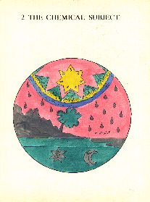
Saturn the Chemical Subject in the Root of Art
Saturn is the first of the planets far exceeding all his brethren in essence, order and dignity. He is accounted the primary son of Nature, the root of metals known to few.
Hence saith the Clangor, the colouring spirit is the philosopher's Mercury with its Red or White Sulphur being naturally mixed with it in the mine and bowels of the Earth, also indifferently prepared, the judgement of the artificer being left until the perfect consummation, as it is in the metaphor of Bellinus concerning the Sun, that which is the spirit is called Saturn, in plain words tincturing and dividing all metallic bodies especially gold with a true and radical dissolution, as is manifest by his words in the Rosary "Know, saith he, that my father the Sun hath given me power above all power and hath clothed me with a garment of glory, and all the world seeks me and runs after me, for I am that excellent one who exalts and debases all things, and none of my servants except one can overcome me, to whom is given that which is contrary to me, and he destroys me, though not my nature, and that is Saturn who separates all my members. Afterwards I turn to my Mother who congregates all my divided and separated members".
Trevisan affirms the same thing, that no other argent vive can be extracted out of any other body, except out of the Red Servant, which is called by Bellinus, the contrary Servant. But it is called a Servant (to wit) the Servant of Nature, because it serves in the generation of Metals in her Minerals, and because it serves in Chemistry to generate that heavenly and also specified stone. It is called Red, because in this last preparation he goes into red dust. But it is termed to be contrary to the Sun, because he doth radically dissolve him and bring him into his first matter. But lest thou should err, my Son, these things are not to be understood of Saturn belonging to metals or mineral Mercury, but concerning the metalline Sun and Moon which are contained in our lead, (to wit) in potential and not visible. Pythagoras says that every secret is in lead.
That I may at length conclude in one word this golden chapter, I do plainly with a constant protestation affirm the more sound Philosophers to have nominated it the Star of the Sun, the Ens of the Moon (Sun and Mercury). Know further, that although the subject of health and riches be the same, and that we will handle them both in these commentaries, yet professedly as to the sons of learning and men of understanding it may appear in this place, we will especially treat of the matter of Medicine, for it is our chief intention. But as yet you see Saturn in the ascendant, and all the planets accompanying him, but having the Sun and Moon under his feet, by which is signified that Saturn himself only doth contain in himself those two tinctures, sought by so many and found or known to few. But that a little solar star appears in the Moon, and a little lunar star in the Sun, doth not want a Mystery, for the Sun and Moon came forth of the one and same root, as may in a short space be occularly demonstrated by an ingenious Artificer, by the little white drops which afterwards become red is signified abundance of Tincture, lying hid especially in the body of Saturn. By the mountain out of which a flourishing tree doth appear, is very fitly signified that Saturn is not gotten elsewhere than in hilly places.
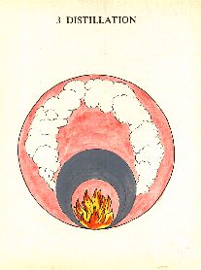
Distillation
After the subject was known, the first intention of the philosophers that water should be got which they had noted with many names amongst which that sharp vinegar so much spoken of by them is one. But the second is dissolving Mercury. The third is Marish water. Dissolving Mercury is defined by a natural dissolution, and is defined by them to be that by whence metals are dissolved by a natural dissolution, and their spirits are brought from power into Action. But before they can be brought to act, Nature ought necessarily to be stirred up, but if the dissolving Mercury should be dry there would be no irritation of Nature, and so by consequence in vain would the solution be hoped for.
There are therefore some which have endeavoured to have that dissolving Mercury, or this water of those marshes, by Distillation, and it was effected. Therefore Distillation with them is the elevation of the watery vapours in the vessel, for in that are two parts of the Stone (to wit), the Superior and the Inferior. They will have the Superior part to be attenuated by Distillation, especially again when the Earth drieth and fasteneth, the Water makes clean and washeth, but the Air and Fire maketh to color.
Arnoldus says, it is necessary that there be much Water and much Air, because the multitude of the tincture will be so much as the multitude of the Air, but the Water is purging and the efficient cause of the clearness of the whole body and Medicine. Hence it is that frequent Distillation is called the most true Ablution of the Elements.
It is therefore necessary that the Stone be divided by the Four Elements and that by Distillation. First, by a light fire equally temperated and continued, water is to be gotten. Then the fire is to be made a little more vigorous and stronger, until the fire be received mixed with the fire. That which remains burned in the bottom is the dry earth where the crystalline Salt of the Stone lieth hid. Moreover, by the inferior circle, the furnace is signified. By that Red as yet beneath, the fire is signified. By the superior circle, the vessel in which the matter is put. By the cloud is signified the smoke which seems to rise like a cloud as you are distilling.
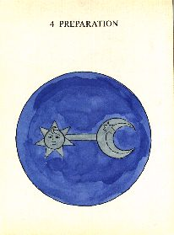
Preparation
To prepare in this art is nothing else than to take away superfluities and supply deficiencies, because light things cannot be fixed without the company of weighty, and weighty things cannot be exalted without the consortship of light things. Neither can the hot without the consortship of the cold, the cold of the hot, the moist of the dry, the dry of the moist, the hard of the soft, the soft without the addition of the hard, be temporated or prepared. But when they are by course fitly espoused, there is generated from them a temporated substance, which the violence of the Fire cannot overcome, nor the putrefaction of the Earth vitiate, neither the limosity of the Water condensate, nor any contract, adumbrate, or overshadow.
We must know further that the preparation of the aforesaid matter is perfected by the removing of the superfIuous part and the addition of the absent, by the exercise of the Four Regimens. The first of them is a reduction to the nature of the Fire. The second is a resolution into Water, and the third is a levigation into Air, and the fourth is a pressing down to the Earth or fixing. The first is by Calcining. The second is by Loosening. The third is by distilling through a still. The fourth is by Coagulating or Congealing with a light fire.
And so the whole preparation is perfected, to which purpose the Hermite did also intimate in his Smaragdine Table, saying, "it ascends from the Earth to Heaven and descends again from Heaven to Earth". And that this doctrine concerning the preparation of the Stone might be better understood, Geber testifieth most openly concerning this. Saith he, "Our art doth not consist in the plurality of things for it is one matter (to wit) of metals in which consisteth our Mystery, to which we have not added any strange thing, neither do we diminish unless that in the preparation we remove superfluity". But the other things pertaining to this Chaos are clearly enough unfolded by the second Chapter, but here it remaineth in the Water.
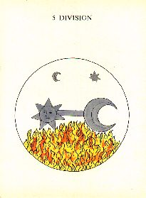
Division
Division in this art is the separation of the parts of the composition that they may be the better at length united. In which sense composition is contrary to Division, which indeed is the beginning and life of the thing, for unless there were a Composition, the thing would not be produced into a being.
Hence the cunning Son of Jazichus, the spirit will not remain in the body, neither will it be in it nor tarry any longer, until the body be subtilated, attenuated as the Spirit is. And when it is so attenuated and subtilated and does go out of his density and thickness to thinness, and from his grossness and corporeality to spirituality, then the spirit will be mingled with and drunk up in them, and so they are both become one and the same and will not be separated, as neither water mixed with water cannot be discerned, so although the Philosopher's Stone be divided into two principles (to wit) into the superior part which ascendeth, and into the inferior part which remaineth in bottom fixed, yet notwithstanding these two parts doth concord in virtue.
Therefore the materials are to be weighed and converted and divided because they are changed from a thing into a thing, as the seed of a man in the womb is in a natural preparation turned from thing to thing, until there be found a perfect man, from which was his root and beginning.
Moreover, by the Solar and Lunar stars is signified the water already gotten out of the body of Saturn. By the Sun and Moon the body of Saturn wherein the Salt yet remaineth. By the red understand the fire, by mediation whereof the aforesaid water was drawn forth.
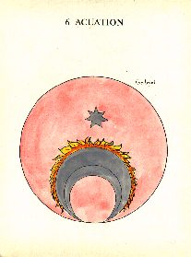
Acuation
Acuation is that by which the Stone is amended by the extraction of his proper earth, that is of the Salt, and by the mixing of the same with Sulphur and his proper Mercury.
Hence Gratianus, of every thing there may be made ashes, and of that Salt there is water, and of that water there is Mercury, and of that Mercury by diverse operations there is made Sun. He therefore that knows the Salt and its solution, knows the hidden secrets of the ancient wise men. Whosoever, therefore will alter spirits and bodies and change them from their nature, it behoveth that he first reduce them to the nature of Salts and Alums otherwise he will do nothing, then let him lave or wash those, that Sal may go forth fusible. You ought as Arnold saith to praise God, from whence also another Philosopher, put therefore thy mind on the Salt, the chief and most hidden Mystery of all the ancient Philosophers.
Moreover, by the lunar star is signified the White Salt of Saturn already gotten. By the circles, the furnace and vessels. By the compassing red, the fire, and that of Calcination, because Saturn is not gotten but first by calcining.
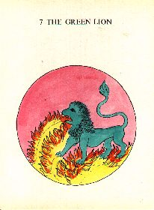
The Green Lion
The Green Lion is that Philosophical Mercury so often spoken of in his first beginning, or flourishing, easily avoiding the fire, because it is not fixed, but being fixed it desires it, and expects it and rejoiceth in it. It is of a Cold and Airy nature, and out of it (as it is in the Rosary), God created all mines. Let it not therefore seem strange to anyone because it reduceth into and doth radically dissolve all metals into their first matter, when as out of him are all things, and in whose bosom are all the planets, they lie hid and are contained. Seeing therefore that some of them affecteth a sublime work to him and is a profitable spirit, and there is no thing in the world besides him, neither is there that may stand in his place, and is only profusive in the body that wants him (hence Rosary).
But the ancient and wise Philosophers have engendered the manner of wit (knowing) until it be a little done that he might expect the fire. It doth not cease to go above the reluctancy of the fire and is nourished with it, so that when any fixation is fastened unto him, there proceeds wonderful things and changes, because when he is changed he changeth, and his entrance appears in his sound and splendour. When therefore it is coloured it coloureth, when it is loosed it looseth, and it doth make itself white in the twinkling of an eye, and it becomes red in succession, and it is a congregating water, milk, and strong urine, softening oil, and the father of all wonderful things. It is smoke and a cloud, and the fugitive servant accidental Mercury eating the Sun, who hath preferred himself before Gold and hath overcome, for it is generated, risen and produced out of him.
But lest thou should err, my son, know that those which understood of Mercury in the body of Philosophical Saturn and metalline, to be true. Moreover the Lion is said to be green in the threefold aspect. First in respect of his attractive power, for here the Central Sun is like to the Celestial Sun and make the world flourishing and green. Secondly, it is called the green Lion, because as yet the Gold is incomplete nor fixed in any body, and therefore is called living Gold. Thirdly, it is called a Lion by reason of its very great strength, reference being had to the Animal Lion, for as all beasts obey the lion, so all metallic bodies do give place to this living Gold.

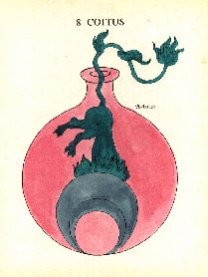
Conjunction
Conjunction in this art is a natural act of two vapours of the body and spirit, in one and the same genus but in a diverse species of actors and sufferers [actives and passives].
But lest thou should err, my Son, thou must now that the spirit is twofold (to wit) Tinctural and Preparing. The Preparing spirit dissolveth brass and extracteth it out of the body of the lodestone, and reduceth it again into the body itself. But the Tinctural spirit is beyond the body, and it is a body itself of a watery nature, but in the Elixir the tinctural spirit being masculine is the body, the woman the spirit.
Hence saith Arnold, the spirit is not altered from the body so that it should lose its spiritual virtue, but every body is altered and coloured by the spirit. Join therefore, my Son, (as it is in the Rosary thy Gabricius more beloved to thee than all thy sons, with his sister Beya, who is a cold girl, sweet and tender. Hence it is rightly gathered, that unless there should be such a copulation, there would never be a Conception, Raising, Pregnation, or Birth. This therefore, is the direction of this disposition, which is especially assimilated to the creation of Man.
But by the circles is signified the vessels and furnace. By the Green Lion as it were but half into the vessel, is signified that one part ought to be put in after another and not altogether, as first Mercury then Salt or Oil, and these things are to be put in by little and little, after they are purified.
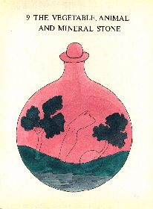
The Animal, Vegetable and Mineral Stone
We find the Philosophers Stone to be variously defined with Philosophers in general, amongst which definitions we will at length rehearse one or other of them.
Therefore, the Stone, as Clangor hath it, is a body composed out of the first essence of metals, which first essence is indeed termed other where Argentvive reduced from the power of them into acting by the art of chemistry, the mystery of all beginnings.
Again the Philosopher's Stone is metallic matter converting the substance and forms of imperfect metals. That this conversion is not done but by its like is long ago agreed upon by all Philosophers. It is therefore necessary that the Stone be got out of a metallic matter (to wit) our Mercury in which is all that which is so sought for by the wise men, and lieth hid in our Mercury, although this Mercury may be termed threefold. From whence three principle Stones are known by philosophers, (to wit) the Mineral of the Wise men, or the Mineral, Animal, and Vegetable Stone of them, threefold in name, one in being.
Whereupon saith one of the Ancients, there are three Stones and three Salts of which the whole magistery consisteth, (to wit) Mineral, Animal, and Vegetable (Mercury is mineral; the Moon is plant, because she receiveth into herself two colours, white and red ; and the Sun is animal because he receiveth three, (to wit) constriction, white and red).
But by the tree upon the mountain on the left hand flourishing and bearing fruit, is signified his vegetability, as by the leg of a man raised out, his animality. By the third mountain upon which also a flourishing tree grows out, two things are signified. First, that Saturn is hid only in hilly places and it behoveth that he should be digged out of the Earth, which may be understood to be noted by the circle, from whence especially his minerality appears.
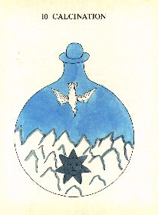
Calcination
Calcination, as subtle witted Geber will, is the turning of a thing into dust by the fire, and by the privation of its humidity, consolidating other parts.
According to others, this Calcination is the last purgation of the Stone, the restoring of its colour, the conserving of its innate Humour, and the induction of Solution. And it is fourfold, for it is either by the desiccation of the moistness of Nature, or by reduction into the bottom of the furnace by fire, and then it is called Alcoole or a subtle powder, or by the amalgamation of familiar metals with quicksilver, by mixing metals with six parts of Mercury, or by strong waters, the spirits of the Salts of black vitriol, of sulphur and the like.
However it be, we use Calcination to mundify the part fixed, and the Earthly part of the Stone. For every calcined thing is in its kind fixed. And so the Sun and Moon are calcined with the first water philosophically, that the bodies may be opened and become spongeous and subtle, that the second water may the better go in to work its work, which is to exalt the Earth into Mirable Salt by its only attractive virtue. Which second water is fire, not natural, by whose virtue the completement of this art is done.
Moreover, by the Sun here joined with the Moon, understand the body of Saturn even now to be calcined with the Philosophical water. By the bird flying from above, that in Calcination the spirit of Saturn goes downwards and remains together with the body, as in Sublimation it always goes upward, as is to be seen in the next chapter. But by the bird or spirit flying upwards, understand dusky clouds ascending frequent indeed but moderately.
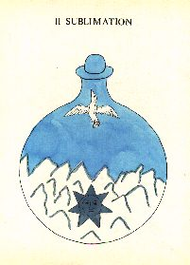
Sublimation
Sublimation according to some is when that which is extracted into the sublime part of the vessel is stirred up and doth subsist there.
According to Geber, it is the elevation of a dry thing by the fire, with the adherency of its vessel.
Either definition is honest. We must know further, that the philosophers for four reasons made sublimation. First, that the body should be made a spirit of a subtle matter. Secondly, that the Mercury might incorporate itself with the body and become one with it. And thirdly, that the whole may become White, then Red and clean, and especially that the innate humidity of the Stone might be restored, which he had at the first lost in the bottom, and may be moved forwards and made fit for a sudden liquefaction, because the medicine ought to be a simple dust of a most subtle and pure substance, adhering out of its nature to the Argent vive or a most easy liquefaction, and hidden or secret subtilation of an easy ingression, after the manner of water, and fixed on the reluctancy of the fire, before the fIight of Mercury.
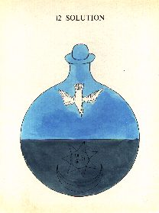
Solution
This Solution is the reduction of a dry thing into water. By this Solution metallic bodies are reduced into their first form, that is into their next matter, to wit, Mercury and Sulphur from whence they took their beginning.
Some of the Philosophers do put the matter of Solution to be twofold, to wit, by hot mud and fervent water, but others do contend that there is but only one Solution necessary in this art, which only hath and is to be done out of and with itself, and it is raw and clear without violence.
Hence saith the Philosopher – a raw solution is better than a sodden one, a moist than a dry, a voluntary than a violent, a temperate than a swift, a fragrant than a stinking, a clean one than a thick, a black one than a red one, and therefore in every Solution we must secretly beware of the vitrification of the matter by the odours and vapours of imperfect bodies, that the force of that generative form may not be choked up with corrosives.
Therefore, saith the Philosopher "help Solution by the Moon and coagulation by the Sun".
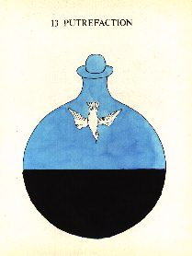
Putrefaction
Putrefaction according to some is the resolution of that which is mingled into the hot and moist by a natural putrefaction. According to others, Putrefaction, which is also termed conception or espousing in the putrefaction which is in the bottom of the glass, is the Conception of the proper and natural callidity in every moisture, under the conservation of it from another moisture going about in the glass.
Yet notwithstanding, Putrefaction is necessary in this work because there is never anything born, increasing, nor animated, except after Putrefaction because if it were not putrefied, it could not be poured forth nor loosed, and if it were not loosed, it will be brought to nothing.
But thou must know this, My Son, that the Putrefaction of the Philosophers is not sordid nor unclean, but it is a mixing of the water with the Earth, and the Earth with the water, by little and little, until the whole body is become one.
Hence Morien "in the Putrefaction of our brass, the spirits are united with the body and are dried up in it. For unless the water should be dried up with or by the Earth, the colours would not appear".
For Putrefaction is nothing else but a mortification of the moist with the dry, between whose mortification there doth appear blackness in regard of the domination of the obscure woman.
Yet the process or force of itself, to wit, of the Philosopher's Stone, is first Black, because unless it were first Black it would not be White, nor Red, because that redness is composed of Black and White. The Philosophers have called this blackness, Silver, the black Lead, the head of the Crow, and from whence it is said in Turba, "when thou shalt see blackness to come to that water, know then the body is melted".
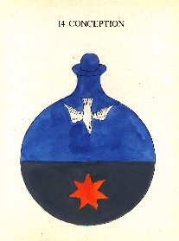
Conception
Thou must know, my Son, that whilst the Earth in the aforesaid blackness doth begin to retain with it some of the Argent vive, then it is termed Conception, and then the male acteth towards the female, to wit, Argent vive, with or into the Earth, and this is the reason why the Philosophers say that our Mystery is nothing else but the male and female and their conjunction. For the water beareth sway over the Argent vive, and the Earth increaseth, multiplieth, and augmenteth.
Hence again Philosophers say, "Conception and Dispousation are to digest it in the putrefaction in the bottom of the vessel, and the generation of the genitors in the air and head of the vessel, to wit, the still".
For the body does nothing except it putrefy and it cannot putrefy except with Mercury.
Therefore the Philosophers, "for with one part of the body are six and thirty parts of the water to be taken, and let putefraction be made with moist gentle fire of hot and moist dung, and in no ways with others, so that nothing may ascend. Because if any thing should ascend a separation would partly be made, which ought not to be done, until the male and female are perfectly joined together, and one received the other, the sign whereof is the superficies in the nature of perfect solution".
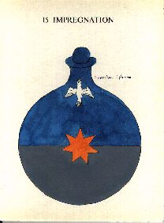
Impregnation
We must know that when the Earth is a little made white, there it is termed Pregnation, because then the Earth is Impregnated. For when the Earth is joined with an imperfect body, it is called Our Earth, because the Earth is the Mother of all the elements, and this is that which they term [unidentified alchemical symbol], when the Earth begins to retain with it somewhat of Arsenic, or Our Salt, or Argent vive, for then it is called a Conception, because the male acteth towards the female, because the Mystery of the Philosophers is nothing else but the male and female and their conjunction. Water coming to them, that is Arsenic or Our Salt, which increases much in the Earth and is augmented and comes out when the Earth is dealbated, then it is called a Pregnation, because the Earth having conceived goes away pregnant.
Moreover, that here and in the former Chapter, the little star formed of seven fold little pricks, becometh Red but not fully, it signifies that the matter of the Stone now shut up in the Philosophical phial, hath in some part suffered putrefaction, but it is far from a plenary mundification, which is made in the bottom of the vessel. For it ought to purge further, as is demonstrated by the thirteenth Chapter.
But whereas the Red and White is not compounded of Red and White, but of Black and White, there is no doubt but by the help of the Governor of all things, it will in short space come into perfect whiteness. But that the little star is not deprived of his blackness, appeareth by the black complements sticking to the little points and planets.
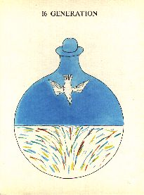
Generation
Matter and form are only contained (as saith the Philosophers) by the Generation of Nature, but they understand by the matter and form, the Agent and Patient, thin and thick, Sulphur and Mercury, male and female, and by consequence know Generation.
He therefore that doth know how to choose matter well disposed and very ready to suffer, and strong to act, this man shall bring forth the more excellent and strong effect, but that the generation of the elixir might be the better done, let the artist diligently consider what things are requisite for Nature in the generation of metals, and what of art is to the generating of the Stone, that a collection being made between these thing he may have, from whence he may judge, whether it be possible to generate the stone.
Thou must know, therefore, my Son, lest thou should err, that there are four things that are altogether requisite or necessary to Nature in the Generation of metals. First, to have composing principles, one whereof hath itself as the Matter, the other is the form of composing. Secondly, to have that due weight of the principles. Thirdly, a fit place is altogether required, that is a solid place, for unless the place where Nature mingleth were according to the two principles solid, the Vapours which are also termed Spirit would exhale, and the solidity of the place doth condensate or thicken those spirits already mixed, from whence it is they begin to act and suffer one towards the other, by subtilizing and separating impurities. The fourth thing requisite in the generation of metals is heat temperated, by which metals are in the end excluded and exhaled into the air.
All these things required are necessary in the art to generate the Stone, all which the artist by imitating Nature in all things, except in her weight, shall easily conceive that the Stone may be gotten. But let him take the weight from Nature necessarily as it shall be meet.
Moreover, of the diverse and intermingled colours appearing here and elsewhere, you may see from day to day in the glass vessel, whereof it is sufficient to have put you in mind, in this place.
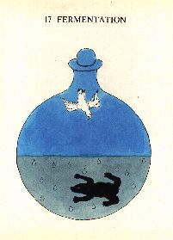
Fermentation

Fermentation with the Philosophers is the incorporation of the Animal part, the restoration of the vapour, the inspiration of the odour, the supplying of the beings, and it is double White and Red, whose ferment is the Sun, the Sun of the Sun, the Moon of the Moon. That is, the Sun is ferment to the Gold, or Red Elixir, and the Moon is ferment to the Silver, or White elixir.
But as substantial bodies, and fixed upon the fire, cannot manifest their qualities, neither do live or are lifted up of themselves, unless by the benefit of spirituality, they are first purified and vivificated, so neither can spiritual accidence manifest their permanent virtue, except they are united and perpetuated with fixed bodies. For then and not before, the body inbreatheth the spirit, teaching him by vigorating, to reluct, strive or struggle against the fire, and the spirit embraceth the body teaching him to pierce through gross bodies, actually to subtilize thick ones, and to generally cure all infirmities and diseases.
But the intention of Fermentation is that the thing to be fermented should be prepared, washed, calcined, and dissolved, that it may the better be joined with the subtle work or body, that is to say, White ferment with White, and Red with Red.
Yet these things not hindering, my Son, you are to know that Fermentation doth not change the powder of the Stone into any form but his own, but it giveth savor, odour, and strength to transmute other bodies to his own nature.
But by the Toad, here understand the sphere of Saturn swelling with tincture, or his heaven to be great and impregnate therewith, and by and by ready to bring forth, which by the ejection of the four elements appeareth most plainly in the next Chapter, in the conversion of whom one after another, until they are inseparably fixed, dependeth the chief completement of this work. The Crowning of Nature

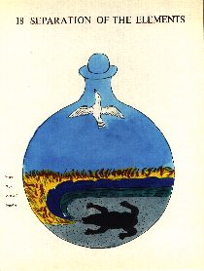
The Separation of the Elements
We being about to speak concerning the generation of the elements and their conjunction, by reason that one of them cannot be understood without the other, we shall handle them both together in this and the subsequent Chapter.
Therefore the separation of the elements in this art is nothing else than to separate or segregate heterogeneous (which are accidents from homogeneous (which are of the Essence of the Stone), that at length the mixture of the elements might be most pure and perfect. But the conjunction of the elements is to keep up homogeneous things, that is, those that are of the nature of the Radical Moisture.
Hence Raymond "have patience in dealbation or whitening, because here lieth much tardity".
Thou must know further, my Son, that the separation of the elements with the Philosophers is termed the conversion of them, as if to convert the elements was to make a thin body of a gross one, that is, of the body a spirit, and afterwards of the moist a dry, of water earth, and the elements are converted one into the other. But the Philosophers do prescribe such a manner of converting the body into the spirit. The earth is resolved into water, and water into air, the air into fire, but the spirit is turned into the body. This way the fire is coagulated and it becomes air, but the air is coagulated and becomes water, but the water is coagulated and becomes earth.
From whence saith Assidnus "behold elements hath met together in one nature, who when they are so impelled (that is coagulated) become friends, but when they wax thin they become enemies. Therefore convert the elements and thou shalt find what thou seeketh".
It behovest thee, therefore, first of all to mortify and exalt the Stone, that is, the body, soul and spirit, seeing that no one gains any thing in this art except he mortifieth, but mortification is by the separation of the elements, by which the effect of every element is shown.
Therefore if thou wilt make the elixir, it will be necessary that thou break this Stone into his elements, which is signified by the parts of the year, and then conjoin the elements by fire, Mercury mediating, which is the Philosopher's chiefest secret, and then this Mystery is completed, for all the art is placed in conjoining and loosing. But these separations are done as seest, my Son, Mercury mediating, for it first looseth the body and makes separation which in the meantime are conjoined by Salt and Mercury.
But here we must diligently note it is first of all Mercury,in the beginning of the work is called water, then the blackness appearing earth, then being sublimated air, and being made red is called fire.
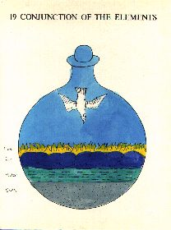
The Conjunction of the Elements
Then being sublimated with some luminary body it is termed Salt.
Then being added to the whole composed matter it is called the Spirit. And so the Earth, with Water, Air and Fire, is a body, the Salt is the life, the last watering of the only Mercury, the spirit.
It is therefore evident that the Stone consisteth of four elements, to wit, Water, Air, Fire and Earth. For in the Stone there are the Soul, the Body and Spirit, and yet but one Stone, as it is above said, behoving to loose and coagulate him again, then all the operations are contained under the Solution until the Albifaction it is sodden again, and becomes a Stone again when it is coagulated. Afterwards it is loosed again and then the solution is reiterated, until the Stone comes out like wax.
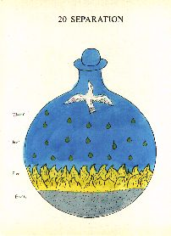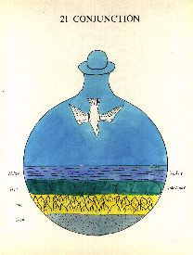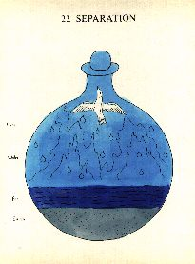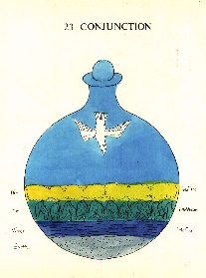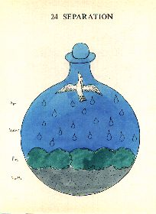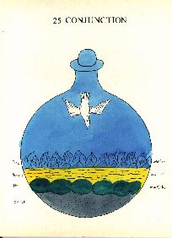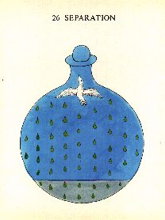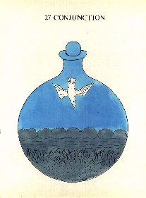

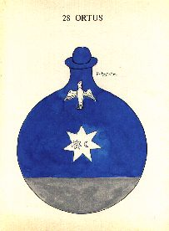
Ortus [the Rising]
Ortus in this art is termed to be conjunction of the second salt or ferment, with the imperfect body prepared.
Hence Morien "we must know that the knowledge of our Mystery is likened to the creation of Man. For first there is conjunction, then conception, then pregnation, then Ortus or a springing or rising, a bringing forth, then Nutrition".
I would therefore have thee understand this one thing, because our seed is Argent vive. When the Earth is joined to an imperfect body, which is termed Our Earth, because the Earth is the Mother of all the elements, and they call it Copulation. But when the Earth begins to retain with it something of the Argent vive, then it is termed Conception, when the male acteth towards the female. But when the Earth is made white then it is called Pregnation, because it is then pregnant, and then the ferment is joined with the imperfect body until they become one in species and aspect, and then it is termed Ortus, because our Stone is then born, which is called a King by the Philosophers.
Whereupon it is said amongst them "Honour your King coming from the Fire. Crown him with a Diadem, and bring him up even to perfect age, whose Father is the Sun, his true Mother the Moon".
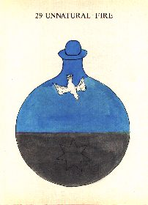
Unnatural Fire or Fermentation
With the philosopher are four fires recorded, to wit, Natural, Unnatural, against Nature, and Elementary, and these fires may better be known by their complexion and compositions. For out of Mercury dissolving and conjoined in the body, there becomes another Mercury, which is called Adrop, Thick Water, Our Water, the Second Water, which is Fire, Strong Fire, Unnatural Fire. For those two, to wit, Spirit and Body, being fit and joined together according to their due proportion, out of them this second Mercury, which we have described is made, and this is that Mercury of which it is written, that in it is whatsoever wise men seek, for the body, the soul and the Tincture are drawn from this Mercury.
But the second Mercury is moist in the vapour, not oily but gummy, of a property indifferent, subtle, easily lying the sharpness of the fire, and vanishing away in it, possessing both body and spirit in loosing remaining water in itself.
Moreover by Fermentation in this place, understand the second fermentation, because the Stone, especially the Inferior part thereof, should as yet be better prepared, washed, calcined, and dissolved, that it may yet unto a more higher and nobler degree of perfection, whereby it may the better be joined with any subtle work or body.
The little star with sevenfold little pricks appearing a colour somewhat duskish, signifies that the star, although it has suffered many alterations and hath his elements indifferently mixed, yet is far from being sufficiently mundified, seeing as yet it wanteth much purgation, as by the same blackness which it hath in putrefaction, appearing in the next Chapter. By the bird flying from above, understand the Spirit descending, the Stone putrefying temperately, and by little and little.
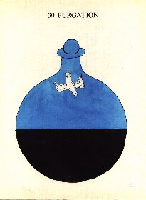
Purgation
Moreover by the domination of the Woman who is of the Mercurial and Lunar humidity, the blackness doth as yet appear, but here it is a little diminished in quantity as in the following Chapters you may see, for by little and little it is changed from colour to colour until the blackness doth altogether vanish away, and the Stone becomes endued with the greatest whiteness, which is a sign of perfection.
By the bird flying from above, understand as you were admonished in the former Chapter.
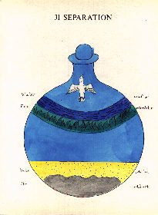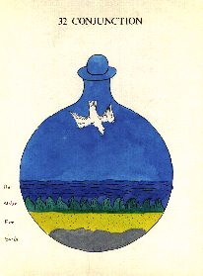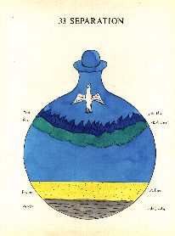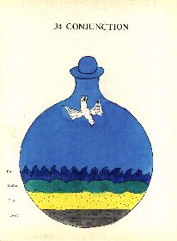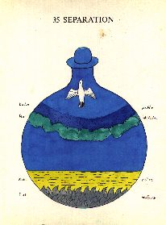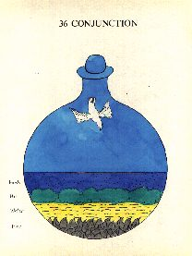

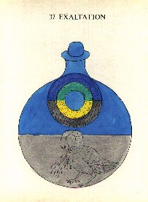
Exaltation
Therefore, Exaltation is an ingenious nobiliating of the magnet or lodestone being dealbated, which is chiefly by the augmentation of the spirit, the sublimation of the Earth, the promotion of the liquefaction by the exaltation of the rectified elements, and by a lively constituting of the Fifth Essence out of them. From whom, saith the Philosophers, "when thou hast had the Water out of the Air, the Air out of the Fire, and the Fire out of the Earth, then thou mayest know that then the Stone hath lost the Water which he had at first out of the Air, after his resolution into it. For the Air and Water are contiguous elements, more light in mixing and better in operation of fire".
When the cold hath overcome the hot, the Air is turned into Water, but when the hot hath overcome the cold, the Water is turned into Air, but thou must have the Air out of the Fire by his Solution.
Moreover now you see the four elements wonderfully altered, exalted and almost fixed.
By the azure colour understand the Earth turned into Air, by the green colour the Air turned into Water, by the yellow colour Water turned into Fire, lastly by the colour somewhat brown understand the Fire to be turned into Earth. By which wonderful alteration is further signified that the Stone now draweth nigh to Fixation.
By the Pelican penetrating and wounding her own breast, from which rivers of blood do seem to flow, understand that this is spoken of the Pelican by a similitude which is called the Blood of Love, for as she doth impart her blood to her young ones, so the Stone being brought to a Quintessence by conversion into the four elements, is ready to impart his tincture to the imperfect wanting it.
Lastly in that you have in the following figure the bird of Hermes sleeping in the midst and applying himself to perpetual rest, understand the discords and hatred of enemies, that is, of the elements, are laid aside, lulled asleep by their long alterations and conversions, laid before our eyes in the former Chapters. But from the fire from above temperately cherishing the Matter, the artificer buildeth the reason of making his Athanor.
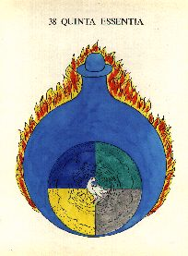
Quinta Essentia
Let putrefaction and much conversion be upon him until it being well purged by sublimation he be made white. For as Marcus saith "when he has drunk his burning Mercury he passeth away and remaineth in the shadows of purgatory with many nights, but conceiveth in baths, and brought forth in the Air, then waxeth Red, goes upon the Water, and is white upon the tops, and is become White, light and airy, which first was ponderous, dry and obscure fire. For the Sun being Exalted the air waxeth hot and drieth".
But take this concerning the fifth essence in this work and Mastery, is the mixing of all the four elements, and the reduction of them into one pure substance. If therefore thou wilt see the Stone, to wit, the fifth substance by the four elements, thou must know that if every one of them do not partake of the fifth nature, the Stone cannot be united nor conjoined with a dry body.
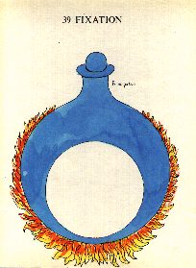
Fixation
Fixation in this art is when the body receives a tinctural or colouring spirit and takes away his volatility or flying, which is by frequent iteration, until it becomes ashes of everlasting duration, and the whole remains in the fire.
We must know further that fixation is always in the white, though not every fixation.
We must know moreover, that out of the perfection of fixation, the fire becomes cold, by whose benefit alone the Stone comes out fixed. When the hidden Mystery of him is made manifest, his colour is Citrine or Red, but after his first fixation in the white, there follows no error in the whole Mystery, although you proceed to the Crowning of Nature by often passing the Philosophical Wheel, and by bettering your blessed Stone by many reiterated solutions and coagulations.
Lastly, by the white circle is signified the white stone, now fixed by the red fire, whose punishment now it suffereth and feareth not, and by the vessel, which is within of an azure colour, is signified the Ethereal spirit of the Stone, which by the benefit of a cold fire doth animate the Stone.
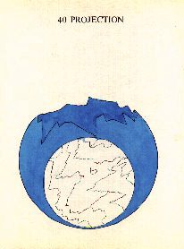
Projection

Projection in this art is the reduction of the fixed earth Multiplicative, or a formal substance firmly coloured, upon much of convenient matter, to the desired joy of the Artist. But because it is not well perceived, cast one pound upon a thousand, but before this moist medicine may go out, the Philosophers have noted some necessity of Ceration.
Hence speaketh Anonimus "it is better to project, now thou dost cast upon fundaments, and fundaments upon. My word, I will love thee, O Lord. I will have thee attend, the which reason is in Saffron. If the Saffron should be projected dry it would colour but little, but if being loosed it be joined with a little liquor, and that little into much, it would colour infinitely. Thou shalt therefore make thy Projection so. First multiply 10 into 10 and then there will be 100, and 100 into 100 and they will be 10000, and so into infinity". But this cannot be done without Ceration, which the Wise have so defined "Ceration is the fitting of a hard and not fusible Medicine to Liquefaction by a frequent Imbibition".
Hence Morien in the Rosary "the whole Mystery is nothing else than an extraction of Water out of the Earth, and a casting of Water on the Earth, until both it and the Earth putrefy, and become clean, seeing as yet the Earth to be mingled with the Water, and the Water or temperate decoction to be a little diminished, the other to increase". They all say that this was perfect Ceration, from whence they have also said further, that the Earth, when the Water is Cered, drunk up and dried with the temperated decoction of the Sun, that is, the heat, and is turned into Earth, that therein is the whole matter. For his force, as that divine Hermes speaketh, is entire if it were turned into Earth. But enough and more than enough has been said of the taking away of the Leprousy of Metals.
Of the curing of Man's body and continual health, understand these things from a few days to a longer time.
For a month every day let there be taken of this blessed powder, the quantity of a grain of mustard seed, in white wine or in any other liquor, early in the morning. It is sudorific or causing sweat, if anything be, to be sent forth by the pores. It is laxative, if anything be, to be evacuated by stool. It is diuretic, if anything be, to be driven forth by the passage of urine. But it is never vomative, as that is altogether contrary to nature.
Moreover, that I may briefly conclude, all this powder is like Ethereal fire, pleasantly consumes all the hurtful superfluities in Man’s body, raising it up, rectifying, and bringing it to a just temperature and equality. Furthermore, it not only rectifieth Man's body but also reneweth the whole man, by the use thereof continued for a few weeks, Lastly, none of the three principles, to wit, of Salt, Sulphur, and Mercury, can in the least exalt itself. But presently, by one little grain, taken as aforesaid, the disease is rooted out, and a man is continued safe and sound without diseases, until the time appointed of God. Therefore to the most Mighty God be Praise, Honour and Glory, for ever and ever. Amen. The Crowning of Nature

Multiplication
In the last Chapter it is made known what it is in general, but not how many fold, but it is by two ways, to wit, quality and quantity But because the Wise have left us a perfect and known complete method concerning this doctrine of Imbibition, and of their ways of operation which follow plainly and fully the Crowning of Nature, I shall altogether give over speaking of them.
I shall add this, instead of the Crown concerning the ruling of Saturn, let a mineral be taken of the same, existing in his first being. Let it putrefy in the belly of a horse, according to the Philosophical month, to wit, 40 days. After putrefaction, by the benefit of Distillation, let the Vinegar so often spoken of, be extracted, to radically dissolve all the metals of the Philosophers. Let that blessed produced vinegar be put upon other Saturn, who from whence may go forth into transparent redness dissolved. Let the redness be extracted and putrefied anew, for the space of a Philosophical month in a horses belly. Then in a strong vessel let it be first urged with a gentle fire, afterwards a strong fire being used, the Red Oil will go forth like blood, through a 1000 small veins. Let the dead head be reduced into Alcool, or subtle powder, calcined, and with phlegm reserved for this use, let it be drunk up and digested and evapourated. Thou shalt have then his natural Salt which if thou wilt mingle with the predicated oil and do urge back again, the red oil will go out transparent, colouring the heavenly Stone, when it hath been coloured by himself. But by the specifical Salt or Ferment, this is truth.
Finis.
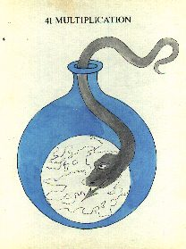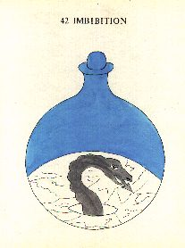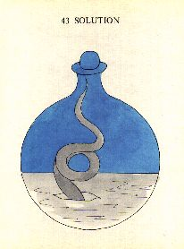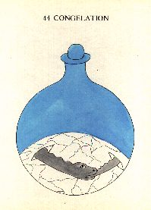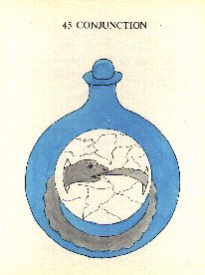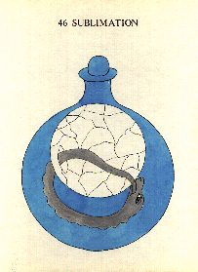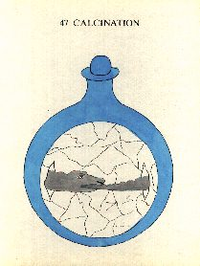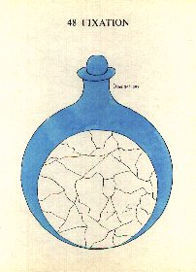

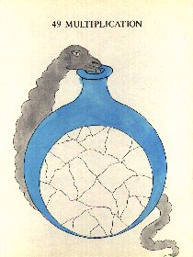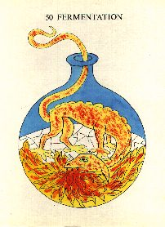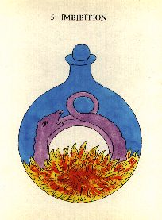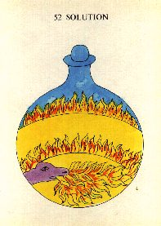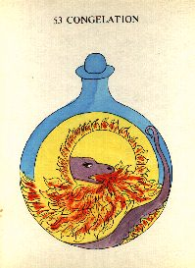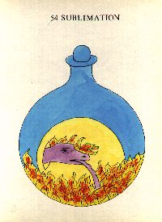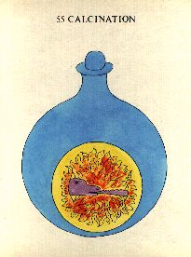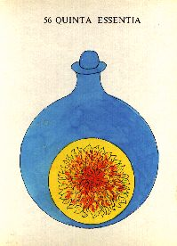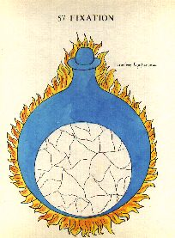

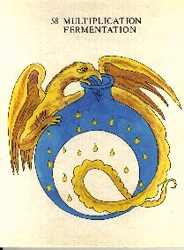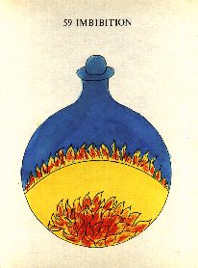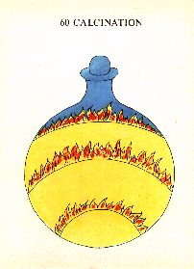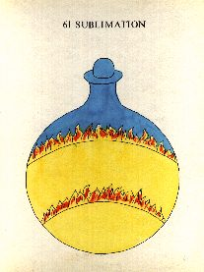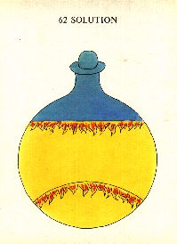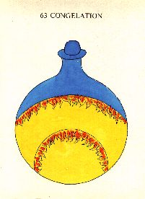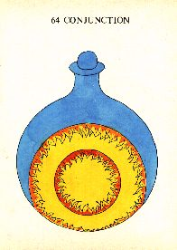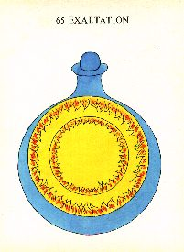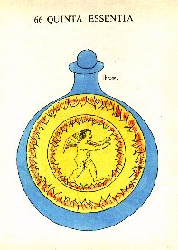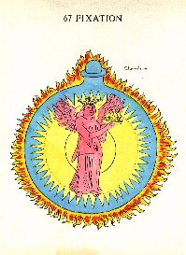

The Crowning of Nature - Commentary

Commentary
by Adam McLean
This commentary is not intended as a complete or final statement on the Crowning of Nature. The work is too multi-dimensional to be completely grasped through one system of ideas. In the heart of the Crowning of Nature series, as in other alchemical works of profound depth, there lies an enigma, a mystery, which can only be touched upon in an inner experience gained by working with these symbols. In undertaking such a meditative work, which of necessity must occupy many years, one will find many different facets and approaches that reveal the spiritual truths hidden in these illustrations. Mere intellectualization will fail to touch the spiritual roots of the work.
In this commentary one envisaging of the spiritual dimension of the Crowning of Nature series is presented, in the hope that it can act as a source of inspiration, a foundation upon which further investigation can rest. I am convinced that a definite system of ideas is revealed as one dimension of the series, and I hope that in what follows I have been able to sketch in adequately the skeleton of the work.
The inspiration that lead to this envisaging of the spiritual content of the series arose over many years of working inwardly with the illustrations, and I have not attempted to relate these perceptions directly to the text. Indeed, the text may not be contemporary with the illustrations (see Introduction), and it is my view that the illustrations can stand upon their own inner revelation.
I discovered that, if the series was arranged in a definite pattern, it was revealed as broken down into a set of ten phases. Internal evidence indicated that this analysis was not an imposition from outside, but indeed was codified in the illustrations, as the ten hierarchies of spiritual beings. With this perspective the system of spiritual perceptions that has been worked into the design of these illustrations, began slowly to reveal itself.
The task of interpreting this series of illustrations, is not, however, merely one of analysis, of breaking down the work into small units, but involves also acts of synthesis, bringing together the different facets, seeing their inter-relationships and how they contribute towards the total picture of the process described in the series.
The series breaks down into two parts: the steps in the preparation of the White Stone, figures 1-40, and the multiplication and transformation of the White into the Red Stone, figures 40 - 67.
The Division of the Series
The series will be analyzed in this commentary as being divided into the following phases.
( 1 - 7) Seven Preparatory Stages
( 8 - 12) The Filling and Sealing of the Retort
(13 - 17) Impregnation
(18 - 27) First Separation-Conjunction Phase
(28 - 30) Ortus, the rising
(31 - 36) Second Separation-Conjunction Phase
(37 - 40) Exaltation
(40 - 48) First Multiplication
(49 - 57) Second Multiplication
(58 - 66)Third Multiplication
(67) The Red Stone and Completion of the Work
The Seven Preparatory Stages
1 Chaos
2 Chemical Subject
3 Distillation
4 Preparation
5 Division
6 Acuation
7 Green Lion
The series opens with the figure named Chaos, which shows the seven planetary archetypal forces, which, together with the four elements depicted in the centre, are the primal substances and forces out of which the work of the alchemical process proceeds. Thus this illustration indicates the foundation of the Great Work.
In the second figure, the Chemical Subject (also called in some manuscript versions ‘Saturn’) we have the first of six circular enclosures, which indicate the basic preparatory stages which must be undertaken before the work proper can begin. The preparatory nature of this initial group of figures is indicated by the fact that they take place in the circular enclosures, contrasting with the rest of the series which without exception, are in the form of flasks or retorts.
The second figure, then, shows us the seven-pointed star of the planetary forces above, standing within a circular descending series of the four elements, which comes right down to the earth realm, with its mountains, land, tree, vegetative growth of nature, and the sea in the foreground, within which the Solar star and the Lunar crescent, important facets of the work, first appear.
The first figure thus shows the Cosmic archetypal aspect of the planetary and elementary forces, while the second shows these same forces in the Earth realm, and points this out as the subject of chemistry. Thus, the alchemist must work with the planetary and elemental forces to achieve the Magnum Opus, and this involves both physical work with substance, and the inner work through meditation upon these forces within the human soul.
It is important that the Solar star and the Lunar crescent both contain within themselves a small fragment, an essence, of their opposites. In these initial preparatory stages, the manifesting and bringing into active relationship, of this syzygy of Sun and Moon, is of vital import.
The Distillation stage follows as figure 3, in which we find the cold, silver-grey, Lunar crescent, being purified through distillation with the Solar fire. This arises out of a direct encounter of the Lunar and Solar forces.
The Preparation stage (figure 4) shows the Sun and Moon in a new relationship, tied together, bound up into an integrated whole. Within the seven-fold Solar star appears a small Moon, and within the crescent of the Moon appears a small seven-pointed star. Thus the Solar and Lunar forces have met inwardly,
When we pass on to the next stage, the fifth figure, a Division has taken place. The cold blue background within the circle has been transformed through the fire rising from below and a division occurs. The small inner Moon and Sun separate from the larger symbols.
The Solar, expansive, active, fiery aspect of matter, meets the Lunar, contractive, passive, cold aspect of matter, through the Distillation stage, and in the Preparation stage seem to come into a fixed relationship. They meet at this turning point of synthesis, and having exchanged part of their essence, divide again. Thus Preparation and Division relate together as two sides of the same experience.
The Acuation stage (figure 6) which follows, mirrors the Distillation stage, but here the Lunar crescent does not bear the fire within its being, but the flames arise out of its surface, an exothermic rather than an endothermic stage. The Lunar crescent itself seems to burn from within. Above floats the seven-pointed star. Acuation in the sense here intended, means a sharpening or stimulation of the process.
The final stage in this series of circular enclosures, the seventh figure, is the Green Lion. The Green Lion is here a symbol of the acidic watery vitriol, which dissolves all that stands within it. The Solar and Lunar forces are merged together in the liquid body of the Green Lion. This stage is the correlate of figure 2, in that the various elements, planetary forces, the Solar and Lunar syzygy, which are seen differentiated there, flow together in the Green Lion stage.
Chaos
______________________________________
/ \
Subject Distillation Preparation Division Acuation Green Lion
\ \_____ ______/ /
\_________________________________________________________/
The physical alchemist, using his or her awareness of the Cosmic archetypal forces (figure 1), has sought for them in the Earth realm, and found the Chemical Subject (figure 2), then working further the alchemist purifies, refines, the prima materia through Distillation, Preparation, by Division and Acuation, and achieves a synthesis of the disparate elements in the Green Lion, a fiery liquid which bears within it all that is necessary for the Great Work to unfold. This provides the basic substance upon which he acts through the many stages in the flasks, which must follow, before the work can reach completion.
The Filling and Sealing of the Retort
8 Coitus
9 The Triune Stone
10 Calcination
11 Sublimation
12 Solution
This section of five stages begins with the pouring of the Green Lion into the flask in which the work of metamorphosis will occur through the following series of 59 stages. At this point (figure 8), the Green Lion, bearing within it the Solar flames and the Lunar crescent, is placed in the flask, as the Coitus, marriage, or joining of the substance of the work with the vessel in which it must be transformed. In physical terms, this vessel is the glass retort or flask. In the terms of soul alchemy, it is the inner meditative space, within which the being of the alchemist, sealed off from the outer world, can work upon itself.
In this short section of five stages, the body of the Green Lion, sealed in the retort, undergoes a kind of initial digestion. But before we enter into this digestion proper, figure 9 reveals that the Green Lion, while it contains the twofold Sun and Moon, the fourfold elements, and the seven planetary forces, also bears within it the Triune Stone of the animal, vegetable and mineral realms. This is indicated in the symbolism of the land as the mineral, the trees as the vegetable, and the human leg as the animal, sealed in the flask. This threefold nature of the stone will appear later as an important aspect of the work, in figures 40 - 66, the Three Multiplications of the Stone.
Stage number 10, reveals the true beginning of the inner operation, the the first Calcination. The liquid of the Green Lion is calcined, burned to ashes, which we see at the bottom of the vessel, and we note that these ashes contain the conjoined Sun and Moon. This is also the first stage in which the bird appears. The bird here represents the soul of the substance of the work. Throughout the following illustrations, the soul is either uniting with the body or substance in the lower part of the flask, or it is separating and entering its own realm. The soul when it rises up as the bird, touches upon the spiritual world, meets with the spiritual forces working in the alchemical process, and returns bearing with it an essence of this impulse from the spirit. Through the many journeys of the bird, rising and falling, the material substance below becomes filled with the spirit. In this Calcination stage, the bird flies downward - the soul dives down and enters into the dead ashes at the bottom of the vessel.
The next stage of Sublimation, figure 11, resembles in form the previous Calcination. except that, most importantly, the bird flies upwards. The soul of the substance rises into the heights of the vessel, touching upon the spiritual.
In the Calcination we have a death process, but in the Sublimation, we find a kind of resurrection, a new life is sought. Thus these Calcination and Sublimation stages must be seen as two sides of the same process. They are inseparable, united in form.
This short section comes to an end with the descent of the bird and the passing into the Solution stage of figure 12. This Solution corresponds to the initial Coitus, or pouring in of the Green Lion, but on a higher level. The forces and elements are again in the liquid form, but having undergone the intermediate Calcination-Sublimation it is more digested, more integrated, than the raw substance of the Green Lion.
__________
/ \
Coitus Triune Stone Calcination Sublimation Solution
\__________________________________________________/
Thus, with the passing into Solution, the substances and forces, having been gathered and purified in the initial Preparation Phase, are now brought to a certain ripeness, a readiness for the work of metamorphosis to begin. We might also note that a division has occurred and the Lunar and Solar forces which were previously united, now stand apart in the Solution.
The Impregnation Phase
13 Putrefaction
14 Conception
15 Impregnation
16 Generation
17 Fermentation
This important group of five stages centered around the Impregnation, opens with the passing of the Solution into a Putrefaction (figure 13). The liquid at the bottom of the retort enters into a dark Putrefaction, a complete blackening. It is essential that the elements and forces undergo a complete digestion, a complete breaking down, in order that their essences may emerge from potentiality into actuality. Out of this dark mass the whole process that is Alchemy has its birth. This is known in other texts as the Nigredo stage. The bird here, of course, flies downwards, entering into the darkness of the Putrefaction.
When we move to the next stage, the Conception (figure 14), a profound change has taken place. The dark mass at the bottom of the flask has lightened, and the seven-pointed star of the planetary forces reveals itself again, but this time more alive, and vermilion in color. The bird flying downwards has borne with it an essence, an impulse, from the spiritual realm, and this has been met by this response from below, the appearance of the star of the planetary forces.
At the next stage, the Conception is Impregnated. The star rises to the surface and thus connects both the upper spiritual part of the vessel and the lower substance. The bird flies upwards, the soul of the process also seeks union with the spirit. The Impregnation (figure 15) is the turning point of this phase, and indeed it marks the point in the whole process where we are no longer dealing with mere material substances, but the seed of the spiritualization of substance has here been sown, and from now on we will see, through the many following stages, just how this seed grows, metamorphoses, and develops.
There follows upon this a Generation stage (figure 16), where the bird flying downwards seems to have brought with it a strength or force of nourishment which works in a living way into the water at the bottom of the retort, and here the liquid becomes multicolored, manifesting the various forces that are being woven into its substance.
This group closes with a Fermentation stage (figure 17). The bird here again flies downwards, but now the multicolored iridescence of the Generation seems to have moved more inward. The liquid darkens to gray, and a rain of droplets falls within the lower part of the flask, and at the bottom the figure of the Black Toad slowly forms. This Black Toad symbolizes the essence of the Earth element. (We have previously met the Green Lion of the watery, liquid nature, the Bird of the Air, and later we shall see the Dragon-serpent of the Fire element.)
This group of five stages relate together as follows.
__________________________
/ \
Putrefaction Conception Impregnation Generation Fermentation
\__________________________________________________/
Fermentation is thus a higher development of the Putrefaction, a return to the darkness of the Putrefaction, but a darkness which bears within it the life, the essence, of the Impregnation stage. In both the birds fly downwards and in both a dark mass forms, but that darkness which in the Putrefaction is total and undifferentiated, is later, in the Fermentation stage, somewhat differentiated into the living form of the Black Toad. Out of this Toad the next stage of the work will unfold.
The Conception and Generation also relate together. In both, the birds fly downwards, and in the Conception the planetary star seems to rise to meet it, while in the Generation stage an essence enters into the liquid mass at the bottom of the flask, stirring it into life.
The Impregnation stage ties these two dyads together, and forms this into an integrated group of five stages.
We find here something which seems to directly relate to the menstrual cycle in women, the Putrefaction being the menstrual flow, the Conception being, in this sense, the release of the egg, the ovulation. Impregnation corresponds to fertilization, or passing of the egg into the womb, Germination being the development of the blastocyst, and Fermentation the embedding into the wall of the womb, or the expulsion of the egg and the beginning of a new cycle. Thus the early alchemists had an intuitive grasp of this process though its spiritual dimension, although the precise details of its material embodiment was not identified until many centuries later, with the development of microscopy.
The First Cycle of Separations and Conjunctions (18-27)
The alchemical process has now reached a crucial stage. Something of the spiritual has been connected to the material in the previous Impregnation phase, and this now lies at the bottom of the flask, symbolized by the Black Toad. Out of the body of the Toad, the four elements, earth, Water, Air and Fire appear (figure 18) and go through a cycle of metamorphosis of Separations and Conjunctions.
In the Separation phase the bird flies upwards and in turn the elements separate and rise upwards in the flask. The Conjunction phase is marked by the return of the bird downwards, and a corresponding re-integration of the elements.
The ten illustrations 18-27 are thus broken down into five cycles of this process of Separation and Conjunction. We wish to look at the total picture of this process, and so, rather than examining the individual illustration in isolation, we shall look at them as part of this integrated process.
We can see this as a kind of spiritual breathing process, the bird flying alternatively upwards and down again. The Separations are a kind of expiration, a breathing out, in which the rigid interconnections of the elements are loosened. The Conjunction phase can be seen as an inspiring or inbreathing; the bird returns downwards, and the elements are tied together into fixed relationships again in the lower part of the vessel. Thus we have in figures 18-27, five cycles of this outbreathing-inbreathing. However, they are not mere repetitions of each other, for profound changes occur in the four elements throughout this cycle. These changes are shown in the retort in two ways - by a metamorphosis of the form of the elements as depicted, and a metamorphosis of their colors.
In order to grasp just what is occurring at this point in the process, we must look at the Separation-Conjunction cycle as a totality. To begin, we must note the first and the last illustration.
Figure 18, the first Separation, shows the four elements being breathed out of the Black Toad, formed during the previous Fermentation, while figure 27, the final Conjunction, shows the four elements being re-absorbed into the Earth nature, in that they are all tinged with the grey of Earth. So we have a cycle which involves an outpouring of the four elements, a metamorphosis of their relationships to one another, and a final re-integration into the Earth.
It is also important to note that this first cycle of transformation of the elements does not involve elementary Earth, but only Fire, Air and Water. The earth remains unchanged at the bottom of the flask in all the illustrations, and this is the essential difference between the first and second cycle of Separations and Conjunctions (figures 31-36) in which the Earth element is itself transformed.
So we have a cycle of transformations of the Fire, Air and water, in which each of these receives, through a series of transformations, the essence of the other elements, and this is indicated by a metamorphosis of forms: the symbols of flames - Fire; clouds - Air; waves - Water; and stipples - Earth; and a metamorphosis of colors: Yellow - Fire; Blue - Air; Green - Water; and Grey - Earth.
At the beginning of these cycles of changes, the elements stand in their normal relationship to one another, that is in the order of their densities - Earth, the densest, at the bottom of the flask, then Water, Air and Fire, the most subtle, at the top. The true work of metamorphosis occurs during the central three groups of Separations and Conjunctions, 20-21, 22-23, 24-25. The two outer cycles involve, in 18-19, the outpouring of the elements and their arrangement into their normal relationship (Conjunction 19), and in 26-27, the re-integration of the elements into the Earth element (Conjunction 27).
So we shall now look at the total picture, focussing upon the central three cycles of transformation. We have the following metamorphosis of form.
18 - 19 20 - 21 22 - 23 24 - 25 26 - 27
Sep - Con Sep - Con Sep - Con Sep - Con Sep - Con

Fire Fire Water Air Fire Air
\ \ \
Air Air \ Air \ Fire \ Water Water
\ \ \
Water Water Fire Fire Water Water Air Air Fire

Earth Earth Earth Earth Earth Earth Earth Earth Earth Earth
During the Separation phase each element in turn remains at the bottom of the flask with the Earth, this element being the one which stood at the top of the flask during the previous Conjunction phase. The two elements remaining in the upper part of the flask during the Separation phase are free to metamorphose into each other, and during the following Conjunction, this new interrelationship passes into a more rigid and fixed form in the bottom part of the retort, where all four elements come together again.
The four elements initially (figure 19) bear their own special color, but their various transformations into one another as the cycle progresses are indicated by a change of colour. Thus in figure 21, the Water which has been changed into Air, bears the Air color (Blue), and the Air transformed into Water has taken on the Water color (Green). Thus we have a cycle of color metamorphosis paralleling the changes in the forms of the elements.
18 - 19 20 - 21 22 - 23 24 - 25 26 - 27
Sep - Con Sep - Con Sep - Con Sep - Con Sep - Con

Yellow Yellow Blue Yellow Blue Grey

Blue Blue Green Green Yellow Grey

Green Green Yellow Yellow Blue Blue Green Green Grey

Grey Grey Grey Grey Grey Grey Grey Grey Grey Grey
These can be further analyzed so that one begins to see two cycles of transformation working through this process.
Fire Fire
/ \ / \
/ A \ / B \
/ \ / \
Air--<--Water Air-->---Water

[Clockwise] [Anti-clockwise]

A being a subtilization, a movement from Water to Air to Fire, while B is the opposite, a fixing or descent into more dense states.
At the end of this process each of the three non-Earth elements, Water, Air and Fire, has undergone a cycle of transformation into the others, and thus now bears within its being the essence of the other three elements. At the conclusion in the Conjunction (figure 27), the elements stand in the following relationship:
Air Blue
Water Green
corresponding to colors
Fire Yellow
Earth Grey
which we find acts as the starting point for the second cycle of Separations and Conjunctions in figures 31-36.
In this part of the commentary, I have only touched upon a few facets of this cycle, in order not to complicate the picture unduly, however, much more can be extracted from analyzing and synthesizing the transformations through the Separations and Conjunctions. For example, the color and form metamorphoses can be interpreted after the manner of the ‘element of the element’ idea. Thus the Blue tinged Water, would be ‘Air of Water’, and Green colored Fire, the ‘Water of Fire’, etc. The color and form metamorphoses can be followed in greater detail, using this and other interpretative ideas, and the reader should try to work with these in meditative exercises.
The Ortus Phase
28 Ortus
29 Fermentation
30 Purgation
The next phase of the whole process we will name after the first figure, number 28, the Ortus or rising.
The first cycle of Separations and Conjunctions, which involved the transformation of the upper elements Water, Air and Fire, into one another, ended with a final absorption into the Earth element, with then all assuming a grey colour. In the Ortus stage (figure 28) this grey mass containing the inward digestion of the elements, lies at the bottom of the flask, and out of this rises the seven pointed star, which had disappeared during the last phase of the process. Now the sevenfold archetype of the planetary forces in the alchemical process must undergo a kind of Separation and Conjunction. Thus the sevenfold star rises up in the Ortus (‘springing up’, ‘rising’, ‘dawning’) with the ascent of the bird. The star bears within it the Solar and Lunar archetypes.
The next illustration (figure 29) is a Fermentation in which the star of the planetary forces again joins with the elements at the bottom of the flask and begins to unite its essence with that of the elementary forces, which process is shown approaching a completion through the following Purgation (figure 30).
The alchemists saw that at the beginning of a new life, there always stood a death process, and so we have here a nigredo or blackness out of which the new forces would emerge, transformed and re-integrated together. This descent into the blackness of Purgation is essential if the process is to continue and evolve to a higher stage.
The Second Cycle of Separations and Conjunctions (31-36)
Now that the process has run the course of the Ortus, and the sevenfold planetary forces have been integrated with the forces of the four elements, a new cycle of Separations and Conjunctions takes place, which this time involves the transformation of the four elements, including the Earth, one into another.
Once again we shall look at this process of metamorphosis as a totality. In the Separation phases we find two elements left at the bottom of the flask, while the remaining two are found in the circular forms at the top of the retort. The Conjunction phase finds, as before, the four elements fixed at the bottom of the flask. The bird flies upwards during the Separations and downwards during the Conjunctions, as in the previous cycle.
We have here in figures 31-36 three iterations of the expiration-inspiration, during which the elements, and in particular the Earth, receive the essence of the others. We have thus the following metamorphosis of form:
31 - 32 33 - 34 35 - 36
Sep - Con Sep - Con Sep - Con

Water Water Fire Fire Earth Earth

Fire Fire Air Air Air Air

Earth Earth Earth Earth Water Water

Air Air Water Water Fire Fire
The three higher elements in turn occupy the lowest (or Earth) place, while the Earth element is raised to the highest of the levels in the final Conjunction.
The colors, at all stages, remain in the following relationships,
Blue Air
Green Water
Yellow Fire
Grey Earth
which is the particular order found in the forms at the final Conjunction (figure 27) of the first cycle of Separations and Conjunctions).
On the figure illustrating each of the three Separation phases the following descriptions of the transformations are found:
Separation 31 Separation 33 Separation 34

Water -> Air Fire -> Air Earth -> Air

Fire -> Water Air -> Water Air -> Water

Earth -> Fire Earth -> Fire Water -> Fire

Air -> Earth Water -> Earth Fire -> Earth

Fire Fire Fire
/ \ / | / \
Earth Water Earth Water Earth Water
\ / | / \ /
Air Air Air
[Clockwise cycle] [Anti-clockwise cycle]
We note that these cycles through which the elements are transformed relate to one another. The pattern of the first stage is reversed in direction in the last phase, while the central transformation is a hybrid or crossing over of both of these patterns of change. (We are reminded of the cyclic relationships among the elements in the Chinese system).
Through this cycle of metamorphosis, the elements fully participate in each other’s essence and the cycle closes with the most subtle element, fire, in the lowest place, and the densest, Earth, in the highest. The spiritual has been brought into incarnation, fixed in the earth realm, and the earthly has been spiritualized.
The Exaltation Phase
37 Exaltation
38 Quinta Essentia
39 Fixation
40 Projection
This phase of the process begins with the Exaltation (figure 37) in which the elements, still formed in the order they assumed at the close of the last cycle, Earth - Air - Water - Fire, form themselves into a circular arrangement which rises in the flask and becomes exalted in the heights of the retort. The elements enter into a more spiritualized state, while below in the substance at the bottom of the flask, wee see that the Bird has taken on the gesture of the Pelican, biting and wounding its own breast, in order to provide the nourishment of its own blood for the process. This symbolizes a kind of sacrificial stage, at which all the work of the bird in its many flights and the long development of the substance into this appearance of seeming completion and beauty, must be sacrificially destroyed in order to proceed further. The alchemist must not hesitate to continue the process, and must resist the temptation to hold back and try to perpetuate the transient beauty of the evolution he has achieved so far.
Thus at the next stage, figure 38, the Quinta Essentia, the circle of the four elements has sunk again in the flask and absorbed the bird into its midst, which appears in the centre of the wheel of the elements in the Phoenix gesture.
The elements have now been quartered and each bears all the colors of the others. This universalizing of the elements is the result of the sacrifice made at the previous stage. From the upper part of the outside of the retort, flames are seen, indicating an exothermic reaction. The formation of this new relationship between the elements has liberated energy, which appears outwardly as fire.
When we move on to the next stage, the Fixation (figure 39), the wheel of the four elements has been entirely transformed into white. This is the beginning of the formation of the White Stone. Through Fixation, the soul nature of substance has been realized in material form as the White Stone, which thus bears the essence of the four elements, plus the fifth essence, the spiritual archetype of materiality which lies beyond matter and yet through alchemy can be brought into outer expression, fixed into earthly form. We note that heat is required from outside to bring this stage to completion.
This White or Lunar Stone is the Tincture of the Moon, or the soul Tincture. In terms of the soul development aspect of alchemy, the White Stone is that inward experience which can act as a sure foundation, that solid centre in the whirlpool of ever flowing soul forces, from which alchemists can work upon their being, and anchor their inward development. In this sense, once the alchemist has the White Stone of the soul, he or she can begin the process of tincting, transforming his or her being from a point of inner security. The White Stone is, however, only half the work of alchemy. The alchemist must carry this process through to completion and create the Red Stone or the Tincture of the Spirit.
The final stage of this first half of the series ends with figure 40, the Projection, in which the flask is broken and the White Stone is ready to be brought out from the inner enclosed realm of the retort into the world, and can begin to be used in the process of transmutation. On one level this is the transmutation of matter, in that it accentuates or catalyses the lunar aspect, when it is brought into contact with a material process. In traditional alchemy this is indicated by its power to transform metals into silver, the Moon metal, but its power is wider than this, and a true understanding of the essence of the White Stone of the Philosophers, can only arise when one recognizes the lunar forces that play through material processes, in the mineral realm, in the pant world, in the animal body, or in the soul of humankind. The White Stone transforms, harmonizes and catalyses the lunar forces in these realms, and this is its true power. The Red Stone which is created at the end of the second part of the process, similarly acts to catalyse the Sun forces in the various realms.
At this centre point of the entire process, we will review diagrammatically its development so far. Diagram one indicates the breakdown of the first 40 figures, into the seven phases which have been described so far. The reader who wishes to grasp this process in depth should copy out the forms of images and set them out in this arrangement. Then they will be able to grasp the process as a totality. (Indeed, while I was working on this series, I constantly had a set of these illustrations arranged in various patterns upon the walls of my study, and thus was able to easily consult, or rearrange the pattern to explore other possibilities.)
1 2 3 4 5 6 7
Chaos Subject Distillation Preparation Division Acuation Green Lion

8 9 10 11 12
Coitus Lapis Triunis Calcination Sublimation Solution

13 14 15 16 17
Putrefaction Conception Impregnation Generation Fermentation

18 19 20 21 22 23 24 25 26 27
Sep Con Sep Con Sep Con Sep Con Sep Con

28 29 30
Ortus Fermentation Purgation

31 32 33 34 35 36
Sep Con Sep Con Sep Con

37 38 39 40
Exaltation Quinta Essentia Fixation Projection
The second part of the work is the transformation of the White Stone of the Lunar forces, into the Solar Red Stone. This is accomplished through a threefold Multiplication, each Multiplication being described by nine figures, and the series finishes with the final fixation of the Red Stone.
This can be analyzed as follows:
Figures 40-48 The First Multiplication in which the serpent unites with the White Stone,
Figures 49-57 The Second Multiplication in which the serpent exteriorizes fire into the process,
Figures 58-66 The Third Multiplication in which the fire is inwardly digested and the Stone transformed,
Figure 67 The final Fixation of the Red Stone.
We note that figure 40 is common to both parts of the work, being the conclusion of the first part, and the beginning of the second part. Each of these phases of Multiplication relates in form to the others, the second and third being higher octaves of the first Multiplication.
The First Multiplication
40 Projection
41 Multiplication
42 Imbibition
43 Solution
44 Congelation
45 Conjunction
46 Sublimation
47 Calcination
48 Fixation
This opens with figure 40, the Projection, which closes the first part of the work, in which we see the White Stone like a cracked egg in the bottom of the opened retort, and out of this egg the Red Stone will be born.
In the next stage, figure 41, entitled Multiplication, this egg of the White Stone first meets the serpent-dragon. Of the four creatures we find in this series, the serpent-dragon represents the living power of fire. The animals here represent the living forces behind the elements, the etheric forces that play through matter, that the alchemist must harness and bring into fixed form, if he is to enliven matter. The White Stone acts as the magnet upon which the ethers can work and eventually be fixed into the Red Stone. The serpent enters the flask at this stage, attracted by the White Stone.
There follows a process of Imbibition (figure 42) in which the serpent is slowly absorbed into the White Stone egg at the bottom of the retort.
This continues through to Solution (figure 43) where the serpent dives down, merging completely with the White Stone substance.
A turning point is reached with the next Congelation (figure 44), when the serpent achieves the Ouroboros gesture - it swallows its own tail. This indicates the development of an inner strength of form in the forces of the serpent. The Ouroboros represents the closing in of a process upon itself, forming an integral ring of being. So with this Congelation, a hardening and integration of the serpent forces is achieved. We also see the White Stone beginning to re-emerge from the bottom of the retort.
The following Conjunction (figure 45) shows the egg of the White Stone rising in the flask conjoined with the Ouroboros serpent, whose body fills the lower part of the vessel.
Then we pass into the Sublimation (figure 46) in which the egg and the serpent rise higher in the flask, moving away from the lower regions and touching upon the more spiritual realms within the process.
During the next stage, the Calcination (figure 47), the egg begins to dominate the flask, the serpent becomes more inward, and only its head and tail can be seen, as it is absorbed into the substance of the White Stone egg.
The first Multiplication phase comes to a close with the Fixation (figure 48) and here the egg of the White Stone seems almost to fill the flask.
In this first Multiplication, the Stone has absorbed the first serpent, the first of the three ethers. The process involves a descent of the etheric serpent during the first four stages, the turning point or merging of the serpent with the Stone, and a final four stages of the ascent of the Stone and the total absorption of the forces of the serpent.
The Second Multiplication
49 Multiplication
50 Fermentation
51 Imbibition
52 Solution
53 Congelation
54 Sublimation
55 Calcination
56 Quinta Essentia
57 Fixation
This phase opens with the stage entitled Multiplication (figure 49) in which the next etheric serpent-dragon enters the flask and joins the White Stone.
This leads to Fermentation (figure 50) during which the purplish bodied serpent-dragon exteriorizes its inner etheric fire, and breathes this out upon the egg of the White Stone.
The next stage is the Imbibition (figure 51) and shows the serpent forming itself around the body of the white egg of the Stone, which it seems to draw down into the flames it has breathed forth, and which fill the bottom of the retort.
Following upon this is a Solution (figure 52), in which the natures of the serpent and the Stone have begun to merge into one another. This is an important stage, in that for the first time we see the Stone beginning to absorb the fire etheric nature of the serpent, becoming tinged yellow. We see here the disc of the Stone covered with the flames which the serpent-dragon has breathed forth.
Figure 53, the Congelation, marks the turning point of this phase of Multiplication. The egg has now become completely tinged with yellow, and it rises above the sea of the serpent’s flames, which fill the lower half of the vessel. Both of these participants in this process have now fully encountered one another, and a hardening and consolidation of their natures has been achieved. The serpent begins to close in upon itself.
In the following stage, Sublimation (figure 54), the serpent now forms its Ouroboros, and the fire and the egg seem to come into a more balanced relationship of their forces.
Next follows a Calcination (figure 55) showing the withdrawing of the etheric fire forces into the inner part of the egg, while the serpent still appears in the Ouroboros state.
In figure 56, Quinta Essentia, the serpent has now become completely absorbed into the egg-stone, where only his flames now burn inwardly.
When we move on to the final stage of the second Multiplication, the Fixation of figure 57, we once again see the egg almost filling the retort. However, now, in distinction to the close of the first phase, it is tinged yellow, a tingeing that was the gift of the second serpent-dragon. The outside of the retort flames with fire, indicating an exothermic reaction, an outpouring of energy.
Thus the White Stone has now absorbed two etheric streams - the two serpent-dragons, and this occurred through a descent of the second serpent into the Stone through fire in the first four stages, the turning point of the Congelation stage with the tingeing of the Stone, and the final ascent of the Stone through four stages to the Fixation.
The Third Multiplication
58 Multiplication-Fermentation
59 Imbibition
60 Calcination
61 Sublimation
62 Solution
63 Congelation
64 Conjunction
65 Exaltation
66 Quintessence
Figure 58 is the Multiplication-Fermentation stage which opens the third phase. Here we see a winged serpent-dragon entering the flask in which the egg rests, and as it enters, a rain of flaming droplets falls to the bottom of the retort.
Then follows an Imbibition (figure 59), in which the flames rise up and almost cover the egg Stone, which flames at its surface and stands within a sea of flames in the lower part of the vessel.
This further leads on to Calcination (figure 60) during which the disc of the egg almost fills the retort and is covered with three broad bands of fire, which we find reduced to two in the next figure, the Sublimation (figure 61).
Then we arrive at the turning point of this third Multiplication phase, figure 62 Solution. In this we see, for the first time, the fire turning inwards. The flames now move towards the centre of the egg of the Stone. Here the Stone dissolves the fire, rather than being dissolved in fire.
Figure 63, Congelation, corresponds directly in form to figure 61, the Sublimation, except that the two bands of fire now move inward. It is similar with the following Conjunction (figure 64) which parallels figure 60, Calcination, except that again the flames move inwards towards the centre of the egg.
Figure 65 is an Exaltation stage in which the egg, with its two inward flowing bands of fire, rises in the retort, touching upon the spiritual realm of its upper regions.
This third Multiplication reaches its fulfillment in the Quintessence stage (figure 66) where we see standing within the egg and its inward flaming fire, a small winged angel-child. This we should see as representing the early stages in the growth of the Red Stone.
The third Multiplication phase involves a final encounter of the Stone with the third serpent-dragon, which is winged in distinction to the other two. Again, the first part of the process, the first four stages, are a descent of the third serpent, reaching a turning point at the fifth stage where the true work of this phase is done, and the process continues with an ascent of the Stone. The essential work of this phase lies in the inturning of the fire, a process which is necessary for the formation of the final Quintessence, which contains the early germ of the Red Stone.
The Final Fixation of the Red Stone
67 Fixation
The summit of this work, the long chain of alchemical operations, is achieved at the 67th step, the Fixation. Here we find within the flaming flask, a nimbus of light, in which stands a winged angelic being holding up a golden crown. With the preparation and fixation of the Red Stone, the alchemist achieves the Crowning of Nature. The alchemist has brought into material form spiritual forces and being, has produced a perfect substance that bears within it the spiritual archetype; a substance that has woven into it the essence of the four elements, and the three ethers, uniting the Solar and Lunar forces and natures, and harmonizing the seven planetary archetypes.
This substance bears a relationship to the initial Prima Materia of the Chaos of figure 1. Out of the Hyle unfolded all the spiritual, soul and material forces and substances that make up the Cosmos. The Red Stone, however, arises out of working with all these spiritual, soul and material forces and substances, bringing them into incarnation in one substance again, the supreme synthesis. The Red Stone belongs therefore to the end of spiritual evolution, as Hyle belongs to the beginning, and it is created out of the work of humankind with Nature, in the direction of spiritual evolution.
This manuscript does not identify any one particular prima materia for the alchemist to work this process upon, and thus it points to the reality that in alchemy it is the process which is important, rather than the substance. We find this in certain schools of twentieth century alchemical teachers, in particular the Paracelsus Research Society, where students are shown methods of extracting the Salt, Sulphur and Mercury of various plants and minerals.
The process of the Crowning of Nature involves the secret of working with the elements and their corresponding ethers. It unfolds an etheric rather than a material secret, and can be applied to many substances.
Diagram two reveals the relationships between the different stages of the second part of the work, the three Multiplications and the final Fixation. As before, it will be found to be of great help in understanding these interrelationships, if the reader arranges copies of the illustrations in this pattern.
40 41 42 43 44 45 46 47 48
Projection Multiplication Imbibition Solution Congelation Conjunction Sublimation Calcination Fixation

49 50 51 52 53 54 55 56 57
Multiplication Fermentation Imbibition Solution Congelation Sublimation Calcination Quinta Essentia Fixation

58 59 60 61 62 63 64 65 66
Multiplication Imbibition Calcination Sublimation Solution Congelation Conjunction Exaltation Quintessence

67
Fixation
The Nine Hierarchies
The division of the process into the series of phases, which I have adopted in this commentary, is not an entirely arbitrary or idiosyncratic one, but is indeed codified in the 67 illustrations by the hierarchies of spiritual beings. It is interesting that another name for this work found on a number of manuscripts is "Opus Angelorum", the work of the angels. Certain of the illustrations are associated in the manuscripts with nine hierarchies of spiritual beings as follows:
6 Acuation Gabriel
8 Coitus Virtutes
16 Impregnation Hierarchiae Ephioma
28 Ortus Potestates
39 Fixation Principatus
48 Fixation Dominations
57 Fixation Hyerarchae Epiphanomia
66 Quintessence Throni
67 Fixation Cherubim
We find that each of these phases (excepting the cycles of Separations and Conjunctions) has one and only one of these Hierarchies presiding over a particular figure from the phase. Thus the forces of the spiritual world, personified as the creative hierarchies of spiritual beings, participate in and aid the progress of this process, and here the true threefold nature of the alchemical work is revealed - the encounter with the forces of the spiritual beings, the evolution of the soul of the alchemist, and the transformation of the substance in the retort.

